

**Nora Alshaalan**

**Norah Alsabti**

**Communication Plan**

**Goal**

**“Literarian” is a non-profit foundation devoted to cultivating learning in youth for the Saudi Arabia of tomorrow. In Literarian, we Believe access to knowledge is a basic human right. To this end, Literarian provides a platform for Saudi students to exchange textbooks in the hope of making learning and knowledge more affordable.The Foundation is invested in helping educating the youth in three wide fields; Science, Art & Culture. These pillars of knowledge will support and advance our country’s future. Enabling the Saudi people to learn effectively is a means to develop and drive advances across the business, technological, literary, cultural, and social aspects of our nation.**

**Objectives**

**Literarian’s goal can be achieved by providing an easy and user-friendly platform for students to:**

* **Offer to sell his/her textbook.**
* **purchase or borrow a textbook.**

**Target Audience**

**All college students In Saudi Arabia.**

**Timelines**

**Week5 Design**

**Week 7-9** **Html and CSS pages**

**Week 9-10** **Javascript functionality / end of Frontend phase**

**Week 10-13 implement beckend functionality**

**Evaluation Plan**

* **Efficiency of the site (speed), the site shall not take longer than 1sec to lookup tables**
* **Security: by providing user accounts (password protected).**
* **Availability: the site will be available 24/7.**
* **Usability: The site will be easy and user friendly.**
* **Reliability: The site will instantly remove any books that have been purchased/borrowed from the Available Books section.**

**Content organization**

**Layer1**

**Homepage, the main page, provides a navigation element to most of the webpage content**

**Layer2**

**Browse Courses,** **provides a list of courses to explore related books based on courses**

**Browse Books,** **browse all available books**

**Browse Universities,provides a list of saudi universities to explore their textbooks**

**About us, describes who we are and our goals beside contact information**

**Login,** **a page for users to login**

**Layer3**

**Bookpage,** **provides all information about a book ,from who you can get it and for how much**

**Signup,** **a page for new users to signup**

**Profile,** **a dashboard page with profile settings**

**Upload book, a page for uploading books**

**Site map**

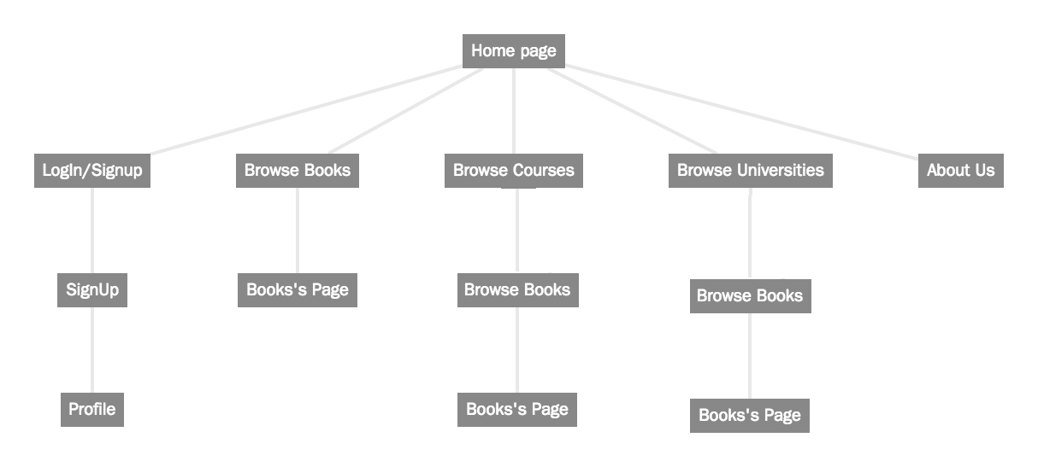

**Wireframe**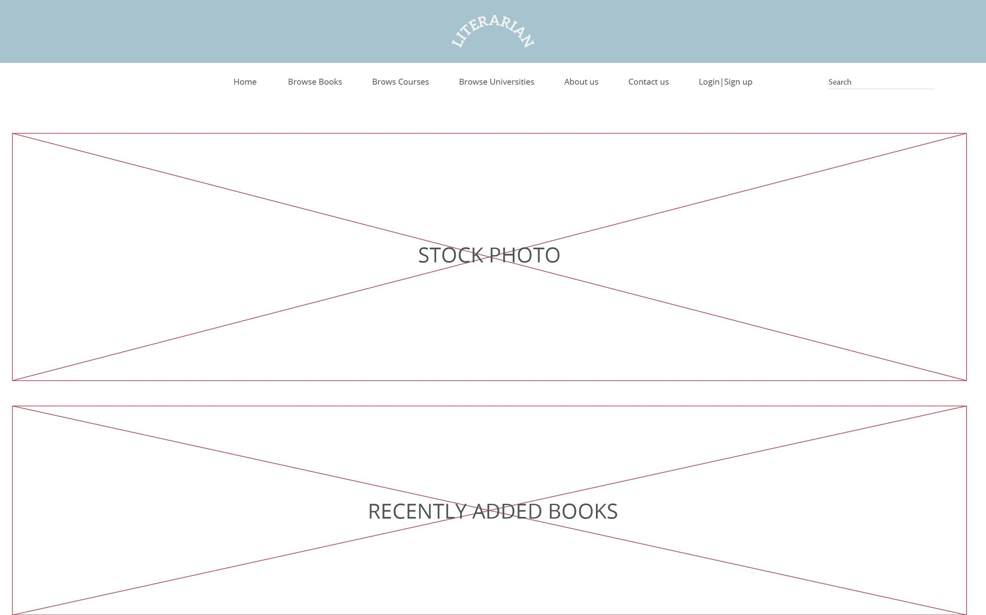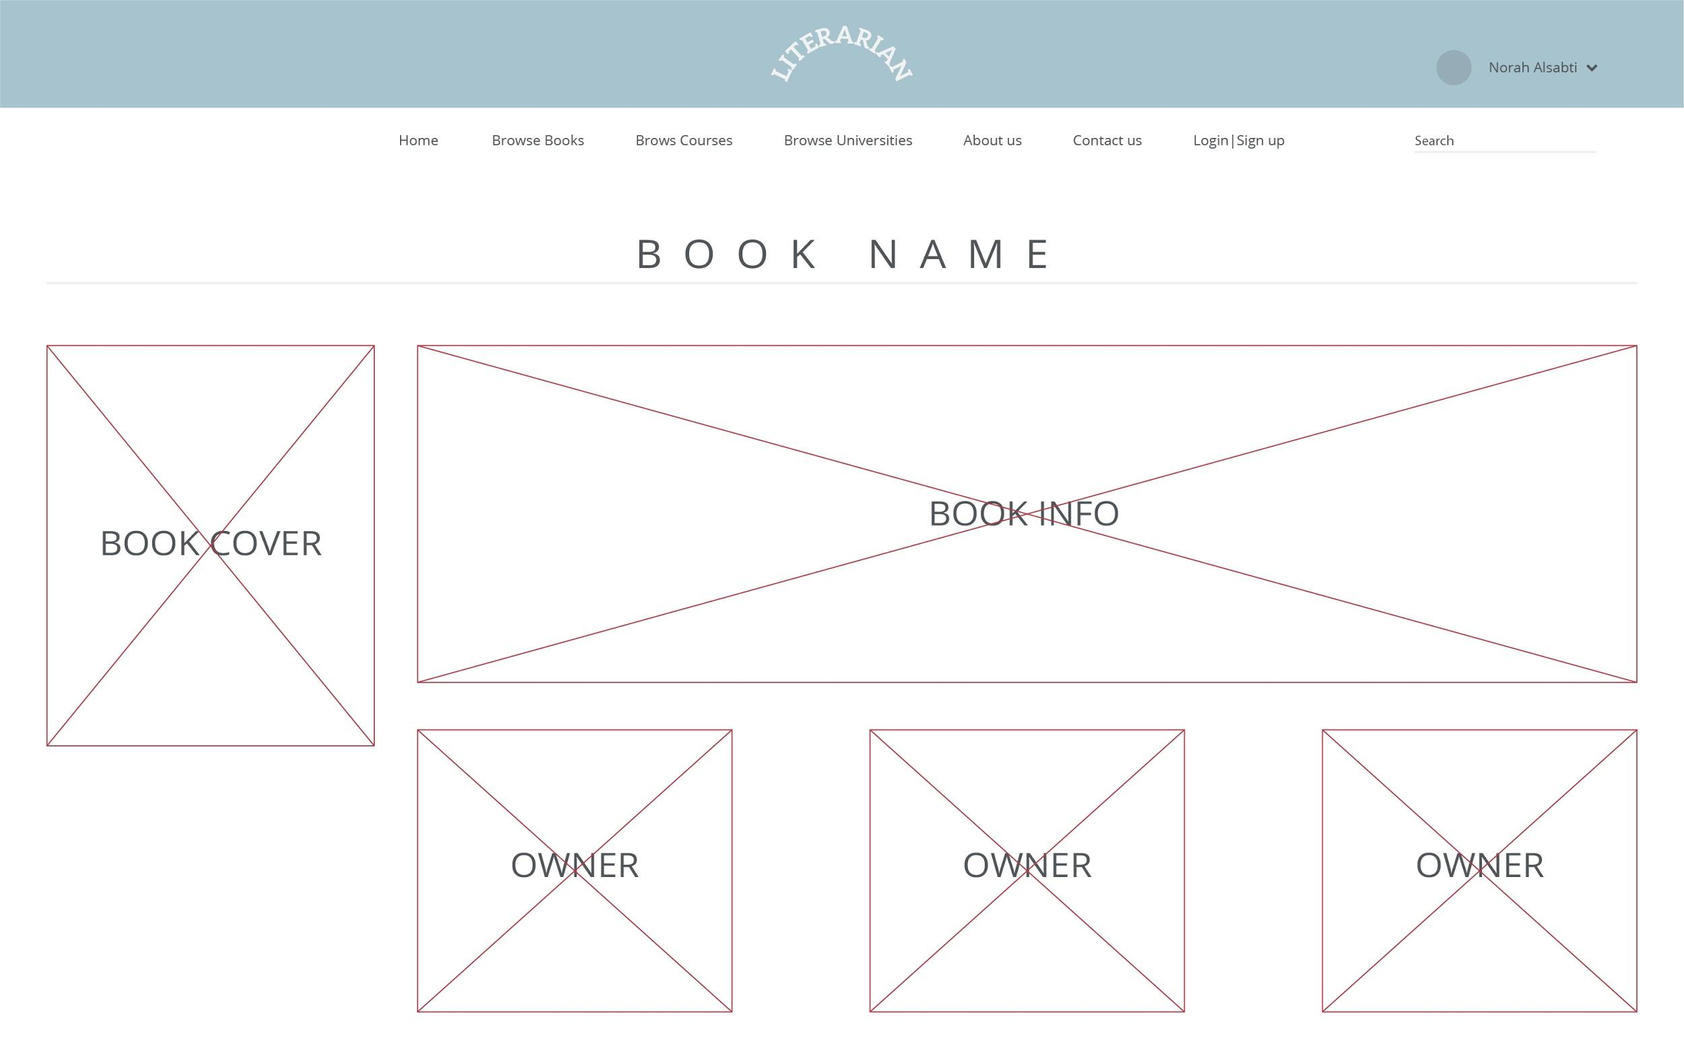

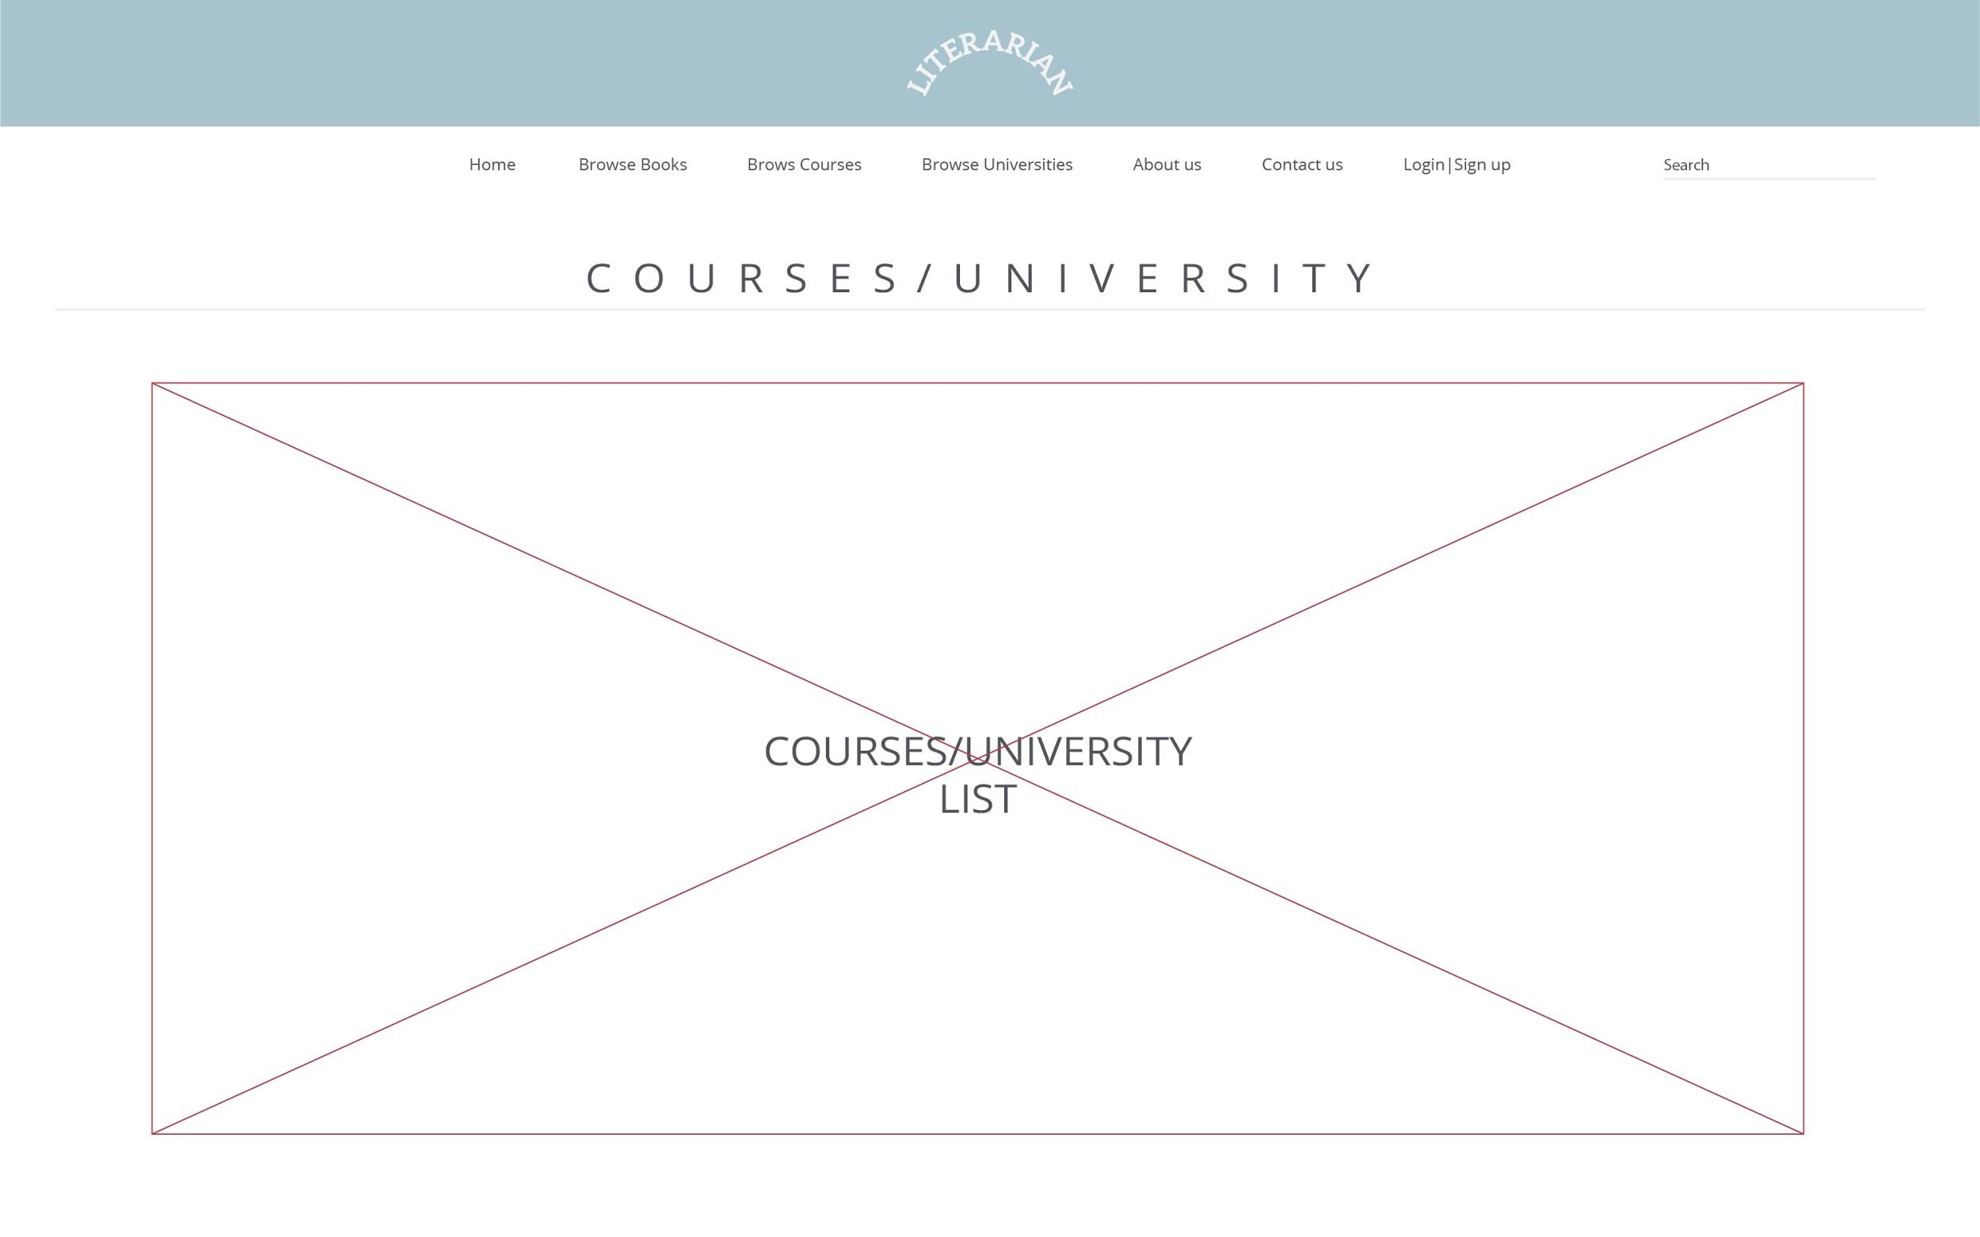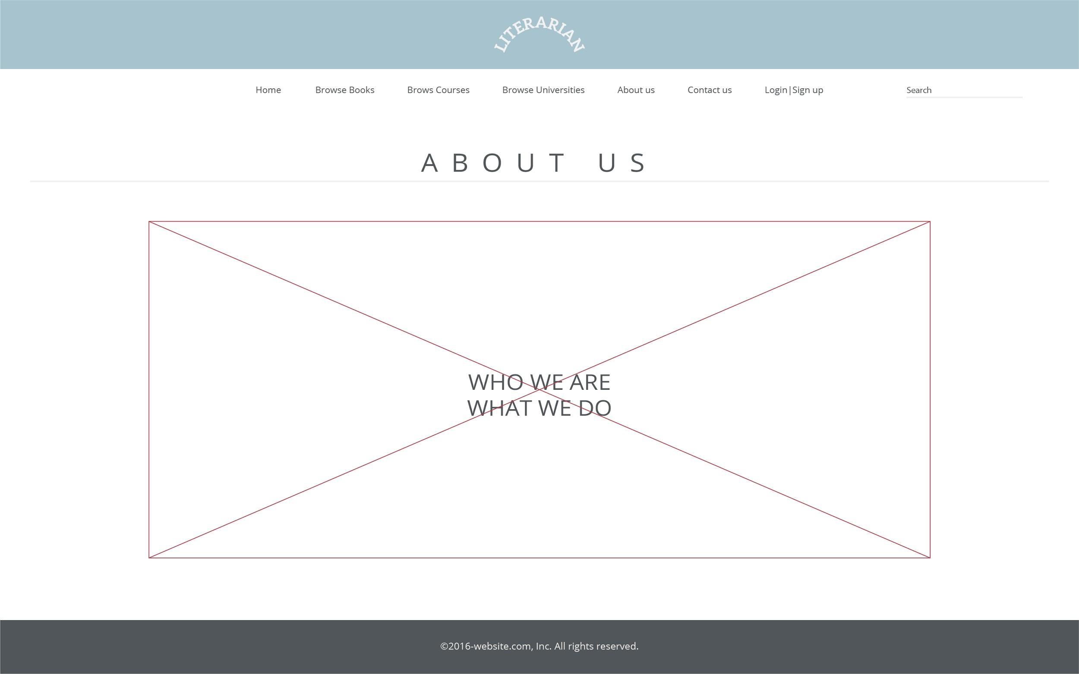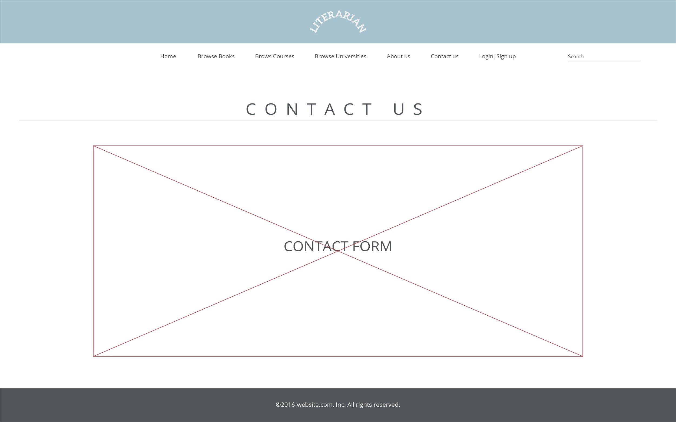

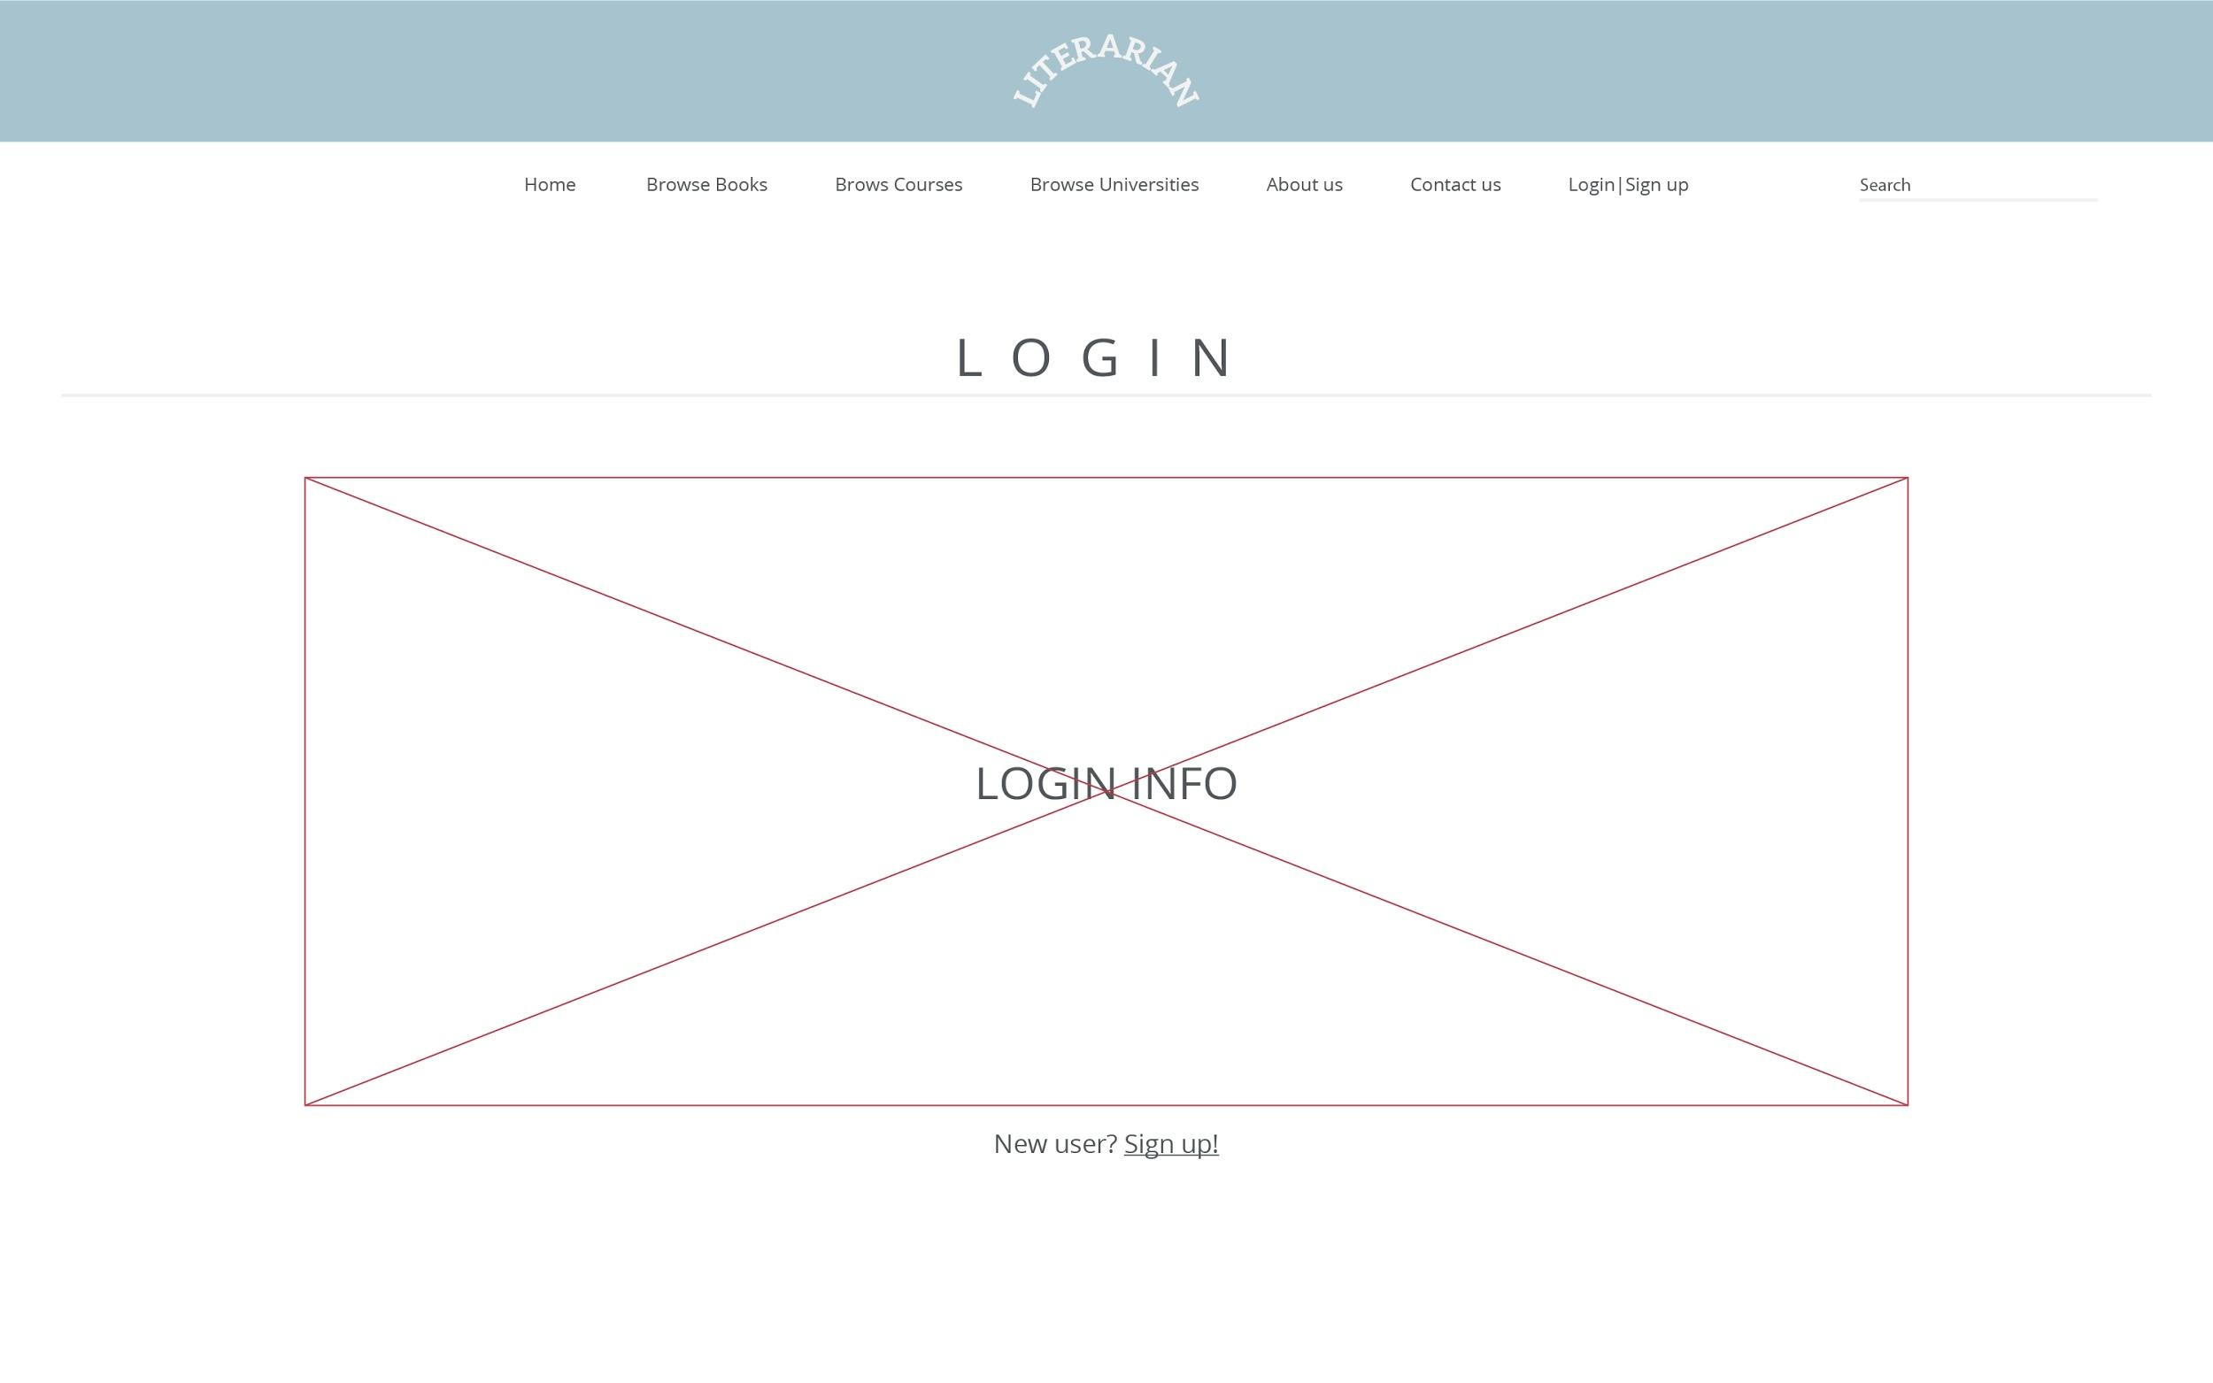

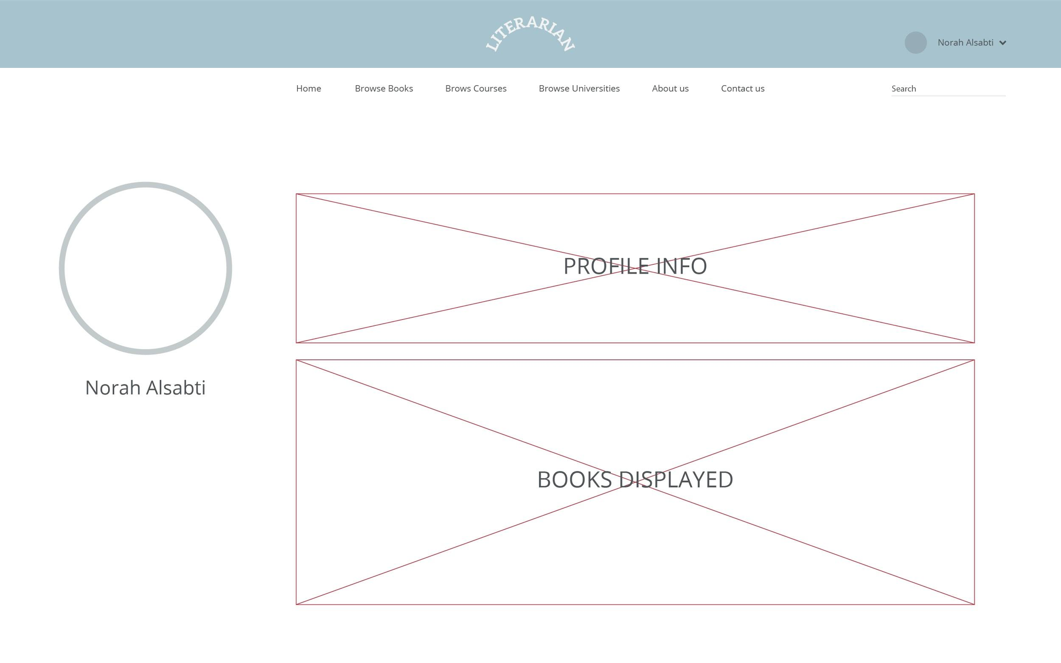

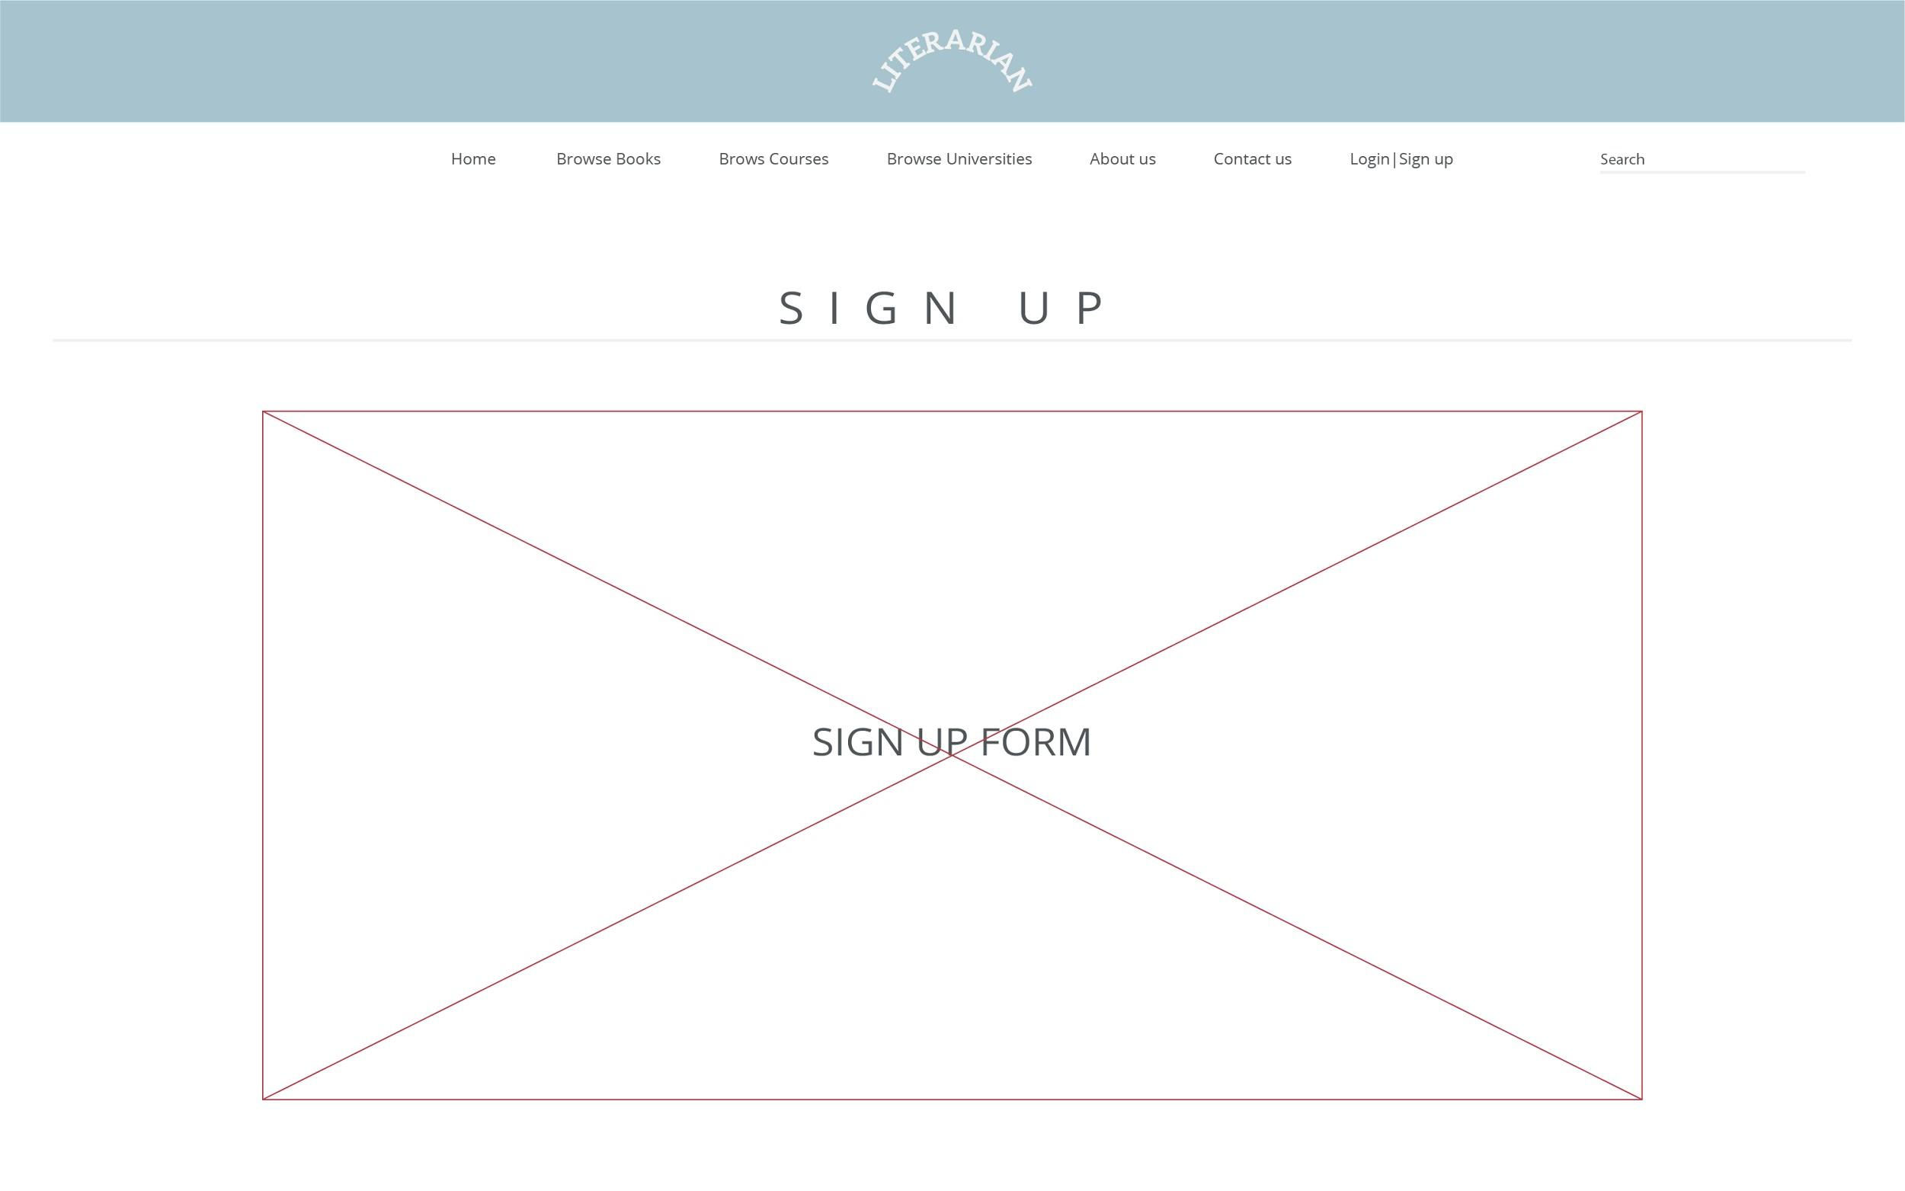

**Design/Navigational Elements**

**Navigational Element**

**Menu (Hyperlinks)**

**Color Scheme**



**Phase II:**

**Home Page**

**HTML header, nav, section, footer, anchors, image, div and paragraphs tags**

**CSS most styling was done in css**

**Bootstrap container , navbar, GRID**

**JavaScript date function**

**JQuery Page intro (window on scroll event), Quote fade using fadeToggle()**

**PHP**  **php was used to check if a user is logged in, using $_SESSION[“logged”]. Whenever, a user is logged, the logIn tab will be replaced by Profile tab.**

**Browse Books**

**HTML header, nav, section, footer, anchors, image, div and paragraphs tags , Forms (search bar)**

**CSS most styling was done in css**

**Bootstrap container , navbar, GRID**

**JavaScript date function**

**PHP**

* **php was used to check if a user is logged in, using $_SESSION[“logged”]. Whenever, a user is logged logIn tab will be replaced by Profile tab.**
* **php was used to query books from the database, add dynamic content to the the page.**
* **php was used to query database for a specific book searched by the user and display that book**

**Browse Courses**

**HTML header, nav, section, footer, anchors, image, div and paragraphs tags, Forms (search bar)**

**CSS most styling was done in css**

**Bootstrap container , navbar, GRID**

**JavaScript date function**

**PHP**

* **php was used to check if a user is logged in, using $_SESSION[“logged”]. Whenever, a user is logged logIn tab will be replaced by Profile tab.**
* **php was used to query courses from the database, add dynamic content to the the page.**
* **php was used to query database for a specific course and display books related to that course.**

**Browse Universities**

**HTML header, nav, section, footer, anchors, image, div and paragraphs tags, Forms (search bar)**

**CSS most styling was done in css**

**Bootstrap container , navbar, GRID**

**JavaScript date function**

**PHP**

* **php was used to check if a user is logged in, using $_SESSION[“logged”]. Whenever, a user is logged logIn tab will be replaced by Profile tab.**
* **php was used to query universities from the database, add dynamic content to the the page.**
* **php was used to query database for a specific university and display books related to that university**

**About us**

**HTML header, nav, section, footer, anchors, image, div and paragraphs tags**

**CSS most styling was done in css**

**Bootstrap container , navbar, GRID**

**JavaScript date function**

**PHP**

* **php was used to check if a user is logged in, using $_SESSION[“logged”]. Whenever, a user is logged logIn tab will be replaced by Profile tab.**

**Contact Us**

**HTML header, nav, section, footer, anchors, image, div and paragraphs tags, Forms**

**CSS most styling was done in css**

**Bootstrap container , navbar, GRID, buttons**

**JavaScript date function**

**PHP**

* **php was used to check if a user is logged in, using $_SESSION[“logged”]. Whenever, a user is logged logIn tab will be replaced by Profile tab.**

**Login**

**HTML header, nav, section, footer, anchors, image, div and paragraphs tags, Forms**

**CSS most styling was done in css**

**Bootstrap container , navbar, GRID, buttons**

**JavaScript**

* **Javascript “onsubmit” event was used to validate form inputs.**
* **Javascript was used to decide whether there was error in the input or not.**
* **date function**

**Ajax: Ajax was used to read special characters error message from text files and changing html node’s content after JavaScript permits it.**

**PHP**

* **php was used to check if a user is logged in, using $_SESSION[“logged”]. Whenever, a user is logged the login page will redirect the user to profile page.**
* **php was used to check username and password creditinality.**
* **php $_SEESION was used to maintain some error messages and user statue**
* **php was used to set cookies whenever a user successfully login**
* **php was used to process submitted login form**

**Sign Up**

**HTML header, nav, section, footer, anchors, image, div and paragraphs tagsm Forms**

**CSS most styling was done in css**

**Bootstrap container , navbar, GRID, buttons**

**JavaScript**

* **Javascript “onsubmit” event was used to validate form inputs.**
* **Javascript was used to decide whether there was error in the input or not.**
* **date function**

**Ajax: Ajax was used to read error messages from text files and changing html node’s content after JavaScript permits it.**

**PHP**

* **php was used to check if a user is logged in, using $_SESSION[“logged”]. Whenever, a user is logged the sign up page will redirect the user to profile page.**
* **php was used to check username and password creditinality.**
* **php $_SEESION was used to maintain some error messages and user statue**
* **php was used to set cookies whenever a user successfully sign up**
* **php was used to process submitted sign up form**

**Profile**

**HTML header, nav, section, footer, anchors, image, div and paragraphs tags**

**CSS most styling was done in css**

**Bootstrap container , navbar, GRID**

**JavaScript date function**

**PHP**

* **php was used to check if a user is logged in, using $_SESSION[“logged”]. unless, a user is logged in the profile page will redirect the user to the login page.**
* **php was used to retrieve user information through $_SESSION[“key”] and $_COOKIE[“key”].**
* **php was used to retrieve books uploaded by the user from the database.**
* **php was used to produce dynamic anchors for retrieved books, that redirect to the book page.**
* **php was used to enable the user to log out.**
* **Php was used to destroy $_SESSION , $_COOKIE info whenever logged out.**

**Upload Book**

**HTML header, nav, section, footer, anchors, image, div and paragraphs tags, Forms**

**CSS most styling was done in css**

**Bootstrap container , navbar, GRID, buttons**

**JavaScript date function**

**PHP**

* **php was used to check if a user is logged in, using $_SESSION[“logged”]. unless, a user is logged in the profile page will redirect the user to the login page.**
* **php was used to retrieve user information through $_SESSION[“key”] and $_COOKIE[“key”].**
* **php was used to process the submitted form**
* **Php was used to add a new book to the database**
* **php was used to redirect the user to the profile page upon successful upload.**

**Book Page**

**HTML header, nav, section, footer, anchors, image, div and paragraphs tags**

**CSS most styling was done in css**

**Bootstrap container , navbar, GRID**

**JavaScript date function**

**PHP**

* **php was used to check if a user is logged in, using $_SESSION[“logged”]. Whenever, a user is logged logIn tab will be replaced by Profile tab.**
* **php was used to process GET submitted form using $_GET[book_id].**
* **Php was used to retrieve the book from the database using the book id**
* **Php was used to add dynamic html content about the owner of the books.**

**Database: LITERARIAN**

**User Table**

* **Username**
* **name**
* **Email**
* **Password**
* **University**
* **Sell**

**Books Table**

* **ID**
* **Name**
* **Version**
* **Owner**
* **Link**
* **Course**
* **uni_ID**
* **Price**

**Courses Table**

* **ID**
* **Course**

**User Table**

* **ID**
* **Name**

**Phase IIl:**

**Publishing website**

**We used “**[**www.000webhost.com**](http://www.000webhost.com)**” to host our website, we created an account and created a new project called “Literarian”, the website provided us with the following domain name “**[**http://literarian.000webhostapp.com/**](http://literarian.000webhostapp.com/)**”. After that we uploaded all our html, php and css files. After that we created a database on the server and imported our database created while developing.**