**Microprocessor Lab**

Laboratory Activity No. 2

**Arduino and Tinkercad Interface**

|  |
| --- |
|  |

Score

*Submitted by:*

**Corpuz, Norbert Christopher**

**S 10:00 am - 1:00 pm/ CPE 0412.1-1**

*Date Submitted*

**29-09-2023**

*Submitted to:*

**Engr. Maria Rizette H. Sayo**

1. Objectives

This laboratory activity aims to implement the principles and techniques of hardware programming using Arduino through:

- creating an Arduino programming and circuit diagram.

II. Method/s

- Perform a task problem given in the presentation.

- Write a code and perform an Arduino circuit diagram of a ring counter that display

eight (8)LEDs starting from left.

III. Results

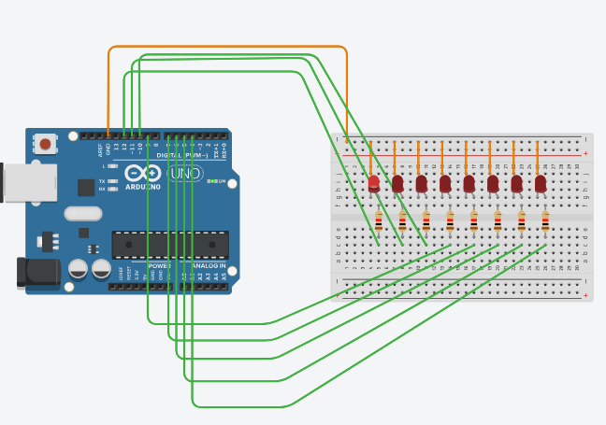 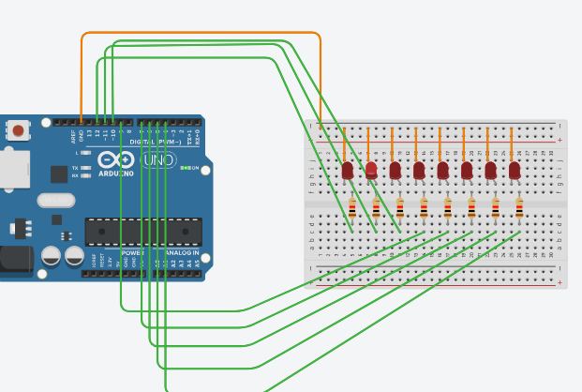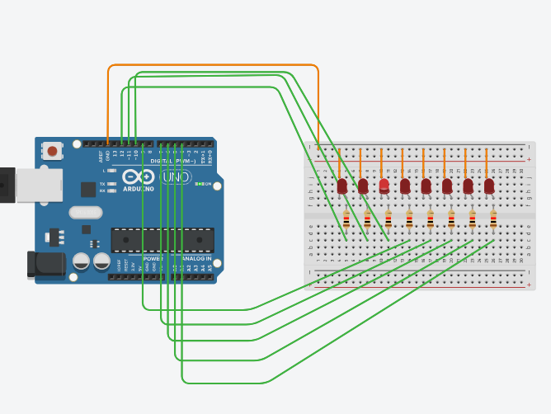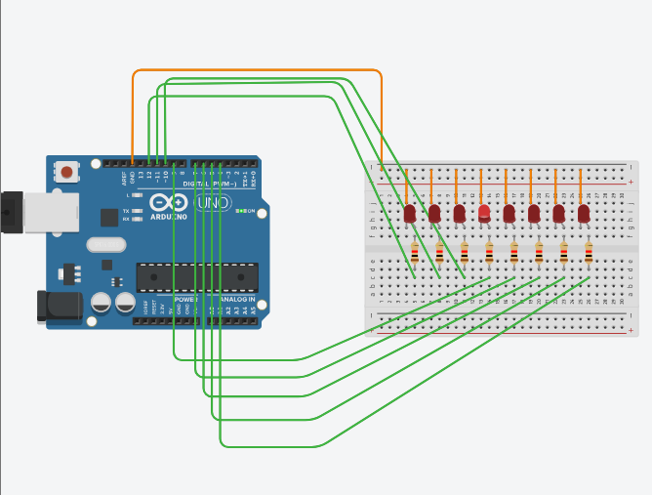

**TinkerCad**

**Exercise 1: Write a code that does a ring counter display for eight (8) LEDs starting from left.**

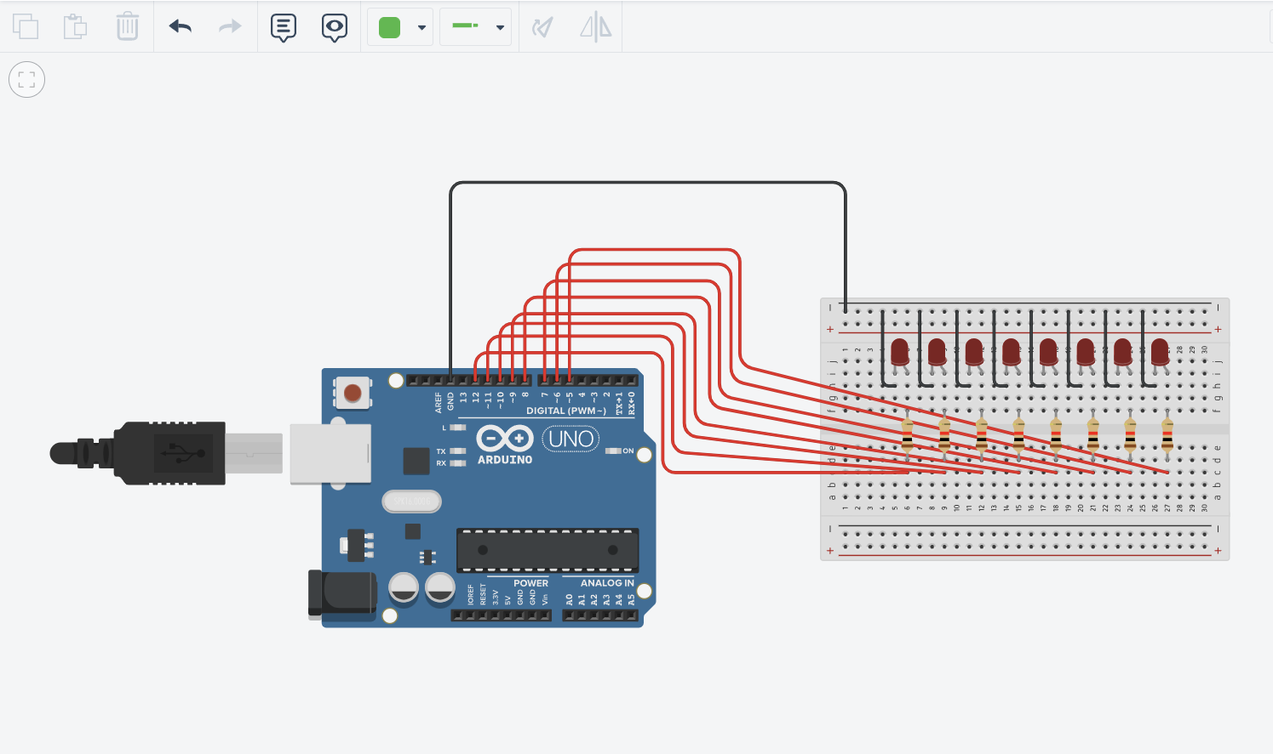

Figure No.1 Ring Counter Display Circuit Diagram

**Components Used**

1. 8 LEDs
2. Resistor
3. Breadboard

**CODE:**

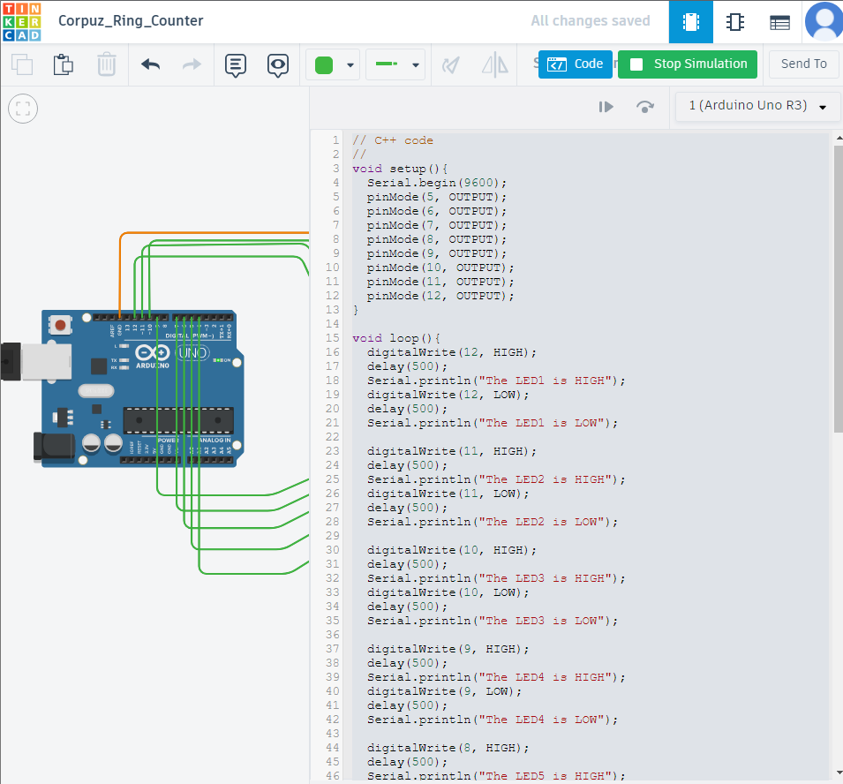

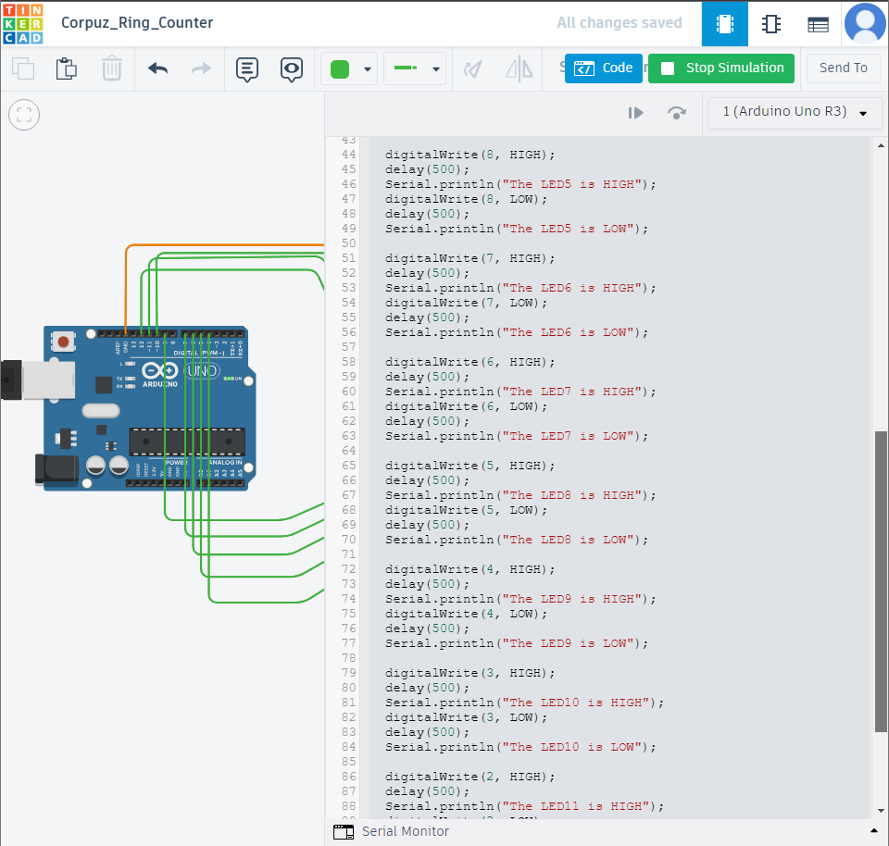

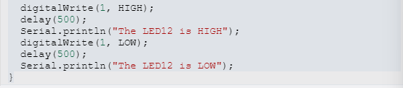

IV. Conclusion

In essence, the primary objective of this laboratory exercise was to introduce participants to the fundamental concepts of hardware programming using Arduino. By instructing students to construct a ring counter circuit that sequentially lights up eight LEDs from left to right, we provided them with an opportunity not only to hone their coding skills but also to gain hands-on experience in generating circuit diagrams. This practical activity not only deepened their comprehension of Arduino but also enabled them to cultivate essential proficiencies in embedded systems and microcontroller programming. These skills serve as a robust groundwork for their future ventures and undertakings in hardware-related projects and applications.

**References**

[1] D.J.D. Sayo. “University of the City of Manila Computer Engineering Department Honor Code,” PLM-CpE Departmental Policies, 2020.

*<This is in a separate page>*