

འཇགི

ས་མདེ

་རྣམ་རྒྱལ་བ

ཟོ

་རགི

་མ

ཐོ

་རིམ

་སློབ་གྲྭ།

**Royal University of Bhutan**

**Jigme Namgyal Engineering Collage, Dewathang**

**Additional Features -- Do-To-list-Tracker**



Submitted by:

Norbu Wangmo (05240141)

**DIPLOMA IN COMPUTER SYSTEM AND NETWORK**

**JIGME NAMGYEL ENGINEERING COLLEGE ROYAL UNIVERSITY OF BHUTAN**

**DEWATHANG**

**(28th August, 2025)**

Contents

Introduction 4

Register Feature 5

Login Feature 6

Forgot password 7

Filtering 8

Reminder 8

Logout 9

Dark Mode / Theming 9

Conclusion 10

**List of Figures**

Figure 1 Register interface 5

Figure 2 Account created successfully 5

Figure 3 Username requirement 5

Figure 4 Password 5

Figure 5 Login Interface 6

Figure 6 User interface 6

Figure 7 Incorrect password 7

Figure 8 Reset password 7

Figure 9 Password reset successfully 7

Figure 10 Filtering by priority 8

Figure 11 Filtering by status 8

Figure 12 Add reminder 8

Figure 13 Logout 9

Figure 14 Dark mode/ Theme 9

# Introduction

This comprehensive To-Do List Tracker application represents a sophisticated task management system designed to enhance productivity and organization for users. Developed as a complete desktop solution, the application incorporates robust user authentication, intuitive task management capabilities, and advanced features that cater to modern user expectations. The system is built using Python with Tkinter for the graphical interface and SQLite for reliable data storage, ensuring both functionality and performance.

The application addresses the fundamental need for effective task organization while providing additional features that elevate the user experience. From secure user registration and authentication to intelligent task filtering and reminder systems, every aspect has been designed with user convenience in mind. The inclusion of dark mode theming demonstrates attention to contemporary interface preferences, allowing users to work comfortably in various lighting conditions.

This documentation outlines the comprehensive feature set that makes this To-Do List Tracker not just a simple task manager, but a complete productivity solution that combines reliability, security, and user-friendly design in a single application.

# Register Feature

I implemented a user registration feature that validates credentials, requiring usernames of at least 3 characters and matching passwords. Successful registration triggers a confirmation message, while errors display appropriate warnings.

|  |  |
| --- | --- |
| Figure 1 Register interface | Figure 2 Account created successfully |

|  |  |
| --- | --- |
| Figure 3 Username requirement | Figure 4 Password |

# Login Feature

User should login with their username and password. After entering username and password users will be able to get access to user interface where they can add, edit, delete task.

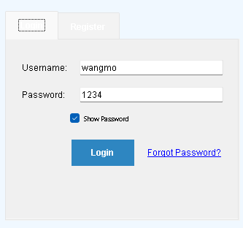

Figure 5 Login Interface

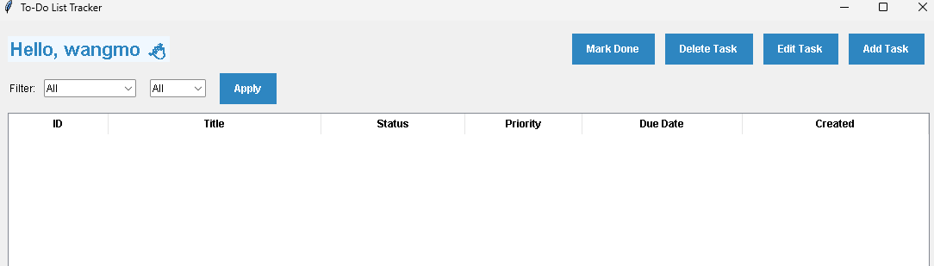

Figure 6 User interface

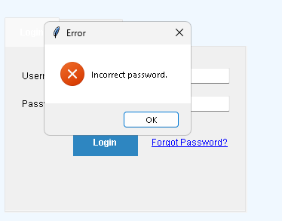

Figure 7 Incorrect password

# Forgot password

If user forgets password, they can click to forgot password. After clicking it will ask for username and new password and the password will be reset successfully.

|  |  |
| --- | --- |
| Figure 8 Reset password | Figure 9 Password reset successfully |

# ****Filtering****

Users can filter tasks by **status** and **priority**.

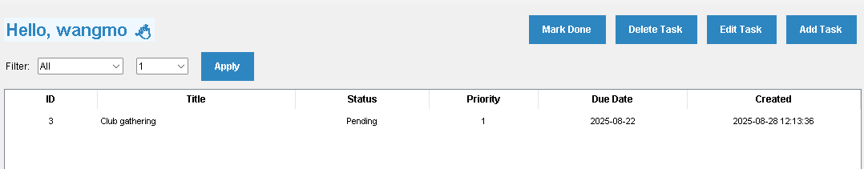

Figure 10 Filtering by priority

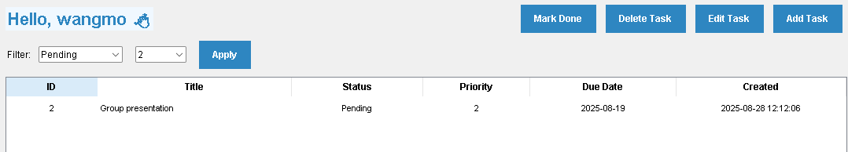

Figure 11 Filtering by status

# Reminder

Users can add reminders to your tasks and view them anytime. Set dates, times, and optional messages for important deadlines.

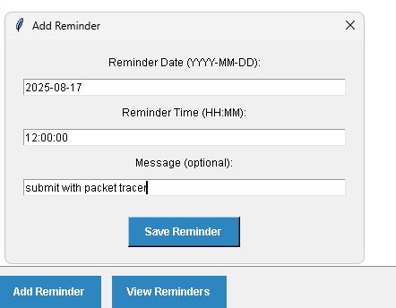

Figure 12 Add reminder

# Logout

After everything users can logout



Figure 13 Logout

# ****Dark Mode / Theming****

Users can customize their interface by turning on dark mode.

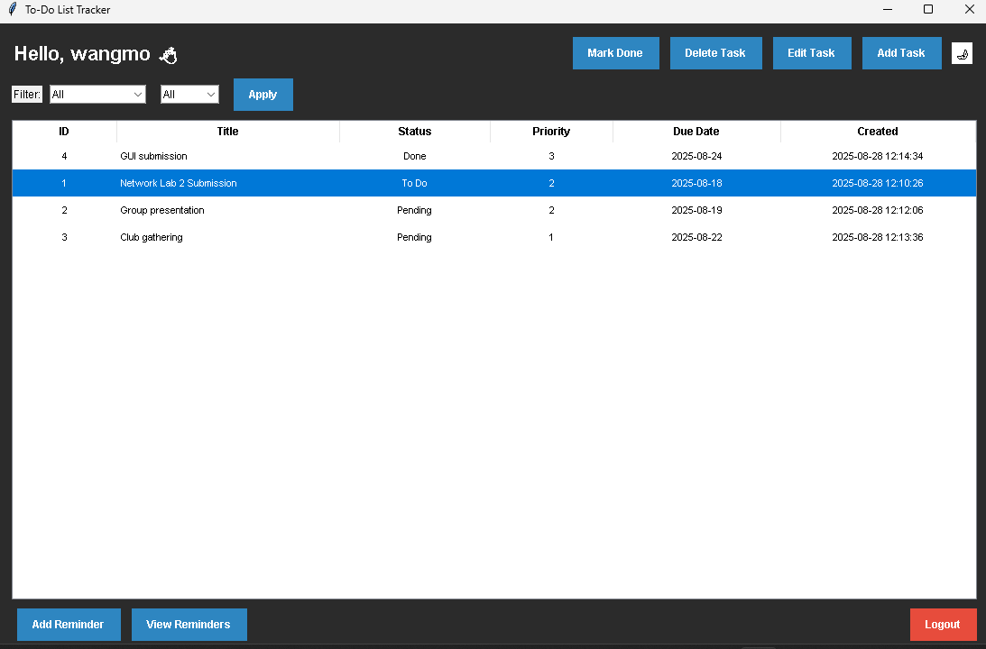

Figure 14 Dark mode/ Theme

# Conclusion

The development of this To-Do List Tracker application has successfully resulted in a comprehensive productivity tool that effectively addresses the core requirements of task management while incorporating advanced features that enhance user experience. The application demonstrates robust functionality through its secure authentication system, intuitive task management capabilities, and thoughtful additional features like intelligent filtering, reminder systems, and customizable theming.

Throughout the development process, particular attention was paid to creating an interface that is both visually appealing and functionally efficient. The dark mode option, responsive design elements, and clear user feedback mechanisms contribute to an engaging user experience. The integration of SQLite database ensures data reliability and persistence, while the object-oriented design approach allows for maintainability and future expansion.

This project successfully showcases the implementation of fundamental programming principles alongside modern user interface considerations. The application stands as a testament to the effective combination of functionality and usability, providing users with a powerful yet accessible tool for managing their daily tasks and responsibilities. The features implemented not only meet basic task management needs but also anticipate user preferences for customization and control, resulting in a polished, professional application ready for real-world use.