

འཇགི

ས་མདེ

་རྣམ་རྒྱལ་བ

ཟོ

་རགི

་མ

ཐོ

་རིམ

་སློབ་གྲྭ།

**Royal University of Bhutan**

**Jigme Namgyal Engineering Collage, Dewathang**

**Draft GUI Report – To Do List Tracker**



Submitted by:

Norbu Wangmo (05240141)

**DIPLOMA IN COMPUTER SYSTEM AND NETWORK**

**JIGME NAMGYEL ENGINEERING COLLEGE ROYAL UNIVERSITY OF BHUTAN**

**DEWATHANG**

**(20th August, 2025)**

Contents

Introduction 4

Main Window 5

Input Fields 6

Buttons 7

Display Area 11

Current Status 12

**List of Figures**

Figure 1 welcome interface 5

Figure 2 Text entry fields 7

Figure 3 Status level 7

Figure 4 Priority level 7

Figure 5 login button 8

Figure 6 Account created 8

Figure 7 Register button 8

Figure 8 Add task button 9

Figure 9Edit task button 9

Figure 10 Delete task button 10

Figure 11 "Mark Done" button 10

Figure 12Logout button 10

Figure 13Apply button 10

Figure 14Display area 11

# Introduction

The To-Do List Tracker is a comprehensive personal task management system designed to help users organize, track, and manage their daily tasks and activities efficiently. This intuitive application allows users to create tasks, categorize them by status, set priorities, and monitor progress through a structured workflow. This system modernizes productivity by replacing manual lists with digital task management, reducing mental load through organized categorization. It enhances efficiency with visual progress tracking, deadline management, and reliable data persistence for all tasks.

# Main Window

This code creates a To-Do List Tracker application with a graphical user interface. It includes user authentication (login/register), task management with priorities and status tracking, and reminder functionality. The application uses SQLite for data storage and features a clean, colorful interface with interactive buttons and filtering options.

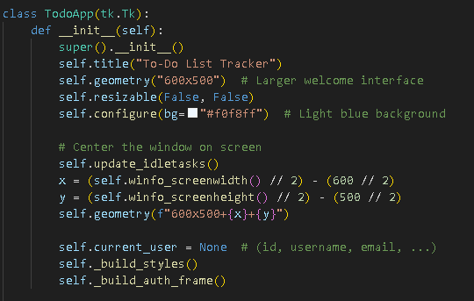

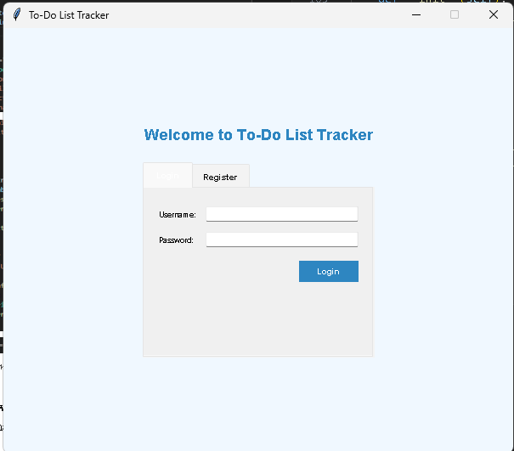

Figure 1 welcome interface

# Input Fields

The interface includes text boxes for entering usernames, passwords, email addresses, and task details like titles, descriptions, and due dates, with dropdown menus for selecting status and priority levels.

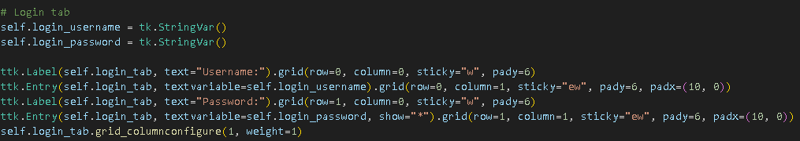

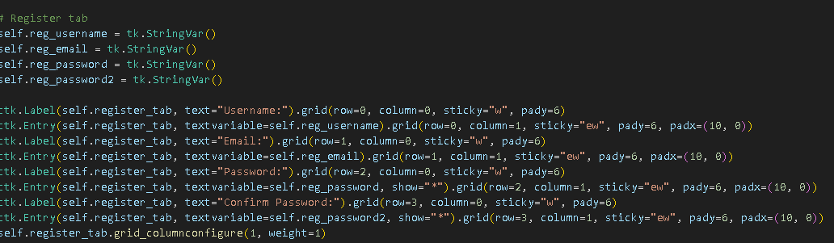

1. **Username Entry Fields:**

The application creates labeled text entry fields for username input in both the login and registration forms, allowing users to enter their credentials.

1. **Password Security Fields:**

For security, the password fields display asterisks (*) instead of actual characters when users type, protecting sensitive information from being visible.

1. **Registration Form Fields:**

The registration form includes additional fields specifically for email input and a second password field for confirmation, ensuring accurate account creation.

1. **Task Management Inputs:**

For task creation and editing, the application provides text entry fields for title, description, and due date, along with dropdown menus for selecting status (Pending, To Do, Done) and priority levels (1, 2, 3).

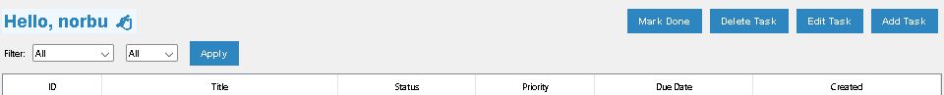

Figure 2 Text entry fields

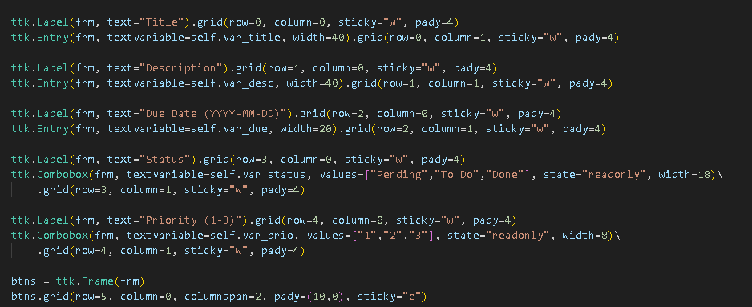

|  |  |
| --- | --- |
| Figure 3 Status level | Figure 4 Priority level |

# Buttons

Colorful, interactive buttons allow users to perform all actions including logging in, registering, adding/editing/deleting tasks, marking tasks as done, applying filters, and logging out.

1. "Login" button to authenticate users

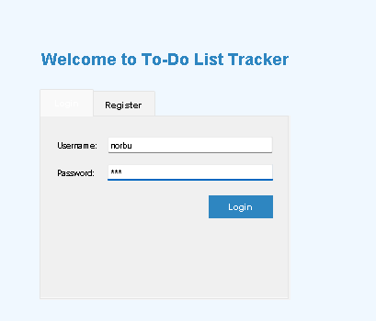

Figure 5 login button

1. "Register" button to create new accounts

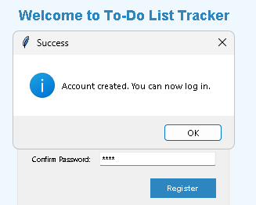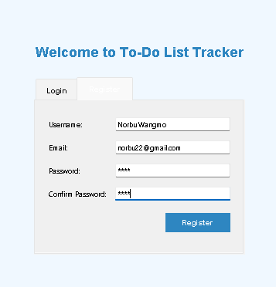

Figure 6 Account created

Figure 7 Register button

1. "Add Task" button to insert new tasks

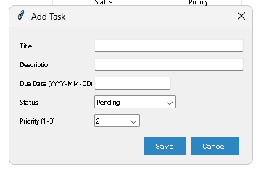

Figure 8 Add task button

1. "Edit Task" button to modify existing tasks

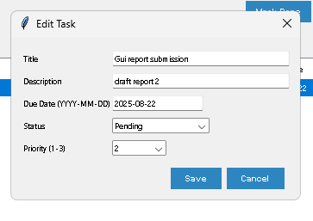

Figure 9Edit task button

1. "Delete Task" button to remove tasks

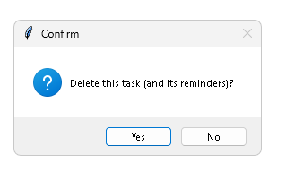

Figure 10 Delete task button

1. "Mark Done" button to update task status

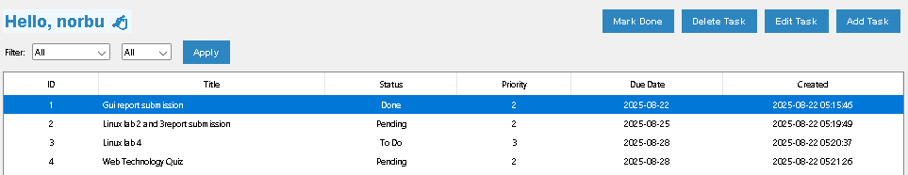

Figure 11 "Mark Done" button

1. "Logout" button to return to login screen



Figure 12Logout button

1. "Apply" button for filtering tasks

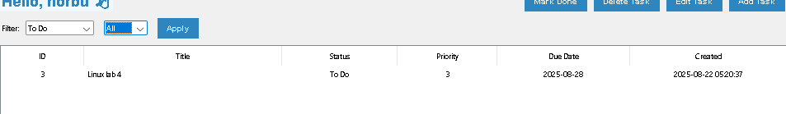

Figure 13Apply button

# Display Area

Tasks are shown in a neat table format with columns showing all important information, and filter options help users organize and find their tasks easily.

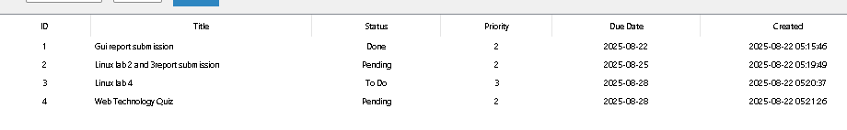

Figure 14Display area

Treeview widget shows task records in tabular form with columns for ID, Title, Status, Priority, Due Date, and Created date. The display includes filtering options for status and priority.

# Current Status

GUI layout is complete for both authentication and main application

Database connection is implemented

Basic CRUD operations are functional (Create, Read, Update, Delete)

User authentication system is working

Task management features are implemented

Reminder system is partially implemented

Next step: Enhance reminder functionality and add data validation