

འཇགི

ས་མདེ

་རྣམ་རྒྱལ་བ

ཟོ

་རགི

་མ

ཐོ

་རིམ

་སློབ་གྲྭ།

**Royal University of Bhutan**

**Jigme Namgyal Engineering Collage, Dewathang**

**Final Report**



Submitted by:

Norbu Wangmo (05240141)

**DIPLOMA IN COMPUTER SYSTEM AND NETWORK**

**JIGME NAMGYEL ENGINEERING COLLEGE ROYAL UNIVERSITY OF BHUTAN**

**DEWATHANG**

**(31st August, 2025)**

Contents

Introduction 4

Database Structure 5

Users Table 5

Tasks Table 5

Reminder Table 6

Main Window 7

Input Fields 8

Buttons 9

Display Area 13

Extra Features 14

Register 14

Login 15

Forgot password 16

Filtering 17

Reminder 17

Logout 18

Dark Mode / Theming 18

Conclusion 20

Reference 21

**List of Figures**

Figure 1 welcome interface 7

Figure 2 Text entry fields 9

Figure 3 Status level 9

Figure 4 Priority level 9

Figure 5 login button 10

Figure 6 Account created 10

Figure 7 Register button 10

Figure 8 Add task button 11

Figure 9Edit task button 11

Figure 10 Delete task button 12

Figure 11 "Mark Done" button 12

Figure 12Logout button 12

Figure 13Apply button 12

Figure 14Display area 13

Figure 15 Register interface 14

Figure 16 Account created successfully 14

Figure 17 Username requirement 14

Figure 18 Password 14

Figure 19 Login Interface 15

Figure 20 User interface 15

Figure 21 Incorrect password 16

Figure 22 Reset password 16

Figure 23 Password reset successfully 16

Figure 24 Filtering by priority 17

Figure 25 Filtering by status 17

Figure 26 Add reminder 18

Figure 27 Reminder added successfully 18

Figure 28 View reminder 18

Figure 29 Logout 18

Figure 30 Dark mode/ Theme 19

# Introduction

This document describes a To-Do List application—a digital tool designed to help you easily manage your daily tasks. Instead of using paper lists that can get lost, this app lets you create, organize, and track your tasks on your computer.

You can add new tasks, set their priority (like high, medium, or low), mark them as done, and even set reminders so you don't forget important deadlines. The app also includes features like user login to keep your tasks private, and a dark mode for comfortable use.

In short, this To-Do List tracker is a simple, efficient, and organized way to stay on top of your work and personal responsibilities.

# Database Structure

## Users Table

The users table is created with the CREATE TABLE command. It defines seven columns: a unique auto-incrementing ID as the primary key, a mandatory and unique username with a minimum length of 3 character, a mandatory password hash, automatic timestamps creation and last login, and a status flag to indicate an active account, ensuring secure and organized user data management.

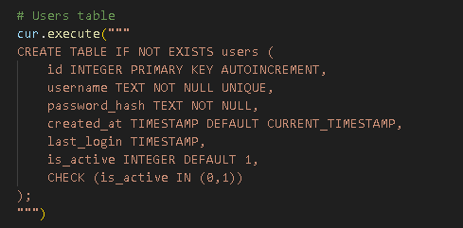

Database:

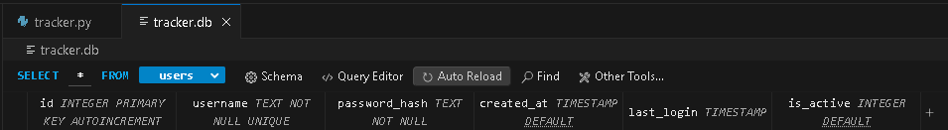

## Tasks Table

The tasks table is created with the CREATE TABLE command. It defines seven columns: a unique auto-incrementing ID as the primary key, a mandatory title, an optional description, a status with predefined options, an automatic creation date, an optional due date, and a priority level between 1 and 3, ensuring organized and consistent tracking of task information.

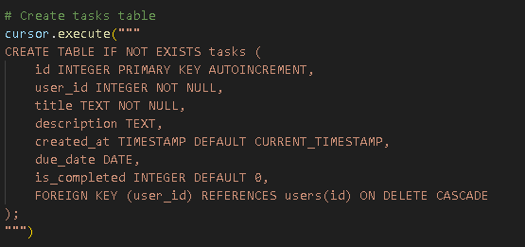

Database



## Reminder Table

The reminder table is created with the CREATE TABLE command. It defines columns to store reminders linked to specific tasks, including a unique ID, the associated task ID, a reminder message, and the date and time the reminder is set to trigger.

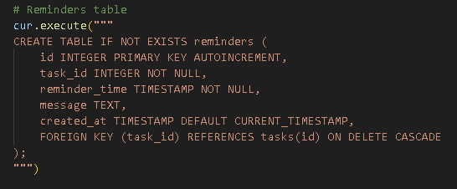

# Main Window

This code creates a To-Do List Tracker application with a graphical user interface. It includes user authentication (login/register), task management with priorities and status tracking, and reminder functionality. The application uses SQLite for data storage and features a clean, colorful interface with interactive buttons and filtering options.

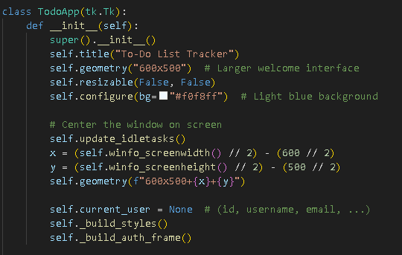

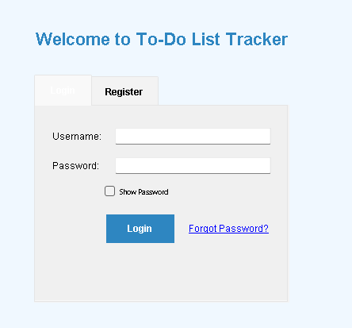

Figure 1 welcome interface

# Input Fields

The interface includes text boxes for entering usernames, passwords, email addresses, and task details like titles, descriptions, and due dates, with dropdown menus for selecting status and priority levels.

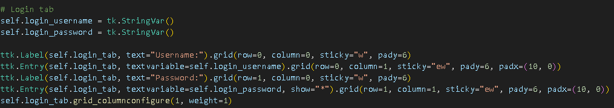

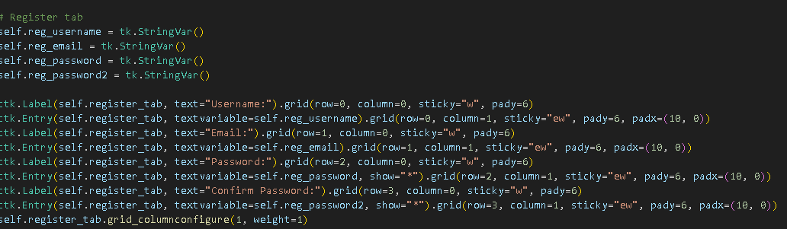

1. **Username Entry Fields:**

The application creates labeled text entry fields for username input in both the login and registration forms, allowing users to enter their credentials.

1. **Password Security Fields:**

For security, the password fields display asterisks (*) instead of actual characters when users type, protecting sensitive information from being visible.

1. **Registration Form Fields:**

The registration form includes additional fields specifically for email input and a second password field for confirmation, ensuring accurate account creation.

1. **Task Management Inputs:**

For task creation and editing, the application provides text entry fields for title, description, and due date, along with dropdown menus for selecting status (Pending, To Do, Done) and priority levels (1, 2, 3).

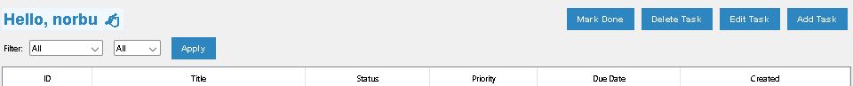

Figure 2 Text entry fields

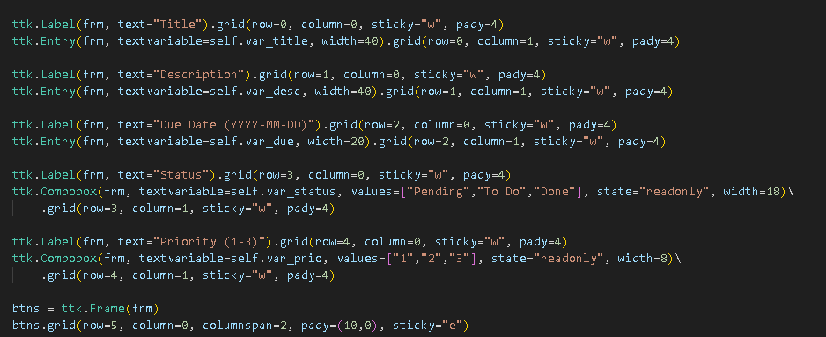

|  |  |
| --- | --- |
| Figure 3 Status level | Figure 4 Priority level |

# Buttons

Colorful, interactive buttons allow users to perform all actions including logging in, registering, adding/editing/deleting tasks, marking tasks as done, applying filters, and logging out.

1. "Login" button to authenticate users



Figure 5 login button

1. "Register" button to create new accounts

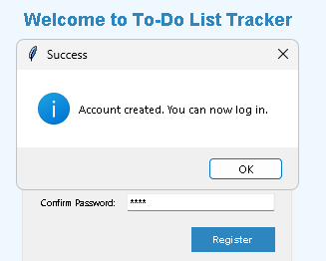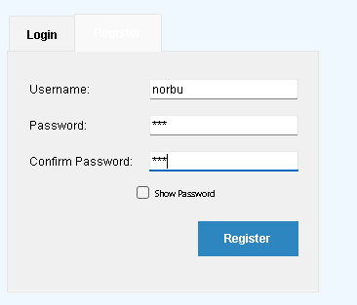

Figure 6 Account created

Figure 7 Register button

1. "Add Task" button to insert new tasks

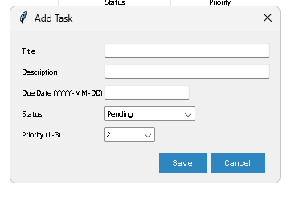

Figure 8 Add task button

1. "Edit Task" button to modify existing tasks

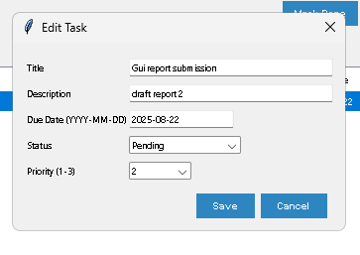

Figure 9Edit task button

1. "Delete Task" button to remove tasks

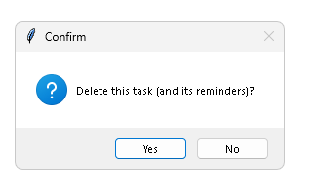

Figure 10 Delete task button

1. "Mark Done" button to update task status

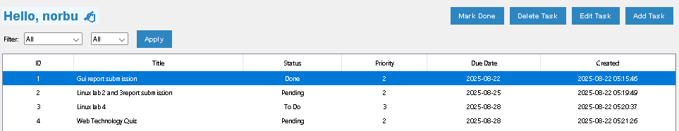

Figure 11 "Mark Done" button

1. "Logout" button to return to login screen



Figure 12Logout button

1. "Apply" button for filtering tasks

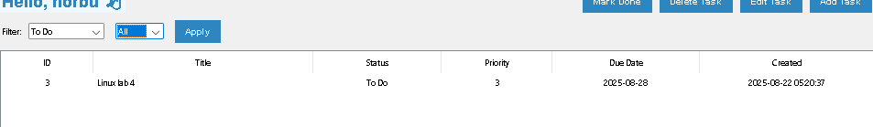

Figure 13Apply button

# Display Area

Tasks are shown in a neat table format with columns showing all important information, and filter options help users organize and find their tasks easily.

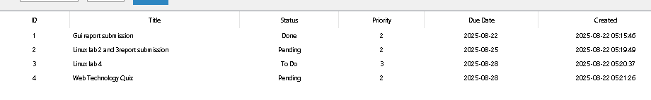

Figure 14Display area

Treeview widget shows task records in tabular form with columns for ID, Title, Status, Priority, Due Date, and Created date. The display includes filtering options for status and priority.

# Extra Features

## Register

I implemented a user registration feature that validates credentials, requiring usernames of at least 3 characters and matching passwords. Successful registration triggers a confirmation message, while errors display appropriate warnings.

|  |  |
| --- | --- |
| Figure 15 Register interface | Figure 16 Account created successfully |

|  |  |
| --- | --- |
| Figure 17 Username requirement | Figure 18 Password |

## Login

User should login with their username and password. After entering username and password users will be able to get access to user interface where they can add, edit, delete task.

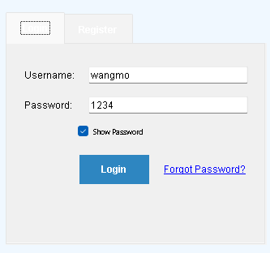

Figure 19 Login Interface

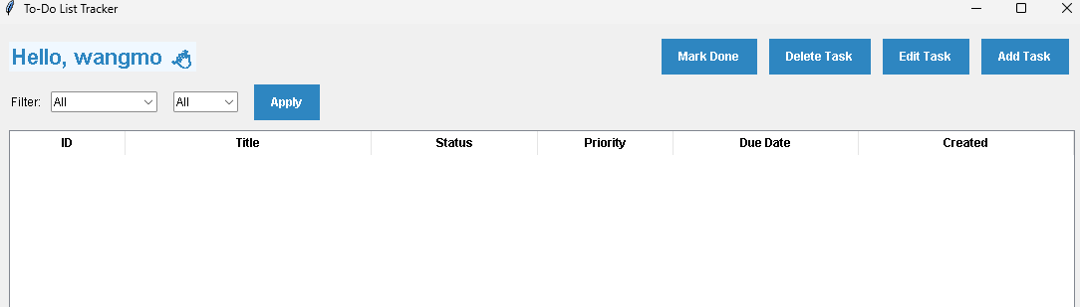

Figure 20 User interface

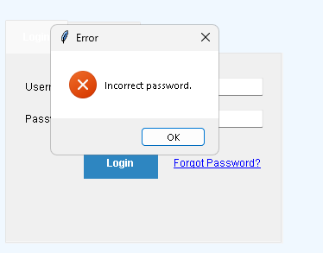

Figure 21 Incorrect password

## Forgot password

If user forgets password, they can click to forgot password. After clicking it will ask for username and new password and the password will be reset successfully.

|  |  |
| --- | --- |
| Figure 22 Reset password | Figure 23 Password reset successfully |

## **Filtering**

Users can filter tasks by **status** and **priority**.

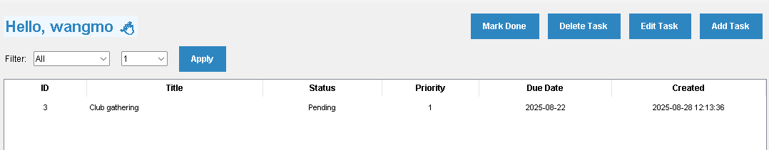

Figure 24 Filtering by priority

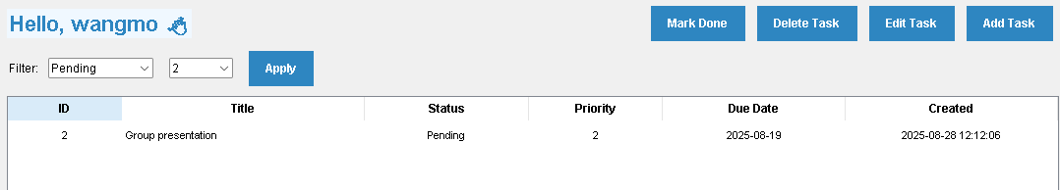

Figure 25 Filtering by status

## Reminder

Users can add reminders to your tasks and view them anytime. Set dates, times, and optional messages for important deadlines.

|  |  |
| --- | --- |
| Figure 26 Add reminder | Figure 27 Reminder added successfully |

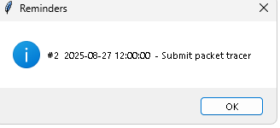

Figure 28 View reminder

## Logout

After everything users can logout



Figure 29 Logout

## **Dark Mode /** Theming

Users can customize their interface by turning on dark mode.

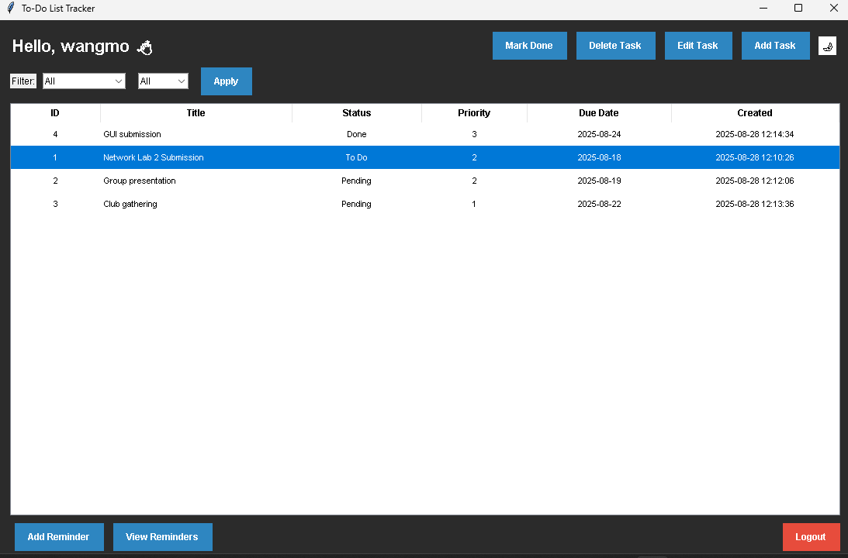

Figure 30 Dark mode/ Theme

# Conclusion

The development of this To-Do List Tracker application has successfully resulted in a comprehensive productivity tool that effectively addresses the core requirements of task management while incorporating advanced features that enhance user experience. The application demonstrates robust functionality through its secure authentication system, intuitive task management capabilities, and thoughtful additional features like intelligent filtering, reminder systems, and customizable theming.

Throughout the development process, particular attention was paid to creating an interface that is both visually appealing and functionally efficient. The dark mode option, responsive design elements, and clear user feedback mechanisms contribute to an engaging user experience. The integration of SQLite database ensures data reliability and persistence, while the object-oriented design approach allows for maintainability and future expansion.

# Reference

BoostMyTool. (2021, October 13). *Create and Read SQLite Databases using DB Browser: How to Use DB Browser 2021* [Video]. YouTube. <https://www.youtube.com/watch?v=b0Dplx4M5zg>

*Downloads - DB browser for SQLite*. (n.d.). <https://sqlitebrowser.org/dl/>

TutorialBrain. (2022, April 20). *How to run SQLITE in Visual Studio Code* [Video]. YouTube. <https://www.youtube.com/watch?v=JrAiefGNUq8>