1. **Main Window**

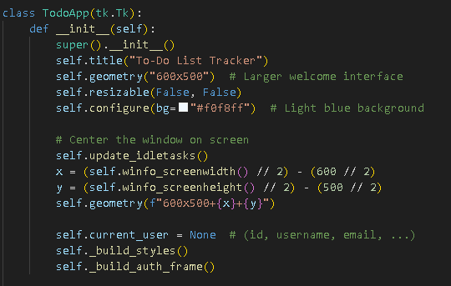

This code creates a To-Do List Tracker application with a graphical user interface. It includes user authentication (login/register), task management with priorities and status tracking, and reminder functionality. The application uses SQLite for data storage and features a clean, colorful interface with interactive buttons and filtering options.

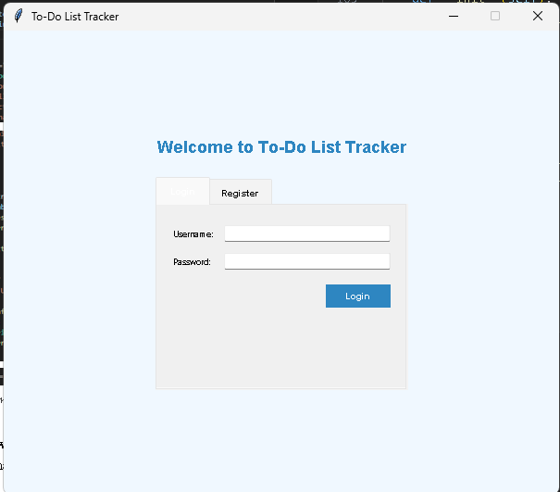

1. **Input Fields**

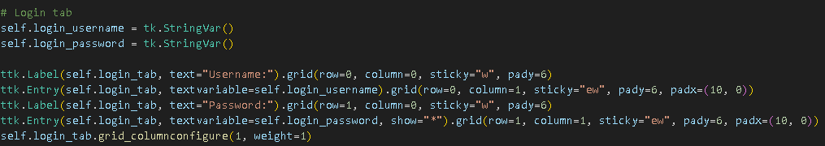

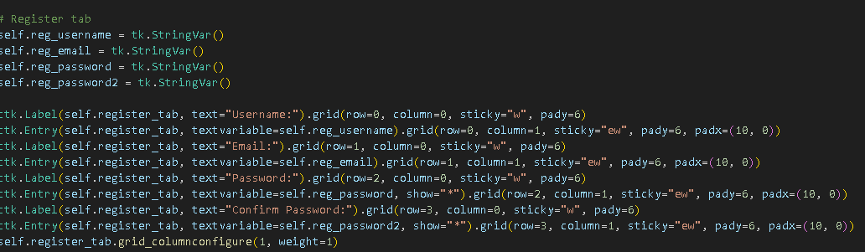

Username Entry Fields:

The application creates labeled text entry fields for username input in both the login and registration forms, allowing users to enter their credentials.

Password Security Fields:

For security, the password fields display asterisks (*) instead of actual characters when users type, protecting sensitive information from being visible.

Registration Form Fields:

The registration form includes additional fields specifically for email input and a second password field for confirmation, ensuring accurate account creation.

Task Management Inputs:

For task creation and editing, the application provides text entry fields for title, description, and due date, along with dropdown menus for selecting status (Pending, To Do, Done) and priority levels (1, 2, 3).

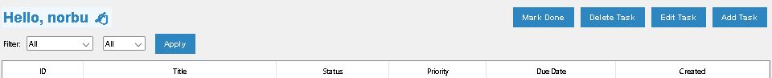

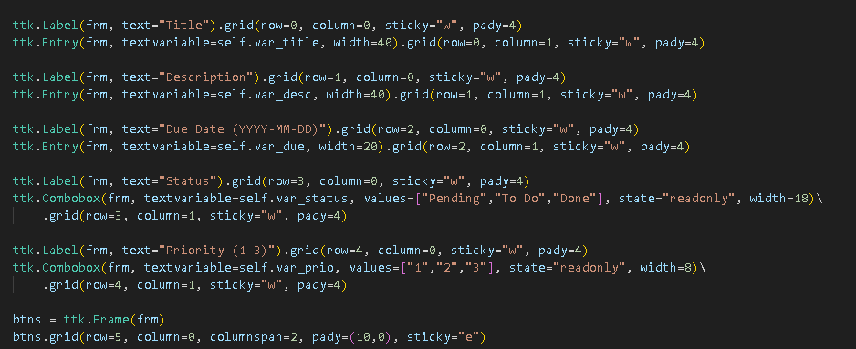

|  |  |
| --- | --- |
|  |  |

1. **Buttons**

"Login" button to authenticate users

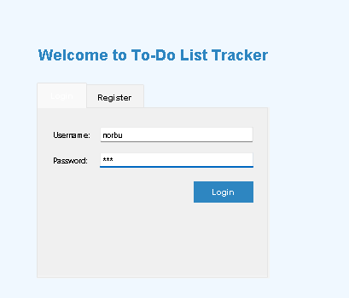

"Register" button to create new accounts

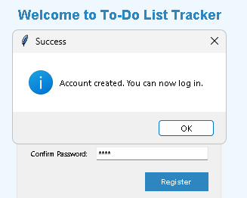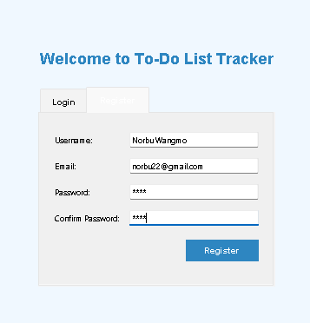

"Add Task" button to insert new tasks

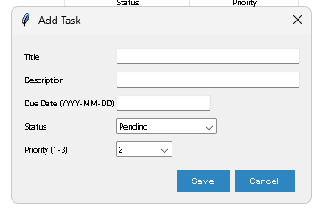

"Edit Task" button to modify existing tasks

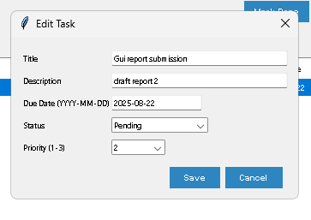

"Delete Task" button to remove tasks

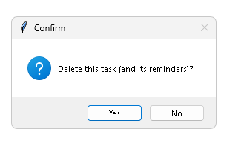

"Mark Done" button to update task status

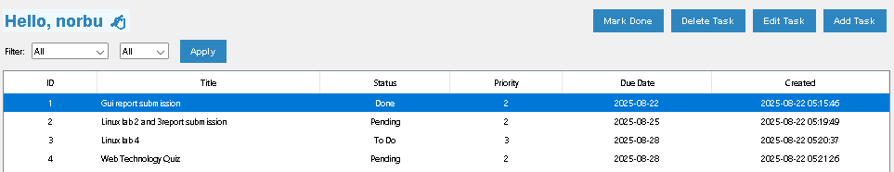

"Logout" button to return to login screen



"Apply" button for filtering tasks

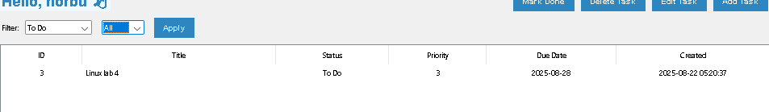

1. **Display Area**

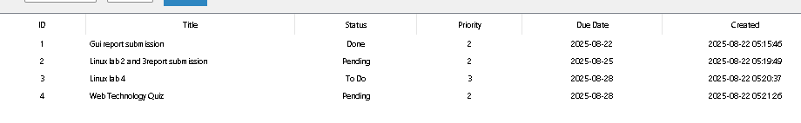

Treeview widget shows task records in tabular form with columns for ID, Title, Status, Priority, Due Date, and Created date. The display includes filtering options for status and priority.

1. **Current Status**

GUI layout is complete for both authentication and main application

Database connection is implemented

Basic CRUD operations are functional (Create, Read, Update, Delete)

User authentication system is working

Task management features are implemented

Reminder system is partially implemented

Next step: Enhance reminder functionality and add data validation