AR8x application note

This guide provides details about the RESTful service which allows you to monitor and configure the device

1. WEB SERVICe

The backend of the web config described in the previous application notes is a RESTful service, which can be accessed also from your own applications. The nginx web server forwards the communication to the backend, so the same http authentication and https is used for backend communication as it is in the web config UI. If we use the example address from the previous application note, we can access these features by using HTTP GET and HTTP POST. So for example performing a simple “Ping”-request to the backend, we would simply send HTTP GET request to <https://ar8x567890.local/Core/Ping>, which would then respond with a JSON string containing “Pong”

* 1. SWAGGER

The RESTful service has Swagger installed on to it, so the documentation for the RESTful API can be accessed directly through your web browser by opening <https://ar8x567890.local/CoreDocs> If you are able to access the correct view, you should be able to see something like this:

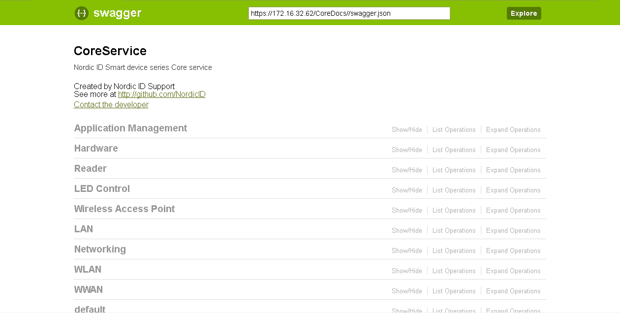

From this view you can see all the available operations along with more detailed view of each operation. For example the Ping-method should show you something like this:

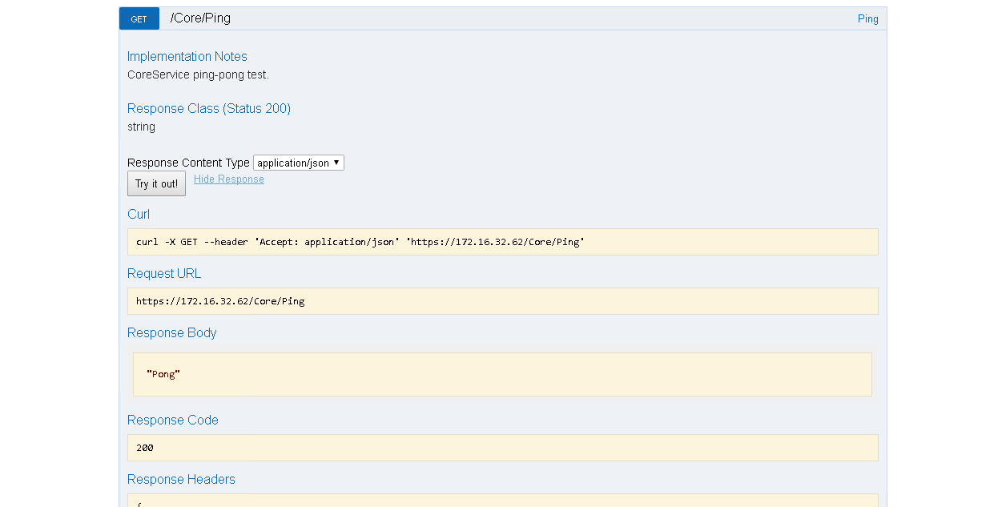

So if you only require accessing certain methods, you could simply just use curl or similar from your application to access these methods and parse the response JSON yourself.

* + 1. GENERATING CLIENT API

As shown on the first screenshot, the Swagger shows the direct URL for the complete JSON version of the API. This URL can be used to open this file, and the file can be used to generate a client API also. If you open this URL, you should see something like this:

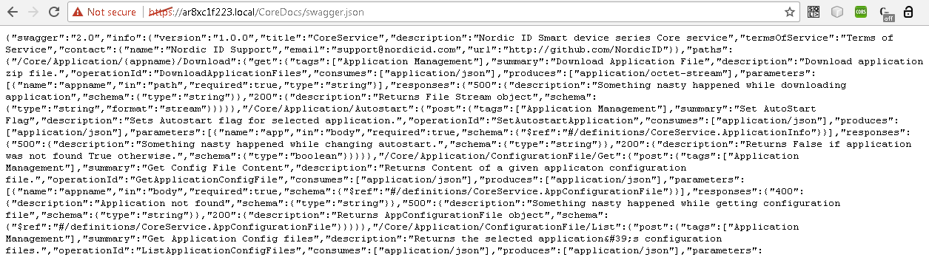

Copy the shown content from the browser by selecting all and ctrl+c. Then you can open another browser window and navigate to <http://editor.swagger.io> If the previously copied content is not automatically inputted on the editor, paste it to the left frame on the view and let the editor convert the content to YAML format if requested. After that the editor should seem like this:

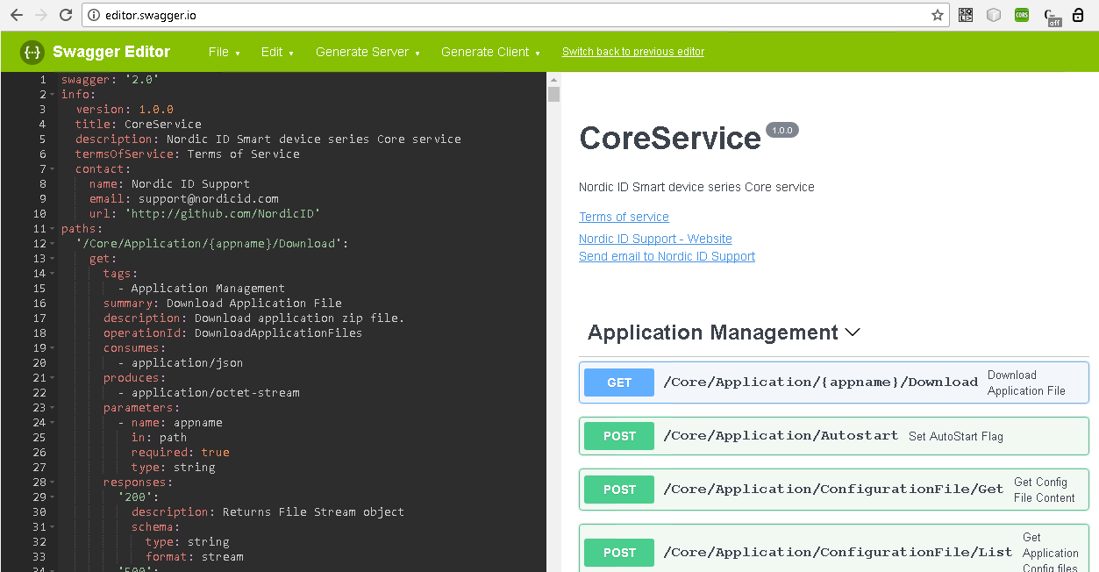

At this point you are good to go for generating the client API your solution requires.

* 1. NOTE

Keep in mind that if you plan to use the generated swagger client API on your AR8x/Sampo S2 device, you can use <http://127.0.0.1:9002/Core> as the connection URL instead of the actual IP and https. Localhost access is possible without https and the login details. When accessing from clients “outside” the device, https and login details are mandatory.