AR8x application note

This guide provides more detailed view on the NurSvc system service used on the Nordic ID Smart Readers.

# SCOPE

Typically client applications have communicated with Nordic ID RFID readers directly using NurAPI over ethernet, wifi or USB(serial) and the RFID module has handled all the HW features by itself. Due to some HW restrictions on the Smart Readers, the module has no longer direct control over some of the IO pins so NurSvc was needed to provide access to them.

For most of the communication the NurSvc acts only as a proxy between the UHF module and the client applications and for the commands which require handling on NurSvc, it will intercept them and respond to the client directly instead of passing the information to the module. On the client applications perspective this does not change anything, i.e. the changes are more or less internal on the “server”-side. The only difference is that when running applications locally on the Smart Reader, the connection to the module needs to be to localhost:4333(default setting for the port) instead of a serial port connection.

The platform does allow also direct serial connection to the module when NurSvc or the internal reader instance is disabled. This however is not recommended since most of the NurAPI features are not available with direct serial port communication. If however you wish to access the module this way, you’ll need to disable NurSvc from the Web UI and use /dev/uartRoute for connecting the module.

1. Configuration

The NurSvc can be configured over the WebUI, as also using by the RESTful service. See **AN003_AR8x_webservice.docx** for more details on how to use RESTful API.

When opening the NurSvc web UI configuration, you will see a list of the configured readers as also a list of other Nordic ID UHF readers available in your network. They are queried using Avahi broadcast & NUR specific UDP broadcasts. The view will look similar to this:

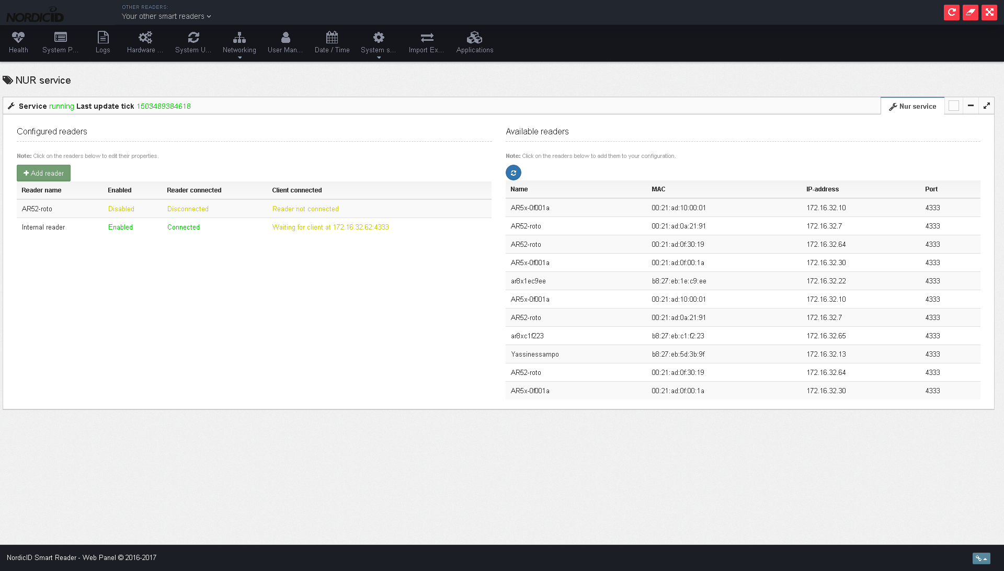

* 1. Configuring existing readers

By clicking any of the configured readers you can bring up the configuration parameters view. On the configuration view you have 2 pages, the first one for the connection settings and the second on for the reader UHF settings.

On the example below we have the connection settings for our internal reader module, which by default accepts client connections on port 4333. The settings for the internal reader only allow chaning the client port and disabling/enabling the instance.

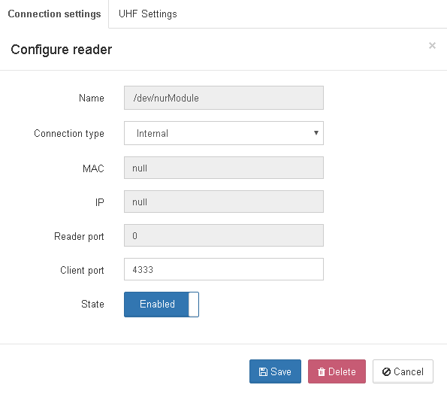

And on the sample below the internal reader has these settings applied when the NurSvc connects the reader. If your solution does not require settings applied before connecting your client, you can just uncheck the “Apply settings on connect” and the NurSvc will ignore them.

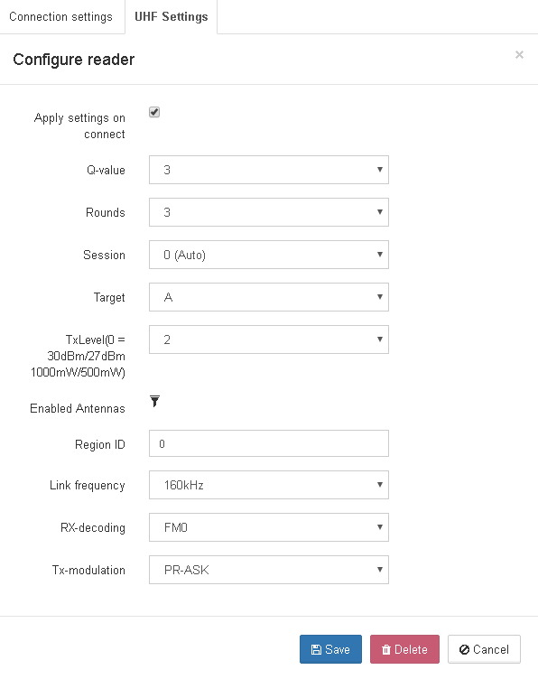

* 1. Adding new readers

New readers can be added manually in case they are out of your local network or if they are in the same network, you can fill the required fields automatically by clicking any of the reader instances found under “Available readers”.

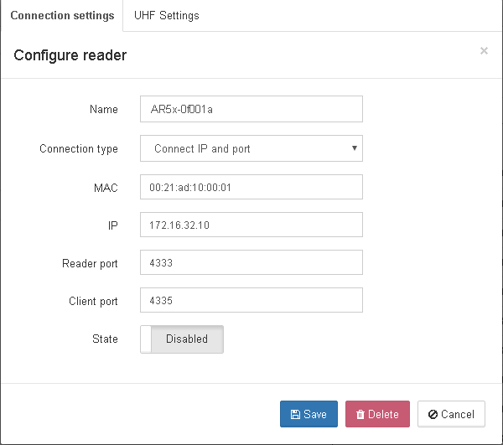

On the above screenshot we have click “AR5x-0f001a” from the available readers section and by default the configuration will add “Connect IP and port” as the “Connection Type”. This means that the NurSvc will try to connect to 172.16.32.10:4333. Other connection types are “Search by mac” and “Search by name”, which mean that instead of a direct connection to a certain address:port, NurSvc will perform a broadcast search on the local network and tries to either find a reader with a specified MAC-address or with a certain name. Using the above settings, when the reader has been successfully connected NurSvc will accept client connections at port 4335 for this instance.

* 1. NOTES

When adding new readers or changing configuration on one of them, keep in mind that the whole NurSvc-instance will get reloaded and any existing connection will be cut at that point.

The reader name is used as an identifier for the reader instances, so unique naming for each reader instance is required. Same goes for the client port, each reader instance require a separate client port.