AR8x application note

This guide provides more detailed view on how to use the Nordic ID Norma LLRP application on the Nordic ID Smart Readers.

SCOPE

Since the NUR module can only be accessed using the NurAPI(NUR protocol) to communicate with it, Nordic ID Norma was created to provide also LLRP communication for the reader. Norma is also available for Windows environment, but this documentation focuses on how to use it on the Nordic ID Smart Readers.

Norma acts as a translator proxy between the LLRP clients and the NUR module i.e. it translates the LLRP communication to Nur protocol and vice versa. This way LLRP clients can access the reader.

The current version 1.0 of Norma provides only the LLRP specification mandatory features, and does not have any custom LLRP commands available.

1. INSTALLATION

Nordic ID Norma for the smart readers is available as a installable application zip package at Nordic ID github repository: <https://github.com/NordicID/ar8x_samples/tree/master/norma> If you are not yet familiar with the application packages, please check **AN002_AR8x_appinterface.docx** for more details.

After downloading the **norma.zip** from the repository, you are ready to install it to your smart reader. Upload the zip using the “Install new application” feature on your Smart Reader and wait for the installation to finish.

After it has finished, you should see something like this on the application management view:

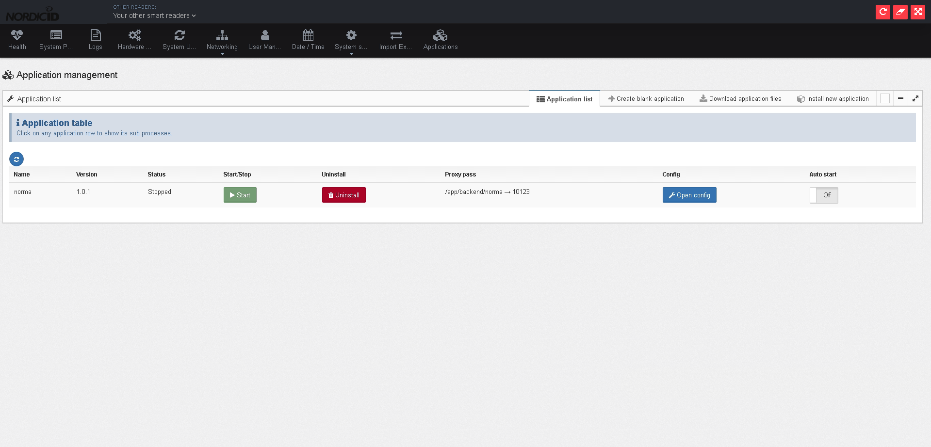

When using the default package from GitHub, the configuration is implemented so that Norma will try to connect to “localhost:4333” i.e. the default NurSvc listening port (See **AN006_AR8x_NurSvc.docx** for more information on how to configure the NurSvc). If you are using the default settings for it, you can start Norma directly.

After Norma has been started, you can open the configuration-view by clicking “Open config”. This view should be similar to the example below

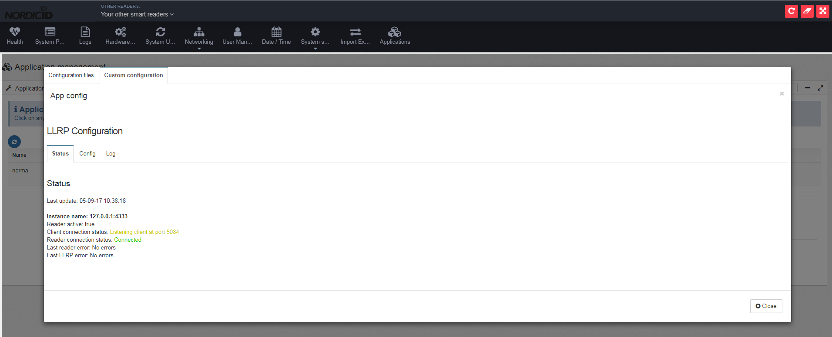

The Status-view on the application shows you a status list for each configured reader which have been able to connect to the readers. Client connection status on this view indicates whether a LLRP client has connected. On the second view on the Norma-app you can find a list of the configured readers, which should look similar to this:

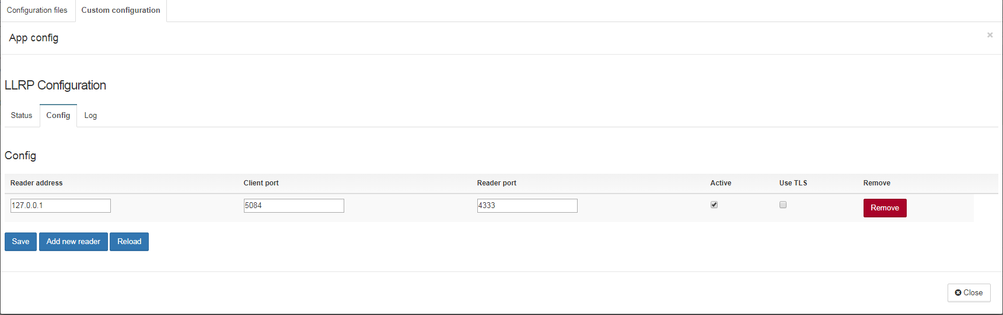

The view allows you to add/remove/edit the readers. The last view is the log-window which shows you the log that Norma has generated. The application package will also generate another log file to /var/log/norma.log, which can be accessed through the “Logs”-view on the WebUI,

* 1. NOTES

If for some reason Norma is unable to connect to the local reader or any other readers, make sure that you don’t have any other software already using these readers. You can check the status of the local reader connection from “System Service->NUR Service”. If the somebody is connecting the reader from an unknown source, you can change the Client port to something other than the defaul 4333 and init the connection to that. In such case, remember to the change the reader port also for Norma.