# Host configuration:

The host_spi_master application is set up to allow an application image, a SoftDevice and a bootloader image to be stored in the flash of a 256kB nRF51822 device. The host application itself will run from 0x0000.

The flash configuration should be as follows:

|  |  |
| --- | --- |
| 0x38000 | Bootloader image |
| 0x30000 | Application image |
| 0x11000 | SoftDevice image |
| 0x10000 | MBR |
| 0x0000 | Host application |

The host application itself can be programmed as any other application.

Storing an app, SD or BL image in the flash is a bit more involved:

1. First, compile/download the hex file as normal.
2. When storing a BL image it is necessary to remove the UICR data from the hex file. This can be done by manually removing the third to last line from the BL hex file:  
   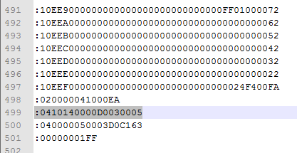
3. Use hex2bin to convert the image hex file to a binary file.
4. Use J-Link commander to flash the binary file to the right part of the flash in the host
   1. Run the command line in the folder where you have your binary files
   2. From the command line, start J-Link commander by running ***jlink*** (this requires the *C:\Program Files (x86)\SEGGER\JLink_VXXX* folder to be in your PATH environment settings in Windows)
   3. In J-Link commander, run the following commands:
      1. ***device nrf51***
      2. ***loadbin sd_image.bin 0x10000***
      3. ***loadbin app_image.bin 0x30000***
      4. ***loadbin bl_image.bin 0x38000***
      5. ***r***
      6. ***g***
5. Now, flash either the APP, SD or BL by pressing Button 1, 2 or 3 on the host respectively.