**Hands-On Exercise No. 1 Batch: 2 Freelancing**

ANS.1: Web development

ANS.2:

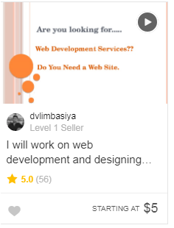

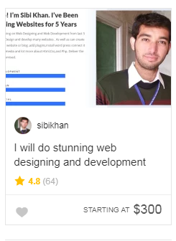

ANS.3:

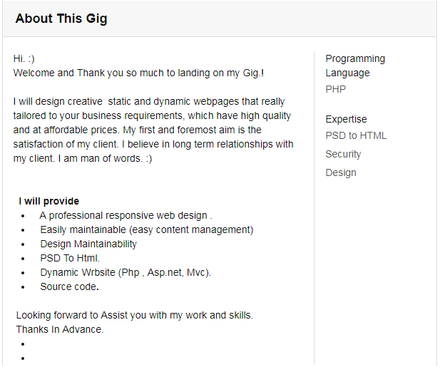ANS.4:

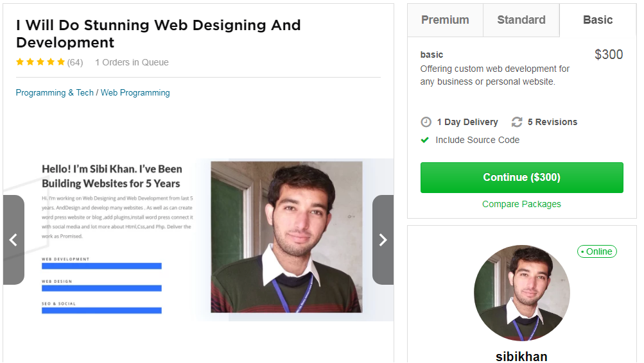 ANS.5: