Product documentation
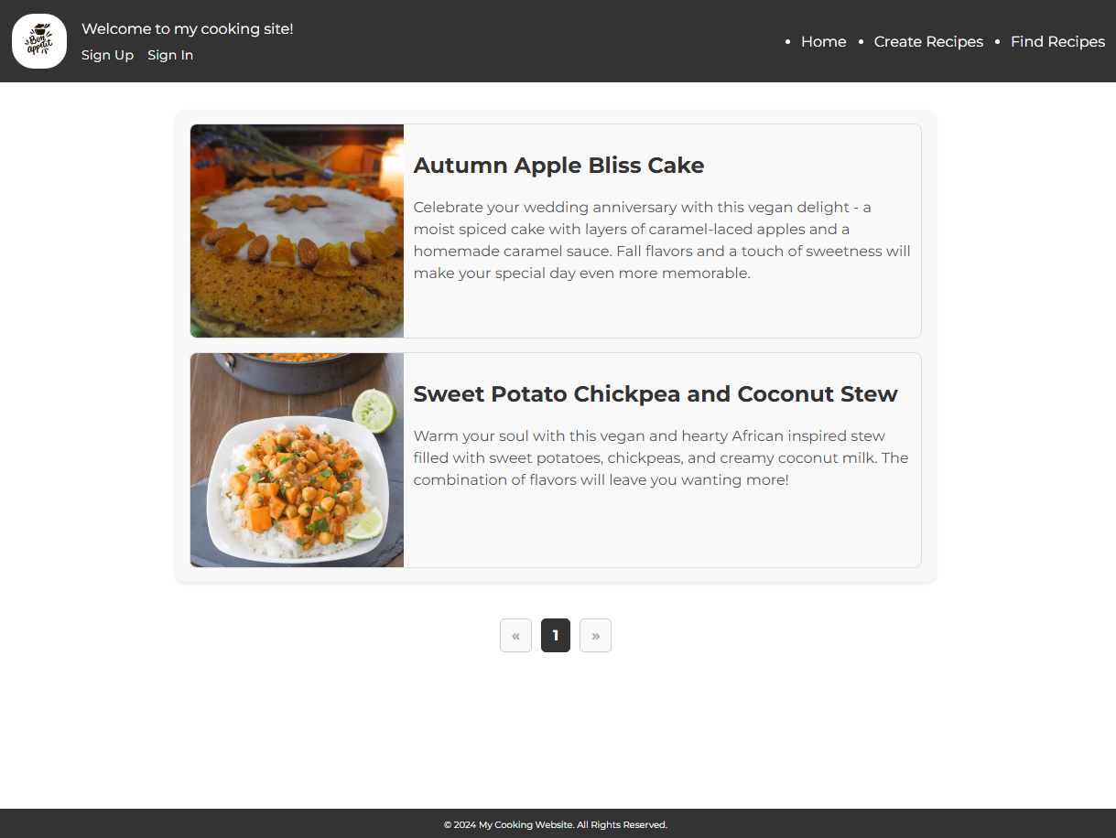
Pic. 1 Main page

This page displays all recipes with a page-by-page display. In the header of the navigation, registration or login menu
Navigation between recipe pages is done by going directly to the page or by using the arrow keys

The next page is the recipe creation page, which has a variety of fields for entering information
The name allows any letters, numbers, and most additional characters. The length of the name should be a minimum of 3 and a maximum of 255 characters. The description, howto, and ingredients fields accept the same character set and should be between 20 and 5000 characters long. The picture of the dish should be a maximum of 400 by 400 pixels and have a total size of no more than 2Mb.
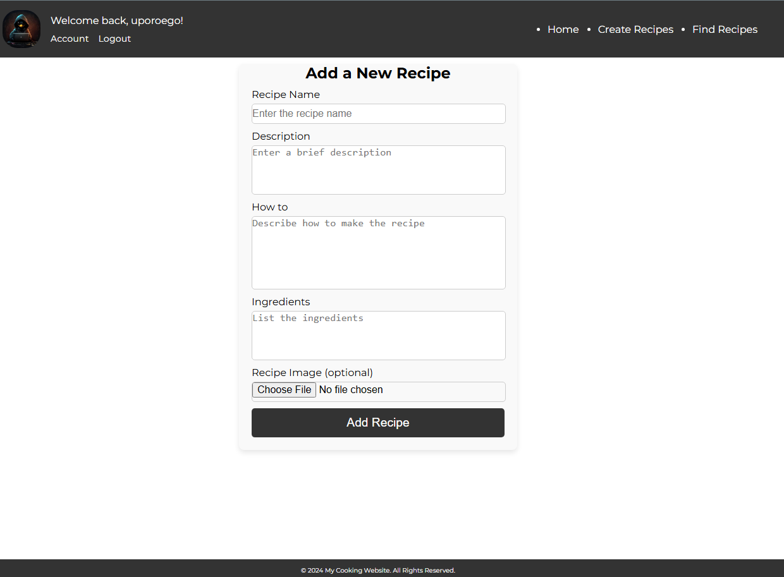
Pic. 2 Recipe page
This page is only available after registering or logging in to the site.

The next page is the account page, which shows all the recipes created by this account plus there is an option to open an account modification and recipe deletion page.
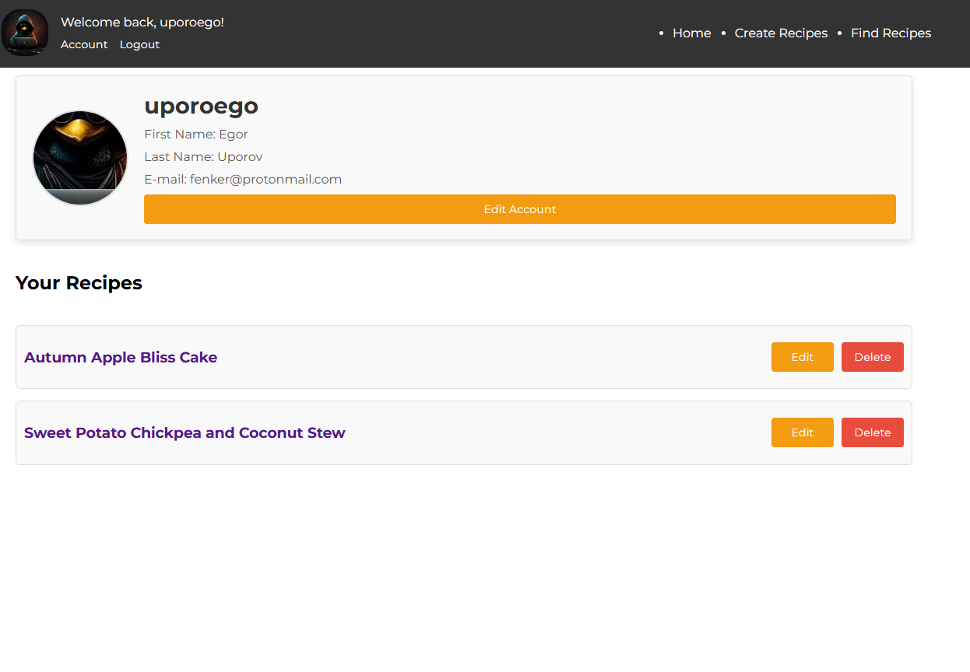
Pic. 3 Account page
The next page is the account update page, where the user is given the option to change their account details, except for their username and profile picture - these are temporarily unchangeable attributes
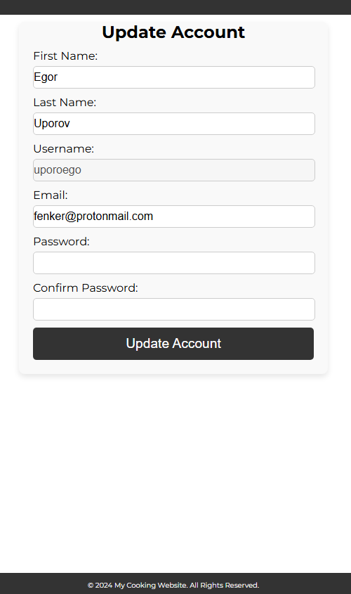
Pic. 4 Account update page

Important elements of the site are the registration and personal account login pages. On the registration page the user is asked to enter the following information: First Name, Last Name, Username, Email, Password and optionally add a 400 x 400 pixel avatar up to 2 megabytes in size.

For validation, the following restrictions on input parameters were specified:
- First and last name should be more than 2 characters and up to 255 with the possibility of water only Latin alphabet characters
- The username must be between 6 and 255 characters, containing only letters and numbers
- The email address must conform to the built-in php standard
- Password must be 8 characters or more using letters, numbers, and symbols
After pressing the Update Account button, a window will appear notifying the server about the result of the operation. If no errors occurred as a result of the operation - a message will appear that the update was successful or the list of detected errors will be returned.

The recipe update window is shown in picture number 5
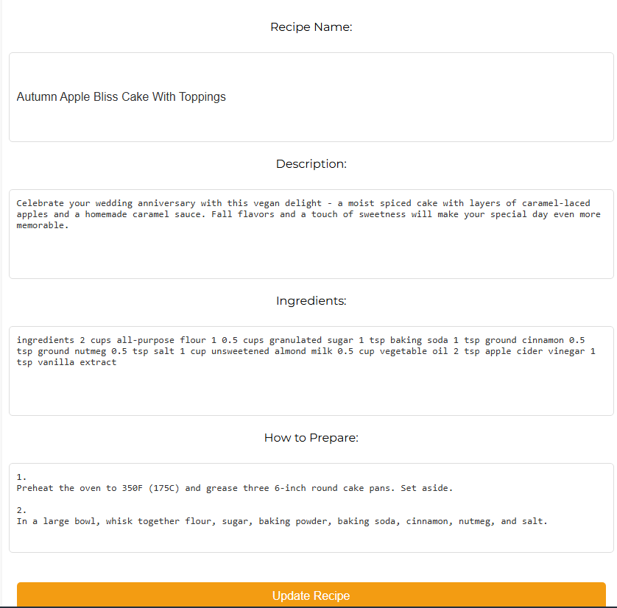
Pic. 5 Recipe update page

The pages that are accessible only to users with elevated access levels will be described below.
The All recipes page shows all recipes available on the site, with the option to delete or modify them
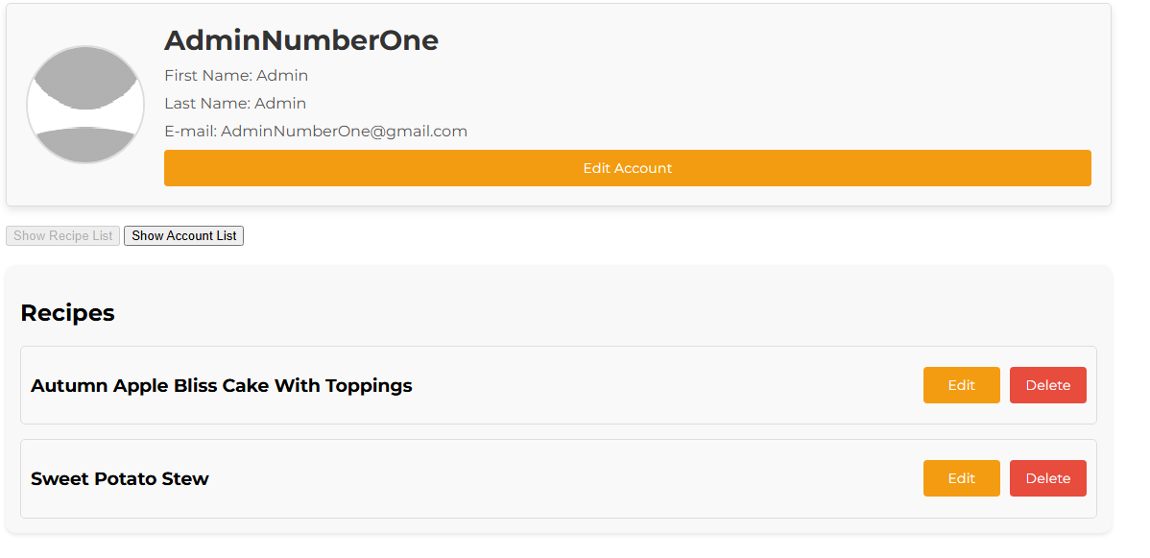
Pic. 6 All recipe page

The accounts section shows all available accounts accordingly
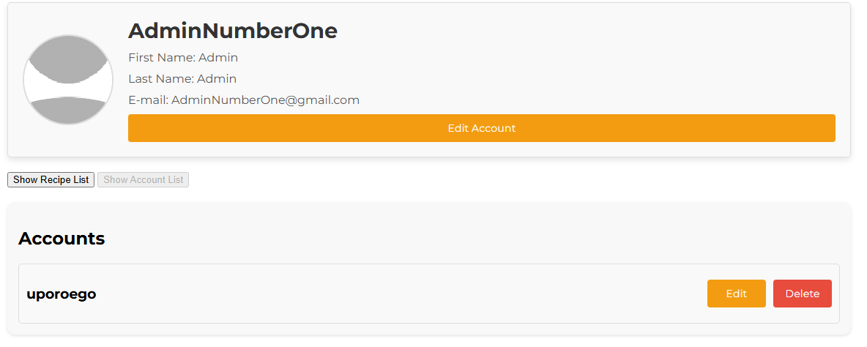
Pic. 7 All account page

Programming documentation

User registration implementation description
Registration form
The sign-up.php file contains an HTML form for registering a new user. It includes required fields (email, username, password, password confirmation) and the option to upload a profile photo. Styling is handled via main.css.

Validation on the client side
The sign-up-action.js file provides a check of the input data before sending it to the server. It uses the formValidation(form) function. The data is sent using XMLHttpRequest() and handles server responses, including errors.

Registration processing
The sign-up-action.php via validator.php file performs data validation, checks for the existence of the user, uploads the photo, and saves the data to the database. The password is encrypted using the password_hash() function. Responses are sent as String.

Description of the user login implementation
Login form
The sign-in.php file contains the HTML form for login. It contains required fields (username and password). The styling is handled via main.css.

Validation on the client side
The sign-in-action.js file checks the input data before sending it to the server. It uses the same function as sign-up-action.js to validate the username and password. The data is sent using XMLHttpRequest() and handles server responses, including errors.

Login processing
The sign-in-action.php file validates login credentials against the database. The password is checked using the password_verify() function. On successful login, a string with user’s data is generated and stored in the cookies.

User logout implementation description
The logout.php file provides user logout:
- Delete cookies by setting it’s expiration date now() - 1 hour using setcookie('username', '', time() - 3600, "/")
- Redirect to the home page.

