Server Setup

Introduction

This document describes the needed setup of the server for PNEK. The software installed is called the VKA interface. The definition is split in the the different programs that should be installed, the rights the different users/programs should have on the filesystem, the access to the outside world and which information should be return by the one setting the server.

For monitoring purpose the (virtual) server should only run the VKA interface. The machine should be daily backup. The backup should be checked!!

Outside world access

The machine is expected to be behind a firewall. Therefor external access to the installed software is restricted.

There are different groups of users / ips that use the system
- developer access: 213.93.33.140, @Roger: ip of NorgesFilm and PNEK
- deployment access: 50.31.156.48 – 50.31.156.79, 50.31.189.108 – 50.31.189.122
- open access: any ip address

Location on the machine

We can identify different location on the machine. The location should be documented and return after the setup has been done. The location should be full qualify path.
- The document root of the Apache server. This location is called apacheDocuments
- The location the FTP stores the file uploaded by the general public. This location is called publicAccess
- The location of the filestore. This where the VKA interface andResource Space will look for the video files after the have been processed. This location is call fileStore
- A location where FFMPEG can store its temp files. This should be on the same machine/drive as the FFMPEG is installed and the same as drive as the general public upload their files. This should be extremely fast drive and large enough to do the temporary storage and processing of thos files. This location is call tempStorage. @Roger something about size. I think about 1Tbyte
- Temp storage used by the apache and the PHP cron job. These location are called runtimeStorage. These are subdirectories from the apacheDocuments.

Installed software
This is the list of the minimal installed programs. Excepted is a full Linux install with all security enabled and with direct internet access and access of the network to the remote storage (fileStorage).

The VKA interface makes use of:
- Apache
- mySQL
- PHP
- FTP server
- CRON jobs
- FFMPEG
- Terminal access

Apache
The standard version of Apache does not need to be changed. The document root will be apacheDocuments (see locations). The ftp server should have access to the document root. The ip range for this access is deployment access.

The structure will be:

document root/

/site

/config/users

/assets

/runtime

directories set by the deployment server

/resourcespace

/filestore

directories set by the resources space setup
The apache process should have read / write access to the assets and runtime directories (including creating new directories). These are the runtimeStorage. The filestore is virtual directory that is mapped to the network share where the files are stored. Location is fileStorage

mySQL
- Version: 5.5.
- Encoding: UTF-8 unicode
- Access through phpmyadmin (restricted by developer access)
- External access to the mySQL database by developer access.

A full backup of the database (rsvideokunstutf8) should be restored on the machine.

PHP
- Standard is PHP 5.5. A higher version is allowed.
- Curl installed

FTP server

This is probably the most complex part of the setup. There are three accounts/groups needed.
- External users can store files on the ftp server. The users we call public. For this there is one account, password protected, through which they can upload to one directory. This account is not ip restricted. public can create subdirectories. The location of the directory should be publicAccess. For the location see Locations
- For the deployment there is a user (deployment) which has access to the root document directory of the Apache server. This account is ip restricted to developer access. This user can read / write. The location is apacheDocuments
- For checking the files there is a user which has access to the filestore. This user is ip restricted to developer access. The location is fileStore.

Cron
Cron is used to process the files. It will run PHP scripts. The process needs read / write access to publicAccess, tempStorage, runtimeStorage and fileStore. The process will move the files around to recompress the video file by FFMPEG.

FFMPEG
FFMPEG is used to re-compress the huge video files. All access may NEVER be done across the network. All compression to be done on a local, very fast, disk. FFMPEG only needs read / write access to the tempStorage.
The FFMPEG installation is part of the Resource Space installation and is not documented in this documention

Terminal access
For maintenance sudo access to the machine is needs from ip address range developer access.

Installing VKA interface

The interface is best installed on the /site directory. This directory will hold all files needed to run the VKA interface except the files used by Resource Space. These files are stored into the /resourcespace directory.
The default url would be then http://www.example.com/site

Installing using GIT
The entire software is stored in a GIT repository. This repository can be found at beanstalkapp.com.
To get the site the repository should be cloned:

#clone the repo
git clone https://toxus.git.beanstalkapp.com/pnek.git site

# install submodues
git submodule init;
git submodule update;

The interface can also be installed with a push ftp from the beanstalk server. This will keep the installation automatic in sync with the latest release. To make use of this feature please contact info@toxus.nl.

Setting up directory access

cd site
# create missing dirs
mkdir site/assets
chmod a+w !$
mkdir site/protected/runtime
chmod a+w !$
mkdir site/protected/config/users
chmod a+w !$

#install subsubmodules
cd site/protected/vendors/toxus
git submodule init;
git submodule update;

More information about the access to the directory structure can be found in the chapter “Directory access”.

General setup

The general setup of the system can be reached in a browser through the url

/site/index.php/setup

The default password is password. This can be changed in the setup.

Setup of the database
The database should be created first. This can be done on the command prompt. See the mysql documentation about creating a sql database. An empty database should be created and a unique user that has full access except GRANT should be created. The default database name is vka_db with the user vka_db and a self chosen password.
In the system setup (/site/index.php/setup) the access to the database also be defined in the setup.
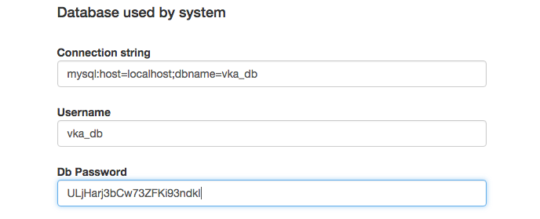
The connection string is the connection to the database: host and db name. Username is the self chosen name (default vka_db) and the password is the chosen password.
After saving the information the connection to the database has been made. If there is an error during the saving (access denied) one should check the write access to the /site/config/users directory.

Creating tables and importing
The structure of the database can be upgraded through the terminal

cd /site/protected
# the database will be migrate to the latest version
php yiic migrate

The first time a setup must run to define the fields needed by the Resource Space and the VKA interface. This my sql script will create the field definition needed to run the interface. The script is in : /sql/setup.sql

Fixed values
The system uses a number of constant values which can be customized through the setup interface. There are more options, but these are controlled by the Resource Space setup (like kind of compression, location of files, etc)
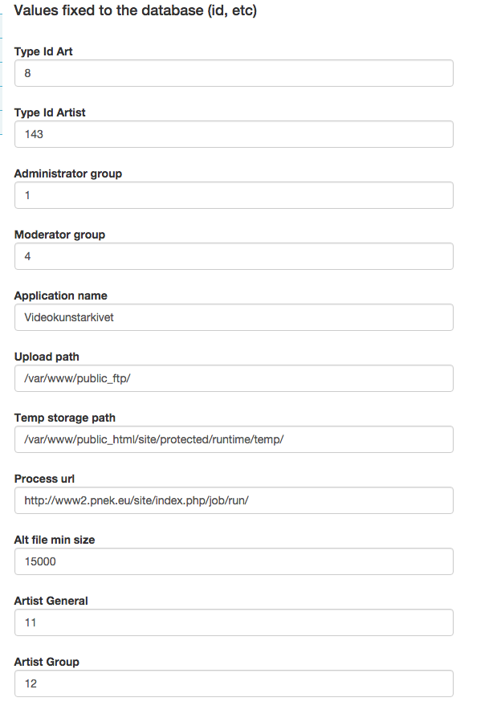
Type id art: this defines the id of the record that Resource Space accepts as Art. Default is 8
Type id Artist: this defines the id of a resource that Resource Space uses for an Artist.
Administrator Group: The group that is defined as being an administrator
Moderator Group: The group that are the moderators of the system: See moderation
Application name: The default name in the header if not changed by the group
Upload Path: the path where the FTP server upload the files
Temp storage Path: the path where temporary files are places. Needed is read/write access (see access)
Process Url: the url called by the processing queue when running an new job
Alt file min size: the size of file in bytes to be accepted as Alternate file
Artist General: The id of the group that holds the view rights for the artist
Artist Group: The id of the group that holds the edit rights for the artist

Transfer
The transfer setting are used for showing the files to the outside world.
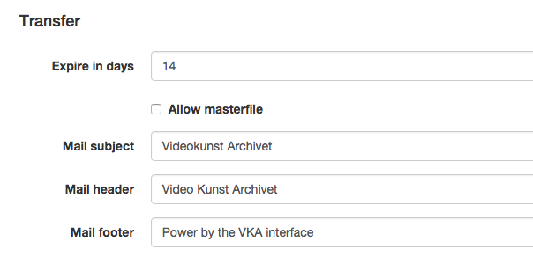
Expire in days: the number of days the download is valid. After this period the files can not be downloaded anymore
Allow Masterfile: default the artist is not allowed to send the master file to anybody. This is because these files are huge and most of the time, of very limited use. Allowing this would cause the system to use extreme amount of resources
Mail subject: The default subject for the mail message
Mail header: the header text used in the mail
Mail footer: the footer text used in the mail.

Mail system
The system can send mail message. The configuration is defined by the mail system settings.
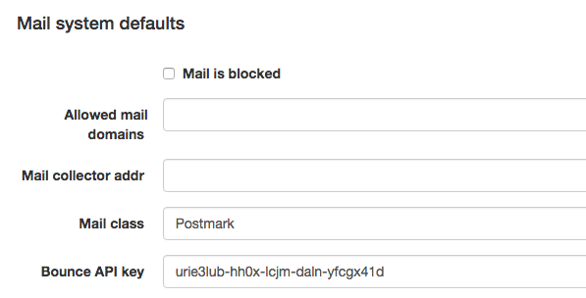
Allowed mail domains: If using a local mail server, on can restrict the domains where to mail to. If a email address is outside this list (; separation), the mail will not be send but will be logged in the mySQL mail table
Mail collector addr: All mail will be send to this email address is the Mail call is local
Mail class: Which type of mail server to use. There are two systems implemented: A local mail server and the Postmark server. The best result are with the Postmark server.
Bounce Api Key: this is the bounce key needed in by Postmark

Postmark
The VKA interface has the possibility to use the Postmark (http://www.postmarkapp.com). This is an email service that handles transactional mail. The advantage of this is that we can track any errors when sending / reciving mail, and that there is no need to install a email server on the server.
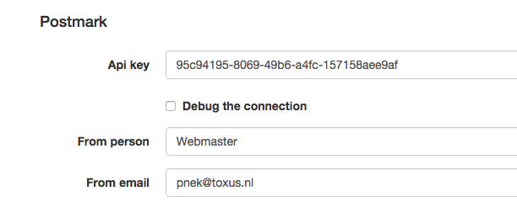
Api key: this is the key that is generated by Postmark and identifies the connector
Debug the connection: For testing purpose a full log can be generated. The information is stored in the mySQL table mail. All the communication between the VKA server and the Postmark server is logged
From Person: the name of the person sending the mail
From Email: the email address used to send the email. This email address should be known in Postmark or an error will occur.

Meta tags
The Meta tags and names used in the interface can be set in the setup.
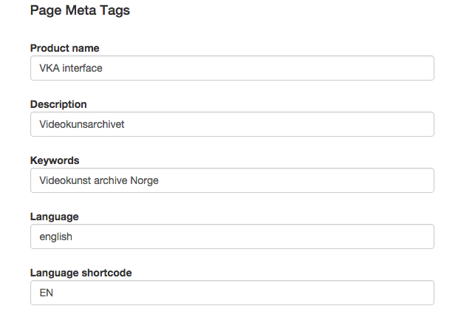
The fields are self explaining

Help system
The system has an flexible help system in which the users can add new topics to the help options.
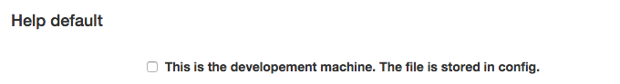
If this option is turned on the master help file is update, otherwise the help file is stored in the /site/config/users directory

System debug information
Depending on the state of the system, extra information can be send to the client or stored in the database.
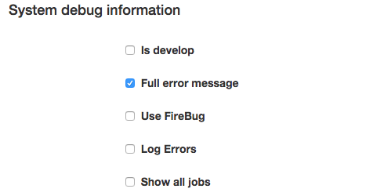
Is develop: This turns on most debug flags in the system. The /site/protected/runtime directory will be used to store the log and dump files.
Full error message: if there is a problem a full stack trace is shown to the user
User Firebug: The debug information is included in the returned header and can be shown in Firebug
Log Error: the full log is written to the /site/protected/runtime directory
Show all jobs: Jobs that are deleted can be show by turning on this flag.

System check with in the VKA interface
In the VKA interface the Administrator has the option to check the current settings of the system. This can be found under the menu System / System Info.
The information should the parameters that configure the current state of the system.
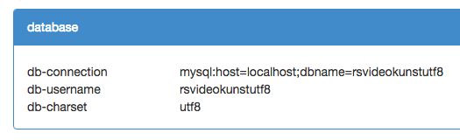
These are setting defined in the setup. Important is that the character set is utf8.
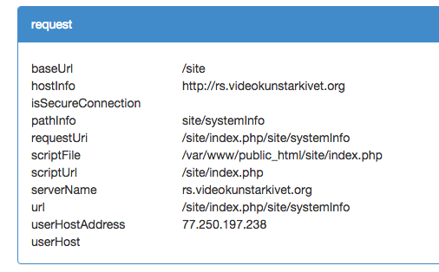
These are the information about the current request. It are the splits of the path.
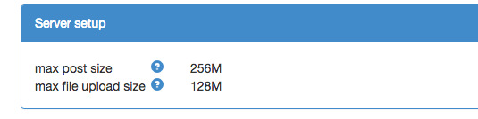
These are the setting that are defined in the .htaccess file. The parameter to set are:
- post_max_size
- upload_max_file_size
Setting these parameters defines the maximum size of post and files. Making the values very high can slowdown the entire system. Large files should be uploaded through FTP.

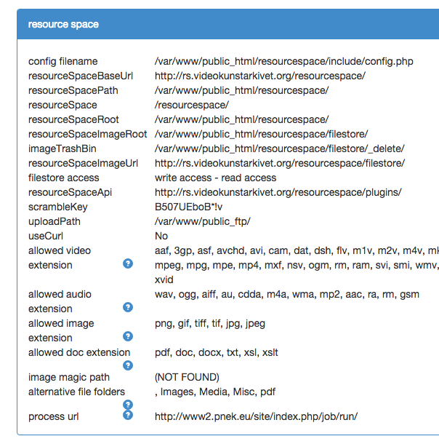
These values are defined in the Resource Space setup. The VKA interface needs to copy these so it can access the files and other resources.

Config filename: which configuration file has been read
resourceSpaceBaseUrl: the url to Resource Space
resourceSpacePath: the fysical path to resourceSpace
resourceSpace: the directory resource space has been installed in
resourceSpaceRoot: same as base url
resourceSpaceImageRoot: the root of the file store where the files are stored. This is the full path / alias to the filestore
imageTrashBin: the location where the delete files are moved to
resourceSpaceImageUrl: the url through resource space to get access to the filestorage
filestore access: the read / write access to the file store. This should always be write access – read access. If not the system can not access the files!
ResourceSpaceApi: the full path to where the importApi should be installed
scrambleKey : the key used to scramble the filenames
uploadPath: the fysical path to the ftp directory
useCurl: the system can use curl or direct access.
Allowed video extension: the extension allowed for the video (set in resource space)
Allowed doc extension: the extensions allowed for the documentation (set in resource space)
Allowed image extension:the extensions allwed for the images (set in resource space)
image Magic Path: the path in the system to image magic
Alternate file folders: the folder names for the alternate files
processUrl: the url to call when a file should be processed

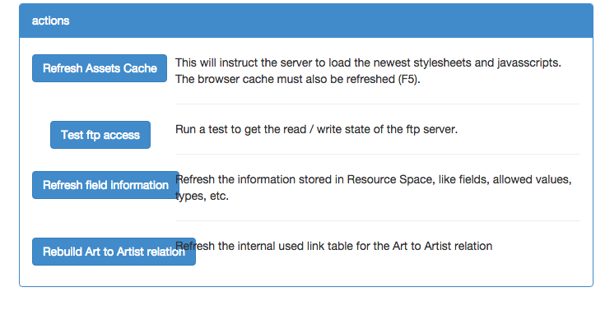
Refresh Assets cache
All javascript, css, image are cached on the server. These cache can be cleared so the new version of the software is retrieve. When there are errors that the old preview image remain visible while a new video has been uploaded, this should be clicked.

Test ftp access
The system runs a test to check if all right are proper set

Refresh Field Information
The field information is cache by the VKA interface. When there are new fields or values have changed in the definition through the Resource Space interface this option should be clicked.
The option will generated the needed files in the /site/protected/runtime directory

Rebuild Art to artist relation.
If artist are renamed, this option can be click so the system will refresh all the links

