**Ain shams university**

**Faculty of computer and information science**

**Bioinformatics department**

**Ain Shams University**

**Faculty of Computer and Information Science**

**Scientific Computing department**

**Project Title**

**Handwritten Signature Identification and Verification**

|  |  |  |
| --- | --- | --- |
| **Name** | **ID** | **Section** |
| **Abdul-Rahman Sayed Ali Mohammed** | **20191700339** | **1** |
| **Mohammed Nour-Elden Abbas Ismael** | **20191700583** | **3** |
| **Nour Mohamed Hussein Kamaly** | **20191700701** | **3** |
| **Nourhan Abdel-Karim Khalaf Abdel-Hafez** | **20191700716** | **4** |

**Under the supervision of**

**Dr. Dina Khattab**

**Scientific Computing Department,**

**Faculty of Computer and Information Science**

**Ain Shams University**

# **Data preparation (preprocessing)**

1. While exploring the data, we noticed that there was class imbalance

1. Removing duplicate images by using “duplicate_images” library.

1. Performing data augmentation with various image processing methods:
2. Converting all images to JPG format.
3. Plotting histogram after augmentation:

**Data Augmentation**

**- There are almost 3000 training images with 6 classes as output: Football, Rowing, Swimming, Tennis, Basketball, Yoga**

**- We applied Augmentation to increase the dataset, we now have almost 19K training and validation images with 6 classes as output: Football, Rowing, Swimming, Tennis, Basketball, Yoga.**

**- Concatenate the training and test sets from the 6 folders.**

**Description of the models and techniques.**

* **Diagram

  Description automatically generatedAlexNet:**
* **Diagram

  Description automatically generatedVGG-16:**
* **Inception:**

* **Diagram

  Description automatically generatedResNet-50:**
* **Chart, schematic

  Description automatically generatedInception-V3:**
* **Diagram

  Description automatically generatedResNext:**

**- All these models we implemented that but we use inception-v3 and vgg16 and depend on its to predict.**

**Inception-v3:**

**-Input shape:**

**shape=(224 , 224 , 3)**

**- Optimizer & Loss:  
 optimizer = RMSprop(lr=0.0001), loss = 'categorical_crossentropy'**

**- Fit Model:**

**- History Plot:**

**VGG-16:**

**- Input shape:**

**input_shape = (224, 224, 3), include_top = False, weights = 'imagenet'**

**- Add some layers which match the dataset:**

**x = layers.Flatten()(base_model.output)**

**x = layers.Dense(512, activation='relu')(x)**

**x = layers.Dropout(0.5)(x)**

**x = layers.Dense(6, activation='Softmax')(x)**

**model = tf.keras.models.Model(base_model.input, x)**

**- Optimizer & Loss:**

**optimizer = 'adam', loss = 'categorical_crossentropy'**

**- Fit Model:**

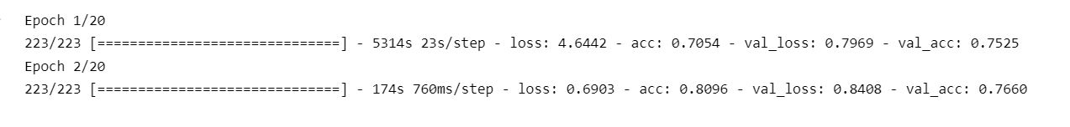

**- History Plot:**