|  |
| --- |
|  |
| **Dimmer System** |
|  |

|  |
| --- |
|  |

* **Static Layered Architecture:**

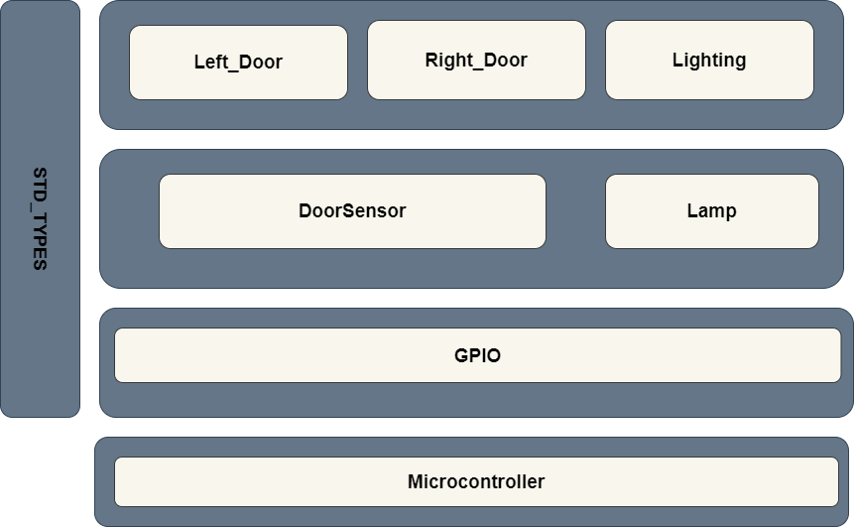

* **APIs:**

|  |  |
| --- | --- |
| **Component Name** | GPIO_Driver |
| **API Name** | Error_Status D_GPIO_Init (u32 Copy_u32Port, u8 Copy_u8Pin, u32 Copy_u8Mode); |
| **Return type** | |  |  | | --- | --- | | Error_Status values |  | | E_OK | 0 | | E_NOK | 1 |   Error_Status |
| **Parameters type** | u32 Copy_u32Port   |  |  | | --- | --- | | PORT_A | 0x01 | | PORT_B | 0x02 | | PORT_C | 0x04 | | PORT_D | 0x08 | | PORT_E | 0x10 | | PORT_F | 0x20 | | PORT_A | 0x01 |   u8 Copy_u8Pin   |  |  | | --- | --- | | PIN0 | 0 | | PIN1 | 1 | | PIN2 | 2 | | PIN3 | 3 | | PIN4 | 4 | | PIN5 | 5 | | PIN6 | 6 | | PIN7 | 7 |   u8 Copy_u8Mode   |  |  | | --- | --- | | INPUT_PIN | 0 | | OUTPUT_PIN | 1 | |
| **Description** | The functionality of this API to select the Mode if it’s INPUT or OUTPUT of a PIN by sending the pin number and port number as arguments |

|  |  |
| --- | --- |
| **Component Name** | GPIO_Driver |
| **API Name** | Error_Status D_GPIO_ReadPin (u32 Copy_u32Port, u8 Copy_u8Pin, u8* Copy_u8Data); |
| **Return type** | |  |  | | --- | --- | | Error_Status values |  | | E_OK | 0 | | E_NOK | 1 |   Error_Status, it returns E_OK or E_NO |
| **Parameters type** | u8 Copy_u8Port   |  |  | | --- | --- | | PORT_A | 0x01 | | PORT_B | 0x02 | | PORT_C | 0x04 | | PORT_D | 0x08 | | PORT_E | 0x10 | | PORT_F | 0x20 | | PORT_A | 0x01 |   u8 Copy_u8Pin   |  |  | | --- | --- | | PIN0 | 0 | | PIN1 | 1 | | PIN2 | 2 | | PIN3 | 3 | | PIN4 | 4 | | PIN5 | 5 | | PIN6 | 6 | | PIN7 | 7 |   u8 *Copy_u32Data  It’s a pointer where the read value will be written in. |
| **Description** | The functionality of this API to read the of a PIN by sending the pin number and port number as arguments and receiving the read value in a pointer |

|  |  |
| --- | --- |
| **Component Name** | GPIO_Driver |
| **API Name** | Error_Status D_GPIO_WritePin (u32 Copy_u32Port, u8 Copy_u8Pin, u8 Copy_u8Data); |
| **Return type** | |  |  | | --- | --- | | Error_Status values |  | | E_OK | 0 | | E_NOK | 1 |   Error_Status, it returns E_OK or E_NO |
| **Parameters type** | u8 Copy_u8Port   |  |  | | --- | --- | | PORT_A | 0x01 | | PORT_B | 0x02 | | PORT_C | 0x04 | | PORT_D | 0x08 | | PORT_E | 0x10 | | PORT_F | 0x20 | | PORT_A | 0x01 |   u8 Copy_u8Pin   |  |  | | --- | --- | | PIN0 | 0 | | PIN1 | 1 | | PIN2 | 2 | | PIN3 | 3 | | PIN4 | 4 | | PIN5 | 5 | | PIN6 | 6 | | PIN7 | 7 |   u8 Copy_u8Data   |  |  | | --- | --- | | SET_PIN | 1 | | CLEAR_PIN | 0 | |
| **Description** | The functionality of this API to write the Copy_u8Data value in a PIN by sending the pin number and port number as arguments, and Copy_u8Data |

|  |  |
| --- | --- |
| **Component Name** | DoorSensorDriver |
| **API Name** | Error_Status DoorSensor_Init(u8 DOOR_SENSOR_ID); |
| **Return type** | |  |  | | --- | --- | | Error_Status values |  | | E_OK | 0 | | E_NOK | 1 |   Error_Status, it returns E_OK or E_NO |
| **Parameters type** | u8 DOOR_SENSOR_ID   |  |  | | --- | --- | | DOOR_SENSOR_CH0 | 0 | | DOOR_SENSOR_CH1 | 1 |   DOOR_SENSOR_CH0   |  |  | | --- | --- | | SENSOR_CH0_PORT | PORT_x (x: A to F) | | SENSOR_CH0_PIN | PINx (x: 0 to 7) | | SENSOR_CH0_MODE | INPUT_PIN |   DOOR_SENSOR_CH1   |  |  | | --- | --- | | SENSOR_CH1_PORT | PORT_x (x: A to F) | | SENSOR_CH1_PIN | PINx (x: 0 to 7) | | SENSOR_CH1_MODE | INPUT_PIN |   SENSOR_MODE   |  |  | | --- | --- | | INPUT_PIN | 0 | | OUTPUT_PIN | 1 | |
| **Description** | The functionality of this API to send the selected sensor pin number and port number as predefined arguments to GPIO. To enable its pin |

|  |  |
| --- | --- |
| **Component Name** | DoorSensorDriver |
| **API Name** | Error_Status DoorSensor_ReadStatus(u8 Sensor_Ch, u8* Sensor_Status); |
| **Return type** | |  |  | | --- | --- | | Error_Status values |  | | E_OK | 0 | | E_NOK | 1 |   Error_Status, it returns E_OK or E_NO |
| **Parameters type** | u8 Sensor_Ch   |  |  | | --- | --- | | DOOR_SENSOR_CH0 | 0 | | DOOR_SENSOR_CH1 | 1 |   DOOR_SENSOR_0   |  |  | | --- | --- | | SENSOR_CH0_PORT | PORT_x (x: A to F) | | SENSOR_CH0_PIN | PINx (x: 0 to 7) |   DOOR_SENSOR_1   |  |  |  | | --- | --- | --- | | SENSOR_CH1_PORT | PORT_x (x: A to F) | PORT_x (x: A to F) | | SENSOR_CH1_PIN | PINx (x: 0 to 7) | PINx (x: 0 to 7) |   u8* Sensor_Status  it’s a pointer where the read value will be written in   |  |  | | --- | --- | | DOOROPEN | 0 | | DOORCLOSED | 1 | |
| **Description** | The functionality of this API to get the current status of the sensor and write its value in u8* Sensor_Status, by sending the sensor Channel number |

|  |  |
| --- | --- |
| **Component Name** | LampDriver |
| **API Name** | Error_Status Lamp_Init(void); |
| **Return type** | |  |  | | --- | --- | | Error_Status values |  | | E_OK | 0 | | E_NOK | 1 |   Error_Status, it returns E_OK or E_NO |
| **Parameters type** | It takes no parameters but there are Predefined values   |  |  | | --- | --- | | LIGHTING_CH0 | LAMP_CH0 |  |  |  |  | | --- | --- | --- | | LAMP_PORT_CH0 | PORT_x (x: A to F) | 'F' | | LAMP_PIN_CH0 | PINx (x: 0 to 7) | 1 | |
| **Description** | The functionality of this API to send the Lamp pin number and port number as predefined arguments to GPIO. To enable its pin |

|  |  |
| --- | --- |
| **Component Name** | LampDriver |
| **API Name** | Error_Status Lamp_Update(u8 LAMP_CH, u8 LAMP_Status); |
| **Return type** | |  |  | | --- | --- | | Error_Status values |  | | E_OK | 0 | | E_NOK | 1 |   Error_Status, it returns E_OK or E_NO |
| **Parameters type** | U8 LAMP_CH   |  |  | | --- | --- | | LIGHTING_CH0 | LAMP_CH0 |   Predefined values   |  |  |  | | --- | --- | --- | | LAMP_PORT_CH0 | PORT_x (x: A to F) | 'F' | | LAMP_PIN_CH0 | PINx (x: 0 to 7) | 1 |   u8 LAMP_Status   |  |  | | --- | --- | | L_ON | 1 | | L_OFF | 0 | |
| **Description** | The functionality of this API to set the selected lamp ON or OFF by sending port and pin number |

|  |  |
| --- | --- |
| **Component Name** | Lighting Driver |
| **API Name** | Error_Status Lighting_Init(void); |
| **Return type** | |  |  | | --- | --- | | Error_Status values |  | | E_OK | 0 | | E_NOK | 1 |   Error_Status, it returns E_OK or E_NO |
| **Parameters type** | It has no parameters |
| **Description** | The functionality of this API to call the lamp driver to initialize the predefined Lamp pin |

|  |  |
| --- | --- |
| **Component Name** | Lighting Driver |
| **API Name** | Error_Status Lighting_Control(u8 *Copy_u8LampStatus) |
| **Return type** | |  |  | | --- | --- | | Error_Status values |  | | E_OK | 0 | | E_NOK | 1 |   Error_Status, it returns E_OK or E_NO |
| **Parameters type** | u8 Copy_u8LampStatus  it’s a parameter carries the lamp desired status and sending it to take action upon it   |  |  | | --- | --- | | L_ON | 1 | | L_OFF | 0 | |
| **Description** | The functionality of this API to call the lamp driver to set the Lamp ON or OFF after checking the status of right door and left door |

|  |  |
| --- | --- |
| **Component Name** | LeftDoor Driver |
| **API Name** | Error_Status Left_Door(void); |
| **Return type** | |  |  | | --- | --- | | Error_Status values |  | | E_OK | 0 | | E_NOK | 1 |   Error_Status, it returns E_OK or E_NO |
| **Parameters type** | It has no parameters |
| **Description** | The functionality of this API to call the door sensor driver to initialize the predefined sensor pin |

|  |  |
| --- | --- |
| **Component Name** | LeftDoor Driver |
| **API Name** | Error_Status LeftDoor_ReadStatus(u8 * Door_Status); |
| **Return type** | |  |  | | --- | --- | | Error_Status values |  | | E_OK | 0 | | E_NOK | 1 |   Error_Status, it returns E_OK or E_NO |
| **Parameters type** | u8 * Door_Status  it’s a pointer carries the status of its door sensor to check if the door is opened or not to turn the lamp on or off.   |  |  | | --- | --- | | Door_OPEN | 1 | | Door_CLOSED | 0 | |
| **Description** | The functionality of this API to call the sensor driver to read its status if it’s OPEN or CLOSED |

|  |  |
| --- | --- |
| **Component Name** | RightDoor Driver |
| **API Name** | Error_Status Right_Door(void); |
| **Return type** | |  |  | | --- | --- | | Error_Status values |  | | E_OK | 0 | | E_NOK | 1 |   Error_Status, it returns E_OK or E_NO |
| **Parameters type** | It has no parameters |
| **Description** | The functionality of this API to call the door sensor driver to initialize the predefined sensor pin |

|  |  |
| --- | --- |
| **Component Name** | RightDoor Driver |
| **API Name** | Error_Status RightDoor_ReadStatus(u8 * Door_Status); |
| **Return type** | |  |  | | --- | --- | | Error_Status values |  | | E_OK | 0 | | E_NOK | 1 |   Error_Status, it returns E_OK or E_NO |
| **Parameters type** | u8 * Door_Status  it’s a pointer carries the status of its door sensor to check if the door is opened or not to turn the lamp on or off.   |  |  | | --- | --- | | Door_OPEN | 1 | | Door_CLOSED | 0 | |
| **Description** | The functionality of this API to call the sensor driver to read its status if it’s OPEN or CLOSED |