PLACEMENT GUIDE - delete this page before submitting
Everything after this page is written to be pasted into the manuscript under Q2 and Q4. All numbers were produced by re-running the BVetter models on the active dataset (consult_2023-2026.xlsx, 2,792 consultation records, January 2023 to July 2026) and the bundled vaccination workbook, using months the models were not trained on. The tables and figures are numbered Q2-1, Q2-2, ... so they are easy to find; renumber them to follow your manuscript's sequence (they come before the Disease Analytics and Mass Vaccination screenshots in Figures 22-23).
# | Insert | Image file (in bvetter/output/q2_q4/figures/) or source | Where it goes
1 | Table Q2-1 + Figure Q2-1 | fig_q2_1_municipal_disease_forecast.png | RQ 2.1, municipal disease forecast
2 | Table Q2-2, Table Q2-3 + Figure Q2-2 | fig_q2_2_barangay_predicted_vs_actual.png | RQ 2.1, predicted vs actual per barangay and risk classification
3 | Table Q2-4 + Figure Q2-3 | fig_q2_3_per_disease_rf_vs_arima.png | RQ 2.1, frequency of specific diseases
4 | Table Q2-5 | (table only) | RQ 2.1, likely diagnosis from a symptom cluster
5 | Tables Q2-6, Q2-7 + Figure Q2-4 | fig_q2_4_vaccination_forecast.png | RQ 2.2, municipal vaccination forecast
6 | Table Q2-8 + Figure Q2-5 | fig_q2_5_vaccination_per_barangay.png | RQ 2.2, forecast per barangay vs historical turnout
7 | Table Q4-1 + Figure Q4-1 | fig_q4_1_classifier_metrics.png | Q4, Random Forest accuracy / precision / recall / F1
8 | Table Q4-2 + Figure Q4-2 | fig_q4_2_forecast_error_vs_baseline.png | Q4, ARIMA MAE / RMSE / MAPE
9 | Figure 22 (existing) | Screenshot: Disease Analytics, All Diseases, latest month | Should show the same barangay action tiers as Table Q2-2
10 | Figure 23 (existing) | Screenshot: Mass Vaccination forecast panel | Should show about 399.6 animals next month
Note on the screenshots: the analytics service reads the active dataset from MySQL only when the Python package `cryptography` is installed. Without it, the service silently falls back to the older 2023-2025 workbook and the Disease Analytics screen shows different accuracy figures (for example 1.1% MAPE instead of 7.8%). Install it (py -3.13 -m pip install cryptography), restart the analytics service, then retake Figures 22-23 so the screens match these tables.

Q2. Transforming Historical Data into Actionable Insights with Machine Learning and Time-Series Models
This section presents the actual output of the ARIMA and Random Forest models implemented in BVetter. The disease models use the consultation dataset currently active in the system (2,792 consultation records from 27 barangays, January 2023 to July 2026, covering 42 diagnoses). The vaccination model uses the municipal rabies vaccination records for 2023-2025. To show how the models perform on data they have not seen, each model was trained only on earlier months, and its predictions for the most recent months were compared with what was actually recorded. These are the same models that produce the numbers on the Disease Analytics and Mass Vaccination screens (Figures 22-23).

2.1 Predicting disease case frequency and suggesting a likely diagnosis

2.1.1 Municipality-wide disease case forecast (Seasonal ARIMA)
The system first forecasts the total number of consultation cases for the whole municipality using a seasonal ARIMA model, SARIMA(0, 0, 0)(0, 1, 1, 12). This model predicts each month from the same month in earlier years, so it captures the yearly pattern of animal illness. It was trained on March 2023 to January 2026 and tested on the six months that followed (February 2026 to July 2026). Table Q2-1 compares the predicted and actual case counts.
Table Q2-1. Predicted vs actual monthly disease cases, municipality-wide (February 2026 - July 2026)
Month | Actual cases | Predicted cases | 80% prediction range | Error (predicted - actual) | Percentage error
Feb 2026 | 80 | 86.5 | 73.1 - 99.9 | +6.5 | 8.1%
Mar 2026 | 78 | 77.5 | 64.1 - 90.9 | -0.5 | 0.6%
Apr 2026 | 92 | 80.3 | 66.9 - 93.7 | -11.7 | 12.7%
May 2026 | 87 | 92.7 | 79.3 - 106.1 | +5.7 | 6.6%
Jun 2026 | 117 | 105.0 | 91.6 - 118.4 | -12.0 | 10.3%
Jul 2026 | 130 | 118.7 | 105.3 - 132.1 | -11.3 | 8.7%
Total / average | 584 | 560.7 | 6 of 6 inside range | MAE 7.95 | MAPE 7.8%
Source: BVetter seasonal ARIMA, trained on March 2023 - January 2026; the six test months were hidden from the model.
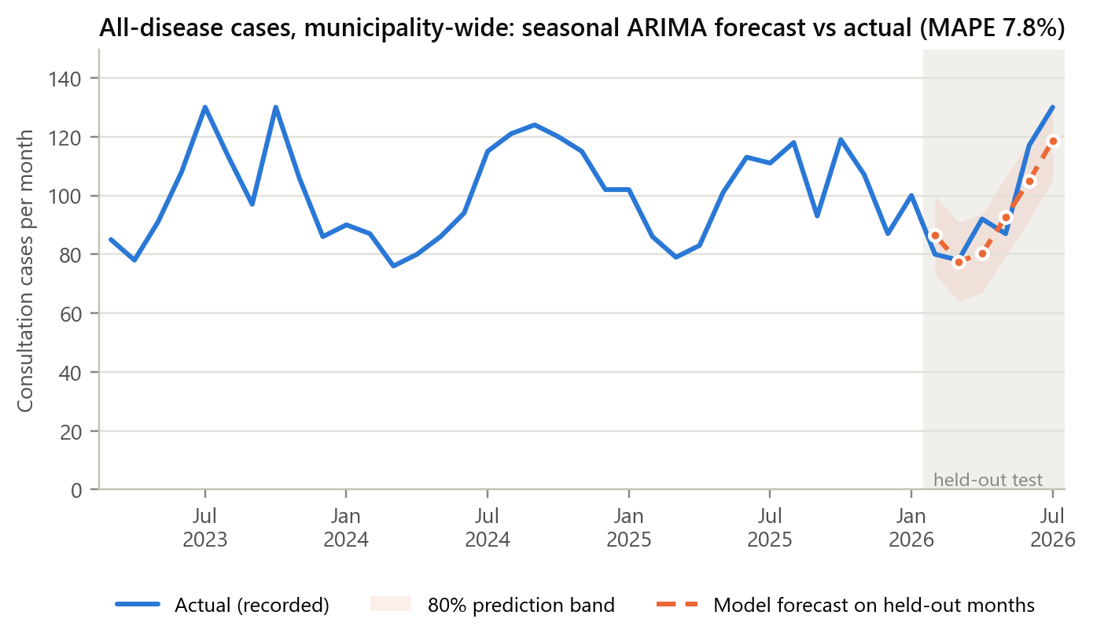
Figure Q2-1. Municipality-wide disease cases: historical record and seasonal ARIMA forecast for the held-out months
The forecast stayed close to the actual caseload in every test month. The average error was 8.0 cases on a caseload of about 97 cases per month (MAPE 7.8%), and all 6 actual values fell inside the model's 80% prediction range. The model also followed the rise from 80 cases in Feb 2026 to 130 cases in Jul 2026, which means it learned the seasonal increase from earlier years rather than simply repeating the last value.

2.1.2 Predicted vs actual cases per barangay and resulting risk classification
A single barangay records only about 3.6 cases per month, which is too few for a reliable separate time-series model. BVetter therefore uses a top-down approach: the municipal forecast above is divided among the 27 barangays according to each barangay's historical share of cases. Each barangay then receives two labels on the Disease Analytics screen. The case volume level (Low, Medium, High) compares the forecast with that barangay's own usual level: above its 75th percentile is Medium and above its 90th percentile is High. The action tier (Needs Action, Watch, Normal) is a documented rule applied to the cases actually recorded: a barangay is marked Needs Action when a reportable disease such as suspected rabies or leptospirosis was seen in the last three months or when its cases are above its usual high level; Watch when cases are above its usual level; otherwise Normal. Table Q2-2 shows the output for all 27 barangays.
Table Q2-2. Predicted vs actual disease cases and risk classification per barangay (test period February 2026 - July 2026)
Barangay | Predicted cases (6 mo.) | Actual cases (6 mo.) | Predicted July | Actual July | Volume level from forecast | Volume level from actual | Action tier shown (July 2026)
Sta. Barbara | 23.5 | 14 | 5.0 | 5 | Low | Low | Normal
Bagong Nayon | 23.1 | 14 | 4.9 | 3 | Low | Low | Normal
Concepcion | 23.1 | 27 | 4.9 | 2 | Low | Low | Normal
Paitan | 22.9 | 20 | 4.8 | 4 | Low | Low | Normal
Sto. Cristo | 22.5 | 30 | 4.8 | 5 | Low | Low | Needs Action
Tibag | 22.3 | 35 | 4.7 | 5 | Low | Low | Normal
Sabang | 21.8 | 34 | 4.6 | 12 | Low | High | Needs Action
Poblacion | 21.8 | 30 | 4.6 | 6 | Low | Medium | Watch
Tangos | 21.8 | 22 | 4.6 | 5 | Low | Low | Normal
San Roque | 21.6 | 22 | 4.6 | 2 | Low | Low | Normal
Pinagbarilan | 21.4 | 17 | 4.5 | 4 | Low | Low | Normal
Tilapayong | 21.4 | 21 | 4.5 | 5 | Low | Low | Normal
Sto. Niño | 21.2 | 21 | 4.5 | 4 | Low | Low | Normal
Barangca | 20.8 | 7 | 4.4 | 3 | Low | Low | Normal
Subic | 20.8 | 12 | 4.4 | 0 | Low | Low | Normal
Tiaong | 20.8 | 26 | 4.4 | 7 | Low | Medium | Watch
Virgen Delas Flores | 20.8 | 16 | 4.4 | 4 | Low | Low | Normal
Hinukay | 20.8 | 31 | 4.4 | 10 | Low | High | Needs Action
Tarcan | 20.2 | 22 | 4.3 | 2 | Low | Low | Normal
Catulinan | 19.8 | 20 | 4.2 | 2 | Low | Low | Normal
Makinabang | 19.8 | 20 | 4.2 | 3 | Low | Low | Needs Action
San Jose | 18.9 | 21 | 4.0 | 4 | Low | Low | Normal
Pagala | 18.7 | 21 | 3.9 | 7 | Low | High | Needs Action
Piel | 18.2 | 19 | 3.9 | 3 | Low | Low | Normal
Matangtubig | 18.2 | 24 | 3.9 | 6 | Low | Medium | Watch
Sulivan | 17.7 | 20 | 3.8 | 8 | Low | High | Needs Action
Calantipay | 16.9 | 18 | 3.6 | 9 | Low | High | Needs Action
Shaded rows are barangays the screen flags as Needs Action or Watch. Volume levels use each barangay's own 75th / 90th percentile of monthly cases from the training months. Of the 7 Needs Action barangays, 2 (Sto. Cristo, Makinabang) were flagged because a reportable disease was recorded in the last three months, and 5 because their cases were above their usual high level.
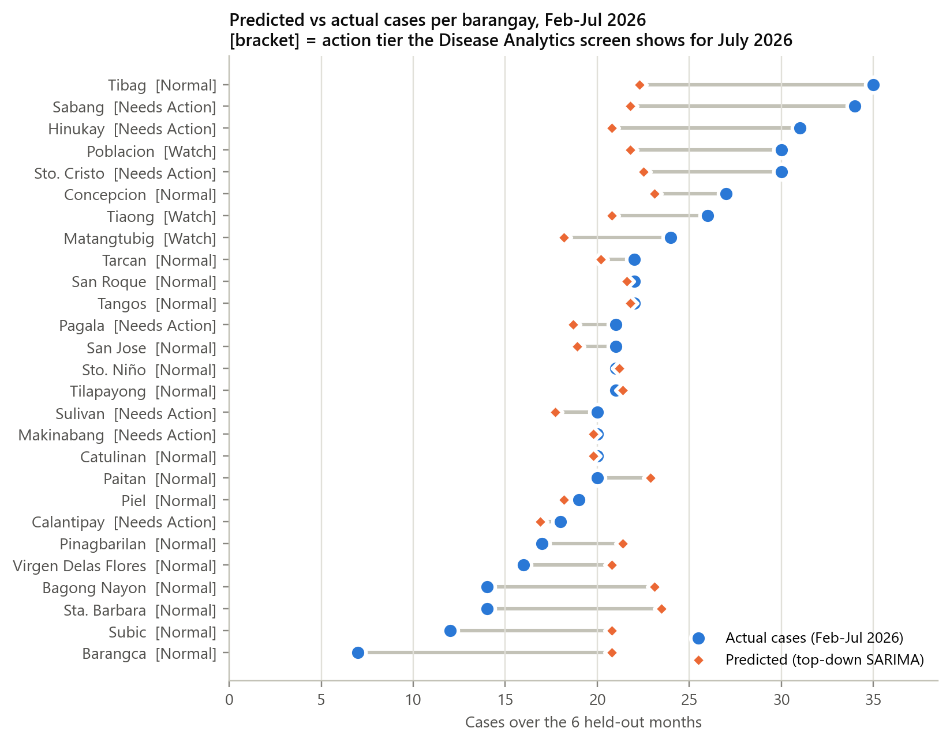
Figure Q2-2. Predicted vs actual cases per barangay over the six test months, with the action tier displayed for July 2026
Table Q2-3. Agreement between forecast-based and actual case volume levels (27 barangays x 6 months = 162 barangay-months)
Actual level | Forecast said Low | Forecast said Medium | Forecast said High | Total
Low | 132 | 0 | 0 | 132
Medium | 16 | 0 | 0 | 16
High | 14 | 0 | 0 | 14
Overall agreement: 81.5% (132 of 162). Agreement in July 2026 alone: 19 of 27 barangays.
Across the 162 barangay-months, the top-down forecast was off by an average of 1.88 cases per barangay per month, slightly better than simply using each barangay's own historical average (1.96 cases). Over three-month totals, which is how barangay visits are planned, the error fell to 30.7% of actual cases, compared with 52.1% for single months. Table Q2-3 shows an important limitation: the forecast-based volume level agreed with the actual level 81.5% of the time, but only because most barangay-months are normal. The forecast never predicted a Medium or High month, so the 30 barangay-months that actually rose above normal were not anticipated by the forecast. This is why BVetter bases the action tier on recorded cases instead of on the forecast: in July 2026 it flagged 7 barangays as Needs Action and 3 as Watch, including the barangays whose July cases most exceeded their forecast (Sabang, 12 actual vs 4.6 predicted, Needs Action; Hinukay, 10 actual vs 4.4 predicted, Needs Action). In practice, the forecast tells the clinic how many cases to prepare for, and the action tier tells it which barangay needs attention now.

2.1.3 Forecasting the frequency of specific diseases (Random Forest and ARIMA)
For individual diseases, the system uses a Random Forest regressor trained on all 42 diseases at once. It learns from each disease's recent months, its usual level and its usual value for that calendar month. Pooling the diseases gives the model far more examples than a separate model per disease would have. To compare it with ARIMA, a separate ARIMA model was also fitted to each disease. Both models forecast one month ahead for each of the six test months (February 2026 to July 2026) using only data recorded before that month. Table Q2-4 shows the ten most frequent diseases.
Table Q2-4. Predicted vs actual cases of the ten most frequent diseases (six test months combined)
Diagnosis | Actual cases | Random Forest predicted | ARIMA predicted | Random Forest MAE (cases/month) | ARIMA MAE (cases/month)
Flea Allergy Dermatitis | 59 | 53.0 | 57.3 | 1.83 | 2.52
Skin Infection | 56 | 53.3 | 56.8 | 1.87 | 1.67
Mange | 53 | 54.5 | 52.2 | 1.90 | 1.87
Parasitic Infection | 40 | 24.3 | 25.1 | 2.62 | 2.55
Ear Mites | 37 | 26.5 | 27.0 | 2.17 | 2.17
Ehrlichiosis | 36 | 23.7 | 24.0 | 2.73 | 3.27
Dental Disease | 32 | 23.1 | 20.7 | 1.90 | 1.88
Ear Infection | 29 | 27.7 | 38.2 | 2.11 | 2.23
Gastroenteritis | 27 | 27.2 | 26.7 | 2.57 | 2.52
Feline Lower Urinary Tract Disease | 25 | 19.3 | 20.4 | 2.02 | 2.03
All 42 diseases |  |  |  | MAE 1.29 | MAE 1.36
MAE = mean absolute error, the average number of cases by which a monthly forecast missed. Keeping each disease at its own historical average gives MAE 1.35.
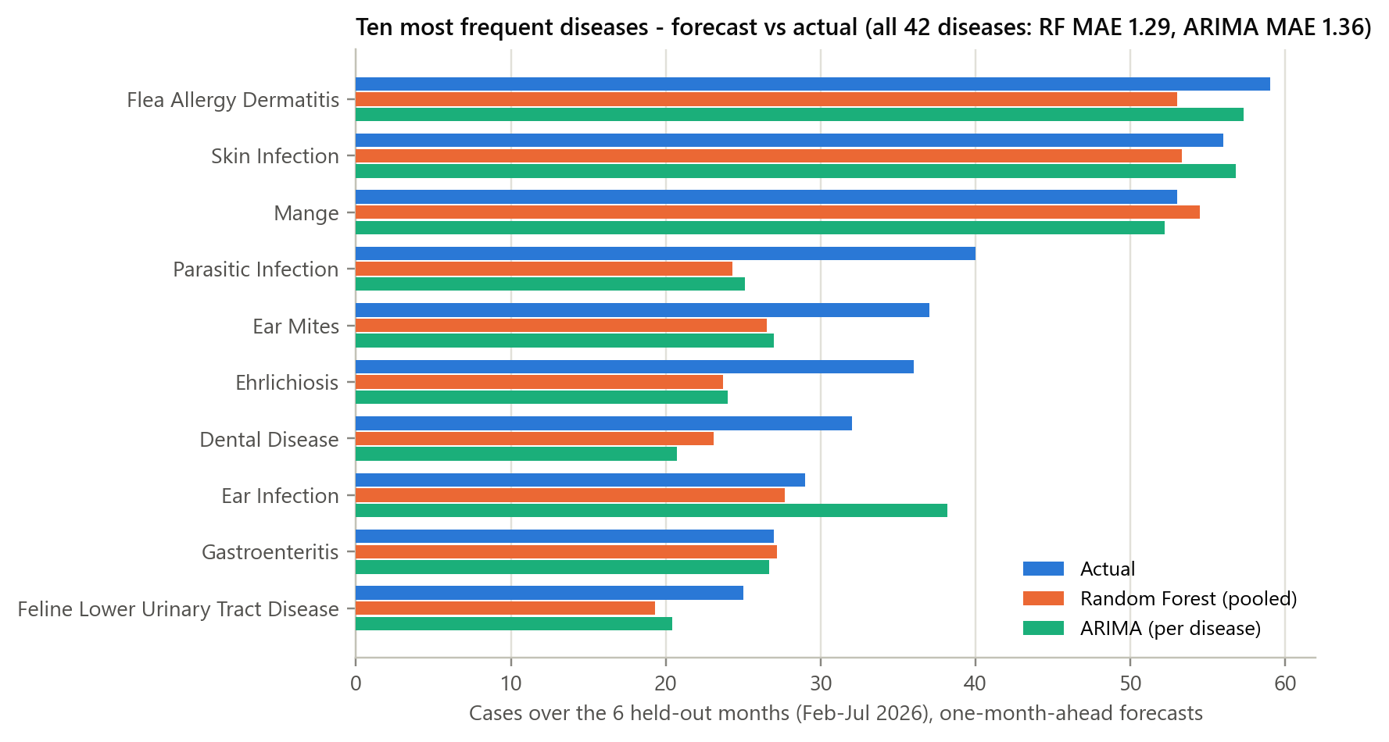
Figure Q2-3. Actual cases vs Random Forest and ARIMA forecasts for the ten most frequent diseases
The Random Forest had the lowest average error (1.29 cases per disease per month), compared with 1.36 for ARIMA and 1.35 for a disease's own average. For the three most common skin conditions both models came within 6 cases of the six-month total. Both models under-predicted Parasitic Infection, Ear Mites, Ehrlichiosis, Dental Disease, each of which had more cases in February-July 2026 than in the same months of any earlier year; a forecast built on history cannot anticipate a new increase, so these diseases are the ones to review with clinic staff.

2.1.4 Suggesting a likely diagnosis from a reported symptom cluster (Random Forest)
A Random Forest classifier suggests likely diagnoses from the reported symptom cluster and the animal group. It was trained on 2,233 consultations and tested on 559 held-out consultations (an 80/20 split). The system lists the three most probable diagnoses, because a single answer out of 42 would overstate what the model knows. Table Q2-5 shows the model's output for one held-out consultation from each of the 10 symptom clusters, taken in the order they appear in the test set rather than chosen by hand.
Table Q2-5. Sample diagnosis suggestions for held-out consultations (one per symptom cluster)
Reported symptom cluster | Animal | Recorded diagnosis | Top-3 suggestions (probability) | First suggestion correct? | In top 3?
vomiting, diarrhea, loss of appetite, weakness | Dogs | Gastroenteritis | 1. Gastroenteritis (56.2%)  2. Intestinal Parasites (43.8%) | Yes | Yes
itching, hair loss, wounds, ear scratching | Dogs | Skin Infection | 1. Flea Allergy Dermatitis (33.0%)  2. Skin Infection (31.9%)  3. Mange (17.9%) | No | Yes
bite exposure, fever, neurological signs, suspected public-health risk | Dogs | Rabies (Suspected) | 1. Leptospirosis (55.3%)  2. Rabies (Suspected) (44.7%) | No | Yes
coughing, nasal discharge, fever, difficulty breathing | Dogs | Kennel Cough | 1. Kennel Cough (100.0%) | Yes | Yes
fever, ticks, anemia, weakness | Carabaos / Water Buffalo | Parasite Infection | 1. Parasite Infection (100.0%) | Yes | Yes
general weakness, appetite loss, abnormal behavior | Goats / Sheep | Parasitic Infection | 1. Parasitic Infection (86.6%)  2. Foot Rot (13.4%) | Yes | Yes
frequent urination, straining, blood in urine | Cats | Feline Lower Urinary Tract Disease | 1. Feline Lower Urinary Tract Disease (100.0%) | Yes | Yes
bad breath, drooling, difficulty eating | Cats | Dental Disease | 1. Dental Disease (100.0%) | Yes | Yes
abdominal swelling, discharge, mammary inflammation | Dogs | Pyometra | 1. Pyometra (100.0%) | Yes | Yes
panting, collapse, high temperature, dehydration | Dogs | Heat Stroke | 1. Heat Stroke (100.0%) | Yes | Yes
Suggestions with 0% probability are not shown. When the reported symptoms are not one of the trained clusters, the system returns no suggestion rather than a guess.
In this sample the first suggestion was correct in 8 of 10 consultations and the recorded diagnosis appeared in the top three in 10 of 10. The misses show the model's main limitation: some symptom clusters are shared by several diagnoses. "Itching, hair loss, wounds, ear scratching" fits Flea Allergy Dermatitis, Skin Infection and Mange, so the model can rank them but cannot tell them apart from the symptoms alone. For the dog with bite exposure and neurological signs, the model ranked Leptospirosis first and Suspected Rabies second; both are reportable diseases, so the suggestion still directs the veterinarian toward the right precautions. The suggestions support the veterinarian's decision and do not replace it.

2.2 Forecasting mass vaccination demand per barangay (ARIMA)
The vaccination forecast uses the municipal record of dogs and cats vaccinated per month from January 2023 to December 2025 (36 months). The 2023 and 2024 records were year-to-date running totals and were converted back into monthly counts before modelling, giving annual totals of 3,959 (2023), 4,006 (2024), 6,422 (2025). Vaccinations recorded in the system in June 2026 and July 2026 (100 and 100 animals) were below the system's minimum for a complete month (183 animals, 45% of the median month) and were treated as not yet fully encoded. The ARIMA order was selected automatically by the lowest AIC. The selected model, ARIMA(0, 0, 0), has no autoregressive or moving-average terms, meaning the previous month did not help predict the next one; the model therefore forecasts the long-run average with a prediction range sized from the month-to-month variation. The forecast starts in Jan 2026 because that follows the last complete month of vaccination records. The model was first tested on the last six months of 2025 (Table Q2-6) and then refitted on all months to forecast the first half of 2026 (Table Q2-7).
Table Q2-6. Predicted vs actual animals vaccinated, municipality-wide (trained to June 2025)
Month | Actual vaccinated | ARIMA predicted | 80% prediction range | Error (predicted - actual)
Jul 2025 | 610 | 379.0 | 0.0 - 781.1 | -231.0
Aug 2025 | 578 | 379.0 | 0.0 - 781.1 | -199.0
Sep 2025 | 546 | 379.0 | 0.0 - 781.1 | -167.0
Oct 2025 | 514 | 379.0 | 0.0 - 781.1 | -135.0
Nov 2025 | 417 | 379.0 | 0.0 - 781.1 | -38.0
Dec 2025 | 353 | 379.0 | 0.0 - 781.1 | +26.0
Total / average | 3,018 | 2,274.0 |  | MAE 132.67; MAPE 24.3%
Table Q2-7. ARIMA vaccination demand forecast, Jan 2026 - Jun 2026, compared with historical turnout in the same month
Month | Forecast (animals) | 80% prediction range | Actual, same month 2023 | Actual, same month 2024 | Actual, same month 2025
Jan 2026 | 399.6 | 25.6 - 773.7 | 25 | 25 | 353
Feb 2026 | 399.6 | 25.6 - 773.7 | 35 | 24 | 386
Mar 2026 | 399.6 | 25.6 - 773.7 | 647 | 441 | 546
Apr 2026 | 399.6 | 25.6 - 773.7 | 389 | 722 | 674
May 2026 | 399.6 | 25.6 - 773.7 | 1,079 | 639 | 739
Jun 2026 | 399.6 | 25.6 - 773.7 | 472 | 396 | 706
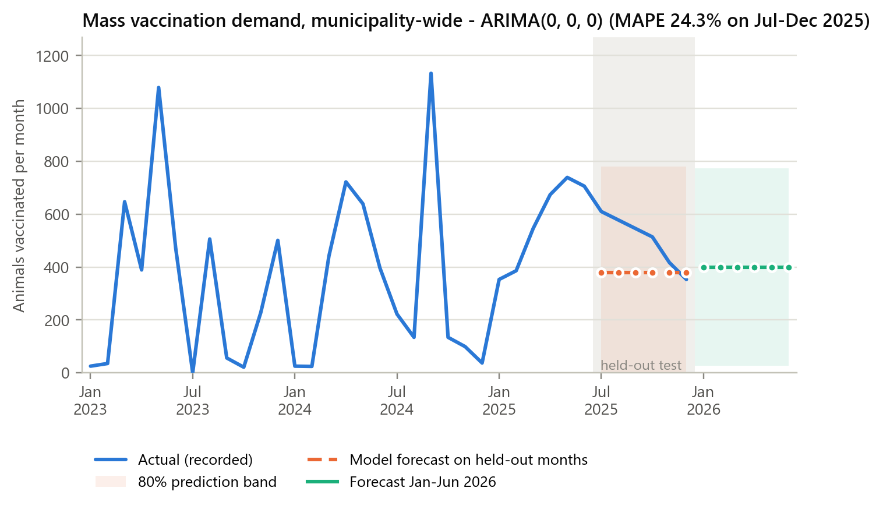
Figure Q2-4. Municipal vaccination turnout, the held-out test forecast and the forward forecast
Because the source records hold municipal totals only, and no vaccination history per barangay, the municipal forecast is distributed to barangays according to each barangay's share of the 16,847 dogs estimated in the 2025 barangay masterlist. The same share is applied to the 2025 turnout to give each barangay's historical baseline. The only turnout recorded per barangay is from the campaigns encoded in the system in 2026, shown in the last column of Table Q2-8.
Table Q2-8. Vaccination demand forecast per barangay compared with historical turnout
Barangay | Est. dogs (2025) | Share of dogs | 2025 turnout, full year* | 2025 turnout, avg. month* | Forecast per month, Jan-Jun 2026 (80% range) | Forecast, 6-month total | Recorded in system, 2026
Tiaong | 945 | 5.6% | 360 | 30.0 | 22.4 (1.4 - 43.4) | 134.4 | -
San Jose | 860 | 5.1% | 328 | 27.3 | 20.4 (1.3 - 39.5) | 122.4 | -
Poblacion | 774 | 4.6% | 295 | 24.6 | 18.3 (1.2 - 35.5) | 109.8 | 25 (Jun)
Sulivan | 774 | 4.6% | 295 | 24.6 | 18.3 (1.2 - 35.5) | 109.8 | -
Tangos | 774 | 4.6% | 295 | 24.6 | 18.3 (1.2 - 35.5) | 109.8 | -
Bagong Nayon | 688 | 4.1% | 262 | 21.8 | 16.3 (1.0 - 31.6) | 97.8 | -
Pagala | 688 | 4.1% | 262 | 21.8 | 16.3 (1.0 - 31.6) | 97.8 | -
Pinagbarilan | 653 | 3.9% | 249 | 20.8 | 15.5 (1.0 - 30.0) | 93.0 | 50 (Jun), 50 (Jul)
Virgen Delas Flores | 653 | 3.9% | 249 | 20.8 | 15.5 (1.0 - 30.0) | 93.0 | -
Tarcan | 619 | 3.7% | 236 | 19.6 | 14.7 (0.9 - 28.4) | 88.2 | -
Makinabang | 619 | 3.7% | 236 | 19.6 | 14.7 (0.9 - 28.4) | 88.2 | -
Tibag | 619 | 3.7% | 236 | 19.6 | 14.7 (0.9 - 28.4) | 88.2 | -
Subic | 602 | 3.6% | 229 | 19.1 | 14.3 (0.9 - 27.6) | 85.8 | -
San Roque | 602 | 3.6% | 229 | 19.1 | 14.3 (0.9 - 27.6) | 85.8 | -
Paitan | 584 | 3.5% | 223 | 18.6 | 13.9 (0.9 - 26.8) | 83.4 | 25 (Jun)
Sto. Cristo | 584 | 3.5% | 223 | 18.6 | 13.9 (0.9 - 26.8) | 83.4 | -
Hinukay | 567 | 3.4% | 216 | 18.0 | 13.5 (0.9 - 26.1) | 81.0 | -
Sto. Niño | 567 | 3.4% | 216 | 18.0 | 13.5 (0.9 - 26.1) | 81.0 | 50 (Jul)
Tilapayong | 550 | 3.3% | 210 | 17.5 | 13.1 (0.8 - 25.3) | 78.6 | -
Concepcion | 550 | 3.3% | 210 | 17.5 | 13.1 (0.8 - 25.3) | 78.6 | -
Barangca | 533 | 3.2% | 203 | 16.9 | 12.6 (0.8 - 24.4) | 75.6 | -
Piel | 533 | 3.2% | 203 | 16.9 | 12.6 (0.8 - 24.4) | 75.6 | -
Catulinan | 516 | 3.1% | 197 | 16.4 | 12.2 (0.8 - 23.7) | 73.2 | -
Calantipay | 516 | 3.1% | 197 | 16.4 | 12.2 (0.8 - 23.7) | 73.2 | -
Sta. Barbara | 516 | 3.1% | 197 | 16.4 | 12.2 (0.8 - 23.7) | 73.2 | -
Sabang | 499 | 3.0% | 190 | 15.8 | 11.8 (0.8 - 22.9) | 70.8 | -
Matangtubig | 462 | 2.8% | 177 | 14.8 | 11.0 (0.7 - 21.4) | 66.0 | -
Municipality | 16,847 | 100% | 6,422 | 535.2 | 399.6 (25.6 - 773.7) | 2,397.6 | 200
* Allocated from the municipal total by the barangay's share of dogs; the source records have no barangay-level vaccination history. Shaded rows have vaccination events recorded in the system in 2026.
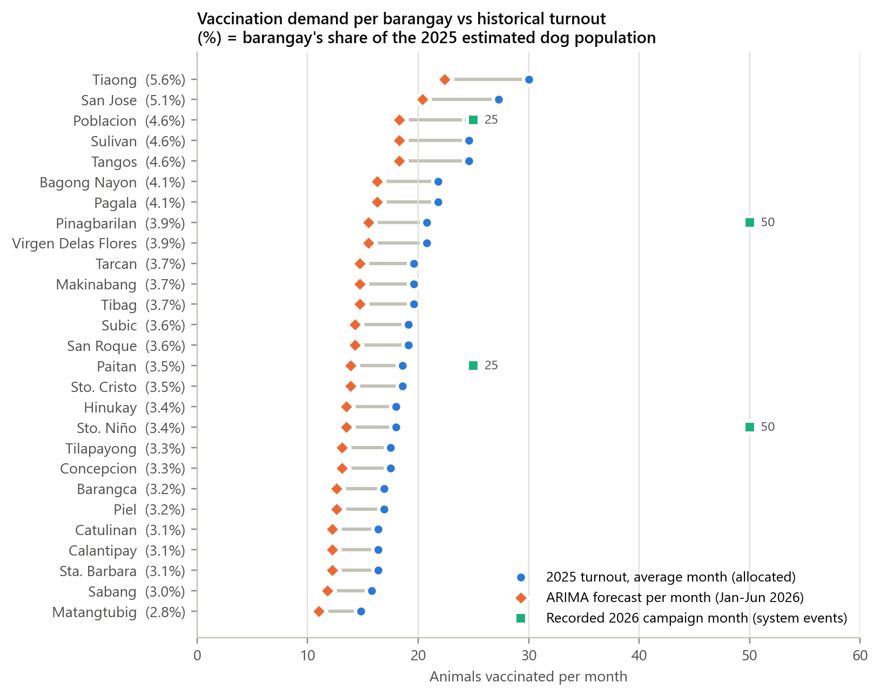
Figure Q2-5. Monthly vaccination forecast per barangay vs 2025 average monthly turnout and campaigns recorded in 2026
On the held-out months the model missed by an average of 133 animals per month (MAPE 24.3%). It under-forecast the second half of 2025 because 2025 was the busiest year on record, and a model that forecasts the three-year average (399.6 animals per month) sits below a year that averaged 535.2. For the same reason, every barangay's monthly forecast is about 25% below its 2025 monthly average: Tiaong, the barangay with the most dogs, is forecast at 22.4 animals against 30.0 per month in 2025. The campaigns recorded in 2026 (Poblacion: 25; Pinagbarilan: 50 and 50; Paitan: 25; Sto. Niño: 50 animals) were each larger than that barangay's monthly forecast. Each was a single campaign day, which shows that demand arrives in campaign-sized batches rather than evenly each month, so a monthly average understates the doses needed on the day of a campaign. For planning, the clinic should treat the forecast as the expected average and prepare stock toward the upper end of the 80% range for barangays with a scheduled campaign. The forecast will become more specific as more campaigns are recorded per barangay in the system.

Q4. Evaluating the Predictive Accuracy and Reliability of the Implemented Models
Each model was evaluated on data it was not trained on. The Random Forest classifier was scored on 559 held-out consultations (20% of the 2,792 records, split so each diagnosis appears in both sets). The forecasting models were scored on the most recent six months, which were hidden during training. Each model is also compared with a simple baseline, because a score is only meaningful if the model does better than an obvious shortcut.
The metrics used are:
- Accuracy: share of consultations where the first suggested diagnosis was the recorded one.
- Precision: of the consultations given a diagnosis, the share that truly had it. Recall: of the consultations that truly had a diagnosis, the share the model found. F1-score: the balance (harmonic mean) of precision and recall. These are averaged across the 42 diagnoses, weighted by how often each occurs.
- MAE (mean absolute error): the average size of a forecast miss, in cases or animals. RMSE (root mean squared error): like MAE but penalizes large misses more. MAPE (mean absolute percentage error): the average miss as a percentage of the actual value (months with zero actual are skipped).
Table Q4-1. Classification performance of the Random Forest diagnosis model (559 held-out consultations, 42 diagnoses)
Metric | Random Forest | Baseline: most common diagnosis for the symptom cluster and animal | Interpretation
Accuracy | 58.3% | 58.1% | First suggestion correct in about 6 of 10 consultations
Precision (weighted) | 44.8% | 45.9% | Lowered by diagnoses that share a symptom cluster
Recall (weighted) | 58.3% | 58.1% | Equals accuracy when weighted by frequency
F1-score (weighted) | 47.2% | 47.9% | Balance of precision and recall
Precision / Recall / F1 (macro) | 50.2% / 60.2% / 52.6% | 51.2% / 61.3% / 53.6% | Every diagnosis counted equally
Top-3 accuracy | 94.5% | - | Recorded diagnosis among the three suggestions
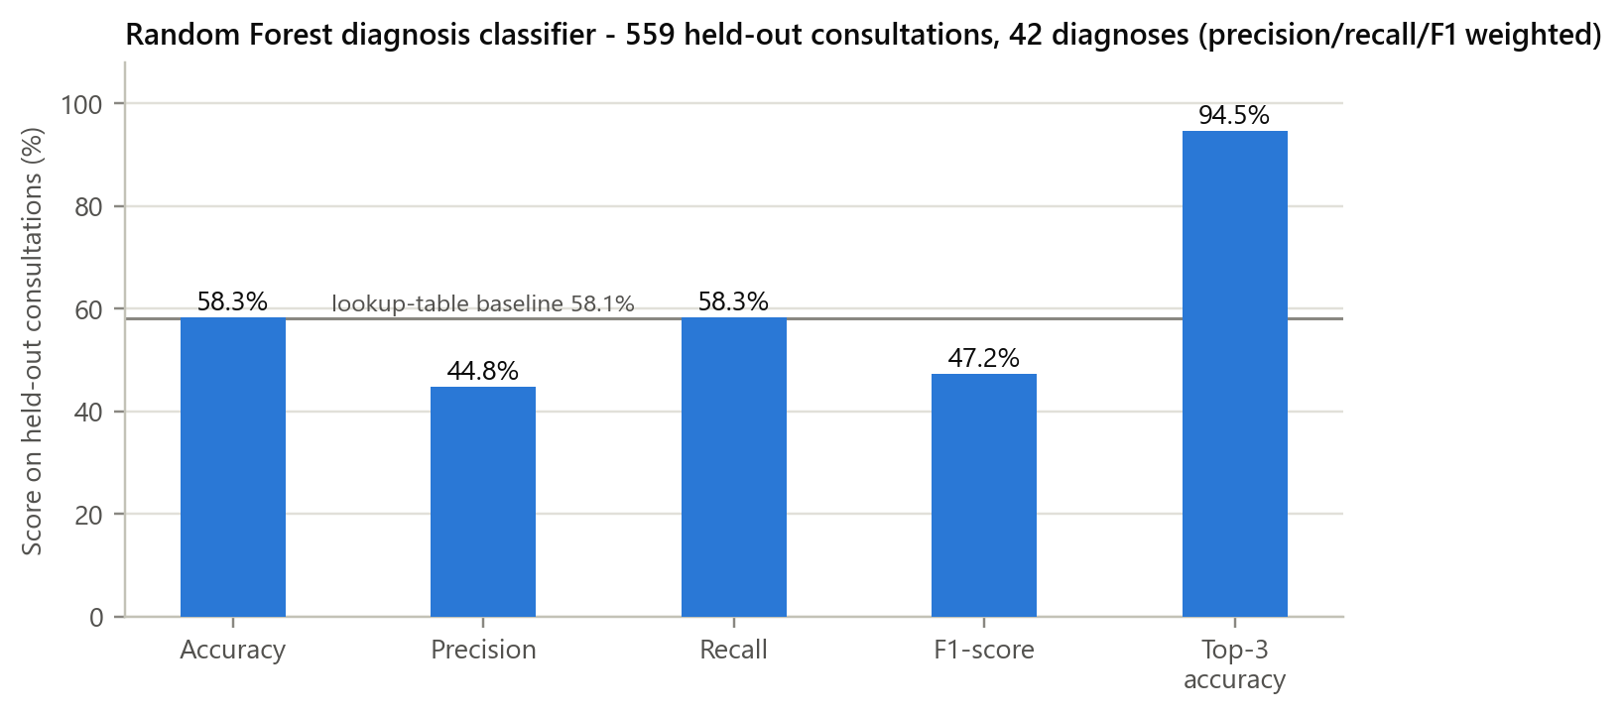
Figure Q4-1. Classification metrics of the Random Forest diagnosis model
Table Q4-2. Forecasting performance on held-out months (lower is better)
Model and level | Test data | MAE | RMSE | MAPE | Baseline (MAE / MAPE)
Seasonal ARIMA - all-disease cases, municipality | 6 months | 7.95 | 8.98 | 7.8% | Same month last year: 8.83 / 8.8%
Seasonal ARIMA (top-down) - cases per barangay, monthly | 162 barangay-months | 1.88 | 2.49 | 58.2% | Barangay's own average: 1.96 / 64.8%
Seasonal ARIMA (top-down) - cases per barangay, 3-month total | 54 barangay-quarters | 3.32 | 4.38 | 32.6% | -
ARIMA - cases per disease | 252 disease-months | 1.36 | 1.81 | 46.4% | Disease's own average: 1.35 / 42.7%
Random Forest regressor - cases per disease (comparison) | 252 disease-months | 1.29 | 1.81 | 45.8% | Disease's own average: 1.35 / 42.7%
ARIMA - animals vaccinated, municipality | 6 months | 132.67 | 153.40 | 24.3% | Same month last year: 405.50 / 81.3%
MAE and RMSE are in cases per month for the disease models and in animals per month for the vaccination model.
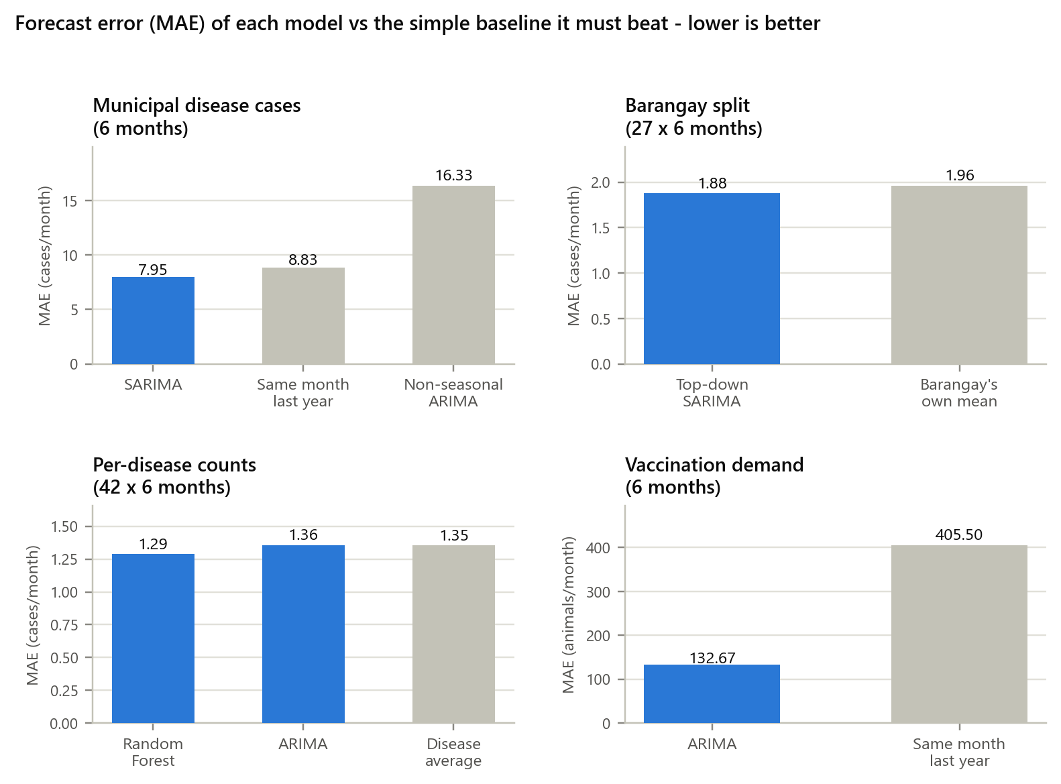
Figure Q4-2. Forecast error of each model compared with the baseline it must beat
Classification. The Random Forest's first suggestion was correct in 58.3% of held-out consultations, and its weighted precision (44.8%) and F1-score (47.2%) are lower still. This is caused by the input rather than by the algorithm: the records describe 10 symptom clusters for 42 diagnoses, so several diagnoses share one cluster. For such a cluster the model can give only one first answer; Skin Infection and Mange, for example, were never the first suggestion (recall 0%) but were in the top three every time (top-3 recall 100%). The model also matches the baseline of simply choosing the most common diagnosis for each symptom cluster and animal (58.1%), which is the highest accuracy these inputs allow. Its top-3 accuracy of 94.5% is the figure that matters for use: in about 19 of 20 consultations the correct diagnosis is on the three-item list the veterinarian sees. The model is therefore reliable as a shortlist that supports the veterinarian's judgment, not as an automatic single diagnosis.
Forecasting. The municipality-wide seasonal ARIMA is the most reliable model: a MAPE of 7.8% (about 8 cases on roughly 97 per month), all six actual months inside its 80% range, and better than both the same-month-last-year baseline (8.8%) and a non-seasonal ARIMA (16.8%). RMSE is only 1.1 to 1.4 times MAE across the models, which shows the errors are steady rather than caused by a few large misses. Percentage errors are much higher at the barangay and disease levels (MAPE 58.2% and 46.4%) even though the absolute errors are small (1.88 and 1.36 cases), because these series have only a few cases per month, so missing by two cases is already a 50% error. Combining three months reduces the barangay error to 32.6%, so three-month totals should be used for barangay planning. At the disease level the Random Forest improved on the disease-average baseline by 4.8% (MAE 1.29 vs 1.35), while ARIMA did not improve on it; this is a real but modest gain. The vaccination ARIMA (MAPE 24.3%, MAE 133 animals) is far better than repeating last year's month (81.3%), but its wide 80% range reflects that vaccination volume depends on campaign schedules. Overall, the models are reliable for municipal planning and for ranking likely diagnoses, and less reliable for exact monthly counts in a single barangay or disease, which is why the system shows prediction ranges and relies on recorded cases for its action tiers.

