PLACEMENT GUIDE - delete this page before submitting
Everything after this page is written to be pasted into the manuscript under Q2 and Q4. All numbers were produced by re-running the BVetter models on the active dataset (consult_2023-2026.xlsx, 2,792 consultation records, January 2023 to July 2026) and the bundled vaccination workbook, using months the models were not trained on. Q2 presents each model's output and how that output is produced; every accuracy measure is consolidated in Q4, so the two sections do not repeat each other. The tables and figures are numbered Q2-1, Q2-2, ... so they are easy to find; renumber them to follow your manuscript's sequence (they come before the Disease Analytics and Mass Vaccination screenshots in Figures 22-23).
# | Insert | Image file (in bvetter/output/q2_q4/figures/) or source | Where it goes
1 | Figure Q2-1 | fig_q2_1_pipeline.png | RQ 2.1 opening, how the three models produce their outputs
2 | Tables Q2-1, Q2-2 + Figure Q2-2 | fig_q2_2_municipal_disease_forecast.png | 2.1.1, municipal case forecast
3 | Tables Q2-3, Q2-4 + Figure Q2-3 | fig_q2_3_barangay_predicted_vs_actual.png | 2.1.2, cases and risk classification per barangay
4 | Table Q2-5 + Figure Q2-4 | fig_q2_5_per_disease_rf_vs_arima.png | 2.1.3, Random Forest regressor, ten most frequent diseases
5 | Table Q2-6 + Figure Q2-5 | fig_q2_4_rf_regressor_output.png | 2.1.3, the same forecasts month by month
6 | Table Q2-7 | (table only) | 2.1.4, diagnosis suggestions from a symptom cluster
7 | Tables Q2-8, Q2-9 + Figure Q2-6 | fig_q2_6_vaccination_forecast.png | 2.2, municipal vaccination demand
8 | Table Q2-10 + Figure Q2-7 | fig_q2_7_vaccination_per_barangay.png | 2.2, demand per barangay vs historical turnout
9 | Table Q4-1 + Figure Q4-1 | fig_q4_1_classifier_metrics.png | Q4, classifier: accuracy / precision / recall / F1
10 | Table Q4-2 + Figure Q4-2 | fig_q4_2_forecast_error_vs_baseline.png | Q4, forecasting models: MAE / RMSE / MAPE
11 | Table Q4-3 + Figure Q4-3 | fig_q4_3_rf_regressor_scatter.png | Q4, risk-level agreement and the regressor scatter
12 | Figure 22 (existing) | Screenshot: Disease Analytics, All Diseases, latest month | Should show the same forecasts and tiers as Table Q2-3
13 | Figure 23 (existing) | Screenshot: Mass Vaccination forecast panel | Should show about 399.6 animals a month
Note on the screenshots: the analytics service reads the active dataset from MySQL only when the Python package `cryptography` is installed. Without it, the service silently falls back to the older 2023-2025 workbook and the Disease Analytics screen shows different accuracy figures (for example 1.1% MAPE instead of 7.8%). Install it (py -3.13 -m pip install cryptography), restart the analytics service, then retake Figures 22-23 so the screens match these tables.

Q2. Transforming Historical Data into Actionable Insights with Machine Learning and Time-Series Models
This section presents the actual output of the ARIMA and Random Forest models implemented in BVetter, and how each output is produced. The disease models use the consultation dataset currently active in the system (2,792 consultation records from 27 barangays, January 2023 to July 2026, covering 42 diagnoses). The vaccination model uses the municipal rabies vaccination records for 2023-2025. For each model, the figures shown are the ones the Disease Analytics and Mass Vaccination screens display (Figures 22-23), followed by the same model's forecasts for six months that were withheld from it, set beside what those months actually recorded. How accurate those forecasts are, measured with the metrics the study adopted, is reported separately in Q4.

2.1 Using ARIMA and Random Forest to predict the frequency of specific disease cases and to generate a suggestion of a likely diagnosis
Three trained models answer this question, each producing a different output from the same consultation records:
- Seasonal ARIMA produces how many cases in total, first for the whole municipality (2.1.1) and then for each barangay with its risk label (2.1.2).
- A pooled Random Forest regressor produces how many cases of each specific disease, covering all 42 diagnoses (2.1.3). A per-disease ARIMA is run alongside it for comparison.
- A Random Forest classifier produces the suggestion of a likely diagnosis from a reported symptom cluster (2.1.4).
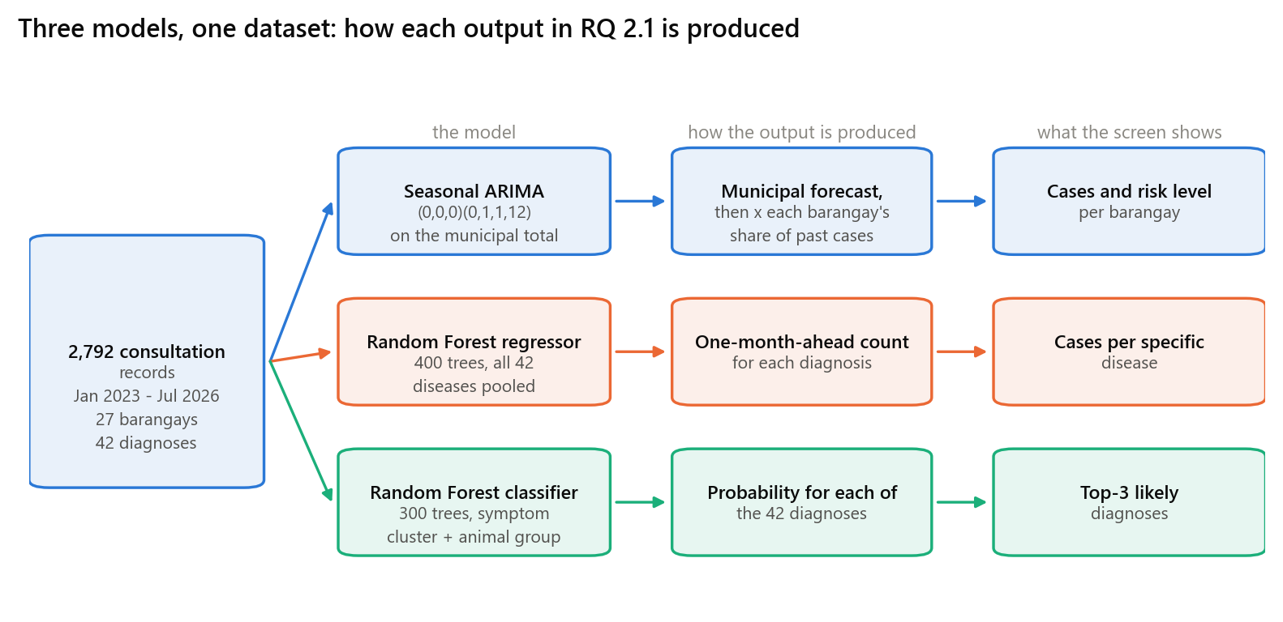
Figure Q2-1. How the three models turn one set of consultation records into the three outputs shown on the Disease Analytics screen

2.1.1 Municipality-wide disease case forecast (Seasonal ARIMA)
The count of cases for the whole municipality is produced by a seasonal ARIMA model, SARIMA(0, 0, 0)(0, 1, 1, 12). The seasonal term makes the model predict each month from the same calendar month in the years already on record, which is how it captures the yearly pattern of animal illness. It is fitted on every month the records contain (41 months, March 2023 to July 2026), and it produces the next three months. The forecast for Aug 2026 is produced as follows.
- The model is fitted on all 41 monthly totals on record, up to July 2026.
- For Aug 2026 it takes the Aug figures already recorded: 113 cases in 2023, 121 cases in 2024, 118 cases in 2025.
- The seasonal term averages those months, giving 117.3 cases - the value reported as 117.3.
- The prediction range is the forecast plus or minus the size of the model's own typical past miss (12.2 cases), giving 105.1 to 129.5.
- That pair of numbers is what the Disease Analytics screen displays for the coming month.
Table Q2-1. Municipality-wide case forecast produced for Aug 2026 to Oct 2026
Month | Cases recorded, same month 2023 | Cases recorded, same month 2024 | Cases recorded, same month 2025 | Forecast | 80% prediction range
Aug 2026 | 113 | 121 | 118 | 117.3 | 105.1 - 129.5
Sep 2026 | 97 | 124 | 93 | 104.7 | 92.5 - 116.9
Oct 2026 | 130 | 120 | 119 | 123.0 | 110.8 - 135.2
The forecast begins in Aug 2026 because that is the month after the last one with consultation records.
To show that this way of producing a number lands close to what happens, the same model was refitted on March 2023 to January 2026 only, and asked for the six months that followed. Those six months were never shown to the model. Table Q2-2 sets its forecasts beside what the clinic actually recorded.
Table Q2-2. Forecast and recorded cases for six months withheld from the model (February 2026 - July 2026)
.
Month | Cases recorded | Forecast | 80% prediction range
Feb 2026 | 80 | 86.5 | 73.1 - 99.9
Mar 2026 | 78 | 77.5 | 64.1 - 90.9
Apr 2026 | 92 | 80.3 | 66.9 - 93.7
May 2026 | 87 | 92.7 | 79.3 - 106.1
Jun 2026 | 117 | 105.0 | 91.6 - 118.4
Jul 2026 | 130 | 118.7 | 105.3 - 132.1
Total | 584 | 560.7 | 6 of 6 recorded months fell inside the range
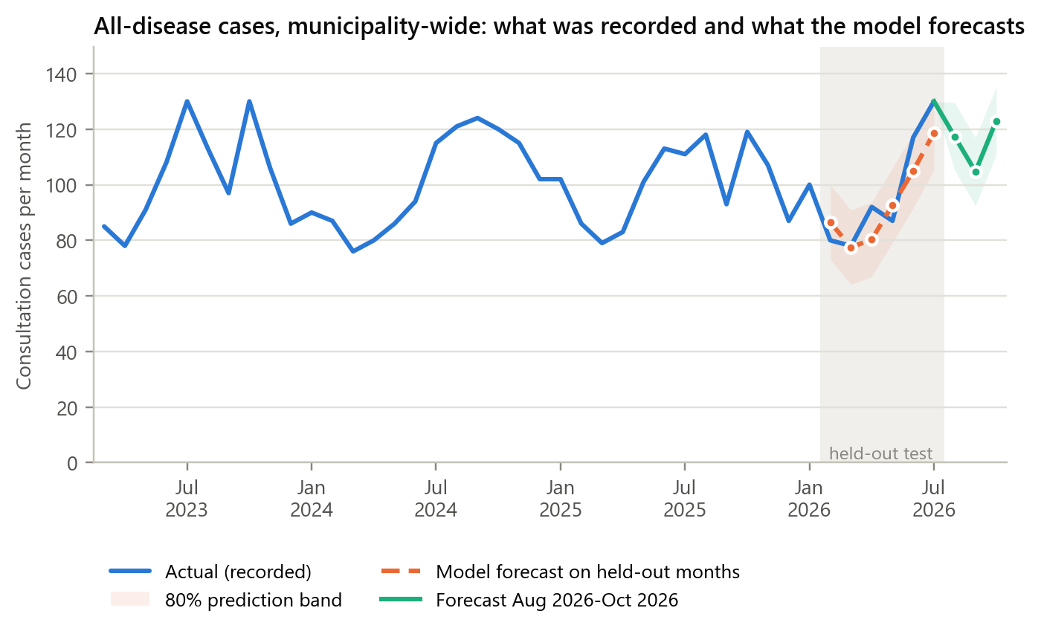
Figure Q2-2. Municipality-wide cases: the recorded history, the forecast for the six withheld months, and the forecast the system now produces
The forecast follows the caseload through the withheld months, including the rise from 80 cases in Feb 2026 to 130 in Jul 2026, which the model produced from the same months of earlier years rather than by repeating the latest value. The accuracy of these forecasts is reported in Q4 (Table Q4-2).

2.1.2 Cases and risk classification per barangay (top-down allocation)
A barangay records only about 3.6 cases a month, too few to support a separate time-series model, so its figure is produced from the municipal forecast above rather than from its own fitted model. The municipal number is divided among the 27 barangays in proportion to the share of cases each barangay has historically recorded. Each barangay then receives two labels. The case volume level (Low, Medium, High) compares the forecast with that barangay's own usual level: above its 75th percentile of past months is Medium, above its 90th percentile is High. The action tier (Needs Action, Watch, Normal) is a documented rule applied to the cases already recorded, not to the forecast: a barangay is marked Needs Action when a reportable disease such as suspected rabies or leptospirosis was recorded in the last three months, or when its recorded cases are above its own usual high level; Watch when they are above its usual level; otherwise Normal. The figure shown for Tibag is produced as follows.
- The municipal forecast for Aug 2026 is 117.3 cases (2.1.1).
- Tibag accounts for 4.3% of all cases recorded across the municipality.
- 117.3 x 4.3% = 5.0 cases for Aug 2026; the three months together give 14.7 cases, which is the figure used for planning barangay visits.
- Its range comes from how far this barangay's actual counts have historically landed from its allocated share, giving 0.9 to 9.1.
- The two labels are added: case volume level Low from the forecast, and action tier Normal from the cases already recorded (nothing unusual in this barangay's recent cases).
Table Q2-3. Case forecast and risk classification produced for each barangay (Aug 2026, with the Aug-Oct 2026 planning total)
Barangay | Share of cases | Forecast, Aug 2026 | 80% prediction range | Total, Aug-Oct 2026 | Case volume level | Action tier
Tibag | 4.3% | 5.0 | 0.9 - 9.1 | 14.7 (4.4 - 25.0) | Low | Normal
Concepcion | 4.2% | 4.9 | 1.5 - 8.3 | 14.4 (5.8 - 23.0) | Low | Normal
Sto. Cristo | 4.2% | 4.9 | 1.6 - 8.2 | 14.4 (6.2 - 22.6) | Low | Needs Action
Sabang | 4.2% | 4.9 | 0.8 - 9.0 | 14.4 (4.1 - 24.7) | Low | Needs Action
Poblacion | 4.1% | 4.8 | 0.9 - 8.7 | 14.0 (4.3 - 23.7) | Low | Watch
Paitan | 4.0% | 4.7 | 1.2 - 8.2 | 13.8 (5.1 - 22.5) | Low | Normal
Sta. Barbara | 3.9% | 4.6 | 1.3 - 7.9 | 13.5 (5.2 - 21.8) | Low | Normal
Hinukay | 3.9% | 4.6 | 0.8 - 8.4 | 13.5 (3.9 - 23.1) | Low | Needs Action
Bagong Nayon | 3.9% | 4.6 | 1.1 - 8.1 | 13.5 (4.6 - 22.4) | Low | Normal
Tangos | 3.9% | 4.5 | 0.9 - 8.1 | 13.3 (4.2 - 22.4) | Low | Normal
San Roque | 3.8% | 4.5 | 1.0 - 8.0 | 13.2 (4.3 - 22.1) | Low | Normal
Tiaong | 3.8% | 4.5 | 1.0 - 8.0 | 13.2 (4.4 - 22.0) | Low | Watch
Tilapayong | 3.8% | 4.4 | 1.0 - 7.8 | 13.1 (4.5 - 21.7) | Low | Normal
Sto. Niño | 3.7% | 4.4 | 0.8 - 8.0 | 12.9 (3.9 - 21.9) | Low | Normal
Pinagbarilan | 3.7% | 4.3 | 1.5 - 7.1 | 12.7 (5.7 - 19.7) | Low | Normal
Tarcan | 3.6% | 4.2 | 0.9 - 7.5 | 12.5 (4.3 - 20.7) | Low | Normal
Virgen Delas Flores | 3.6% | 4.2 | 1.1 - 7.3 | 12.3 (4.6 - 20.0) | Medium | Normal
Catulinan | 3.5% | 4.1 | 0.9 - 7.3 | 12.1 (4.0 - 20.2) | Low | Normal
Makinabang | 3.5% | 4.1 | 0.5 - 7.7 | 12.1 (3.2 - 21.0) | Low | Needs Action
Subic | 3.5% | 4.1 | 0.6 - 7.6 | 12.0 (3.3 - 20.7) | Low | Normal
San Jose | 3.4% | 4.0 | 1.1 - 6.9 | 11.8 (4.4 - 19.2) | Low | Normal
Matangtubig | 3.4% | 4.0 | 0.6 - 7.4 | 11.7 (3.2 - 20.2) | Low | Watch
Barangca | 3.4% | 3.9 | 0.8 - 7.0 | 11.5 (3.8 - 19.2) | Low | Normal
Pagala | 3.4% | 3.9 | 0.7 - 7.1 | 11.5 (3.5 - 19.5) | Low | Needs Action
Piel | 3.3% | 3.8 | 0.5 - 7.1 | 11.2 (3.0 - 19.4) | Low | Normal
Sulivan | 3.2% | 3.8 | 1.0 - 6.6 | 11.1 (4.1 - 18.1) | Low | Needs Action
Calantipay | 3.0% | 3.5 | 0.4 - 6.6 | 10.4 (2.7 - 18.1) | Low | Needs Action
Shaded rows are the barangays the screen flags as Needs Action or Watch. Of the 7 Needs Action barangays, 2 (Sto. Cristo, Makinabang) were flagged because a reportable disease was recorded in the last three months, and the rest because their recorded cases were above their own usual high level.
Table Q2-4 shows the same allocation applied to the six withheld months, beside the cases those barangays actually recorded, together with the case volume level each barangay would have been given from the forecast and the level its recorded cases turned out to deserve.
Table Q2-4. Forecast and recorded cases per barangay for the six withheld months (February 2026 - July 2026)
Barangay | Forecast, 6 months | Recorded, 6 months | Forecast, July | Recorded, July | Volume level from forecast | Volume level from recorded cases
Sta. Barbara | 23.5 | 14 | 5.0 | 5 | Low | Low
Bagong Nayon | 23.1 | 14 | 4.9 | 3 | Low | Low
Concepcion | 23.1 | 27 | 4.9 | 2 | Low | Low
Paitan | 22.9 | 20 | 4.8 | 4 | Low | Low
Sto. Cristo | 22.5 | 30 | 4.8 | 5 | Low | Low
Tibag | 22.3 | 35 | 4.7 | 5 | Low | Low
Sabang | 21.8 | 34 | 4.6 | 12 | Low | High
Poblacion | 21.8 | 30 | 4.6 | 6 | Low | Medium
Tangos | 21.8 | 22 | 4.6 | 5 | Low | Low
San Roque | 21.6 | 22 | 4.6 | 2 | Low | Low
Pinagbarilan | 21.4 | 17 | 4.5 | 4 | Low | Low
Tilapayong | 21.4 | 21 | 4.5 | 5 | Low | Low
Sto. Niño | 21.2 | 21 | 4.5 | 4 | Low | Low
Barangca | 20.8 | 7 | 4.4 | 3 | Low | Low
Subic | 20.8 | 12 | 4.4 | 0 | Low | Low
Tiaong | 20.8 | 26 | 4.4 | 7 | Low | Medium
Virgen Delas Flores | 20.8 | 16 | 4.4 | 4 | Low | Low
Hinukay | 20.8 | 31 | 4.4 | 10 | Low | High
Tarcan | 20.2 | 22 | 4.3 | 2 | Low | Low
Catulinan | 19.8 | 20 | 4.2 | 2 | Low | Low
Makinabang | 19.8 | 20 | 4.2 | 3 | Low | Low
San Jose | 18.9 | 21 | 4.0 | 4 | Low | Low
Pagala | 18.7 | 21 | 3.9 | 7 | Low | High
Piel | 18.2 | 19 | 3.9 | 3 | Low | Low
Matangtubig | 18.2 | 24 | 3.9 | 6 | Low | Medium
Sulivan | 17.7 | 20 | 3.8 | 8 | Low | High
Calantipay | 16.9 | 18 | 3.6 | 9 | Low | High
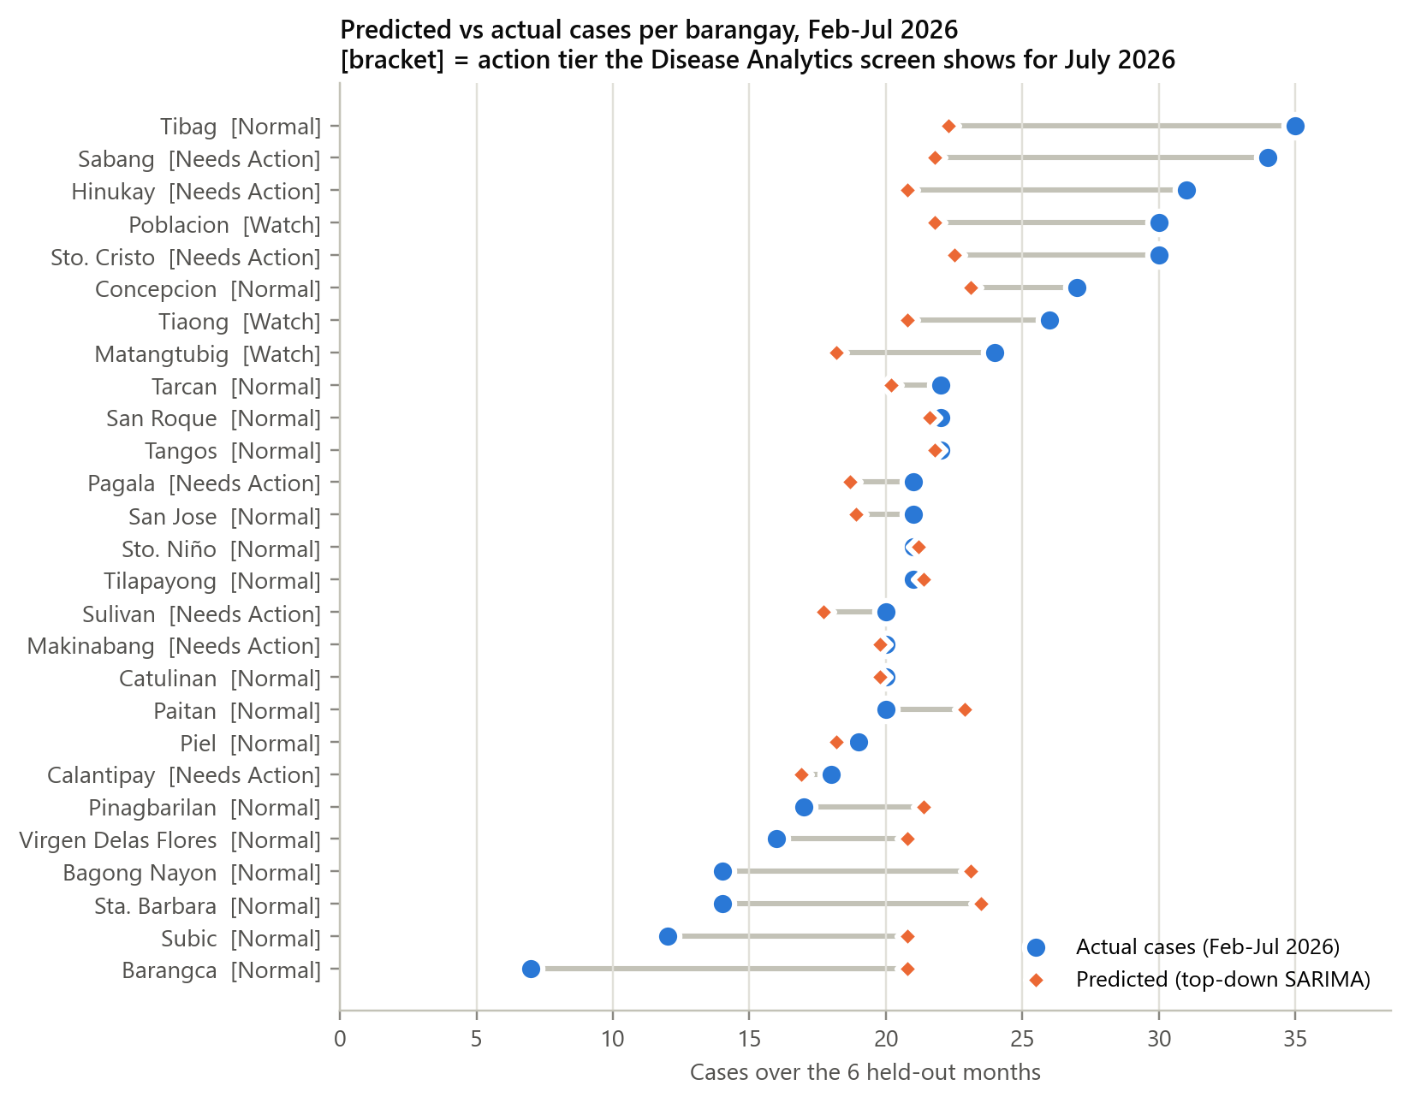
Figure Q2-3. Forecast and recorded cases per barangay over the six withheld months, with the action tier the screen displays for July 2026
The allocation keeps the barangay figures consistent with the municipal total, since the shares add up to one, and it gives every barangay a figure even when its own history is too thin to fit. What it cannot do is anticipate a barangay that suddenly rises above its usual level, which is why the action tier beside it reports what has already been recorded instead: in July 2026 it flagged 7 barangays as Needs Action and 3 as Watch, among them Sabang (12 cases recorded against a forecast of 4.6) and Hinukay (10 cases recorded against a forecast of 4.4). How closely the two levels agree, and how large the allocation error is, are reported in Q4 (Tables Q4-2 and Q4-3).

2.1.3 Predicting the frequency of specific disease cases (Random Forest regressor)
The count for each separate disease is produced by a pooled Random Forest regressor: one regression model of 400 decision trees trained across all 42 diagnoses at once rather than one model per disease. Each training row is one disease in one month, described by 12 features computed only from earlier months: the counts of the previous three months, the three-month rolling average and variation, the disease's own running average, its recent direction, its usual value for that calendar month, the calendar month itself and the disease category. Pooling matters because one disease has only about three years of monthly history, too little to fit alone, while the pooled model learns from 1,302 disease-months and carries what a rising month looks like in one disease over to another. The two features the trained model leans on most are the disease's own running average (40.5% of its decisions) and its usual value for that calendar month (33.3%). The forecast for Flea Allergy Dermatitis in Aug 2026 is produced as follows.
- The model reads the months already recorded for Flea Allergy Dermatitis: 8 cases in May 2026, 11 cases in Jun 2026, 8 cases in Jul 2026.
- From those it forms the recent picture: a three-month average of 9.0 cases and a three-month direction of 0.0.
- It adds the longer view: this disease has averaged 9.4 cases a month over the whole record, and its Aug figures in earlier years were 7 (2023), 8 (2024), 11 (2025), an average of 8.7.
- These 12 values are passed to all 400 trees. Each tree follows its own splits to a leaf holding a case count, and the forest averages those 400 answers.
- The averaged answer, 10.6 cases, is what the system reports for Flea Allergy Dermatitis in Aug 2026.
Table Q2-5 lists the forecast produced this way for the ten most frequent diseases, beside the same models run over the six withheld months. For the comparison, both the Random Forest and a per-disease ARIMA forecast one month ahead at a time, each using only the months recorded before the month being predicted.
Table Q2-5. Disease-level output: the current forecast, and forecasts for the six withheld months beside the recorded cases
Diagnosis | Forecast, Aug 2026 | Recorded, 6 withheld months | Random Forest forecast, same months | ARIMA forecast, same months
Flea Allergy Dermatitis | 10.6 | 59 | 53.0 | 57.3
Skin Infection | 10.2 | 56 | 53.3 | 56.8
Mange | 10.6 | 53 | 54.5 | 52.2
Parasitic Infection | 4.4 | 40 | 24.3 | 25.1
Ear Mites | 4.7 | 37 | 26.5 | 27.0
Ehrlichiosis | 6.0 | 36 | 23.7 | 24.0
Dental Disease | 5.5 | 32 | 23.1 | 20.7
Ear Infection | 3.1 | 29 | 27.7 | 38.2
Gastroenteritis | 4.1 | 27 | 27.2 | 26.7
Feline Lower Urinary Tract Disease | 3.0 | 25 | 19.3 | 20.4
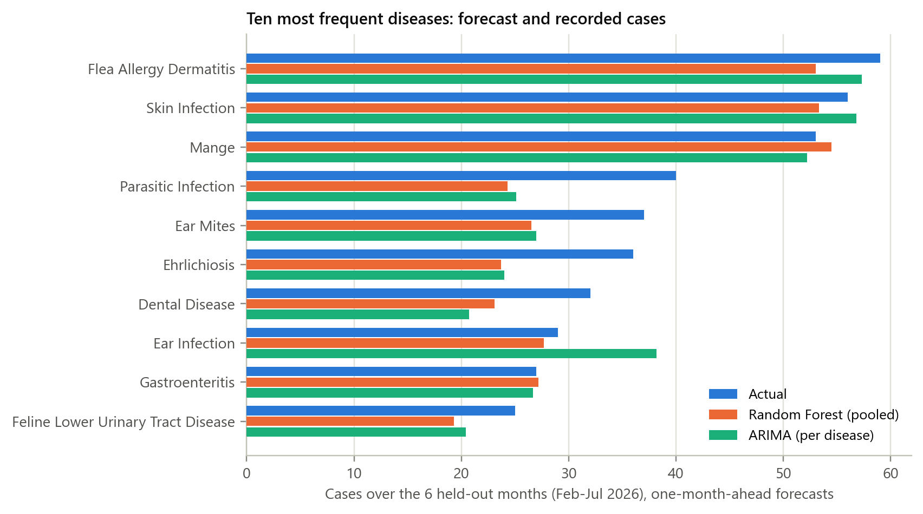
Figure Q2-4. Recorded cases and the two models' forecasts for the ten most frequent diseases over the six withheld months
Table Q2-6. Disease forecasts summed across all 42 diagnoses, month by month
Month | Cases recorded | Random Forest forecast | ARIMA forecast
Feb 2026 | 80 | 85.6 | 96.5
Mar 2026 | 78 | 82.4 | 96.0
Apr 2026 | 92 | 88.0 | 97.7
May 2026 | 87 | 96.3 | 101.0
Jun 2026 | 117 | 105.7 | 91.6
Jul 2026 | 130 | 112.7 | 99.8
All six months | 584 | 570.7 | 582.6
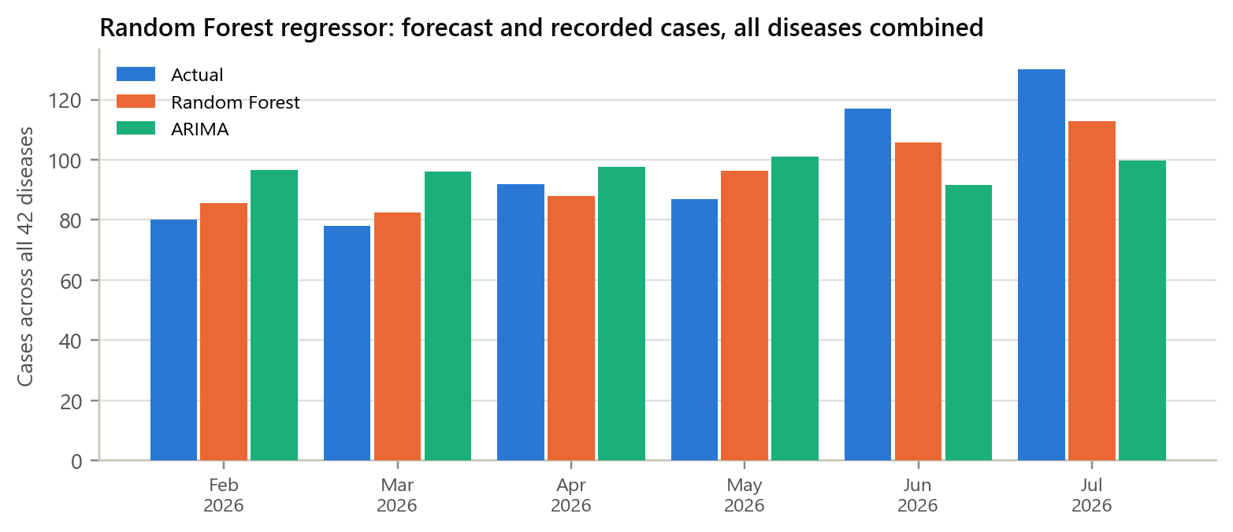
Figure Q2-5. Random Forest forecasts and recorded cases across all 42 diseases, for each withheld month
The regressor stayed close to the recorded totals in the quieter months (Feb 2026: 85.6 forecast against 80 recorded) and fell short during the rise in Jul 2026 (112.7 against 130), which is what a model built on history does when a caseload climbs above anything it has seen. The same pattern shows disease by disease: Parasitic Infection, Ear Mites, Ehrlichiosis, Dental Disease each recorded more cases in February 2026-July 2026 than in the same months of any earlier year, and both models forecast them low, so they are the diseases to review with clinic staff. The error of both models is reported in Q4 (Table Q4-2).

2.1.4 Generating a suggestion of a likely diagnosis from a reported symptom cluster (Random Forest classifier)
The diagnosis suggestion is produced by a Random Forest classifier of 300 decision trees. Its inputs are the two things a clinic knows before any test: the symptom cluster chosen from a list of 10, and the animal group. Its output is a probability for each of the 42 diagnoses in the records, of which the system displays the three highest, because presenting one answer out of 42 would overstate what the model knows. The suggestion for a dog presenting "vomiting, diarrhea, loss of appetite, weakness" is produced as follows.
- The veterinarian selects the symptom cluster and the animal group; here, "vomiting, diarrhea, loss of appetite, weakness" and Dogs.
- The records hold 89 earlier consultations with that same pair of inputs, which ended in 2 different diagnoses: Gastroenteritis in 50, Intestinal Parasites in 39.
- Each of the 300 trees was grown on a different random sample of the records, and each votes for one diagnosis.
- The share of votes becomes the probability, which reproduces the mix in the records: Gastroenteritis 56.2%, Intestinal Parasites 43.8%.
- The three highest are displayed as the shortlist. A symptom description that is not one of the 10 listed clusters returns no suggestion at all, rather than a guess.
Table Q2-7 shows the suggestions produced for one held-out consultation from each of the 10 symptom clusters, taken in the order they appear in the test set rather than chosen by hand, beside the diagnosis the attending veterinarian actually recorded.
Table Q2-7. Diagnosis suggestions produced for held-out consultations, one per symptom cluster
Reported symptom cluster | Animal | Recorded diagnosis | Suggestions produced (probability) | First suggestion matched? | Recorded diagnosis in the three?
vomiting, diarrhea, loss of appetite, weakness | Dogs | Gastroenteritis | 1. Gastroenteritis (56.2%)  2. Intestinal Parasites (43.8%) | Yes | Yes
itching, hair loss, wounds, ear scratching | Dogs | Skin Infection | 1. Flea Allergy Dermatitis (33.0%)  2. Skin Infection (31.9%)  3. Mange (17.9%) | No | Yes
bite exposure, fever, neurological signs, suspected public-health risk | Dogs | Rabies (Suspected) | 1. Leptospirosis (55.3%)  2. Rabies (Suspected) (44.7%) | No | Yes
coughing, nasal discharge, fever, difficulty breathing | Dogs | Kennel Cough | 1. Kennel Cough (100.0%) | Yes | Yes
fever, ticks, anemia, weakness | Carabaos / Water Buffalo | Parasite Infection | 1. Parasite Infection (100.0%) | Yes | Yes
general weakness, appetite loss, abnormal behavior | Goats / Sheep | Parasitic Infection | 1. Parasitic Infection (86.6%)  2. Foot Rot (13.4%) | Yes | Yes
frequent urination, straining, blood in urine | Cats | Feline Lower Urinary Tract Disease | 1. Feline Lower Urinary Tract Disease (100.0%) | Yes | Yes
bad breath, drooling, difficulty eating | Cats | Dental Disease | 1. Dental Disease (100.0%) | Yes | Yes
abdominal swelling, discharge, mammary inflammation | Dogs | Pyometra | 1. Pyometra (100.0%) | Yes | Yes
panting, collapse, high temperature, dehydration | Dogs | Heat Stroke | 1. Heat Stroke (100.0%) | Yes | Yes
Suggestions with 0% probability are not shown. The same inputs always produce the same three suggestions, so these are also what the screen returns for those symptom clusters.
The two cases where the first suggestion did not match show what the inputs allow. "Itching, hair loss, wounds, ear scratching" is recorded for Flea Allergy Dermatitis, Skin Infection and Mange alike, so the model can rank the three but cannot separate them from the symptoms alone; all three appeared in the shortlist. For the dog with bite exposure and neurological signs, the model put Leptospirosis first and Suspected Rabies second, and both are reportable diseases, so the shortlist still directs the veterinarian toward the right precautions. The suggestions support the veterinarian's decision and do not replace it. How often the first suggestion and the shortlist are right is reported in Q4 (Table Q4-1).

2.2 Estimating future mass vaccination demand per barangay (ARIMA)
Vaccination demand is produced from the municipal record of dogs and cats vaccinated per month, January 2023 to December 2025 (36 months). The 2023 and 2024 records were kept as year-to-date running totals and were converted back into monthly counts before modelling, giving annual totals of 3,959 (2023), 4,006 (2024), 6,422 (2025). Vaccinations recorded in the system in June 2026 and July 2026 (100 and 100 animals) fall below the minimum the system requires before it treats a month as fully encoded (183 animals, 45% of the median month), so they are held out of the series and the forecast begins in Jan 2026, the month after the last complete record. Because the source records hold municipal totals only, with no vaccination history for any individual barangay, the municipal figure is distributed using each barangay's share of the 16,847 dogs estimated in the 2025 barangay masterlist. The figure for Tiaong is produced as follows.
- The 36 monthly totals on record add up to 14,387 animals vaccinated.
- The ARIMA order is selected by the lowest AIC, and the winner is ARIMA(0, 0, 0): no autoregressive or moving-average term improved the fit, meaning last month does not help predict next month, because campaigns are scheduled rather than continuous.
- With no such term, the model's forecast is the long-run average: 14,387 / 36 = 399.6 animals a month, the same figure for each month ahead.
- The range is the forecast plus or minus 1.28 times the month-to-month standard deviation (292.1 animals), giving 25.6 to 773.7 - wide, because campaign months and quiet months differ greatly.
- Tiaong holds 945 of the 16,847 estimated dogs, a share of 5.6%: 399.6 x 5.6% = 22.4 animals a month, or 134.4 over six months for stock planning.
Table Q2-8. Municipal vaccination demand produced for Jan 2026 - Jun 2026, beside the turnout recorded in the same month of earlier years
Month | Forecast (animals) | 80% prediction range | Recorded, same month 2023 | Recorded, same month 2024 | Recorded, same month 2025
Jan 2026 | 399.6 | 25.6 - 773.7 | 25 | 25 | 353
Feb 2026 | 399.6 | 25.6 - 773.7 | 35 | 24 | 386
Mar 2026 | 399.6 | 25.6 - 773.7 | 647 | 441 | 546
Apr 2026 | 399.6 | 25.6 - 773.7 | 389 | 722 | 674
May 2026 | 399.6 | 25.6 - 773.7 | 1,079 | 639 | 739
Jun 2026 | 399.6 | 25.6 - 773.7 | 472 | 396 | 706
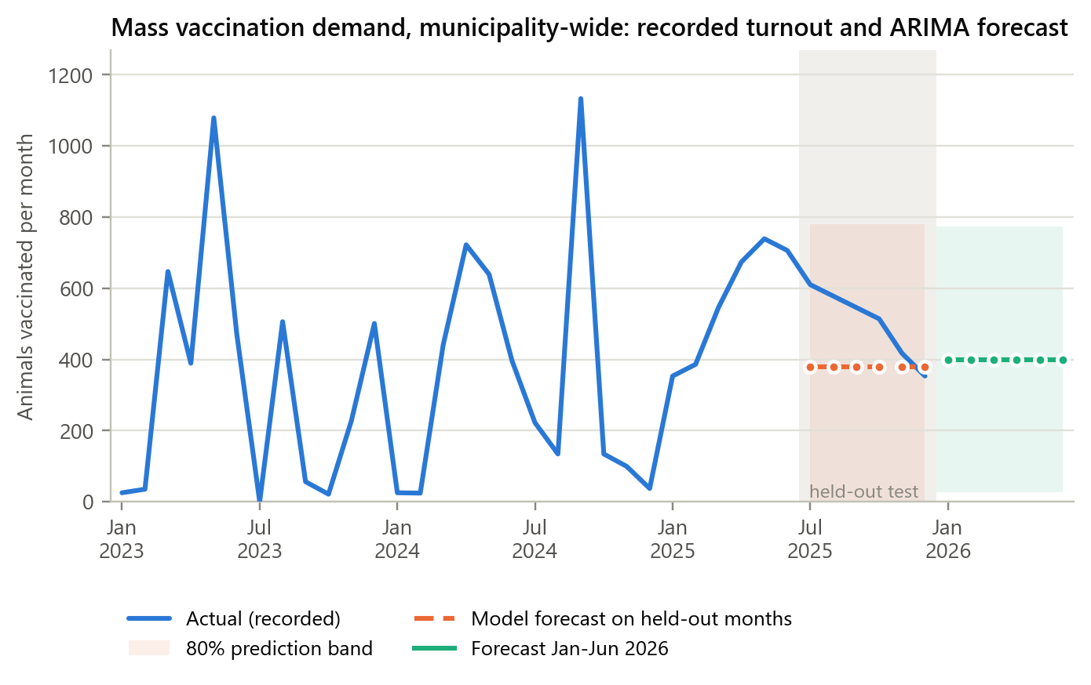
Figure Q2-6. Municipal vaccination turnout on record, the forecast for the six withheld months, and the forecast the system now produces
The same model was refitted on the record up to June 2025 and asked for the six months that followed, which it had not seen. Table Q2-9 sets those forecasts beside the turnout actually recorded.
Table Q2-9. Forecast and recorded turnout for six months withheld from the model (Jul 2025 - Dec 2025)
Month | Animals vaccinated | Forecast | 80% prediction range
Jul 2025 | 610 | 379.0 | 0.0 - 781.1
Aug 2025 | 578 | 379.0 | 0.0 - 781.1
Sep 2025 | 546 | 379.0 | 0.0 - 781.1
Oct 2025 | 514 | 379.0 | 0.0 - 781.1
Nov 2025 | 417 | 379.0 | 0.0 - 781.1
Dec 2025 | 353 | 379.0 | 0.0 - 781.1
Total | 3,018 | 2,274.0
Table Q2-10. Vaccination demand produced for each barangay, beside the turnout recorded historically
Barangay | Est. dogs (2025) | Share of dogs | Recorded 2025 turnout, full year* | Recorded 2025 turnout, average month* | Forecast per month (80% range) | Forecast, 6-month total | Recorded in system, 2026
Tiaong | 945 | 5.6% | 360 | 30.0 | 22.4 (1.4 - 43.4) | 134.4 | -
San Jose | 860 | 5.1% | 328 | 27.3 | 20.4 (1.3 - 39.5) | 122.4 | -
Poblacion | 774 | 4.6% | 295 | 24.6 | 18.3 (1.2 - 35.5) | 109.8 | 25 (Jun)
Sulivan | 774 | 4.6% | 295 | 24.6 | 18.3 (1.2 - 35.5) | 109.8 | -
Tangos | 774 | 4.6% | 295 | 24.6 | 18.3 (1.2 - 35.5) | 109.8 | -
Bagong Nayon | 688 | 4.1% | 262 | 21.8 | 16.3 (1.0 - 31.6) | 97.8 | -
Pagala | 688 | 4.1% | 262 | 21.8 | 16.3 (1.0 - 31.6) | 97.8 | -
Pinagbarilan | 653 | 3.9% | 249 | 20.8 | 15.5 (1.0 - 30.0) | 93.0 | 50 (Jun), 50 (Jul)
Virgen Delas Flores | 653 | 3.9% | 249 | 20.8 | 15.5 (1.0 - 30.0) | 93.0 | -
Tarcan | 619 | 3.7% | 236 | 19.6 | 14.7 (0.9 - 28.4) | 88.2 | -
Makinabang | 619 | 3.7% | 236 | 19.6 | 14.7 (0.9 - 28.4) | 88.2 | -
Tibag | 619 | 3.7% | 236 | 19.6 | 14.7 (0.9 - 28.4) | 88.2 | -
Subic | 602 | 3.6% | 229 | 19.1 | 14.3 (0.9 - 27.6) | 85.8 | -
San Roque | 602 | 3.6% | 229 | 19.1 | 14.3 (0.9 - 27.6) | 85.8 | -
Paitan | 584 | 3.5% | 223 | 18.6 | 13.9 (0.9 - 26.8) | 83.4 | 25 (Jun)
Sto. Cristo | 584 | 3.5% | 223 | 18.6 | 13.9 (0.9 - 26.8) | 83.4 | -
Hinukay | 567 | 3.4% | 216 | 18.0 | 13.5 (0.9 - 26.1) | 81.0 | -
Sto. Niño | 567 | 3.4% | 216 | 18.0 | 13.5 (0.9 - 26.1) | 81.0 | 50 (Jul)
Tilapayong | 550 | 3.3% | 210 | 17.5 | 13.1 (0.8 - 25.3) | 78.6 | -
Concepcion | 550 | 3.3% | 210 | 17.5 | 13.1 (0.8 - 25.3) | 78.6 | -
Barangca | 533 | 3.2% | 203 | 16.9 | 12.6 (0.8 - 24.4) | 75.6 | -
Piel | 533 | 3.2% | 203 | 16.9 | 12.6 (0.8 - 24.4) | 75.6 | -
Catulinan | 516 | 3.1% | 197 | 16.4 | 12.2 (0.8 - 23.7) | 73.2 | -
Calantipay | 516 | 3.1% | 197 | 16.4 | 12.2 (0.8 - 23.7) | 73.2 | -
Sta. Barbara | 516 | 3.1% | 197 | 16.4 | 12.2 (0.8 - 23.7) | 73.2 | -
Sabang | 499 | 3.0% | 190 | 15.8 | 11.8 (0.8 - 22.9) | 70.8 | -
Matangtubig | 462 | 2.8% | 177 | 14.8 | 11.0 (0.7 - 21.4) | 66.0 | -
Municipality | 16,847 | 100% | 6,422 | 535.2 | 399.6 (25.6 - 773.7) | 2,397.6 | 200
* Allocated from the municipal total by the barangay's share of dogs; the source records hold no barangay-level vaccination history. Shaded rows are barangays with vaccination events recorded in the system in 2026.
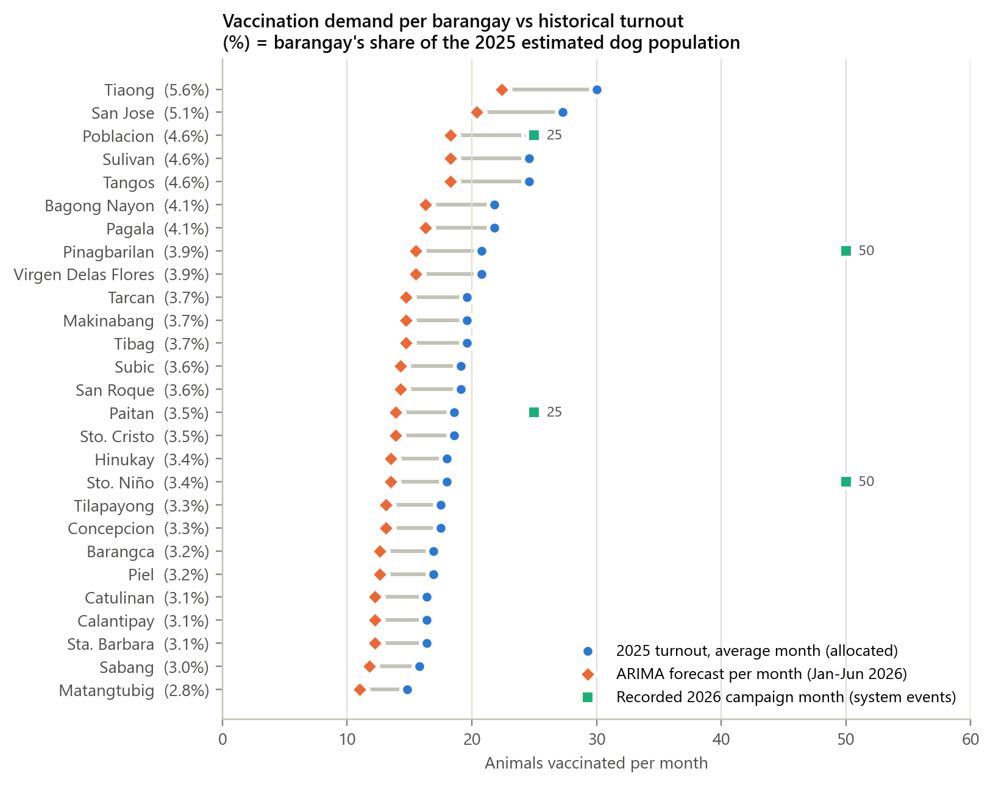
Figure Q2-7. Vaccination demand produced for each barangay, against its 2025 average monthly turnout and the campaigns recorded in 2026
Because the selected model produces the long-run average, every barangay's monthly figure sits about 25% below its 2025 average: Tiaong is given 22.4 animals a month against the 30.0 its share of the 2025 turnout implies, because 2025 was the busiest of the three years on record. The campaigns recorded in 2026 (Poblacion: 25; Pinagbarilan: 50 and 50; Paitan: 25; Sto. Niño: 50 animals) were each larger than that barangay's monthly figure, since a campaign concentrates into one day what the monthly average spreads across a month. For stock planning the clinic should therefore treat the figure as an expected average and prepare toward the upper end of the range for a barangay with a campaign scheduled. Encoding complete monthly totals for 2026 moves the forecast forward to the latest encoded month; campaigns encoded for months the workbook already covers (2023-2025) are deliberately ignored by the forecast so that no month is counted twice. How far these forecasts fell from the recorded turnout is reported in Q4 (Table Q4-2).

Q4. Evaluating the Predictive Accuracy and Reliability of the Implemented Models
Each model was evaluated on data it was not trained on. The Random Forest classifier that suggests a diagnosis was scored on 559 held-out consultations (20% of the 2,792 records, split so each diagnosis appears in both sets), and is reported with classification measures. The forecasting models - the seasonal ARIMA for case counts, the Random Forest regressor for specific disease cases, and the ARIMA for vaccination demand - were scored on the most recent six months, which were hidden during training, and are reported with error measures. Each model is also compared with a simple baseline, because a score is only meaningful if the model does better than an obvious shortcut.
The metrics used are:
- Accuracy: share of consultations where the first suggested diagnosis was the recorded one.
- Precision: of the consultations given a diagnosis, the share that truly had it. Recall: of the consultations that truly had a diagnosis, the share the model found. F1-score: the balance (harmonic mean) of precision and recall. These are averaged across the 42 diagnoses, weighted by how often each occurs.
- MAE (mean absolute error): the average size of a forecast miss, in cases or animals. RMSE (root mean squared error): like MAE but penalizes large misses more. MAPE (mean absolute percentage error): the average miss as a percentage of the actual value (months with zero actual are skipped).
Table Q4-1. Classification performance of the Random Forest diagnosis model (559 held-out consultations, 42 diagnoses)
Metric | Random Forest | Baseline: most common diagnosis for the symptom cluster and animal | Interpretation
Accuracy | 58.3% | 58.1% | First suggestion correct in about 6 of 10 consultations
Precision (weighted) | 44.8% | 45.9% | Lowered by diagnoses that share a symptom cluster
Recall (weighted) | 58.3% | 58.1% | Equals accuracy when weighted by frequency
F1-score (weighted) | 47.2% | 47.9% | Balance of precision and recall
Precision / Recall / F1 (macro) | 50.2% / 60.2% / 52.6% | 51.2% / 61.3% / 53.6% | Every diagnosis counted equally
Top-3 accuracy | 94.5% | - | Recorded diagnosis among the three suggestions
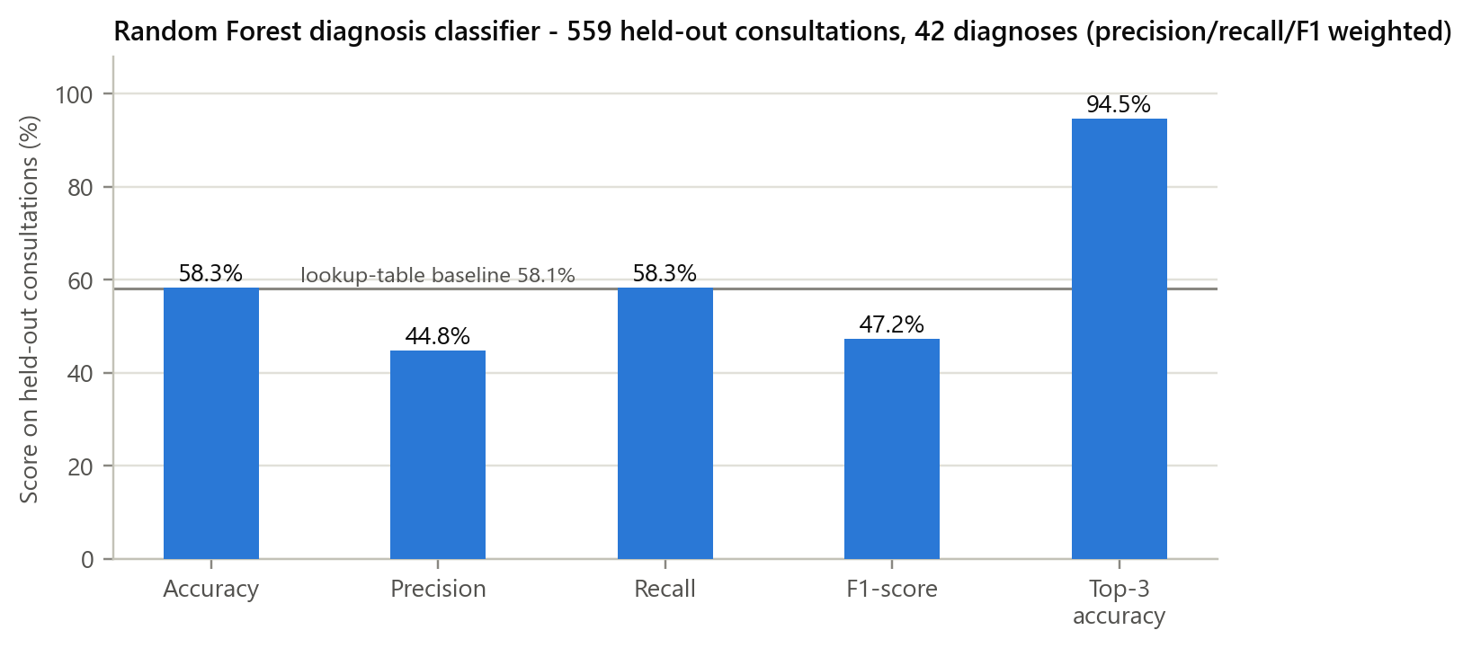
Figure Q4-1. Classification metrics of the Random Forest diagnosis model
Table Q4-2. Forecasting performance on held-out months (lower is better)
Model and level | Test data | MAE | RMSE | MAPE | Baseline (MAE / MAPE)
Seasonal ARIMA - all-disease cases, municipality | 6 months | 7.95 | 8.98 | 7.8% | Same month last year: 8.83 / 8.8%
Seasonal ARIMA (top-down) - cases per barangay, monthly | 162 barangay-months | 1.88 | 2.49 | 58.2% | Barangay's own average: 1.96 / 64.8%
Seasonal ARIMA (top-down) - cases per barangay, 3-month total | 54 barangay-quarters | 3.32 | 4.38 | 32.6% | -
Random Forest regressor - cases per specific disease | 252 disease-months | 1.29 | 1.81 | 45.8% | Disease's own average: 1.35 / 42.7%
ARIMA - cases per specific disease (comparison) | 252 disease-months | 1.36 | 1.81 | 46.4% | Disease's own average: 1.35 / 42.7%
ARIMA - animals vaccinated, municipality | 6 months | 132.67 | 153.40 | 24.3% | Same month last year: 405.50 / 81.3%
MAE and RMSE are in cases per month for the disease models and in animals per month for the vaccination model.
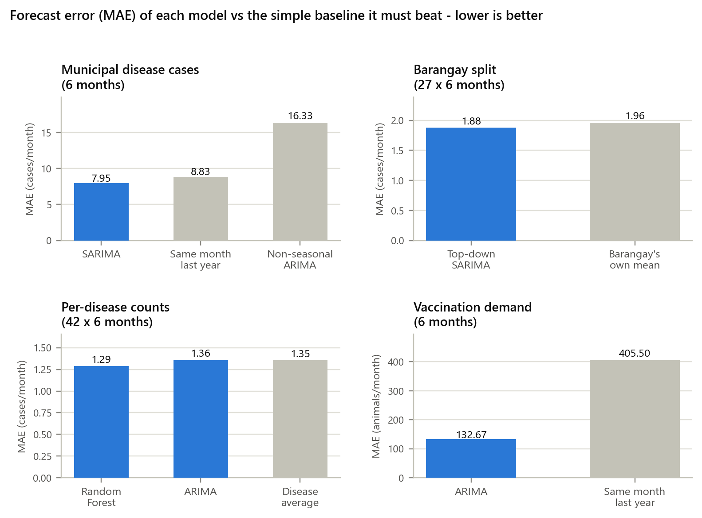
Figure Q4-2. Forecast error of each model compared with the baseline it must beat
Table Q4-3. Agreement between the case volume level produced from the forecast and the level the recorded cases deserved (27 barangays x 6 months = 162 barangay-months)
Level from recorded cases | Forecast said Low | Forecast said Medium | Forecast said High | Total
Low | 132 | 0 | 0 | 132
Medium | 16 | 0 | 0 | 16
High | 14 | 0 | 0 | 14
Overall agreement: 81.5% (132 of 162). The case volume level is a threshold rule applied to the forecast, not a trained classifier; it is reported here because its reliability is what decides whether a barangay is flagged.
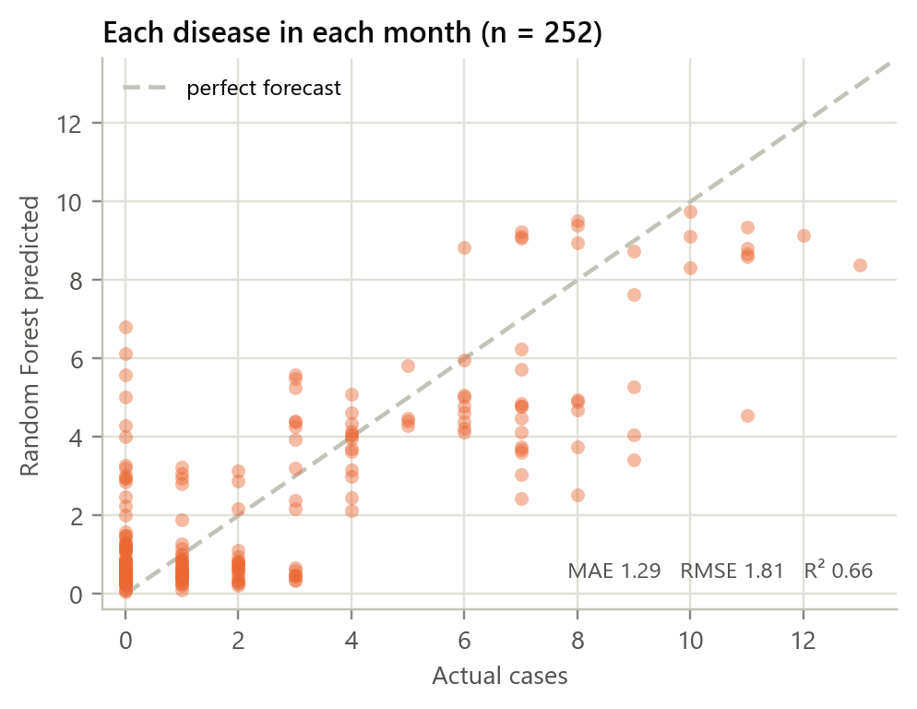
Figure Q4-3. Random Forest regressor: each of the 252 held-out disease-months against the count it forecast
Classification. The Random Forest's first suggestion was correct in 58.3% of held-out consultations, and its weighted precision (44.8%) and F1-score (47.2%) are lower still. This is caused by the input rather than by the algorithm: the records describe 10 symptom clusters for 42 diagnoses, so several diagnoses share one cluster. For such a cluster the model can give only one first answer; Skin Infection and Mange, for example, were never the first suggestion (recall 0%) but were in the top three every time (top-3 recall 100%). The model also matches the baseline of simply choosing the most common diagnosis for each symptom cluster and animal (58.1%), which is the highest accuracy these inputs allow. Its top-3 accuracy of 94.5% is the figure that matters for use: in about 19 of 20 consultations the correct diagnosis is on the three-item list the veterinarian sees. The model is therefore reliable as a shortlist that supports the veterinarian's judgment, not as an automatic single diagnosis.
Forecasting. The municipality-wide seasonal ARIMA is the most reliable model: a MAPE of 7.8% (about 8 cases on roughly 97 per month), all six actual months inside its 80% range, and better than both the same-month-last-year baseline (8.8%) and a non-seasonal ARIMA (16.8%). RMSE is only 1.1 to 1.4 times MAE across the models, which shows the errors are steady rather than caused by a few large misses. Percentage errors are much higher at the barangay and disease levels (MAPE 58.2% and 46.4%) even though the absolute errors are small (1.88 and 1.36 cases), because these series have only a few cases per month, so missing by two cases is already a 50% error. Combining three months reduces the barangay error to 32.6%, so three-month totals should be used for barangay planning. Table Q4-3 shows the limit this imposes on the case volume level: it agreed with the level the recorded cases deserved in 81.5% of barangay-months, but only because most months are ordinary - the forecast never produced a Medium or High level, so none of the 30 barangay-months that did rise above normal were flagged in advance. This is the measured reason the action tier beside each barangay reports recorded cases instead of the forecast. For the frequency of specific diseases, the Random Forest regressor was the most accurate method tested: MAE 1.29 and RMSE 1.81 across 252 disease-months, explaining 66.1% of the variation in actual counts, against 1.36 for a per-disease ARIMA, 1.35 for the disease's own average and 1.52 for repeating last month. That is a 4.8% reduction in error against the baseline, which is real but modest, and it is why the system uses the pooled regressor rather than one ARIMA per disease. Its MAPE (45.8%) looks worse than the baseline's (42.7%) only because percentage error punishes misses on diseases with one or two cases a month. The vaccination ARIMA (MAPE 24.3%, MAE 133 animals) is far better than repeating last year's month (81.3%), but its wide 80% range reflects that vaccination volume depends on campaign schedules. Overall, the models are reliable for municipal planning and for ranking likely diagnoses, and less reliable for exact monthly counts in a single barangay or disease, which is why the system shows prediction ranges and relies on recorded cases for its action tiers.

