Contents

QUESTION 1: WATER BOTTLE PURCHASE WEBSITE 3

<--HEAD SECTION--> 3

<!-- CSS FOR STYLING THE PAGE --> 3

<--HTML BODY SECTION--> 6

<!-- JAVASCRIPT FUNCTIONALITY --> 8

CORRESPONDING OUTPUT 9

QUESTION 2 11

<--HEAD SECTION--> 11

<!-- CSS FOR STYLING THE PAGE --> 12

<--HTML BODY SECTION--> 15

<!-- JAVASCRIPT FUNCTIONALITY --> 16

CORRESPONDING OUPUT 20

COMPLETED TASKS 20

ADDED TASKS 21

ALL TASKS 22

QUESTION 3 : PIE CHART 24

<--HEAD SECTION--> 24

<--HTML BODY SECTION--> 24

<!-- JAVASCRIPT FUNCTIONALITY --> 25

CORRESPONDING OUTPUT 27

# QUESTION 1: WATER BOTTLE PURCHASE WEBSITE

## <--HEAD SECTION-->

<html lang="en"> <!-- Sets the language to English -->

<head>

  <meta charset="UTF-8"> <!-- Allows special characters (like emojis, symbols) -->

  <meta name="viewport" content="width=device-width, initial-scale=1.0"> <!-- Makes the website responsive -->

  <title>EcoSmart Water Bottle</title> <!-- Title shown in the browser tab -->

<!-- CSS FOR STYLING THE PAGE -->

<!--2.CSS PART-->

  <style>

    body {

      font-family: monospace; /* Sets a cool code-style font */

      margin: 0; /* Removes default spacing around the body */

      padding: 0;

      font-size: xx-large; /* Makes everything pretty big */

    }

    nav {

      background-color: #333; /* Dark navbar background */

      color: white; /* Text color */

      padding: 40px 20px 10px 20px; /* Space inside the nav: top, right, bottom, left */

      text-align: center; /* Centers the text horizontally */

      height: 60px; /* Fixes nav height */

    }

    nav ul {

      list-style-type: none; /* Removes bullets from list items */

      margin: 0;

      padding: 0;

    }

    nav ul li {

      display: inline; /* Makes the list items appear in a row */

      margin-right: 20px; /* Space between links */

    }

    nav ul li a {

      color: white; /* Link color */

      text-decoration: none; /* Removes underline */

    }

    .water-container {

      text-align: center; /* Center content inside the div */

      margin: 20px;

      padding: 20px;

      transition: background-color 0.3s ease; /* Smooth background color change */

    }

    .button-1,

    .button-2 {

      background-color: #4CAF50; /* Green buttons */

      border: none; /* No border outline */

      color: white;

      font-family: monospace;

      border-radius: 5px; /* Rounded corners */

      padding: 15px 32px;

      text-align: center;

      text-decoration: none;

      display: inline-block;

      font-size: 19px;

      margin: 4px 2px;

      cursor: pointer; /* Makes cursor a pointer on hover */

    }

    .contact-container {

      text-align: center;

      margin: 20px;

      font-family: monospace;

      font-size: xx-large;

      background-color: #333; /* Dark background */

      padding: 30px;

      color: white; /* Text color */

    }

    footer div h2 {

      font-family: monospace;

      font-size: xx-large;

    }

    #name,

    #email,

    #message {

      width: 50%;

      padding: 10px;

      margin: 10px 0;

      border-radius: 5px;

      border: 1px solid #ccc; /* Light grey border */

    }

    #terms-conditions {

      margin: 0 auto; /* Center horizontally */

      width: 50%;

      padding: 10px;

      font-size: large;

      text-align: left;

    }

    textarea {

      width: 50%;

      height: 100px;

      padding: 10px;

      margin: 10px 0;

      border-radius: 5px;

      border: 1px solid #ccc;

    }

    #color-select {

      font-size: 18px;

      padding: 8px 12px;

      margin: 10px;

      border-radius: 5px;

      font-family: monospace;

    }

  </style>

</head>

<--HTML BODY SECTION-->

<body>

  <!-- NAVIGATION BAR -->

  <nav>

    <ul>

      <li><a href="#">Home</a></li> <!-- Link to home -->

      <li><a href="#">Features</a></li> <!-- Link to features -->

      <li><a href="#">Pricing</a></li> <!-- Link to pricing -->

      <li><a href="#">Contact Us</a></li> <!-- Link to contact -->

    </ul>

  </nav>

<!-- MAIN PRODUCT SECTION -->

  <div class="water-container">

    <h1>EcoSmart Water Bottle</h1>

    <img src="waterBottle.jpg" alt="Water Bottle" width="300px" height="300px"> <!-- Product image -->

    <p>EcoSmart Water Bottle</p>

    <!-- COLOR DROPDOWN -->

    <label for="color-select">Choose a color:</label>

    <select id="color-select"> <!-- Dropdown to choose color -->

      <option value="white">White</option>

      <option value="lightblue">Light Blue</option>

      <option value="lightgreen">Light Green</option>

      <option value="lightpink">Light Pink</option>

      <option value="lightgray">Light Gray</option>

    </select>

    <br>

    <button class="button-1">Buy Now</button> <!-- Buy button -->

    <p id="price">Total Price: R750.00</p> <!-- Default price text -->

  </div>

  <!-- FOOTER CONTACT SECTION -->

  <footer>

    <div class="contact-container">

      <h2>Contact Us</h2>

      <input type="text" placeholder="Your name" id="name" required><br> <!-- Name field -->

      <input type="text" placeholder="Your email" id="email" required><br> <!-- Email field -->

      <textarea id="message" placeholder="Your message"></textarea><br> <!-- Message textarea -->

      <p id="terms-conditions">

        <input type="checkbox"> I agree to the <a href="#">Terms and Conditions</a> <!-- Terms checkbox -->

      </p>

      <button class="button-2">Submit</button> <!-- Submit button -->

    </div>

  </footer>

## <!-- JAVASCRIPT FUNCTIONALITY -->

  <!-- JAVASCRIPT FUNCTIONALITY -->

  <script>

    const colorSelect = document.getElementById("color-select"); // Get the color dropdown

    const waterContainer = document.querySelector(".water-container"); // Get product section

    const priceTag = document.getElementById("price"); // Get price text

    colorSelect.addEventListener("change", function () { // When user changes color

      const selectedColor = colorSelect.value; // Store selected color

      waterContainer.style.backgroundColor = selectedColor; // Change background color

      // Set price based on selected color

      let price;

      if (selectedColor === "lightblue") {

        price = "R800.00"; // Ocean edition

      } else if (selectedColor === "lightgreen") {

        price = "R850.00"; // Eco edition

      } else if (selectedColor === "lightpink") {

        price = "R780.00"; // Cute edition

      } else if (selectedColor === "lightgray") {

        price = "R770.00"; // Minimal edition

      } else {

        price = "R750.00"; // Default white

      }

      priceTag.textContent = `Total Price: ${price}`; // Update price on screen

    });

  </script>

</body>

</html>

CORRESPONDING OUTPUT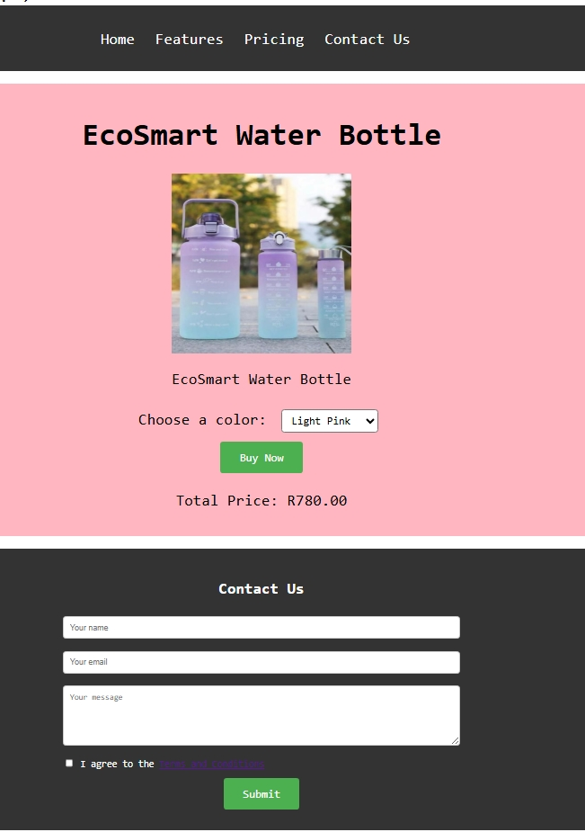

# QUESTION 2

## <--HEAD SECTION-->

<!DOCTYPE html>

<html lang="en">

<head>

    <!-- Sets the character encoding and makes site responsive on mobile -->

    <meta charset="UTF-8">

    <meta name="viewport" content="width=device-width, initial-scale=1.0">

    <!-- Webpage title shown on the browser tab -->

    <title>To-do List</title>

    <!-- Link to external CSS file -->

    <link rel="stylesheet" href="style.css">

    <!-- Link to external JavaScript file  -->

    <script src="todolist.js"></script>

    <!-- Font Awesome Icons for the trash/delete icon -->

    <link rel="stylesheet" href="https://cdnjs.cloudflare.com/ajax/libs/font-awesome/6.4.0/css/all.min.css">

</head>

## <!-- CSS FOR STYLING THE PAGE -->

<!-- CSS for styling the page -->

<style>

    /* Body styling */

    body {

        font-family: monospace;

        width: 800px;

        margin: 0 auto;

        padding: 20px;

        background-color: #fffefe;

        border: 1px solid #838282;

        border-radius: 10px;

    }

    /* Heading style */

    h1 {

        margin: 0;

        padding: 0;

        width: fit-content;

    }

    /* Container for filter buttons */

    .button-options {

        display: flex;

        justify-content: flex-end;

        gap: 10px;

    }

    /* Button base styles */

    button {

        background-color: #fffefe;

        color: #000000;

        border: 1px solid #000000;

        border-radius: 5px;

        font-family: monospace;

        padding: 10px 20px;

        font-size: 16px;

        margin: 4px 2px;

        cursor: pointer;

    }

    /* Button active state */

    button:active {

        background-color: #080808;

        color: aliceblue;

    }

    /* Button hover animation */

    button:hover {

        background-color: #000000;

        color: #fffefe;

        transition: 0.3s ease;

    }

    /* Input box styling */

    #todo-input {

        width: 87%;

        padding: 10px;

        font-size: 16px;

        font-family: monospace;

        border: 1px solid #000000;

        border-radius: 5px;

    }

    /* To-do list style */

    #todo-list {

        margin-top: 20px;

        padding: 0;

        list-style-type: none;

        font-size: medium;

    }

    /* Each list item */

    #todo-list li {

        display: flex;

        align-items: center;

        gap: 10px;

        padding: 10px;

        border-radius: 5px;

        margin-bottom: 10px;

    }

    /* Checkbox styling */

    #todo-list li input[type="checkbox"] {

        width: 20px;

        height: 20px;

    }

    /* To-do text */

    #todo-list li span {

        flex-grow: 1;

        padding-left: 10px;

        font-size: 16px;

    }

    /* Completed task style */

    .completed {

        text-decoration: line-through;

        color: #808080;

    }

    /* Delete/trash icon */

    .delete-icon {

        color: red;

        cursor: pointer;

        margin-left: 10px;

    }

</style>

## <--HTML BODY SECTION-->

<body>

    <!-- Title and filter buttons -->

    <div class="heading-container">

        <h1>To-Do List</h1>

        <!-- Buttons to filter tasks -->

        <div class="button-options">

            <button onclick="filterTodos('all')">All</button>

            <button onclick="filterTodos('active')">Active</button>

            <button onclick="filterTodos('completed')">Completed</button>

            <!-- Button to load fake tasks from an API -->

            <button onclick="fetchApiTodos()">API</button>

        </div>

    </div>

    <!-- Input field and add button -->

    <div class="add-todo">

        <input type="text" placeholder="Add a new to-do..." id="todo-input">

        <button onclick="addTodo()">+ Add</button>

    </div>

    <!-- List where tasks will be displayed -->

    <ul id="todo-list"></ul>

## <!-- JAVASCRIPT FUNCTIONALITY -->

<!-- JavaScript functionality -->

    <script>

        // Load to-dos when page loads

        window.onload = function () {

            loadTodos();

        };

        // Toggle the "completed" style when checkbox is clicked

        function toggleStrike(checkbox) {

            const li = checkbox.parentElement;

            const span = checkbox.nextElementSibling;

            span.classList.toggle("completed");

            li.setAttribute("data-status", checkbox.checked ? "completed" : "active");

            saveTodos(); // Save the updated list

        }

        // Remove a to-do from the list

        function deleteTodo(icon) {

            const li = icon.parentElement;

            li.remove();

            saveTodos();

        }

 // Add new to-do item

        function addTodo() {

            const input = document.getElementById("todo-input");

            const todoText = input.value.trim();

            if (todoText === "") return;

            const ul = document.getElementById("todo-list");

            const li = document.createElement("li");

            li.setAttribute("data-status", "active");

            li.innerHTML = `

                <input type="checkbox" onclick="toggleStrike(this)">

                <span>${todoText}</span>

                <i class="fas fa-trash delete-icon" onclick="deleteTodo(this)"></i>

            `;

            ul.appendChild(li);

            input.value = "";

            saveTodos();

        }

        // Filter the list based on status

        function filterTodos(filter) {

            const tasks = document.querySelectorAll("#todo-list li");

            tasks.forEach(task => {

                const status = task.getAttribute("data-status");

                task.style.display = (filter === "all" || filter === status) ? "flex" : "none";

            });

        }

        // Save current to-dos to browser's localStorage

        function saveTodos() {

            const todos = [];

            document.querySelectorAll("#todo-list li").forEach(li => {

                const checkbox = li.querySelector("input[type='checkbox']");

                const span = li.querySelector("span");

                todos.push({

                    text: span.textContent,

                    completed: checkbox.checked

                });

            });

            localStorage.setItem("todos", JSON.stringify(todos));

        }

        // Load saved to-dos from localStorage

        function loadTodos() {

            const todos = JSON.parse(localStorage.getItem("todos")) || [];

            const ul = document.getElementById("todo-list");

            ul.innerHTML = "";

            todos.forEach(todo => {

                const li = document.createElement("li");

                li.setAttribute("data-status", todo.completed ? "completed" : "active");

                li.innerHTML = `

                    <input type="checkbox" onclick="toggleStrike(this)" ${todo.completed ? "checked" : ""}>

                    <span class="${todo.completed ? "completed" : ""}">${todo.text}</span>

                    <i class="fas fa-trash delete-icon" onclick="deleteTodo(this)"></i>

                `;

                ul.appendChild(li);

            });

        }

        // Load fake todos from external API for testing/demo

        function fetchApiTodos() {

            fetch("https://jsonplaceholder.typicode.com/todos?_limit=10")

                .then(response => response.json())

                .then(todos => {

                    const ul = document.getElementById("todo-list");

                    ul.innerHTML = "";

                    todos.forEach(todo => {

                        const li = document.createElement("li");

                        li.setAttribute("data-status", todo.completed ? "completed" : "active");

                        li.innerHTML = `

                            <input type="checkbox" onclick="toggleStrike(this)" ${todo.completed ? "checked" : ""}>

                            <span class="${todo.completed ? "completed" : ""}">${todo.title}</span>

                            <i class="fas fa-trash delete-icon" onclick="deleteTodo(this)"></i>

                        `;

                        ul.appendChild(li);

                    });

                });

        }

    </script>

</body>

</html>



## CORRESPONDING OUPUT

## COMPLETED TASKS

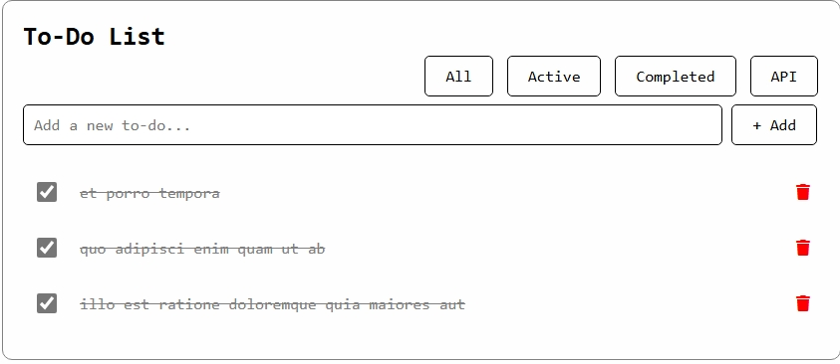

## ADDED TASKS

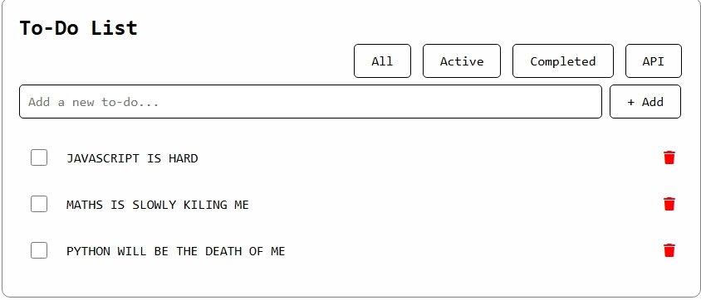

## ALL TASKS

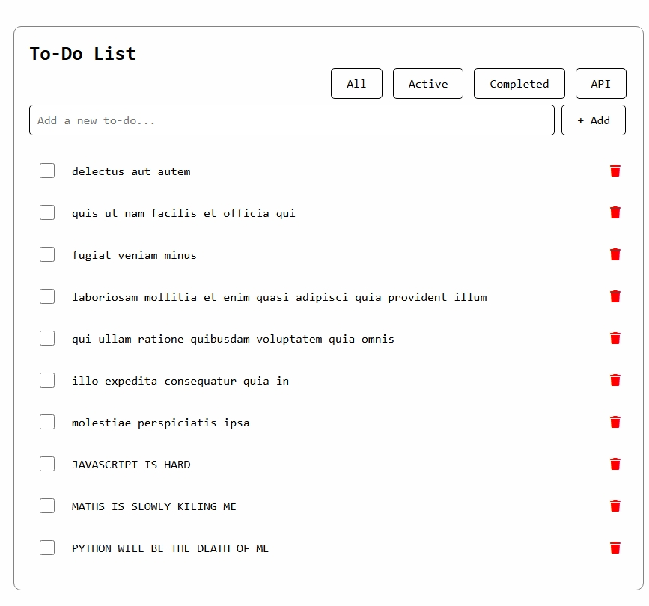

ACTIVE TASKS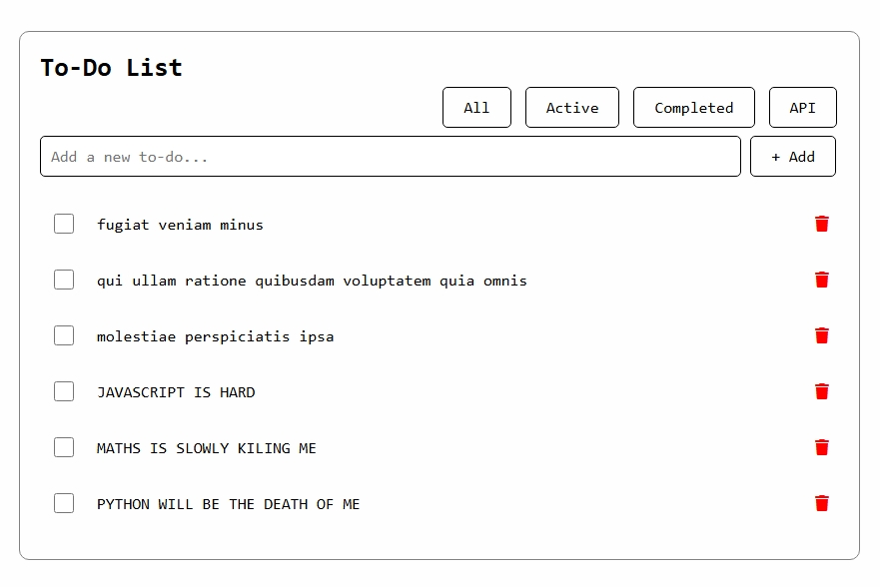



# QUESTION 3 : PIE CHART



<--HEAD SECTION-->

<!DOCTYPE html>

<html lang="en">

<head>

    <meta charset="UTF-8">

    <meta name="viewport" content="width=device-width, initial-scale=1.0">

    <title>Pie Chart</title>

    <link rel="stylesheet" href="style.css">

    <!-- Link to Chart.js CDN -->

    <script src="https://cdn.jsdelivr.net/npm/chart.js"></script>

</head>

<--HTML BODY SECTION-->

<body>

    <center>

        <h1>My Pie Chart</h1>

        <!-- Canvas where the pie chart will be drawn -->

        <canvas id="myPieChart" width=" 500" height="500"></canvas>

<!-- JAVASCRIPT FUNCTIONALITY -->

        <script>

            const ctx = document.getElementById('myPieChart').getContext('2d');

            new Chart(ctx, {

                type: 'pie', // Pie chart type

                data: {

                    labels: ['DAD PARTY', 'PPP PARTY', 'CCCC PARTY', 'MCD PARTY'], // Labels for each slice

                    datasets: [{

                        data: [45, 5, 27, 23], // Values for each slice

                        backgroundColor: ['#FAA0A0', '#99C5C4', '#A7C7E7', '#C1E1C1'], // Slice colors

                        borderColor: 'white', // Border color between slices

                        borderWidth: 4 // Width of the border between slices (space)

                    }]

                },

                options: {

                    responsive: false, // Disable responsiveness

                    plugins: {

                        legend: {

                            position: 'bottom',

                            labels: {

                                color: '#333',

                                font: {

                                    size: 16

                                }

                            }

                        }

                    }

                }

            });

        </script>

    </center>

</body>

</html>

## CORRESPONDING OUTPUT

