Distributed Power Monitoring System with Multi-Node Sensors

Author: Noridel Herron
BS in Computer Engineering
Fall 2025

Introduction
Embedded power monitoring systems play a critical role in modern electrical distribution, industrial control, and energy management infrastructures. These systems continuously observe electrical conditions, detect abnormal behavior, and initiate protective responses to maintain safe and reliable operation. In real-world deployments, monitoring and protection functionality is often distributed across multiple embedded devices, where local sensing and decision-making are coordinated through a centralized supervisory controller.
Designing distributed embedded monitoring systems introduces several challenges. These include implementing accurate signal processing under constrained computational resources, coordinating fault detection at both local and system levels, and ensuring safe concurrency on centralized controllers. Additional design tradeoffs arise in determining where signal processing boundaries should be placed, specifically, whether nodes should transmit raw analog-to-digital converter (ADC) samples or preprocessed quantities such as RMS values, and how unit conversion and calibration should be managed across the system. Addressing these challenges is essential for developing scalable architectures that reflect the structure and behavior of deployed power monitoring systems.
This project explores the design of a distributed embedded power monitoring system using multiple ESP32 sensor nodes and a Raspberry Pi central controller, with emphasis on the accuracy and reliability of embedded signal processing and fault detection. The system adopts a hierarchical architecture in which sensor nodes perform local signal processing and immediate protection functions, while the central controller aggregates measurements and performs system-level analysis. To support development and validation without reliance on physical power hardware, the design incorporates a software-based waveform streaming mechanism that enables controlled fault injection while preserving identical signal-processing behavior to analog inputs.
A primary objective of this work is to demonstrate that embedded signal processing implemented on resource-constrained microcontrollers can achieve accuracy comparable to floating-point reference models, while maintaining reliable fault detection across a range of operating conditions. The remainder of this report describes the system architecture, node-level and controller-level implementation, experimental results and validation, and conclusion.

System Architecture
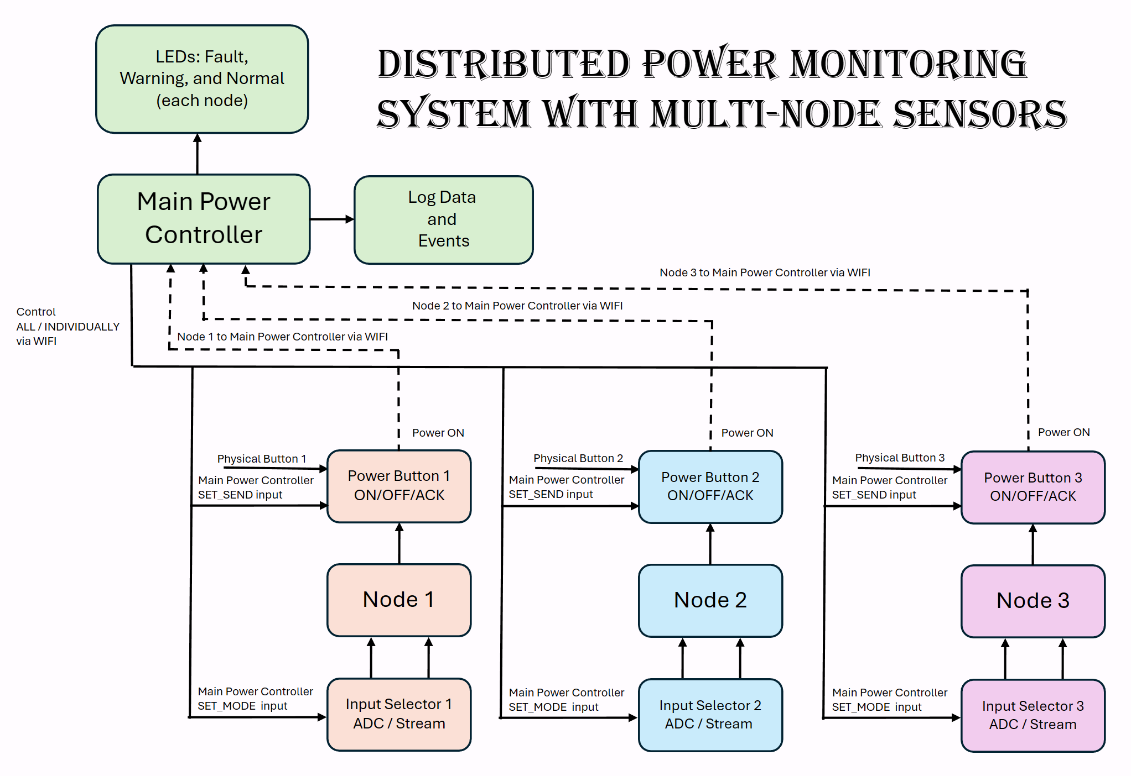Figure 1: Overall System Architecture

Figure 1 illustrates the overall system-level architecture of the distributed power monitoring system. The design consists of three independent ESP32-based sensor nodes and a Raspberry Pi–based main power controller. Each node performs local signal acquisition and processing, while the main controller coordinates system-wide control, fault indication, and data logging across all nodes.
The Main Power Controller acts as the centralized supervisory unit. It receives measurement data from each node via Wi-Fi, issues control commands either globally or on a per-node basis, and manages system feedback mechanisms. The controller drives visual fault indicators for each node and records time-stamped measurement data and fault events for offline analysis.
Each ESP32 node operates as an independent sensing subsystem. Nodes acquire voltage and current inputs, compute RMS values locally, and respond to control commands issued by the main controller. By performing signal processing at the node level, the system reduces communication bandwidth and enables low-latency device-level response. In addition, each node implements a local protection mechanism: when a persistent overcurrent condition is detected, the node autonomously suppresses data transmission to isolate the faulted node from system-level monitoring, independent of the central controller.
Each node includes an input selection mechanism that supports multiple operating modes, allowing voltage and current data to be obtained either from physical analog inputs or from software-driven waveform streams delivered over Wi-Fi. This approach enables repeatable testing and controlled fault injection without reliance on physical power hardware, while maintaining identical signal-processing behavior across all modes.
Nodes support both physical power control and remote enable/disable commands issued by the main controller during normal operation. When a node enters a locally detected overcurrent protection state, re-enabling operation requires explicit acknowledgment from the main controller. This dual-control mechanism reflects practical embedded power systems, where local protection actions and centralized supervisory control coexist.
Communication between nodes and the main controller is implemented over Wi-Fi using a lightweight, connectionless protocol (UDP). Each node transmits measurement data independently, allowing asynchronous operation and preventing a single node failure from blocking system-wide monitoring.

Implementation

ESP32 Node Firmware Implementation

Node Configuration and Communication Setup
Each ESP32 node is configured with a unique node identifier and establishes a Wi-Fi connection to the local network during initialization. Three UDP sockets are used to separate functionality: one for receiving control and acknowledgment commands from the Raspberry Pi, one for transmitting measurement data, and one for receiving streamed waveform samples when operating in software-driven input modes. This separation simplifies command handling and prevents interference between data streaming and control traffic.

Input Acquisition and Operating Modes
Each node supports multiple operating modes that determine the source of voltage and current samples. In analog input mode, samples are acquired directly from ADC pins connected to voltage and current sensors or external signal sources such as a function generator. In streaming mode, raw ADC-equivalent samples are received over UDP from a software-based waveform source. Regardless of the input mode, all samples are processed using a unified signal-processing pipeline to ensure consistent behavior across testing and deployment scenarios.
Mode selection is controlled remotely by the main controller and reflected locally through dedicated mode indicator LEDs.

Local RMS Computation
Voltage and current samples are accumulated into fixed-size buffers of 60 samples corresponding to a single measurement cycle. Once the buffer is filled, root mean square (RMS) values are computed for both voltage and current. Each RMS result is tagged with a cycle identifier to support offline validation and comparison against reference data.
Equations:

Performing RMS computation locally reduces communication bandwidth by avoiding transmission of raw samples and allows nodes to operate independently of the central controller for measurement processing.

Local Overcurrent Detection and Fault Latching
Each ESP32 node implements autonomous overcurrent detection using locally computed RMS current values. An overcurrent condition is identified when the RMS current exceeds 15 A and is evaluated across three consecutive measurement cycles to distinguish persistent faults from transient spikes. When a persistent overcurrent condition is detected, the node enters a latched fault state.
In the faulted state, the node suppresses further data transmission and reports a fault event to the main controller. This behavior isolates the faulted node from system-level monitoring while allowing the remainder of the system to continue operating normally. Fault recovery is intentionally prevented until the RMS current falls below a clear threshold of 12 A and an explicit acknowledgment command is received from the main controller.

Data Transmission Control
Measurement data packets containing the node identifier, cycle counter, and RMS (voltage and current) values are transmitted to the main controller using UDP immediately after new RMS results are computed, subject to a maximum transmission rate of one packet every 100 ms. Transmission may be explicitly enabled or disabled either by commands from the main controller or via a local physical switch during normal operation.

Command Handling and Acknowledgment Logic
Each node continuously listens for incoming control commands from the main controller. Supported commands include mode selection, transmission enable/disable, cycle counter reset, and fault acknowledgment. When operating in UDP input mode, the node additionally listens for streamed waveform data on a dedicated UDP port used exclusively for software-based testing and validation.

Raspberry Pi

Process 1: Network Controller and Command Interface
Process 1 serves as the network-facing controller on the Raspberry Pi and is responsible for coordinating communication between the ESP32 sensor nodes and the data-processing in Process 2. Its primary functions include receiving measurement data from all nodes, handling asynchronous fault notifications, issuing control commands, and forwarding aggregated data to the data-processing process through inter-process communication (IPC).
Process 1 employs a multithreaded design consisting of three concurrent threads. A UDP receiver thread listens for incoming measurement packets from ESP32 nodes on UDP port 5005 and updates a shared aggregate data structure containing the latest RMS voltage and current values from each node. A separate fault receiver thread listens on UDP port 6000 for asynchronous fault event messages generated by ESP32 nodes when local protection mechanisms are triggered. An interactive command thread provides a terminal-based supervisory interface that allows the operator to issue control commands to individual nodes or to all nodes simultaneously.
Measurement data and control or fault messages are received on separate UDP ports to ensure that regular measurement traffic does not delay time-critical fault or command handling. Process 1 aggregates the latest measurements from all nodes and forwards them to Process 2 using shared memory and semaphores, allowing network communication to operate independently from data processing and logging tasks.
The command interface supports mode selection, transmission enable or disable, cycle counter reset, and fault acknowledgment commands. Commands may be broadcast to all nodes or targeted to a specific node. Fault acknowledgment commands are only acted upon when nodes have satisfied fault-clear conditions, ensuring that recovery from protection events is explicitly supervised and preventing premature resumption of operation.
For development and debugging purposes, Process 1 drives mode indicator LEDs on the Raspberry Pi to reflect the currently selected system input mode. When a mode change command is issued, the corresponding LED provides immediate visual confirmation that the command was received and processed, allowing verification that the ESP32 nodes are correctly responding to supervisory control commands without requiring intrusive debugging tools or serial output.

Process 2: Data Processing, Fault Classification, and Logging
Process 2 implements system-level signal processing, fault classification, visualization, and persistent data logging for the distributed power monitoring system. It receives aggregated RMS voltage and current measurements from Process 1 via POSIX shared memory and semaphores and performs all derived computations independently of network communication. This architectural separation ensures that analysis, logging, and visualization are decoupled from network latency and packet arrival variability.
Process 2 uses a multithreaded design consisting of four concurrent worker threads. A voltage processing thread computes peak voltage values from received RMS measurements and classifies voltage conditions such as NORMAL, SAG, or SWELL. A current processing thread computes peak current values and classifies current conditions as NORMAL or OVERCURRENT. A logging thread records time-stamped measurement data and fault events to persistent storage, while a dedicated LED control thread provides real-time visual fault indication for each monitored node.
Peak voltage and current values are computed from RMS measurements using the standard sinusoidal relationships

These peak values are logged and displayed for observation and analysis only and are not used to trigger protective actions. Voltage fault classification is performed using RMS voltage thresholds of 50 V for voltage sag and 130 V for voltage swell.
System-level overcurrent detection in Process 2 uses an RMS current threshold of 11 A, which serves as a warning and diagnostic indicator only. This threshold is intentionally lower than the protection threshold enforced locally on each ESP32 node. When RMS current exceeds this level, the condition is logged and reported as an overcurrent warning, but does not trigger protective action at the controller.
Each ESP32 node independently enforces a higher overcurrent threshold and autonomously suppresses further data transmission when that threshold is exceeded persistently. As a result, the node becomes isolated from system-level monitoring without requiring intervention from the central controller. If a node subsequently stops transmitting data, historical log entries allow reviewers to infer that current levels were rising and likely reached the ESP32’s protection threshold, resulting in intentional node-level isolation.
Voltage swell detection is intentionally handled only at the supervisory controller rather than at the ESP32 node level. Unlike overcurrent events, which represent immediate safety risks requiring fast device-level intervention, voltage swell is treated as a system-level operating condition. Voltage abnormalities typically persist over longer time scales and are therefore more appropriately monitored, logged, and analyzed centrally rather than triggering autonomous node shutdown.
To support offline analysis and traceability, Process 2 logs measurement data to a CSV file at a fixed interval of 10 seconds, including RMS values, peak values, calculated power, and fault status for all nodes. Fault events are additionally recorded to a separate event log file, capturing transitions into and out of abnormal operating states with time stamps and node identifiers. This dual-logging approach enables both long-term trend analysis and precise reconstruction of fault behavior.
Visual fault indication is implemented using dedicated LEDs for each node, driven by the LED control thread. Voltage and current fault states are displayed using priority-based blinking patterns, allowing rapid identification of abnormal conditions without reliance on terminal output. LED updates are only performed when state changes occur, minimizing unnecessary GPIO activity. These indicators primarily serve as development and debugging aids during system integration and validation.
All shared data structures accessed by Process 2 threads are protected using mutexes to ensure thread-safe operation. Threads are executed at fixed update intervals of approximately 50 ms, providing responsive monitoring while avoiding excessive CPU utilization. By separating data reception, processing, logging, and visualization into independent threads, Process 2 achieves deterministic behavior and scalable performance as system complexity increases.

Result and Validation
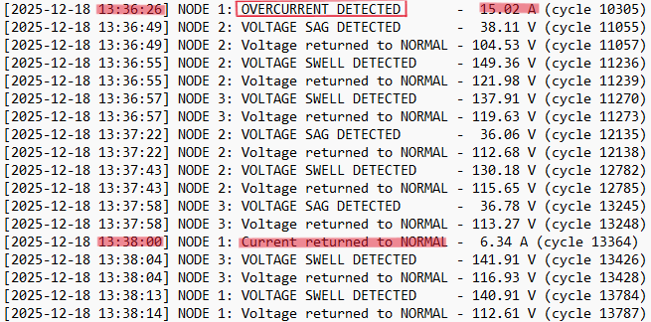 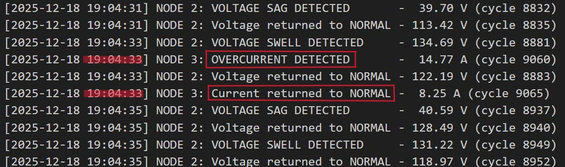Figure 2a: Fault Log Events Figure 2b: Fault Log Events
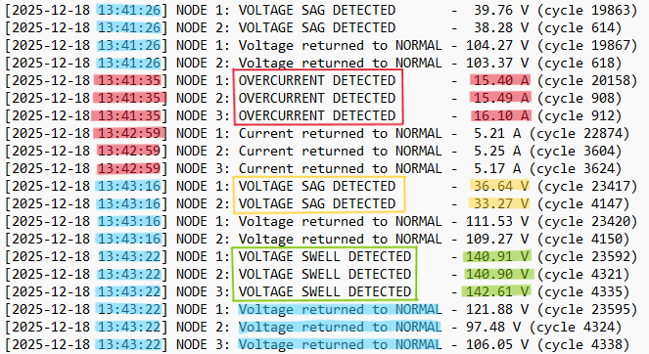 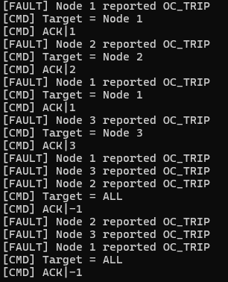 Figure 2c: Fault Log Events Figure 2d: ESP reported to PI
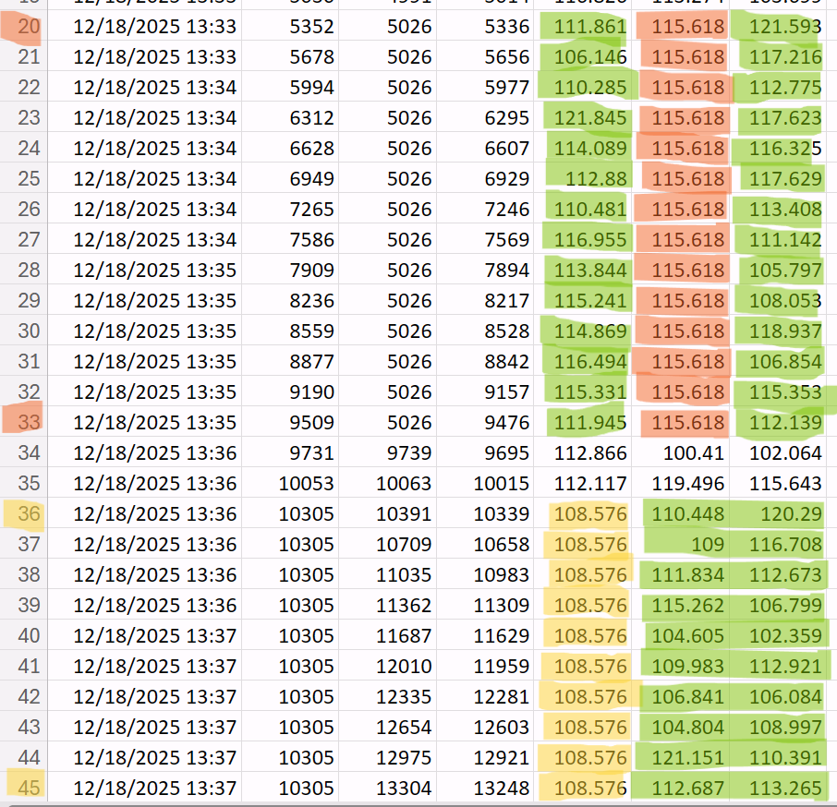 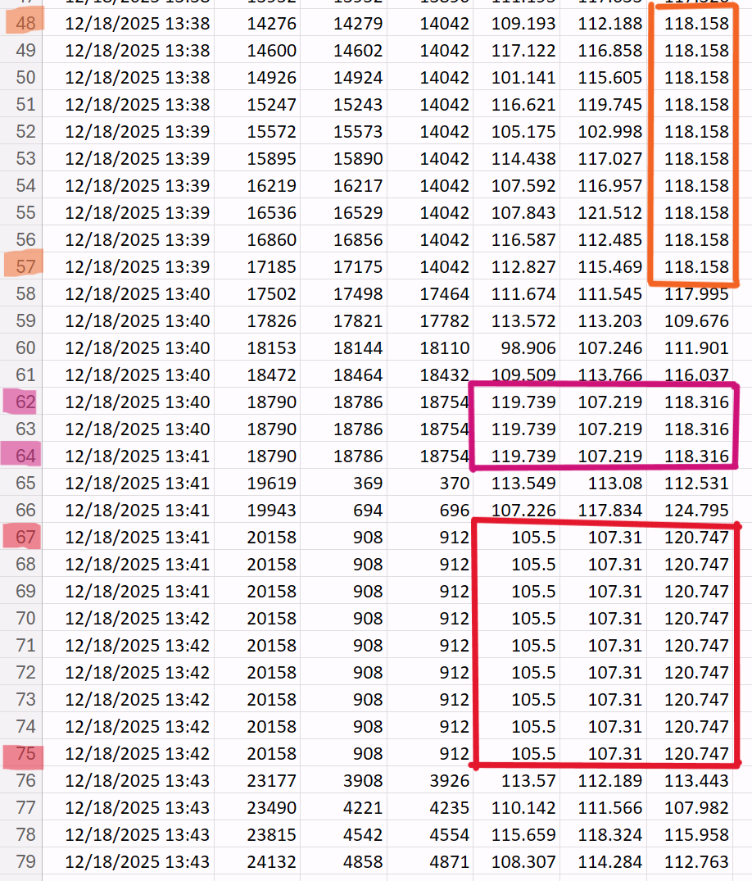 Figure 3
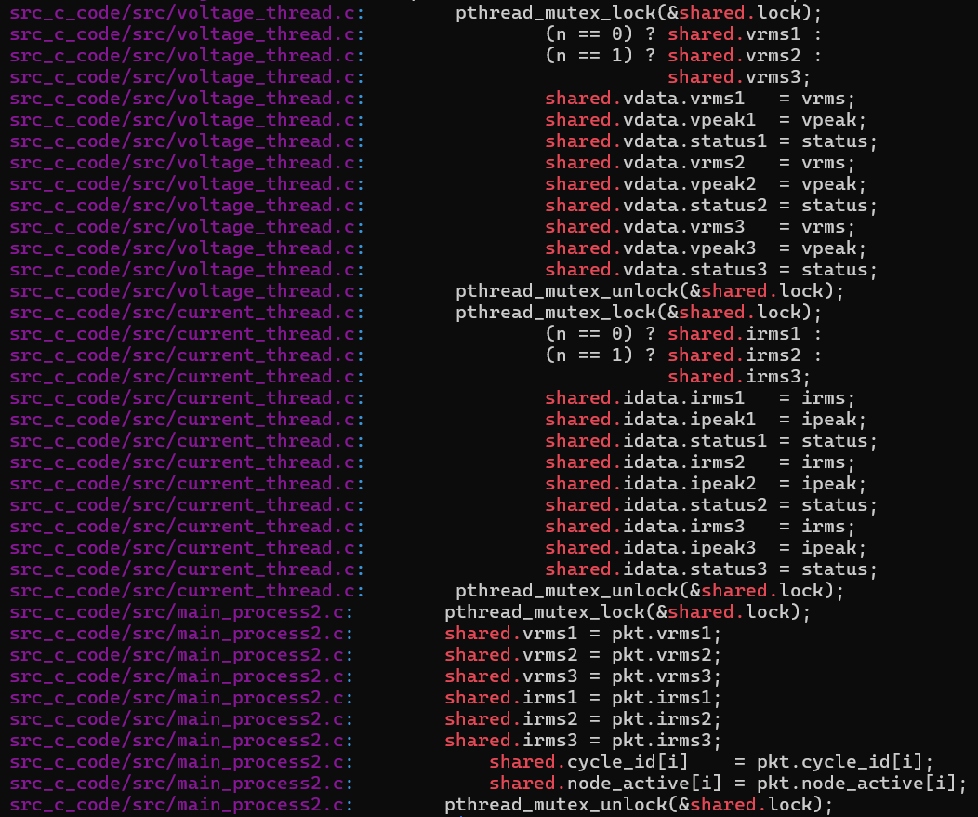 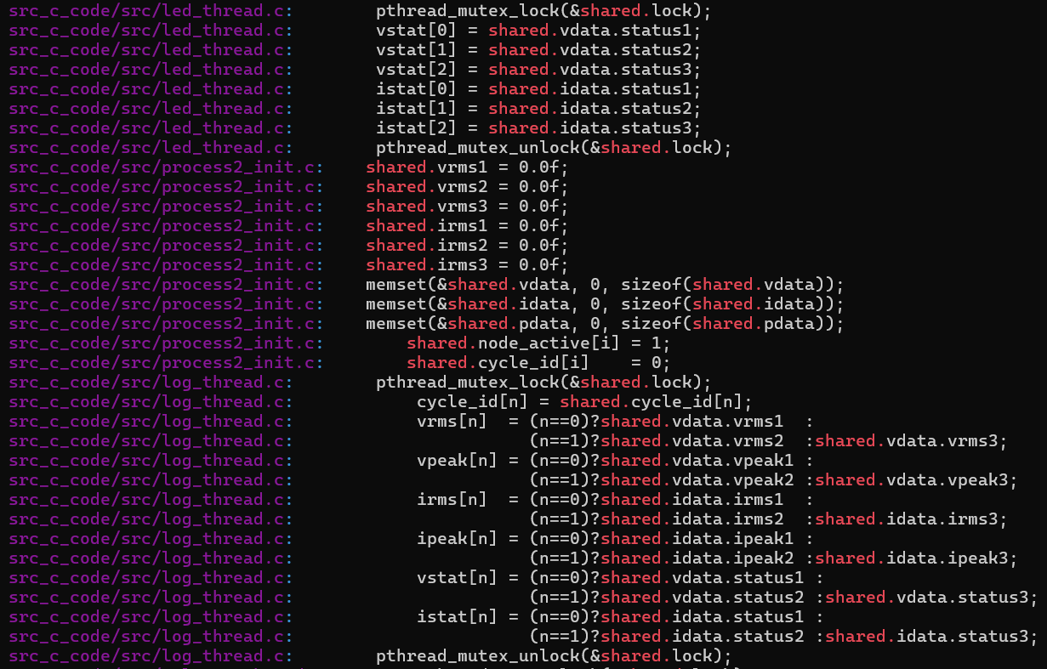 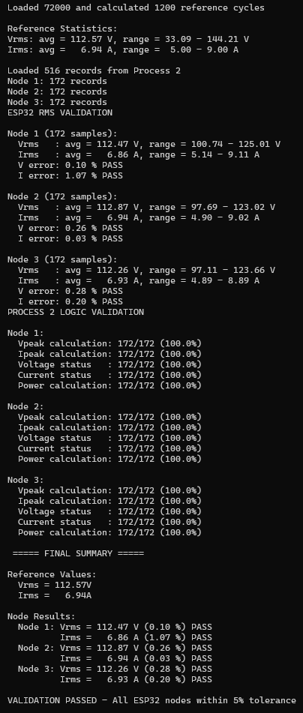 Figure 4a: Mutex protected Figure 4b: Validation
The system was evaluated through fault event logging, numerical validation, concurrency inspection, and visual observability. The results confirm correct detection and classification of voltage and current abnormalities, accurate distributed RMS computation, reliable multi-threaded execution, and intentional node isolation behavior under fault conditions.
As shown in Figures 2a–2c, voltage-related faults are detected and classified correctly based on RMS voltage thresholds. Voltage sag events occur when RMS voltage falls below 50 V, while voltage swell events occur when RMS voltage exceeds 130 V. In all observed cases, voltage sag and swell conditions are followed by a corresponding “Voltage returned to NORMAL” entry within the same or immediately subsequent timestamp. This behavior confirms that voltage faults are treated as transient operating conditions and recover automatically once voltage returns to an acceptable range.
Current-related behavior exhibits three distinct operating regions. When RMS current remains at or below 11 A, the system operates normally and no fault condition is recorded. When RMS current exceeds 11 A, but remains less than or equal to 15 A, the condition is detected and logged as a system-level overcurrent warning. In this range, the system behavior mirrors that of voltage sag and swell events: once the current returns below the threshold, a corresponding “Current returned to NORMAL” entry is recorded within the same or subsequent timestamp. No transmission suppression or node isolation occurs in this regime, confirming that these events are treated as recoverable warnings rather than protection triggers.
A different behavior is observed when RMS current exceeds 15 A. As shown in Figure 2c, currents above this threshold trigger a local fault condition on the ESP32 node. In this case, the node enters a latched fault state and autonomously suppresses further data transmission. Because the node intentionally stops sending measurement packets, the system does not immediately log a return to normal operation. Recovery from this condition requires an explicit acknowledgment command from the main controller before data transmission resumes. This distinction confirms that currents above 11 A, but below the local protection threshold are handled as transient warnings, while currents above 15 A trigger intentional node-level isolation.
This behavior is further validated in Figure 2d, which shows OC_TRIP fault messages reported by the ESP32 nodes to the main controller whenever the local protection threshold is exceeded. These messages indicate that the node has entered a faulted state and is awaiting acknowledgment before resuming operation. The presence of earlier system-level overcurrent warnings in the logs allows reviewers to infer that current levels were rising prior to node isolation.
Intentional suppression of data transmission following a local overcurrent trip is verified in Figure 3, where multiple consecutive log entries show unchanged values across specific line ranges (lines 20–33, 36–45, 48–57, 62–64, and 67–75). The absence of updated measurement values in these highlighted regions confirms that the ESP32 node stopped transmitting new packets after entering the faulted state. This demonstrates that missing data during overcurrent events is an intentional design feature rather than a communication failure.
Numerical accuracy of the distributed signal-processing pipeline is validated in Figure 4b, which compares RMS voltage and current values computed by the ESP32 nodes against offline reference calculations. A total of 72,000 samples were processed, yielding 1,200 reference RMS cycles, with 172 validated records per node received by Process 2. Across all nodes, RMS voltage and current errors remained below 0.3%, and all validation checks for peak calculation, voltage classification, current classification, and power computation passed with 100% success. These results confirm that embedded RMS computation on the ESP32 nodes is accurate and consistent with reference models.
Correct concurrent operation within Process 2 is demonstrated in Figure 4a, which shows mutex-protected access to shared voltage, current, status, and cycle count variables across multiple threads. Consistent use of mutex locking ensures thread-safe data exchange between voltage processing, current processing, logging, and LED control threads. No race conditions or inconsistent classifications were observed during continuous operation.
In addition to software-level validation, visual status indicators were used as a lightweight verification mechanism during development and testing. Onboard LEDs provided real-time feedback of node operating mode, transmission enable state, and fault conditions. These indicators were used to confirm correct mode transitions, verify intentional suppression of data transmission during fault events, and validate proper recovery behavior following fault acknowledgment without requiring intrusive debugging tools or serial output.
Overall, the results demonstrate that the system reliably detects voltage and current abnormalities, accurately performs distributed RMS computation, maintains data integrity under concurrent processing, and provides sufficient observability to interpret node isolation events. The layered warning-and-isolation approach enables early diagnostic insight at the supervisory controller while preserving autonomous node-level protection behavior.

Conclusion
This project demonstrated the design and validation of a distributed embedded power monitoring system using multiple ESP32 sensor nodes and a Raspberry Pi central controller. By distributing signal acquisition and RMS computation to the node level, the system achieved accurate measurements while enabling early detection of abnormal operating conditions without relying on centralized processing.
Local RMS computation on the ESP32 nodes closely matched reference calculations, confirming that reliable signal processing can be performed on resource-constrained microcontrollers. Sustained overcurrent conditions triggered autonomous suppression of data transmission at the node level, intentionally isolating faulted nodes and requiring explicit acknowledgment before resuming operation. This behavior provided fast, localized protection while remaining observable at the system level through historical logs.
At the supervisory level, the Raspberry Pi aggregated measurements, classified voltage and current conditions, and logged system behavior without interfering with time-critical communication. Separating network handling from data processing ensured deterministic operation under concurrent execution. Layered current thresholds allowed the system to record early warnings while reserving transmission suppression for more severe conditions.
The use of software-based waveform streaming enabled repeatable testing and controlled fault injection without physical power hardware, supporting thorough validation of accuracy, fault detection, and recovery behavior. Overall, the project shows that combining local autonomy with centralized supervision results in a flexible and observable distributed embedded monitoring system suitable for studying real-world power system behavior.

Codes


