GAME DESIGN DOCUMENT

CARD GAME

[Tapez le résumé du document ici. Il s'agit généralement d'une courte synthèse du document. Tapez le résumé du document ici. Il s'agit généralement d'une courte synthèse du document.]

2019

Gondet Loïc, Leveque Samuel,Lecacheux Thomas

Notre Dame de La Providence

27/09/2019

Sommaire

Explication du projet 2

# Présentation du projet CardGame

# Synopsis

# Game objectif

# Game rules

Données Techniques………………………………………………………………………………………………………………3 Type de jeu….............................................................................................................................3 But du jeu ………………………………………………………………………………………………………………………….….3 Special Feature………………………………………………………………………………………………………………………3 Références…………………………………………………………………………………………………………………….………3 Contexte …………………………………………………….…………………………………………………………………………4 Univers Graphique……………………………………………………………………………..…………………………………4 Menus …………………………………………………….……………………………………………………………………………5 Descriptif des niveaux…………………………………………… .……………………………………………………………5 Eléments de gameplay…………………………………….……………………………………………………………………5 Situations de jeu…………………………………………………….…………………………………………….………………5 Feedback…………………………………………………….…………………………………………………………………….…10 Sauvegarde…………………………………………………….……………………………………………………………………10 Musique…………………………………………………….…………………………………………………………………………10

[Overview](https://docs.google.com/document/d/1-I08qX76DgSFyN1ByIGtPuqXh7bVKraHcNIA25tpAzE/edit#heading=h.yj5nhqp5cf0j)

[Theme / Setting / Genre](https://docs.google.com/document/d/1-I08qX76DgSFyN1ByIGtPuqXh7bVKraHcNIA25tpAzE/edit#heading=h.5s48wntac2es)

[Core Gameplay Mechanics Brief](https://docs.google.com/document/d/1-I08qX76DgSFyN1ByIGtPuqXh7bVKraHcNIA25tpAzE/edit#heading=h.uzq23hfhdv6e)

[Targeted platforms](https://docs.google.com/document/d/1-I08qX76DgSFyN1ByIGtPuqXh7bVKraHcNIA25tpAzE/edit#heading=h.kvz0cxkhwt0s)

[Monetization model (Brief/Document)](https://docs.google.com/document/d/1-I08qX76DgSFyN1ByIGtPuqXh7bVKraHcNIA25tpAzE/edit#heading=h.421ijgnpyvmc)

[Project Scope](https://docs.google.com/document/d/1-I08qX76DgSFyN1ByIGtPuqXh7bVKraHcNIA25tpAzE/edit#heading=h.rdb2xo3rjh0s)

[Influences (Brief)](https://docs.google.com/document/d/1-I08qX76DgSFyN1ByIGtPuqXh7bVKraHcNIA25tpAzE/edit#heading=h.155cm8v36jpc)

[- <Influence #1>](https://docs.google.com/document/d/1-I08qX76DgSFyN1ByIGtPuqXh7bVKraHcNIA25tpAzE/edit#heading=h.c6nxu1rzd2cc)

[- <Influence #2>](https://docs.google.com/document/d/1-I08qX76DgSFyN1ByIGtPuqXh7bVKraHcNIA25tpAzE/edit#heading=h.ssiemceczw16)

[- <Influence #3>](https://docs.google.com/document/d/1-I08qX76DgSFyN1ByIGtPuqXh7bVKraHcNIA25tpAzE/edit#heading=h.31bxzkfeuvl6)

[- <Influence #4>](https://docs.google.com/document/d/1-I08qX76DgSFyN1ByIGtPuqXh7bVKraHcNIA25tpAzE/edit#heading=h.o4f1wa5aq6q3)

[The elevator Pitch](https://docs.google.com/document/d/1-I08qX76DgSFyN1ByIGtPuqXh7bVKraHcNIA25tpAzE/edit#heading=h.337xnergkz1b)

[Project Description (Brief):](https://docs.google.com/document/d/1-I08qX76DgSFyN1ByIGtPuqXh7bVKraHcNIA25tpAzE/edit#heading=h.z7oe7x50rpf3)

[Project Description (Detailed)](https://docs.google.com/document/d/1-I08qX76DgSFyN1ByIGtPuqXh7bVKraHcNIA25tpAzE/edit#heading=h.exbmsy55zuvb)

[What sets this project apart?](https://docs.google.com/document/d/1-I08qX76DgSFyN1ByIGtPuqXh7bVKraHcNIA25tpAzE/edit#heading=h.s4h84uy3suza)

[Core Gameplay Mechanics (Detailed)](https://docs.google.com/document/d/1-I08qX76DgSFyN1ByIGtPuqXh7bVKraHcNIA25tpAzE/edit#heading=h.a8x4s87df6uk)

[- <Core Gameplay Mechanic #1>](https://docs.google.com/document/d/1-I08qX76DgSFyN1ByIGtPuqXh7bVKraHcNIA25tpAzE/edit#heading=h.jyik8zbcjcio)

[- <Core Gameplay Mechanic #2>](https://docs.google.com/document/d/1-I08qX76DgSFyN1ByIGtPuqXh7bVKraHcNIA25tpAzE/edit#heading=h.y46mn9zee60t)

[- <Core Gameplay Mechanic #3>](https://docs.google.com/document/d/1-I08qX76DgSFyN1ByIGtPuqXh7bVKraHcNIA25tpAzE/edit#heading=h.lmzwvmw5e0hr)

[- <Core Gameplay Mechanic #4>](https://docs.google.com/document/d/1-I08qX76DgSFyN1ByIGtPuqXh7bVKraHcNIA25tpAzE/edit#heading=h.kct9c2l3dr9p)

[Story and Gameplay](https://docs.google.com/document/d/1-I08qX76DgSFyN1ByIGtPuqXh7bVKraHcNIA25tpAzE/edit#heading=h.6pmf08ssy6y0)

[Story (Brief)](https://docs.google.com/document/d/1-I08qX76DgSFyN1ByIGtPuqXh7bVKraHcNIA25tpAzE/edit#heading=h.ctv1wxi9dpll)

[Story (Detailed)](https://docs.google.com/document/d/1-I08qX76DgSFyN1ByIGtPuqXh7bVKraHcNIA25tpAzE/edit#heading=h.kqt2h5q76zyt)

[Gameplay (Brief)](https://docs.google.com/document/d/1-I08qX76DgSFyN1ByIGtPuqXh7bVKraHcNIA25tpAzE/edit#heading=h.ejtq4v6r30ui)

[Gameplay (Detailed)](https://docs.google.com/document/d/1-I08qX76DgSFyN1ByIGtPuqXh7bVKraHcNIA25tpAzE/edit#heading=h.cl69l94amjmx)

[Assets Needed](https://docs.google.com/document/d/1-I08qX76DgSFyN1ByIGtPuqXh7bVKraHcNIA25tpAzE/edit#heading=h.6m1256af7s3j)

[- 2D](https://docs.google.com/document/d/1-I08qX76DgSFyN1ByIGtPuqXh7bVKraHcNIA25tpAzE/edit#heading=h.1wb69txjqarm)

[- 3D](https://docs.google.com/document/d/1-I08qX76DgSFyN1ByIGtPuqXh7bVKraHcNIA25tpAzE/edit#heading=h.xdk2cy4n4ovn)

[- Sound](https://docs.google.com/document/d/1-I08qX76DgSFyN1ByIGtPuqXh7bVKraHcNIA25tpAzE/edit#heading=h.f8xx8iwg5gs9)

[- Code](https://docs.google.com/document/d/1-I08qX76DgSFyN1ByIGtPuqXh7bVKraHcNIA25tpAzE/edit#heading=h.ky1qxs88utre)

[- Animation](https://docs.google.com/document/d/1-I08qX76DgSFyN1ByIGtPuqXh7bVKraHcNIA25tpAzE/edit#heading=h.isk96p5euy3r)

[Schedule](https://docs.google.com/document/d/1-I08qX76DgSFyN1ByIGtPuqXh7bVKraHcNIA25tpAzE/edit#heading=h.kmt9zaowjejr)

[- <Object #1>](https://docs.google.com/document/d/1-I08qX76DgSFyN1ByIGtPuqXh7bVKraHcNIA25tpAzE/edit#heading=h.r3fjjzh8krjg)

[- <Object #2>](https://docs.google.com/document/d/1-I08qX76DgSFyN1ByIGtPuqXh7bVKraHcNIA25tpAzE/edit#heading=h.j584764hn4bz)

[- <Object #3>](https://docs.google.com/document/d/1-I08qX76DgSFyN1ByIGtPuqXh7bVKraHcNIA25tpAzE/edit#heading=h.lbj31oz0xb3v)

[- <Object #4>](https://docs.google.com/document/d/1-I08qX76DgSFyN1ByIGtPuqXh7bVKraHcNIA25tpAzE/edit#heading=h.p0jgh8xq0o3r)

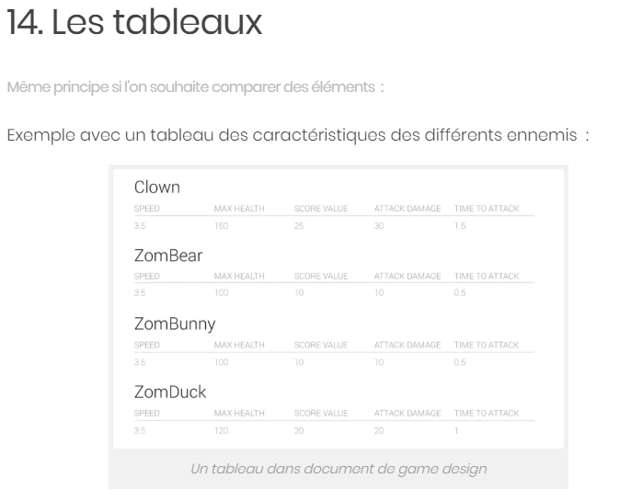

# Sources :

<https://videogamecreation.fr/documents-de-game-design-17-conseils-pour-une-mise-en-forme/>

<https://docs.google.com/document/d/1-I08qX76DgSFyN1ByIGtPuqXh7bVKraHcNIA25tpAzE/edit>

<https://www.studytonight.com/3d-game-engineering-with-unity/tdd-and-gdd>