**《电子时钟》智能装置课程设计报告**

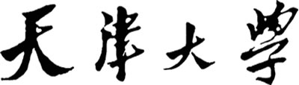

**目录**

一、设计题目 2

二、设计目的 2

三、设计内容 2

四、设计要求 2

五、实验设备 3

六、实验器件工作原理 3

七、硬件接线图 4

7.1硬件设计图 4

7.2 硬件接线图 4

7.3 硬件设计思路 5

八、软件 6

8.1程序框图 6

8.2程序清单 14

九、电子时钟的功能操作说明。 14

十、误差分析 16

十一、心得体会 18

十二、参考文献 19

十三、附录 19

一、设计题目

电子时钟

二、设计目的

1. 深入了解PIC16F877单片机的工作原理，熟练掌握汇编语言程序设计方法，熟练使用MPLAB-ICD仿真器及MPLAB-IDE仿真调试软件。
2. 通过该课程设计使学生初步掌握以单片机为核心的智能装置设计的简单原则、步骤和方法。
3. 熟悉智能装置设计中有关的硬件设计调试，如人机界面等。
4. 熟悉智能装置设计中相关软件的设计、编程和调试。

三、设计内容

1. 以16F877单片机为核心，结合给出的其他原器件和智能装置实验系统原有的内容设计电子时钟硬件电路电路。
2. 利用实验板上的半导体温度传感器和四个独立按键，温度传感器按其原理介绍采集，时钟利用液晶显示器进行显示。
3. 时钟按照时分秒、温度以及年月日显示，并可以利用按键逐位进行修改设置。
4. 利用PIC16F877自带EEPROM进行掉电保护。
5. 创新内容：增加了开机欢迎界面。

四、设计要求

1. 根据实验指导书的设计内容及和智能装智实验系统所给出的元件，设计电子时钟的硬件原理图。
2. 按照设计好的硬件原理图在实验系统上用导线搭建硬件电路。
3. 用万用表检查硬件电路连接是否正确，检查无误后上电并编制简单的测试程 序分步调试各部分功能。
4. 在各部分功能实现后，编制完整的电子时钟系统软件，并进行软硬件联调，直到达到设计要求。
5. 按照设计内容要求测试仪表误差并做分析，给出仪表精度，完成后由教师进行验收检查。

五、实验设备

MPLAB-ICD模块与仿真头

智能装置实验系统

安装了MPLAB-IDE开发软件的计算机

数字万用表

导线若干

六、实验器件工作原理

**LCD工作原理**

液晶显示的原理是液晶在不同电压的作用下会呈现不同的光特性液晶显示屏就是由许多液晶排成阵列而构成的,在单色液晶显示屏中,一个液晶就是一个象素。具体到我们使用的这个串行的LCD屏，即单位传输，一个字节后将命令或数据进行读写。需要注意的是，要注意时序。必须检测LCD为非忙状态下，在CLK为高电平时进行bit的写入。并且要注意读写的地址为80H到87H，90H到97H。

**温度传感器工作原理**

感应温度的变化，使敏感元件(如：热敏电阻、热电偶等)的阻值发生变化，从而在电路中，使输出的电压发生变化。

在0℃时，传感器输出电压为0.5V；在25℃时输出电压为750mV。温度每增加1℃输出电压增加10mV，即温度的变化量与输出电压的增量成线性关系。根据此线性关系，可以由电压计算得出温度值。由于温度传感器实时监测温度，并不需要激活指令，我们只需要进行AD转换即可算出相应温度。

七、硬件接线图

# 7.1硬件设计图

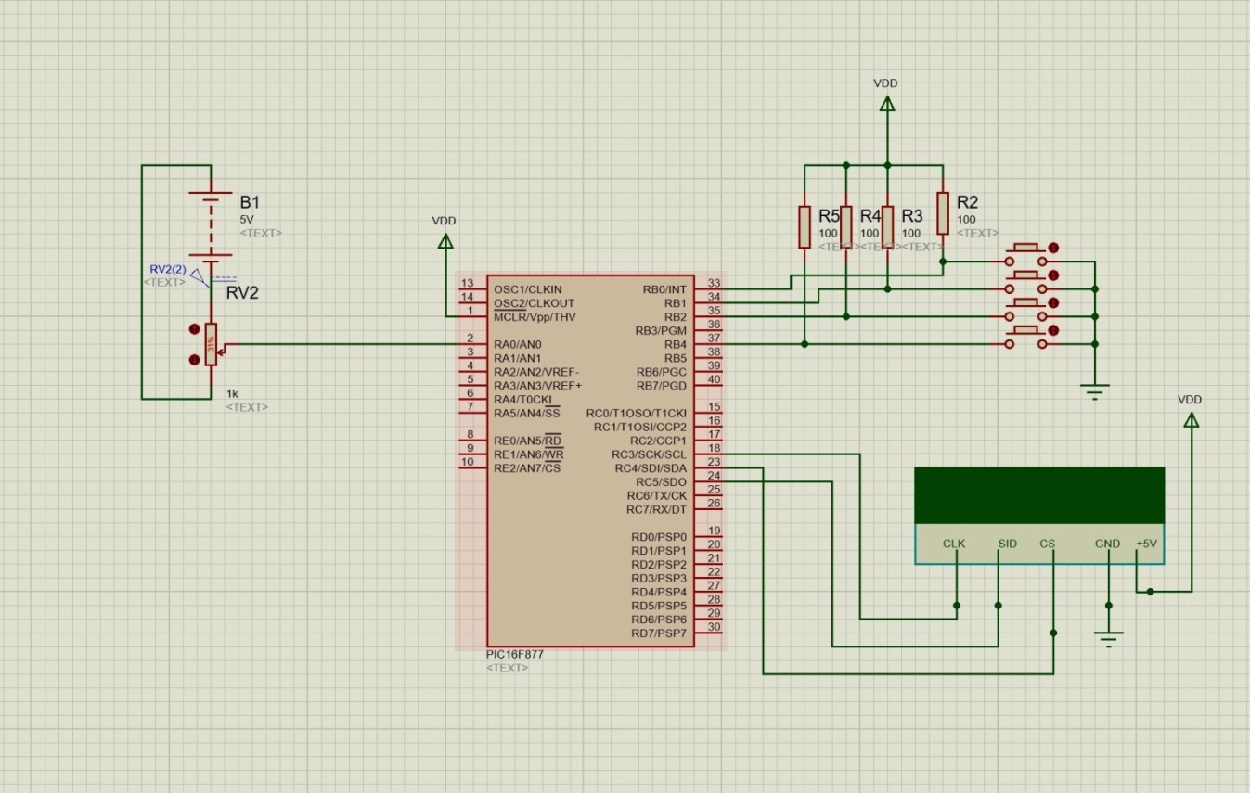

上图中，模拟量输入表示温度传感器所测电压的输入

# 7.2 硬件接线图

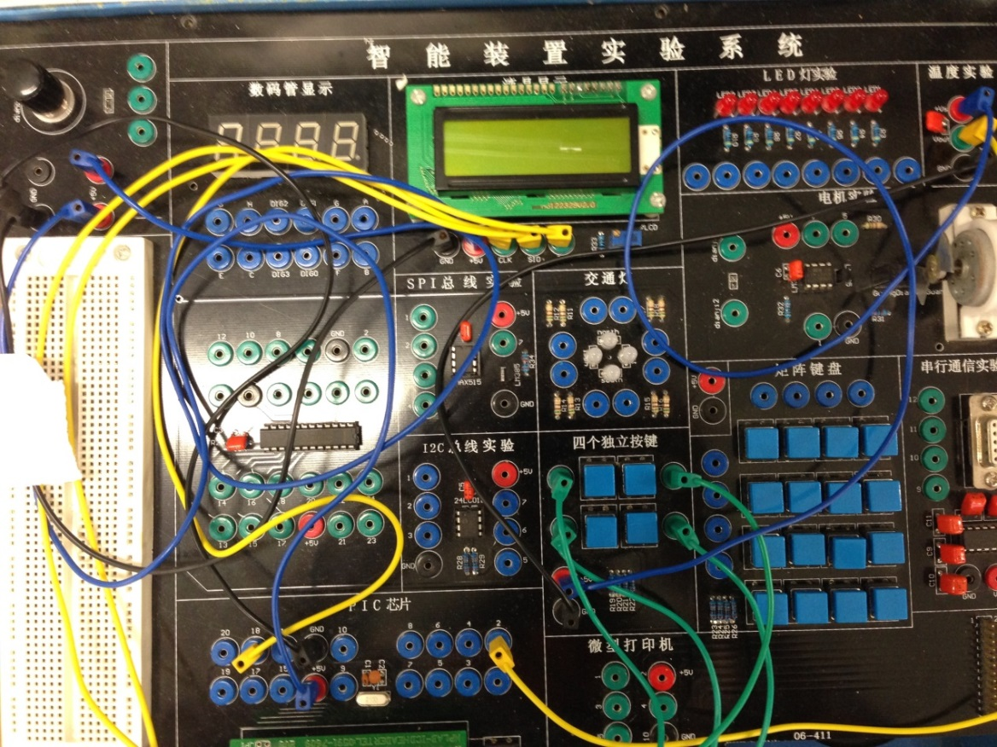

# 7.3 硬件设计思路

主要的外围器件为按键，显示屏和温度传感器。由于使用了外部中断，所以其中一个按键要接在PB口，如PB0。而其他的案件则无要求，只要不要占用被仿真器占据的PB3，PB6，PB7即可。温度传感器输出一个模拟量，由于要进行Ad转换，所以要将输出结果接到PA口，如PA0。而LCD的接口主要关注SID和CLK,由于CLK为时钟输入，可以采用定时器作为波特率发生器，也可以编程拉高和拉低电平，这里选用了后者。好处是不需要判断当前电平。而SID只要连接单片机一个空余的引脚即可。

八、软件

# 8.1程序框图

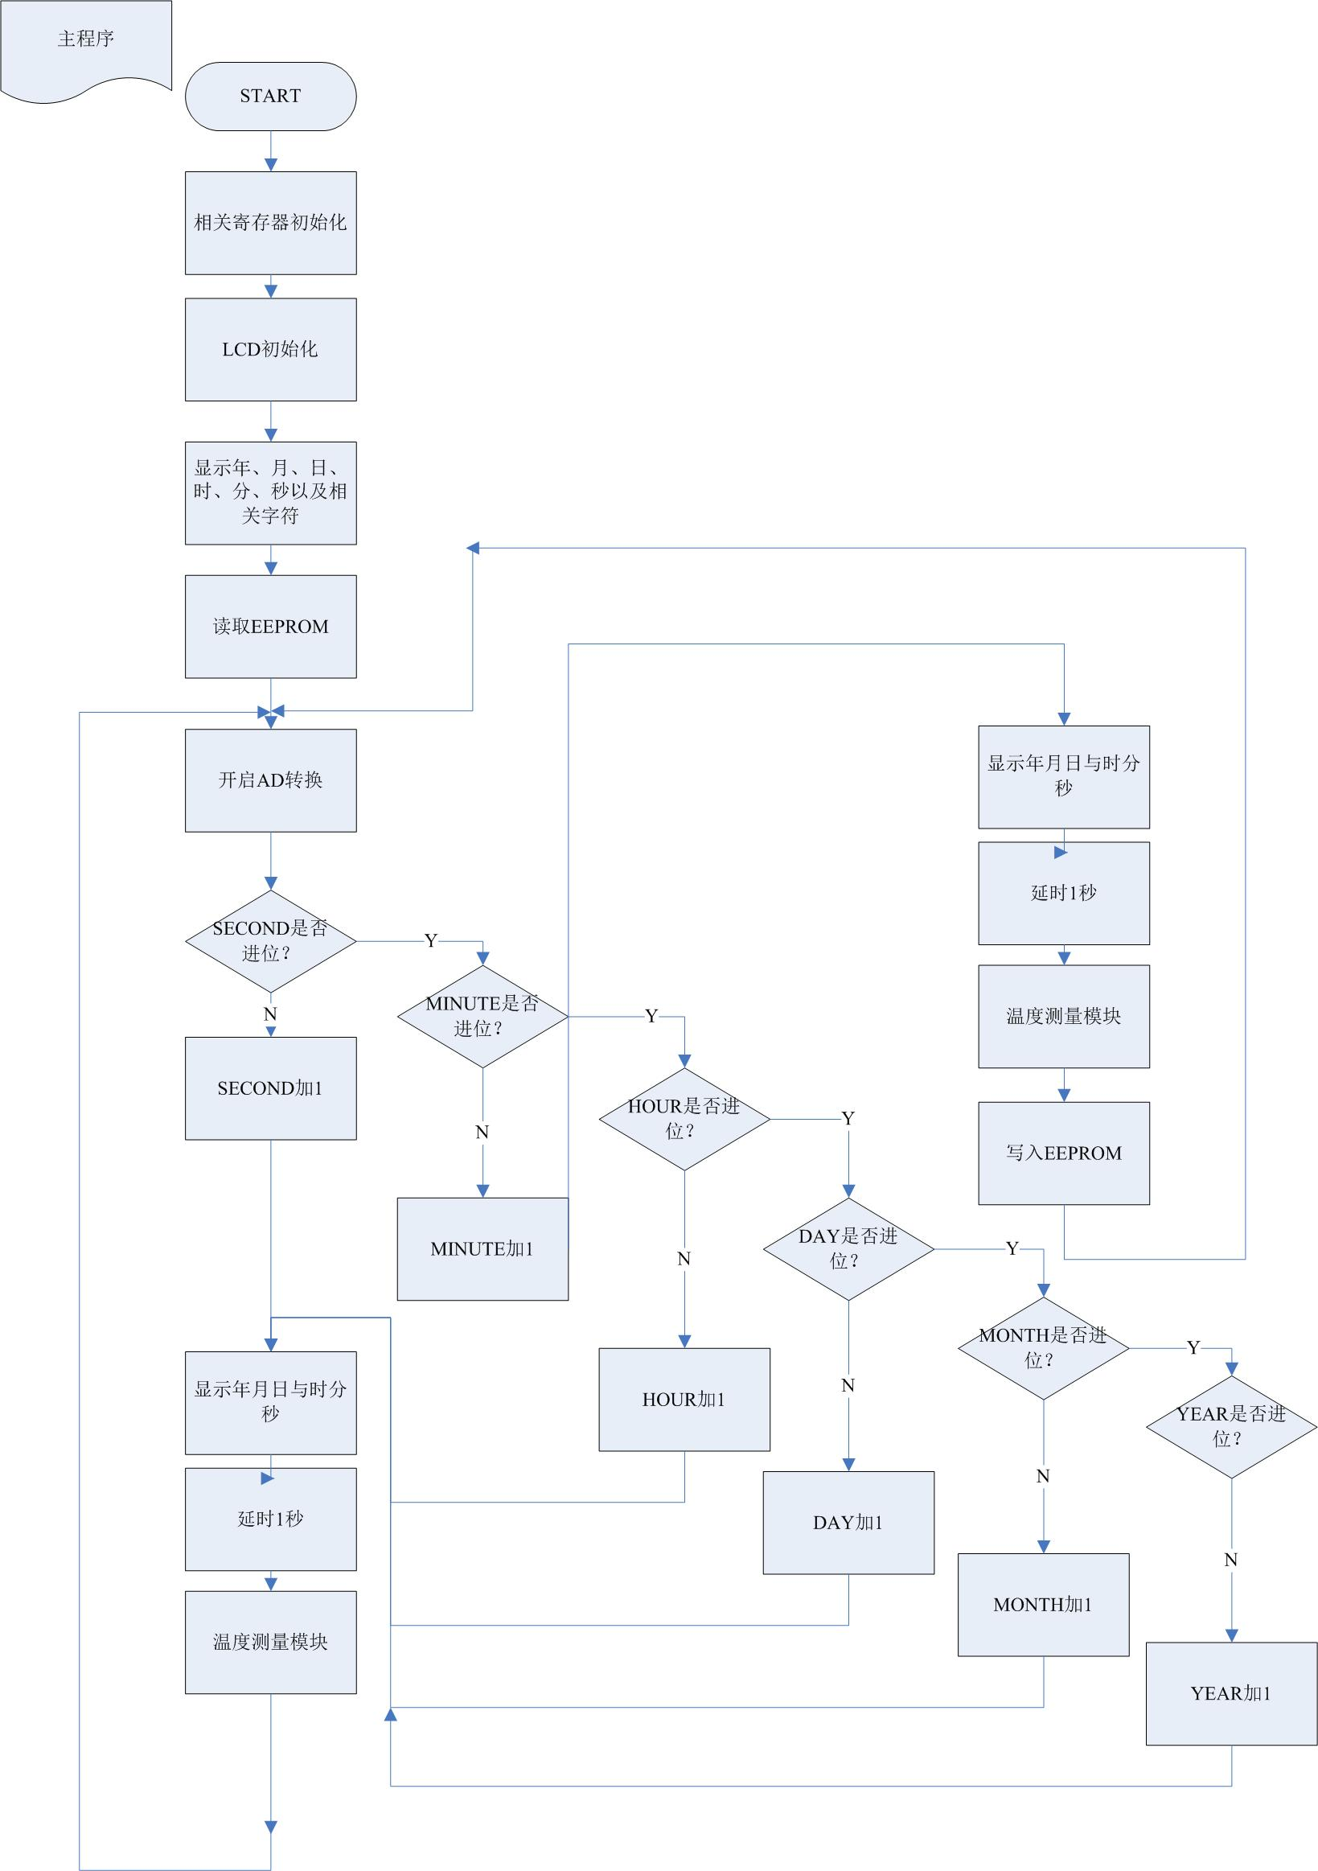

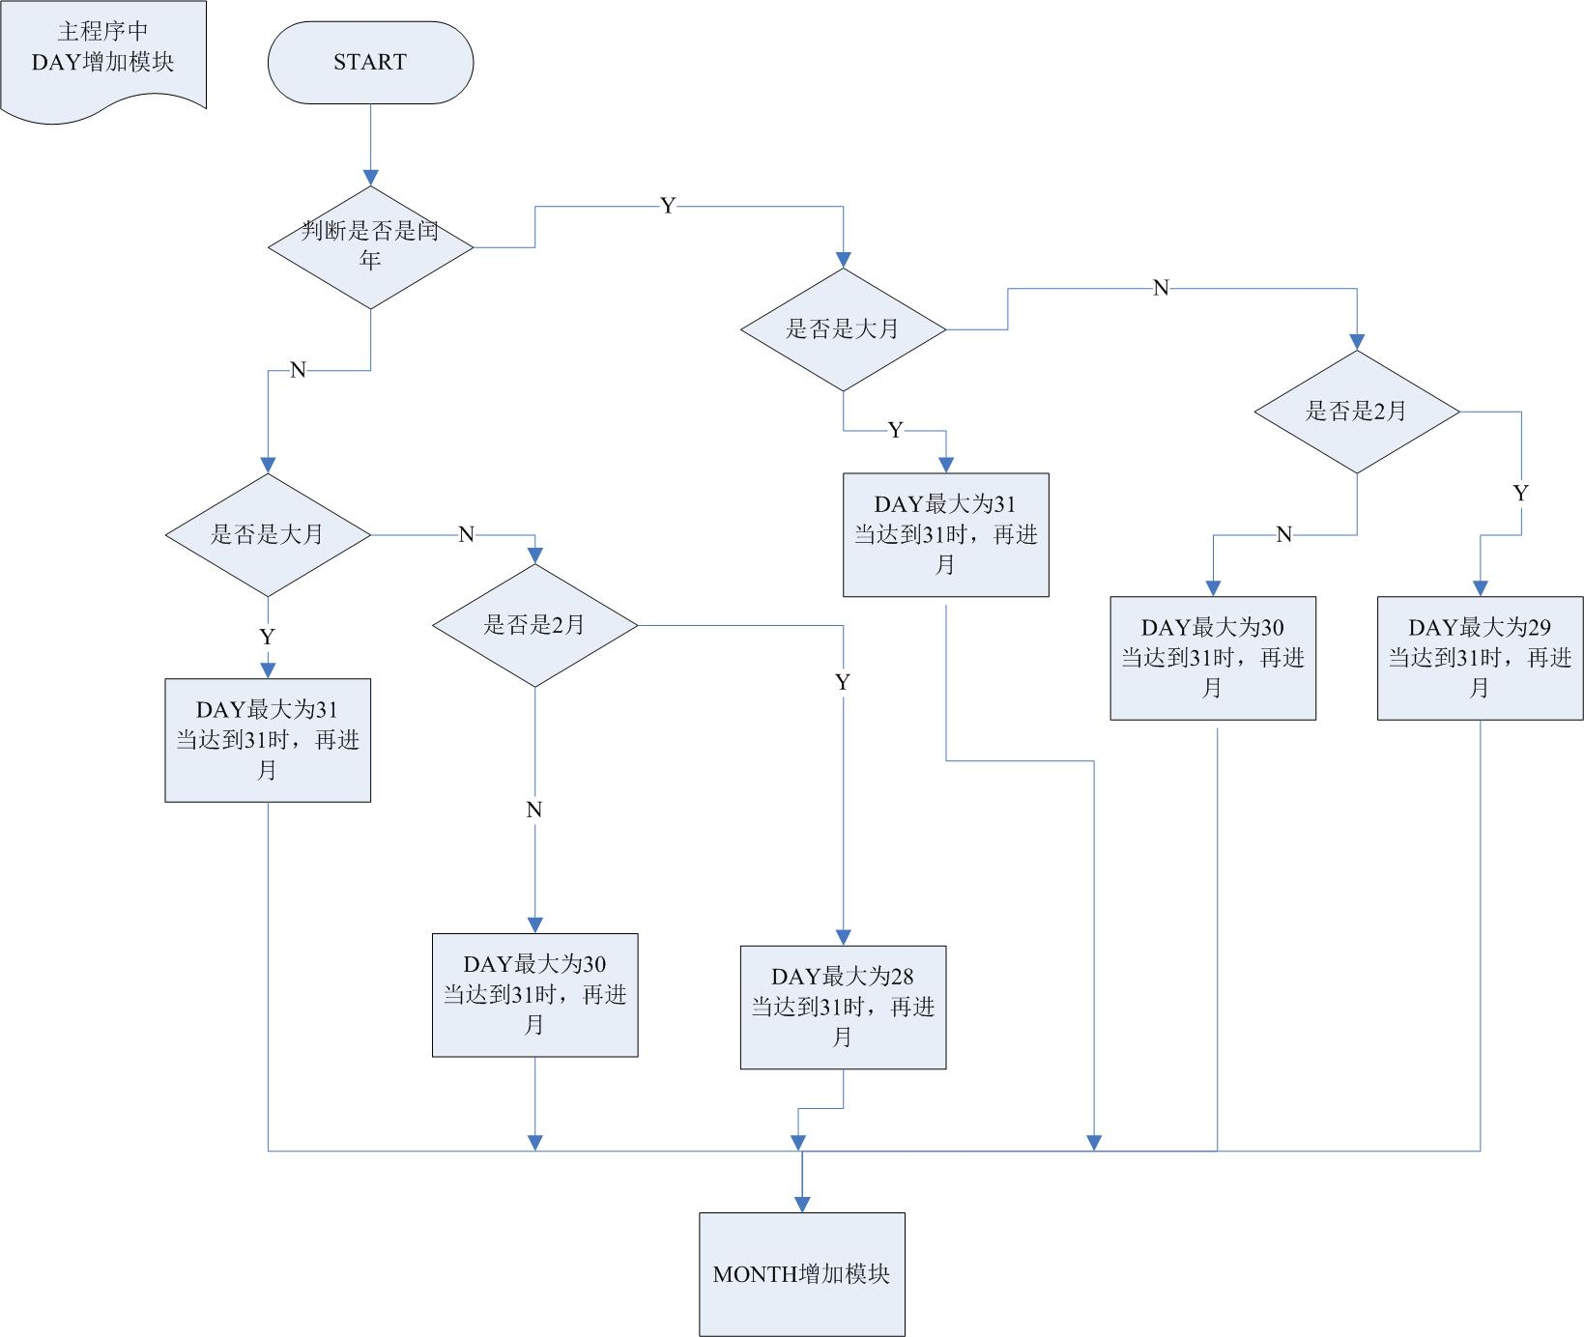

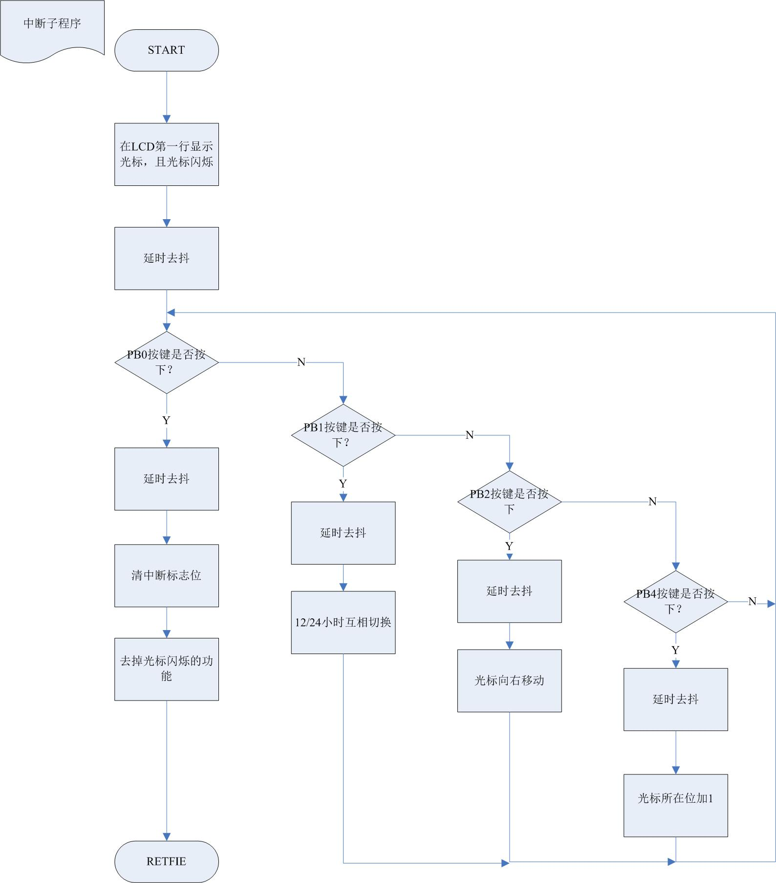

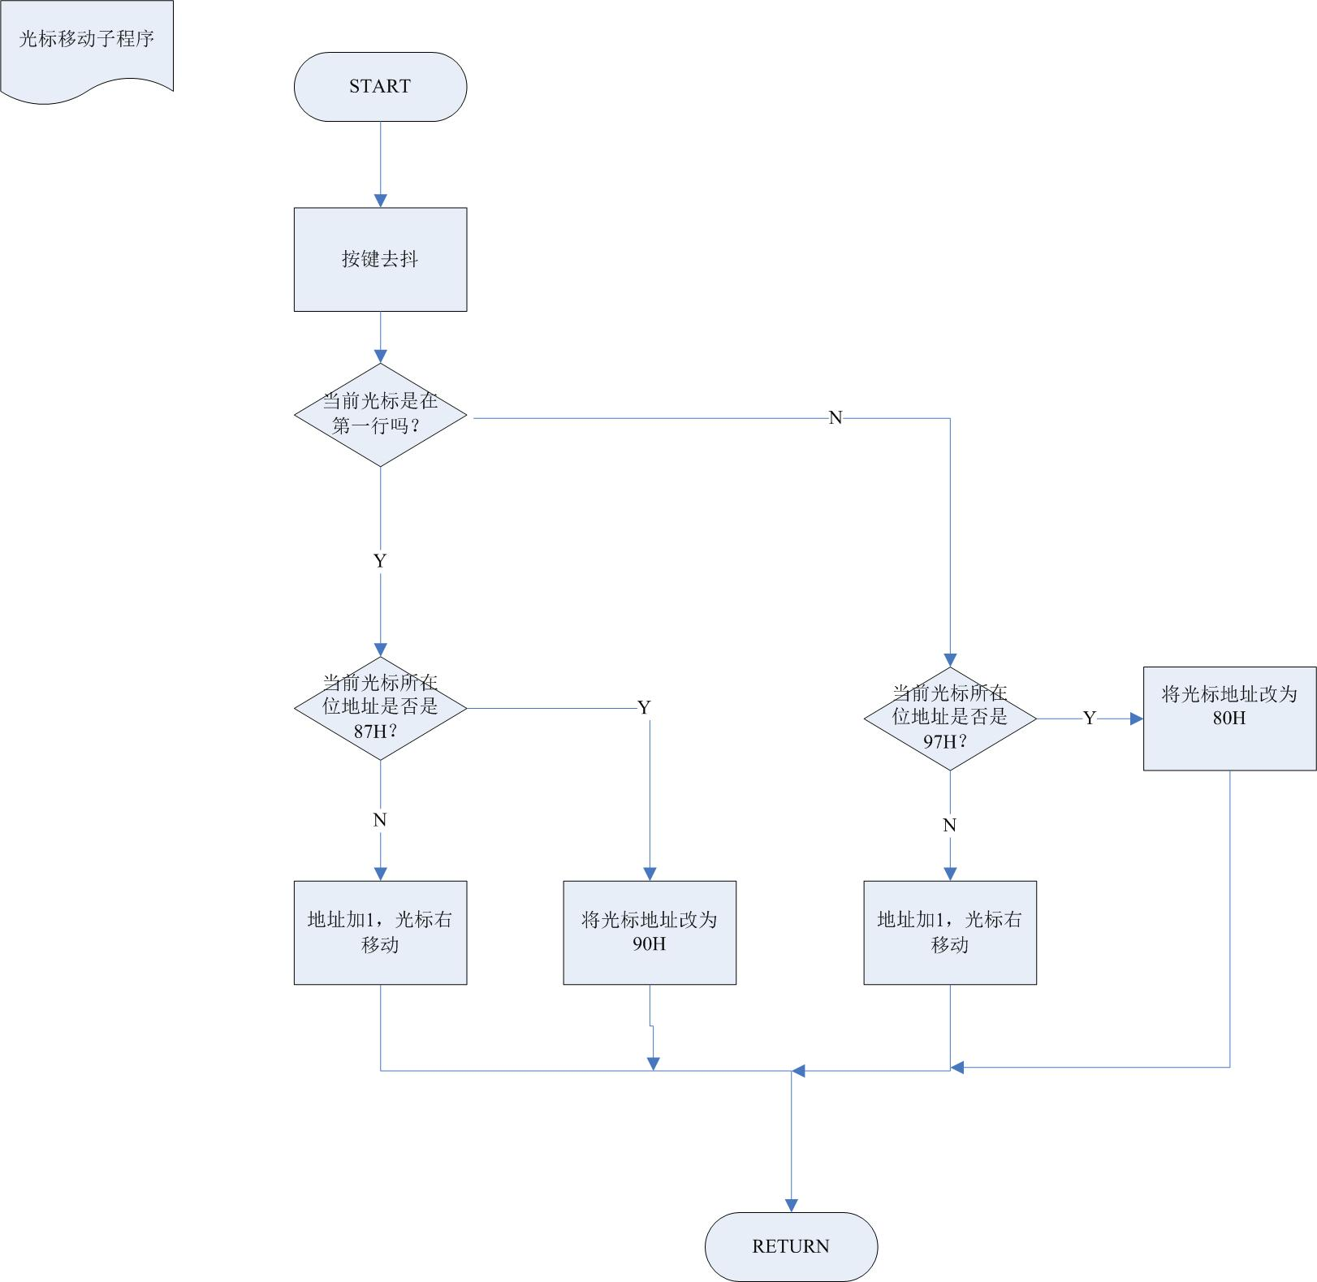

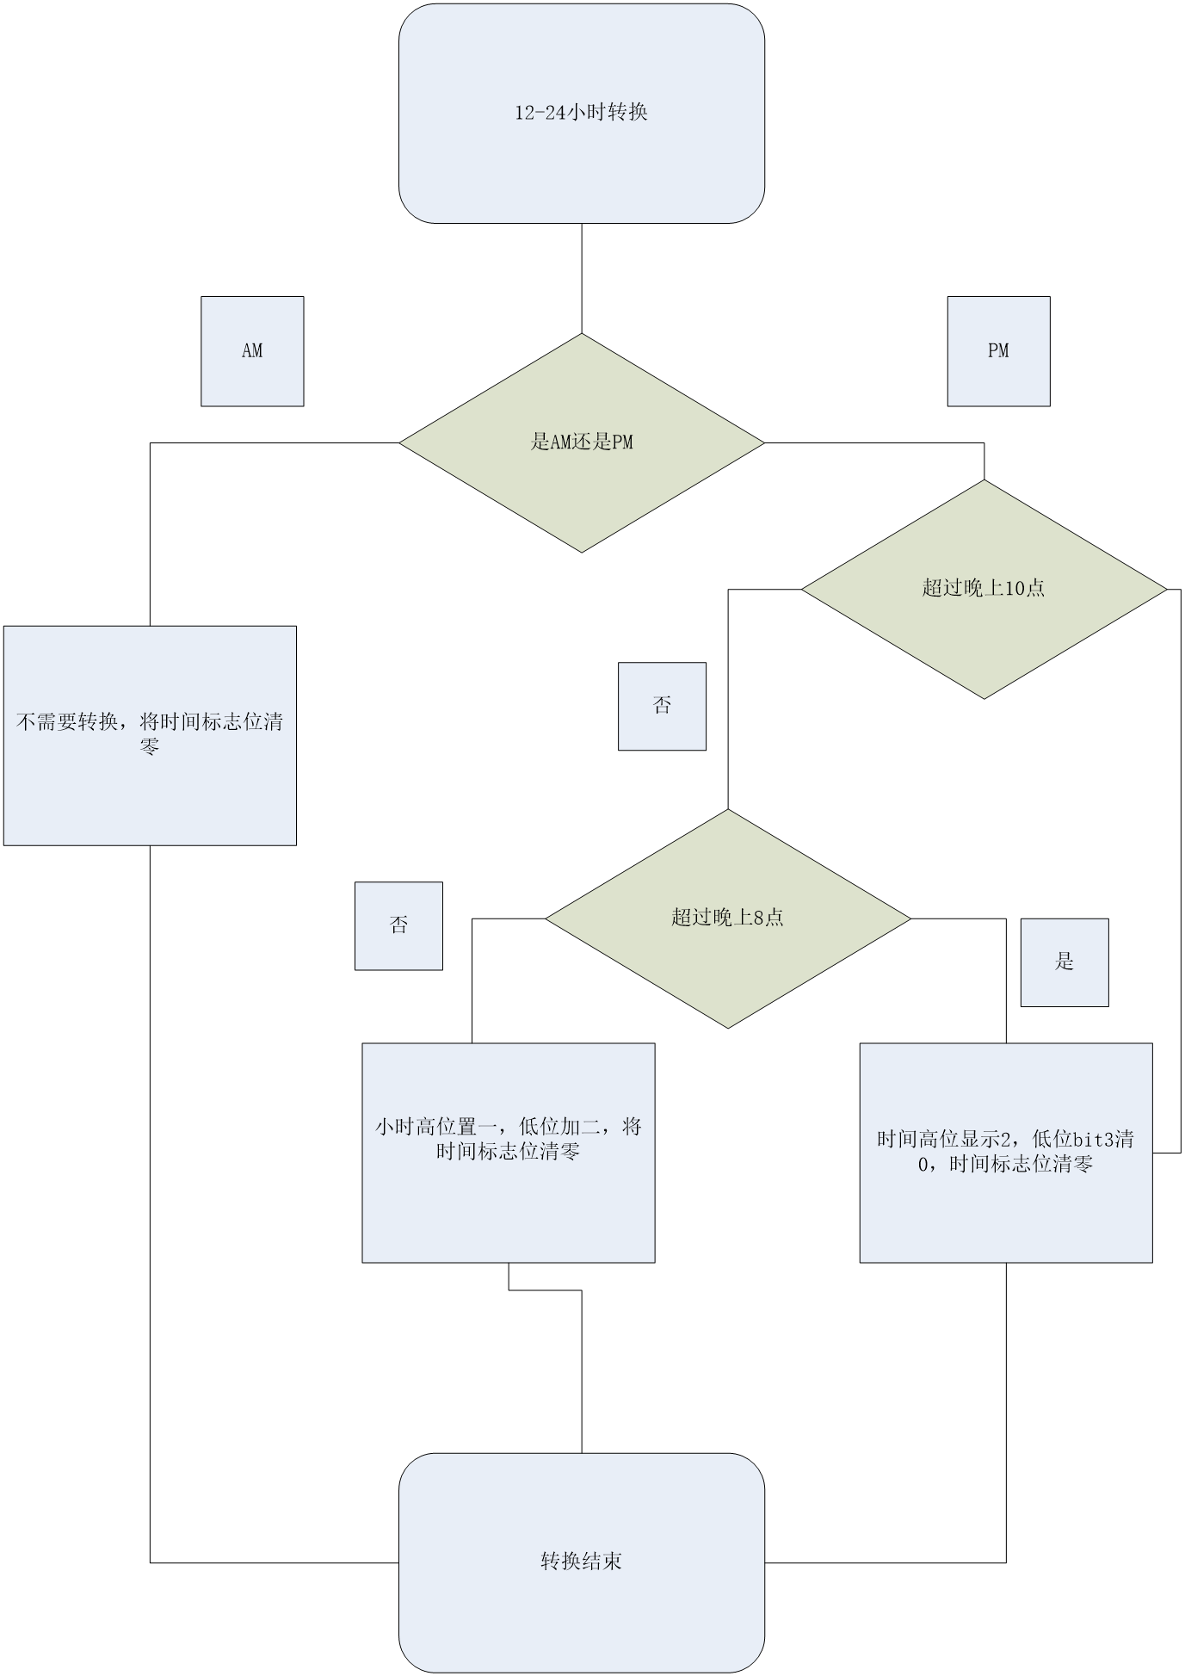

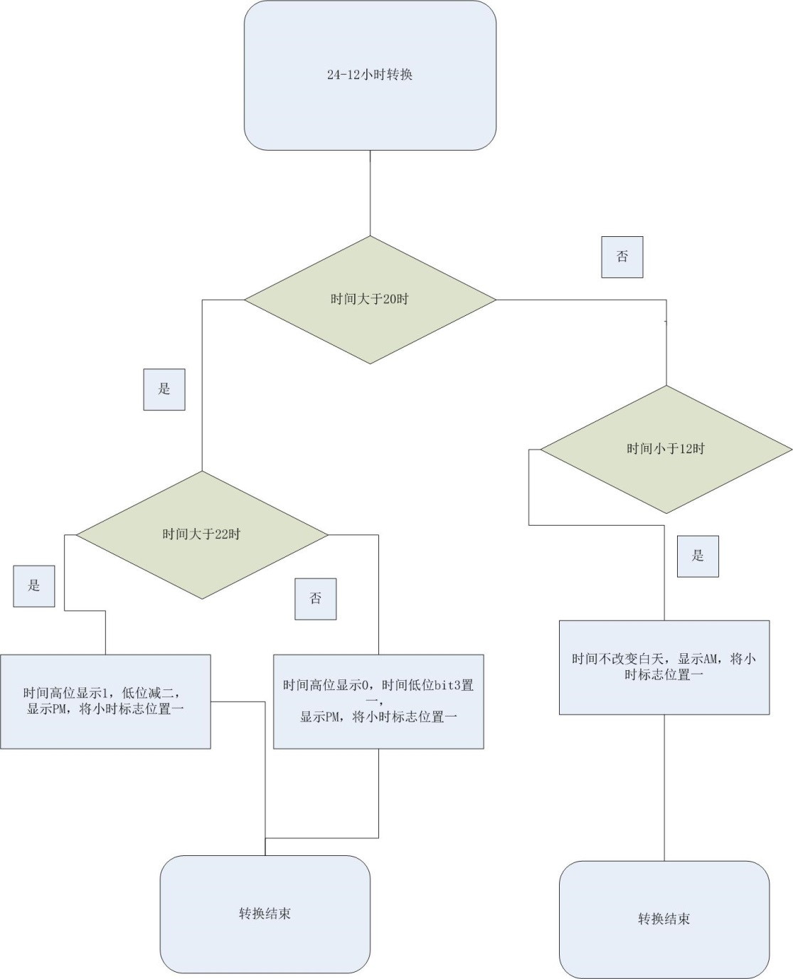

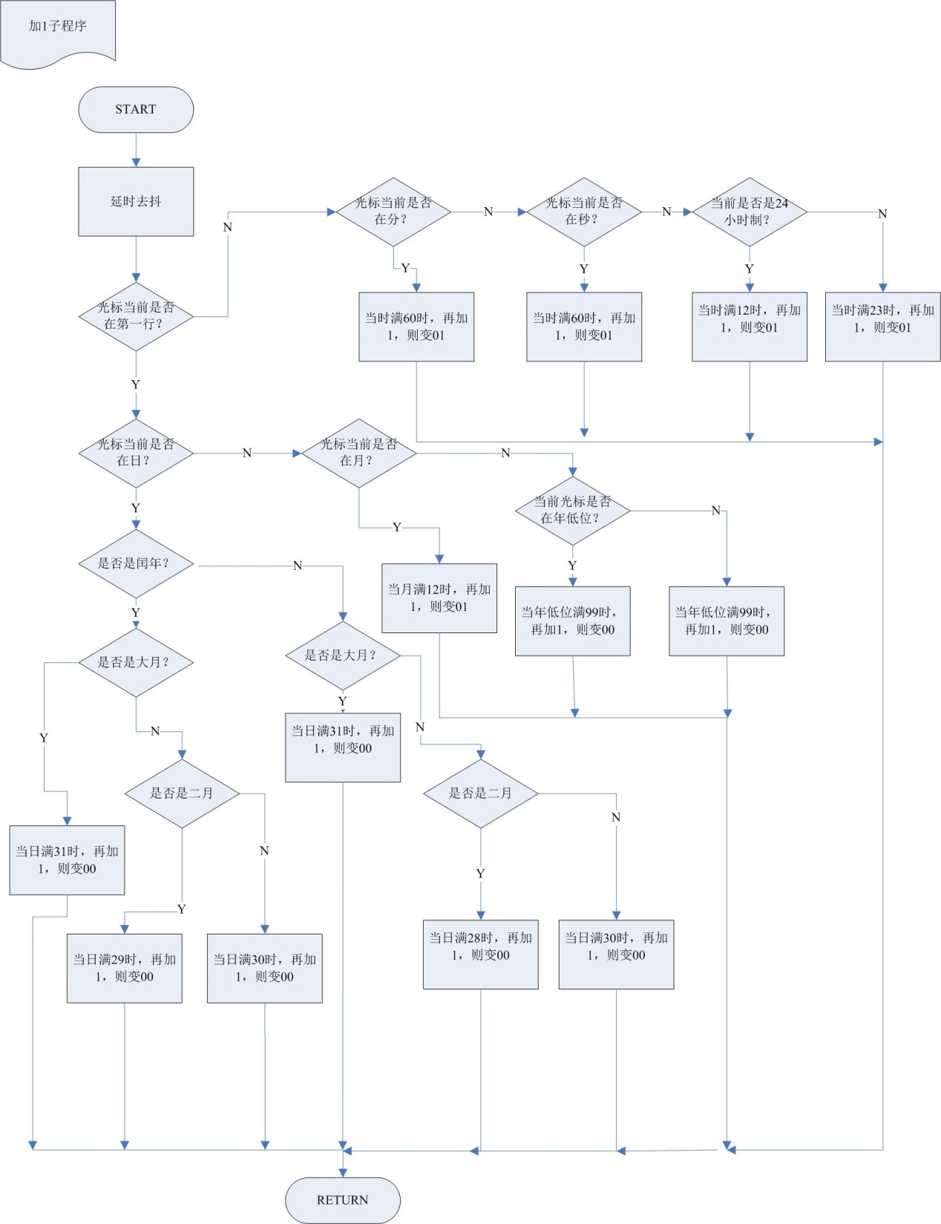

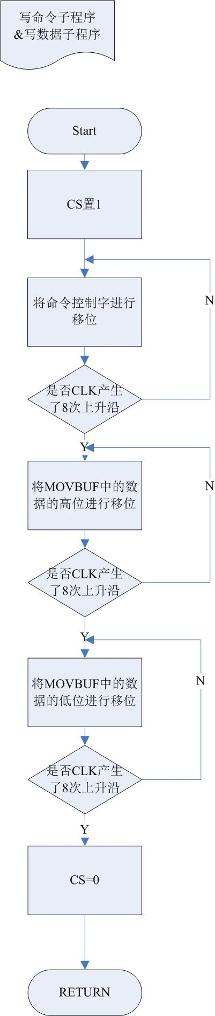 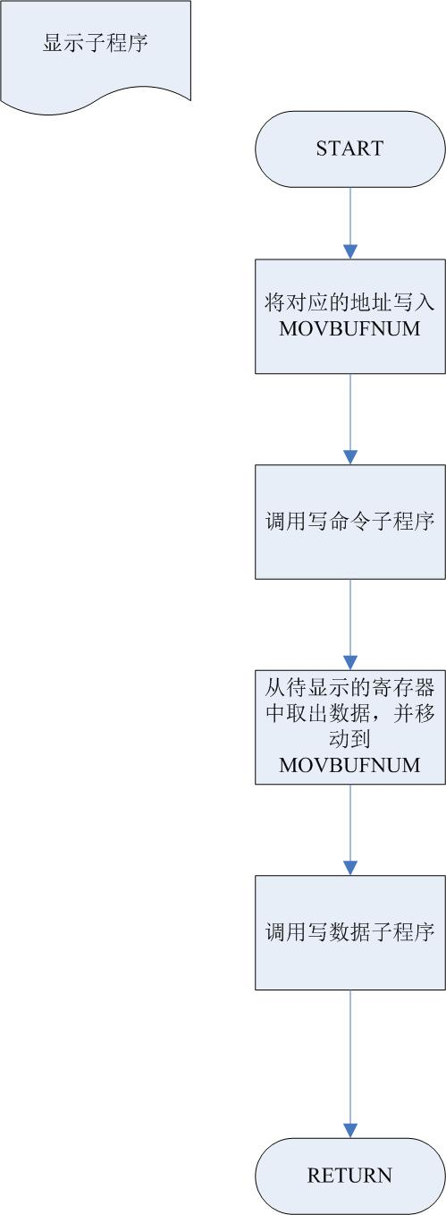

九、电子时钟的功能操作说明

1. 开机后，出现欢迎界面

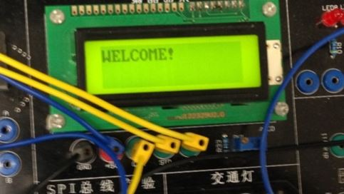

按照题目要求，主要分为三大部分：

1. 自主计时：即像正常的时钟一样，可以实现计时，并测量温度，且进行24小时制，12小时制的互相切换

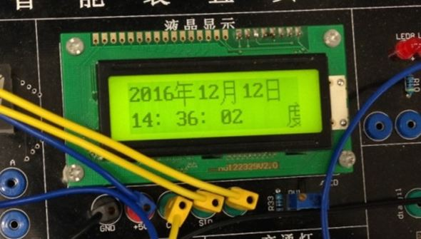

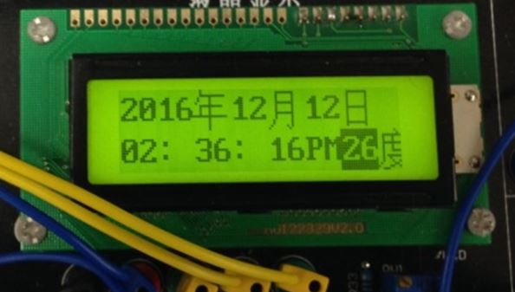

1. 更改时间：当重启实验箱或由于故障时间错误时，能够通过按键进行时间的更改；

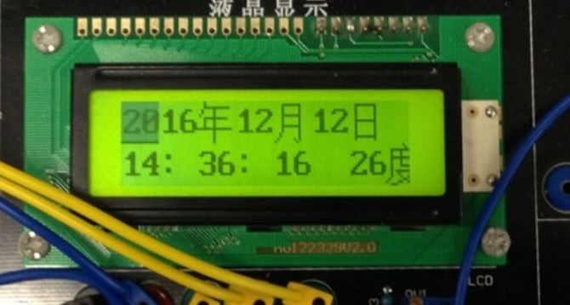

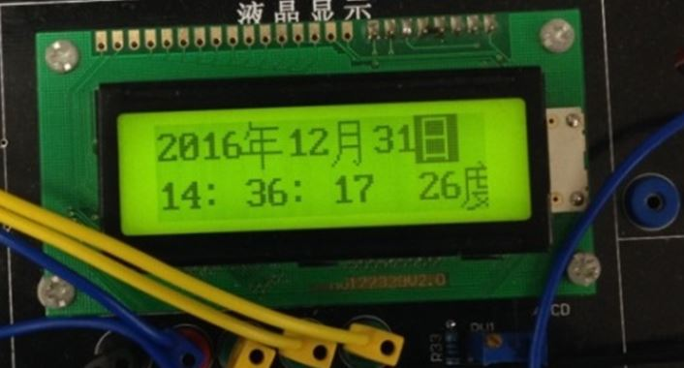

1. 掉电保护：当瞬间失电，重启后保留除秒意外的其他时间位，这样调整时间会非常的方便。

功能一是自主功能，我们不需要任何操作，其实质是单片机内部的定时器与程序判断的结合工作。功能二通过PBO选择进入/退出调整时间功能，PB1实现24/12小时的切换，并能够显示上下午，PB2移动光标，PB4实现数字的加。

功能三主要依靠单片机的EEPROM实现掉电保护，EEPROM稳定，并可多次擦写。

十、误差分析

在实验室测试的时候，我们设计的时钟误差非常大。每一分钟慢3秒。这个误差真是相当地可怕，这相当于一天下来，我们设计的电子表少了一个多小时。在仔细分析问题后，我们发现这些问题：

1. 程序是每过1s，就向EEPROM写入月、日、时、分。将数据写入EEPROM是一个极其耗时的过程。所以之后我改为每一分钟写入一次EEPROM
2. 关于温度转换，之前我是在程序开始进入温度模块的时候才启动AD，然后再判断标志位是否为0，以确定AD转换是否结束。这也很费时，于是我在每一秒的开始就启动了AD转换，由于程序是每10s检测一次温度，所以又把判断标志位语句删掉了。

做了以上处理后，我们再看看误差：

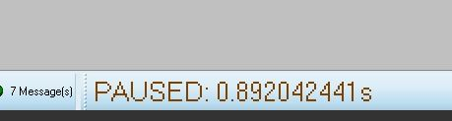这是我们设计的开机画面的持续时间

0.892042411s

将断点插在每一秒的开始

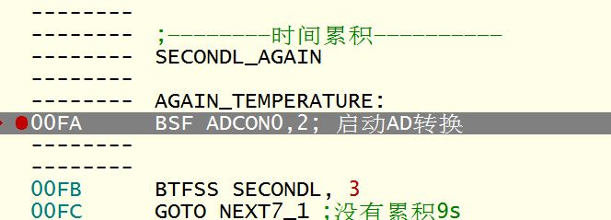

等待LCD屏幕上的数字走1min后,再与实际时间进行比较

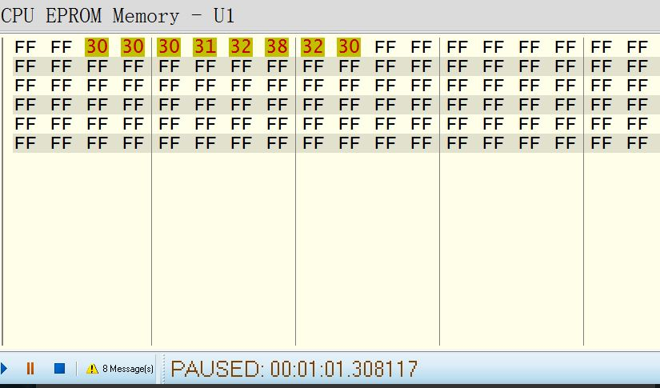

**寄存器分别代表小时与分钟**

减去开机的欢迎界面时间：61.308117s—0.892042411s = 60.41607459s

误差近似为0.416s，这相当于这个表1天24小时少走了不到10分钟。误差相比之前小了不少，但误差依然不小。

接下来，由于TMR0相对于TMR1来说精确度较差，所以我将原本用TMR0换成了用TMR1，再等待LCD屏幕上的数字走1min后,与实际时间进行比较。

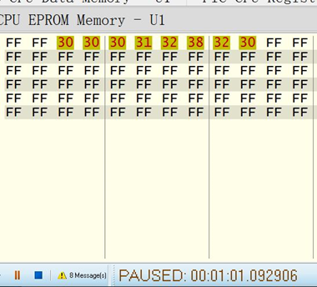如图所示

此时，每1min的误差缩小为 61.092906s—0.892042411s = 60.20086356s

误差为0.20086356s/min，这相当于该电子始终每走一天（24小时），会比实际时间少走了4.82min，不到5min，这个误差相比用TMR0来计时又小了不少！

对于剩下的误差，若想继续减小误差，直到忽略不计为止，我们需要从软件与硬件两方面入手。

软件方面，减少冗余程序与判断，改变程序构架。

硬件方面，设计针对特定运算的专用的芯片，以提升程序读写的速度。

十一、心得体会

十二、参考文献

《智能仪器仪表》 清华大学出版社 孙宏军 张涛 王超 编著

十三、附录

LIST P=16F877

#INCLUDE "P16F877.INC"

TMGENR1 EQU 20H

TMGENR2 EQU 21H

MOVNUM EQU 22H;循环数

MOVBUFCOM EQU 23H;命令控制字

MOVBUFNUM EQU 24H;命令控制数

BUFNUMH EQU 25H;命令控制数高位

BUFNUML EQU 26H;命令控制数低位

TIM0COUNT EQU 27H;TMR0循环

INIADDRESS EQU 28H;初始化用的地址

ININUM EQU 29H;初始化用的循环

SECONDL EQU 2AH

SECONDH EQU 2BH

MINUTEL EQU 2CH

MINUTEH EQU 2DH

HOURL EQU 2EH

HOURH EQU 2FH

DAYL EQU 30H

DAYH EQU 31H

MONTHL EQU 32H

MONTHH EQU 33H

YEAR1 EQU 34H

YEAR2 EQU 35H

YEAR3 EQU 36H

YEAR4 EQU 37H

ADDRESSTEMP EQU 38H

HOURFLAG EQU 39H

PAJUDGING EQU 3AH

FLAG EQU 3BH

TEM_REG EQU 3CH

TEMH EQU 3DH

TEML EQU 3EH

WELCOME EQU 3FH

PING_RUN_FLAG EQU 40H

ORG 0000H

GOTO MAIN

ORG 0004H

GOTO INTAD

ORG 0050H

MAIN

;——————————初始化————————————

BCF STATUS,RP0;BANK0

BCF STATUS,RP1

;;;;;;;;;

;;;;;;;;;;;

CLRF PING_RUN_FLAG

CLRF HOURFLAG

CLRF PORTB

CLRF INTCON

CLRF PORTC

CLRF ADRESH

MOVLW 41H

MOVWF ADCON0

BSF INTCON,GIE

BSF INTCON,PEIE

BSF INTCON,INTE

MOVLW .40

MOVWF TIM0COUNT

MOVLW 0FFH

MOVWF WELCOME

MOVLW 80H

MOVWF ADDRESSTEMP

BSF STATUS,RP0;BANK1

MOVLW 8EH

MOVWF ADCON1

BSF TRISA,0;RA0输入模式

CLRF TRISC; PORTC输出模式

BSF OPTION_REG,INTEDG

MOVLW 07H

MOVWF OPTION_REG

CLRF TRISC;PORTC OUTPUT

BSF TRISB,0; RB0输入

BSF TRISB,1

BSF TRISB,2

BSF TRISB,4

BCF STATUS,RP0;BANK0

;LCD INITIATION

MOVLW 01H

MOVWF MOVBUFNUM;00000001

CALL WRITING_COMMAND

MOVLW 20H;

MOVWF MOVBUFNUM

CALL WRITING_COMMAND;功能设定

MOVLW 02H

MOVWF MOVBUFNUM

CALL WRITING_COMMAND;地址归位

MOVLW 0CH

MOVWF MOVBUFNUM

CALL WRITING_COMMAND;显示状态

MOVLW 01H

MOVWF MOVBUFNUM;00000001

CALL WRITING_COMMAND

;欢迎界面

MOVLW 80H

MOVWF MOVBUFNUM

CALL WRITING_COMMAND

MOVLW 57H;W

MOVWF MOVBUFNUM

CALL WRITING_DATA

MOVLW 45H;E

MOVWF MOVBUFNUM

CALL WRITING_DATA

MOVLW 81H

MOVWF MOVBUFNUM

CALL WRITING_COMMAND

MOVLW 4CH;L

MOVWF MOVBUFNUM

CALL WRITING_DATA

MOVLW 43H;C

MOVWF MOVBUFNUM

CALL WRITING_DATA

MOVLW 82H

MOVWF MOVBUFNUM

CALL WRITING_COMMAND

MOVLW 4FH;O

MOVWF MOVBUFNUM

CALL WRITING_DATA

MOVLW 4DH;M

MOVWF MOVBUFNUM

CALL WRITING_DATA

MOVLW 83H

MOVWF MOVBUFNUM

CALL WRITING_COMMAND

MOVLW 45H;E

MOVWF MOVBUFNUM

CALL WRITING_DATA

MOVLW 21H;!

MOVWF MOVBUFNUM

CALL WRITING_DATA

WELCOME_AGAIN

CALL DELAY1

DECFSZ WELCOME,F

GOTO WELCOME_AGAIN

NOP;

MOVLW 38H;显示数字0，以进行初始化

MOVWF DAYL

MOVLW 32H

MOVWF DAYH

MOVLW 32H

MOVWF MONTHL

MOVLW 30H

MOVWF MONTHH

MOVLW 38H

MOVWF YEAR1

MOVLW 30H

MOVWF YEAR2

MOVLW 30H

MOVWF YEAR3

MOVLW 32H

MOVWF YEAR4

MOVLW 32H

MOVWF HOURH

MOVLW 33H

MOVWF HOURL

MOVLW 30H

MOVWF SECONDH

MOVWF MINUTEH

MOVLW 39H

MOVWF MINUTEL

MOVLW 30H

MOVWF SECONDL

CALL DISPLAY_YEAR

CALL DISPLAY_MONTH

CALL DISPLAY_DAY

CALL DISPLAY_HOUR

CALL DISPLAY_MINUTE

CALL DISPLAY_SECOND

;显示汉字年

MOVLW 82H

MOVWF MOVBUFNUM

CALL WRITING_COMMAND

MOVLW 0C4H; 显示YEAR

MOVWF MOVBUFNUM

CALL WRITING_DATA

MOVLW 0EAH

MOVWF MOVBUFNUM

CALL WRITING_DATA

;显示汉字月

MOVLW 84H

MOVWF MOVBUFNUM

CALL WRITING_COMMAND

MOVLW 0D4H; 显示MONTH

MOVWF MOVBUFNUM

CALL WRITING_DATA

MOVLW 0C2H

MOVWF MOVBUFNUM

CALL WRITING_DATA

;显示汉字日

MOVLW 86H

MOVWF MOVBUFNUM

CALL WRITING_COMMAND

MOVLW 0C8H; 显示DAY

MOVWF MOVBUFNUM

CALL WRITING_DATA

MOVLW 0D5H

MOVWF MOVBUFNUM

CALL WRITING_DATA

;显示：

MOVLW 91H

MOVWF MOVBUFNUM

CALL WRITING_COMMAND

MOVLW 3AH; 显示：

MOVWF MOVBUFNUM

CALL WRITING_DATA

;显示：

MOVLW 93H

MOVWF MOVBUFNUM

CALL WRITING_COMMAND

MOVLW 3AH;

MOVWF MOVBUFNUM

CALL WRITING_DATA

;显示汉字度

MOVLW 97H

MOVWF MOVBUFNUM

CALL WRITING_COMMAND

; 显示汉字度

MOVLW 0B6H

MOVWF MOVBUFNUM

CALL WRITING_DATA

MOVLW 0C8H;

MOVWF MOVBUFNUM

CALL WRITING_DATA

CALL EEPROM_LOAD

;————————时间累积——————————

SECONDL_AGAIN

AGAIN_TEMPERATURE:

BSF ADCON0,2; 启动AD转换

BTFSS SECONDL,3

GOTO NEXT7_1;没有累积9s

BTFSS SECONDL,0;第三位为1，那第零位是不是1呢？

GOTO NEXT7_1;不是9，是8

GOTO NEXT7_2

NEXT7_1

CALL TIM0_DELAY

INCF SECONDL,F

CALL DISPLAY_SECOND

GOTO SECONDL_AGAIN

NEXT7_2

CALL TIM0_DELAY

MOVLW 30H;是9，1S后置0重来

MOVWF SECONDL

BTFSS SECONDH,2

GOTO NEXT1_1;第2位=0

BTFSS SECONDH,0

GOTO NEXT1_1;此时secondh位为4

MOVLW 30H

MOVWF SECONDH

;——————————————————

MINUTE_ADD:

BTFSS MINUTEL,3

GOTO BACK_TO_SECOND;没有累积9s

BTFSS MINUTEL,0;第三位为1，那第零位是不是1呢？

GOTO BACK_TO_SECOND;不是9，是8

MOVLW 30H;是9，1S后置0重来

MOVWF MINUTEL

GOTO BACK_WITHOUT_ADD

BACK_TO_SECOND

INCF MINUTEL,F

GOTO NEXT2_2

BACK_WITHOUT_ADD

BTFSS MINUTEH,2

GOTO NEXT2_1;第2 位=0

BTFSS MINUTEH,0

GOTO NEXT2_1;此时MINUTEh位为4

MOVLW 30H

MOVWF MINUTEH

;———————— HOUR_ADD————————

HOUR_ADD:

BTFSS HOURH,1

GOTO NEXT3_3;HOURH不为2

GOTO NEXT3_4;HOURH是2

;

NEXT3_4

BTFSS HOURL,1

GOTO BACK_TO_MINUTE;不是3

BTFSS HOURL,0;第1位为1，那第0位是不是1呢？

GOTO BACK_TO_MINUTE;不是3，是2

MOVLW 30H;是9，1S后置0重来

MOVWF HOURL

MOVLW 30H

MOVWF HOURH

;_________DAY_ADD_______

;;;;;;;WO_li;;;;;;;;;;;;;先看是不是30号

;;;;;;;;;;;;;;判断平年和闰年,因为10位为奇数的年份，比如201x，203x，205x，末位数字为2,6，而偶数年份末位为0,4,8，所以先判断十位数，这是100年内有效的，但因为100是4的倍数，所以全部年份都有效

;YEAR1

;YEAR2

;YEAR3

;YEAR4

;;;;;;;;;

BTFSS YEAR2,0 ;;;;;;思路如上，先判断奇偶年份

GOTO TEST_YEAR__EVEN ;;不成立则为偶数年，判断其个位数是否为0,4,8

BTFSC YEAR1,0 ;2和6都是偶数，先排除奇数

GOTO PINGNIAN

BTFSS YEAR1,1

GOTO PINGNIAN ;;;这一位为0，则一定是4，或8或0，是平年

GOTO RUNNIAN

TEST_YEAR__EVEN ;;;;20EVENX

BTFSC YEAR1,0 ;;;;;;;;;0，4，8都是偶数，先排除奇数

GOTO PINGNIAN

BTFSC YEAR1,1 ;;;;;;;;权重为2，因为数字只有0-9，这一位成立一定是2或6，所以排除掉，剩下的则都是闰年

GOTO PINGNIAN

GOTO RUNNIAN

PINGNIAN

BCF PING_RUN_FLAG,0

GOTO THEN_

RUNNIAN

BSF PING_RUN_FLAG,0

THEN_

BTFSS MONTHH,0

GOTO __JANUARY__TO__SEPTEMBER

BTFSS MONTHL,1

GOTO OCT__OR__NOV

GOTO _DECEMBER

OCT__OR__NOV

BTFSS MONTHL,0

GOTO _OCTOBER

GOTO _NOVEMBER

__JANUARY__TO__SEPTEMBER

BTFSS MONTHL,3

GOTO __JAN__TO__JULY

BTFSS MONTHL,0

GOTO _AUGUST

GOTO _SEPTEMBER

__JAN__TO__JULY

BTFSS MONTHL,2

GOTO __JAN__TO__MARCH

BTFSS MONTHL,1

GOTO APRIL__MAY

BTFSS MONTHL,0

GOTO _JUNE

GOTO _JULY

APRIL__MAY

BTFSS MONTHL,0

GOTO _APRIL

GOTO _MAY

__JAN__TO__MARCH

BTFSS MONTHL,1

GOTO _JANUARY

BTFSS MONTHL,0

GOTO _FEBRUARY

GOTO _MARCH

_JANUARY

GOTO _31_LARGE_MONTH

_FEBRUARY

GOTO _LEAP_MONTH

_MARCH

GOTO _31_LARGE_MONTH

_APRIL

GOTO _30_LITTLE_MONTH

_MAY

GOTO _31_LARGE_MONTH

_JUNE

GOTO _30_LITTLE_MONTH

_JULY

GOTO _31_LARGE_MONTH

_AUGUST

GOTO _31_LARGE_MONTH

_SEPTEMBER

GOTO _30_LITTLE_MONTH

_OCTOBER

GOTO _31_LARGE_MONTH

_NOVEMBER

GOTO _30_LITTLE_MONTH

_DECEMBER

GOTO _31_LARGE_MONTH

_LEAP_MONTH

BTFSS PING_RUN_FLAG,0

GOTO _28_MONTH;平年

GOTO _29_MONTH;闰年

;;;;;;;;;;;;;;;;;;;;;;;;;;;

;;;;;;;;;;;;;;;;;;;;;;;;;;29天的进制

_29_MONTH

BTFSS DAYH,1

GOTO LESS_29TH ;;;;;;;;;没有到20号

BTFSS DAYL,3

GOTO LESS_29TH;;;;;;;;;;;没有到28号

BTFSS DAYL,0

GOTO LESS_29TH

MOVLW 31H

MOVWF DAYL

MOVLW 30H

MOVWF DAYH

GOTO TEST_MONTH

LESS_29TH

;;;;;;;;;;;;;;;;;;;;;;;

;;;;;;;;;;;;;;;;;;;;;;;没有到29号

BTFSS DAYL,3

GOTO INC_DAYL

BTFSS DAYL,0

GOTO INC_DAYL

MOVLW 30H

MOVWF DAYL

INCF DAYH,F

CALL DISPLAY

;;;;;;WO_Li

INC_DAYL

INCF DAYL,F

GOTO DISPLAY

DAY_HIGH_TEST

BTFSS DAYH,1

GOTO INC_HIGH

BTFSS DAYH,0

GOTO INC_HIGH

MOVLW 30H

MOVWF DAYH

GOTO TEST_MONTH

_28_MONTH

;;;;;;;;;;;;;;;;;;;;;;;;;;28天的进制

BTFSS DAYH,1

GOTO LESS_28TH

BTFSS DAYL,3

GOTO LESS_28TH

MOVLW 31H

MOVWF DAYL

MOVLW 30H

MOVWF DAYH

GOTO TEST_MONTH

LESS_28TH

；到28号,看是不是9已经满了

BTFSS DAYL,3

GOTO INC_DAYL_

BTFSS DAYL,0

GOTO INC_DAYL_

MOVLW 30H

MOVWF DAYL

INCF DAYH,F

GOTO DISPLAY

INC_DAYL_

INCF DAYL,F

GOTO DISPLAY

DAY_HIGH_TEST_

BTFSS DAYH,1

GOTO INC_HIGH

BTFSS DAYH,0

GOTO INC_HIGH

MOVLW 30H

MOVWF DAYH

GOTO TEST_MONTH

_31_LARGE_MONTH

BTFSS DAYH,1

GOTO LESS_31TH ;;;小于20号

BTFSS DAYH,0

GOTO LESS_31TH ;;;小于30号

BTFSS DAYL,0

GOTO LESS_31TH

MOVLW 31H

MOVWF DAYL

MOVLW 30H

MOVWF DAYH

GOTO TEST_MONTH

LESS_31TH

;;;;;;;;;;;;;;;;;;;;;;;没有到31号

;BTFSS DAYH,1

;GOTO LESS__30TH

;BTFSS DAYH,1

;GOTO LESS__30TH

;INCF DAYL,F

;GOTO DISPLAY

LESS__31TH

BTFSS DAYL,3

GOTO INC__DAYL

BTFSS DAYL,0

GOTO INC__DAYL

MOVLW 30H

MOVWF DAYL

INCF DAYH,F

GOTO DISPLAY

;;;;;;WO_Li

INC__DAYL

INCF DAYL,F

GOTO DISPLAY

DAY__HIGH_TEST

BTFSS DAYH,1

GOTO INC_HIGH

BTFSS DAYH,0

GOTO INC_HIGH

MOVLW 30H

MOVWF DAYH

GOTO TEST_MONTH

;;;;日满了进月;;;Wo_Li

_30_LITTLE_MONTH

BTFSS DAYH,1

GOTO LESS_30TH

BTFSS DAYH,1

GOTO LESS_30TH

MOVLW 31H

MOVWF DAYL

MOVLW 30H

MOVWF DAYH

GOTO TEST_MONTH

LESS_30TH

;;;;;;;;;;;;;;;;;;;;;;;没有到30号

BTFSS DAYL,3

GOTO INC_DAYL___

BTFSS DAYL,0

GOTO INC_DAYL___

MOVLW 30H

MOVWF DAYL

GOTO DAY_HIGH_TEST___

INC_DAYL___

INCF DAYL,F

GOTO DISPLAY

DAY_HIGH_TEST___

BTFSS DAYH,1

GOTO INC_HIGH

BTFSS DAYH,0

GOTO INC_HIGH

MOVLW 30H

MOVWF DAYH

;;;;日满了进月;;;Wo_Li

;;;;;;;;;;;;;;;;;;;;;;;;;;

TEST_MONTH

BTFSS MONTHH,0

GOTO ADD__MONTH_LOW

BTFSS MONTHL,1

GOTO ADD__MONTH_LOW

MOVLW 31H

MOVWF MONTHL

MOVLW 30H

MOVWF MONTHH

TEST_YEAR_1TO4

BTFSS YEAR1,3

GOTO YEAR_ADD_BIT0

BTFSS YEAR1,0

GOTO YEAR_ADD_BIT0

MOVLW 30H

MOVWF YEAR1

GOTO TEST_YEAR2

YEAR_ADD_BIT0

INCF YEAR1,F

GOTO DISPLAY

TEST_YEAR2

BTFSS YEAR2,3

GOTO YEAR_ADD_BIT1

BTFSS YEAR2,0

GOTO YEAR_ADD_BIT1

MOVLW 30H

MOVWF YEAR2

GOTO TEST_YEAR3

YEAR_ADD_BIT1

INCF YEAR2,F

GOTO DISPLAY

TEST_YEAR3

BTFSS YEAR3,3

GOTO YEAR_ADD_BIT2

BTFSS YEAR3,0

GOTO YEAR_ADD_BIT2

MOVLW 30H

MOVWF YEAR3

GOTO TEST_YEAR4

YEAR_ADD_BIT2

INCF YEAR3,F

GOTO DISPLAY

TEST_YEAR4

BTFSS YEAR4,3

GOTO YEAR_ADD_BIT3

BTFSS YEAR4,0

GOTO YEAR_ADD_BIT3

MOVLW 30H

MOVWF YEAR4

GOTO DISPLAY

YEAR_ADD_BIT3

INCF YEAR4,F

GOTO DISPLAY

;;;;;;;;;不是11月，不是12月

ADD__MONTH_LOW

BTFSS MONTHL,3

GOTO ADD_LOW

BTFSS MONTHL,0

GOTO ADD_LOW

MOVLW 30H

MOVWF MONTHL

MOVLW 31H

MOVWF MONTHH

GOTO DISPLAY

ADD_LOW

INCF MONTHL

GOTO DISPLAY

INC_HIGH

INCF DAYH

DISPLAY

CALL DISPLAY_DAY

CALL DISPLAY_MONTH

CALL DISPLAY_YEAR

GOTO NEXT3_2

NEXT3_3

BTFSS HOURL,3

GOTO BACK_TO_MINUTE;没有累积9s

BTFSS HOURL,0;第三位为1，那第零位是不是1呢？

GOTO BACK_TO_MINUTE;不是9，是8

MOVLW 30H;是9，1S后置0重来

MOVWF HOURL

GOTO BACK_WITHOUT_ADDH

BACK_TO_MINUTE

INCF HOURL,F

GOTO NEXT3_2

BACK_WITHOUT_ADDH

INCF HOURH,F

NEXT3_2

CALL DISPLAY_HOUR

GOTO NEXT2_2

NEXT2_1

INCF MINUTEH,F

NEXT2_2

CALL DISPLAY_MINUTE

CALL EEPROM_SAVE

GOTO NEXT1_2

NEXT1_1

INCF SECONDH,F

NEXT1_2

CALL DISPLAY_SECOND

;;;;;temperature

;LOOP_TEM:

;BTFSC ADCON0,2

;GOTO LOOP_TEM; GO/DONE=1，还没有转换完毕

BSF STATUS,RP0

MOVF ADRESL,W

BCF STATUS,RP0

MOVWF TEM_REG

BTFSS TEM_REG,7

GOTO NEXT20_1

BTFSS TEM_REG,6

GOTO TEM_32

BTFSS TEM_REG,5

GOTO TEM_33

GOTO TEM_34

NEXT20_1

BTFSS TEM_REG,6

GOTO NEXT20_2

GOTO TEM_31

NEXT20_2

BTFSS TEM_REG,5

GOTO TEM_29

GOTO TEM_30

TEM_29

MOVLW 32H

MOVWF TEMH

MOVLW 39H

MOVWF TEML

CALL DISPLAY_TEMP

GOTO NEXT20_5

TEM_30

MOVLW 33H

MOVWF TEMH

MOVLW 30H

MOVWF TEML

CALL DISPLAY_TEMP

GOTO NEXT20_5

TEM_31

MOVLW 33H

MOVWF TEMH

MOVLW 31H

MOVWF TEML

CALL DISPLAY_TEMP

GOTO NEXT20_5

TEM_32

MOVLW 33H

MOVWF TEMH

MOVLW 32H

MOVWF TEML

CALL DISPLAY_TEMP

GOTO NEXT20_5

TEM_33

MOVLW 33H

MOVWF TEMH

MOVLW 33H

MOVWF TEML

CALL DISPLAY_TEMP

GOTO NEXT20_5

TEM_34

MOVLW 33H

MOVWF TEMH

MOVLW 34H

MOVWF TEML

CALL DISPLAY_TEMP

GOTO NEXT20_5

NEXT20_5

GOTO SECONDL_AGAIN

GOTO ENDING

;————————下面全都是子函数 ————————

INTAD;RB0是用来进入中断的功能开始键

NOP

PB0_DOWN_OVER

BTFSC PORTB,0

GOTO NEXT_FUNCTION

GOTO PB0_DOWN_OVER

NEXT_FUNCTION

MOVLW 80H

MOVWF MOVBUFNUM;首地址

CALL WRITING_COMMAND

MOVLW 0FH

MOVWF MOVBUFNUM;光标闪烁

CALL WRITING_COMMAND

SCAN_AGAIN

BTFSC PORTB,0

GOTO CONTINUE_SCAN1;RB0=1

GOTO DISCERN_PB0;RB0=0;按下

CONTINUE_SCAN1:

BTFSC PORTB,1

GOTO CONTINUE_SCAN2

GOTO DISCERN_PB1;PB1=0;PRESS,24/12

CONTINUE_SCAN2

BTFSC PORTB,2

GOTO CONTINUE_SCAN4

GOTO DISCERN_PB2;PB2=0;PRESS,moving right

CONTINUE_SCAN4

BTFSC PORTB,4

GOTO SCAN_AGAIN

GOTO DISCERN_PB4;PB4=0;PRESS,adding

;24/12 FUNCTION

DISCERN_PB1

NOP

PB1_DOWN_OVER

BTFSC PORTB,1

GOTO NEXT_24_12

GOTO PB1_DOWN_OVER

NEXT_24_12

BTFSS HOURFLAG,0

GOTO _24_TO_12;HOURFLAG=0

GOTO _12_TO_24;HOURFLAG=1

;

_24_TO_12

BTFSS HOURH,1

GOTO HOURH_NOT_TWO;不是2X

GOTO HOURH_IS_2;是2X

HOURH_NOT_TWO

BTFSS HOURH,0

GOTO LESS_12

BTFSS HOURL,3

GOTO NEXT5_1;HOURL.3=0

GOTO ABOVE_12

NEXT5_1

BTFSS HOURL,2

GOTO NEXT5_2

GOTO ABOVE_12

NEXT5_2

BTFSS HOURL,1

GOTO LESS_12

BTFSS HOURL,0;2_OR_3?

GOTO LESS_12

GOTO ABOVE_12

LESS_12

;显示AM

MOVLW 95H

MOVWF MOVBUFNUM;地址

CALL WRITING_COMMAND

MOVLW 41H;A

MOVWF PAJUDGING

MOVWF MOVBUFNUM

CALL WRITING_DATA

MOVLW 4DH;M

MOVWF MOVBUFNUM

CALL WRITING_DATA

BSF HOURFLAG,0

GOTO SWITCH_OVER

;

ABOVE_12

MOVLW 30H

MOVWF HOURH

CALL DISPLAY_HOUR

MOVLW 02H

SUBWF HOURL,F

CALL DISPLAY_HOUR

MOVLW 95H

MOVWF MOVBUFNUM;地址

CALL WRITING_COMMAND

MOVLW 50H;P

MOVWF PAJUDGING

MOVWF MOVBUFNUM

CALL WRITING_DATA

MOVLW 4DH;M

MOVWF MOVBUFNUM

CALL WRITING_DATA

BSF HOURFLAG,0

GOTO SWITCH_OVER

;

HOURH_IS_2

BTFSS HOURL,1

GOTO NEXT5_4;1OR0

;——————2OR3————

MOVLW 02H;3

SUBWF HOURL,F

MOVLW 31H

MOVWF HOURH

GOTO NEXT5_5

;————————

NEXT5_4

MOVLW 30H

MOVWF HOURH

BSF HOURL,3

NEXT5_5

CALL DISPLAY_HOUR

;显示PM

MOVLW 95H

MOVWF MOVBUFNUM;地址

CALL WRITING_COMMAND

MOVLW 50H;P

MOVWF PAJUDGING

MOVWF MOVBUFNUM

CALL WRITING_DATA

MOVLW 4DH;M

MOVWF MOVBUFNUM

CALL WRITING_DATA

BSF HOURFLAG,0

GOTO SWITCH_OVER

;

_12_TO_24

NOP

BTFSS PAJUDGING,4

GOTO MORNING

GOTO AFTERNOON

MORNING

MOVLW 95H

MOVWF MOVBUFNUM;地址

CALL WRITING_COMMAND

MOVLW 20H;空格

MOVWF MOVBUFNUM

CALL WRITING_DATA

MOVLW 20H;空格

MOVWF MOVBUFNUM

CALL WRITING_DATA

BCF HOURFLAG,0

GOTO SWITCH_OVER

AFTERNOON

BTFSC HOURH,0

GOTO EVENING;HOURH.1=1,晚10点或11点

BTFSS HOURL,3

GOTO _PM_1_TO_7

GOTO EVENING

_PM_1_TO_7

;1点到7点

MOVLW 31H

MOVWF HOURH

MOVLW 02H

ADDWF HOURL,F

CALL DISPLAY_HOUR

MOVLW 95H

MOVWF MOVBUFNUM;地址

CALL WRITING_COMMAND

MOVLW 20H;空格

MOVWF MOVBUFNUM

CALL WRITING_DATA

MOVLW 20H;空格

MOVWF MOVBUFNUM

CALL WRITING_DATA

BCF HOURFLAG,0

GOTO SWITCH_OVER

;

EVENING;晚上8点到11点

BTFSC HOURL,3

GOTO _PM_8_TO_9

GOTO NIGHT

_PM_8_TO_9

MOVLW 32H

MOVWF HOURH

BCF HOURL,3

CALL DISPLAY_HOUR

MOVLW 95H

MOVWF MOVBUFNUM;地址

CALL WRITING_COMMAND

MOVLW 20H;空格

MOVWF MOVBUFNUM

CALL WRITING_DATA

MOVLW 20H;空格

MOVWF MOVBUFNUM

CALL WRITING_DATA

BCF HOURFLAG,0

GOTO SWITCH_OVER

;

NIGHT

MOVLW 32H

MOVWF HOURH

MOVLW 02H

ADDWF HOURL,F

CALL DISPLAY_HOUR

MOVLW 95H

MOVWF MOVBUFNUM;地址

CALL WRITING_COMMAND

MOVLW 20H;空格

MOVWF MOVBUFNUM

CALL WRITING_DATA

MOVLW 20H;空格

MOVWF MOVBUFNUM

CALL WRITING_DATA

BCF HOURFLAG,0

;

SWITCH_OVER

GOTO AGAIN_INT

;MOVING FUNCTION

DISCERN_PB2

PB2_DOWN_OVER

BTFSC PORTB,2

GOTO NEXT_MOVING

GOTO PB2_DOWN_OVER

NEXT_MOVING

BTFSS ADDRESSTEMP,4

GOTO IT_IS_EIGHT

GOTO IT_IS_NINE

;

IT_IS_EIGHT

BTFSS ADDRESSTEMP,2

GOTO JUST_DO_IT;!=1

BTFSS ADDRESSTEMP,1

GOTO JUST_DO_IT;!=1

BTFSS ADDRESSTEMP,0

GOTO JUST_DO_IT;!=1

MOVLW 90H

MOVWF ADDRESSTEMP

GOTO THEN_DISPLAY

;

IT_IS_NINE

BTFSS ADDRESSTEMP,2

GOTO JUST_DO_IT;!=1

BTFSS ADDRESSTEMP,1

GOTO JUST_DO_IT;!=1

BTFSS ADDRESSTEMP,0

GOTO JUST_DO_IT;!=1

MOVLW 80H

MOVWF ADDRESSTEMP

GOTO THEN_DISPLAY

NOP

JUST_DO_IT

INCF ADDRESSTEMP,F

THEN_DISPLAY

MOVF ADDRESSTEMP,W

MOVWF MOVBUFNUM;首地址

CALL WRITING_COMMAND

CALL DELAY

CALL DELAY

CALL DELAY

GOTO AGAIN_INT

——adding function———

DISCERN_PB4

NOP

PB4_DOWN_OVER

BTFSC PORTB,4

GOTO ADDING_ONE

GOTO PB4_DOWN_OVER

ADDING_ONE

BTFSS ADDRESSTEMP,4

GOTO ROW_1; 8XH

GOTO ROW_2; 9XH

ROW_1

BTFSS ADDRESSTEMP,2

GOTO CONSUME_1

;现在所在位是日

BTFSS MONTHH,0

GOTO _JANUARY_TO_SEPTEMBER_____

BTFSS MONTHL,1

GOTO OCT_OR_NOV

GOTO DECEMBER

OCT_OR_NOV

BTFSS MONTHL,0

GOTO OCTOBER

GOTO NOVEMBER

_JANUARY_TO_SEPTEMBER_____

BTFSS MONTHL,3

GOTO _JAN_TO_JULY

BTFSS MONTHL,0

GOTO AUGUST

GOTO SEPTEMBER

_JAN_TO_JULY

BTFSS MONTHL,2

GOTO JAN_TO_MARCH

BTFSS MONTHL,1

GOTO APRIL_MAY

BTFSS MONTHL,0

GOTO JUNE

GOTO JULY

APRIL_MAY

BTFSS MONTHL,0

GOTO APRIL

GOTO MAY

JAN_TO_MARCH

BTFSS MONTHL,1

GOTO JANUARY

BTFSS MONTHL,0

GOTO FEBRUARY

GOTO MARCH

SPECIAL_MONTH

BTFSS PING_RUN_FLAG,0

GOTO _28_MONTH_;平年

GOTO _29_MONTH__;闰年

_29_MONTH__

NOP

BTFSS DAYH,1

GOTO LESS__29TH ;;;;;;;;;没有到20号

BTFSS DAYL,3

GOTO LESS__29TH;;;;;;;;;;;没有到28号

BTFSS DAYL,0

GOTO LESS__29TH

MOVLW 31H

MOVWF DAYL

MOVLW 30H

MOVWF DAYH

CALL DISPLAY_DAY

GOTO AGAIN_INT

LESS__29TH

;;;;;;;;;;;;;;;;;;;;;;;

;;;;;;;;;;;;;;;;;;;;;;;没有到29号

BTFSS DAYL,3

GOTO INC__DAYL__

BTFSS DAYL,0

GOTO INC__DAYL__

MOVLW 30H

MOVWF DAYL

INCF DAYH,F

CALL DISPLAY_DAY

GOTO AGAIN_INT

;;;;;;WO_Li

INC__DAYL__

INCF DAYL,F

CALL DISPLAY_DAY

GOTO AGAIN_INT

BTFSS DAYH,1

GOTO INC_HIGH

BTFSS DAYH,0

GOTO INC_HIGH

MOVLW 30H

MOVWF DAYH

CALL DISPLAY_DAY

GOTO AGAIN_INT

_28_MONTH_

BTFSS DAYH,1

GOTO S_LESS_20;比20号要小

BTFSS DAYL,3

GOTO S_EASY_ADDING;不到28号

MOVLW 31H

MOVWF DAYL

MOVLW 30H

MOVWF DAYH

CALL DISPLAY_DAY

GOTO AGAIN_INT

S_LESS_20

BTFSS DAYL,3

GOTO S_EASY_ADDING

BTFSS DAYL,0

GOTO S_EASY_ADDING

MOVLW 30H

MOVWF DAYL

INCF DAYH,F

NEXT21_1

CALL DISPLAY_DAY

GOTO AGAIN_INT

S_EASY_ADDING

INCF DAYL,F

GOTO NEXT21_1

BIG_MONTH

BTFSS DAYH,1

GOTO B_LESS_30

BTFSS DAYH,0

GOTO B_LESS_30

BTFSS DAYL,0

GOTO B_30TH

MOVLW 30H;31ST

MOVWF DAYH

MOVLW 31H

MOVWF DAYL

CALL DISPLAY_DAY

GOTO AGAIN_INT

B_30TH

INCF DAYL,F

CALL DISPLAY_DAY

GOTO AGAIN_INT

B_LESS_30

BTFSS DAYL,3

GOTO NEXT16_2;日最低位不是9

BTFSS DAYL,0

GOTO NEXT16_2;日最低位不是9，是8

MOVLW 30H

MOVWF DAYL

BTFSS DAYH,1

GOTO NEXT16_1;日最高位不是3

BTFSS DAYH,0

GOTO NEXT16_1;日最高位不是3

BTFSS DAYL,0

GOTO B_30TH

MOVLW 30H;31ST

MOVWF DAYH

MOVLW 31H

MOVWF DAYL

CALL DISPLAY_DAY

GOTO AGAIN_INT

MOVLW 30H

MOVWF DAYH

GOTO NEXT16_3

NEXT16_1

INCF DAYH,F;先累加日的高位

NEXT16_3

CALL DISPLAY_DAY

GOTO AGAIN_INT

NEXT16_2

INCF DAYL,F

CALL DISPLAY_DAY

GOTO AGAIN_INT

JANUARY

GOTO BIG_MONTH

FEBRUARY

GOTO SPECIAL_MONTH

MARCH

GOTO BIG_MONTH

APRIL

GOTO LITTLE_MONTH

MAY

GOTO BIG_MONTH

JUNE

GOTO LITTLE_MONTH

JULY

GOTO BIG_MONTH

AUGUST

GOTO BIG_MONTH

SEPTEMBER

GOTO LITTLE_MONTH

OCTOBER

GOTO BIG_MONTH

NOVEMBER

GOTO LITTLE_MONTH

DECEMBER

GOTO BIG_MONTH

LITTLE_MONTH

BTFSS DAYH,1

GOTO _LESS_30

BTFSS DAYH,0

GOTO _LESS_30

MOVLW 30H

MOVWF DAYH

MOVLW 31H

MOVWF DAYL

CALL DISPLAY_DAY

GOTO AGAIN_INT;;;;;;;;;;;;;;;;;;;;;;;;;;;;

_LESS_30

BTFSS DAYL,3

GOTO NEXT6_2;日最低位不是9

BTFSS DAYL,0

GOTO NEXT6_2;日最低位不是9，是8

MOVLW 30H

MOVWF DAYL

BTFSS DAYH,1

GOTO NEXT6_1;日最高位不是3

BTFSS DAYH,0

GOTO NEXT6_1;日最高位不是3

MOVLW 30H

MOVWF DAYH

GOTO NEXT6_3

NEXT6_1

INCF DAYH,F;先累加日的高位

NEXT6_3

CALL DISPLAY_DAY

GOTO AGAIN_INT

NEXT6_2

INCF DAYL,F

CALL DISPLAY_DAY

GOTO AGAIN_INT

CONSUME_1

BTFSS ADDRESSTEMP,1

GOTO CONSUME_2

;现在的位置是月

MONTH_adding

BTFSS MONTHH,0

GOTO JAN_SEP

GOTO OCT_DEC

JAN_SEP

BTFSS MONTHL,3

GOTO NEXT9_2;月最低位不是9

BTFSS MONTHL,0

GOTO NEXT9_2;月最低位不是9，是8

MOVLW 30H

MOVWF MONTHL

MOVLW 31H

MOVWF MONTHH

GOTO NEXT9_1

NEXT9_2

INCF MONTHL,F

NEXT9_1

CALL DISPLAY_MONTH

GOTO AGAIN_INT

OCT_DEC

BTFSS MONTHL,1

GOTO NEXT9_3;月最低位不是2

MOVLW 30H

MOVWF MONTHL

MOVLW 30H

MOVWF MONTHH

GOTO NEXT9_4

NEXT9_3

INCF MONTHL,F

NEXT9_4

CALL DISPLAY_MONTH

GOTO AGAIN_INT

NOP

CONSUME_2

BTFSS ADDRESSTEMP,0

GOTO YEAR_H_SETTING

;现在所处位置是YEAR_L_SETTING

BTFSS YEAR1,3

GOTO NEXT8_2;年最低位不是9

BTFSS YEAR1,0

GOTO NEXT8_2;年最低位不是9，是8

MOVLW 30H

MOVWF YEAR1

BTFSS YEAR2,3

GOTO NEXT8_3;年最GAO位不是9

BTFSS YEAR2,0

GOTO NEXT8_3;年最GAO位不是9，是8

MOVLW 30H

MOVWF YEAR2

BTFSS YEAR3,3

GOTO NEXT8_4;年H最低位不是9

BTFSS YEAR3,0

GOTO NEXT8_4;年H最低位不是9，是8

MOVLW 30H

MOVWF YEAR3

BTFSS YEAR4,3

GOTO NEXT8_5;年H最GAO位不是9

BTFSS YEAR4,0

GOTO NEXT8_5;年H最GAO位不是9，是8

MOVLW 30H

MOVWF YEAR4

GOTO NEXT8_1

NEXT8_3

INCF YEAR2,F

GOTO NEXT8_1

NEXT8_4

INCF YEAR3,F

GOTO NEXT8_1

NEXT8_5

INCF YEAR4,F

GOTO NEXT8_1

NEXT8_2

INCF YEAR1,F

NEXT8_1

CALL DISPLAY_YEAR

GOTO AGAIN_INT

YEAR_H_SETTING

BTFSS YEAR3,3

GOTO NEXT10_2;年最低位不是9

BTFSS YEAR3,0

GOTO NEXT10_2;年最低位不是9，是8

MOVLW 30H

MOVWF YEAR3

BTFSS YEAR4,3

GOTO NEXT10_3;年最GAO位不是9

BTFSS YEAR4,0

GOTO NEXT10_3;年最GAO位不是9，是8

MOVLW 30H

MOVWF YEAR4

GOTO NEXT10_1

NEXT10_3

INCF YEAR4,F

GOTO NEXT10_1

NEXT10_2

INCF YEAR3,F

NEXT10_1

CALL DISPLAY_YEAR

GOTO AGAIN_INT

ROW_2

NOP

BTFSS ADDRESSTEMP,2

GOTO GO_ON1

BTFSS ADDRESSTEMP,0;SECOND_OR_AP

GOTO SECOND_ADDING

GOTO _P_A_CHANGING

;ADDING SECOND

;;;;;;显示年，月，日，时分秒，注意进制，分，秒为60

;;;;;;参数说明：FLAG用来判断得到的数是几

SECOND_ADDING

BTFSS SECONDL,3

GOTO GO_ON2

BTFSS SECONDL,0

GOTO GO_ON2

MOVLW 30H

MOVWF SECONDL

BTFSS SECONDH,2

GOTO GO_ON3

BTFSS SECONDH,0

GOTO GO_ON3

MOVLW 30H

MOVWF SECONDH

GOTO NEXT11_1

GO_ON3

INCF SECONDH,F

GOTO NEXT11_1

GO_ON2

INCF SECONDL,F

NEXT11_1

CALL DISPLAY_SECOND

GOTO AGAIN_INT

;;;;;;;

GO_ON1

BTFSS ADDRESSTEMP,1

GOTO HOUR_ADDING

GOTO MINUTE_ADDING

_P_A_CHANGING

;此时正处于PM/AM

;;;_P_A_CHANGING

NOP

BTFSS HOURFLAG,0

GOTO AGAIN_INT;24小时制，无需调上下午

BTFSS PAJUDGING,4

GOTO A_2_P

GOTO P_2_A

A_2_P

MOVLW 95H

MOVWF MOVBUFNUM

CALL WRITING_COMMAND

MOVLW 50H;P

MOVWF PAJUDGING

MOVWF MOVBUFNUM

CALL WRITING_DATA

MOVLW 4DH;M

MOVWF MOVBUFNUM

CALL WRITING_DATA

GOTO AGAIN_INT

P_2_A

MOVLW 95H

MOVWF MOVBUFNUM

CALL WRITING_COMMAND

MOVLW 41H;A

MOVWF PAJUDGING

MOVWF MOVBUFNUM

CALL WRITING_DATA

MOVLW 4DH;M

MOVWF MOVBUFNUM

CALL WRITING_DATA

GOTO AGAIN_INT

HOUR_ADDING

BTFSS HOURFLAG,0

GOTO _24_ADDING

GOTO _12_ADDING

;;;;;;;;;;;;;;;;

_12_ADDING

BTFSS HOURH,0

GOTO _12_0_9

GOTO _0_2

_12_0_9

BTFSS HOURL,3

GOTO KEEP_ON1

BTFSS HOURL,0

GOTO KEEP_ON1

MOVLW 30H

MOVWF HOURL

INCF HOURH,F

GOTO NEXT12_1

_0_2

BTFSS HOURL,1

GOTO CARRY_ON1

MOVLW 30H

MOVWF HOURH

MOVLW 31H

MOVWF HOURL

GOTO NEXT12_1

CARRY_ON1

INCF HOURL,F

GOTO NEXT12_1

;;;;;;;;;;;;;;;;;;

_24_ADDING

BTFSS HOURH,1

GOTO _0_9

GOTO _0_4

_0_4

BTFSS HOURL,1

GOTO KEEP_ON1

BTFSS HOURL,0

GOTO KEEP_ON1

MOVLW 30H

MOVWF HOURH

MOVWF HOURL

GOTO NEXT12_1

_0_9

BTFSS HOURL,3

GOTO KEEP_ON1

BTFSS HOURL,0

GOTO KEEP_ON1

MOVLW 30H

MOVWF HOURL

INCF HOURH,F

GOTO NEXT12_1

KEEP_ON1

INCF HOURL,F

NEXT12_1

CALL DISPLAY_HOUR

GOTO AGAIN_INT

MINUTE_ADDING

NOP

BTFSS MINUTEL,3

GOTO GO_ON4

BTFSS MINUTEL,0

GOTO GO_ON4

MOVLW 30H

MOVWF MINUTEL

BTFSS MINUTEH,2

GOTO GO_ON5

BTFSS MINUTEH,0

GOTO GO_ON5

MOVLW 30H

MOVWF MINUTEH

GOTO NEXT11_2

GO_ON5

INCF MINUTEH,F

GOTO NEXT11_2

GO_ON4

INCF MINUTEL,F

NEXT11_2

CALL DISPLAY_MINUTE

GOTO AGAIN_INT

AGAIN_INT

GOTO SCAN_AGAIN

DISCERN_PB0;设定完毕，回去喽~~~

BCF INTCON,INTF

MOVLW 80H

MOVWF MOVBUFNUM;首地址

CALL WRITING_COMMAND

MOVLW 0CH

MOVWF MOVBUFNUM;光标NO闪烁

CALL WRITING_COMMAND

RETFIE

DISPLAY_YEAR

;显示年的前两位

MOVLW 80H

MOVWF MOVBUFNUM

CALL WRITING_COMMAND;显示第一行

MOVF YEAR4,W

MOVWF MOVBUFNUM

CALL WRITING_DATA

MOVF YEAR3,W

MOVWF MOVBUFNUM

CALL WRITING_DATA

;显示年的后两位

MOVLW 81H

MOVWF MOVBUFNUM

CALL WRITING_COMMAND;显示第一行

MOVF YEAR2,W

MOVWF MOVBUFNUM

CALL WRITING_DATA

MOVF YEAR1,W

MOVWF MOVBUFNUM

CALL WRITING_DATA

RETURN

DISPLAY_MONTH

;显示月

MOVLW 83H

MOVWF MOVBUFNUM

CALL WRITING_COMMAND;显示第一行

MOVF MONTHH,W

MOVWF MOVBUFNUM

CALL WRITING_DATA

MOVF MONTHL,W

MOVWF MOVBUFNUM

CALL WRITING_DATA

RETURN

DISPLAY_DAY

MOVLW 85H

MOVWF MOVBUFNUM

CALL WRITING_COMMAND;显示第一行

MOVF DAYH,W

MOVWF MOVBUFNUM

CALL WRITING_DATA

MOVF DAYL,W

MOVWF MOVBUFNUM

CALL WRITING_DATA

RETURN

DISPLAY_HOUR

MOVLW 90H

MOVWF MOVBUFNUM

CALL WRITING_COMMAND

MOVF HOURH,W

MOVWF MOVBUFNUM

CALL WRITING_DATA

MOVF HOURL,W

MOVWF MOVBUFNUM

CALL WRITING_DATA

RETURN

DISPLAY_MINUTE

;显示分

MOVLW 92H

MOVWF MOVBUFNUM

CALL WRITING_COMMAND;显示第一行

MOVF MINUTEH,W

MOVWF MOVBUFNUM

CALL WRITING_DATA

MOVF MINUTEL,W

MOVWF MOVBUFNUM

CALL WRITING_DATA

RETURN

DISPLAY_TEMP

MOVLW 96H

MOVWF MOVBUFNUM

CALL WRITING_COMMAND;显示第一行

MOVF TEMH,W

MOVWF MOVBUFNUM

CALL WRITING_DATA

MOVF TEML,W

MOVWF MOVBUFNUM

CALL WRITING_DATA

RETURN

DISPLAY_SECOND

MOVLW 94H

MOVWF MOVBUFNUM

CALL WRITING_COMMAND;显示第一行

MOVF SECONDH,W

MOVWF MOVBUFNUM

CALL WRITING_DATA

MOVF SECONDL,W

MOVWF MOVBUFNUM

CALL WRITING_DATA

RETURN

TIM0_DELAY:

BCF INTCON,2

MOVLW .109

MOVWF TMR0

TEST

BTFSS INTCON,T0IF

GOTO TEST

DECFSZ TIM0COUNT,F

GOTO TIM0_DELAY

MOVLW .40

MOVWF TIM0COUNT

RETURN

WRITING_COMMAND;写命令子函数

CALL DELAY

BSF PORTC,4;CS=1

MOVLW 08H

MOVWF MOVNUM;移动8次

MOVLW 0F8H;命令控制字写指令

MOVWF MOVBUFCOM

AGAIN1_1:

BCF STATUS,C;C位清零

RLF MOVBUFCOM,F

BCF PORTC,3;CLK=0

BTFSS STATUS,C

GOTO CISZERO1_1;C=0

GOTO CNOTZERO1_1;C=1

CISZERO1_1

BCF PORTC,5;SID=0

GOTO THEN1_1

CNOTZERO1_1

BSF PORTC,5;SID=1

THEN1_1:

BSF PORTC,3;CLK=1产生上升沿

DECFSZ MOVNUM,F

GOTO AGAIN1_1

;命令控制字已写入

MOVLW 08H

MOVWF MOVNUM;移动8次

;在子函数外将命令控制数写入MOVBUFNUM,例如80H

;MOVLW 80H;命令控制字写指令

;MOVWF MOVBUFNUM

MOVLW 0F0H;11110000 高四位

ANDWF MOVBUFNUM,W

MOVWF BUFNUMH

AGAIN1_2:

BCF STATUS,C;C位清零

RLF BUFNUMH,F

BCF PORTC,3;CLK=0

BTFSS STATUS,C

GOTO CISZERO1_2;C=0

GOTO CNOTZERO1_2;C=1

CISZERO1_2

BCF PORTC,5;SID=0

GOTO THEN1_2

CNOTZERO1_2

BSF PORTC,5;SID=1

THEN1_2

BSF PORTC,3;CLK=1产生上升沿

DECFSZ MOVNUM,F

GOTO AGAIN1_2

;控制数高位已经移动完毕

MOVLW 08H

MOVWF MOVNUM

SWAPF MOVBUFNUM,F;MOVBUFNUM高低位交换

MOVLW 0F0H;11110000 高四位

ANDWF MOVBUFNUM,W

MOVWF BUFNUML

AGAIN1_3:

BCF STATUS,C;C位清零

RLF BUFNUML,F

BCF PORTC,3;CLK=0

BTFSS STATUS,C

GOTO CISZERO1_3;C=0

GOTO CNOTZERO1_3;C=1

CISZERO1_3:

BCF PORTC,5;SID=0

GOTO THEN1_3

CNOTZERO1_3

BSF PORTC,5;SID=1

THEN1_3

BSF PORTC,3;CLK=1产生上升沿

DECFSZ MOVNUM,F

GOTO AGAIN1_3

BCF PORTC,4;CS=0

RETURN

WRITING_DATA;写数据子函数

CALL DELAY

BSF PORTC,4;CS=1

MOVLW 08H

MOVWF MOVNUM;移动8次

MOVLW 0FAH;命令控制字写指令

MOVWF MOVBUFCOM

AGAIN2_1:

BCF STATUS,C;C位清零

RLF MOVBUFCOM,F

BCF PORTC,3;CLK=0

BTFSS STATUS,C

GOTO CISZERO2_1;C=0

GOTO CNOTZERO2_1;C=1

CISZERO2_1

BCF PORTC,5;SID=0

GOTO THEN2_1

CNOTZERO2_1

BSF PORTC,5;SID=1

THEN2_1:

BSF PORTC,3;CLK=1产生上升沿

DECFSZ MOVNUM,F

GOTO AGAIN2_1

;命令控制字已写入

MOVLW 08H

MOVWF MOVNUM;移动8次

;在子函数外将命令控制数写入MOVBUFNUM,例如80H

;MOVLW 80H;命令控制字写指令

;MOVWF MOVBUFNUM

MOVLW 0F0H;11110000 高四位

ANDWF MOVBUFNUM,W

MOVWF BUFNUMH

AGAIN2_2:

BCF STATUS,C;C位清零

RLF BUFNUMH,F

BCF PORTC,3;CLK=0

BTFSS STATUS,C

GOTO CISZERO2_2;C=0

GOTO CNOTZERO2_2;C=1

CISZERO2_2

BCF PORTC,5;SID=0

GOTO THEN2_2

CNOTZERO2_2

BSF PORTC,5;SID=1

THEN2_2

BSF PORTC,3;CLK=1产生上升沿

DECFSZ MOVNUM,F

GOTO AGAIN2_2

MOVLW 08H

MOVWF MOVNUM

SWAPF MOVBUFNUM,F;MOVBUFNUM高低位交换

MOVLW 0F0H;11110000 高四位

ANDWF MOVBUFNUM,W

MOVWF BUFNUML

AGAIN2_3:

BCF STATUS,C;C位清零

RLF BUFNUML,F

BCF PORTC,3;CLK=0

BTFSS STATUS,C

GOTO CISZERO1_3;C=0

GOTO CNOTZERO1_3;C=1

CISZERO2_3:

BCF PORTC,5;SID=0

GOTO THEN2_3

CNOTZERO2_3

BSF PORTC,5;SID=1

THEN2_3

BSF PORTC,3;CLK=1产生上升沿

DECFSZ MOVNUM,F

GOTO AGAIN2_3

BCF PORTC,4;CS=0

RETURN

DELAY:

MOVLW .15

MOVWF TMGENR1

L1

MOVLW .11

MOVWF TMGENR2

L2

DECFSZ TMGENR2,F

GOTO L2

DECFSZ TMGENR1,F

GOTO L1

RETURN

DELAY1:

MOVLW .15

MOVWF TMGENR1

LL1

MOVLW .110

MOVWF TMGENR2

LL2

DECFSZ TMGENR2,F

GOTO LL2

DECFSZ TMGENR1,F

GOTO LL1

RETURN

EEPROM_SAVE

;

;;;;;;;;;;;;;;;;;写YEAR2

BSF STATUS,RP1

BCF STATUS,RP0 ;;;;;;;;;;;;BANK2 ;;;写入地址和写入数据顺序反过来不会影响吧？

MOVLW 02H

MOVWF EEADR

BCF STATUS,RP1

BCF STATUS,RP0

MOVF HOURH,W

BSF STATUS,RP1

BCF STATUS,RP0

MOVWF EEDATA

BSF STATUS,RP0

BCF EECON1,7

BSF EECON1,WREN

BCF INTCON,GIE

MOVLW 55H

MOVWF EECON2

MOVLW 0AAH

MOVWF EECON2

BSF EECON1,WR

BSF INTCON,GIE

TEST_FINISH_WRITE2

BTFSC EECON1,1

GOTO TEST_FINISH_WRITE2

BCF EECON1,WREN

;;;;;;;;;;;;;;;;;写YEAR1

BSF STATUS,RP1

BCF STATUS,RP0 ;;;;;;;;;;;;BANK2

MOVLW 03H

MOVWF EEADR

BCF STATUS,RP1

BCF STATUS,RP0

MOVF HOURL,W

BSF STATUS,RP1

BCF STATUS,RP0

MOVWF EEDATA

BSF STATUS,RP0

BCF EECON1,7

BSF EECON1,WREN

BCF INTCON,GIE

MOVLW 55H

MOVWF EECON2

MOVLW 0AAH

MOVWF EECON2

BSF EECON1,WR

BSF INTCON,GIE

TEST_FINISH_WRITE3

BTFSC EECON1,1

GOTO TEST_FINISH_WRITE3

BCF EECON1,WREN

;;;;;;;;;;;;;;;;;写MONTH

BSF STATUS,RP1

BCF STATUS,RP0 ;;;;;;;;;;;;BANK2 ;;;写入地址和写入数据顺序反过来不会影响吧？

MOVLW 04H

MOVWF EEADR

BCF STATUS,RP1

BCF STATUS,RP0

MOVF MINUTEH,W

BSF STATUS,RP1

BCF STATUS,RP0

MOVWF EEDATA

BSF STATUS,RP0

BCF EECON1,7

BSF EECON1,WREN

BCF INTCON,GIE

MOVLW 55H

MOVWF EECON2

MOVLW 0AAH

MOVWF EECON2

BSF EECON1,WR

BSF INTCON,GIE

TEST_FINISH_WRITE4

BTFSC EECON1,1

GOTO TEST_FINISH_WRITE4

BCF EECON1,WREN

;;;;;;;;;;;;;;;;;写MONTHL

BSF STATUS,RP1

BCF STATUS,RP0 ;;;;;;;;;;;;BANK2 ;;;写入地址和写入数据顺序反过来不会影响吧？

MOVLW 05H

MOVWF EEADR

BCF STATUS,RP1

BCF STATUS,RP0

MOVF MINUTEL,W

BSF STATUS,RP1

BCF STATUS,RP0

MOVWF EEDATA

BSF STATUS,RP0

BCF EECON1,7

BSF EECON1,WREN

BCF INTCON,GIE

MOVLW 55H

MOVWF EECON2

MOVLW 0AAH

MOVWF EECON2

BSF EECON1,WR

BSF INTCON,GIE

TEST_FINISH_WRITE5

BTFSC EECON1,1

GOTO TEST_FINISH_WRITE5

BCF EECON1,WREN

;;;;;;;;;;;;;;;;;写DAYH

BSF STATUS,RP1

BCF STATUS,RP0 ;;;;;;;;;;

MOVLW 06H

MOVWF EEADR

BCF STATUS,RP1

BCF STATUS,RP0

MOVF DAYH,W

BSF STATUS,RP1

BCF STATUS,RP0

MOVWF EEDATA

BSF STATUS,RP0

BCF EECON1,7

BSF EECON1,WREN

BCF INTCON,GIE

MOVLW 55H

MOVWF EECON2

MOVLW 0AAH

MOVWF EECON2

BSF EECON1,WR

BSF INTCON,GIE

TEST_FINISH_WRITE6

BTFSC EECON1,1

GOTO TEST_FINISH_WRITE6

BCF EECON1,WREN

;;;;;;;;;;;;;;;;;写DAYL

BSF STATUS,RP1

BCF STATUS,RP0 ;;;;;;;;;;;;BANK2 ;;;写入地址和写入数据顺序反过来不会影响吧？

MOVLW 07H

MOVWF EEADR

BCF STATUS,RP1

BCF STATUS,RP0

MOVF DAYL,W

BSF STATUS,RP1

BCF STATUS,RP0

MOVWF EEDATA

BSF STATUS,RP0

BCF EECON1,7

BSF EECON1,WREN

BCF INTCON,GIE

MOVLW 55H

MOVWF EECON2

MOVLW 0AAH

MOVWF EECON2

BSF EECON1,WR

BSF INTCON,GIE

TEST_FINISH_WRITE7

BTFSC EECON1,1

GOTO TEST_FINISH_WRITE7

BCF EECON1,WREN

BSF STATUS,RP1

BCF STATUS,RP0 ;;;;;;;;;;;;BANK2 ;;;写入地址和写入数据顺序反过来不会影响吧？

MOVLW 08H

MOVWF EEADR

BCF STATUS,RP1

BCF STATUS,RP0

MOVF MONTHL,W

BSF STATUS,RP1

BCF STATUS,RP0

MOVWF EEDATA

BSF STATUS,RP0

BCF EECON1,7

BSF EECON1,WREN

BCF INTCON,GIE

MOVLW 55H

MOVWF EECON2

MOVLW 0AAH

MOVWF EECON2

BSF EECON1,WR

BSF INTCON,GIE

TEST_FINISH_WRITE8

BTFSC EECON1,1

GOTO TEST_FINISH_WRITE8

BCF EECON1,WREN

BSF STATUS,RP1

BCF STATUS,RP0 ;;;;;;;;;;;;BANK2 ;;;写入地址和写入数据顺序反过来不会影响吧？

MOVLW 09H

MOVWF EEADR

BCF STATUS,RP1

BCF STATUS,RP0

MOVF MONTHH,W

BSF STATUS,RP1

BCF STATUS,RP0

MOVWF EEDATA

BSF STATUS,RP0

BCF EECON1,7

BSF EECON1,WREN

BCF INTCON,GIE

MOVLW 55H

MOVWF EECON2

MOVLW 0AAH

MOVWF EECON2

BSF EECON1,WR

BSF INTCON,GIE

TEST_FINISH_WRITE9

BTFSC EECON1,1

GOTO TEST_FINISH_WRITE9

BCF EECON1,WREN

BCF STATUS,RP1 ;;;;;退出的时候在主程序，还原到第零页

BCF STATUS,RP0

RETURN

EEPROM_LOAD

;;;;;;;;;;;;;;;;;;;;;读EEPROM

BSF STATUS,RP1

BCF STATUS,RP0 ;;;;;;;;;;;;BANK2

MOVLW 02H

MOVWF EEADR

BSF STATUS,RP0

BCF EECON1,EEPGD

BSF EECON1,RD

BCF STATUS,RP0

MOVF EEDATA,W

BCF STATUS,RP0

BCF STATUS,RP1

MOVWF HOURH

BSF STATUS,RP1

BCF STATUS,RP0 ;;;;;;;;;;;;BANK2 ;;;

MOVLW 03H

MOVWF EEADR

BSF STATUS,RP0

BCF EECON1,EEPGD

BSF EECON1,RD

BCF STATUS,RP0

MOVF EEDATA,W

BCF STATUS,RP0

BCF STATUS,RP1

MOVWF HOURL

BSF STATUS,RP1

BCF STATUS,RP0 ;;;;;;;;;;;;BANK2

MOVLW 04H

MOVWF EEADR

BSF STATUS,RP0

BCF EECON1,EEPGD

BSF EECON1,RD

BCF STATUS,RP0

MOVF EEDATA,W

BCF STATUS,RP0

BCF STATUS,RP1

MOVWF MINUTEH

BSF STATUS,RP1

BCF STATUS,RP0 ;;;;;;;;;;;;BANK2

MOVLW 05H

MOVWF EEADR

BSF STATUS,RP0

BCF EECON1,EEPGD

BSF EECON1,RD

BCF STATUS,RP0

MOVF EEDATA,W

BCF STATUS,RP0

BCF STATUS,RP1

MOVWF MINUTEL

BSF STATUS,RP1

BCF STATUS,RP0 ;;;;;;;;;;;;BANK2

MOVLW 06H

MOVWF EEADR

BSF STATUS,RP0

BCF EECON1,EEPGD

BSF EECON1,RD

BCF STATUS,RP0

MOVF EEDATA,W

BCF STATUS,RP0

BCF STATUS,RP1

MOVWF DAYH

BSF STATUS,RP1

BCF STATUS,RP0 ;;;;;;;;;;;;BANK2 ;;;

MOVLW 07H

MOVWF EEADR

BSF STATUS,RP0

BCF EECON1,EEPGD

BSF EECON1,RD

BCF STATUS,RP0

MOVF EEDATA,W

BCF STATUS,RP0

BCF STATUS,RP1

MOVWF DAYL

BSF STATUS,RP1

BCF STATUS,RP0 ;;;;;;;;;;;;BANK2 ;;;

MOVLW 08H

MOVWF EEADR

BSF STATUS,RP0

BCF EECON1,EEPGD

BSF EECON1,RD

BCF STATUS,RP0

MOVF EEDATA,W

BCF STATUS,RP0

BCF STATUS,RP1

MOVWF MONTHL

BSF STATUS,RP1

BCF STATUS,RP0 ;;;;;;;;;;;;BANK2

MOVLW 09H

MOVWF EEADR

BSF STATUS,RP0

BCF EECON1,EEPGD

BSF EECON1,RD

BCF STATUS,RP0

MOVF EEDATA,W

BCF STATUS,RP0

BCF STATUS,RP1

MOVWF MONTHH

CALL DISPLAY_MONTH

CALL DISPLAY_MINUTE

CALL DISPLAY_DAY ;;;;;;;;退出的时候返回第0页

CALL DISPLAY_HOUR

RETURN

ENDING

END