Ejercicio 3

Find the least squares polynomials of degrees 1, 2, and 3 for the data in the following table. Compute the error E in each case. Graph the data and the polynomials.



Ejercicio 5

Given the data:



1. Construct the least squares polynomial of degree 1, and compute the error.
2. Construct the least squares polynomial of degree 2, and compute the error.
3. Construct the least squares polynomial of degree 3, and compute the error.
4. Construct the least squares approximation of the form beax, and compute the error.
5. Construct the least squares approximation of the form bxa, and compute the error.

Ejercicio 8

The following list contains homework grades and the ﬁnal-examination grades for 30 numerical analysisstudents.Findtheequationoftheleastsquareslineforthisdata,andusethislinetodetermine the homework grade required to predict minimal A (90%) and D (60%) grades on the ﬁnal.

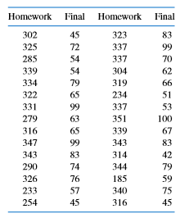

Ejercicio 13

In a paper dealing with the efﬁciency of energy utilization of the larvae of the modest sphinx moth (Pachysphinx modesta), L. Schroeder [Schr1] used the following data to determine a relation between W, the live weight of the larvae in grams, and R, the oxygen consumption of the larvae in milliliters/hour.Forbiologicalreasons,itisassumedthatarelationshipintheformofR=bWa exists between W and R.

1. Find the logarithmic linear least squares polynomial by using:



1. Compute the error associated with the approximation in part (a):

