ELL 786: Multimedia Systems

Assignment - 1 Report

Ayush Goyal – 2019MT10961

Aabid Hoda – 2019MT100068

Part – 1:

Input file has a length of 7784 (M) bits.

Random Binary pattern code:

def random_bin_pattern(M,d):

    t = int(M/d)

    r = random.randrange(1,t+1)

    ran_pattern = ""

    for i in range(M):

        if((i-r+1)%t == 0):

            ran_pattern += '1'

        else:

            ran_pattern += '0'

    return ran_pattern

Experiment – 1:

Results Obtained:

d = 10, modified percentage = 0.8992805755395683

d = 100, modified percentage = 9.082733812949641

d = 200, modified percentage = 18.43525179856115

d = 500, modified percentage = 46.672661870503596

d = 5000, modified percentage = 100.0

As d (number of errors) are increased, the resulted character string is modified as per above table. Here we can see that the number of modified characters is much more than number of percentage error in bits, this is because each error introduced changes 1 character which is of 7 bits. So, effectively each error introduced is magnified by 7 times.

Experiment – 2:

Huffman:

With the file of 7784 bits, the file was broken into chunks of size 7784/7 = 1112 bits and the Huffman codes generated through Huffman Tree were {‘0’ or ‘1’} for ‘0’ and {‘1’ or ‘0’} for ‘1’. Using the coding scheme, the modified file was generated, which was of 7772 bits and it was xored with error pattern for various hamming weights.

Extended Huffman:

With the file of 7784 bits, the file was broken into chunks of size 7784/7 = 1112 bits and extended Huffman codes were generated for 4-bits/ symbol (i.e., 16 symbols in total) for each chunk. Using the coding scheme, the modified file was generated, which was of 7763 bits and it was xored with error pattern for various hamming weights.

Arithmetic:

Let us take the string to be: “ell”

Binary for of the above string is: 1100101 1101100 1101100

Using arithmetic coding we get encoding for ‘0’ = ‘01’ and for ‘1’ is ‘11’

We get the unique tag to be: 0.7119655347181151

After using the decoding function of our code, we again get the same binary string equivalent to “ell”

**Part 2 :**

In this part of the assignment, we used Discrete Wavelet Transform on a grayscale image and observed the compressed image and the loss in quality.

The image we used:



Level of decomposition used were 3 and 4, and ‘db1’ and ‘db35’ wavelet transform were used. For (iii) question, thresholds values used are {x, 0.5x, 0.25x, 0.125x} where x is the rms of the energy of each sub-band. For (iv) – keeping {50,20,10,9,7,5}% coefficients in each sub-band.

In the below results

- Left image is for (iii) – threshold values on the basis of c*rms of energy of each sub-band (c is a constant).

- Right image if for (iv) – here keep represents the percentage of coefficients retained.

Results are as follows:

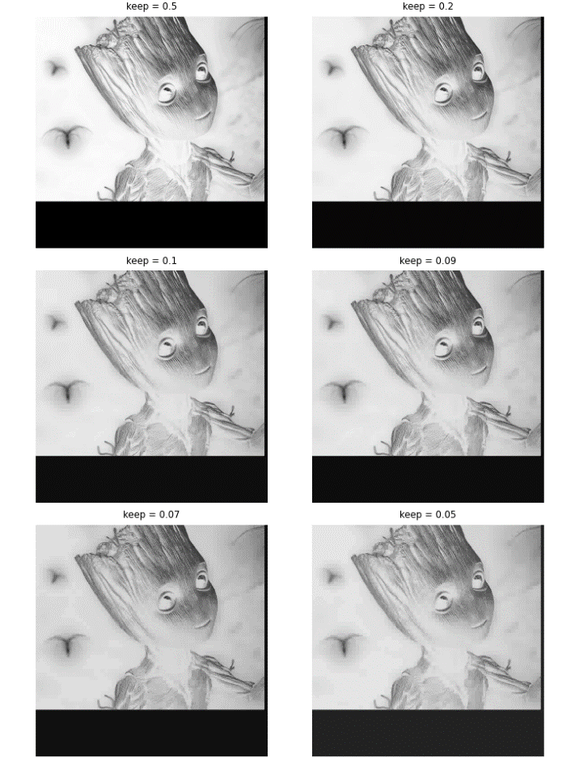Level of Decomposition: 3

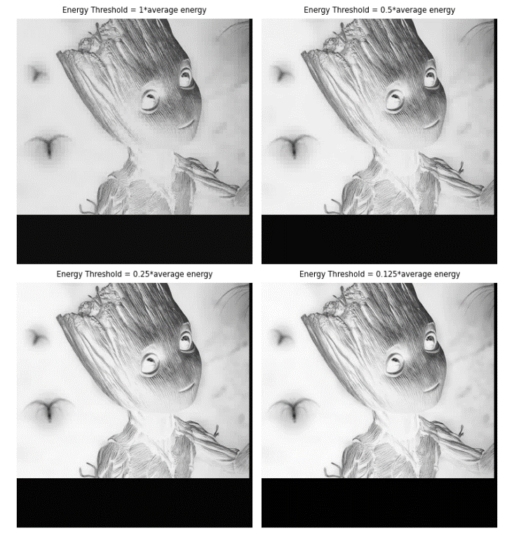Wavelet Transform: ‘db1’

RMS Error at 1*average energy = 0.023057366

RMS Error at 0.5*average energy = 0.011269444

RMS Error at 0.25*average energy = 0.0055669085

RMS Error at 0.125*average energy = 0.0028159919

RMS Error keeping 50.0 percent coefficients = 0.0006312367

RMS Error keeping 20.0 percent coefficients = 0.011883095

RMS Error keeping 10.0 percent coefficients = 0.029543787

RMS Error keeping 9.0 percent coefficients = 0.03234109

RMS Error keeping 7.0 percent coefficients = 0.039038736

RMS Error keeping 5.0 percent coefficients = 0.04778069

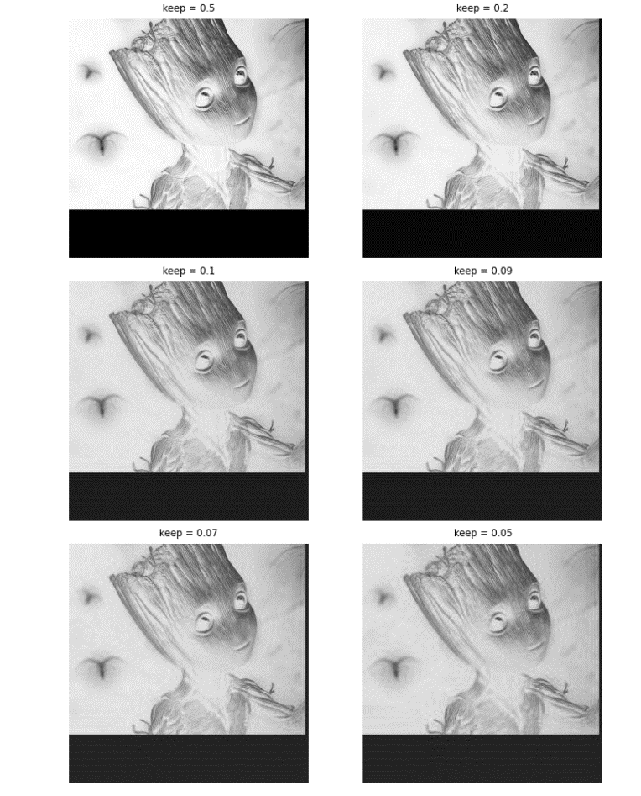Level of Decomposition = 3

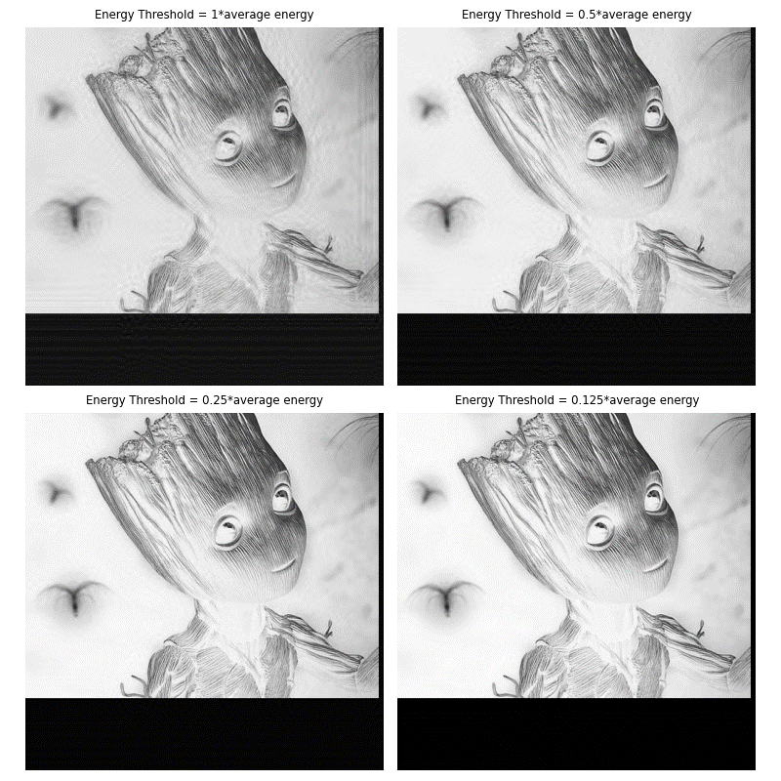Wavelet Transform = ‘db35’

RMS Error at 1*average energy = 0.025151609

RMS Error at 0.5*average energy = 0.01222844

RMS Error at 0.25*average energy = 0.0057084863

RMS Error at 0.125*average energy = 0.0026825417

RMS Error keeping 50.0 percent coefficients = 0.0002116093

RMS Error keeping 20.0 percent coefficients = 0.009123949

RMS Error keeping 10.0 percent coefficients = 0.028725106

RMS Error keeping 9.0 percent coefficients = 0.03190402

RMS Error keeping 7.0 percent coefficients = 0.038881782

RMS Error keeping 5.0 percent coefficients = 0.050536245

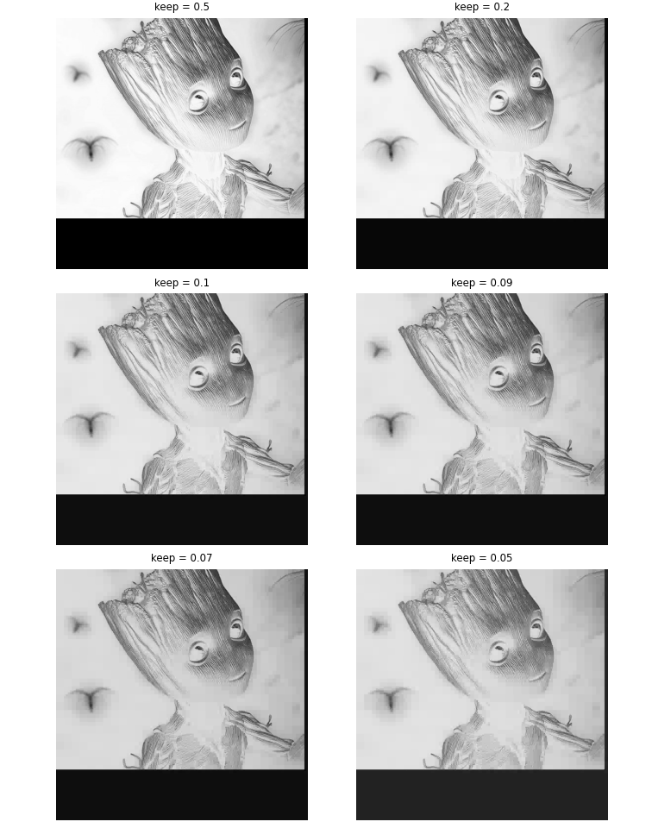Level of decomposition: 4

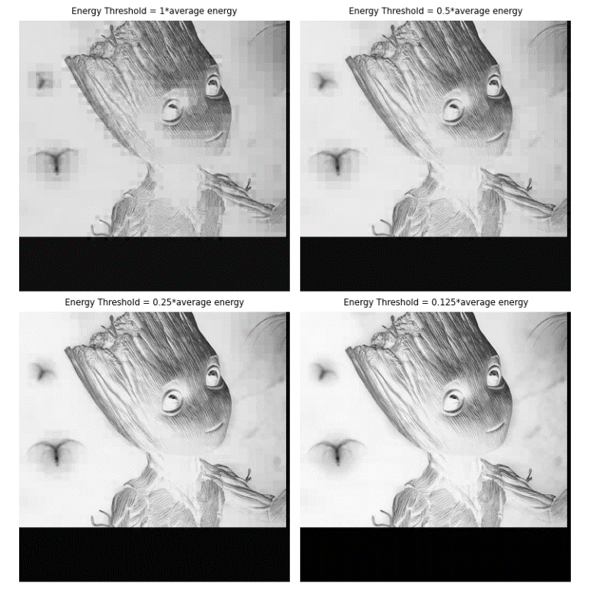Wavelet Transform: ‘db1’

RMS Error at 1*average energy = 0.0339713

RMS Error at 0.5*average energy = 0.017521823

RMS Error at 0.25*average energy = 0.008975823

RMS Error at 0.125*average energy = 0.0042525087

RMS Error keeping 50.0 percent coefficients = 0.0006175526

RMS Error keeping 20.0 percent coefficients = 0.01135681

RMS Error keeping 10.0 percent coefficients = 0.027938562

RMS Error keeping 9.0 percent coefficients = 0.030533753

RMS Error keeping 7.0 percent coefficients = 0.036688868

RMS Error keeping 5.0 percent coefficients = 0.044566076

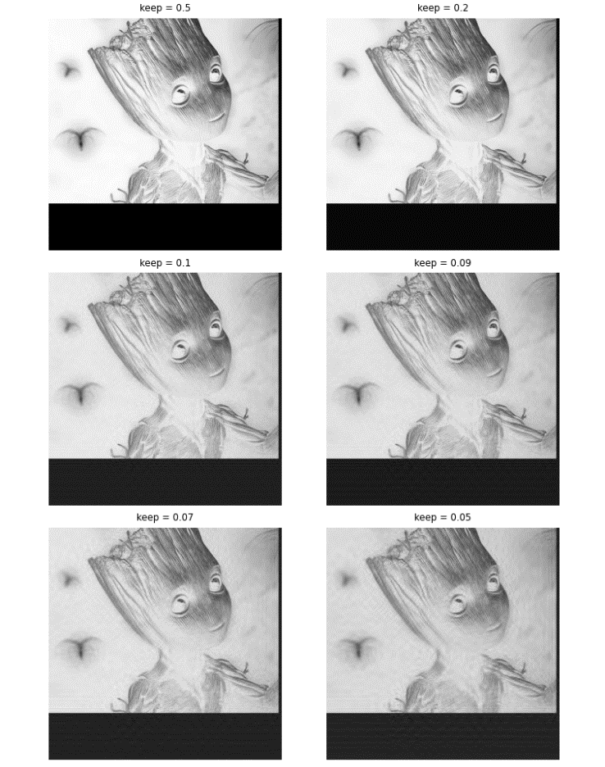Level of decomposition: 4

Wavelet Transform: ‘db35’

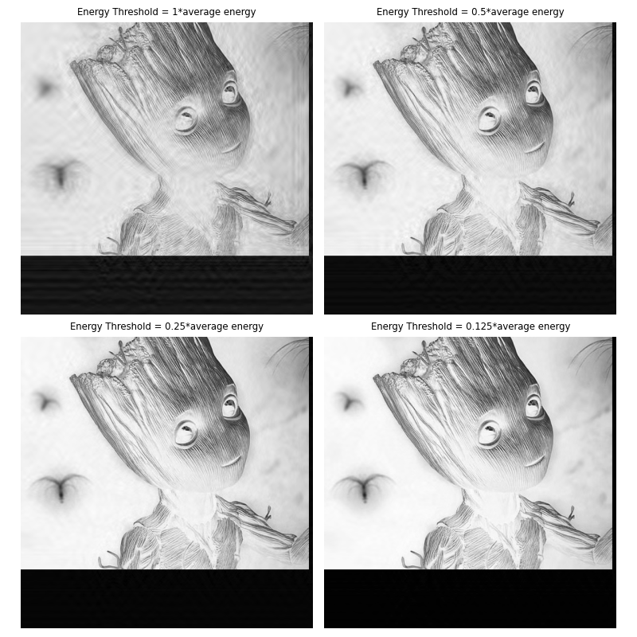

RMS Error at 1*average energy = 0.031212755

RMS Error at 0.5*average energy = 0.015060488

RMS Error at 0.25*average energy = 0.0067983996

RMS Error at 0.125*average energy = 0.003028431

RMS Error keeping 50.0 percent coefficients = 7.4769334e-05

RMS Error keeping 20.0 percent coefficients = 0.0072910516

RMS Error keeping 10.0 percent coefficients = 0.027141463

RMS Error keeping 9.0 percent coefficients = 0.030817168

RMS Error keeping 7.0 percent coefficients = 0.03999047

RMS Error keeping 5.0 percent coefficients = 0.0519082