My Prison in a Database
by Norman Heinzmann

1. Introduction
The application is designed to manage prison operations, focusing on current inmates and comprehensive oversight of prison operations. It handles prisoner details including their sentences, family relations, staff (guards, medical, administrative, and the prison director), and facility management (cells, security zones, and isolation areas).
- Scope:
The system will maintain real-time data for current inmates, track detailed family information (including contact data and visit history), manage various staff roles with scheduling and assignments, and oversee facility infrastructure. Additionally, it will enforce constraints such as unique cell assignments and special limitations on visitations for high-risk or special inmates.

2. Database Use Cases
- CRUD Operations:
  - Create:
    - Add new prisoners along with their sentence records.
    - Insert new staff members (guards or administrative staff).
    - Create and assign cells (optionally with Storage).
  - Read:
    - Retrieve prisoner details and their sentence information.
    - Display staff guard shift information.
    - Query facility details including cell occupancy and zone configurations.
  - Update:
    - Modify prisoner records (sentence updates, adding program).
    - Change cell capacity
    - Adjust staff schedules
  - Delete:
    - Remove outdated or incorrect records while maintaining referential integrity
    - Remove inmate specialization
    - Remove attached storage

ER Model
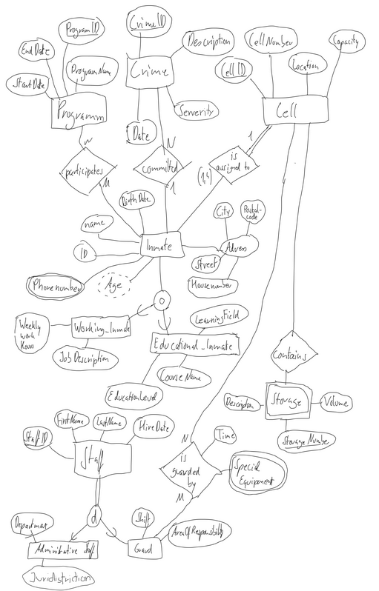
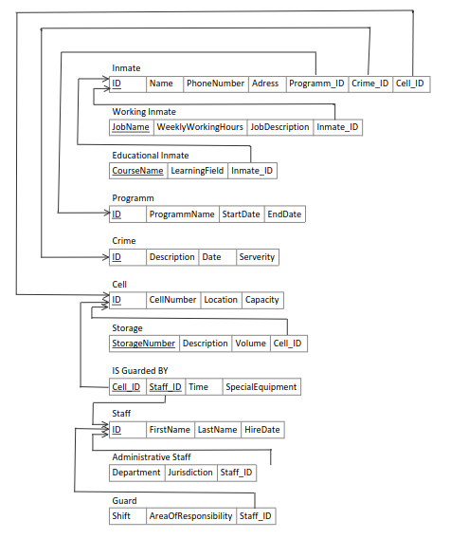
Relation Model
Normalization Steps
List of non-trivial dependencies

Highlights

Actual usage and implementation of the Database

