Project Proposal — draft sections for the AT2 report
Replaces the guidance text under each Project Proposal heading. Task IDs (T1 to T7), objectives (O1 to O4) and requirement IDs (FR, NFR, SR) match the rest of the report. Items in [brackets] are assumptions or targets the team must confirm.

Project Proposal

Project aims and Objectives
Aim. To give NSW river valleys reliable, local flash flood warnings in the 0 to 6 hour window, by predicting for each catchment the probability that a flash flood occurs within the next 6 hours and turning that probability into controller-approved alerts.
The aim serves the business objective set out in the Business context: closing the operational blindspot between coarse weather models and valley-scale flooding, so that lead time, local precision and public trust all improve together.
ID | Objective | Measure of success | Requirements
O1 | Build a shared, versioned, labelled dataset of past flash flood events and their inputs, with one train/validation/test split by event and the 2022 Lismore flood held out | Dataset documented with sources, licences and known gaps; split signed off by all three technique owners | FR-2
O2 | Develop three candidate predictors of the same target: computer vision (A), sequential model (B) and foundation model (C) | Each outputs a calibrated catchment probability, works without a river gauge, and reports its main drivers | FR-1, FR-3, FR-4, NFR-1
O3 | Compare the candidates on the same held-out events and measures | Recall, false alarm ratio and warning lead time reported for each candidate and for the rainfall-threshold baseline, also broken down by region | SR-2
O4 | Select the best candidate (or a combination, only if it beats the best single model) and embed it in an alert workflow with human sign-off | Improves recall and lead time over the rainfall-threshold baseline at an equal or lower false alarm ratio [target values to be agreed with emergency management partners]; every public alert approved by a controller | FR-4, SR-1, SR-2

Methodology
The project runs for 12 months [assumed duration]. Tasks T2 to T4 run in parallel because the three candidates are independent until the common evaluation in T5.
Table 3. Project tasks, time allocation and milestones
Task | Description and expected result | Time (months) | Milestone | Objective
T1 | Shared dataset. Define the study catchments and period; assemble event labels from flood records and gauge-based event detection, with Sentinel-1 flood maps as an independent check; assemble radar, rain gauge, soil, terrain and land-cover inputs; agree data licences; freeze one split by event. Result: documented dataset v1 | 1 to 3 | M1: dataset frozen and split signed off | O1
T2 | Candidate A, computer vision. Build 10-channel catchment tiles and train the CNN on the shared labels. Result: trained model, probabilities, saliency maps | 4 to 6 | Trained model on validation set | O2
T3 | Candidate B, sequential model. Build 72-hour hourly sequences per catchment and train the LSTM on the same labels. Result: trained model (B1 without gauge, B2 with gauge), probabilities, input attributions | 4 to 6 | Trained model on validation set | O2
T4 | Candidate C, foundation model. Fine-tune a pretrained geospatial or weather model on the same labels. Result: trained model, probabilities | 4 to 7 | Trained model on validation set | O2
T5 | Common evaluation. Run all candidates and baselines on the held-out events with identical metrics; test whether a combination of candidates beats the best single one. Result: filled technique comparison table and selection recommendation | 8 | M3: comparison report (M2: all candidates complete, month 7) | O3
T6 | Selection, alert logic and dashboard. Calibrate the alert threshold, build the controller dashboard (probability, drivers, uncertainty) and the sign-off workflow. Result: working prototype | 9 to 10 | M4: prototype accepted by partner agency | O4
T7 | Pilot. Run the system in shadow mode with one emergency management committee: it produces recommendations alongside official warnings, and no public alert is issued from it. Result: pilot report with lessons for scale-up | 11 to 12 | M5: pilot report delivered | O4
Each candidate follows the same task pattern so that T5 compares like with like: same target, same inputs, same events, same metrics. This is what lets the report justify its final selection through explicit trade-offs rather than assertion.

Expected outcomes
On completion the project delivers:
- A documented shared dataset of flash flood events and model inputs for the study catchments, with a datasheet stating sources, licences, labelling method and known quality limits.
- Three trained candidate models that each output the probability of a flash flood in a catchment within 6 hours, usable for catchments without a river gauge.
- An evaluation report with the filled technique comparison, results by region, and the selection decision.
- A prototype alert system: the selected model, a calibrated alert threshold, and a controller dashboard that shows the probability, its main drivers and its uncertainty, with sign-off before any public alert.
- A pilot report from shadow-mode operation with one committee, including false alarms and misses and what the controllers found usable.
The project does not deliver a production system or public alerts. It delivers the evidence and prototype an agency would need to decide whether to adopt one.

Benefits and significance of this project
Why AI is necessary. Each non-AI alternative fails on a different part of the requirement (Table 4).
Table 4. Alternatives to the proposed AI approach
Alternative | Limitation for flash floods | Where AI helps
Global weather models | Grids of about 9 km and 6-hour update cycles (ECMWF, 2016) average out the narrow valleys where flash floods start | Learns the link between local rain, terrain and soil at catchment scale
Physics-based hydrological and hydrodynamic models | Simulations take 4 to 6 hours on high-performance clusters [source needed], so results arrive after the rain | A trained model runs in seconds, within the radar cycle (NFR-1)
Gauge-based forecasting | Over 70% of headwater creeks are ungauged [source needed] | Models trained across many catchments can predict at catchments they have never seen (Kratzert et al., 2019; Nearing et al., 2024)
Fixed rainfall thresholds | Ignore how wet the ground already is and how each catchment responds [source needed] | Candidates use soil wetness and catchment attributes, and are tested against the threshold as a baseline
Published work supports the technical case. A CNN mapped terrain and rainfall to flood depths in about 0.5% of the time a physics-based model needed (Guo et al., 2021), and LSTM models stayed accurate on extreme events and beat a national process-based model (Frame et al., 2022).
Societal value. Lead time decides survival in rapid-onset flooding, and vehicle drownings account for about half of Australian flood fatalities (FitzGerald et al., 2010; Haynes et al., 2017). The 2022 Lismore flood, where the Wilsons River reached 14.4 m, 2 m above previous records, two days after a forecast of minor to moderate flooding, shows the cost of forecast error (Australian Institute for Disaster Resilience [AIDR], n.d.). The project’s benefits are measured by recall, false alarm ratio and warning lead time against the baseline (see Evaluation design), not asserted.
Equity and trust. Catchment-level targeting reduces blanket warnings and so the alert fatigue that teaches residents to ignore alerts. Because the models need no river gauge, rural and headwater communities that gauge-based systems miss gain the most. Performance is reported by region so that weaker coverage is visible and corrected. Alerts are designed for residents who rely on carers or public transport, who need longer lead time, and for linguistically diverse communities.
Significance. The project is a controlled head-to-head test of three AI families on one problem with shared data. Whatever the outcome, it tells flood agencies which approach is worth operational investment.

Resources
Table 5. Team for the full project
Role | Responsibility
Project lead | Plan, budget, milestones, partner agency relationship
Hydrology and flood domain expert | Event labels, catchment selection, interpretation of results
Data engineer | Pipelines for radar, gauge, soil and terrain data; data quality and versioning (T1)
Machine learning engineers (3) | One per candidate: computer vision (T2), sequential (T3), foundation model (T4)
Software and MLOps engineer | Common evaluation harness, dashboard, deployment (T5, T6)
Emergency communication and human factors specialist | Alert wording, accessibility, controller workflow, pilot (T6, T7)
Ethics and legal adviser (part-time) | Data licences, liability, privacy, equity review
Computational resources. GPU capacity for training, with the foundation model the heaviest; storage for the radar archive; a low-latency inference server able to complete a regional sweep within 90 seconds (NFR-1) [sizing and cost to be quoted].
Data. Bureau of Meteorology radar rainfall and AWRA-L soil moisture; rain gauge and river level records from state and Bureau networks; 30 m elevation model; Soil and Landscape Grid of Australia; land-cover mapping; Sentinel-1 flood maps (European Space Agency [ESA], n.d.); flood event records from emergency services. Licence terms and any acquisition costs, particularly for radar archives and sub-daily gauge data, are to be confirmed in T1.

Risks
Mitigations are in Risk management. Risk factors are:
- Personnel: loss of a key member; shortage of hydrology expertise inside the machine learning team.
- Data: few labelled flash floods, which are rare; noise in event labels; radar underestimates rain in mountains where floods start; delays or licence limits on radar and gauge data; uneven radar and gauge coverage between regions.
- Computational: foundation model fine-tuning and radar storage exceed the budget or schedule.
- Technical: skill falls on rare, heavy rain, the case that matters most; models do not transfer to catchments or storms unlike the training events.
- Deployment: integration with agency systems, degraded connectivity in the field, and latency beyond the radar cycle.
- Social: alert fatigue from false alarms; low trust or uptake among controllers.
- Ethical: weaker warnings for rural and underserved communities.
- Legal: liability for a missed or wrong warning; data licensing breaches.
- Safety: a missed event leaves people without warning.
- Misuse: spoofed alerts or misread probabilities spreading misinformation.

Timeline
The 12-month plan is in Figure 3. T2 to T4 overlap so that the three candidates reach evaluation together at month 8.
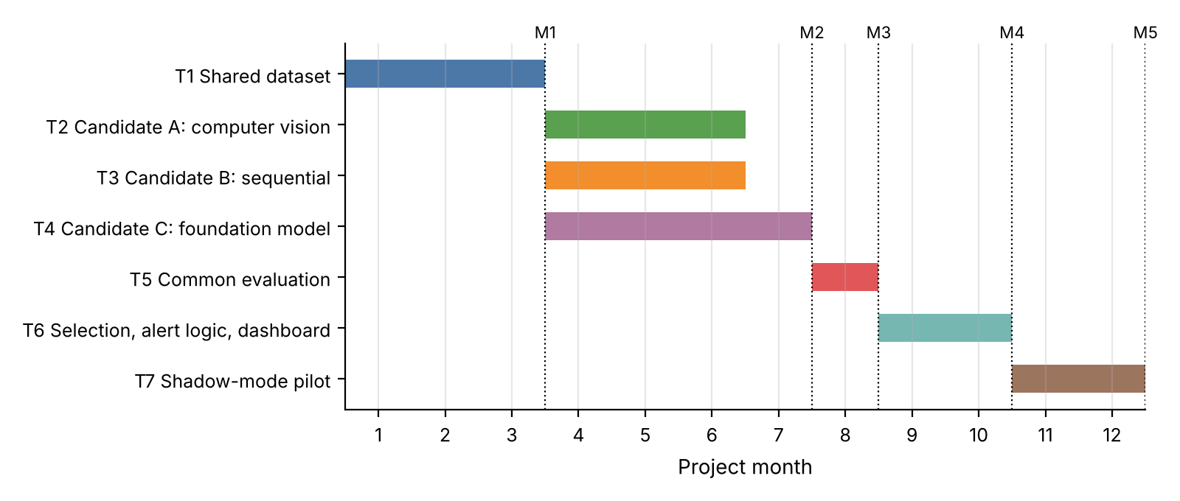
Figure 3. Project timeline. Dotted lines mark milestones M1 (dataset frozen, month 3), M2 (all candidates complete, month 7), M3 (comparison report, month 8), M4 (prototype accepted, month 10) and M5 (pilot report, month 12).

Communication of expected outcomes
Audience | What they receive | Channel
Emergency managers and Bureau hydrologists (Tier 1) | Evaluation report, dashboard demonstration, pilot results | Agency briefings and workshops; pilot debrief
Frontline responders (Tier 2) | Road and bridge risk guidance in the dashboard | Training sessions
Affected communities (Tier 3) | Plain-language explanation of what the system does and its limits; alerts only through official channels | Community meetings, local radio, official SMS and warning channels, translated materials
Infrastructure operators (Tier 4) | Evidence on lead time and false alarm cost | Targeted briefings
Research community | Dataset datasheet, methods and results | Open documentation and publications [subject to licence terms]

