DAS4 Assessed Exercise

2228147T

Norman Tan Jian Liang

**1 Overall Design**

*1.1 Running the Server*

Usage:

* Open a Terminal
* Navigate to the src/ folder of the program
* ./runServer.sh or windows run the runServer.bat

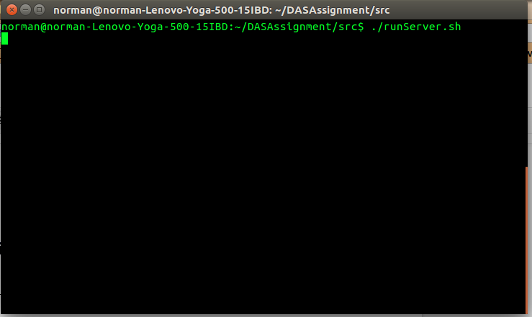

*1.2 Client UI*

Usage:

* Open a Terminal
* Navigate to the src/ folder of the program
* ./runClient.sh or windows run the runClient.bat
* Enter Email

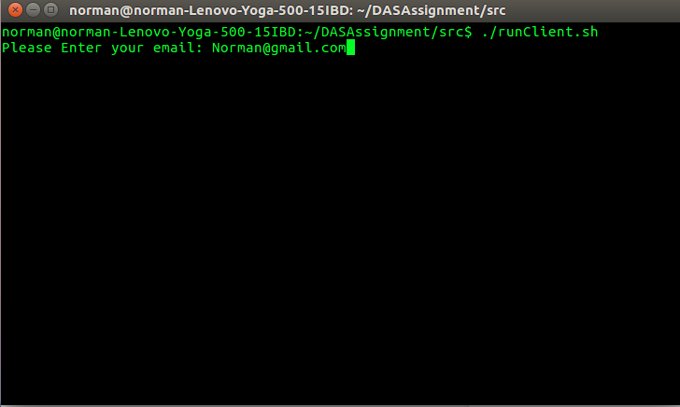

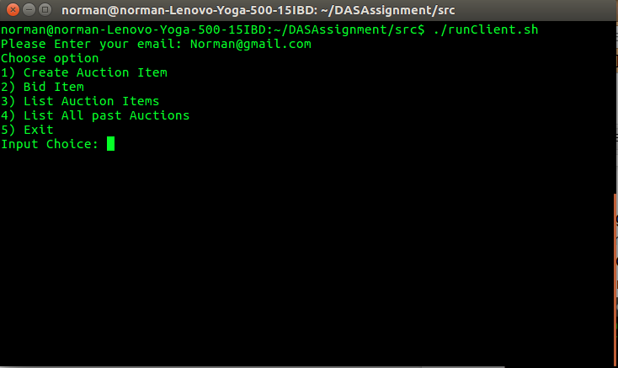

*1.3 Creating an Auction*

Usage:

* Choose the option 1 for Creating an Auction
* Input the name, value of item and closing time in seconds
* Auction creation complete

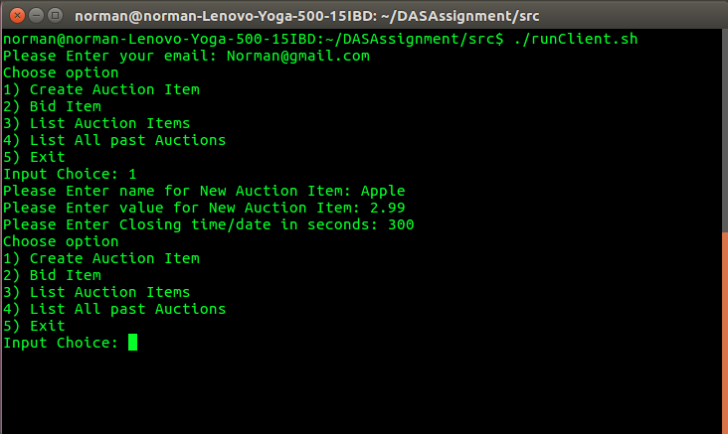

*1.4 Bidding in an Auction*

Usage:

* Enter option 2 to bid for an item (Recommended to use option 3 before entering option 2 to know which auction to bid)
* Enter the item id to bid
* Enter the value to bid

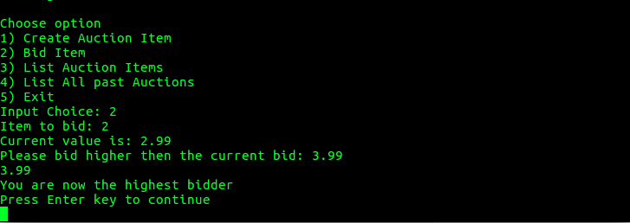

*1.5 Displaying Current Auctions Available*

Usage:

* Enter option 3 to view all Current Auctions

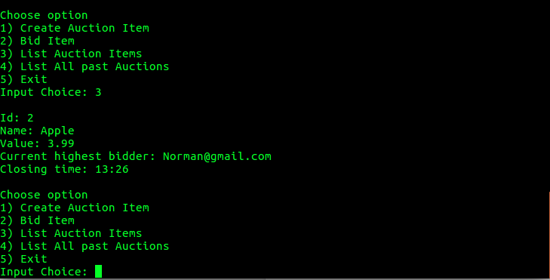

*1.6 Displaying all Auctions*

Usage:

* Enter option 4 to view all Auctions happening now and happened in the past

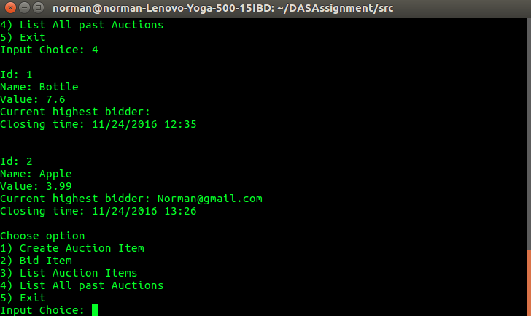

*1.7 Callbacks*

Usage:

* Wait until the item or auction is closed after bidding for an item or creating an auction

1. Bidder won bid and Owner is notified

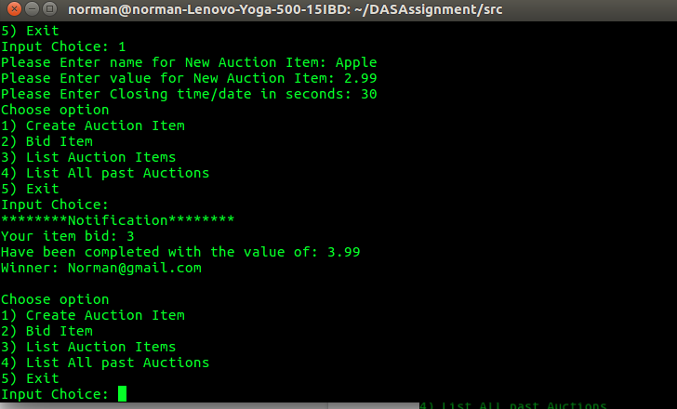

Owner Call back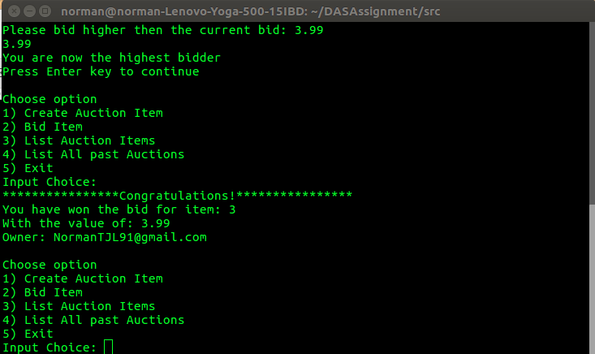

Winner Callback

2) Nobody bid for item

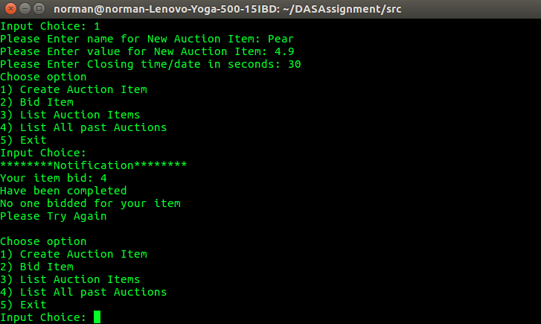

Owner Callback if nobody bid for the item

3) Losing a bid to another client

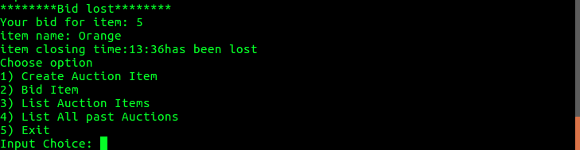

Callback to losing client to notify that bid is losing

*1.8 Pinging server and client*

Usage:

* Every five seconds client will ping the server to check if the server is still “alive” if the server is not “alive” the program will state that the server is not online and will exit the client program

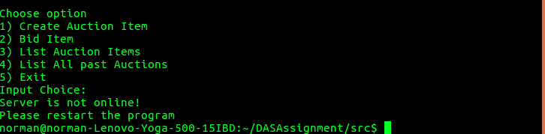

**2 Implemented specifications**

*2.1 general design*

The general design is that, a client has to communicate to the server through an server interface, after that the server that has received the request will order the servant to complete a task and return the results to the client. The server interface is a list of methods the client is able to utilise in the server, although initially the general idea is only one interface, server interface, the following task requires a second interface which is callback functions to allow the server to callback to clients. By requiring the server to callback to clients it is required of the clients to be part server part client.

*2.2 Client*

Client is able to create auction items specifying name, item value and closing date/time specified in seconds, Section 1.3 shows that this specification has been met. Method for listing available auctions is also completed and shown in section 1.5, meeting the specification. By the end of the auction the owner as well as the bidder of the item should be notified of the result, is implemented in section 1.7.

The client is able to disconnect and reconnect to the server(if the server has not been restarted or turned off) using the same email address but it is provided if there is only one person using that email address.

Creating auction items creates an object of auction item and pass it to the server which is then saved into a hashmap of objects which every client can retrieve and view.

The client is able to specify the port number and ip address to connect to the server but the only limitation is that some ports might be used by other background programs that are not known to the user.

*2.3 Server*

Auctions create by Clients will be used and saved into a csv file every time a method is called and completed this saves the state of the ongoing auctions. Past auctions are retrievable from the section 1.6.

There is also a ping function for clients to check if the server is still alive, when that happens the client program is stopped intentionally and will request the user to restart the system.

When a client starts running it registers itself with its client interface to the server, the server then keeps a hashmap of Client with keys as their email and value as their client interface object. This allows the server to callback to clients when required for example when a bid ends, or they lost a bid but auction is not over yet, or nobody bid on their auction and it ends. The server will notify the owner of the bid and winner of the bid and provide the email address of the owner to the winner and email address of the winner to the own to allow further communication between the two parties. The server will also notify the owner of the auction if nobody has bidded on the item and the auction has ended. The server will also notify the client whose bid has been lost but has a chance of raising the bid.

When the server’s method has been invoked it saves its state into a csv file. Every time the server is restarted it will load the state saved, but is it unable load all the client’s interface for the current auctions. It is able to retrieve the list of all past auctions.

The server has a java method that check if items in the list is expired and save the current available auctions into another hashmap of items.

Together with this report is the java files of the project, there will also be a csv file for the saved state and a separate java file namely runmultiple.java to do the rmi call multiple times used to get the results for the performance portion of this report. Usage of the runmultiple.java is java runmultiple <item id to bid> <number of threads to bid

**3 Performance**

The test will temporarily stop the callback function as the threads are calling the bid method, the threads did not register as a client therefore on the server terminal there will be nullpointer exceptions

*Usage*

* Open a terminal
* Navigate to src/
* Java runmultiple <item id> <number of threads to run>

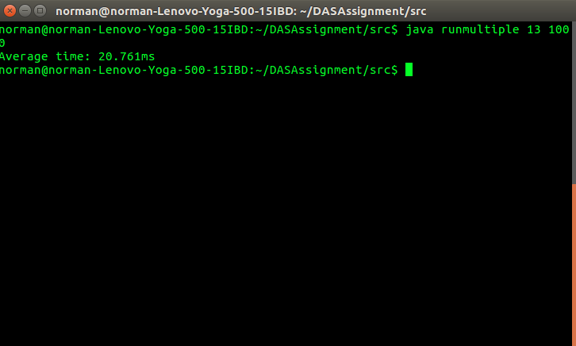

Time taken is computed in average of per bidding an item

|  |  |  |  |
| --- | --- | --- | --- |
| Number of calls | 1st Method call Duration (ms) | 2nd Method call Duration (ms) | 3rd Method call Duration |
| 1 | 1.0ms | 2.0ms | 1.0ms |
| 10 | 2.9 | 1.9ms | 1.9ms |
| 100 | 11.51ms | 18.36ms | 8.91ms |
| 1000 | 58.67ms | 14.414ms | 15.914ms |
| 10000 | 91.3582ms | 11.5093ms | 20.492ms |

**4 Other improvements**

Other improvements might include saving of client interfaces on the server side so when the server is down it can save and load the client interfaces and perform callbacks even after the server is down. Saving everything on a database is also an option and provide an automated service of sending a notification to the clients so that when the clients are not logged on the server they are still able to receive information about the bids they were interested in.

Other viable improvements include adding the view function to include expired items for one day or two days. It is also viable to allow only unique email at one time disallowing others to use the same email as the original user. The server can also be modified that can take in parameters when running the program to receive port numbers to allow users to enter through a certain port number.