Register a .gif file as a shape, and draw it using t.stamp().

Draw a rectangle, place stamp in center.

Bitmaps are 100x100, rectangle is (0,0) to (101,101), image at (51,50)

Create remaining .gif files.

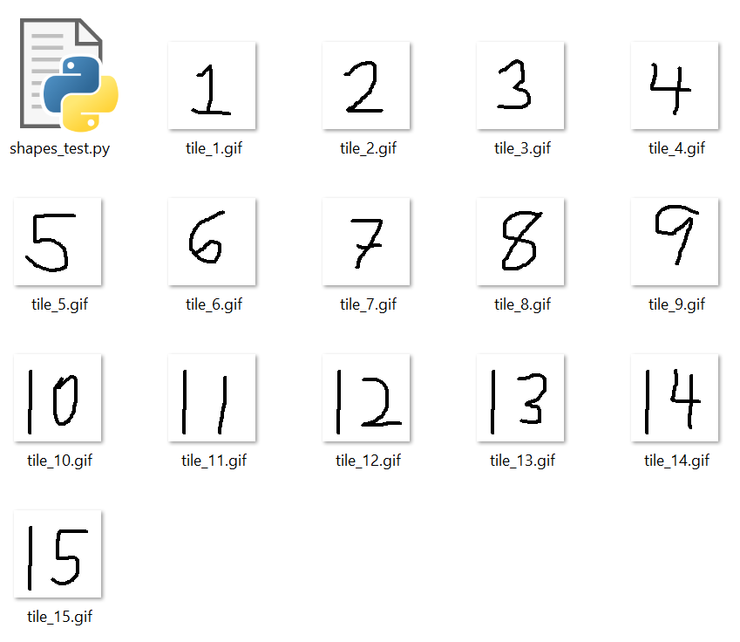

Draw two rectangles, with two bitmaps.

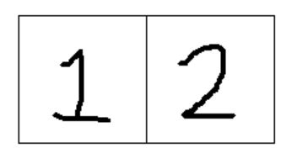

Draw board

Set window size and world coordinates

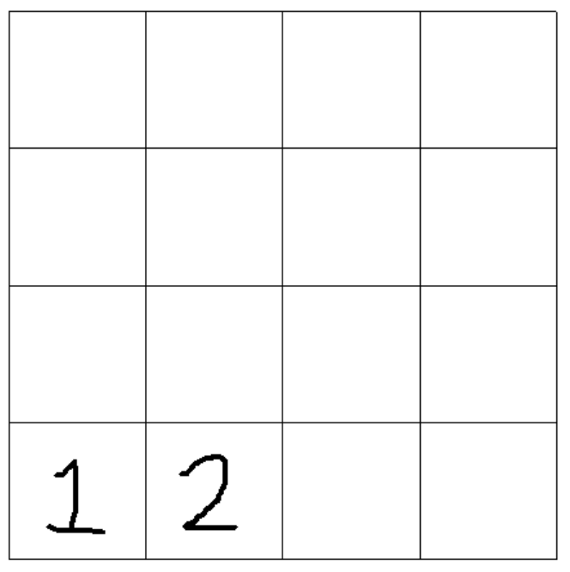

Problem: had to increase square size and adjust stamp positions – don’t know why.

Initial attempts to increase the turtle speed failed; had to move t.speed() and t.hideturtle() after shapes were registered.