Storyboard – Portfolio Website (Norman Ranger)

Two responsive layout designs as required: one for mobile (min 600px) and one for desktop (min 950px). Each layout shows the main <div> groups used in the HTML/CSS structure: .logo, nav, .hero-grid, .grid-2, .grid-3, and .card.

# Mobile Layout (≥ 600px)

• Stacked sections with single-column cards.  
• Header with .logo and nav.  
• Hero shows intro then photo.  
• Sections use .grid-2 / .grid-3 as 1 column on mobile.

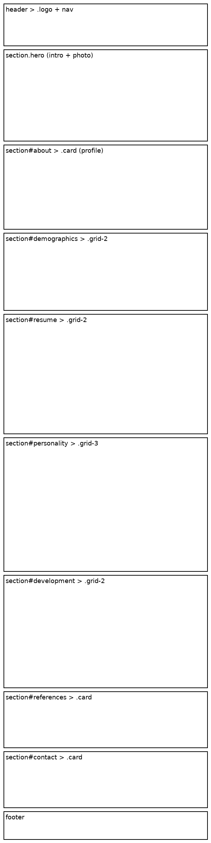

# Desktop Layout (≥ 950px)

• Multi-column grids: .grid-2 (two columns) and .grid-3 (three columns).  
• Hero splits intro and photo side by side.  
• Cards (.card) group content within each section.

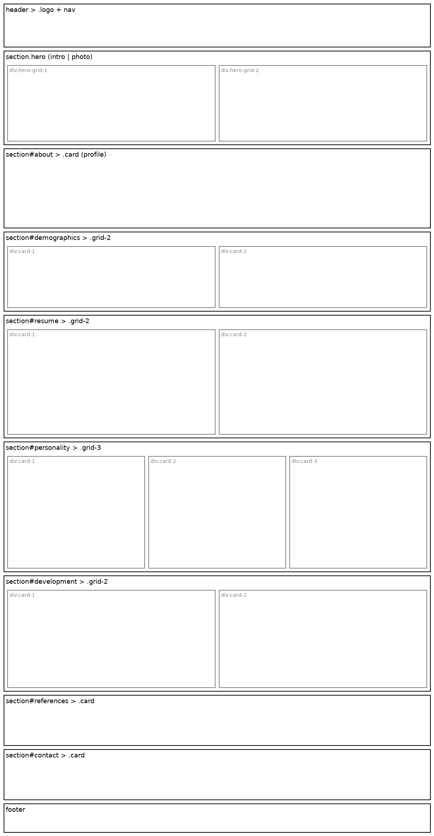

# Legend of <div> Groups

• header > .logo + nav  
• section.hero > .hero-grid  
• section#about > .card  
• section#demographics > .grid-2 > .card  
• section#resume > .grid-2 > .card  
• section#personality > .grid-3 > .card  
• section#development > .grid-2 > .card  
• section#references > .card  
• section#contact > .card  
• footer