Open Source Gonioreflectometer: a four-axis BRDF instrument and 3D scanner built from printed parts without soldering
Aleksander Norman
Abstract
The Open Source Gonioreflectometer measures the bidirectional reflectance distribution function (BRDF) of flat samples and scans objects in 3D. A light arm on a 305 mm ring and three sample axes (yaw, tilt, spin) set every illumination and viewing direction relative to a fixed camera, following Ansari-Asl et al. (2024). All 58 structural parts are 3D printed in ABS; the 48 bought parts cost US$511.60 from three distributors. No soldering, drilling, sawing or crimping is needed. Calibration uses a mirror for angles, an exposure series for camera response and a pressed-PTFE tile for absolute reflectance. Fitted Lambert + GGX parameters export to game engines. [TBD: repeatability, accuracy vs. reference data].
BRDF ,gonioreflectometer ,material appearance ,open hardware ,3D printing ,photometric calibration

Specifications table
Hardware name | Open Source Gonioreflectometer
Subject area | Engineering and materials science; computer graphics (material appearance)
Hardware type | Measuring physical properties and in-lab sensors; imaging tools
Closest commercial analog | Laboratory gonioreflectometers and goniospectrophotometers
Open source license | Hardware CERN-OHL-S-2.0; software GPL-3.0-or-later; documentation CC BY-SA 4.0
Cost of hardware | US$511.60 in parts (cap US$630); tools US$469.76
Source file repository | https://github.com/Normansrule/Gonioreflectometer-Open-Source (DOI at release)

Hardware in context
Gonioreflectometers measure how a surface reflects light as a function of incident and reflected direction (Nicodemus et al., 1977). Laboratory instruments reach high accuracy at high cost (Höpe et al., 2006; Höpe et al., 2012; Saha et al., 2024); image-based (Marschner et al., 2000; Matusik et al., 2003) and robot-arm (Lyngby et al., 2019) setups lower the cost but still need machining or industrial arms. Consumer-hardware capture (Filip et al., 2014) trades angular coverage for speed. Ansari-Asl et al. (2024) describe a multispectral goniometric device with a light arm and a three-axis sample stage. The Open Source Gonioreflectometer reproduces that geometry with printed parts, stepper motors and a USB camera, for builders without a workshop, consistent with open-hardware practice (Bonvoisin et al., 2017; Pearce, 2012).

Hardware description
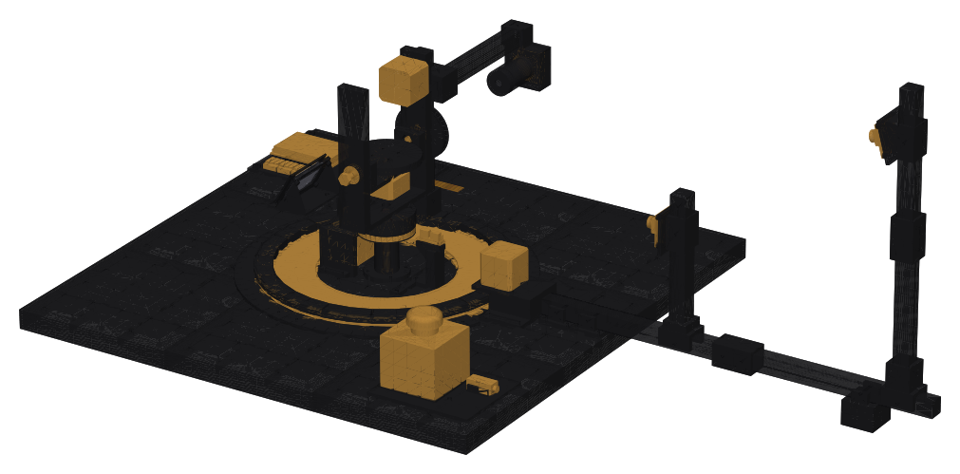
Whole-machine assembly from the repository CAD (cad/assembly). Sample axes at centre, light arm on the ring, measuring camera on the right.
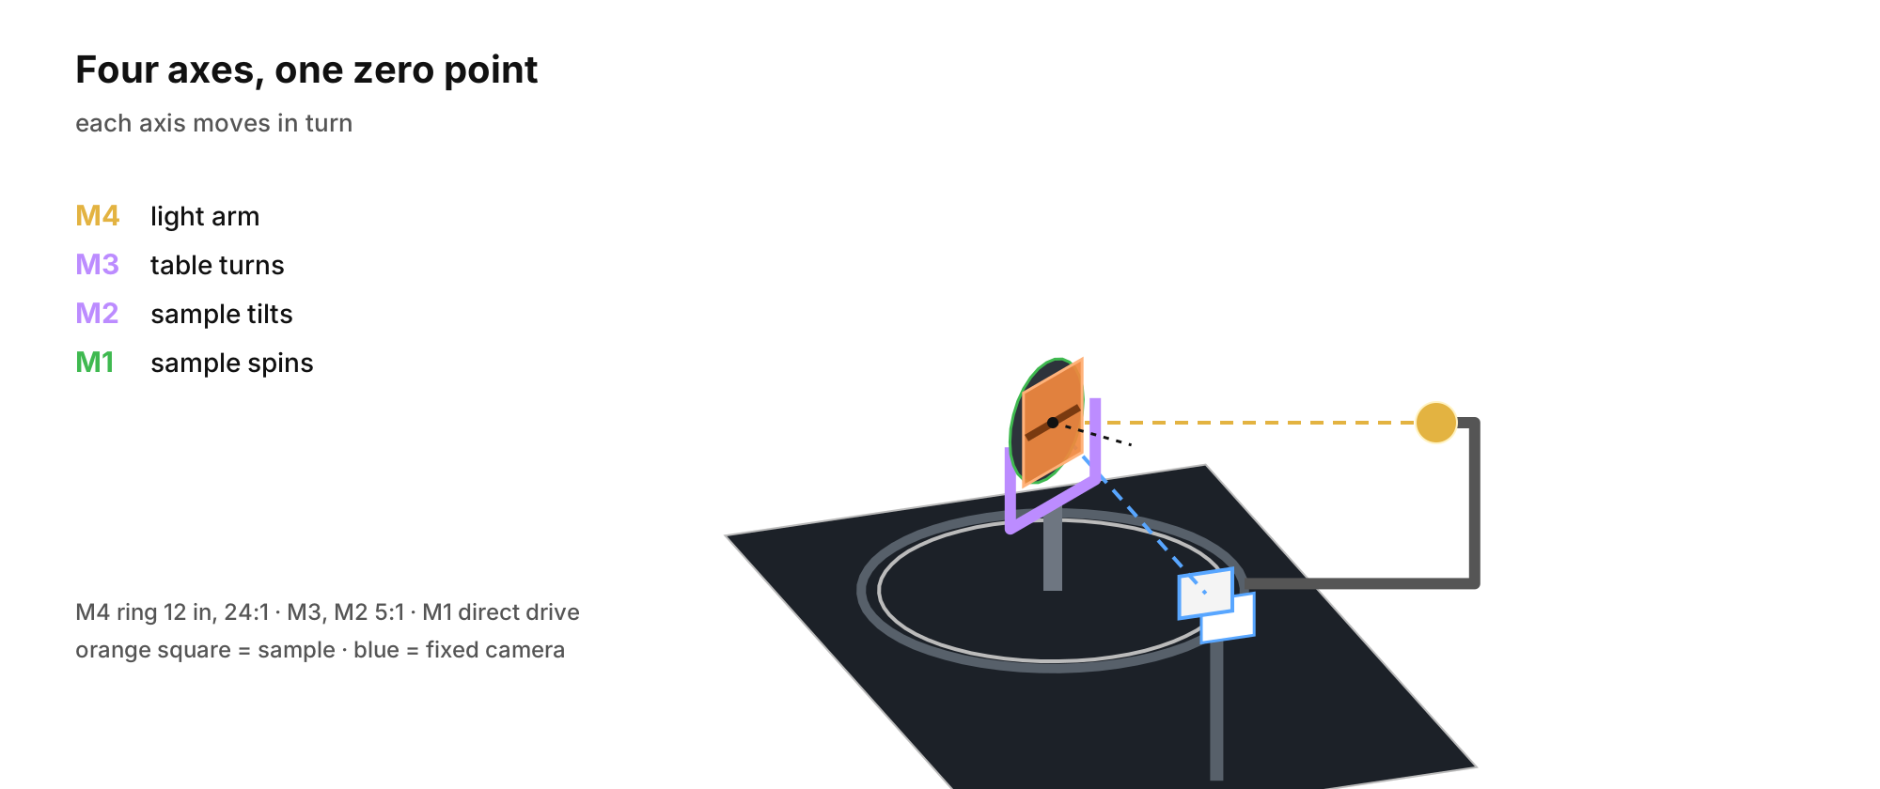
Four axes, one zero point. M4: light arm; M3: table yaw; M2: tilt; M1: spin.
- Geometry. M4 (light arm, 20–324, 24:1 belt on the ring), M3 (yaw, $±$180, 5:1), M2 (tilt, $±$90, 5:1), M1 (spin, direct drive). Camera fixed at 350 mm; light at 300 mm (Fig. 2). Anisotropic materials need M1 (Ward, 1992).
- Light. Chip-on-board LED, colour rendering index 97, 350 mA constant current, collimating printed tube with a 10 mm aperture; solderless holder clamped by the lamp body.
- Camera. 12 MP IMX477 USB module, 16 mm lens, printed f/8 stop; exposure, gain and white balance locked.
- Control. grblHAL on an RP2040 board (BTT SKR Pico, USB-C) drives four steppers; a microcontroller reads keypads and sensors; optical homing on every axis; over-travel switches in the emergency-stop loop.
- One screw size. Every printed join and module mount is an M2 screw self-tapping into a printed pilot; M3 only into the motors, M8 bolts as axles. The base is a printed deck of nine tiles with a pilot at every mount point.
- No-tool joins. Lever connectors, screw terminals and modules (optocoupler, LED driver) instead of loose chips.

Design files summary
Design file | Type | License | Location
PLAN-01 tolerance coupon | STEP, STL | CERN-OHL-S-2.0 | 00-plan
PWR-18 power plate | STEP, STL | CERN-OHL-S-2.0 | 01-power
CTL-10a button panel | STEP, STL | CERN-OHL-S-2.0 | 02-controller
CTL-10b controller tray | STEP, STL | CERN-OHL-S-2.0 | 02-controller
FRM-01a deck tile SW | STEP, STL | CERN-OHL-S-2.0 | 03-frame
FRM-01b deck tile S | STEP, STL | CERN-OHL-S-2.0 | 03-frame
FRM-01c deck tile SE | STEP, STL | CERN-OHL-S-2.0 | 03-frame
FRM-01d deck tile W | STEP, STL | CERN-OHL-S-2.0 | 03-frame
FRM-01e deck tile C | STEP, STL | CERN-OHL-S-2.0 | 03-frame
FRM-01f deck tile E | STEP, STL | CERN-OHL-S-2.0 | 03-frame
FRM-01g deck tile NW | STEP, STL | CERN-OHL-S-2.0 | 03-frame
FRM-01h deck tile N | STEP, STL | CERN-OHL-S-2.0 | 03-frame
FRM-01i deck tile NE | STEP, STL | CERN-OHL-S-2.0 | 03-frame
FRM-02a outrigger bar 1 | STEP, STL | CERN-OHL-S-2.0 | 03-frame
FRM-02b outrigger bar 2 | STEP, STL | CERN-OHL-S-2.0 | 03-frame
FRM-02c scan post bar 1 | STEP, STL | CERN-OHL-S-2.0 | 03-frame
FRM-02d scan post bar 2 | STEP, STL | CERN-OHL-S-2.0 | 03-frame
FRM-09c protractor segment | STEP, STL | CERN-OHL-S-2.0 | 03-frame
FRM-09d bar saddle | STEP, STL | CERN-OHL-S-2.0 | 03-frame
FRM-09e post socket | STEP, STL | CERN-OHL-S-2.0 | 03-frame
FRM-09f end foot | STEP, STL | CERN-OHL-S-2.0 | 03-frame
FRM-09h camera pillar | STEP, STL | CERN-OHL-S-2.0 | 03-frame
FRM-09i bar coupler | STEP, STL | CERN-OHL-S-2.0 | 03-frame
LAR-08a rim segment | STEP, STL | CERN-OHL-S-2.0 | 04-light-arm
LAR-08b ring motor mount | STEP, STL | CERN-OHL-S-2.0 | 04-light-arm
LAR-08c arm segment | STEP, STL | CERN-OHL-S-2.0 | 04-light-arm
LAR-08e cross clamp | STEP, STL | CERN-OHL-S-2.0 | 04-light-arm
LAR-08f upright bar | STEP, STL | CERN-OHL-S-2.0 | 04-light-arm
LAR-08g arm bar | STEP, STL | CERN-OHL-S-2.0 | 04-light-arm
TBL-07a table drum | STEP, STL | CERN-OHL-S-2.0 | 05-table
TBL-07b home flag | STEP, STL | CERN-OHL-S-2.0 | 05-table
TBL-07c table motor bracket | STEP, STL | CERN-OHL-S-2.0 | 05-table
TBL-07d table post | STEP, STL | CERN-OHL-S-2.0 | 05-table
TBL-07f spacers | STEP, STL | CERN-OHL-S-2.0 | 05-table
TBL-07g endstop riser | STEP, STL | CERN-OHL-S-2.0 | 05-table
TBL-07h table flag | STEP, STL | CERN-OHL-S-2.0 | 05-table
CAM-03a aperture stop f8 | STEP, STL | CERN-OHL-S-2.0 | 06-camera-light
CAM-03b camera plate | STEP, STL | CERN-OHL-S-2.0 | 06-camera-light
LSR-05a lamp tube | STEP, STL | CERN-OHL-S-2.0 | 06-camera-light
LSR-05b lamp cap | STEP, STL | CERN-OHL-S-2.0 | 06-camera-light
CAL-06a ptfe holder | STEP, STL | CERN-OHL-S-2.0 | 07-calibrate
CAL-06b mirror holder | STEP, STL | CERN-OHL-S-2.0 | 07-calibrate
CAL-06c ball holder | STEP, STL | CERN-OHL-S-2.0 | 07-calibrate
ENC-04a dowel socket | STEP, STL | CERN-OHL-S-2.0 | 07-calibrate
TLT-07a tilt yoke | STEP, STL | CERN-OHL-S-2.0 | 08-tilt
TLT-07b pulley 100T | STEP, STL | CERN-OHL-S-2.0 | 08-tilt
TLT-07c tilt cradle | STEP, STL | CERN-OHL-S-2.0 | 08-tilt
SPN-07a spin platter | STEP, STL | CERN-OHL-S-2.0 | 09-spin
MSK-06a led ring | STEP, STL | CERN-OHL-S-2.0 | 10-color
MSK-06b led mast | STEP, STL | CERN-OHL-S-2.0 | 10-color
SPC-03a spectral tube | STEP, STL | CERN-OHL-S-2.0 | 10-color
SCN-03a riser 20 | STEP, STL | CERN-OHL-S-2.0 | 11-scan-capture
SCN-03b riser 40 | STEP, STL | CERN-OHL-S-2.0 | 11-scan-capture
SCN-03c riser 60 | STEP, STL | CERN-OHL-S-2.0 | 11-scan-capture
SCN-03d scan camera plate 15 | STEP, STL | CERN-OHL-S-2.0 | 11-scan-capture
STA-07a pi zero mount | STEP, STL | CERN-OHL-S-2.0 | 15-standalone
STA-10a screen stand | STEP, STL | CERN-OHL-S-2.0 | 15-standalone
STA-10b screen bezel | STEP, STL | CERN-OHL-S-2.0 | 15-standalone
Bought-part stand-ins | STEP, STL | CERN-OHL-S-2.0 | cad/bought
Whole-machine assembly | STEP | CERN-OHL-S-2.0 | cad/assembly
CAD source (CadQuery) | Python | GPL-3.0-or-later | tools/cad

Bill of materials summary
Parts from Digi-Key, Amazon and Adafruit. Tools (US$469.76, including the printer) are listed separately in the repository. Printed parts: $≈$2666 g ABS.
Designator | Component | No. | Unit | Total | Source
FIL-01 | ABS filament 1.75 mm, black, 1 kg (4 spools) | 4 | 15.99 | 63.96 | Amazon
PWR-30 | 24 V 3 A wall adapter with screw-terminal DC jack | 1 | 17.85 | 17.85 | Amazon
PWR-28 | Emergency stop in its own box, latching, 1 NO + 1 NC, screw terminals | 1 | 8.99 | 8.99 | Amazon
PWR-10 | Optocoupler module PC817, 24 V input, screw terminals (2-pack) | 1 | 6.99 | 6.99 | Amazon
PWR-15 | 18 AWG silicone wire red/black, 1.5 m (5 ft) each colour | 1 | 7.98 | 7.98 | Amazon
PWR-20 | Lever wire connectors, WAGO 221 assortment (12) | 2 | 12.45 | 24.90 | Amazon
CTL-01 | BIGTREETECH SKR Pico V1.0 (RP2040, 4 $×$ TMC2209 UART, USB-C) | 1 | 35.99 | 35.99 | Amazon
CTL-03 | USB-A to USB-C data cables, 3 ft (2-pack) | 1 | 8.99 | 8.99 | Amazon
CTL-05 | Membrane keypad 1 x 4 | 1 | 7.89 | 7.89 | Amazon
CTL-06 | JST-XH pre-crimped lead kit | 1 | 10.99 | 10.99 | Amazon
CTL-07 | Jumper wires male-female 20 cm (120) | 1 | 6.98 | 6.98 | Amazon
FRM-06 | M2 socket screw kit, 4–25 mm, with nuts and washers (900 pcs) | 1 | 7.58 | 7.58 | Amazon
FRM-07 | Socket screw kit M2/M3/M4 with nuts (820 pcs): M3 for the motors | 1 | 9.88 | 9.88 | Amazon
FRM-08 | 608-2RS bearings (10) | 1 | 4.99 | 4.99 | Amazon
LAR-01 | 12 in lazy Susan bearing | 1 | 13.99 | 13.99 | Amazon
LAR-02 | NEMA 17 stepper 42 Ncm 1.5 A, 38 mm (5-pack: M4, M3, M2 + 2 spare) | 1 | 32.99 | 32.99 | Amazon
LAR-03 | GT2 6 mm open belt (5 m) | 1 | 7.59 | 7.59 | Amazon
LAR-04 | GT2 20T pulley 5 mm bore (5-pack) | 1 | 3.99 | 3.99 | Amazon
LAR-05 | Optical endstop module, slot type (6-pack) | 1 | 8.99 | 8.99 | Amazon
LAR-06 | Roller-lever limit switch, sealed, 3 wires attached (2-pack) | 1 | 9.88 | 9.88 | Amazon
TBL-02 | GT2 6 mm closed belt 232 mm | 1 | 8.19 | 8.19 | Amazon
TBL-05 | M8 x 75 hex bolt, partial thread + M8 nut (fixed table axle) | 1 | 15.37 | 15.37 | Amazon
CAM-01 | USB camera 12 MP IMX477, M12 mount (UVC) | 1 | 59.99 | 59.99 | Amazon
CAM-02 | M12 lens 16 mm, $≥$ 1/2 in format, low distortion | 1 | 30.11 | 30.11 | Amazon
LSR-06 | Solderless COB holder 13.5 mm (TE LUMAWISE Z35) | 1 | 3.30 | 3.30 | Digi-Key
LSR-01 | COB LED CRI 90, 9 V, 13.5 mm (Citizen CLU701) | 1 | 4.60 | 4.60 | Digi-Key
LSR-02 | Constant-current driver 350 mA, wire leads (MEAN WELL NLDD-350HW) | 1 | 7.20 | 7.20 | Digi-Key
LSR-03 | Heatsink 40 x 40 x 11.6 mm, pin fin (Wakefield 910) | 1 | 10.67 | 10.67 | Digi-Key
ENC-02 | Black felt sheet | 1 | 6.99 | 6.99 | Amazon
CAL-01 | PTFE sheets 100 x 100 x 3 mm (2): white tile = 3 stacked 50 mm squares | 1 | 16.99 | 16.99 | Amazon
CAL-02 | Glass mirror tile ~50 mm | 1 | 11.49 | 11.49 | Amazon
CAL-04 | ChArUco print + picture-frame glass | 1 | 4.31 | 4.31 | Amazon
TLT-02 | GT2 6 mm closed belt 280 mm | 1 | 7.49 | 7.49 | Amazon
TLT-05 | M8 x 35 hex bolts, half thread (10-pack; 2 used) | 1 | 9.19 | 9.19 | Amazon
SPN-01 | NEMA 17 pancake stepper 16 Ncm 1 A (direct drive) | 1 | 11.99 | 11.99 | Amazon
SCN-01 | Mounting putty 2 oz | 1 | 2.33 | 2.33 | Amazon
 |  |  | Total | 511.60

Build instructions
The repository splits the build into stages (power, controller, frame, each axis, camera and light, calibration). Each step lists time, parts, actions, a measured pass criterion and what to check on failure ().
- Print the tolerance coupon; set clearance and self-tap hole size.
- Wire the power (wall adapter, e-stop, limit switch); check polarity before the first power-on.
- Mount the controller; move one motor from the laptop.
- Print and bolt the deck; screw every mount into its pilot; assemble the axes; home each axis.
- Mount camera and lamp; run the mirror test; calibrate (Section 7).

Operation instructions
- opengonio check-pose M4=60 M3=30: angle and collision check.
- opengonio capture inplane –step 10 –out data/s: in-plane sweep.
- opengonio curve data/s: calibrated BRDF curve and Lambert + GGX fit (Trowbridge & Reitz, 1975; Walter et al., 2007).
Safety: the lamp is viewed only through the sample; the emergency stop cuts motor power.

Validation and characterization

Calibration.
Angle offset from the mirror peak ($M_{3}=M_{4}/2$ in-plane); dark level from a lamp-off frame; camera response from an exposure series (Debevec & Malik, 1997); absolute scale from pressed PTFE (Weidner & Hsia, 1981):
$$f_{r}=\frac{C_{lin}}{C_{w,lin}} \frac{ρ_{w}}{π} \frac{cos{45}^{∘}}{cosθ_{i}}, C_{lin}={\left(C−C_{d}\right)}^{γ}.$$

Results.
[TBD: angular repeatability per axis (mirror, 10 repeats); lamp drift over a run; PTFE reflectance vs. reference; matte and glossy samples vs. MERL (Matusik et al., 2003) or RGL (RGL-EPFL Material Database, n.d.) data; scan accuracy].

Ethics statements
No human or animal subjects.

CRediT author statement
Aleksander Norman: Conceptualization, Methodology, Software, Hardware, Writing – original draft.

Declaration of competing interest
None.

Acknowledgements
[TBD: acknowledgements]
Ansari-Asl, M., Barbieri, M., Obein, G., & Hardeberg, J. Y. (2024). Optical and electromechanical design and implementation of an advanced multispectral device to capture material appearance. Journal of Imaging, 10(3), 55. https://doi.org/10.3390/jimaging10030055
Bonvoisin, J., Mies, R., Boujut, J.-F., & Stark, R. (2017). What is the ’source’ of open source hardware? Journal of Open Hardware, 1(1). https://doi.org/10.5334/joh.7
Debevec, P., & Malik, J. (1997). Recovering high dynamic range radiance maps from photographs. Proc. SIGGRAPH ’97. https://pauldebevec.com/Research/HDR/debevec-siggraph97.pdf
Filip, J., Vávra, R., & Krupička, M. (2014). Rapid material appearance acquisition using consumer hardware. Sensors, 14(10), 19785–19805. https://doi.org/10.3390/s141019785
Höpe, A. et al. (2012). ARGon3: ’3D appearance robot-based gonioreflectometer’ at PTB. Review of Scientific Instruments, 83(4), 045102. https://pubs.aip.org/aip/rsi/article/83/4/045102/355039/ARGon3-3D-appearance-robot-based
Höpe, A., Hünerhoff, D., & Hauer, K.-O. (2006). Robot-based gonioreflectometer. In Industrial robotics: Programming, simulation and applications (pp. 624–632). (ed. L. K. Huat). https://cdn.intechopen.com/pdfs/284/InTech-Robot_based_gonioreflectometer.pdf
Lyngby, R. A., Matthiassen, J. B., Frisvad, J. R., Dahl, A. B., & Aanæs, H. (2019). Using a robotic arm for measuring BRDFs. SCIA 2019. https://doi.org/10.1007/978-3-030-20205-7_16
Marschner, S. R., Westin, S. H., Lafortune, E. P. F., & Torrance, K. E. (2000). Image-based bidirectional reflectance distribution function measurement. Applied Optics, 39(16), 2592–2600. https://doi.org/10.1364/AO.39.002592
Matusik, W., Pfister, H., Brand, M., & McMillan, L. (2003). Efficient isotropic BRDF measurement. Proc. 14th Eurographics Workshop on Rendering. https://www.pbr-book.org/4ed/Reflection_Models/Further_Reading
Nicodemus, F. E., Richmond, J. C., Hsia, J. J., Ginsberg, I. W., & Limperis, T. (1977). Geometrical considerations and nomenclature for reflectance. NBS Monograph, 160. https://doi.org/10.6028/NBS.MONO.160
Pearce, J. M. (2012). Building research equipment with free, open-source hardware. Science, 337(6100), 1303–1304. https://doi.org/10.1126/science.1228183
RGL-EPFL material database. (n.d.). Retrieved https://rgl.epfl.ch/pages/lab/material-database
Saha, D., Gevaux, L., Frisvad, J. R., & Obein, G. (2024). Bidirectional reflectance measurements over a micrometric surface area using a goniospectrophotometer. Review of Scientific Instruments, 95(5), 055114. https://doi.org/10.1063/5.0193490
Trowbridge, T. S., & Reitz, K. P. (1975). Average irregularity representation of a rough surface for ray reflection. Journal of the Optical Society of America, 65(5), 531–536. https://doi.org/10.1364/JOSA.65.000531
Walter, B., Marschner, S., Li, H., & Torrance, K. (2007). Microfacet models for refraction through rough surfaces. Eurographics Symposium on Rendering.
Ward, G. J. (1992). Measuring and modeling anisotropic reflection. ACM SIGGRAPH Computer Graphics, 26(2), 265–272. https://doi.org/10.1145/142920.134078
Weidner, V. R., & Hsia, J. J. (1981). Reflection properties of pressed polytetrafluoroethylene powder. Journal of the Optical Society of America, 71(7), 856–861. https://doi.org/10.1364/JOSA.71.000856

