

Kauno technologijos universitetas

Informatikos fakultetas

Objektinis programavimas 2 (P175B123)

Laboratorinių darbų ataskaita

Normantas Stankevičius IFF-1/4

Studentas

Prof. Vacius Jusas

Kaunas 2022

TURINYS

1. Rekursija (L1) 4

1.1. Darbo užduotis 4

1.2. Grafinės vartotojo sąsajos schema 5

1.3. Sąsajoje panaudotų komponentų keičiamos savybės 5

1.4. Klasių diagrama 6

1.5. Programos vartotojo vadovas 6

1.6. Programos tekstas 6

1.7. Pradiniai duomenys ir rezultatai 14

1.8. Dėstytojo pastabos 18

2. Dinaminis atminties valdymas (L2) 19

2.1. Darbo užduotis 19

2.2. Grafinės vartotojo sąsajos schema 19

2.3. Sąsajoje panaudotų komponentų keičiamos savybės 20

2.4. Klasių diagrama 21

2.5. Programos vartotojo vadovas 21

2.6. Programos tekstas 21

2.7. Pradiniai duomenys ir rezultatai 38

2.8. Dėstytojo pastabos 44

3. Bendrinės klasės ir testavimas (L3) 46

3.1. Darbo užduotis 46

3.2. Grafinės vartotojo sąsajos schema 46

3.3. Sąsajoje panaudotų komponentų keičiamos savybės 46

3.4. Klasių diagrama 47

3.5. Programos vartotojo vadovas 47

3.6. Programos tekstas 48

3.7. Pradiniai duomenys ir rezultatai 67

3.8. Dėstytojo pastabos 73

4. Polimorfizmas ir išimčių valdymas (L4) 74

4.1. Darbo užduotis 74

4.2. Grafinės vartotojo sąsajos schema 74

4.3. Sąsajoje panaudotų komponentų keičiamos savybės 74

4.4. Klasių diagrama 74

4.5. Programos vartotojo vadovas 74

4.6. Programos tekstas 74

4.7. Pradiniai duomenys ir rezultatai 74

4.8. Dėstytojo pastabos 75

5. Deklaratyvusis programavimas (L5) 76

5.1. Darbo užduotis 76

5.2. Grafinės vartotojo sąsajos schema 76

5.3. Sąsajoje panaudotų komponentų keičiamos savybės 76

5.4. Klasių diagrama 76

5.5. Programos vartotojo vadovas 76

5.6. Programos tekstas 76

5.7. Pradiniai duomenys ir rezultatai 76

5.8. Dėstytojo pastabos 77

# Rekursija (L1)

## Darbo užduotis

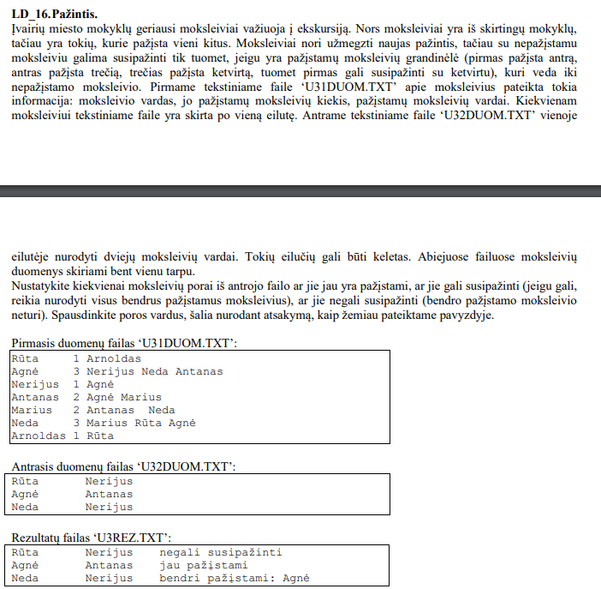

## Grafinės vartotojo sąsajos schema

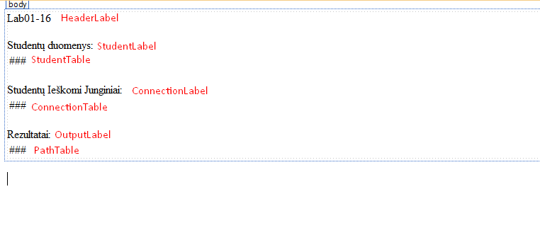

## Sąsajoje panaudotų komponentų keičiamos savybės

|  |  |  |
| --- | --- | --- |
| Komponentas | Savybė | Reikšmė |
| HeaderLabel | Text | "Lab01-16" |
| StudentLabel | Text | "Studentų duomenys:" |
| ConnectionLabel | Text | "Studentų Ieškomi Junginiai:" |
| OutputLabel | Text | "Rezultatai:" |

## Klasių diagrama

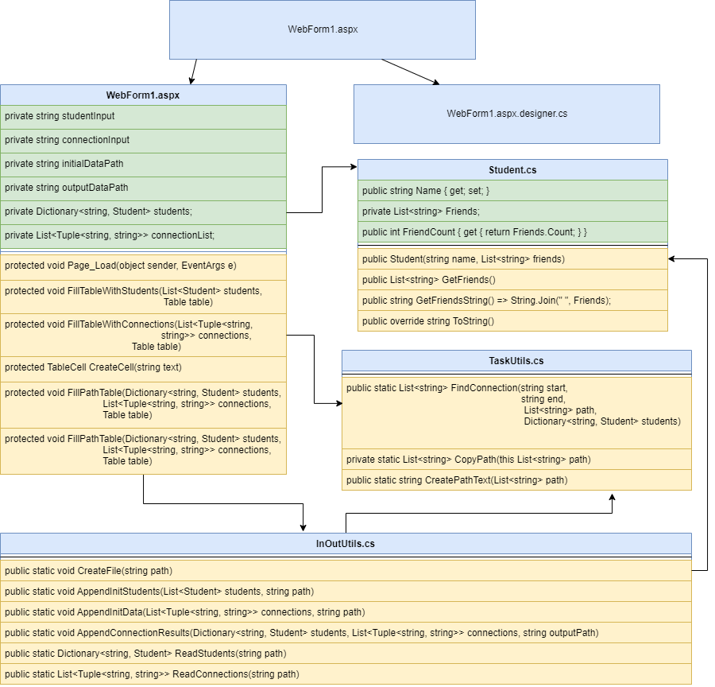

## Programos vartotojo vadovas

Atsidarius programą, programa nuskaito App_Data/students.txt ir App_Data/connections.txt. Naudojant tą informaciją, parašo visą informaciją į StudentTable, ConnectionTable, PathTable su duota ir apskaičiuota informacija.

## Programos tekstas

InOutUtils.cs:

using System;

using System.Collections.Generic;

using System.IO;

using System.Linq;

using System.Web;

namespace Lab01

{

/// <summary>

/// InOutUtils class for reading and writing data from/to a file

/// </summary>

public static class InOutUtils

{

/// <summary>

/// Creates a new empty file, ready for appending data

/// </summary>

/// <param name="path">path to the file</param>

public static void CreateFile(string path)

{

using (FileStream fs = new FileStream(path, FileMode.Create))

new StreamWriter(fs, encoding: System.Text.Encoding.UTF8).Close();

}

/// <summary>

/// appends initial student data to TXT file

/// </summary>

/// <param name="students">List of all students (Student object)</param>

/// <param name="path">path to the file where information will be appended</param>

public static void AppendInitStudents(List<Student> students, string path)

{

using (StreamWriter sr = new StreamWriter(path, append: true))

{

sr.WriteLine("Studentai ir jų draugai");

sr.WriteLine($"{"Studentas",-20}|{"Draugų kiekis",-20}|{"Draugai:"}");

foreach (Student student in students)

sr.WriteLine(student);

sr.WriteLine();

}

}

/// <summary>

/// Appends initial connection data to output file

/// </summary>

/// <param name="connections">List of Tuples(string, string) that work as nodes from student a to student b while using DFS</param>

/// <param name="path">path to the file where to append initial data</param>

public static void AppendInitData(List<Tuple<string, string>> connections, string path)

{

using (StreamWriter sr = new StreamWriter(path, append: true))

{

sr.WriteLine("Studentai ir jų ieškomi draugai:");

sr.WriteLine($"{"Studentas",-20} {"Ieškomas draugas",-20}");

foreach (Tuple<string, string> connection in connections)

sr.WriteLine($"{connection.Item1,-20} {connection.Item2,-20}");

sr.WriteLine();

}

}

/// <summary>

/// Appends output connection data to output file

/// </summary>

/// <param name="students">Dictionary, key -> string, name of the student, value -> Student class object of the student</param>

/// <param name="connections">List of tuples(string, string) that is compromised of student names that work as nodes that are used for DFS</param>

/// <param name="outputPath">output path to the txt file where data will be APPENDED</param>

public static void AppendConnectionResults(Dictionary<string, Student> students, List<Tuple<string, string>> connections, string outputPath)

{

using (StreamWriter sr = new StreamWriter(outputPath))

{

sr.WriteLine("Draugai ir jų junginiai, bei keliai:");

sr.WriteLine($"{"Draugas",-20}|{"Ieškomas draugas:",-20}|{"Kelias:"}");

foreach (Tuple<string, string> connection in connections)

{

List<string> studentPath = new List<string>();

studentPath.Add(connection.Item1);

studentPath = TaskUtils.FindConnection(connection.Item1, connection.Item2, studentPath, students);

string pathText = TaskUtils.CreatePathText(studentPath);

sr.WriteLine($"{connection.Item1,-20}|{connection.Item2,-20}|{pathText}");

}

}

}

/// <summary>

/// Creates a name to Student class object relation dictionary

/// </summary>

/// <param name="path">Path to the the text file containing the data</param>

/// <returns>Dictionary(key -> string, value -> Student class object) </returns>

public static Dictionary<string, Student> ReadStudents(string path)

{

Dictionary<string, Student> students = new Dictionary<string, Student>();

using (StreamReader sr = new StreamReader(path))

{

string line;

while ((line = sr.ReadLine()) != null)

{

string[] elements = line.Split(' ');

string name = elements[0];

List<string> friends = new List<string>();

for (int i = 2; i < elements.Length; i++)

friends.Add(elements[i]);

students.Add(name, new Student(name, friends));

}

}

return students;

}

/// <summary>

/// Gets the connections of students

/// </summary>

/// <param name="path">.txt file to the input</param>

/// <returns>List of Tupples(string, string)</returns>

public static List<Tuple<string, string>> ReadConnections(string path)

{

List<Tuple<string, string>> conncetions = new List<Tuple<string, string>>();

using (StreamReader sr = new StreamReader(path))

{

string line;

while ((line = sr.ReadLine()) != null)

{

string[] elements = line.Split(' ');

conncetions.Add(new Tuple<string, string>(elements[0], elements[1]));

}

}

return conncetions;

}

}

}

TaskUtils.cs:

using System;

using System.Collections.Generic;

using System.IO;

using System.Linq;

using System.Web;

namespace Lab01

{

/// <summary>

/// TaskUtils class for extra (backend) computation functions

/// </summary>

public static class TaskUtils

{

/// <summary>

/// Recursive implementation of DFS

/// </summary>

/// <param name="start">Start of the person</param>

/// <param name="end">End of the person</param>

/// <param name="path">path to current position from initial start</param>

/// <param name="students">Dictionary, key: string (name of the student), value Student class object</param>

/// <returns>List of strings, that create a path from student a to b</returns>

public static List<string> FindConnection(string start, string end, List<string> path, Dictionary<string, Student> students)

{

Student curr = students[start];

List<string> outputPath = null;

foreach(string next in curr.GetFriends())

{

if (next == end)

return path;

else if (path.Contains(next)) // Checks if the current node has been visited, so it does not loop

continue;

Student nextStudent = students[next];

List<string> pathCopy = path.CopyPath();

pathCopy.Add(next);

List<String> pathToEnd = FindConnection(next, end, pathCopy, students); // Recursion Call

if(outputPath == null || (pathToEnd != null && pathToEnd.Count < outputPath.Count))

outputPath = pathToEnd;

}

return outputPath; // Did not found the path

}

/// <summary>

/// Deep copies a string list

/// </summary>

/// <param name="path">string list</param>

/// <returns>string list</returns>

private static List<string> CopyPath(this List<string> path)

{

List<string> copy = new List<string>();

foreach (string s in path)

copy.Add(s);

return copy;

}

/// <summary>

/// Creates connection depending on the path

/// </summary>

/// <param name="path"> List of strings that the path is compromised of </param>

/// <returns>a string form of the path from student a to student b</returns>

public static string CreatePathText(List<string> path)

{

if (path == null)

return "negali susipažinti";

else if (path.Count == 1)

return "jau pažįstami";

else

{

path.RemoveAt(0);

return $"bendri pažįstami: {String.Join(" ", path)}";

}

}

}

}

Student.cs:

using System;

using System.Collections.Generic;

using System.Linq;

using System.Web;

namespace Lab01

{

/// <summary>

/// Student Class Data Object that stores the name and connection

/// </summary>

public class Student

{

public string Name { get; set; }

private List<string> Friends;

public int FriendCount { get { return Friends.Count; } }

/// <summary>

/// Constructor

/// </summary>

public Student(string name, List<string> friends)

{

Name = name;

Friends = new List<string>();

foreach (string friend in friends)

Friends.Add(friend);

}

/// <summary>

/// Copies friends

/// </summary>

/// <returns>Deep copy of Friends List</returns>

public List<string> GetFriends()

{

List<string> friendList = new List<string>();

foreach (string friend in Friends)

friendList.Add(friend);

return friendList;

}

/// <summary>

/// Transforms Friends list into a string seperated by spaces

/// </summary>

/// <returns>string of all friends</returns>

public string GetFriendsString() => String.Join(" ", Friends);

/// <summary>

/// ToString Override

/// </summary>

/// <returns>string version of the object: Name, Friend Count, Friends</returns>

public override string ToString()

{

return $"{Name,-20}|{Friends.Count,20}|{GetFriendsString()}";

}

}

}

WebForm1.aspx:

<%@ Page Language="C#" AutoEventWireup="true" CodeBehind="WebForm1.aspx.cs" Inherits="Lab01.WebForm1" %>

<!DOCTYPE html>

<html xmlns="http://www.w3.org/1999/xhtml">

<head runat="server">

<title></title>

</head>

<body>

<form id="form1" runat="server">

<div>

<asp:Label ID="HeaderLabel" runat="server" Text="Lab01-16"></asp:Label>

<br />

<br />

<asp:Label ID="StudentLabel" runat="server" Text="Studentų duomenys:"></asp:Label>

<br />

<asp:Table ID="StudentTable" runat="server">

</asp:Table>

<br />

<asp:Label ID="ConnectionLabel" runat="server" Text="Studentų Ieškomi Junginiai:"></asp:Label>

<br />

<asp:Table ID="ConnectionTable" runat="server">

</asp:Table>

<br />

<asp:Label ID="OutputLabel" runat="server" Text="Rezultatai:"></asp:Label>

<br />

<asp:Table ID="PathTable" runat="server">

</asp:Table>

</div>

</form>

</body>

</html>

using System;

using System.Collections.Generic;

using System.Linq;

using System.Web;

using System.Web.UI;

using System.Web.UI.WebControls;

namespace Lab01

{

public partial class WebForm1 : System.Web.UI.Page

{

private string studentInput = @"App_Data/students.txt";

private string connectionInput = @"App_Data/connections.txt";

private string initialDataPath = @"App_Data/initial_data.txt";

private string outputDataPath = @"App_Data/result.txt";

private Dictionary<string, Student> students;

private List<Tuple<string, string>> connectionList;

protected void Page_Load(object sender, EventArgs e)

{

// Initial Data

InOutUtils.CreateFile(Server.MapPath(initialDataPath));

students = InOutUtils.ReadStudents(Server.MapPath(studentInput));

FillTableWithStudents(new List<Student>(students.Values),

StudentTable);

InOutUtils.AppendInitStudents(new List<Student>(students.Values),

Server.MapPath(initialDataPath));

connectionList = InOutUtils.ReadConnections(Server.MapPath(connectionInput));

FillTableWithConnections(connectionList,

ConnectionTable);

InOutUtils.AppendInitData(connectionList,

Server.MapPath(initialDataPath));

FillPathTable(students, connectionList, PathTable);

InOutUtils.CreateFile(Server.MapPath(outputDataPath));

InOutUtils.AppendConnectionResults(students,

connectionList,

Server.MapPath(outputDataPath));

}

/// <summary>

/// Used to show initial Student Data

/// </summary>

/// <param name="students">List Student data type</param>

/// <param name="table">Table Object data type</param>

protected void FillTableWithStudents(List<Student> students, Table table)

{

TableRow row = new TableRow();

row.Cells.Add(CreateCell("Studentas"));

row.Cells.Add(CreateCell("Draugų Kiekis"));

row.Cells.Add(CreateCell("Studentų Draugai:"));

table.Rows.Add(row);

foreach (Student student in students)

{

row = new TableRow();

row.Cells.Add(CreateCell(student.Name));

row.Cells.Add(CreateCell(student.FriendCount.ToString()));

row.Cells.Add(CreateCell(student.GetFriendsString()));

table.Rows.Add(row);

}

}

/// <summary>

/// Used to show initial connection data

/// </summary>

/// <param name="connections">List of Tuples compromised of string, string containing the initial node and end node to use for DFS</param>

/// <param name="table">Table object data type</param>

protected void FillTableWithConnections(List<Tuple<string,

string>> connections,

Table table)

{

TableRow row = new TableRow();

row.Cells.Add(CreateCell("Draugas"));

row.Cells.Add(CreateCell("Ieškomas Draugas"));

table.Rows.Add(row);

foreach (Tuple<string, string> connection in connections)

{

row = new TableRow();

row.Cells.Add(CreateCell(connection.Item1));

row.Cells.Add(CreateCell(connection.Item2));

table.Rows.Add(row);

}

}

/// <summary>

/// Creates A cell with provided Text

/// </summary>

/// <param name="text">text to be added to the Cell.text param</param>

/// <returns>TableCell object</returns>

protected TableCell CreateCell(string text)

{

TableCell cell = new TableCell();

cell.Style.Add("padding", "5px");

cell.Text = text;

return cell;

}

/// <summary>

/// Fills the table with paths from student a to b

/// </summary>

/// <param name="students"> Dictionary, key -> string of the student, value -> student object</param>

/// <param name="connections">List of Tuples compromised of string, string containing the initial node and end node to use for DFS</param>

/// <param name="table">Table object where the data will be added</param>

protected void FillPathTable(Dictionary<string, Student> students,

List<Tuple<string, string>> connections,

Table table)

{

TableRow row = new TableRow();

row.Cells.Add(CreateCell("Draugas"));

row.Cells.Add(CreateCell("Ieškomas Draugas"));

row.Cells.Add(CreateCell("Kelias: "));

table.Rows.Add(row);

foreach (Tuple<string, string> connection in connections)

{

List<string> path = new List<string>();

path.Add(connection.Item1);

path = TaskUtils.FindConnection(connection.Item1,

connection.Item2,

path, students);

string pathText = TaskUtils.CreatePathText(path);

row = new TableRow();

row.Cells.Add(CreateCell(connection.Item1));

row.Cells.Add(CreateCell(connection.Item2));

row.Cells.Add(CreateCell(pathText));

table.Rows.Add(row);

}

}

}

}

## Pradiniai duomenys ir rezultatai

Pradiniai Duomenys 1:

students.txt:

Rūta 1 Arnoldas

Agnė 3 Nerijus Neda Antanas

Nerijus 1 Agnė

Antanas 2 Agnė Marius

Marius 2 Antanas Neda

Neda 3 Marius Rūta Agnė

Arnoldas 1 Rūta

connections.txt:

Rūta Nerijus

Agnė Antanas

Neda Nerijus

Rezultatai 1:

Vartotojo sąsaja:

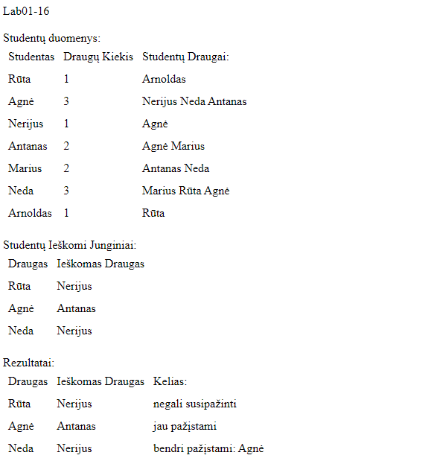

initial_data.txt:

Studentai ir jų draugai

Studentas |Draugų kiekis |Draugai:

Rūta | 1|Arnoldas

Agnė | 3|Nerijus Neda Antanas

Nerijus | 1|Agnė

Antanas | 2|Agnė Marius

Marius | 2|Antanas Neda

Neda | 3|Marius Rūta Agnė

Arnoldas | 1|Rūta

Studentai ir jų ieškomi draugai:

Studentas Ieškomas draugas

Rūta Nerijus

Agnė Antanas

Neda Nerijus

Result.txt:

Draugai ir jų junginiai, bei keliai:

Draugas |Ieškomas draugas: |Kelias:

Rūta |Nerijus |negali susipažinti

Agnė |Antanas |jau pažįstami

Neda |Nerijus |bendri pažįstami: Agnė

Pradiniai Duomenys 2:

students.txt:

a 2 g b

b 2 a c

c 2 b f

d 1 e

e 1 d

f 2 h c

g 2 a h

h 2 g f

connections.txt:

a f

a b

a e

Rezultatai 2:

Vartotojo Sąsaja:

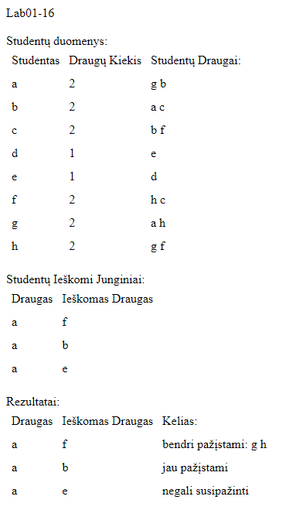

Initial_data.txt:

Studentai ir jų draugai

Studentas |Draugų kiekis |Draugai:

a | 2|g b

b | 2|a c

c | 2|b f

d | 1|e

e | 1|d

f | 2|h c

g | 2|a h

h | 2|g f

Studentai ir jų ieškomi draugai:

Studentas Ieškomas draugas

a f

a b

a e

result.txt:

Draugai ir jų junginiai, bei keliai:

Draugas |Ieškomas draugas: |Kelias:

a |f |bendri pažįstami: g h

a |b |jau pažįstami

a |e |negali susipažinti

## Dėstytojo pastabos

1. Reiktų šiek tiek pakeisti ataskaitos įvardinimą. Jūsų grupė nėra IFF14.

2. Klasių diagramai vien tik Visual Studio įrankio neužtenka. Jis ne neatskleidžia pilnai klasės vidaus.

3. Garmatinės klaidos "su duotą ir apskaičiuotą "

4. • Įvedimo ir išvedimo metodus, veikiančius su tekstiniu failu, talpinkite į public static class InOutUtils.

5. Parametrus reikia komentuoti visiems metodams // /// appends students to TXT file  
/// public static void AppendInitialStudentData(List students, string path)

6. Čia tik rodyklės perrašymas:

public Student(string name, List friends)

{

Name = name;

Friends = friends;

# Dinaminis atminties valdymas (L2)

## Darbo užduotis

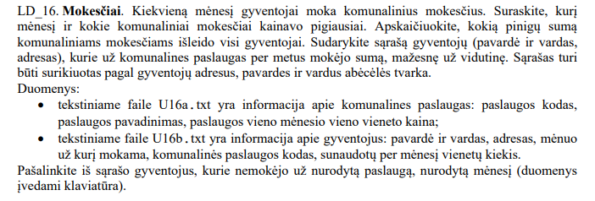

## Grafinės vartotojo sąsajos schema

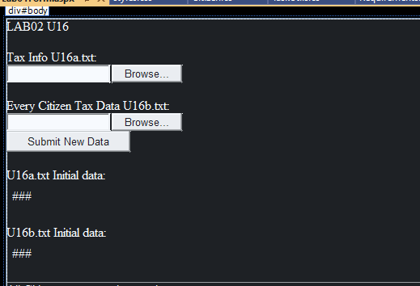

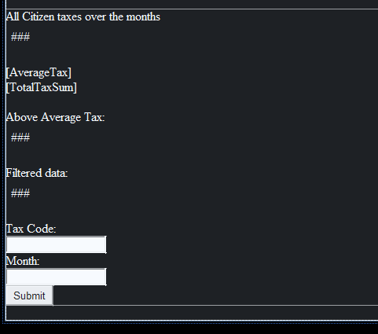

## Sąsajoje panaudotų komponentų keičiamos savybės

|  |  |  |
| --- | --- | --- |
| Komponentas | Savybė | Reikšmė |
| HeaderLabel | Text | LAB02 U16 |
| Label1 | Text | Tax InfoU16a.txt: |
| Label2 | Text | Every Citizen Tax Data U16b: |
| InitTaxLabel | Text | U16a.txt Initial data: |
| InitCitizenLabel | Text | U16b.txt Initial data: |
| CitizenTaxLabel | Text | All Citizen taxes over the months |
| AverageTax | Text | “” |
| TotalTaxSum | Text | “” |
| CitizenTaxLabel0 | Text | Above Average Tax: |
| FilterData | Text | Filtered data: |
| ButtonFilter | Text | Tax Code: |
| DataButton | Text | Month: |

## Klasių diagrama

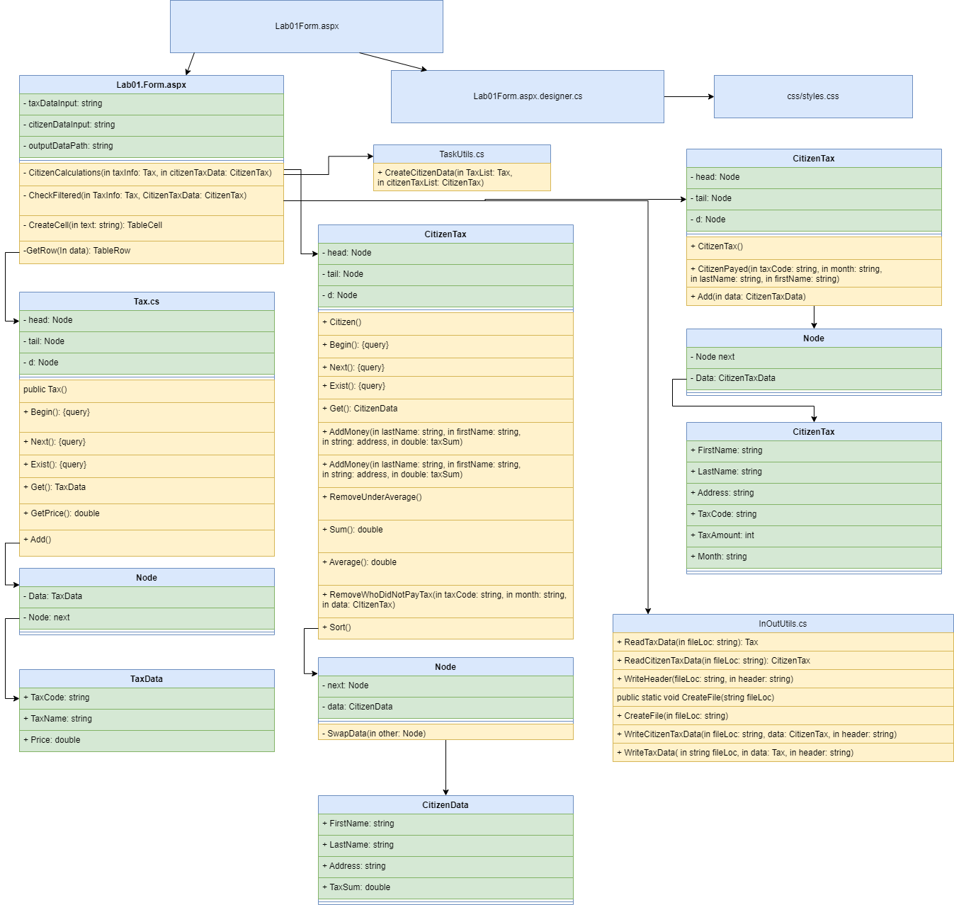

## Programos vartotojo vadovas

Jeigu neranda failų visų duombazėje, programa paprašo failų. Jeigu randa tik vieną pradinį failą, rodo tik jį ir prašo likusių failų. Kai abu failai atsiranda duombazėje, užkrauna skaičiavimus. Apskaičiuoja vidutinę mokesčių kainą, sumą visų ir individualių žmonių. Tekstas yra rikiuojamas A-Z pagal: adresą, pavardę, vardą. Kodas leidžia filtruoti žmones, kurie mokėjo nurodytą mėnesį (mėnuo yra string) už nurodytus mokesčius naudojant „Tax Code“ (string). Prie filtered lentelės prideda tik filtruotus duomenis.

## Programos tekstas

CitizenData.cs:

using System;

using System.Collections.Generic;

using System.Linq;

using System.Web;

using System.Web.UI.WebControls;

namespace Lab02

{

/// <summary>

/// TaskUtils static class for helper functions

/// </summary>

public static class TaskUtils

{

/// <summary>

/// Creates Citizen class object using Tax object

/// </summary>

/// <param name="TaxList">Tax class object</param>

/// <param name="citizenTaxList">CitizenTax object</param>

/// <returns>Citizen class object</returns>

public static Citizen CreateCitizenData(Tax TaxList, CitizenTax citizenTaxList)

{

Citizen citizens = new Citizen();

for (citizenTaxList.Begin(); citizenTaxList.Exist(); citizenTaxList.Next())

{

CitizenTaxData citizenTaxData = citizenTaxList.Get();

for (TaxList.Begin(); TaxList.Exist(); TaxList.Next())

{

TaxData taxData = TaxList.Get();

if(citizenTaxData.TaxCode == taxData.TaxCode)

{

citizens.AddMoney(citizenTaxData.LastName, citizenTaxData.FirstName, citizenTaxData.Address, (double)taxData.Price * citizenTaxData.TaxAmount);

}

}

}

return citizens;

}

}

}

Citizen.cs:

using System;

using System.Collections.Generic;

using System.Linq;

using System.Web;

using System.Web.UI.WebControls;

namespace Lab02

{

/// <summary>

/// Citizen class object

/// </summary>

public class Citizen

{

private Node head;

private Node tail;

private Node d;

/// <summary>

/// Construcotr

/// </summary>

/// <param name="head"></param>

/// <param name="tail"></param>

public Citizen()

{

head = null;

tail = null;

}

/** Address of the head of the list is assigned */

public void Begin()

{ d = head; }

/** Interface variable gets address of the next entry*/

public void Next()

{ d = d.next; }

/** Return true, if list is empty*/

public bool Exist()

{ return d != null; }

//-----------------------------------------------

/** Return data according to the interface address*/

public CitizenData Get()

{ return d.Data; }

/// <summary>

/// Returns Citizen with keys

/// </summary>

/// <param name="lastName">Last Name of Citizen</param>

/// <param name="firstName">First Name of Citizen</param>

/// <param name="address">Address of citizen</param>

/// <returns></returns>

public CitizenData Get(string lastName, string firstName, string address)

{

// If Citizen exists, adds sum to his current balance

for (Begin(); Exist(); Next())

{

CitizenData curr = Get();

if (curr.LastName == lastName && curr.FirstName == firstName && curr.Address == address)

{

return curr;

}

}

return null;

}

/// <summary>

/// Adds CitizenData to Citizen Linked List

/// </summary>

/// <param name="data">CitizenData object</param>

internal void Add(CitizenData data)

{

// If No citizen was found, adds the citizen to Linked List

if (head == null)

{

head = new Node(data, null);

tail = head;

}

else

{

tail.next = new Node(data, null);

tail = tail.next;

}

}

/// <summary>

/// Removes citiznens from linked list who payed belove average taxes

/// </summary>

public void RemoveUnderAverage()

{

if (head == null)

return;

Node prev = head;

Node curr = head.next;

double average = GetAverage();

while(curr != null)

{

if(curr.Data.TaxSum < average)

{

prev.next = curr.next;

curr = curr.next;

}

else

{

curr = curr.next;

prev = prev.next;

}

}

RemoveUnderAverageHead(average);

ResetTail();

}

/// <summary>

/// Checks if head/start of linked list is below average. If true removes

/// </summary>

/// <param name="average">Average tax sum of a citizen</param>

private void RemoveUnderAverageHead(double average)

{

Node curr = head;

while(curr.Data.TaxSum < average)

{

curr = curr.next;

}

head = curr;

}

/// <summary>

/// Resets tail after removing elements

/// </summary>

private void ResetTail()

{

Node curr = head;

if (curr == null)

{

tail = null;

return;

}

while(curr.next != null)

{

curr = curr.next;

}

tail = curr;

}

/// <summary>

/// Returns the total amount citizens payed for taxes

/// </summary>

/// <returns></returns>

public double Sum()

{

Node curr = head;

double sum = 0;

while (curr != null)

{

sum += curr.Data.TaxSum;

curr = curr.next;

}

return sum;

}

public double GetAverage()

{

Node curr = head;

double sum = 0;

int i = 0;

while (curr != null)

{

sum += curr.Data.TaxSum;

i++;

curr = curr.next;

}

if (i == 0)

return 0;

else

return (double)sum / i;

}

/// <summary>

/// Removes citizens who did not pay taxes specified month

/// </summary>

/// <param name="taxCode"> Tax Code of the tax</param>

/// <param name="month">Specified Month </param>

/// <param name="data">CitizenTaxData to see what citizen payed what tax at the specified month</param>

public void RemoveWhoDidNotPayTax(string taxCode, string month, CitizenTax data)

{

{

if (head == null)

return;

Node prev = head;

Node curr = head.next;

while (curr != null)

{

// Checks if the citizen has payed Taxes in CitizenTaxData on specified Month

if (curr != null && data.CitizenPayed(taxCode, month, curr.Data.LastName, curr.Data.FirstName) == false)

{

prev.next = curr.next;

curr = curr.next;

}

else

{

curr = curr.next;

prev = prev.next;

}

}

RemoveWhoDidNotPayTaxHead(taxCode, month, data);

ResetTail();

}

}

/// <summary>

/// Checks first/start/head element of the linked list if the tax was paid

/// </summary>

/// <param name="taxCode">Tax code of the specified tax</param>

/// <param name="month">specified month to check</param>

/// <param name="data">CitizenTaxData to check if the first element of the linked list payed for taxes</param>

private void RemoveWhoDidNotPayTaxHead(string taxCode, string month, CitizenTax data)

{

Node curr = head;

// Checks if the citizen has payed Taxes in CitizenTaxData on specified Month

while (curr != null && data.CitizenPayed(taxCode, month, curr.Data.LastName, curr.Data.FirstName) == false)

{

curr = curr.next;

}

head = curr;

}

/// <summary>

/// Sorts LinkedList A-Z using keys: address, last name, first name. Does data swap instead of pointers.

/// </summary>

public void Sort()

{

Node timer = head;

while(timer != null)

{

Node curr = head;

Node next = head.next;

while(next != null)

{

if (curr.Data.CompareTo(next.Data) > 0)

{

curr.SwapData(next);

}

curr = next;

next = next.next;

}

timer = timer.next;

}

}

/// <summary>

/// Node class to be used to save every citizen seperately

/// </summary>

class Node

{

public CitizenData Data { get; set; }

public Node next { get; set; }

/// <summary>

/// Constructor

/// </summary>

/// <param name="data">CitizenData pointer</param>

public Node(CitizenData data, Node _next)

{

Data = data;

next = _next;

}

/// <summary>

/// Swaps the DATA, keeps the pointers

/// </summary>

/// <param name="other">Other node to be swapped with</param>

public void SwapData(Node other)

{

CitizenData temp = Data;

Data = other.Data;

other.Data = temp;

}

}

}

}

CitizenTaxData.cs:

using System;

using System.Collections.Generic;

using System.Linq;

using System.Web;

namespace Lab02

{

public class CitizenTaxData

{

public string FirstName { get; set; }

public string LastName { get; set; }

public string Address { get; set; }

public string TaxCode { get; set; }

public int TaxAmount { get; set; }

public string Month { get; set; }

/// <summary>

/// Constructor

/// </summary>

/// <param name="lastName">last name of citizen</param>

/// <param name="firstName">first name of citizen</param>

/// <param name="address">address of the citizen</param>

/// <param name="month">the month the tax was paid</param>

/// <param name="taxCode">tax code</param>

/// <param name="taxAmount">tax amount</param>

public CitizenTaxData(string lastName, string firstName, string address, string month, string taxCode, int taxAmount)

{

FirstName = firstName;

LastName = lastName;

Address = address;

TaxCode = taxCode;

TaxAmount = taxAmount;

Month = month;

}

public override string ToString()

{

return $"{LastName,-20} {FirstName,-20}|{Address,-20}|{Month,-15}|{TaxCode,-20}|{TaxAmount,10}|";

}

}

}

CitizenTax.cs:

using System;

using System.Collections.Generic;

using System.Linq;

using System.Web;

using System.Web.UI.WebControls;

namespace Lab02

{

/// <summary>

/// Citizen class object meant to store name and how much the individual payed for taxe

/// </summary>

public class CitizenTax

{

private Node head;

private Node tail;

private Node d;

/// <summary>

/// Constructor

/// </summary>

public CitizenTax()

{

head = null;

tail = null;

}

/// <summary>

/// Adds element to Linked List

/// </summary>

/// <param name="lastName">Last Name</param>

/// <param name="firstName">First Name</param>

/// <param name="address">Address</param>

/// <param name="month">Month</param>

/// <param name="taxCode">Tax Code</param>

/// <param name="taxAmount">Tax Amount</param>

public void Add(CitizenTaxData data)

{

if (head == null)

{

head = new Node(data, null);

tail = head;

}

else

{

tail.next = new Node(data, null);

tail = tail.next;

}

}

/** Address of the head of the list is assigned */

public void Begin()

{ d = head; }

/** Interface variable gets address of the next entry*/

public void Next()

{ d = d.next; }

/** Return true, if list is empty*/

public bool Exist()

{ return d != null; }

//-----------------------------------------------

/** Return data according to the interface address*/

public CitizenTaxData Get()

{ return d.Data; }

/// <summary>

/// Checks of the specified citizen has payed

/// </summary>

/// <param name="taxCode">Tax Code of the Tax Company</param>

/// <param name="month">Month</param>

/// <param name="lastName">Last name of the citizen</param>

/// <param name="firstName"> First Name of the citizen</param>

/// <returns>true if citizen has payed for specified tax on specified month, false if the citizen did not</returns>

public bool CitizenPayed(string taxCode, string month, string lastName, string firstName)

{

Node curr = head;

while (curr != null)

{

if (curr.Data.LastName == lastName && curr.Data.FirstName == firstName && curr.Data.Month == month && curr.Data.TaxCode == taxCode)

return true; // The Person paid for the month

curr = curr.next;

}

return false;

}

/// <summary>

/// Node class object for CitizenTaxData

/// </summary>

class Node

{

public Node next;

public CitizenTaxData Data { get; set; }

/// <summary>

/// Constructor

/// </summary>

/// <param name="data">Pointer to CitizenTaxData object</param>

public Node(CitizenTaxData data, Node _next)

{

Data = data;

next = _next;

}

}

}

}

TaxData.cs:

using System;

using System.Collections.Generic;

using System.Linq;

using System.Web;

namespace Lab02

{

/// <summary>

/// TaxData object to be inherited by Tax object

/// </summary>

public class TaxData

{

public string TaxCode { get; set; }

public string TaxName { get; set; }

public double Price { get; set; }

/// <summary>

/// Constructor

/// </summary>

/// <param name="taxCode"></param>

/// <param name="taxName"></param>

/// <param name="price"></param>

public TaxData(string taxCode, string taxName, double price)

{

TaxCode = taxCode;

TaxName = taxName;

Price = price;

}

/// <summary>

/// Returns Node in string format

/// </summary>

/// <returns>Node in string format</returns>

public override string ToString()

{

return $"{TaxCode,-20}|{TaxName,-20}|{Price,10:f}|";

}

}

}

Tax.cs:

using System;

using System.Collections.Generic;

using System.Linq;

using System.Web;

using System.Web.UI.WebControls;

namespace Lab02

{

public class Tax

{

private Node head;

private Node tail;

private Node d;

public Tax()

{

head = null;

tail = null;

}

/** Address of the head of the list is assigned */

public void Begin()

{ d = head; }

/** Interface variable gets address of the next entry*/

public void Next()

{ d = d.next; }

/** Return true, if list is empty*/

public bool Exist()

{ return d != null; }

//-----------------------------------------------

/** Return data according to the interface address*/

public TaxData Get()

{ return d.Data; }

/// <summary>

/// Returns the price of the tax of a single use

/// </summary>

/// <param name="taxCode">Code to identify the type of tax</param>

/// <returns>Double, price of a single use tax item</returns>

public double GetPrice(string taxCode)

{

Node curr = head;

while (curr != null)

{

if (curr.Data.TaxCode == taxCode)

return curr.Data.Price;

curr = curr.next;

}

return 0;

}

/// <summary>

/// Adds Node to the tail of the LinkedList

/// </summary>

/// <param name="taxCode">Code of the tax</param>

/// <param name="name"> name of the company</param>

/// <param name="price">price of a single use</param>

public void Add(TaxData data)

{

if (head == null)

{

head = new Node(data, null);

tail = head;

}

else

{

tail.next = new Node(data, null);

tail = tail.next;

}

}

/// <summary>

/// Tax Node

/// </summary>

class Node

{

public Node next;

public TaxData Data { get; set; }

/// <summary>

/// Constructor

/// </summary>

/// <param name="data">TaxData pointer</param>

public Node(TaxData data, Node _next)

{

Data = data;

next = _next;

}

}

}

}

InOutUtils.cs:

using System;

using System.Collections.Generic;

using System.IO;

using System.Linq;

using System.Web;

namespace Lab02

{

/// <summary>

/// Static InOutUtils helper class for Input/Output with files

/// </summary>

public static class InOutUtils

{

/// <summary>

/// Reads Tax Data from txt to Tax class object+

/// </summary>

/// <param name="fileLoc">Location of the data in .txt format</param>

/// <returns>Tax class object</returns>

public static Tax ReadTaxData(string fileLoc)

{

Tax taxes = new Tax();

string[] lines = File.ReadAllLines(fileLoc);

foreach (string line in lines)

{

string[] elements = line.Split(';');

taxes.Add(new TaxData(elements[0], elements[1], double.Parse(elements[2])));

}

return taxes;

}

/// <summary>

/// Creates CitizenTaxData from .txt file

/// </summary>

/// <param name="fileLoc">Location of .txt file</param>

/// <returns>CitizenTaxData class object</returns>

public static CitizenTax ReadCitizenTaxData(string fileLoc)

{

CitizenTax data = new CitizenTax();

string[] lines = File.ReadAllLines(fileLoc);

foreach (string line in lines)

{

string[] elements = line.Split(';');

CitizenTaxData temp = new CitizenTaxData(elements[1], elements[0], elements[2], elements[3], elements[4], int.Parse(elements[5]));

data.Add(temp);

}

return data;

}

/// <summary>

/// Appends a header to a file

/// </summary>

/// <param name="fileLoc">Name/location of the file</param>

/// <param name="header">text to be appended</param>

public static void WriteHeader(string fileLoc, string header)

{

using (StreamWriter writer = new StreamWriter(fileLoc, append: true))

{

writer.WriteLine(header);

writer.WriteLine();

}

}

/// <summary>

/// Creates a new or wipes a file

/// </summary>

/// <param name="fileLoc">Location of the file</param>

public static void CreateFile(string fileLoc)

{

using (FileStream fs = new FileStream(fileLoc, FileMode.Create))

new StreamWriter(fs, encoding: System.Text.Encoding.UTF8).Close();

}

/// <summary>

/// Appends CitizenTaxData to a file

/// </summary>

/// <param name="fileLoc">Location/name of the file</param>

/// <param name="data">data to append to the .txt file</param>

/// <param name="header">Header text of the data file</param>

public static void WriteCitizenTaxData(string fileLoc, CitizenTax data, string header)

{

using (StreamWriter writer = new StreamWriter(fileLoc, append:true))

{

writer.WriteLine(header);

writer.WriteLine();

writer.WriteLine($"{"LastName",-20} {"FirstName",-20}|{"Address",-20}|{"Month",-15}|{"TaxCode",-20}|{"TaxAmount",10}|");

for (data.Begin(); data.Exist(); data.Next())

{

CitizenTaxData temp = data.Get();

writer.WriteLine(temp.ToString());

}

writer.WriteLine();

}

}

/// <summary>

/// appends Citizen class object data to text file

/// </summary>

/// <param name="fileLoc">location/name of the file</param>

/// <param name="data">data to append to the file</param>

/// <param name="header">Header of the file</param>

public static void WriteCitizenData(string fileLoc, Citizen data, string header)

{

using (StreamWriter writer = new StreamWriter(fileLoc, append: true))

{

writer.WriteLine(header);

writer.WriteLine();

writer.WriteLine($"{"LastName",-20} {"FirstName",-20}|{"Address",-20}|{"TaxSum",-10}|");

for (data.Begin(); data.Exist(); data.Next())

{

CitizenData temp = data.Get();

writer.WriteLine(temp.ToString());

}

writer.WriteLine();

}

}

/// <summary>

/// Appends Tax data to a .txt file

/// </summary>

/// <param name="fileLoc">Location/name of the file</param>

/// <param name="data">data to append to the .txt file</param>

/// <param name="header">header to be added to the file</param>

public static void WriteTaxData(string fileLoc, Tax data, string header)

{

using (StreamWriter writer = new StreamWriter(fileLoc, append: true))

{

writer.WriteLine(header);

writer.WriteLine();

writer.WriteLine($"{"TaxCode",-20}|{"TaxName",-20}|{"Price",10:2f}|");

for (data.Begin(); data.Exist(); data.Next())

{

TaxData temp = data.Get();

writer.WriteLine(temp.ToString());

}

writer.WriteLine();

}

}

}

}

css/styles.css:

body {

color:white;

background:black;

}

td

{

padding:5px;

}

Lab01Form.aspx:

<%@ Page Language="C#" AutoEventWireup="true" CodeBehind="Lab01Form.aspx.cs" Inherits="Lab02.Lab01Form" %>

<!DOCTYPE html>

<html xmlns="http://www.w3.org/1999/xhtml">

<head runat="server">

<link rel="stylesheet" runat="server" media="screen" href="~/css/styles.css" />

<title>Lab02 U16</title>

</head>

<body>

<form id="form1" runat="server">

<div id="body">

<asp:Label ID="HeaderLabel" runat="server" Text="LAB02 U16"></asp:Label>

<br />

<br />

<asp:Label ID="Label1" runat="server" Text="Tax Info U16a.txt:"></asp:Label>

<br />

<asp:FileUpload ID="FileUpload1" runat="server" />

<br />

<br />

<asp:Label ID="Label2" runat="server" Text="Every Citizen Tax Data U16b.txt: "></asp:Label>

<br />

<asp:FileUpload ID="FileUpload2" runat="server" />

<br />

<asp:Button ID="DataButton" runat="server" Text="Submit New Data" OnClick="DataButton_Click" />

<br />

<br />

<asp:Label ID="InitTaxLabel" runat="server" Text="U16a.txt Initial data:"></asp:Label>

<asp:Table ID="InitTaxTable" runat="server">

</asp:Table>

<br />

<asp:Label ID="InitCitizenLabel" runat="server" Text="U16b.txt Initial data:"></asp:Label>

<asp:Table ID="InitCitizenTable" runat="server">

</asp:Table>

<br />

<asp:Panel ID="CalculationsPanel" runat="server">

<asp:Label ID="CitizenTaxLabel" runat="server" Text="All Citizen taxes over the months"></asp:Label>

<asp:Table ID="CitizenTaxTable" runat="server">

</asp:Table>

<br />

<asp:Label ID="AverageTax" runat="server"></asp:Label>

<br />

<asp:Label ID="TotalTaxSum" runat="server"></asp:Label>

<br />

<br />

<asp:Label ID="CitizenTaxLabel0" runat="server" Text="Above Average Tax:"></asp:Label>

<asp:Table ID="AboveAverageTable" runat="server">

</asp:Table>

<br />

<asp:Label ID="FilterData" runat="server" Text="Filtered data:"></asp:Label>

<asp:Table ID="FilterTable" runat="server">

</asp:Table>

<br />

Tax Code:<br />

<asp:TextBox ID="TaxCodeTextBox" runat="server"></asp:TextBox>

<br />

Month:<br />

<asp:TextBox ID="TaxMonthTextBox" runat="server"></asp:TextBox>

<br />

<asp:Button ID="ButtonFilter" runat="server" Text="Submit" OnClick="ButtonFilter_Click" />

</asp:Panel>

<br />

</div>

</form>

</body>

</html>

Lab01Form.aspx.cs:

using System;

using System.Collections.Generic;

using System.IO;

using System.Linq;

using System.Web;

using System.Web.UI;

using System.Web.UI.WebControls;

namespace Lab02

{

public partial class Lab01Form : System.Web.UI.Page

{

private string taxDataInput = @"App_Data/U16a.txt";

private string citizenDataInput = @"App_Data/U16b.txt";

private string outputDataPath = @"App_Data/U16result.txt";

protected void Page_Load(object sender, EventArgs e)

{

CitizenTax citizenTaxData = null;

Tax taxInfo = null;

InOutUtils.CreateFile(Server.MapPath(outputDataPath));

if (File.Exists(Server.MapPath(taxDataInput)))

{

taxInfo = InOutUtils.ReadTaxData(Server.MapPath(taxDataInput));

InOutUtils.WriteTaxData(Server.MapPath(outputDataPath), taxInfo, "Initial Tax Company Data:");

FillTaxDataTable(taxInfo, InitTaxTable);

}

else

{

InitTaxLabel.Text = "";

}

if (File.Exists(Server.MapPath(citizenDataInput)))

{

citizenTaxData = InOutUtils.ReadCitizenTaxData(Server.MapPath(citizenDataInput));

InOutUtils.WriteCitizenTaxData(Server.MapPath(outputDataPath), citizenTaxData, "Initial Citizen Tax Data:");

FillCitizenTaxDataTable(citizenTaxData, InitCitizenTable);

}

else

{

InitCitizenLabel.Text = "";

}

if (citizenTaxData != null && taxInfo != null)

{

// Reads Initial Data and Outputs the Initial Data To WebForm and to text

CitizenCalculations(taxInfo, citizenTaxData);

CheckFiltered(taxInfo, citizenTaxData);

}

else

{

HeaderLabel.Text = "Plaese Upload remaining data files";

CalculationsPanel.Visible = false;

}

}

/// <summary>

/// Does calculations from Tax and CitizenTax object

/// </summary>

/// <param name="taxInfo">Tax object</param>

/// <param name="citizenTaxData">CitizenTax object</param>

protected void CitizenCalculations(Tax taxInfo, CitizenTax citizenTaxData)

{

Citizen citizensAverage = TaskUtils.CreateCitizenData(taxInfo, citizenTaxData); // For Above Average

InOutUtils.WriteCitizenData(Server.MapPath(outputDataPath), citizensAverage, "Tax Sum of all citizens:");

citizensAverage.Sort();

InOutUtils.WriteCitizenData(Server.MapPath(outputDataPath), citizensAverage, "Tax Sum of all citizens SORTED A-Z:");

FillCitizenTable(citizensAverage, CitizenTaxTable);

double sum = citizensAverage.Sum();

double average = citizensAverage.GetAverage();

InOutUtils.WriteHeader(Server.MapPath(outputDataPath), $"All Citizen TOTAL Tax Sum: {sum:f}");

InOutUtils.WriteHeader(Server.MapPath(outputDataPath), $"Average Tax Sum: {average:f}");

AverageTax.Text = $"Average tax per citizen: {average}";

TotalTaxSum.Text = $"Total tax sum: {sum}";

citizensAverage.RemoveUnderAverage();

InOutUtils.WriteCitizenData(Server.MapPath(outputDataPath), citizensAverage, "Citizens who paid above average:");

FillCitizenTable(citizensAverage, AboveAverageTable);

}

/// <summary>

/// Updates filtered data

/// </summary>

/// <param name="taxInfo">Tax Object</param>

/// <param name="citizenTaxData">CitizenTax object</param>

protected void CheckFiltered(Tax taxInfo, CitizenTax citizenTaxData)

{

if (Session["TaxCode"] != null && Session["Month"] != null)

{

Citizen citizensFiltered = TaskUtils.CreateCitizenData(taxInfo, citizenTaxData); // For Filter

citizensFiltered.Sort();

citizensFiltered.RemoveWhoDidNotPayTax(Session["TaxCode"].ToString(), Session["Month"].ToString(), citizenTaxData);

InOutUtils.WriteCitizenData(Server.MapPath(outputDataPath), citizensFiltered, $"Citizens who paid TaxCode: \"{Session["TaxCode"]}\" on Month: \"{Session["Month"]}\"");

FillCitizenTable(citizensFiltered, FilterTable);

}

else

{

FilterData.Text = "No Filter provided";

}

Session["TaxCode"] = null;

Session["Month"] = null;

}

## Pradiniai duomenys ir rezultatai

U16a.txt:

11; Elektra; 0.12

21; Dujos; 0.58

31; Benzinas; 1.78

32; Diezelis; 1.90

U16b.txt:

pavardė1; vardas1; adresas1;1;22;28;

pavardė1; vardas1; adresas1;5;22;20;

pavardė1; vardas1; adresas1;1;32;100;

pavardė1; vardas1; adresas1;2;32;97;

pavardė1; vardas1; adresas1;3;32;63;

pavardė1; vardas1; adresas1;2;22;25;

pavardė1; vardas1; adresas1;3;22;29;

pavardėAA; vardasAA; adresasAA;1;21;13;

pavardėAA; vardasAA; adresasAA;2;21;84;

pavardėAA; vardasAA; adresasAA;3;21;76;

pavardė1; vardas1; adresas1;4;22;39;

pavardė2; vardas2; adresas2;3;31;67;

pavardė2; vardas2; adresas2;4;31;98;

pavardė0; vardas2; adresas2;5;31;125;

pavardė0; vardas0; adresas3;1;11;31;

pavardė1; vardas1; adresas1;4;32;39;

pavardė1; vardas1; adresas1;5;32;20;

pavardė1; vardas1; adresas1;3;11;80;

pavardė1; vardas1; adresas1;4;11;39;

pavardė1; vardas1; adresas1;1;11;120;

pavardė1; vardas1; adresas1;2;11;100;

pavardė1; vardas1; adresas1;5;11;139;

pavardė2; vardas2; adresas2;1;31;31;

pavardė2; vardas2; adresas2;2;31;48;

pavardė0; vardas0; adresas3;2;11;48;

pavardė0; vardas0; adresas3;3;11;67;

pavardė0; vardas0; adresas3;4;11;98;

pavardė0; vardas0; adresas3;5;11;125;

pavardėAA; vardasAA; adresasAA;4;21;8;

pavardėAA; vardasAA; adresasAA;5;21;25;

Rezultatai 1:

Vartotojo sąsaja:

Duombazėje nerado jokio failo:

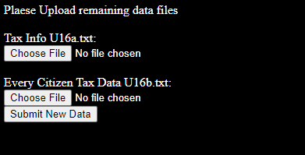

Prikabinamo U16a.txt failą:

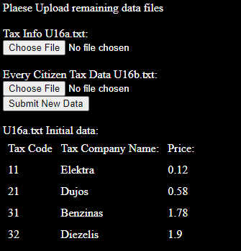

Prikabinome U16b.txt:

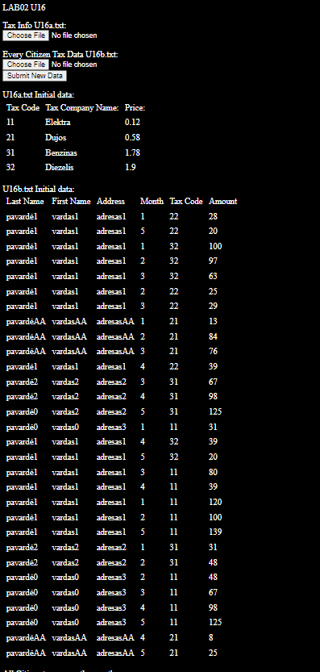

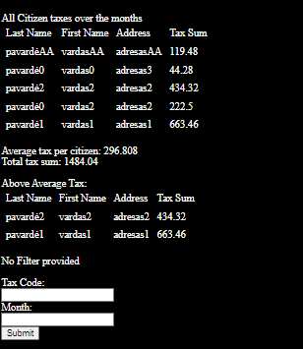

Prafiltravome duomenis pagal kodą: „11“, mėnesį: „2“. Prisidėjo lentelė papildoma.

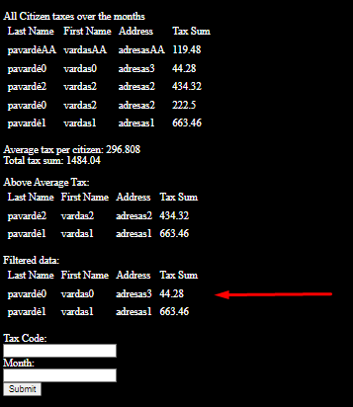

U16result.txt:

Tax Sum of all citizens:

LastName FirstName |Address |TaxSum |

pavardė1 vardas1 | adresas1 | 663.46|

pavardėAA vardasAA | adresasAA | 119.48|

pavardė2 vardas2 | adresas2 | 434.32|

pavardė0 vardas2 | adresas2 | 222.50|

pavardė0 vardas0 | adresas3 | 44.28|

Tax Sum of all citizens SORTED A-Z:

LastName FirstName |Address |TaxSum |

pavardėAA vardasAA | adresasAA | 119.48|

pavardė0 vardas0 | adresas3 | 44.28|

pavardė2 vardas2 | adresas2 | 434.32|

pavardė0 vardas2 | adresas2 | 222.50|

pavardė1 vardas1 | adresas1 | 663.46|

All Citizen TOTAL Tax Sum: 1484.04

Average Tax Sum: 296.81

Citizens who paid above average:

LastName FirstName |Address |TaxSum |

pavardė2 vardas2 | adresas2 | 434.32|

pavardė1 vardas1 | adresas1 | 663.46|

Citizens who paid TaxCode: "11" on Month: "2"

LastName FirstName |Address |TaxSum |

pavardė0 vardas0 | adresas3 | 44.28|

pavardė1 vardas1 | adresas1 | 663.46|

Duomenys 2:

U16a.txt:

VAND; Vanduo; 0.07

KVND; Karštas vanduo; 0.20

LH20; Ledinis Vanduo; 0.10

U16b.txt:

Pavardauskis; Vardenis; Adresatas;Vasaris;Benzinas;28;

Pavardauskis; Vardenis; Adresatas;Vasaris;VAND;14;

Pavardauskis; Vardenis; Adresatas;Kovas;KVND;20;

Pavardauskis; Vardenis; Adresatas;Kovas;LH20;30;

Pavardauskis; Vardenis; Adresatas;Kovas;VAND;15;

Pavardauskis; Vardenis; Adresatas;Balandis;VAND;99;

Tomas; Tomukas; Tomo namas 1;Kovas;VAND;97;

Tomas; Tomukas; Tomo namas 1;Balandis;VAND;156;

Tomas; Tomukas; Tomo namas 1;Rugsėjis;VAND;20;

Rezultatai:

Vartotojo sąsaja

Naudojant mėnesį: Balandis ir mokesčių kodą: VAND:

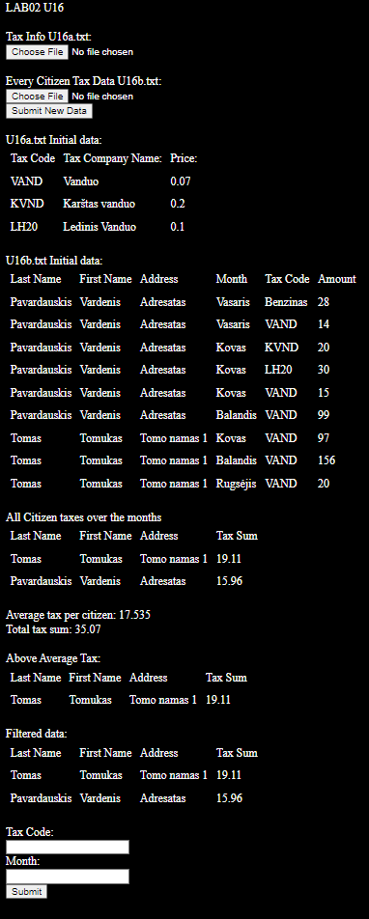

U16result.txt:

Tax Sum of all citizens:

LastName FirstName |Address |TaxSum |

Pavardauskis Vardenis | Adresatas | 15.96|

Tomas Tomukas | Tomo namas 1 | 19.11|

Tax Sum of all citizens SORTED A-Z:

LastName FirstName |Address |TaxSum |

Tomas Tomukas | Tomo namas 1 | 19.11|

Pavardauskis Vardenis | Adresatas | 15.96|

All Citizen TOTAL Tax Sum: 35.07

Average Tax Sum: 17.54

Citizens who paid above average:

LastName FirstName |Address |TaxSum |

Tomas Tomukas | Tomo namas 1 | 19.11|

Citizens who paid TaxCode: "VAND" on Month: "Balandis"

LastName FirstName |Address |TaxSum |

Tomas Tomukas | Tomo namas 1 | 19.11|

Pavardauskis Vardenis | Adresatas | 15.96|

## Dėstytojo pastabos

1. Klasių diagramoje nebūna žodžių private ar public. Tam yra spec. simboliai.
2. Negalima private int count;
3. Kam žodis internal, internal class Node?
4. Negalim painioti su sąsaja:

public TableRow GetRow(int index

1. Taip neturi būti:

public string TaxCode { get; set; }

public string TaxName { get; set; }

public double Price { get; set; }

public Node next;

1. Kur klasės Tax sąsajos metodai?

Perdaryti.

1. Negaliu sutikti su tokia klase Node:

public Node(string lastName, string firstName, string address)

{

Data = new CitizenData(lastName, firstName, address);

}

/// <summary>

/// Swaps the DATA, keeps the pointers

/// </summary>

/// <param name="other">Other node to be swapped with</param>

public void SwapData(Node other)

{

CitizenData temp = Data;

Data = other.Data;

other.Data = temp;

}

1. Nėra klasės InoutUtils.
2. AddMoney(string lastName, string firstName, string address, double  
   Kodėl ne citizen?
3. Kodėl nėra Next antraštėje?

public Node(CitizenData data)

# Bendrinės klasės ir testavimas (L3)

## Darbo užduotis



## Grafinės vartotojo sąsajos schema

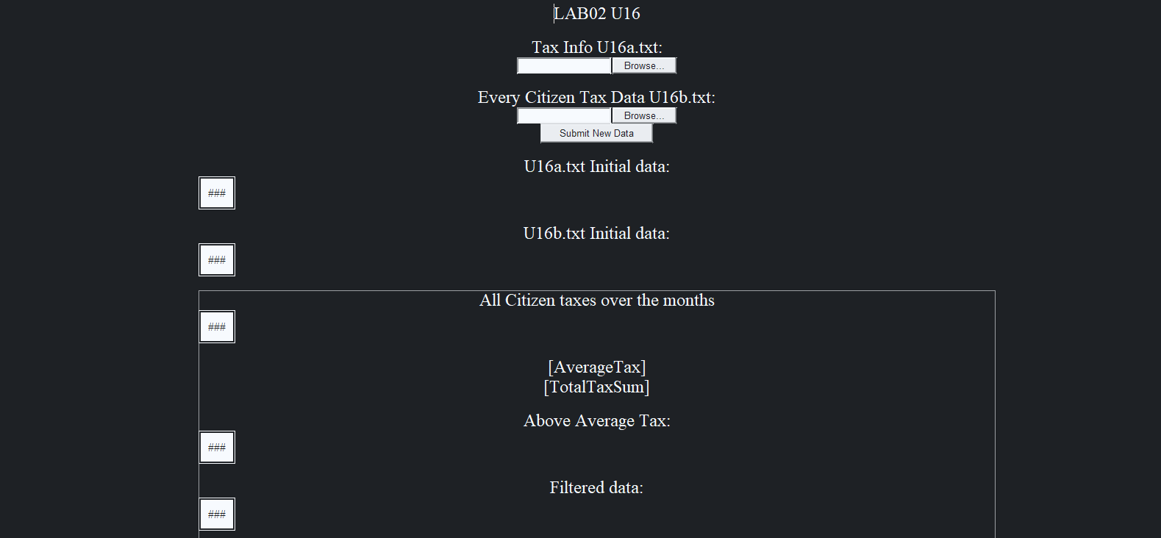

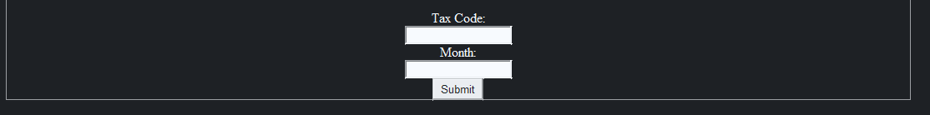

## Sąsajoje panaudotų komponentų keičiamos savybės

|  |  |  |
| --- | --- | --- |
| Komponentas | Savybė | Reikšmė |
| HeaderLabel | Text | LAB02 U16 |
| Label1 | Text | Tax InfoU16a.txt: |
| Label2 | Text | Every Citizen Tax Data U16b: |
| InitTaxLabel | Text | U16a.txt Initial data: |
| InitCitizenLabel | Text | U16b.txt Initial data: |
| CitizenTaxLabel | Text | All Citizen taxes over the months |
| AverageTax | Text | “” |
| TotalTaxSum | Text | “” |
| CitizenTaxLabel0 | Text | Above Average Tax: |
| FilterData | Text | Filtered data: |
| ButtonFilter | Text | Tax Code: |
| DataButton | Text | Month: |

## Klasių diagrama

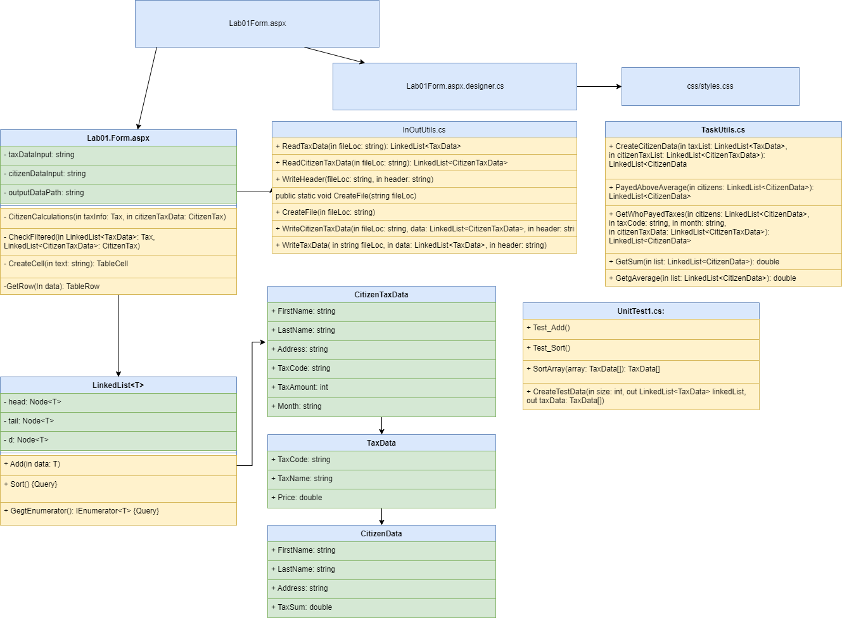

## Programos vartotojo vadovas

Jeigu neranda failų visų duombazėje, programa paprašo failų. Jeigu randa tik vieną pradinį failą, rodo tik jį ir prašo likusių failų. Kai abu failai atsiranda duombazėje, užkrauna skaičiavimus. Apskaičiuoja vidutinę mokesčių kainą, sumą visų ir individualių žmonių. Tekstas yra rikiuojamas A-Z pagal: adresą, pavardę, vardą. Kodas leidžia filtruoti žmones, kurie mokėjo nurodytą mėnesį (mėnuo yra string) už nurodytus mokesčius naudojant „Tax Code“ (string). Prie filtered lentelės prideda tik filtruotus duomenis.

## Programos tekstas

CitizenData.cs:

using System;

using System.Collections.Generic;

using System.Linq;

using System.Web;

namespace Lab02

{

/// <summary>

/// CitizenData class object to be used by class Citizen

/// </summary>

public class CitizenData : IComparable<CitizenData>, IEquatable<CitizenData>

{

public string FirstName { get; set; }

public string LastName { get; set; }

public string Address { get; set; }

public double TaxSum { get; set; }

/// <summary>

/// Constructor

/// </summary>

/// <param name="lastName">Last name of the citizen</param>

/// <param name="firstName">First Name of the citizen</param>

/// <param name="address">Address of the citizen</param>

public CitizenData(string lastName, string firstName, string address, double taxSum)

{

LastName = lastName;

FirstName = firstName;

Address = address;

TaxSum = taxSum;

}

/// <summary>

/// To String override

/// </summary>

/// <returns>stringg format of the citizen</returns>

public override string ToString()

{

return $"{LastName,-20} {FirstName,-20}|{Address,-20}|{TaxSum,10:f}|";

}

/// <summary>

/// Compares to other Node of citizen type

/// </summary>

/// <param name="other"></param>

/// <returns>Integer</returns>

public int CompareTo(CitizenData other)

{

int comparison = other.Address.CompareTo(Address);

if (comparison == 0)

{

comparison = other.LastName.CompareTo(LastName);

if (comparison == 0)

{

comparison = other.FirstName.CompareTo(FirstName);

}

}

return comparison;

}

/// <summary>

/// IEquatable iomplementation

/// </summary>

/// <param name="other">Comparison object</param>

/// <returns>Boolean</returns>

public bool Equals(CitizenData other)

{

if (FirstName == other.FirstName && LastName == other.LastName && Address == other.Address)

return true;

return false;

}

/// <summary>

/// IEquatable iomplementation

/// </summary>

/// <param name="other">Comparison object</param>

/// <returns>Boolean</returns>

public bool Equals(CitizenTaxData other)

{

if (FirstName == other.FirstName && LastName == other.LastName && Address == other.Address)

return true;

return false;

}

}

}

CitizenTaxData.cs:

using System;

using System.Collections.Generic;

using System.Linq;

using System.Web;

namespace Lab02

{

public class CitizenTaxData : IComparable<CitizenTaxData>, IEquatable<CitizenTaxData>

{

public string FirstName { get; set; }

public string LastName { get; set; }

public string Address { get; set; }

public string TaxCode { get; set; }

public int TaxAmount { get; set; }

public string Month { get; set; }

/// <summary>

/// Constructor

/// </summary>

/// <param name="lastName">last name of citizen</param>

/// <param name="firstName">first name of citizen</param>

/// <param name="address">address of the citizen</param>

/// <param name="month">the month the tax was paid</param>

/// <param name="taxCode">tax code</param>

/// <param name="taxAmount">tax amount</param>

public CitizenTaxData(string lastName, string firstName, string address, string month, string taxCode, int taxAmount)

{

FirstName = firstName;

LastName = lastName;

Address = address;

TaxCode = taxCode;

TaxAmount = taxAmount;

Month = month;

}

/// <summary>

/// ToString implementation

/// </summary>

/// <returns>String</returns>

public override string ToString()

{

return $"{LastName,-20} {FirstName,-20}|{Address,-20}|{Month,-15}|{TaxCode,-20}|{TaxAmount,10}|";

}

/// <summary>

/// IEquatable implementation

/// </summary>

/// <param name="other">Comparison object</param>

/// <returns>Boolean</returns>

public bool Equals(CitizenTaxData other)

{

if (FirstName == other.FirstName && LastName == other.LastName && Address == other.Address)

return true;

return false;

}

/// <summary>

/// IComparable Implementation

/// </summary>

/// <param name="other">Comparison object</param>

/// <returns>Integer</returns>

public int CompareTo(CitizenTaxData other)

{

int comparison = LastName.CompareTo(other.LastName);

if (comparison == 0)

{

comparison = FirstName.CompareTo(other.FirstName);

if (comparison == 0)

comparison = TaxAmount.CompareTo(other.TaxAmount);

}

return comparison;

}

}

}

TaxData.cs:

using System;

using System.Collections.Generic;

using System.Linq;

using System.Web;

namespace Lab02

{

/// <summary>

/// TaxData object to be inherited by Tax object

/// </summary>

public class TaxData : IComparable<TaxData>, IEquatable<TaxData>

{

public string TaxCode { get; set; }

public string TaxName { get; set; }

public double Price { get; set; }

/// <summary>

/// Constructor

/// </summary>

/// <param name="taxCode"></param>

/// <param name="taxName"></param>

/// <param name="price"></param>

public TaxData(string taxCode, string taxName, double price)

{

TaxCode = taxCode;

TaxName = taxName;

Price = price;

}

/// <summary>

/// Returns Node in string format

/// </summary>

/// <returns>Node in string format</returns>

public override string ToString()

{

return $"{TaxCode,-20}|{TaxName,-20}|{Price,10:f}|";

}

/// <summary>

/// IComparable implementation

/// </summary>

/// <param name="other">Comparison object</param>

/// <returns>Integer</returns>

public int CompareTo(TaxData other)

{

int comparison = Price.CompareTo(other.Price);

return comparison;

}

/// <summary>

/// IEquatable implementation

/// </summary>

/// <param name="other"> comparison object </param>

/// <returns>boolean</returns>

public bool Equals(TaxData other)

{

if (TaxCode == other.TaxCode)

return true;

return false;

}

}

}

LinkedList.cs:

using System;

using System.Collections;

using System.Collections.Generic;

using System.Linq;

using System.Web;

namespace Lab02

{

/// <summary>

/// Linked List Class Object

/// </summary>

/// <typeparam name="T">Object Type</typeparam>

public class LinkedList<T> : IEnumerable<T> where T : IComparable<T>, IEquatable<T>

{

private Node<T> head;

private Node<T> tail;

private Node<T> d;

/// <summary>

/// Construcotr

/// </summary>

public LinkedList()

{

head = null;

tail = null;

}

//Deprecated, Use Foreach with IEnumerable

/** Address of the head of the list is assigned */

public void Begin()

{ d = head; }

/** Interface variable gets address of the next entry*/

public void Next()

{ d = d.next; }

/** Return true, if list is empty*/

public bool Exist()

{ return d != null; }

//-----------------------------------------------

/** Return data according to the interface address*/

public T Get()

{ return d.Data; }

/// <summary>

/// Adds T object to Linked List

/// </summary>

/// <param name="data"> <T> Type Object</param>

public void Add(T data)

{

// If No citizen was found, adds the citizen to Linked List

if (head == null)

{

head = new Node<T>(data, null);

tail = head;

}

else

{

tail.next = new Node<T>(data, null);

tail = tail.next;

}

}

/// <summary>

/// Sort Function using iComprable

/// </summary>

public void Sort()

{

Node<T> timer = head;

while (timer != null)

{

Node<T> curr = head;

Node<T> next = head.next;

while (next != null)

{

if (curr.Data.CompareTo(next.Data) > 0)

{

curr.SwapData(next);

}

curr = next;

next = next.next;

}

timer = timer.next;

}

}

/// <summary>

/// IEnumerable implementation

/// </summary>

/// <returns>yield of T data</returns>

public IEnumerator<T> GetEnumerator()

{

for (Node<T> dd = head; dd != null; dd = dd.next)

{

yield return dd.Data;

}

}

/// <summary>

/// Obligatory, since IEnumerable<T> inherits IEnumerable

/// </summary>

/// <returns>none</returns>

/// <exception cref="NotImplementedException">Not Implemented</exception>

IEnumerator IEnumerable.GetEnumerator()

{

throw new NotImplementedException();

}

/// <summary>

/// Node class to be used to save every citizen seperately

/// </summary>

class Node<T>

{

public T Data { get; set; }

public Node<T> next { get; set; }

/// <summary>

/// Constructor

/// </summary>

/// <param name="data">CitizenData pointer</param>

public Node(T data, Node<T> link)

{

Data = data;

next = link;

}

/// <summary>

/// Swaps the DATA, keeps the pointers

/// </summary>

/// <param name="other">Other node to be swapped with</param>

public void SwapData(Node<T> other)

{

T temp = Data;

Data = other.Data;

other.Data = temp;

}

}

}

}

TaskUtils.cs:

using System;

using System.Collections.Generic;

using System.Linq;

using System.Web;

using System.Web.UI.WebControls;

namespace Lab02

{

/// <summary>

/// TaskUtils static class for helper functions

/// </summary>

public static class TaskUtils

{

/// <summary>

/// Creates Citizen class object using Tax object

/// </summary>

/// <param name="TaxList">Tax class object</param>

/// <param name="citizenTaxList">CitizenTax object</param>

/// <returns>Citizen class object</returns>

public static LinkedList<CitizenData> CreateCitizenData(LinkedList<TaxData> taxList, LinkedList<CitizenTaxData> citizenTaxList)

{

LinkedList<CitizenData> citizens = new LinkedList<CitizenData>();

// Goes through every tax data record

foreach (CitizenTaxData citizenTaxData in citizenTaxList)

{

// Finds the the tax code and returns price

foreach(TaxData taxData in taxList)

{

if(citizenTaxData.TaxCode == taxData.TaxCode)

{

CitizenData temp = null;

// Finds the citizen if already exists

foreach (CitizenData citizen in citizens)

{

// Finds the citizen if it already exists

if(citizen.Equals(citizenTaxData))

{

temp = citizen;

break;

}

}

// Creates a new citizen or appends the data

if (temp != null)

{

temp.TaxSum += (double)taxData.Price * citizenTaxData.TaxAmount;

}

else

{

temp = new CitizenData(citizenTaxData.LastName, citizenTaxData.FirstName, citizenTaxData.Address, (double)taxData.Price * citizenTaxData.TaxAmount);

citizens.Add(temp);

}

}

}

}

return citizens;

}

/// <summary>

/// Returns a list for people who payed above average

/// </summary>

/// <param name="citizens">CitizenData Linked List</param>

/// <returns>Citizen Data Linked List</returns>

public static LinkedList<CitizenData> PayedAboveAverage(LinkedList<CitizenData> citizens)

{

double average = GetAverage(citizens);

LinkedList<CitizenData> output = new LinkedList<CitizenData>();

foreach (CitizenData citizen in citizens)

{

if (citizen.TaxSum >= average)

{

output.Add(citizen);

}

}

return output;

}

/// <summary>

/// Creates a new list who payed taxes specified tax, month

///

/// </summary>

/// <param name="citizens">CitizenData Linked List</param>

/// <param name="taxCode">Tax Code to filter by</param>

/// <param name="month">Month to filter by</param>

/// <param name="citizenTaxData">CitizenTaxData Linked List</param>

/// <returns></returns>

public static LinkedList<CitizenData> GetWhoPayedTaxes(LinkedList<CitizenData> citizens, string taxCode, string month, LinkedList<CitizenTaxData> citizenTaxData)

{

LinkedList<CitizenData> output = new LinkedList<CitizenData>();

foreach (CitizenData citizen in citizens)

{

foreach (CitizenTaxData citizenTax in citizenTaxData)

{

if(citizenTax.TaxCode == taxCode && citizenTax.Month == month && citizen.Equals(citizenTax))

{

output.Add(citizen);

break;

}

}

}

return output;

}

/// <summary>

/// Returns Sum

/// </summary>

/// <param name="list">CitizenData LinkedList</param>

/// <returns>Double</returns>

public static double GetSum(LinkedList<CitizenData> list)

{

double sum = 0;

foreach (CitizenData citizen in list)

sum += citizen.TaxSum;

return sum;

}

/// <summary>

/// Gets Average

/// </summary>

/// <param name="list">CitizenData Linked List</param>

/// <returns>Double</returns>

public static double GetAverage(LinkedList<CitizenData> list)

{

double sum = 0;

int i = 0;

foreach (CitizenData citizen in list)

{

sum += citizen.TaxSum;

i++;

}

return (double)(i > 0 ? sum / i : 0);

}

}

}

InOutUtils.cs:

using System;

using System.Collections.Generic;

using System.IO;

using System.Linq;

using System.Web;

namespace Lab02

{

/// <summary>

/// Static InOutUtils helper class for Input/Output with files

/// </summary>

public static class InOutUtils

{

/// <summary>

/// Reads Tax Data from txt to Tax class object+

/// </summary>

/// <param name="fileLoc">Location of the data in .txt format</param>

/// <returns>Linked ListTaxData class object</returns>

public static LinkedList<TaxData> ReadTaxData(string fileLoc)

{

LinkedList<TaxData> taxes = new LinkedList<TaxData>();

string[] lines = File.ReadAllLines(fileLoc);

foreach (string line in lines)

{

string[] elements = line.Split(';');

taxes.Add(new TaxData(elements[0], elements[1], double.Parse(elements[2])));

}

return taxes;

}

/// <summary>

/// Creates CitizenTaxData from .txt file

/// </summary>

/// <param name="fileLoc">Location of .txt file</param>

/// <returns>LinkedList CitizenTaxData class object</returns>

public static LinkedList<CitizenTaxData> ReadCitizenTaxData(string fileLoc)

{

LinkedList<CitizenTaxData> data = new LinkedList<CitizenTaxData>();

string[] lines = File.ReadAllLines(fileLoc);

foreach (string line in lines)

{

string[] elements = line.Split(';');

CitizenTaxData temp = new CitizenTaxData(elements[1], elements[0], elements[2], elements[3], elements[4], int.Parse(elements[5]));

data.Add(temp);

}

return data;

}

/// <summary>

/// Appends a header to a file

/// </summary>

/// <param name="fileLoc">Name/location of the file</param>

/// <param name="header">text to be appended</param>

public static void WriteHeader(string fileLoc, string header)

{

using (StreamWriter writer = new StreamWriter(fileLoc, append: true))

{

writer.WriteLine(header);

writer.WriteLine();

}

}

/// <summary>

/// Creates a new or wipes a file

/// </summary>

/// <param name="fileLoc">Location of the file</param>

public static void CreateFile(string fileLoc)

{

using (FileStream fs = new FileStream(fileLoc, FileMode.Create))

new StreamWriter(fs, encoding: System.Text.Encoding.UTF8).Close();

}

/// <summary>

/// Appends CitizenTaxData to a file

/// </summary>

/// <param name="fileLoc">Location/name of the file</param>

/// <param name="data">data to append to the .txt file</param>

/// <param name="header">Header text of the data file</param>

public static void WriteCitizenTaxData(string fileLoc, LinkedList<CitizenTaxData> data, string header)

{

using (StreamWriter writer = new StreamWriter(fileLoc, append:true))

{

writer.WriteLine(header);

writer.WriteLine();

writer.WriteLine($"{"LastName",-20} {"FirstName",-20}|{"Address",-20}|{"Month",-15}|{"TaxCode",-20}|{"TaxAmount",10}|");

foreach (CitizenTaxData taxData in data)

{

writer.WriteLine(taxData.ToString());

}

writer.WriteLine();

}

}

/// <summary>

/// appends Citizen class object data to text file

/// </summary>

/// <param name="fileLoc">location/name of the file</param>

/// <param name="data">data to append to the file</param>

/// <param name="header">Header of the file</param>

public static void WriteCitizenData(string fileLoc, LinkedList<CitizenData> data, string header)

{

using (StreamWriter writer = new StreamWriter(fileLoc, append: true))

{

writer.WriteLine(header);

writer.WriteLine();

writer.WriteLine($"{"LastName",-20} {"FirstName",-20}|{"Address",-20}|{"TaxSum",-10}|");

foreach (CitizenData taxData in data)

{

writer.WriteLine(taxData.ToString());

}

writer.WriteLine();

}

}

/// <summary>

/// Appends Tax data to a .txt file

/// </summary>

/// <param name="fileLoc">Location/name of the file</param>

/// <param name="data">data to append to the .txt file</param>

/// <param name="header">header to be added to the file</param>

public static void WriteTaxData(string fileLoc, LinkedList<TaxData> data, string header)

{

using (StreamWriter writer = new StreamWriter(fileLoc, append: true))

{

writer.WriteLine(header);

writer.WriteLine();

writer.WriteLine($"{"TaxCode",-20}|{"TaxName",-20}|{"Price",10:2f}|");

foreach (TaxData taxData in data)

{

writer.WriteLine(taxData.ToString());

}

writer.WriteLine();

}

}

}

}

UnitTest1.cs:

using Microsoft.VisualStudio.TestTools.UnitTesting;

using System;

using Lab02;

namespace UnitTest

{

[TestClass]

public class UnitTest1

{

/// <summary>

/// Compares CitizenData object with same parameters. Comparison should return 0

/// </summary>

[TestMethod]

public void CompareTo_CitizenDataSame_Returns0()

{

CitizenData cData1 = new CitizenData("lastname", "firstname", "address", 0);

CitizenData cData2 = new CitizenData("lastname", "firstname", "address", 0);

Assert.AreEqual(cData1.CompareTo(cData2),0);

}

/// <summary>

/// Compares lhs CitizenData object with alphabetically higher parameters. Comparison should return 1

/// </summary>

[TestMethod]

public void CompareTo_CitizenDataSame_Returns1()

{

CitizenData cData1 = new CitizenData("a", "a", "a", 0);

CitizenData cData2 = new CitizenData("b", "b", "b", 0);

Assert.AreEqual(cData1.CompareTo(cData2), 1);

}

/// <summary>

/// Compares lhs CitizenData object with alphabetically lower parameters. Comparison should return -1

/// </summary>

[TestMethod]

public void CompareTo_CitizenDataSame_ReturnsMinus1()

{

CitizenData cData1 = new CitizenData("b", "b", "b", 0);

CitizenData cData2 = new CitizenData("a", "a", "a", 0);

Assert.AreEqual(cData1.CompareTo(cData2), -1);

}

/// <summary>

/// Tests CitizenTax and CitizenTaxData object comparison with different parameters

/// </summary>

[TestMethod]

public void Equals_CitizenDataCitizenTaxDataDifferentParameters_False()

{

CitizenData cData = new CitizenData("lastname1", "firstname1", "address1", 0);

CitizenTaxData cTaxData = new CitizenTaxData("lastname0", "firstname0", "address0", "April", "0", 0);

Assert.IsFalse(cData.Equals(cTaxData));

}

/// <summary>

/// Tests CitizenTax and CitizenTaxData object comparison with same parameters

/// </summary>

[TestMethod]

public void Equals_CitizenDataCitizenTaxDataSameParameters_True()

{

CitizenData cData = new CitizenData("lastname", "firstname", "address", 0);

CitizenTaxData cTaxData = new CitizenTaxData("lastname", "firstname", "address", "April", "0", 0);

Assert.IsTrue(cData.Equals(cTaxData));

}

/// <summary>

/// Tests 2 Citizen Data Comparison with same parameters. Should Return True.

/// </summary>

[TestMethod]

public void Equals_CitizenDataSameParameters_True()

{

CitizenData cData1 = new CitizenData("lastname1", "firstname1", "address1", 0);

CitizenData cData2 = new CitizenData("lastname1", "firstname1", "address1", 0);

Assert.IsTrue(cData1.Equals(cData2));

}

/// <summary>

/// Tests 2 Citizen Data Comparison with different Keys. Should Return false.

/// </summary>

[TestMethod]

public void Equals_CitizenDataDifferentParameters_False()

{

CitizenData cData1 = new CitizenData("lastname1", "firstname1", "address1", 0);

CitizenData cData2 = new CitizenData("lastname2", "firstname2", "address2", 0);

Assert.IsFalse(cData1.Equals(cData2));

}

/// <summary>

/// Tets add function and compares to array

/// </summary>

[TestMethod]

public void Add_LinkedListArrayEquality_True()

{

TaxData[] testArray;

LinkedList<TaxData> list;

CreateTestData(10, out list, out testArray);

int index = 0;

foreach (TaxData taxData in list)

{

Assert.IsTrue(taxData.Equals(testArray[index]));

index++;

}

}

/// <summary>

/// Tests LinkedList Sort() function and compares to array funcction

/// </summary>

[TestMethod]

public void Sort_LinkedListArrayEquality_True()

{

TaxData[] testArray;

LinkedList<TaxData> list;

CreateTestData(10, out list, out testArray);

list.Sort();

testArray = SortArray(testArray);

int index = 0;

foreach (TaxData taxData in list)

{

Assert.IsTrue(taxData.Equals(testArray[index]));

index++;

}

}

/// <summary>

/// Sorts TaxData[] object to compare to LinkedList object

/// </summary>

/// <param name="array">Unsorted object</param>

/// <returns>sorted array</returns>

public TaxData[] SortArray(TaxData[] array)

{

for (int i = 0; i < array.Length - 1; i++)

{

for (int j = 0; j < array.Length - 1 - i; j++)

{

if(array[j].CompareTo(array[j+1]) > 0)

{

// SWAP

TaxData temp = array[j];

array[j] = array[j+1];

array[j+1] = temp;

}

}

}

return array;

}

/// <summary>

/// Creates test data with the same objects to compare while doing testsgggg

/// </summary>

/// <param name="size">amount of elements</param>

/// <param name="linkedList">OUT Lab03 implementation of linked list</param>

/// <param name="taxData">OUT Array</param>

public void CreateTestData(int size, out LinkedList<TaxData> linkedList, out TaxData[] taxData)

{

linkedList = new LinkedList<TaxData>();

taxData = new TaxData[size];

for (int i = 0; i < size; i++)

{

Random rng = new Random();

TaxData temp = new TaxData(rng.Next(100).ToString(), i.ToString(), (double)i/10);

linkedList.Add(temp);

taxData[i] = temp;

}

}

}

}

Lab01Form.aspx:

<%@ Page Language="C#" AutoEventWireup="true" CodeBehind="Lab01Form.aspx.cs" Inherits="Lab02.Lab01Form" %>

<!DOCTYPE html>

<html xmlns="http://www.w3.org/1999/xhtml">

<head runat="server">

<link rel="stylesheet" runat="server" media="screen" href="~/css/styles.css" />

<title>Lab02 U16</title>

</head>

<body>

<form id="form1" runat="server">

<div id="body">

<asp:Label ID="HeaderLabel" runat="server" Text="LAB02 U16"></asp:Label>

<br />

<br />

<asp:Label ID="Label1" runat="server" Text="Tax Info U16a.txt:"></asp:Label>

<br />

<asp:FileUpload ID="FileUpload1" runat="server" />

<br />

<br />

<asp:Label ID="Label2" runat="server" Text="Every Citizen Tax Data U16b.txt: "></asp:Label>

<br />

<asp:FileUpload ID="FileUpload2" runat="server" />

<br />

<asp:Button ID="DataButton" runat="server" Text="Submit New Data" OnClick="DataButton_Click" />

<br />

<br />

<asp:Label ID="InitTaxLabel" runat="server" Text="U16a.txt Initial data:"></asp:Label>

<asp:Table ID="InitTaxTable" runat="server">

</asp:Table>

<br />

<asp:Label ID="InitCitizenLabel" runat="server" Text="U16b.txt Initial data:"></asp:Label>

<asp:Table ID="InitCitizenTable" runat="server">

</asp:Table>

<br />

<asp:Panel ID="CalculationsPanel" runat="server">

<asp:Label ID="CitizenTaxLabel" runat="server" Text="All Citizen taxes over the months"></asp:Label>

<asp:Table ID="CitizenTaxTable" runat="server">

</asp:Table>

<br />

<asp:Label ID="AverageTax" runat="server"></asp:Label>

<br />

<asp:Label ID="TotalTaxSum" runat="server"></asp:Label>

<br />

<br />

<asp:Label ID="CitizenTaxLabel0" runat="server" Text="Above Average Tax:"></asp:Label>

<asp:Table ID="AboveAverageTable" runat="server">

</asp:Table>

<br />

<asp:Label ID="FilterData" runat="server" Text="Filtered data:"></asp:Label>

<asp:Table ID="FilterTable" runat="server">

</asp:Table>

<br />

Tax Code:<br />

<asp:TextBox ID="TaxCodeTextBox" runat="server"></asp:TextBox>

<br />

Month:<br />

<asp:TextBox ID="TaxMonthTextBox" runat="server"></asp:TextBox>

<br />

<asp:Button ID="ButtonFilter" runat="server" Text="Submit" OnClick="ButtonFilter_Click" />

</asp:Panel>

<br />

</div>

</form>

</body>

</html>

using System;

using System.Collections.Generic;

using System.IO;

using System.Linq;

using System.Web;

using System.Web.UI;

using System.Web.UI.WebControls;

namespace Lab02

{

public partial class Lab01Form : System.Web.UI.Page

{

private string taxDataInput = @"App_Data/U16a.txt";

private string citizenDataInput = @"App_Data/U16b.txt";

private string outputDataPath = @"App_Data/U16result.txt";

protected void Page_Load(object sender, EventArgs e)

{

LinkedList<CitizenTaxData> citizenTaxData = null;

LinkedList<TaxData> taxInfo = null;

InOutUtils.CreateFile(Server.MapPath(outputDataPath));

if (File.Exists(Server.MapPath(taxDataInput)))

{

taxInfo = InOutUtils.ReadTaxData(Server.MapPath(taxDataInput));

InOutUtils.WriteTaxData(Server.MapPath(outputDataPath), taxInfo, "Initial Tax Company Data:");

FillTaxDataTable(taxInfo, InitTaxTable);

}

else

{

InitTaxLabel.Text = "";

}

if (File.Exists(Server.MapPath(citizenDataInput)))

{

citizenTaxData = InOutUtils.ReadCitizenTaxData(Server.MapPath(citizenDataInput));

//citizenTaxData.Sort(); Test

InOutUtils.WriteCitizenTaxData(Server.MapPath(outputDataPath), citizenTaxData, "Initial Citizen Tax Data:");

FillCitizenTaxDataTable(citizenTaxData, InitCitizenTable);

}

else

{

InitCitizenLabel.Text = "";

}

if (citizenTaxData != null && taxInfo != null)

{

// Reads Initial Data and Outputs the Initial Data To WebForm and to text

CitizenCalculations(taxInfo, citizenTaxData);

CheckFiltered(taxInfo, citizenTaxData);

}

else

{

HeaderLabel.Text = "Plaese Upload remaining data files";

CalculationsPanel.Visible = false;

}

}

/// <summary>

/// Does calculations from Tax and CitizenTax object

/// </summary>

/// <param name="taxInfo">Tax object</param>

/// <param name="citizenTaxData">CitizenTax object</param>

protected void CitizenCalculations(LinkedList<TaxData> taxInfo, LinkedList<CitizenTaxData> citizenTaxData)

{

LinkedList<CitizenData> citizensAverage = TaskUtils.CreateCitizenData(taxInfo, citizenTaxData); // For Above Average

InOutUtils.WriteCitizenData(Server.MapPath(outputDataPath), citizensAverage, "Tax Sum of all citizens:");

citizensAverage.Sort();

InOutUtils.WriteCitizenData(Server.MapPath(outputDataPath), citizensAverage, "Tax Sum of all citizens SORTED A-Z:");

FillCitizenTable(citizensAverage, CitizenTaxTable);

double sum = TaskUtils.GetSum(citizensAverage);

double average = TaskUtils.GetAverage(citizensAverage);

InOutUtils.WriteHeader(Server.MapPath(outputDataPath), $"All Citizen TOTAL Tax Sum: {sum:f}");

InOutUtils.WriteHeader(Server.MapPath(outputDataPath), $"Average Tax Sum: {average:f}");

AverageTax.Text = $"Average tax per citizen: {average}";

TotalTaxSum.Text = $"Total tax sum: {sum}";

citizensAverage = TaskUtils.PayedAboveAverage(citizensAverage);

InOutUtils.WriteCitizenData(Server.MapPath(outputDataPath), citizensAverage, "Citizens who paid above average:");

FillCitizenTable(citizensAverage, AboveAverageTable);

}

/// <summary>

/// Updates filtered data

/// </summary>

/// <param name="taxInfo">Tax Object</param>

/// <param name="citizenTaxData">CitizenTax object</param>

protected void CheckFiltered(LinkedList<TaxData> taxInfo, LinkedList<CitizenTaxData> citizenTaxData)

{

if (Session["TaxCode"] != null && Session["Month"] != null)

{

LinkedList<CitizenData> citizensFiltered = TaskUtils.CreateCitizenData(taxInfo, citizenTaxData); // For Filter

citizensFiltered = TaskUtils.GetWhoPayedTaxes(citizensFiltered, Session["TaxCode"].ToString(), Session["Month"].ToString(), citizenTaxData);

citizensFiltered.Sort();

InOutUtils.WriteCitizenData(Server.MapPath(outputDataPath), citizensFiltered, $"Citizens who paid TaxCode: \"{Session["TaxCode"]}\" on Month: \"{Session["Month"]}\"");

FillCitizenTable(citizensFiltered, FilterTable);

}

else

{

FilterData.Text = "No Filter provided";

FilterTable.Visible = false;

}

Session["TaxCode"] = null;

Session["Month"] = null;

}

/// <summary>

/// Fills Table from CitizenTax object

/// </summary>

/// <param name="citizenTaxes">CitizenTaxData LinkedList</param>

/// <param name="table">Table UI object</param>

protected void FillCitizenTaxDataTable(LinkedList<CitizenTaxData> citizenTaxes, Table table)

{

TableRow headerRow = new TableRow();

headerRow.Cells.Add(CreateCell("Last Name"));

headerRow.Cells.Add(CreateCell("First Name"));

headerRow.Cells.Add(CreateCell("Address"));

headerRow.Cells.Add(CreateCell("Month"));

headerRow.Cells.Add(CreateCell("Tax Code"));

headerRow.Cells.Add(CreateCell("Amount"));

table.Rows.Add(headerRow);

foreach (CitizenTaxData data in citizenTaxes)

{

table.Rows.Add(GetRow(data));

}

}

/// <summary>

/// Fills Table from Tax object

/// </summary>

/// <param name="taxes">LinkedList TaxData object</param>

/// <param name="table">UI Table object</param>

protected void FillTaxDataTable(LinkedList<TaxData> taxes, Table table)

{

TableRow headerRow = new TableRow();

headerRow.Cells.Add(CreateCell("Tax Code"));

headerRow.Cells.Add(CreateCell("Tax Company Name:"));

headerRow.Cells.Add(CreateCell("Price:"));;

table.Rows.Add(headerRow);

foreach (TaxData data in taxes)

{

table.Rows.Add(GetRow(data));

}

}

/// <summary>

/// Fills citizen table

/// </summary>

/// <param name="citizens">Citizen object</param>

/// <param name="table">UI.Table object</param>

protected void FillCitizenTable(LinkedList<CitizenData> citizens, Table table)

{

TableRow headerRow = new TableRow();

headerRow.Cells.Add(CreateCell("Last Name"));

headerRow.Cells.Add(CreateCell("First Name"));

headerRow.Cells.Add(CreateCell("Address"));

headerRow.Cells.Add(CreateCell("Tax Sum"));

table.Rows.Add(headerRow);

foreach (CitizenData data in citizens)

{

table.Rows.Add(GetRow(data));

}

}

protected void ButtonFilter_Click(object sender, EventArgs e)

{

string taxCode = TaxCodeTextBox.Text;

string month = TaxMonthTextBox.Text;

if (month != "" && taxCode != null)

{

Session["TaxCode"] = TaxCodeTextBox.Text;

Session["Month"] = TaxMonthTextBox.Text;

}

Response.Redirect("Lab01Form.aspx");

}

protected void DataButton_Click(object sender, EventArgs e)

{

if(FileUpload1.HasFile && FileUpload1.FileName.EndsWith(".txt"))

{

FileUpload1.SaveAs(Server.MapPath(taxDataInput));

}

if (FileUpload2.HasFile && FileUpload2.FileName.EndsWith(".txt"))

{

FileUpload2.SaveAs(Server.MapPath(citizenDataInput));

}

Response.Redirect("Lab01Form.aspx");

}

/// <summary>

/// Creates TableCell from text to speed up TableCell creation

/// </summary>

/// <param name="text">string text to add to the table cell</param>

/// <returns>TableCell class object</returns>

protected static TableCell CreateCell(string text)

{

TableCell cell = new TableCell();

cell.Text = text;

return cell;

}

/// <summary>

/// Creates TableRow from TaxData object

/// </summary>

/// <param name="data">TaxData object</param>

/// <returns>TableRow object</returns>

public TableRow GetRow(TaxData data)

{

TableRow row = new TableRow();

row.Cells.Add(CreateCell(data.TaxCode));

row.Cells.Add(CreateCell(data.TaxName));

row.Cells.Add(CreateCell(data.Price.ToString()));

return row;

}

/// <summary>

/// Creates a row from CitizenTaxData

/// </summary>

/// <param name="data">CitizenTaxData class object</param>

/// <returns>TableRow object</returns>

public TableRow GetRow(CitizenTaxData data)

{

TableRow row = new TableRow();

row.Cells.Add(CreateCell(data.LastName));

row.Cells.Add(CreateCell(data.FirstName));

row.Cells.Add(CreateCell(data.Address));

row.Cells.Add(CreateCell(data.Month));

row.Cells.Add(CreateCell(data.TaxCode));

row.Cells.Add(CreateCell(data.TaxAmount.ToString()));

return row;

}

/// <summary>

/// Returns cictizen in TableRow format for the specified citizen

/// </summary>

/// <param name="data">data of the citizen</param>

/// <returns>TableRow format of the specified citizen</returns>

public TableRow GetRow(CitizenData data)

{

TableRow row = new TableRow();

row.Cells.Add(CreateCell(data.LastName));

row.Cells.Add(CreateCell(data.FirstName));

row.Cells.Add(CreateCell(data.Address));

row.Cells.Add(CreateCell(data.TaxSum.ToString()));

return row;

}

}

}

## Pradiniai duomenys ir rezultatai

Testavimo rezultatai:

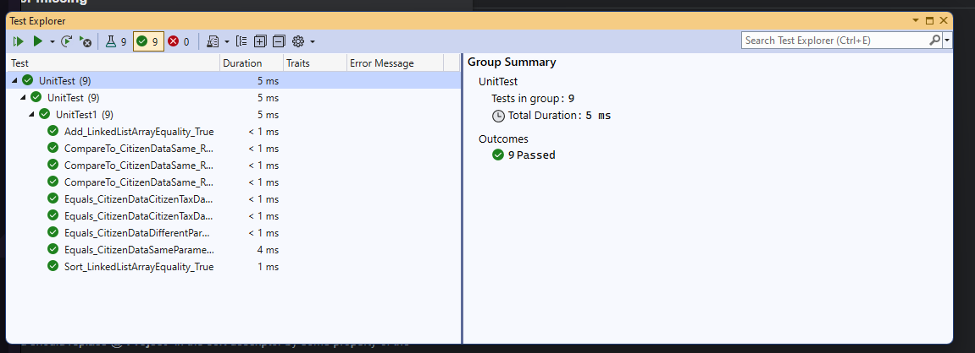

Pradiniai duomenys 1:

U16a.txt:

11; Elektra; 0.12

21; Dujos; 0.58

31; Benzinas; 1.78

32; Diezelis; 1.90

U16b.txt:

pavardė1; vardas1; adresas1;1;22;28;

pavardė1; vardas1; adresas1;5;22;20;

pavardė1; vardas1; adresas1;1;32;100;

pavardė1; vardas1; adresas1;2;32;97;

pavardė1; vardas1; adresas1;3;32;63;

pavardė1; vardas1; adresas1;2;22;25;

pavardė1; vardas1; adresas1;3;22;29;

pavardėAA; vardasAA; adresasAA;1;21;13;

pavardėAA; vardasAA; adresasAA;2;21;84;

pavardėAA; vardasAA; adresasAA;3;21;76;

pavardė1; vardas1; adresas1;4;22;39;

pavardė2; vardas2; adresas2;3;31;67;

pavardė2; vardas2; adresas2;4;31;98;

pavardė0; vardas2; adresas2;5;31;125;

pavardė0; vardas0; adresas3;1;11;31;

pavardė1; vardas1; adresas1;4;32;39;

pavardė1; vardas1; adresas1;5;32;20;

pavardė1; vardas1; adresas1;3;11;80;

pavardė1; vardas1; adresas1;4;11;39;

pavardė1; vardas1; adresas1;1;11;120;

pavardė1; vardas1; adresas1;2;11;100;

pavardė1; vardas1; adresas1;5;11;139;

pavardė2; vardas2; adresas2;1;31;31;

pavardė2; vardas2; adresas2;2;31;48;

pavardė0; vardas0; adresas3;2;11;48;

pavardė0; vardas0; adresas3;3;11;67;

pavardė0; vardas0; adresas3;4;11;98;

pavardė0; vardas0; adresas3;5;11;125;

pavardėAA; vardasAA; adresasAA;4;21;8;

pavardėAA; vardasAA; adresasAA;5;21;25;

Rezultatai 1:

Pradinė vartotojo sąsaja:

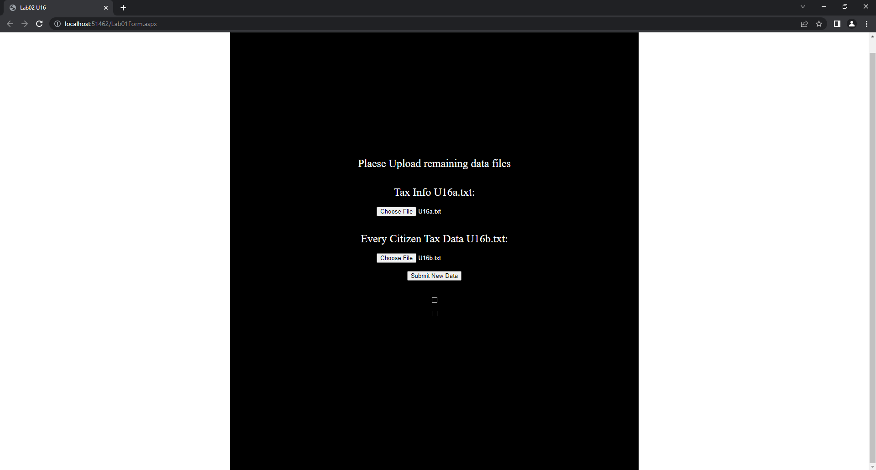

Įkeliam U16a.txt ir U16b.txt:

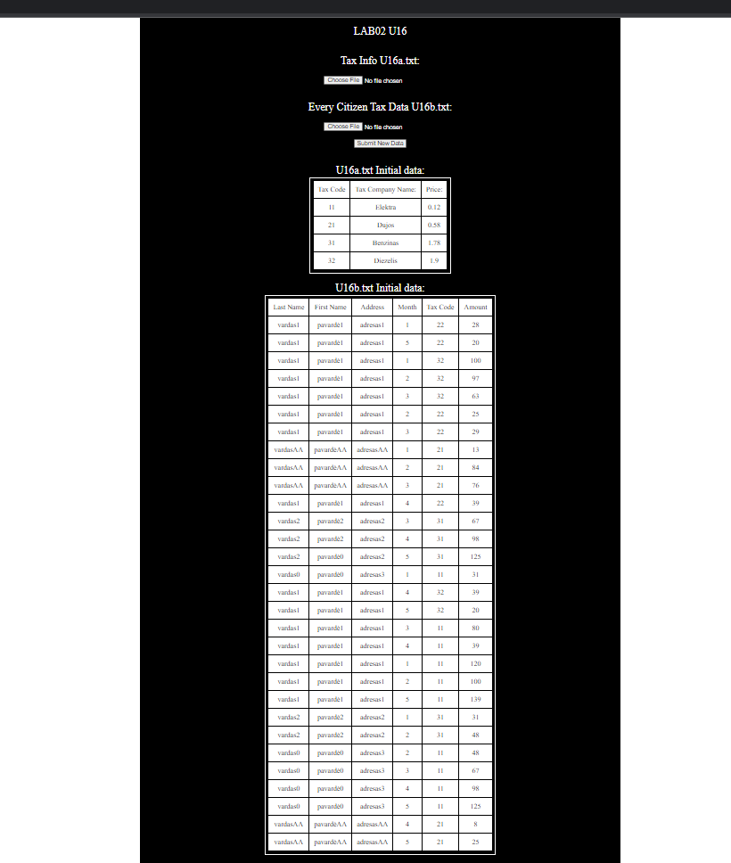

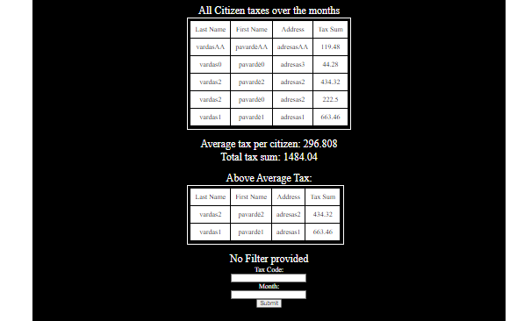

Filtruojame duomenis pagal TaxCode: 11, Month: 1:



U16result.txt:

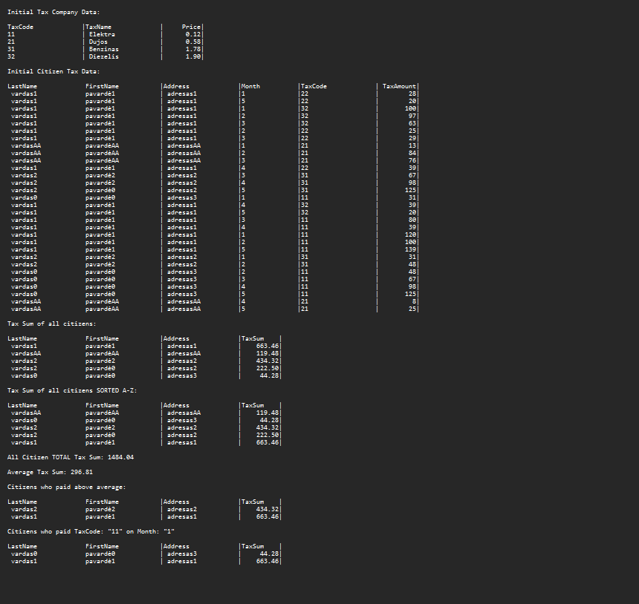

Pradiniai duomenys 2:

U16a.txt:

VAND; Vanduo; 0.07

KVND; Karštas vanduo; 0.20

LH20; Ledinis Vanduo; 0.10

U16b.txt:

Pavardauskis; Vardenis; Adresatas;Vasaris;Benzinas;28;

Pavardauskis; Vardenis; Adresatas;Vasaris;VAND;14;

Pavardauskis; Vardenis; Adresatas;Kovas;KVND;20;

Pavardauskis; Vardenis; Adresatas;Kovas;LH20;30;

Pavardauskis; Vardenis; Adresatas;Kovas;VAND;15;

Pavardauskis; Vardenis; Adresatas;Balandis;VAND;99;

Tomas; Tomukas; Tomo namas 1;Kovas;VAND;97;

Tomas; Tomukas; Tomo namas 1;Balandis;VAND;156;

Tomas; Tomukas; Tomo namas 1;Rugsėjis;VAND;20;

Rezultatai 2:

Vartotojo sąsaja:

Naudojant filtrus: TaxCode: Vand, Month: Kovas

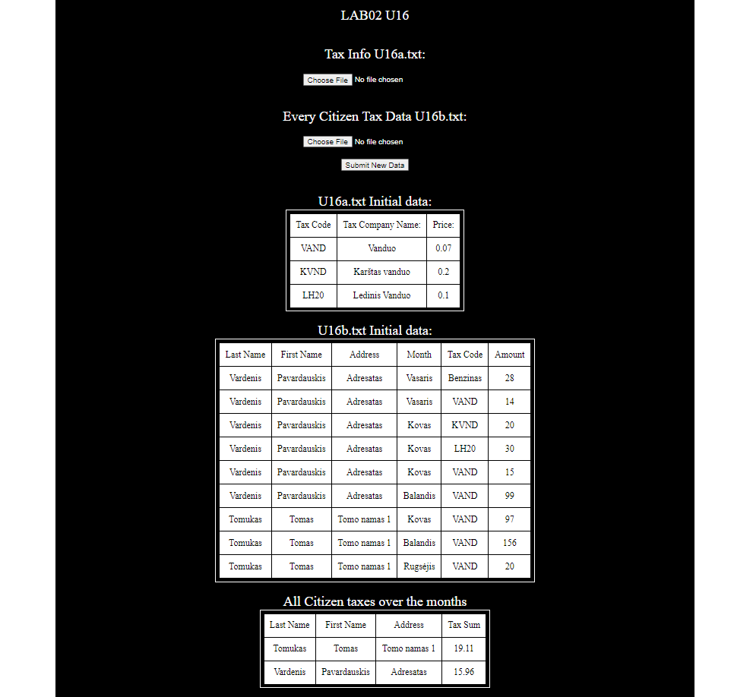

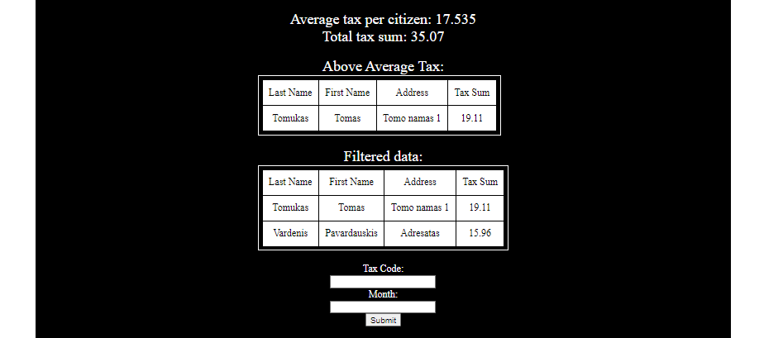

U16Result.txt:

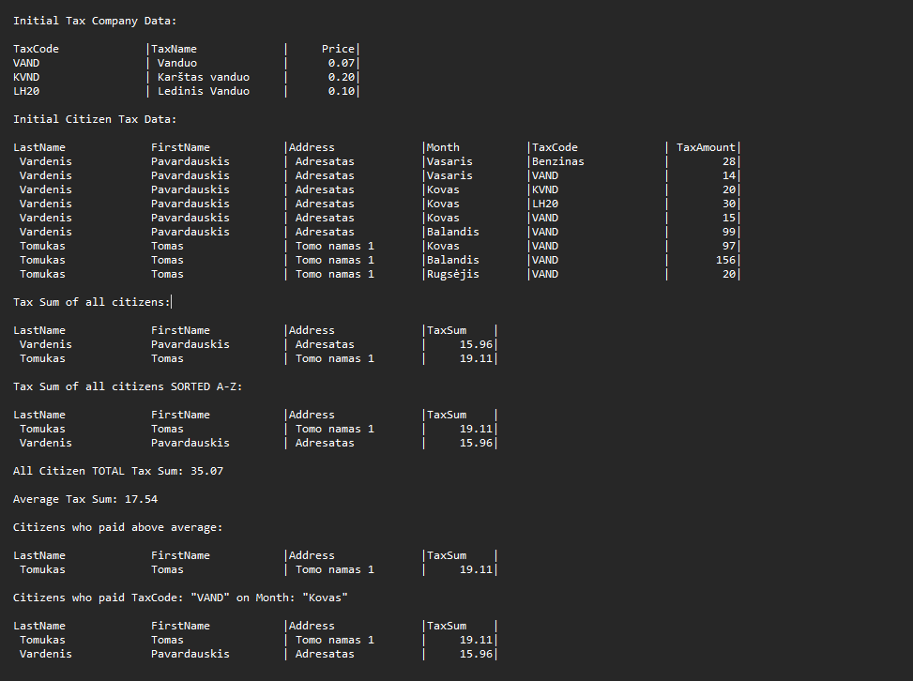

css/styles.css:

body {

color: white;

background: white;

padding: 0;

margin: 0;

display: flex;

justify-content: center;

}

#body {

display: flex;

flex-direction: column;

justify-content: center;

align-items: center;

text-align: center;

padding: 15px 280px;

background-color: black;

min-height:100vh;

}

td {

background-color: white;

}

table {

border: 1px solid;

border-color:white;

padding: 5px;

}

td {

color: black;

padding:10px;

}

span {

font-size: 1.5em;

}

Lab01Form.aspx:

## Dėstytojo pastabos

Ačiū, puikus darbas, tik:

1. Testiniai variantai neturi tikslų.
2. Vienetų testavimas yra minimalus.
3. Vienetų testavimo rezultatai nėra įtraukti į ataskaitą.

# Polimorfizmas ir išimčių valdymas (L4)

## Darbo užduotis

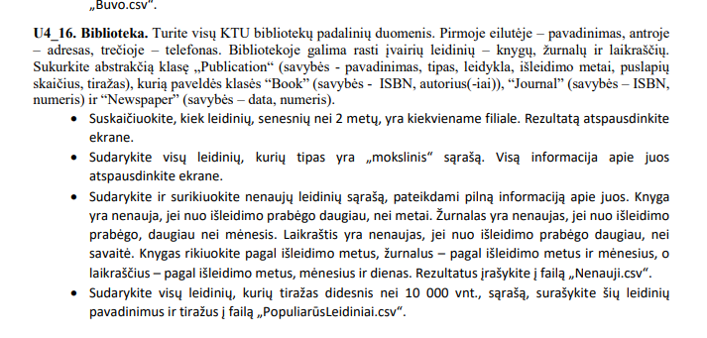

## Grafinės vartotojo sąsajos schema

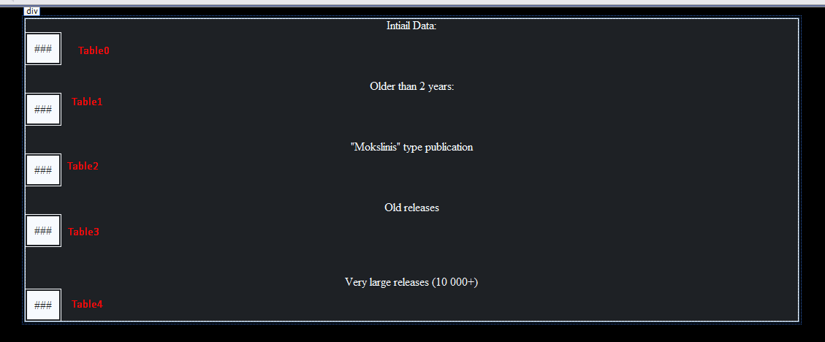

## Sąsajoje panaudotų komponentų keičiamos savybės

|  |  |  |
| --- | --- | --- |
| Komponentas | Savybė | Reikšmė |
|  |  |  |
|  |  |  |
|  |  |  |

Sąsajoje nebuvo panaudotų komponentų savybės keičiamos

## Klasių diagrama

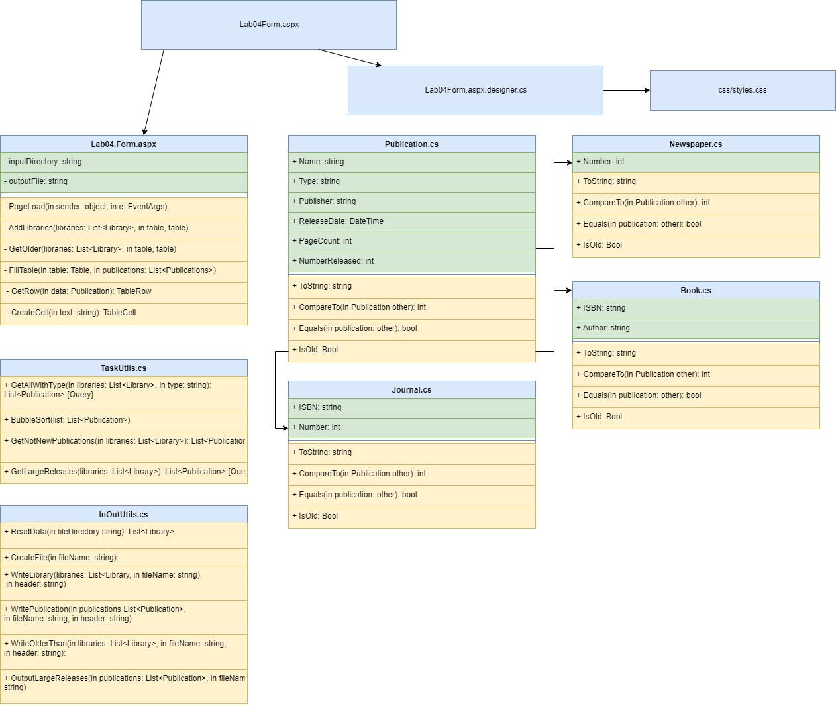

## Programos vartotojo vadovas

Programa įjungiama. Užkrauną visus duomenų failus rastus App_Data/Data folderyję ir parodo vartotojui.

## Programos tekstas

Publication.cs:

using System;

using System.Collections.Generic;

using System.Linq;

using System.Web;

namespace Lab04

{

public abstract class Publication : IComparable<Publication>, IEquatable<Publication>

{

public string Name { get; set; }

public string Type { get; set; }

public string Publisher { get; set; }

public DateTime ReleaseDate { get; set; }

public int PageCount { get; set; }

public int NumberReleased { get; set; }

/// <summary>

/// Custructor

/// </summary>

/// <param name="name"> Name of the Publication </param>

/// <param name="type"> Type of the Publication </param>

/// <param name="publisher"> Publisher of the publication </param>

/// <param name="realeseYear"> Year in which the publication was released </param>

/// <param name="pageCount"> Page Count </param>

/// <param name="numberReleased"> Number of publications released</param>

public Publication(string name, string type, string publisher, DateTime releaseDate, int pageCount, int numberReleased)

{

Name = name;

Type = type;

Publisher = publisher;

ReleaseDate = releaseDate;

PageCount = pageCount;

NumberReleased = numberReleased;

}

public override string ToString()

{

return $"{Name,-25} |{Type,-15} |{Publisher,-25} |{ReleaseDate,-20} |{PageCount,10} |{NumberReleased,15} |";

}

/// <summary>

/// CompareTo Implementation

/// </summary>

/// <param name="other"> Other object to compare to</param>

/// <returns>integer</returns>

public virtual int CompareTo(Publication other)

{

return ReleaseDate.CompareTo(other.ReleaseDate);

}

/// <summary>

/// Equals Override

/// </summary>

/// <param name="other"> Other Publication to compare to</param>

/// <returns> Boolean </returns>

public virtual bool Equals(Publication other)

{

return Name == other.Name;

}

/// <summary>

/// IsOld Function. Checks if the publication is old

/// </summary>

public virtual bool IsOld()

{

if(DateTime.Now.AddYears(-1).CompareTo(ReleaseDate) < 0)

return true;

return false;

}

}

}

Book.cs:

using System;

using System.Collections.Generic;

using System.Linq;

using System.Web;

namespace Lab04

{

public class Book : Publication, IComparable<Publication>, IEquatable<Publication>

{

public Book(string name, string type, string publisher, DateTime releaseDate, int pageCount, int numberReleased, string isbn, string author) : base(name, type, publisher, releaseDate, pageCount, numberReleased)

{

ISBN = isbn;

Author = author;

}

public string ISBN { get; set; }

public string Author { get; set; }

/// <summary>

/// To String Implementation

/// </summary>

/// <returns> string </returns>

public override string ToString()

{

return base.ToString() + $"{ISBN,-15} |{Author,-20}";

}

/// <summary>

/// CompareTo override

/// </summary>

/// <param name="other"> Other Publication to compare to </param>

/// <returns> Publication </returns>

public override int CompareTo(Publication other)

{

int comparison = ReleaseDate.Year.CompareTo(other.ReleaseDate.Year);

return comparison;

}

/// <summary>

/// iEquatable override

/// </summary>

/// <param name="other"> Other Publication to compare to</param>

/// <returns> Bool </returns>

public override bool Equals(Publication other)

{

return Name == other.Name;

}

/// <summary>

/// IsOld Function. Checks if the publication is old

/// </summary>

public override bool IsOld()

{

if (DateTime.Now.AddYears(-1).CompareTo(ReleaseDate) > 0)

return true;

return false;

}

}

}

Journal.cs:

using System;

using System.Collections.Generic;

using System.Linq;

using System.Web;

namespace Lab04

{

public class Journal : Publication, IComparable<Publication>, IEquatable<Publication>

{

public Journal(string name, string type, string publisher, DateTime releaseDate, int pageCount, int numberReleased, string isbn, int number) : base(name, type, publisher, releaseDate, pageCount, numberReleased)

{

ISBN = isbn;

Number = number;

}

public string ISBN { get; set; }

public int Number { get; set; }

/// <summary>

/// To String Implementation

/// </summary>

/// <returns> string </returns>

public override string ToString()

{

return base.ToString() + $"{ISBN,-15} |{Number,20}";

}

/// <summary>

/// CompareTo override

/// </summary>

/// <param name="other"> Other Publication to compare to </param>

/// <returns> Publication </returns>

public override int CompareTo(Publication other)

{

int comparison = ReleaseDate.Year.CompareTo(other.ReleaseDate.Year);

return comparison;

}

/// <summary>

/// iEquatable override

/// </summary>

/// <param name="other"> Other Publication to compare to</param>

/// <returns> Bool </returns>

public override bool Equals(Publication other)

{

return Name == other.Name;

}

/// <summary>

/// IsOld Function. Checks if the publication is old

/// </summary>

public override bool IsOld()

{

if (DateTime.Now.AddDays(-30).CompareTo(ReleaseDate) < 0)

return true;

return false;

}

}

}

Newspaper.cs:

using System;

using System.Collections.Generic;

using System.Linq;

using System.Web;

namespace Lab04.App_Code

{

public class Newspaper : Publication, IComparable<Publication>, IEquatable<Publication>

{

public Newspaper(string name, string type, string publisher, DateTime releaseDate, int pageCount, int numberReleased, int number) : base(name, type, publisher, releaseDate, pageCount, numberReleased)

{

Number = number;

}

public int Number { get; set; }

/// <summary>

/// To String Implementation

/// </summary>

/// <returns> string </returns>

public override string ToString()

{

return base.ToString() + $"{Number,15} |";

}

/// <summary>

/// CompareTo override

/// </summary>

/// <param name="other"> Other Publication to compare to </param>

/// <returns> Publication </returns>

public override int CompareTo(Publication other)

{

int comparison = ReleaseDate.Year.CompareTo(other.ReleaseDate.Year);

if (comparison != 0)

{

comparison = ReleaseDate.Month.CompareTo(other.ReleaseDate.Month);

}

return comparison;

}

/// <summary>

/// iEquatable override

/// </summary>

/// <param name="other"> Other Publication to compare to</param>

/// <returns> Bool </returns>

public override bool Equals(Publication other)

{

return Name == other.Name;

}

/// <summary>

/// IsOld Function. Checks if the publication is old

/// </summary>

public override bool IsOld()

{

if (DateTime.Now.AddDays(-7).CompareTo(ReleaseDate) > 0)

return true;

return false;

}

}

}

Library.cs:

using System;

using System.Collections.Generic;

using System.Linq;

using System.Web;

namespace Lab04.App_Code

{

public class Library

{

public string Name { get; set; }

public string Address { get; set; }

public string PhoneNumber { get; set; }

private List<Publication> publications;

public int Count { get { return publications.Count; } }

/// <summary>

/// Constructor

/// </summary>

/// <param name="name"> Name of the library</param>

/// <param name="adress"> Adress of the library</param>

/// <param name="phoneNumber"></param>

public Library(string name, string address, string phoneNumber)

{

Name = name;

Address = address;

PhoneNumber = phoneNumber;

publications = new List<Publication>();

}

/// <summary>

/// Adds a publication

/// </summary>

/// <param name="publication"> Publication Data Type</param>

public void Add(Publication publication)

{

publications.Add(publication);

}

/// <summary>

/// Returns Items with selected index. If out of bounds error is thrown, returns null-

/// </summary>

/// <param name="index"> index of the item to return</param>

/// <returns></returns>

public Publication Get(int index)

{

try

{

return publications[index];

}

catch

{

return null;

}

}

/// <summary>

/// Gets The count of publications older than specified num ber

/// </summary>

/// <param name="year"> Years to check for older count</param>

/// <returns> Older Count</returns>

/// <exception cref="Exception"> Failed to compare the objects, Publication type error</exception>

public int OlderThanCount(int year)

{

int count = 0;

try

{

foreach (Publication publication in publications)

{

if (publication.ReleaseDate.CompareTo(DateTime.Now.AddYears(-year)) < 0)

{

count++;

}

}

}

catch (Exception ex)

{

throw new Exception(string.Format(" Method {0}, Message {1}, Source {2}", ex.TargetSite, ex.Message, ex.Source));

}

return count;

}

}

}

TaskUtils.cs:

using System;

using System.Collections.Generic;

using System.Linq;

using System.Web;

namespace Lab04.App_Code

{

public static class TaskUtils

{

/// <summary>

/// Gets all Publications with specified Typer

/// </summary>

/// <param name="libraries"> List Library class object</param>

/// <param name="type"> string, type of the object</param>

/// <returns></returns>

public static List<Publication> GetAllWithType(List<Library> libraries, string type)

{

List<Publication> list = new List<Publication>();

try

{

foreach (Library library in libraries)

{

for (int i = 0; i < library.Count; i++)

{

Publication publication = library.Get(i);

if(publication.Type == type)

list.Add(publication);

}

}

}

catch (Exception ex)

{

throw new Exception(string.Format(" Method {0}, Message {1}, Source {2}", ex.TargetSite, ex.Message, ex.Source));

}

return list;

}

public static void BubbleSort( this List<Publication> list)

{

for (int i = 0; i < list.Count - 1; i++)

{

for (int j = 0; j < list.Count - 1 - i; j++)

{

if(list[j].CompareTo(list[j]) < 0)

{

Publication temp = list[j];

list[j] = list[j + 1];

list[j + 1] = temp;

}

}

}

}

/// <summary>

/// Gets Not New Publications

/// </summary>

/// <param name="libraries"> All Library datas</param>

/// <returns> List Publications of not new publicaitopns</returns>

/// <exception cref="Exception"></exception>

public static List<Publication> GetNotNewPublications(List<Library> libraries)

{

List<Publication> list = new List<Publication>();

try

{

foreach (Library library in libraries)

{

for (int i = 0; i < library.Count; i++)

{

Publication publication = library.Get(i);

if(publication.IsOld())

{

list.Add(publication);

}

}

}

}

catch (Exception ex)

{

throw new Exception(string.Format(" Method {0}, Message {1}, Source {2}", ex.TargetSite, ex.Message, ex.Source));

}

return list;

}

/// <summary>

/// Gets LargeReleases

/// </summary>

/// <param name="libraries"> All Libraries to check data for</param>

/// <returns></returns>

/// <exception cref="Exception"></exception>

public static List<Publication> GetLargeReleases(List<Library> libraries)

{

List<Publication> list = new List<Publication>();

try

{

foreach (Library library in libraries)

{

for (int i = 0; i < library.Count; i++)

{

Publication pub = library.Get(i);

if(pub.NumberReleased >= 10000)

list.Add(pub);

}

}

}

catch (Exception ex)

{

throw new Exception(string.Format(" Method {0}, Message {1}, Source {2}", ex.TargetSite, ex.Message, ex.Source));

}

return list;

}

}

}

InOutUtils.cs:

using System;

using System.Collections.Generic;

using System.Globalization;

using System.IO;

using System.Linq;

using System.Web;

namespace Lab04.App_Code

{

public static class InOutUtils

{

/// <summary>

/// Reads Data from file directory

/// </summary>

/// <param name="fileDirectory"> file directory</param>

/// <returns></returns>

/// <exception cref="Exception"></exception>

public static List<Library> ReadData(string fileDirectory)

{

List<Library> list = new List<Library>();

foreach (string filePath in Directory.GetFiles(fileDirectory))

{

string[] lines = File.ReadAllLines(filePath);

Library library = new Library(lines[0], lines[1], lines[2]);

for (int i = 3; i < lines.Length; i++)

{

string[] elements = lines[i].Split(';');

string name = elements[0];

string publisherType = elements[1];

string type = elements[2];

string publisher = elements[3];

DateTime releaseDate;

int pageCount;

int numberReleased;

try

{

releaseDate = DateTime.Parse(elements[4]);

pageCount = int.Parse(elements[5]);

numberReleased = int.Parse(elements[6]);

}

catch (Exception ex)

{

throw new Exception(string.Format(" Method {0}, Message {1}, Source {2}", ex.TargetSite, ex.Message, ex.Source));

}

try

{

switch (publisherType)

{

case "Book":

string isbnBook = elements[7];

string author = elements[8];

Book book = new Book(name, type, publisher, releaseDate, pageCount, numberReleased, isbnBook, author);

library.Add(book);

break;

case "Journal":

string isbnJournal = elements[7];

int number = int.Parse(elements[8]);

Journal journal = new Journal(name, type, publisher, releaseDate, pageCount, numberReleased, isbnJournal, number);

library.Add(journal);

break;

case "Newspaper":

int numberPaper = int.Parse(elements[7]);

Newspaper paper = new Newspaper(name, type, publisher, releaseDate, pageCount, numberReleased, numberPaper);

library.Add(paper);

break;

}

}

catch (Exception ex)

{

throw new Exception(string.Format(" Method {0}, Message {1}, Source {2}", ex.TargetSite, ex.Message, ex.Source));

}

}

list.Add(library);

}

return list;

}

public static void CreateFile(string fileName)

{

new StreamWriter(fileName).Close();

}

public static void WriteLibrary(List<Library> libraries, string fileName, string header)

{

try

{

using (StreamWriter sw = new StreamWriter(fileName, append: true))

{

sw.WriteLine(header);

sw.WriteLine();

foreach (Library library in libraries)

{

sw.WriteLine(library.Name);

sw.WriteLine(library.Address);

sw.WriteLine(library.PhoneNumber);

sw.WriteLine(new String('-', 100));

sw.WriteLine($"{"Name",-25} |{"Type",-15} |{"Publisher",-25} |{"ReleaseDate",-20} |{"PageCount",-10} |{"NumberReleased",-15} |{"ISBN/Number",-15} |{"Author/Number",-20}");

for (int i = 0; i < library.Count; i++)

{

sw.WriteLine(library.Get(i));

}

sw.WriteLine();

}

}

}

catch (Exception ex)

{

throw new Exception(string.Format(" Method {0}, Message {1}, Source {2}", ex.TargetSite, ex.Message, ex.Source));

}

}

/// <summary>

/// Writes all publications from List Publicatrion object

/// </summary>

/// <param name="publications"> List Publication object</param>

/// <param name="fileName"> Output file</param>

/// <param name="header"> Headerd</param>

public static void WritePublication(List<Publication> publications, string fileName, string header)

{

using (StreamWriter sw = new StreamWriter(fileName, append: true))

{

sw.WriteLine(header);

sw.WriteLine();

sw.WriteLine($"{"Name",-25} |{"Type",-15} |{"Publisher",-25} |{"ReleaseDate",-20} |{"PageCount",-10} |{"NumberReleased",-15} |{"ISBN/Number",-15}| {"Author/Number",-20}");

foreach (Publication publication in publications)

{

sw.WriteLine(publication);

}

sw.WriteLine();

}

}

/// <summary>

/// Writes Older than 2 years List to txt file

/// </summary>

/// <param name="libraries"> List Library file </param>

/// <param name="fileName"> Filename to input file </param>

/// <param name="header"> Header of the text</param>

public static void WriteOlderThan(List<Library> libraries, string fileName, string header)

{

using (StreamWriter sw = new StreamWriter(fileName, append: true))

{

sw.WriteLine(header);

sw.WriteLine();

foreach (Library library in libraries)

{

sw.WriteLine($"{library.Name} has {library.OlderThanCount(2)} publications older than 2 years");

sw.WriteLine();

}

sw.WriteLine();

}

}

public static void OutputLargeReleases(List<Publication> publications, string fileName)

{

using (StreamWriter sw = new StreamWriter(fileName))

{

sw.WriteLine("Name;Release Number");

foreach (Publication publication in publications)

{

sw.WriteLine($"{publication.Name};{publication.NumberReleased}");

}

}

}

}

}

Lab04Form.aspx:

<%@ Page Language="C#" AutoEventWireup="true" CodeBehind="Lab04Form.aspx.cs" Inherits="Lab04.Lab04Form" %>

<!DOCTYPE html>

<html xmlns="http://www.w3.org/1999/xhtml">

<head runat="server">

<link rel="stylesheet" runat="server" media="screen" href="~/css/stylesheet.css" />

<title></title>

</head>

<body>

<form id="form1" runat="server">

<div>

Intiail Data:<br />

<asp:Table ID="Table0" runat="server">

</asp:Table>

<br />

Older than 2 years:<br />

<asp:Table ID="Table1" runat="server">

</asp:Table>

<br />

&quot;Mokslinis&quot; type publication<br />

<asp:Table ID="Table2" runat="server">

</asp:Table>

<br />

Old releases<br />

<asp:Table ID="Table3" runat="server">

</asp:Table>

<br />

<br />

Very large releases (10 000+)<br />

<asp:Table ID="Table4" runat="server">

</asp:Table>

</div>

</form>

</body>

</html>

using System;

using System.Collections.Generic;

using System.Linq;

using System.Web;

using System.Web.UI;

using System.Web.UI.WebControls;

using Lab04.App_Code;

namespace Lab04

{

public partial class Lab04Form : System.Web.UI.Page

{

private string inputDirectory = @"App_Data/Data1";

private string outputFile = @"App_Data/Output.txt";

protected void Page_Load(object sender, EventArgs e)

{

// Starting Data

List<Library> libraries = InOutUtils.ReadData(Server.MapPath(inputDirectory));

InOutUtils.CreateFile(Server.MapPath(outputFile));

InOutUtils.WriteLibrary(libraries, Server.MapPath(outputFile), "Initial Data:");

AddLibraries(libraries, Table0);

// Task 1

InOutUtils.WriteOlderThan(libraries, Server.MapPath(outputFile), "Older Than 2 Years Publications in specific libraries");

GetOlder(Table1, libraries);

// Task 2

List<Publication> withSelectedType = TaskUtils.GetAllWithType(libraries, "Mokslinis");

InOutUtils.WritePublication(withSelectedType, Server.MapPath(outputFile), "\"Mokslinis\" type publication:");

FillTable(Table2, withSelectedType);

// Task 3

List<Publication> notNewPublications = TaskUtils.GetNotNewPublications(libraries);

notNewPublications.BubbleSort();

InOutUtils.WritePublication(notNewPublications, Server.MapPath(outputFile), "Old Publications");

FillTable(Table3, notNewPublications);

// Task 4

List<Publication> largePublications = TaskUtils.GetLargeReleases(libraries);

InOutUtils.OutputLargeReleases(largePublications, Server.MapPath("App_Data/PopuliarusLeidiniai.csv"));

FillTable(Table4, largePublications);

}

public void AddLibraries(List<Library> libraries, Table table)

{

try

{

foreach (Library library in libraries)

{

TableRow row = new TableRow();

row.Cells.Add(CreateCell(library.Name));

row.Cells.Add(CreateCell(library.Address));

row.Cells.Add(CreateCell(library.PhoneNumber));

table.Rows.Add(row);

row = new TableRow();

row.Cells.Add(CreateCell("Name"));

row.Cells.Add(CreateCell("Type"));

row.Cells.Add(CreateCell("Publisher"));

row.Cells.Add(CreateCell("ReleaseDate"));

row.Cells.Add(CreateCell("PageCount"));

row.Cells.Add(CreateCell("NumberReleased"));

row.Cells.Add(CreateCell("ISBN/Number"));

row.Cells.Add(CreateCell("Author/Number"));

table.Rows.Add(row);

for (int i = 0; i < library.Count; i++)

{

Publication publication = library.Get(i);

table.Rows.Add(GetRow(publication));

}

}

}

catch (Exception ex)

{

throw new Exception(string.Format(" Method {0}, Message {1}, Source {2}", ex.TargetSite, ex.Message, ex.Source));

}

}

/// <summary>

/// Gets Older than 2 years publications

/// </summary>

/// <param name="table"> Input Table</param>

/// <param name="libraries">List<Library> libraries</Library></param>

/// <exception cref="Exception"></exception>

public void GetOlder(Table table, List<Library> libraries)

{

try

{

TableRow row = new TableRow();

foreach (Library library in libraries)

{

TableRow tempRow = new TableRow();

tempRow.Cells.Add(CreateCell($"{library.Name} has {library.OlderThanCount(2)} publications older than 2 years"));

table.Rows.Add(tempRow);

}

}

catch (Exception ex)

{

throw new Exception(string.Format(" Method {0}, Message {1}, Source {2}", ex.TargetSite, ex.Message, ex.Source));

}

}

/// <summary>

/// Fills Table

/// </summary>

/// <param name="table"></param>

/// <param name="publications"></param>

/// <exception cref="Exception"></exception>

public void FillTable(Table table, List<Publication> publications)

{

try

{

TableRow row = new TableRow();

row.Cells.Add(CreateCell("Name"));

row.Cells.Add(CreateCell("Type"));

row.Cells.Add(CreateCell("Publisher"));

row.Cells.Add(CreateCell("ReleaseDate"));

row.Cells.Add(CreateCell("PageCount"));

row.Cells.Add(CreateCell("NumberReleased"));

row.Cells.Add(CreateCell("ISBN/Number"));

row.Cells.Add(CreateCell("Author/Number"));

table.Rows.Add(row);

foreach (Publication publication in publications)

{

table.Rows.Add(GetRow(publication));

}

}

catch (Exception ex)

{

throw new Exception(string.Format(" Method {0}, Message {1}, Source {2}", ex.TargetSite, ex.Message, ex.Source));

}

}

/// <summary>

/// Creates TableRow from Book object

/// </summary>

/// <param name="data">Book object</param>

/// <returns>TableRow object</returns>

public TableRow GetRow(Publication data)

{

TableRow row = new TableRow();

string[] elements = data.ToString().Split('|');

foreach (string element in elements)

row.Cells.Add(CreateCell(element.Trim()));

return row;

}

/// <summary>

/// Creates TableCell from text to speed up TableCell creation

/// </summary>

/// <param name="text">string text to add to the table cell</param>

/// <returns>TableCell class object</returns>

protected static TableCell CreateCell(string text)

{

TableCell cell = new TableCell();

cell.Text = text;

return cell;

}

}

}

## Pradiniai duomenys ir rezultatai

Pradiniai Duomenys 1:

KTU.txt:

Kauno Biblioteka

Kauno adresato g. 1

8675946855

Knyga 1;Book;Mokslinis;Kauno knygos;5/3/2020;125;1000;123546;Visų Rašytojas;

Laikraštis 1918;Newspaper;Istorinis;Istoriniai laikraščiai;5/3/2022;25;200;124

Knyga 3;Book;Pramoginis;Stumbro Lapai;5/5/2022;253;250;111111;Rašytojas 1

Žurnalas Pasaulis;Journal;Geografinis;Pasaulio žemėlapiai;1/1/2000;64;15000;555555;1

Žurnalas Mokslas;Journal;Mokslinis;Mokslu susidomėja;5/3/2022;32;3000;444444;45

VDU.txt:

VDU Biblioteka

Mickevičiaus g. 10

86666666666

Laikraštis Įvairovė;Newspaper;Viskas;Leidykla Supratimas;10/10/2018;15;20000;15

Žurnalas Pasaulis;Journal;Geografinis;Pasaulio žemėlapiai;1/1/2000;64;1500;123456789;25

Žurnalas Informatika;Journal;Mokslinis;Informatikai;9/8/1995;120;25000;987654321;13

Rezultatai 1:

Vartotojo sąsaja:

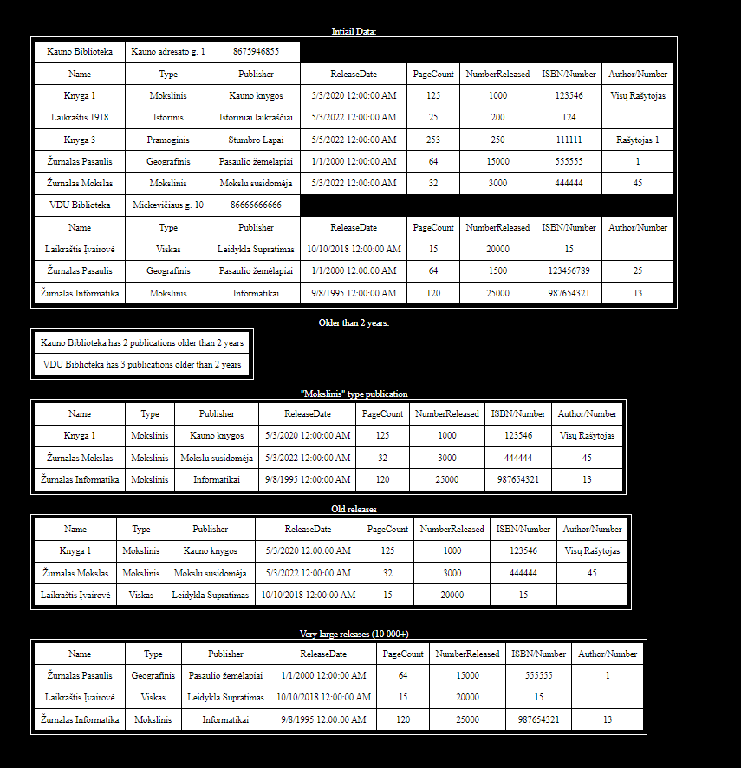

Output.txt:

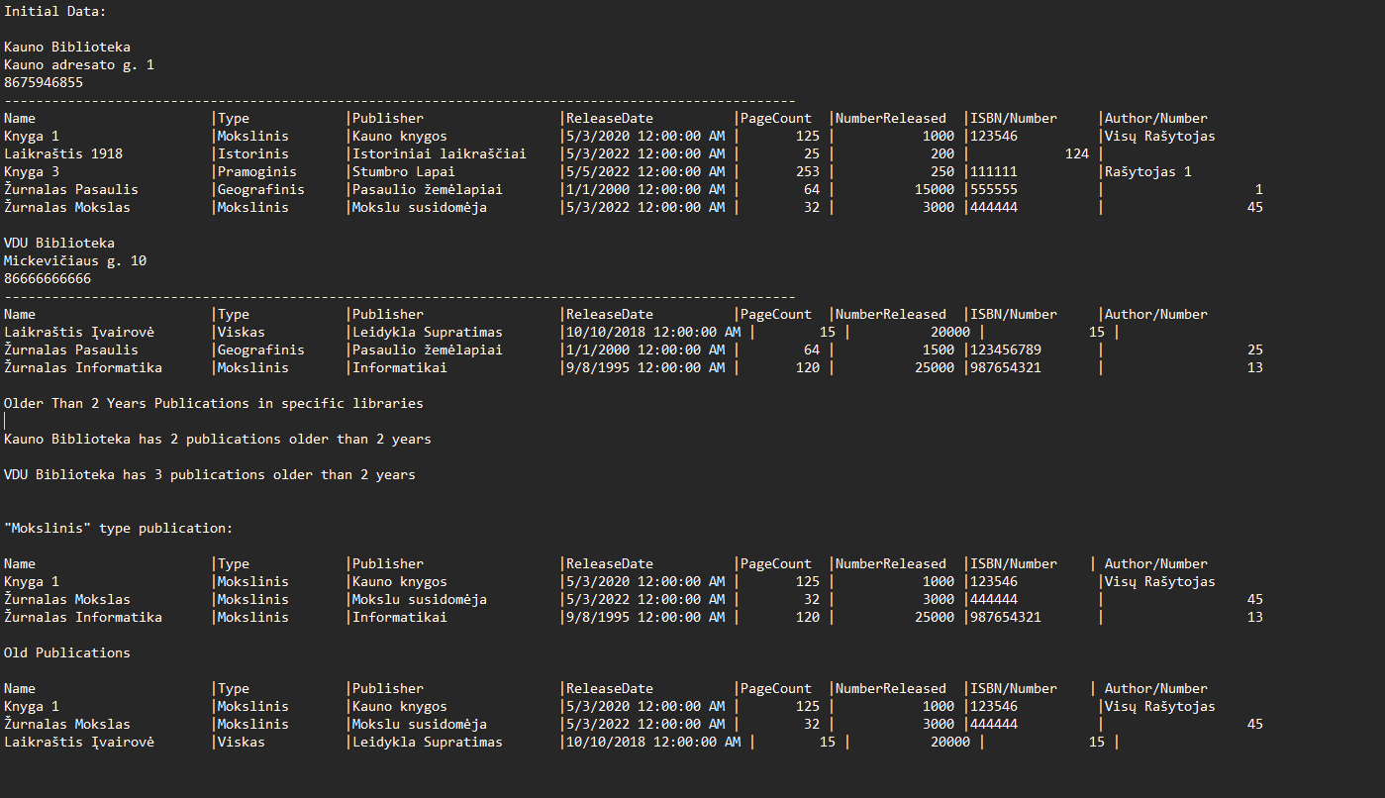

## Dėstytojo pastabos

# Deklaratyvusis programavimas (L5)

## Darbo užduotis

## Grafinės vartotojo sąsajos schema

## Sąsajoje panaudotų komponentų keičiamos savybės

|  |  |  |
| --- | --- | --- |
| Komponentas | Savybė | Reikšmė |
|  |  |  |
|  |  |  |
|  |  |  |

## Klasių diagrama

## Programos vartotojo vadovas

## Programos tekstas

## Pradiniai duomenys ir rezultatai

## Dėstytojo pastabos