Complete tasks, related to training 40:

Locate css and xpath selectors for following elements in tut.by (2 variants – css and xpath – for each, do NOT add them to project, just create word document with these locators):

**Start page:**

1. Search input

Xpath: //input[@id='search_from_str']

CSS: #search_from_str

1. Find button

Xpath: //input[@value='Найти']

CSS: #search > div > div.search-controls > input.button.big

For c,d,e needed to activate authorize pop-up (//a[@data-target-popup='authorize-form'])

1. Remember me label

Xpath: //*[@id="authorize"]/div/div/div/form/div[4]/span/label

CSS: #authorize > div > div > div > form > div:nth-child(5) > span > label

1. Remember me input

Xpath: //input[@id='memory']

CSS: #memory

1. Register button

Xpath: //a[@class='button wide auth__reg']

CSS: #authorize > div > div > div > a

**Email page (switch from full to light version, see screenshot a):**

Needed to wait and click on Mail link ("//*[@id='mainmenu']/ul/li[3]") then switching by (//a[contains(text(),'Лёгкая версия')])

1. Write email button

Xpath: //span[@class='mail-ComposeButton-Text']

CSS: #mail-ComposeButton-Text

1. Logout link

Xpath: //*[@id="nb-3"]/svg

CSS: #nb-5 > div > div > div:nth-child(8) > a

1. Settings link

Xpath: //*[@id="nb-3"]

CSS: #nb-3 > svg

1. Select Inbox, Sent, Deleted and Spam links using 1 locator

Xpath: //div[@class='b-folders__folder]

CSS: # b-folders__folder

**New email page:**

1. To input

Xpath: //*[@id="id1169319402504"]

CSS: #id1169319402504

1. Topic input

Xpath: //input[@id='id1169319402488']

CSS: #id1169319402488

1. Find button

Xpath: //input[@value='Найти']

CSS: #input[type="submit"]

**Screenshot a:**

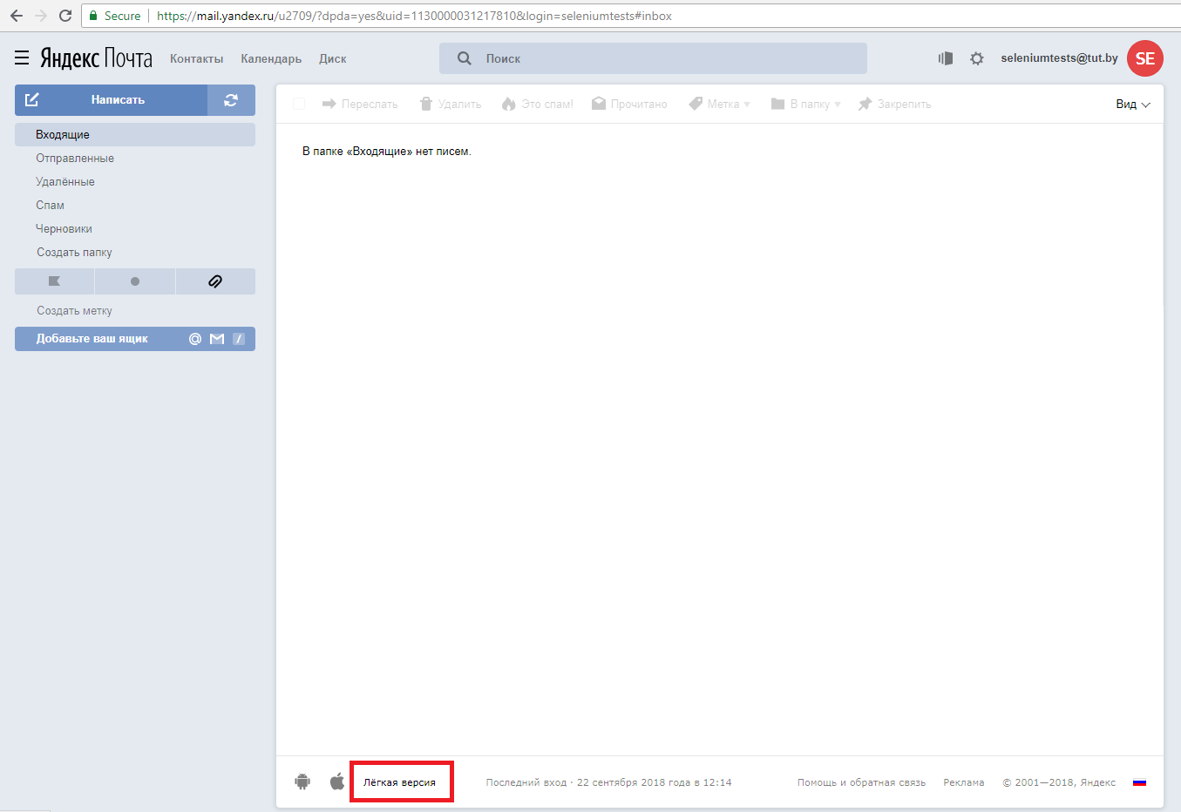

**Light version:**

