System Analysis: Medical Clinic Management Application
By:
Abdulrahman Mousa
Shayan Delbari
Thi Vy Nguyen
Ahmed Agha
The Medical Clinic Management Application:
- Administrator Account:
Admin can create Doctor, Receptionist, Patient Accounts and can control availability time of a doctor. Admin’s can update, delete and view all accounts as well as perform any action that the other accounts can do.
- Doctor Account
Doctor can update their own account (including availability), book or update patient appointments, create adjust or delete patient information. The ability to book appointments requires access to view Doctors and Receptionists so that is inherently provided to anyone who can do that.
- Receptionist Account:
Book or update patient appointments, create adjust or delete patient information.
  - Identify the objects that will be part of the system.
- User
Is the User that will access the system with their own personal password, each with their own Role and level of access: Doctor, Receptionist or Administrator.
- Doctor
An extension of a User with the Role Doctor, simply to get important information like the specialization, name and availability of this doctor. Availability is the combination of the allowed hours minus the timeboxes the doctor is booked (retrieved from appointments) to avoid double booking or booking outside of work hours.
- Patient
Has the patient’s important details, just like we need the doctor’s details we need the patient’s details to be a successful clinic management application. This object will hold details about the patient like their first and last name, health card number, date of birth and contact information to be able to reach them.
- Appointment
This is the main objective of the application, everything else is built to support this feature. The appointment object will contain details about the patient who booked it, the time it’ll take place, the agent who helped them book it, the doctor who will fulfill it, more information about I, and the status of it. Considering the nature of appointments we will eventually have no-shows, cancellations, confirmations and completed appointments so we keep track of it here.
1.2- Identify the characteristics of each object as well as its functionalities.

User
- User Id (Id IDENTITY PK)
- Username
- PasswordHash (Hashed and salted)
- Role (Administrator, Doctor, Receptionist)
Functionality
- Log in and log out of the system using secure authentication
- Access specific system functions based on assigned role
- Update personal account information (such as contact details or password)
- For role-based access:
  - Administrator: full access to all system operations
  - Doctor: limited to medical and scheduling tasks
  - Receptionist: limited to front-desk and appointment operations

Doctor (Inherited from User so also shares User characteristics of the Role Doctor)
- Doctor Id (Linked to User Id)
- Name
- Specialization
- Availability (working hours)
Functionality
- View and update personal information and availability
- Access patient records for their assigned or booked appointments
- Book, update, or cancel patient appointments within their schedule
- View appointment details including time, patient, and status
- Communicate with receptionists and administrators regarding scheduling
Patient
- Patient Id
- First and last name
- Health card number
- Date of birth
- Contact information (email, phone number)
Functionality
- Can be created, updated, or deleted by authorized users (any authorized user)
- Patient details can be viewed by anyone authenticated as well
- Allows us to contact them regarding appointment updates or reminders

Appointment
- Appointment Id
- Patient Id (Linked to the Patient object)
- Doctor Id (Linked to the Doctor object)
- Receptionist or User Id (who booked it)
- Appointment date and time
- Duration
- Status (Scheduled, Confirmed, Cancelled, Completed, No-show)
- Description or more details
- Last modified date and time
Functionality
- Created by any authorized user
- Updated or cancelled by authorized users (cannot be deleted unless it’s an administrator)
- Only valid if doctor’s availability allows it to prevent double booking
- Tracks appointment status and changes for record accuracy
- Used to provide real-time updates to doctors and receptionists with the last-modified characteristic

2- Design ( U.M.L. Diagrams)
2.1- Use case Diagrams
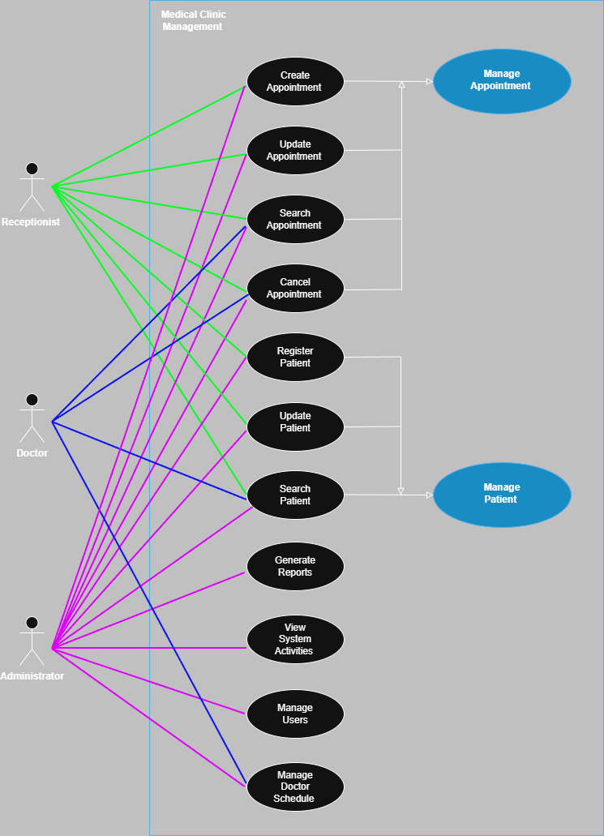

2.2- Class Diagrams

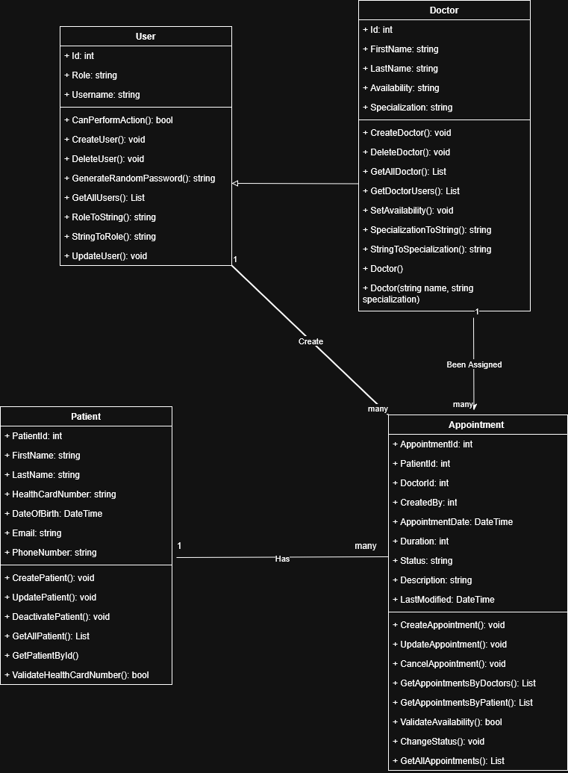

2.3- Activity Diagrams
Login and Role
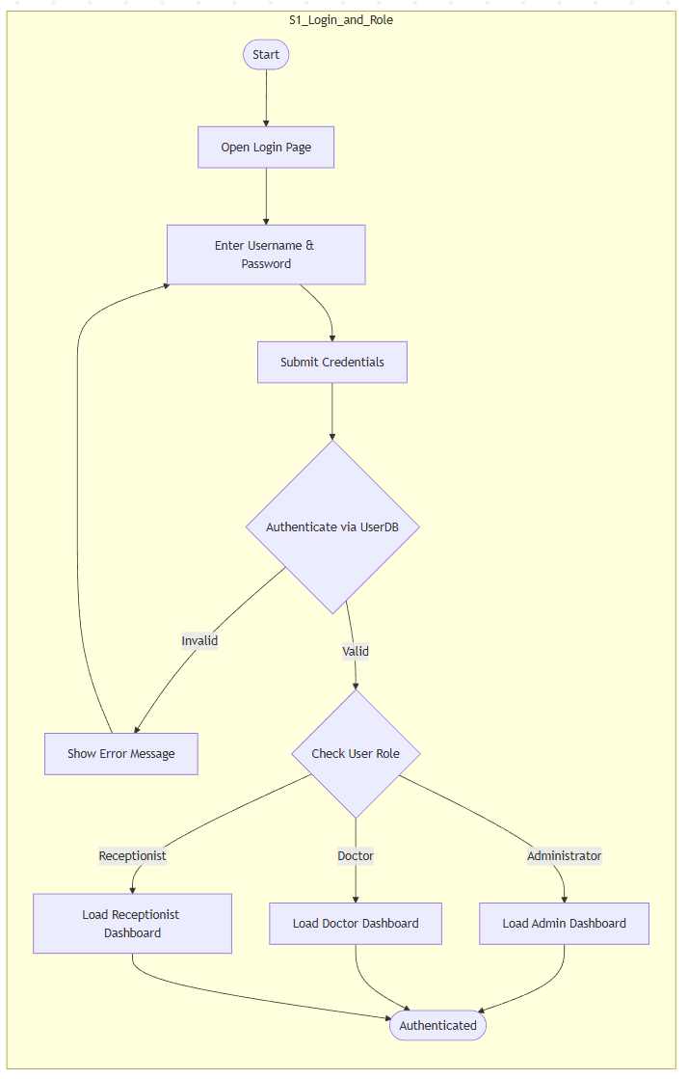
Admin Dashboard
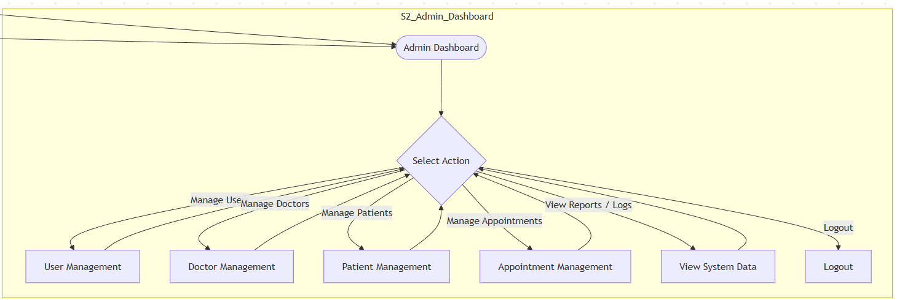
Admin User Management
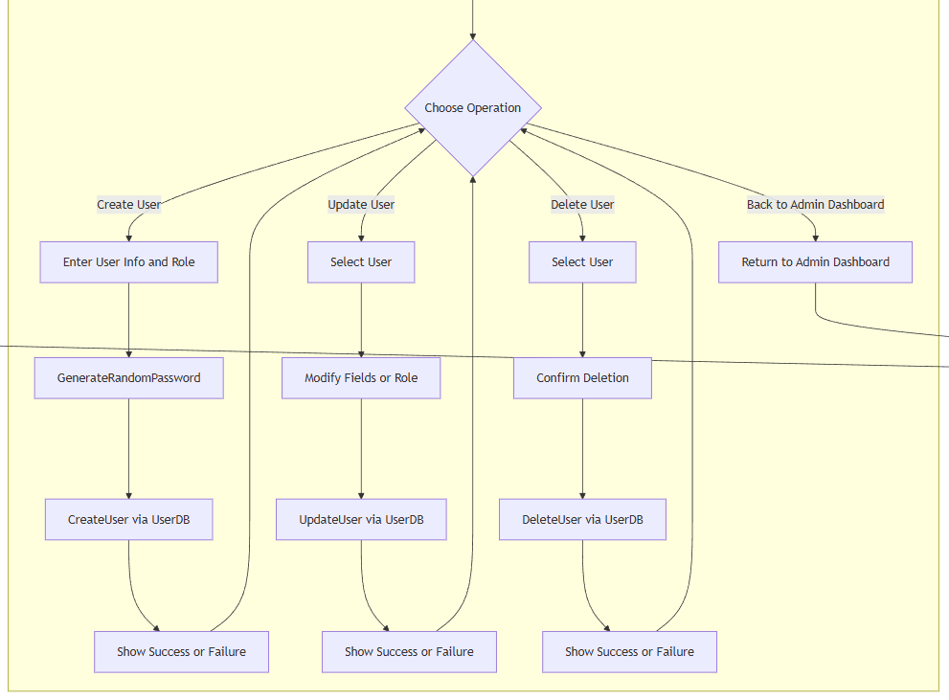
Admin Appointment Management
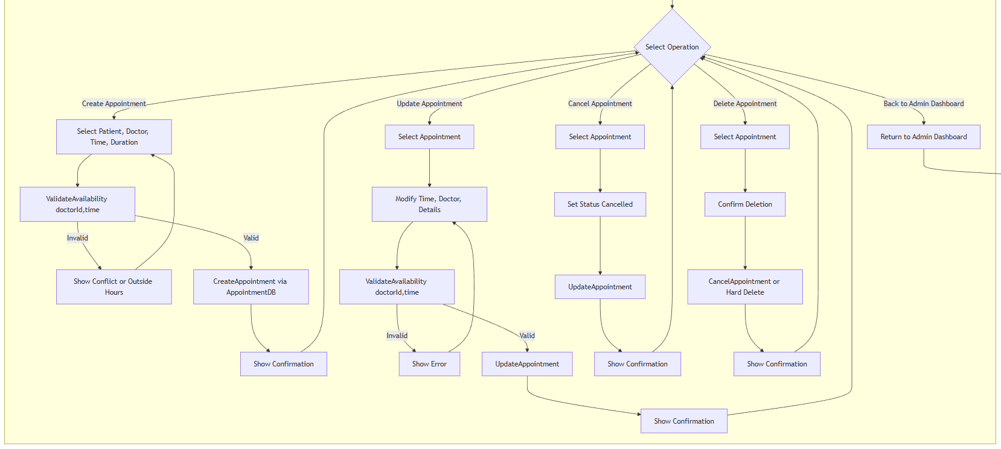
Admin Doctor Availability
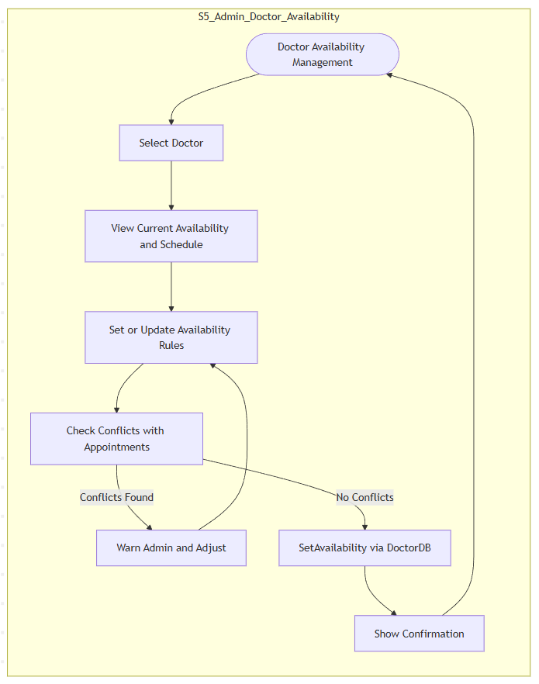
Doctor Dashboard
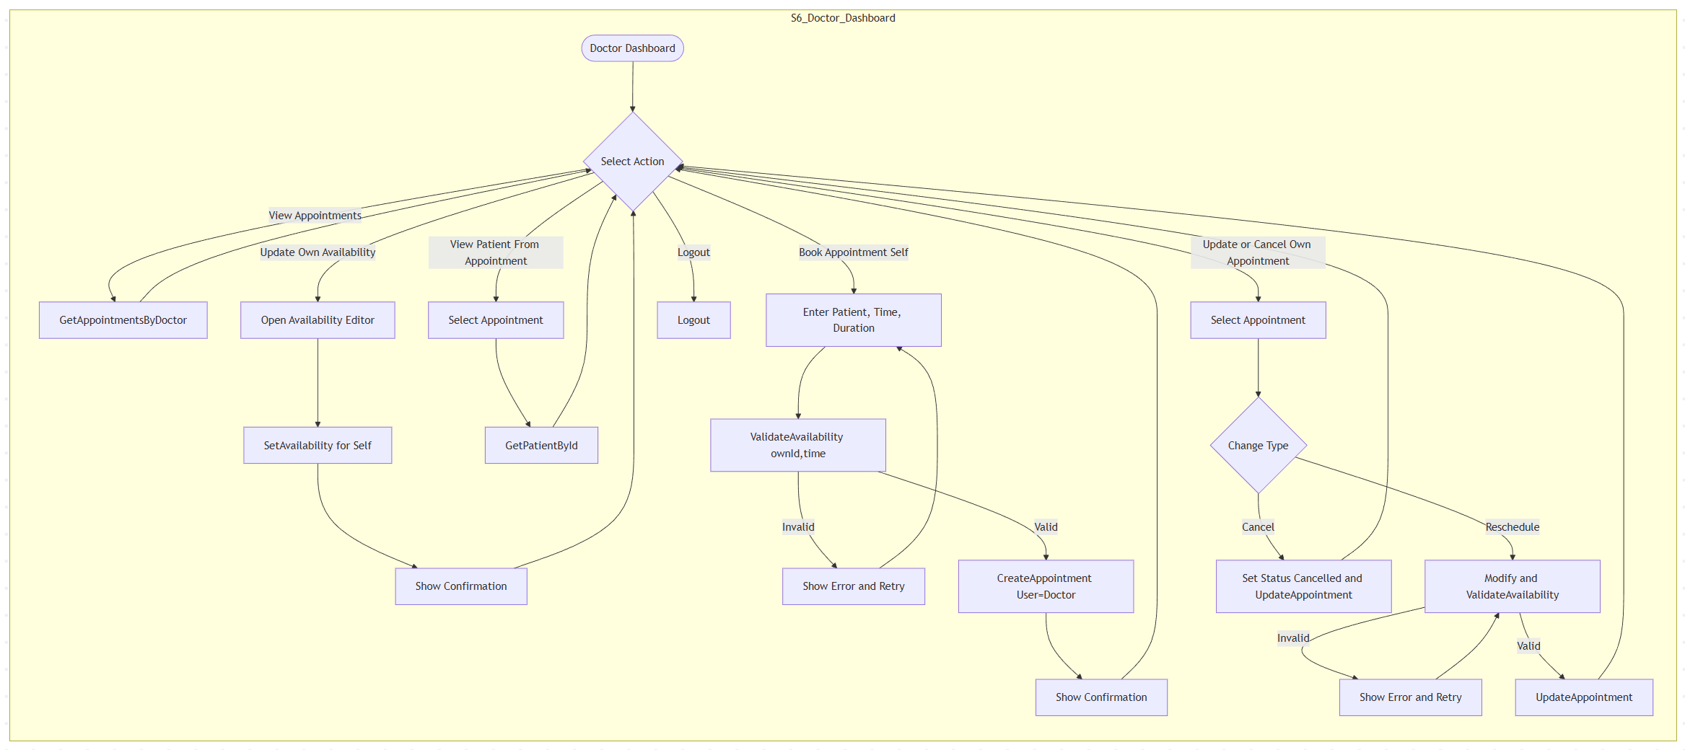
Receptionist Dashboard
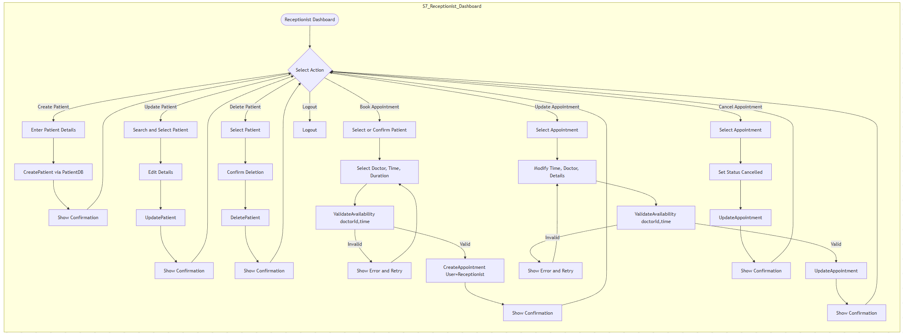

General Book Appointment
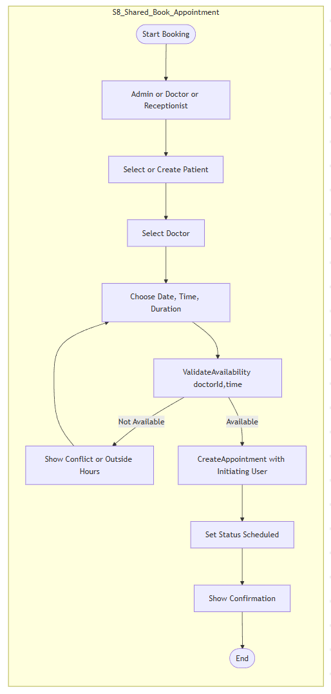
General Update Appointment
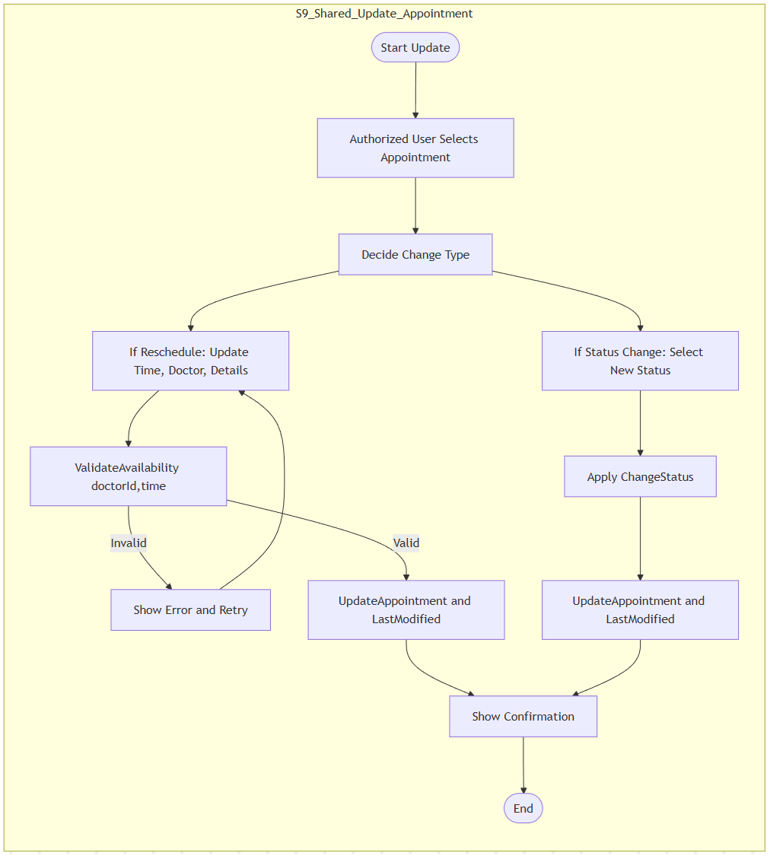

2.4- Sequence Diagram.

