Question 1

a-

x=float(input("enter the number:"))  
if (x>0) :  
 print("the namber is positive")  
elif(x<0):  
 print("the number is negative")  
else:  
 print("the number is 0")

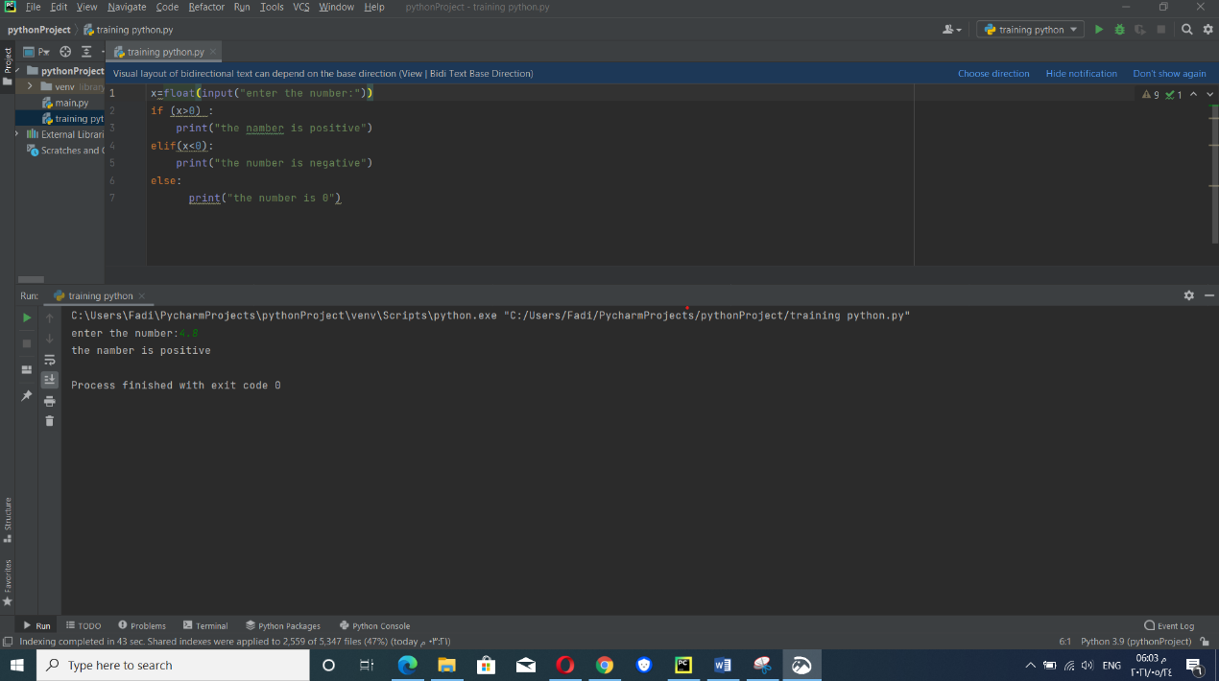

b-

x=float(input("enter the number:"))  
y=float(input("enter thr second number:"))  
z=input("What is the math you want?")  
if (z=='*'):  
 print(x*y)  
elif (z=='/'):  
 print(x/y)  
elif(z=='-') :  
 if(x>y):  
 print(x-y)  
 else:  
 print(y-x)  
else:  
 print(x+y)

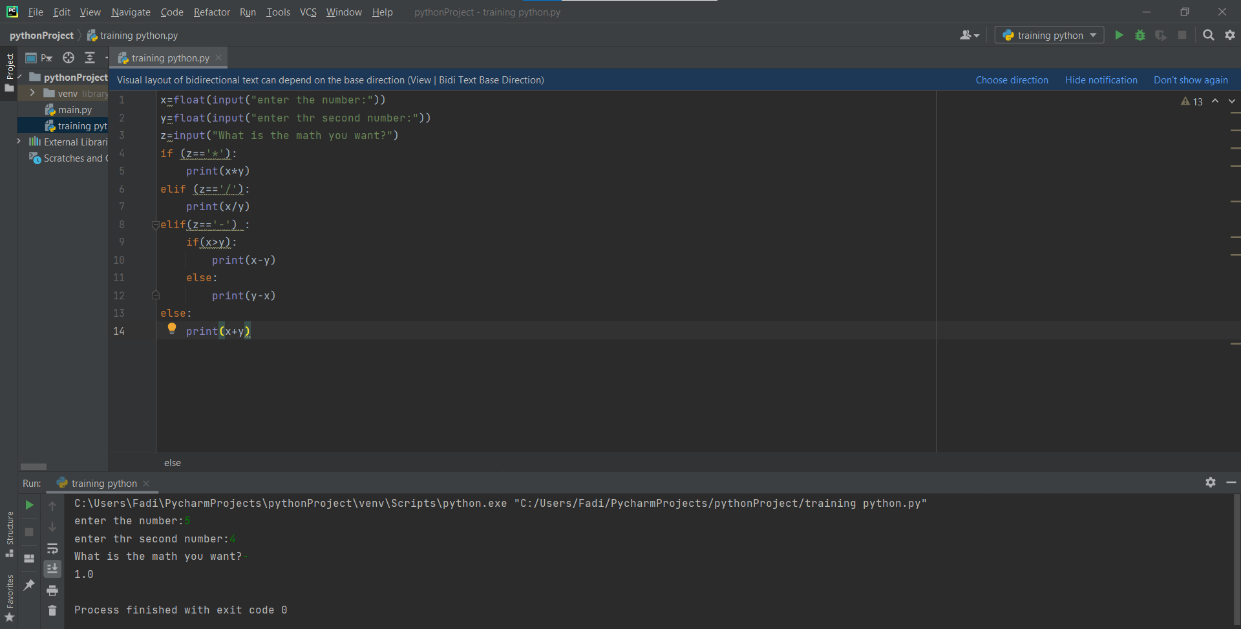

c-

student_list=["pob","peter","jon","soul","brayan"]  
x=input("enter your name:")  
if (x in student_list):  
 print("Graduated")  
else:  
 print("not Graduated")

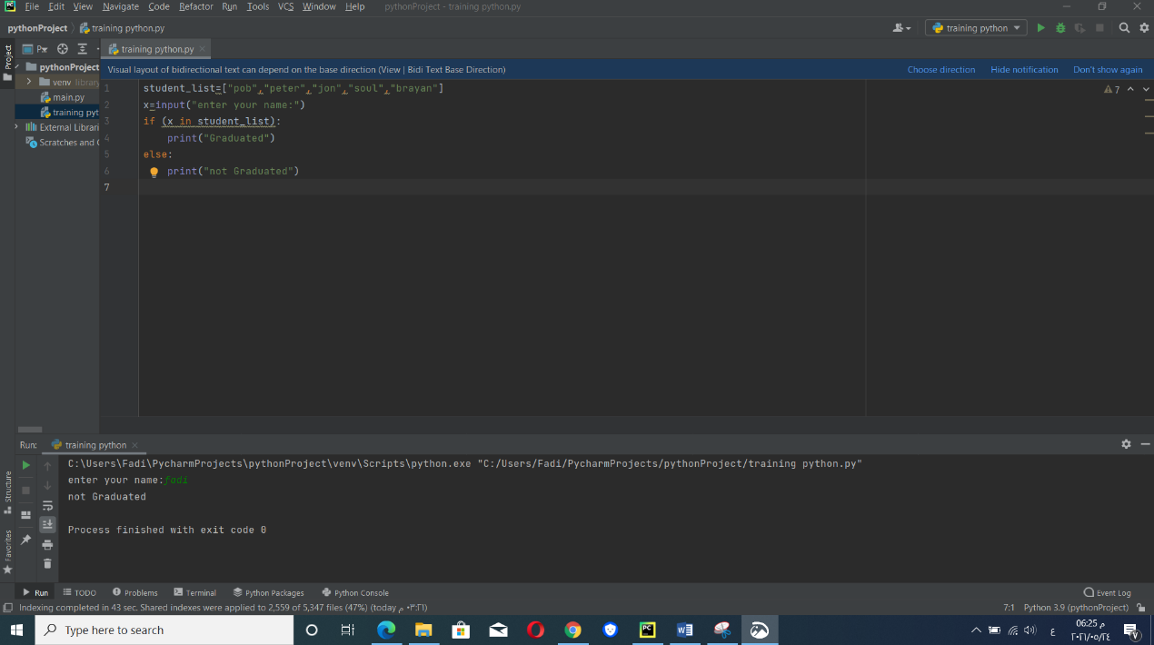

d-

L=['Network' , 'Math' , 'Programming', 'Physics' , 'Music']  
longest_word = 'Network'  
for i in L:  
 if len(i) > len(longest_word):  
 longest_word = i  
print("The Longest word is: ", longest_word)

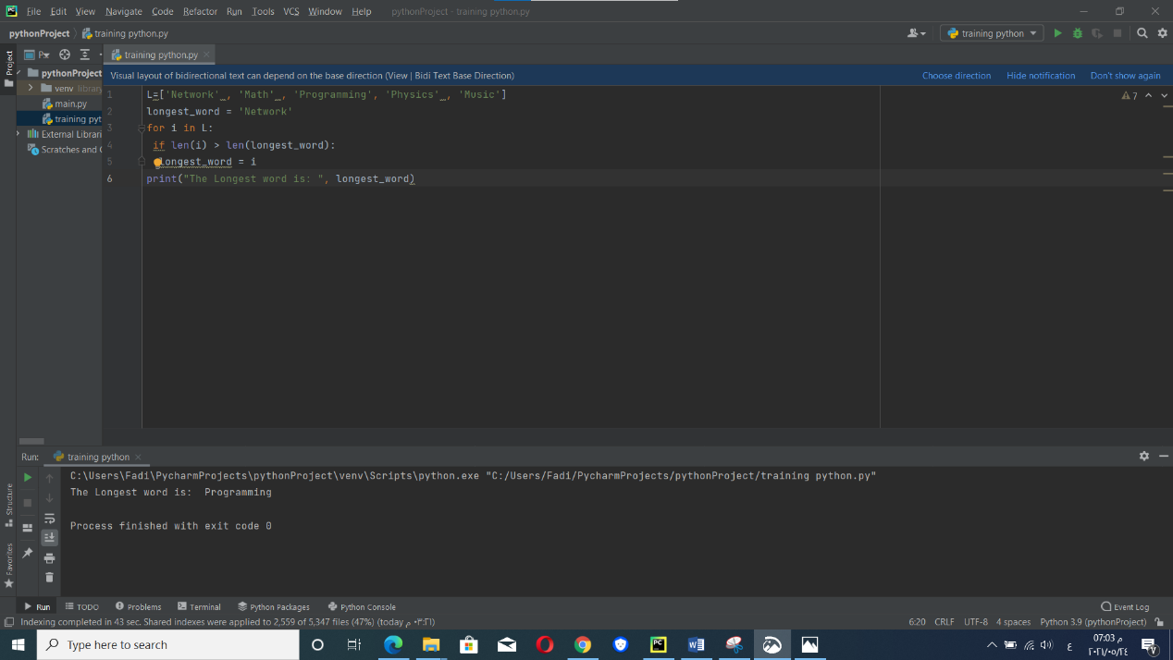

Question 2

binary=[]  
dec = int(input("Enter the decimal number: "))  
x = dec  
while x != 0:  
 remind = x % 2  
 binary.append(remind)  
 x = x // 2  
binary.reverse()  
s=""  
for i in binary:  
 s = s +str(i)  
print(s)

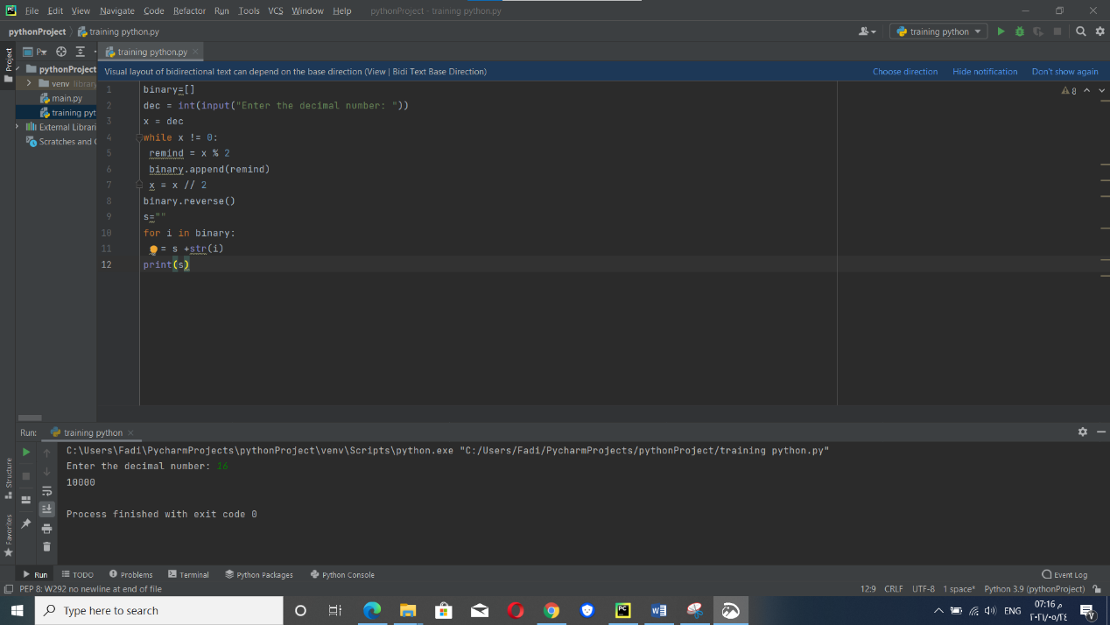

Question 3

x=input("enter your job translator developer or translator user ")  
if x=="translator developer":  
 print("enter the words in dic_En_Ar")  
  
  
  
dic_En_Ar = {"hello":"مرحبا","good":"جيد","house":"منزل","laptob":"حاسوب محمول"  
 }  
word = input("أدخل الكلمة التي تريد ترجمتها : ")  
try:  
 print("ترجمة كلمة {} للعربية هي : {}".format(word, dic_En_Ar[word]))  
except:  
 print("عذرا، لم نجد الكلمة التي تبحث عنها في قاموسنا")

