# Project Exam 1

Rolf Greger Gundersen

957 words

[GitHub](https://github.com/Noroff-FEU-Assignments/project-exam-1-GregerGundersen)

[Web Site](https://projectexam.netlify.app/index.html)

## Design

### **What went well on the project**

### I started this project with a lot of inspiration, since I have had the idea to make my own recipe page for a while. This made it quite easy for me to choose the design aspects and layout for my project.

### I decided to go with pretty little colour and a lot of space to make the website easy to navigate and give it a clean look. The colour i decided to use as my primary is #FD8664. I chose this colour after looking through a few food related moodboards(Fig. 1) and consulting friends and family for feedback. My final decision was based of the fact that it’s an earth, natural and calming colour which fits nicely with a food recipe website. You can mainly find colour in the header, footer and some of the text, while the rest is white. This brings out important elements like navigation, CtA and links when hovered.

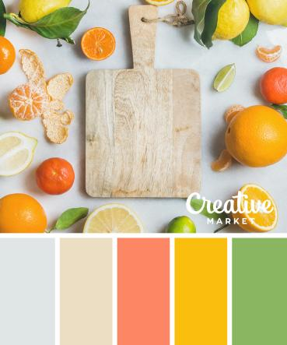

Figure 1

### I am also quite happy with how I made use of scaling while minimizing the use of borders. Both on the contact us page and the recipe page I have used scaling and some very discreet box shadow to outline important items. This has some of the same functionality as a border would have, but looks a lot better in my opinion. It also gives the site some “depth” on the things you’re currently looking at, while the rest of the elements have a flat look.

### **What was difficult/didn’t go well on the project**

The thing that went the worst on this project is probably the mobile navigation. Due to being a bit pressed for time I chose a somewhat easy solution. When the navigation would normally wrap down to the next line (~650px) I simply place it in a grid and reduce the size. If I had more time I would have liked to make a more tailored solution for phones. Possibly a hamburger menu or some sort of overlay. However I think my solution works well; It saves you a click compared to a hamburger menu and always shows you your navigation options.

I also deviated somewhat from the [rough prototype](https://xd.adobe.com/view/db1c9430-c826-439f-92e5-ce934243a678-8e4f/) due to some technical difficulties but I am happy with how it turned out.

### **What would you do differently next time**

Next time I would have liked a more responsive navigation as well as a somewhat sleeker “Latest posts” carousel. The one I have now lacks loading indicators and would probably look better with some smooth transitions.

## Technical

### **What went well on the project**

Most of the technical aspects of the page went really well. The Wordpress page for the API was up and running pretty quick. All the functionality I wanted was relatively easy to develop and I am quite satisfied with how it all worked out.

One of my users noticed while testing that the “Load more” button(Oppskrifter) would load the same posts several times if clicked. I corrected this and remembered to add a “Last page” update to the button so users knew when they had reached the bottom.

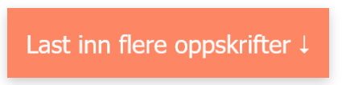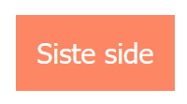

I am also satisfied with how I styled the specific recipe pages(Blog Specific Pages in the assignment). I had a hard time separating elements in different containers through wordpress and therefore had to add a lot of classes and wrap elements in containers after they had been called in from the API. This took some back and forth from me, but I think I solved it in a good way and the final layout of the specific recipe page looks neat and good.

### **What was difficult/didn’t go well on the project**

One thing I found quite challenging was making the carousel for the “Latest posts” section. I did not quite understand the concept of pagination and per-page in the WP API when I started making the carousel and this cost me quite a bit of time and frustration. When I first understood it everything worked out pretty fast. I am also happy with how I made sure to make the carousel loop around so that you don’t have to go all the way back when you reach the end.

### **What would you do differently next time**

Next time I could read API documentation more carefully.

## WCAG guidelines, content management and SEO

### **What went well on the project**

The website is designed for all people. During development I have made sure to check colour contrast, use semantic HTML for screen readers, validate HTML and add alt text on media. This ensures better SEO and a good experience for all users regardless of disabilities.I also ran the index page through a WCAG checker to sample check for any big mistakes.

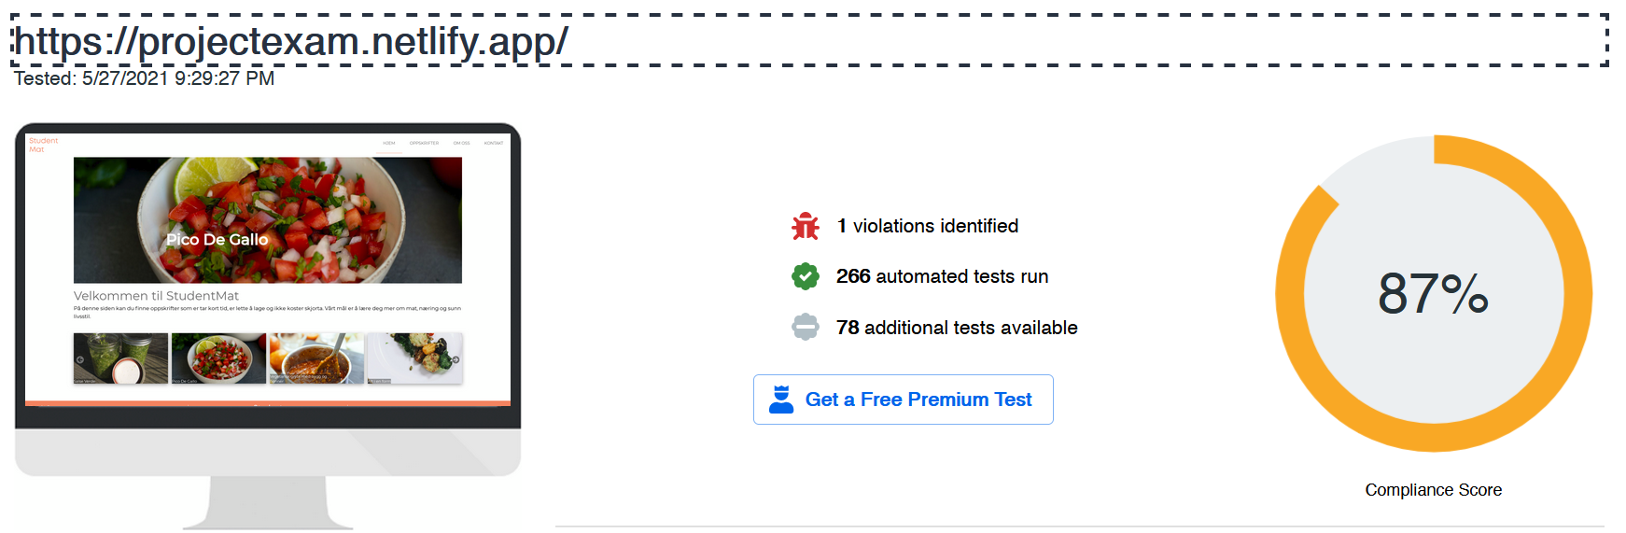

Figure 2

Feedback and user testing

Lastly I want to go over adjustments I made based on feedback and user testing.

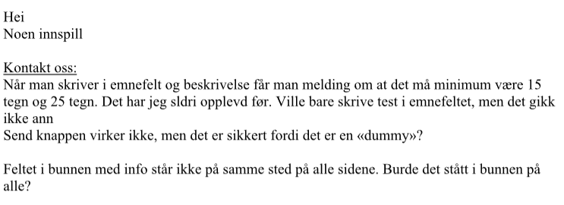

-Adjusted footer(“Feltet i bunnen”). I agree that the validation for this project was a bit extreme but there was nothing to be done about this.

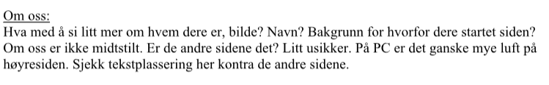

-Added a header photo to the About Us page, made sure to center the content.

I also made certain other changes and made sure users where happy with navigation, typography and the general look and feel of the site. I also installed hotjar on my page and intended to use it for user testing but my trial unfortunately ended before I managed to collect any data so I didn’t get a chance to review anything.

## References

(place references to websites, books, forums etc. that helped you in the project)