# Project Exam 1

Student Name

Jean Christoffer Dahl

Word count

900

## Design

### **What went well on the project**

I researched a lot of blogs beforehand to find out how to make the blog posts a good reading experience, especialy posts with a lot of text. I took a lot of insperation from “medium”.

How they did the fontsize, lineheight etc, it was something i didn’t no think about at first but I think in the end it made my posts much more readable and easy on the eyes. I made the font size and line height larger than the rest of the layout which I think worked out well.

I wanted to make a more minimal design this time, and try to make the images, text and some <hr> tags make the page come to life. So I only went with black and white, and some gradients of white on the blog cards, comment section etc. I went with some svgs and animation on the about page as I want to have a more engaging about page instead of just some boring text. I think the large contact us pitch and floating notes makes the about page really pop and stand out.

The main font I use is source sans pro, which is a another variant of the font medium.com use, which I think worked really well and made it easier to read the text.

The images are made with midjourney which I think turned out really cool, and it was a fun experience to learn how to prompt propperly to get the best result.

### **What was difficult/didn’t go well on the project**

I’m a bit inpatient, which makes it harder to focus on things I’m not 100% invested in. So the Figma part I only made a rough sketch before getting into the coding part, I doesn’t always have to be a negative thing, but I did end up making some changes to the design multiple times and it would be easier to have been 100% happy with the figma design before coding. This is something I will work on in the future. But I am happy with the end result.

### **What would you do differently next time**

Spend more time on Figma to make a fully fledge protype before coding as its easier to make changes during the design part.

## Technical

### **What went well on the project**

I’ve been practising a lot of javascript besides the studies and also been working with React for some time now, so I felt comfortable with a lot of the core concepts. I choose to use Vite as it compiles the js into smaller and optimized files, and removes unused code, which in turn reduces the bundle size. It also makes it easier to work with .env in my opinion. I use .env as I do not want my wordpress link public on github, I know you can see it in the network tab when using the site, but it’s good practice to get comfortable using .env.

### **What was difficult/didn’t go well on the project**

The slider / Carousel was something that took more time than I imagined. I don’t like product carousels that just go on forever, only on images. So I wanted to make a slider that disabled the button when you reached the end. And a carousel that went on forever when viewing a image gallary. The carousel on the index page only disabled the button when clicking again after you reached the end which annoyed me for quite some time. I solved it with making a button checker function than ran everytime the nex or prev button is clicked. I don’t know if it is the correct way as it seems a little strange, but atleast it works. I wanted to have a max 6 posts as latest posts as having the option to slide through all 12 posts seems strange to me. I wanted to focus on the 6 latest posts.

### **What would you do differently next time**

Next time I will focus more on keeping the code DRY as I’m coding as going through the css,html,js after everything works was kind of a bad descission on my part and I’m sure I missed some optimization because of it.

## WCAG guidelines, content management and SEO

### **What went well on the project**

Lighthouse gives me a 90% performance, 100% accessibility, 100% best Practices and 100% SEO, which I’m happy with .

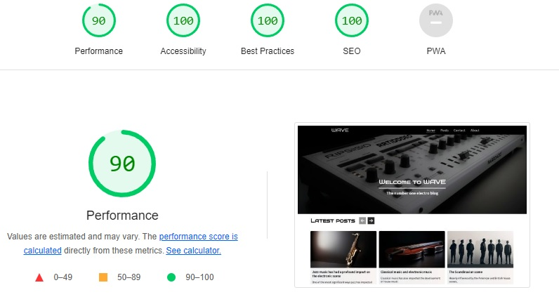

### **What was difficult/didn’t go well on the project**

I have some issues with Wave tool. I get no errors on all my pages expect blog specific page. I don’t know if it is because the the blog-post is not loaded before it throws the error.   
<https://wave.webaim.org/report#/https://charming-mousse-954d3d.netlify.app/details.html?id=46>

As you can see the error points to nowhere and checking my post in dev tools I do indeed use alt text and there is no empty button on the page. So I might be missing something but I cant find out what it is.

### **What would you do differently next time**

Also here I have the tendency to just code and design and worry about contrast, accesibilty later. It would have been smoother and faster to do all of these things while im coding and making sure the contrast fits the design. I’ve learned from this and will take this into account on my next project.

## References

(place references to websites, books, forums etc. that helped you in the project)

* <https://medium.com/>
* <https://www.compart.com/en/unicode/U+2669>
* <https://www.midjourney.com/app/>
* The SVG of the City on the about page I cant find anymore. It’s from a online tool where you create svg with assets from the site. Been searching all over the place for the source.
* <https://tinypng.com/>
* <https://learnjavascript.online/>
* https://stackoverflow.com/
* <https://mui.com/> (forms,inputs and option/select)
* <https://cssgradient.io/>
* <https://medium.com/@mahesh_joshi/wordpress-contact-form-7-rest-api-endpoints-bf45907b571c>
* https://www.youtube.com/c/webdevsimplified