# Project Exam 1

Ravand

## Design

### **What went well on the project**

Design prototype for website went well, I went for colours that attracts gym people. Layout is also made considering what attracts gym freaks. Colour, text and buttons went very well.

Successfully implementing responsive design principles improved the website's compatibility with various devices, enhancing the user experience across different screen sizes.

Improving the clickable images feature addressed a significant usability issue and made the browsing experience more intuitive for users.

Simplifying navigation pathways, especially to product pages, positively impacted user engagement and satisfaction. Users can now access product details more efficiently, leading to increased conversions.

### **What was difficult/didn’t go well on the project**

Making the NAV head bar didn’t go as quite as I wanted because of colours mix.

Working within resource constraints, including time and budget limitations, posed challenges in implementing all desired design improvements and conducting extensive usability testing.

Overcoming technical challenges, such as resolving compatibility issues across different browsers and devices, proved to be a significant hurdle during the project implementation phase.

Initially, users experienced confusion navigating the website, particularly in accessing product pages. This highlighted the need for clearer signposting and more intuitive design elements.

## Technical

### **What went well on the project**

HTML and CSS part went very well. I used a lot of previous practice from previous CA’s, but I am still new to JavaScript. For JavaScript I struggled a lot and had to use YouTube and Google a lot.

Establishing a clear structure and organization in the HTML markup facilitated easier maintenance. Using semantic HTML elements appropriately enhanced accessibility and SEO.

Successfully implementing responsive design principles using CSS media queries ensured that the website displayed effectively across various devices and screen sizes, improving user experience and accessibility.

Leveraging JavaScript to enhance website functionality, such as form validation and interactive elements, contributed to a more dynamic and engaging user experience.

Embracing an iterative development process allowed for continuous improvement and refinement of features based on user feedback and testing results. Regular code reviews and updates helped maintain code quality and address issues promptly.

### **What was difficult/didn’t go well on the project**

Fetching single product by Worpress API. When a blog is clicked it has to gather the right blog page. I struggled to code this a lot.

Achieving consistent rendering and functionality across different web browsers presented challenges, particularly with older browser versions that may not fully support modern CSS and JavaScript features.

Implementing complex JavaScript functionality, such as asynchronous data fetching or intricate DOM manipulation, required careful planning and debugging to ensure reliable performance and compatibility.

Optimizing website performance, including minimizing page load times and reducing resource consumption, proved challenging, especially when dealing with large CSS or JavaScript files or resource-intensive tasks.

Anticipating and addressing edge cases, such as unusual user inputs or unexpected browser behaviors, required thorough testing and debugging to ensure robustness and reliability across different scenarios.

## WCAG guidelines, content management and SEO

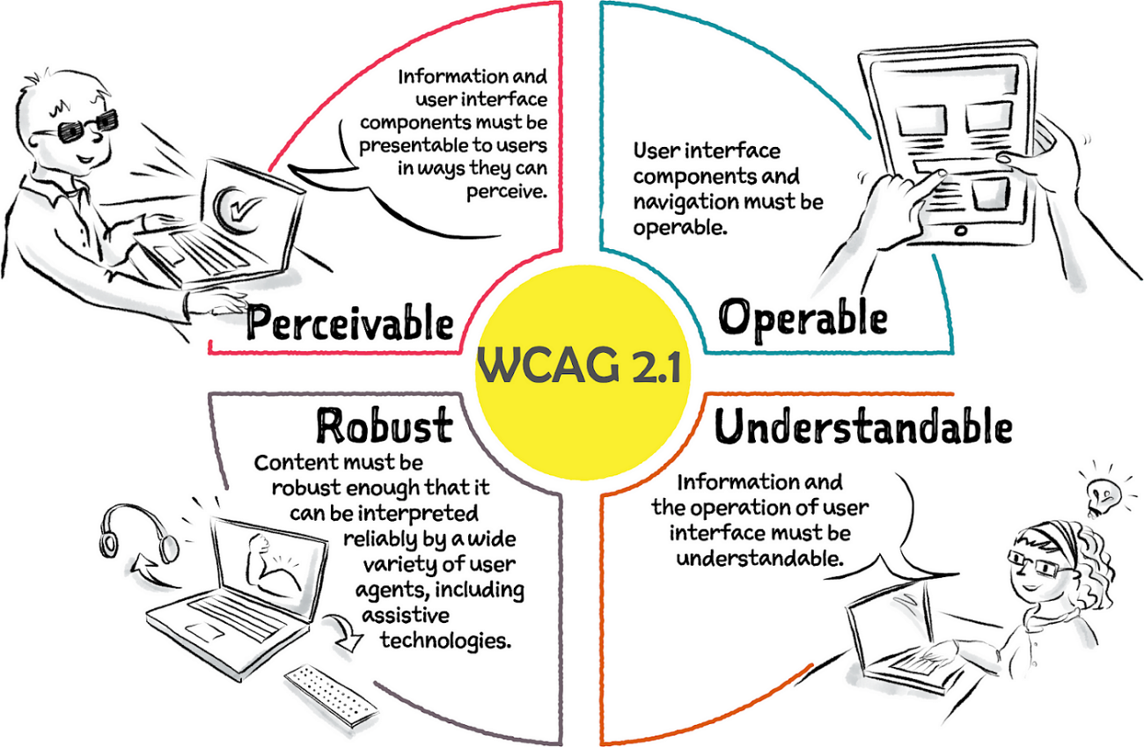

For WCAG, I have been following this image as an example for building the best website for customers.

**Usability Report**

An overview of the usability testing conducted for an online muscle building website was implemented. The primary goal was to gain insights into the user experience, identify potential issues, and propose practical solutions based on user feedback.

To ensure a comprehensive understanding of how users interact with the website, a combination of in-person and remote testing methods was employed.

In-person testing allowed for direct observation of reactions and body language, offering quick insights into users' thoughts and feelings during interactions. Meanwhile, remote tests enabled users to explore the site independently, providing feedback based on their genuine experience, free from direct oversight and potential influence.

I chose to use 'Hotjar' as a remote test. Features used from Hotjar are 'Heatmaps' and 'Recordings'. I can now see playbacks of users' journeys to find out what attracts the users.

The goal for the report is to assess the user's capacity to navigate the platform and find relevant muscle building information seamlessly.

I participated with the following people:

- Christina

- 20 years old from Moss.

- Experience: Engages in muscle building workouts regularly.

- Device: iPhone.

- Has a lot of knowledge about fitness and nutrition.

- In-person testing and remote.

- Siar

- 24 years old from Sweden

- Experience: Fitness enthusiast and personal trainer.

- Device: Laptop

- Has a degree in Fitness Science and works as a personal trainer.

- In-person testing and remote.

- Sidra

- 27 years old from Oslo

- Experience: Enjoys weightlifting and strength training.

- Device: Laptop and iPhone

- Has a degree in kinesiology. Knows about muscle building techniques.

- In-person testing and remote

- Rezan

- 35 years old from Sweden

- Experience: Owns a fitness YouTube channel.

- Device: Laptop

- Has 10+ years of experience in bodybuilding.

- In-person testing

I asked all my participants the following questions to understand user experience and find any issues:

- What aspects of the site do you appreciate?

- Which device do you typically utilize for browsing fitness websites?

- Is the content on the site relevant and easy to understand?

- Have you previously used a similar fitness website?

- How would you describe your overall experience on my site?

- What are your impressions of the user interface and design?

- Do you have any recommendations to enhance the functionality or design of my site?

- Did you find navigating the site to be uncomplicated?

- Were you able to find the information you were looking for?

The feedback I received was generally positive. The users found the site easy to navigate and appreciated the layout. They described the website as informative and engaging, providing valuable insights into muscle building techniques and nutrition.

However, several issues and suggestions for improvement were identified:

1. Images of products are not clickable.

2. Resolution on smaller screens is not responsive.

3. Lack of information

4. No hovering effects

5. Users had difficulty finding their way to specific blog page.

Addressing these concerns will enhance the overall user experience and ensure the website meets the needs of its audience effectively.

**Implemented Changes**

Based on the feedback received through both in-person and remote testing, several improvements have been made to the muscle building website to enhance its usability and functionality.

1. Compatibility with All Screen Sizes:

- The website's responsiveness has been improved to ensure compatibility with all screen sizes. Now, users can access the website seamlessly from various devices, including mobile phones, tablets, and desktops.

2. Clickable Images:

- Images of blogs are now clickable, allowing users to navigate to the blogs pages with ease. Previously, only the blog titles were clickable, which caused confusion among users. Now, the entire image serves as a clickable link, providing a more intuitive browsing experience.

3. Improved Product Display:

- The layout of product displays on all pages has been redesigned for better visibility and accessibility. Products are now showcased in a more organized manner, making it easier for users to browse through the available options and make informed purchasing decisions.

4. Enhanced Navigation:

- Navigation to product pages has been simplified for user convenience. Now, users can easily access product details by clicking on the respective images or titles directly from the homepage or category pages. This streamlined navigation pathway reduces the steps required to reach the desired products, improving the overall user experience.

5. Optimized Blogs Page:

- The blogs page has been optimized for faster navigation and improved user experience. Categories are now presented in a more visually appealing and user-friendly format, allowing users to quickly locate and explore their preferred product categories.

These implemented changes aim to address the issues identified during usability testing and provide users with a more intuitive, seamless, and enjoyable browsing experience on the muscle building website.

Heatmaps:

### **What went well on the project**

Following WCAG and using Hotjar to get feedback.

### **What was difficult/didn’t go well on the project**

Improving the website after feedback from people.

### **What would you do differently next time**

Using Hotjar earlier in process. I started to ask for reviews very late.

## References

(place references to websites, books, forums etc. that helped you in the project)

Github: <https://github.com/Noroff-FEU-Assignments/project-exam-1-RavandTaha>

Netlify: <https://musclegymnation.netlify.app/>

Netlify is without API

I will with the delivery of this PDF, upload local zip file of my WordPress. So, you can download my WordPress site on Local and test it on your device.

Admin Username: [businessravand@gmail.com](mailto:businessravand@gmail.com)

Admin Passord: Duhok12345!!

ALL images used in this project are used under FAIR USE.

Images are also from Adobe Stock

<https://stock.adobe.com/no/>

Tutorial videos used:

<https://youtube.com/watch?v=osIXgJRDyvc>

<https://www.youtube.com/watch?v=U4nbKMJRVaw&t=17s>

<https://www.youtube.com/watch?v=jo1wphDCu3k&t=192s>

Earlier Modules and CA’s