Technical Report

Project Exam

Thomas Eitrheim

Table of Contents

1. Summary **Feil! Bokmerke er ikke definert.**

2. Body **Feil! Bokmerke er ikke definert.**

2.1. Introduction **Feil! Bokmerke er ikke definert.**

2.2. Main section of report **Feil! Bokmerke er ikke definert.**

2.3. Conclusion **Feil! Bokmerke er ikke definert.**

3. References **Feil! Bokmerke er ikke definert.**

4. Acknowledgements **Feil! Bokmerke er ikke definert.**

5. Appendices **Feil! Bokmerke er ikke definert.**

In this report I will explain how I managed to solve the assignment I was given as my first-year exam.

I have been tasked with putting into practice the skills I’ve learned over your first year of studies. This will include planning, designing, creating a blog with html, CSS, and JavaScript, and testing it on users.

The first thing I did was to look over the assignment and see what work needed to be done. I made a Trello board with the different tasks set up.

With the Trello board set up I could easily see what’s going on and what was next on the agenda.

I found out I would make a blog about the different styles of martial art (at least the one that have been “proven” works). I have been interested in martial arts since I was a child so I thought it would be fun to make a blog about that. I got free images from the web, and I asked ChatGPT for text to the different images. I then imported those assets to WordPress so I could fetch it later.

After deciding the architecture and what resources should be used, the designing began. I used Figma for this and made a high-fidelity prototype. I took inspiration from several different websites about martial arts. These are websites I use daily. A couple of examples would be MMA Junkie, The MacLife, Bloody Elbow etc. I started with the mobile design before I started with the desktop. I first made it with different colours, but it was too much so I stripped it down and was left with red, pink, and white.

After I finished the design, I started with the coding in vsCode. I started with the index/landing page. First, I did the html and CSS and made all the elements I needed with that first. This I did first because then I would have most time finishing the JS required. JS is what I’m most insecure about when it comes to what I’ve learned this far by Noroff. I feel I have a “good” grip on html and CSS and not so good on JS. So, I gathered I needed most of the time doing JS. After doing most of the html and CSS I started on the JS. The first JS I started on was the contact validation form. Here the requirements from the CA were: “Create a contact us page, there should be 4 textboxes on this page.

* Name (Should be more than 5 characters long)
* Email address (Must be a valid email address)
* Subject (Should be more than 15 characters long)
* Message content (Should be more than 25 characters long)

Please use JavaScript for validation, show error messages if the values in the textboxes do not meet the requirements.”

To do this I needed to do something I had not done before, and that was reading and learning about regex. A regex accepts a certain set of strings and rejects the rest. So, I needed to find what was accurate in terms of contact validation. This sound easy enough but it took some time before I could get it to work properly with the JS.

The next thing I did was to make the JS for the “all blog posts”. I made the functions and fetched the product/posts from the WordPress API. I had previously worked with WP to import all my blog info like images and text. I got ChatGPT to produce the text to the images. This proved to be the easiest task I did in the assignment.

The hardest part I did was the last part that I really didn’t know how to do: the carousel. This was a very hard task for me, and it took me the longest time. After getting the images to show I just couldn’t get them inside a carousel. I struggled with this for many, many days. I asked around on discord and other forums. I asked my class and got some good videos to watch. The problem with the YouTube videos and the “follow along” is that it seldom transferred to my own codes. Especially when I had already finished with the html and CSS with my own set-up and names. One of the problems I had was finding the correct Json endpoint. I either got a title or some text, or the image but no text. I tried to first make the arrows in the carousel with html and CSS but quicky found out that I needed to make them with JS. When I first got the “getElementById” and the click event I figured it wasn’t so hard actually. My console.log helped me a lot with figuration of the code. Often the message was that something wasn’t defined. And from experience I know that’s often because of the scope. So, when I changed or copied and dragged the code inside the scope it worked.

Of all the things needed to be done the JS was the thing I used most of my time with. There was A LOT of trying and failing, and sometimes I really don’t understand how I got it to work.

When there was a couple of days left before submission, I posted it on discord for feedback from my classmates and I installed a Hotjar tracking on all the pages.

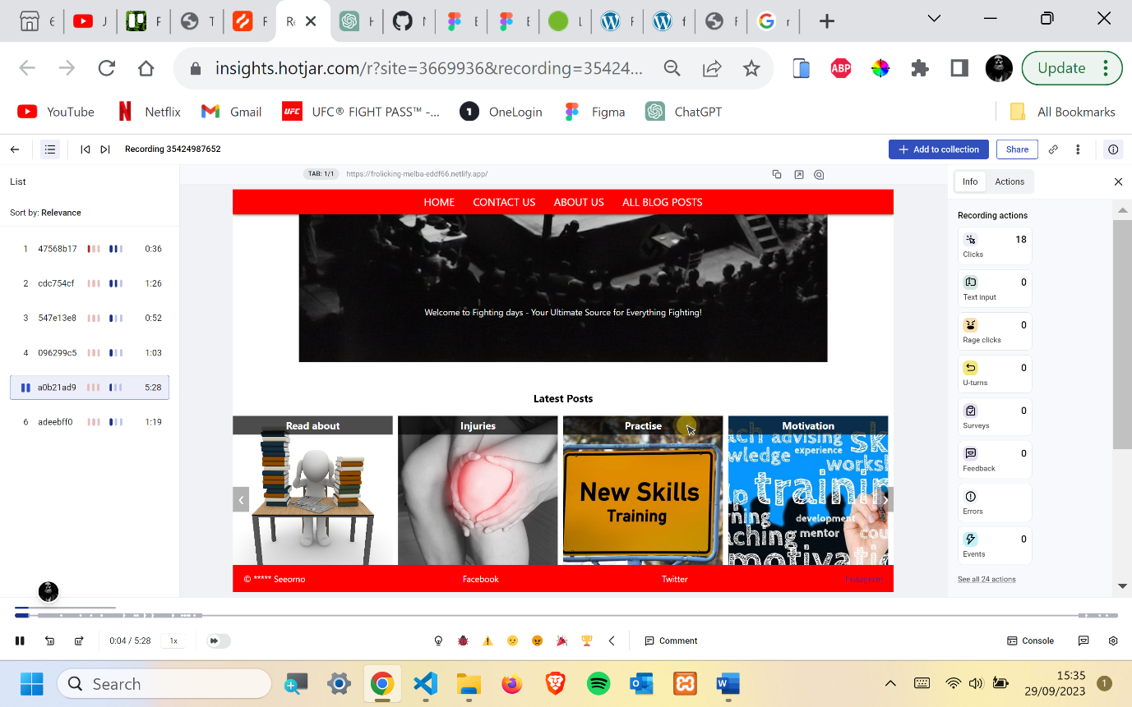

I also tested it on my wife and my brother. The feedback I got was mostly about the design. One user asked me if I had tried to just have the colour white on some of the backgrounds instead of pink. I tried this and ended up removing the pink colour. Some people thought the red colour was too strong. This I didn’t agree with myself, so I did not change it. Also, on the about page I changed the font size. Another thing I changed because of feedback was to move the hamburger menu from the left to the right. I could see what needed improvement by comparing the Hotjar highlights and the other user testing.

One of the last things I did was to check my website on the wc3 validator and wave. Here the only errors I got was contrast errors. So, I had to fix them. I did this with font-size and filter: brightness.

In this report I’ve explained how I did the work that was required for this assignment. I planned, designed with users in mind and created the website with html, CSS, and JavaScript.

Netlify: <https://frolicking-melba-eddf66.netlify.app/>

Github: https://github.com/Noroff-FEU-Assignments/project-exam-1-Teitrheim.git

Reference’s:

pixabay

unsplash

dummy text generator

mdn web docs

wordpress rest api

wikipedia

www.rexegg.com

code pen

discord

stack overflow