# Project Exam 1

Emil Thorsplass

Word count: 994

## Design

### **What went well on the project**

By far, I am the most satisfied with the design of the desktop version of my site. I feel like based on my initial vision, I managed to turn it best into reality there. Mobile became and after thought. From a mobile-first perspective this is not great. But it boils down to that I a carousel element and hover effects don’t translate well to touch screens in my opinion, and that I spent the most time on these elements ‘popping’ than anything else.

I am also quite happy with the business/contact card section on the home page. And tiny things like how the “back to blog” button scales up and down with the browser on the blog specific page (not that anyone is gonna notice).

### **What was difficult/didn’t go well on the project**

From a design-point, I believe the most challenging thing was getting things to look right on Safari. That goes for all devices, iPhone, iPad and Mac. Some CSS rules simply got overruled by Apple’s browser. This led me to have to make, sometimes, somewhat sub-optimal compromises for something that would work decently cross-platform. But I do think I resolved it pretty decently using media quieries in some instances for scaling issues on elements using the position:absolute; property for example. There are traces of my struggles with this if you try to scale the browser down towards tablet and mobile on the latest-post-title text falling outside of the latest post element, on the blog page, at some points.

The biggest flaw design-wise though, in my opinion, also is a result of Safari restrictions, and that is the left and right arrows on each side of the Carousel track on the home page are invisible. They show on all other browsers. I’ve tried everything it seems. The only solution in the future will be to get rid of the W3 svg arrows and implement some standard arrows that I am allowed to style...

### **What would you do differently next time**

Next time I would plan ahead more for the mobile version of the site. Especially the home-posts element (the featured blog post cards which replace the carousel element on mobile). It needs to be more exciting and I don’t feel they are as appealing or interactive as the carousel items on desktop.

## Technical

### **What went well on the project**

The category buttons/tags on each specific blog post element. From user testing I realized that people expect these to be functional and a way to navigate to more of the content they are interested in seeing so therefore that evolved into a form of filtering out the blog posts by a single category on the blog page. I am happy about this cross page integration.

I am really satisfied with the smooth feel of the carousel. Also I am quite happy about the hover effects on the blog elements on the blog page.

### **What was difficult/didn’t go well on the project**

There sometimes are glitches where the right arrow on the carousel won’t be clickable on page load. I spent forever trying to solve this to no help. But it mostly works. I find it mostly is an issue if you rescale the browser after loading the page, but that is not normal user behaviour so I couldn’t spend too much time going crazy over that.

Another thing is that I am fetching the excerpt from wordpress and deplaying the first few words as a preview to the blog content when you hover over a blog post card (or latest post element). The problem is that there are no spaces between sentences. I tried fixing this for a long time but I couldn’t make it happen. Some sort of formatting issue.

### **What would you do differently next time**

What can I say, spend more time on fixing my issues? Not procrastinating away the first week of the exam period. But in the end I think it boils down to time management. I often thought of new features along the way that I wanted to implement and in those cases I didn’t plan well ahead how it would end of looking exactly but winging it instead. I can’t say that it was a mistake in this case though as it is my own blog and experimenting is half the fun. But it did result in more issues than I could handle and that is the consequence and something I must account for in the future when working on client projects for example.

## WCAG guidelines, content management and SEO

### **What went well on the project**

Once I got the hang of Wordpress it went surprisingly well. It was fascinating how I could fetch and do whatever I wanted to with the data I fetched, like creating category tags and update my elements with data which automatically adopt my styles and looking good.

### **What was difficult/didn’t go well on the project**

Wordpress was a bit tricky incorporating in the beginning It started with bluehost ghosting me (still haven’t heard from them) even they have locked me out of my account and hold my domain name hostage. Probably because my IP address is all over the place as a result of my traveling.

After giving up and going with Siteground things went more smoothly. The whole Netlify thing was a bit confusing too. Something I wasted the most time on (a whole day) was getting wordpress to be shown on my Netlify deployments. It would work fine locally but nothing would be fetched on netlify. Really furstrating. It turns out that the API url you fetch from in javascript has to be HTTPS and not HTTP if not in won’t work with Netlify.

### **What would you do differently next time**

Study more.

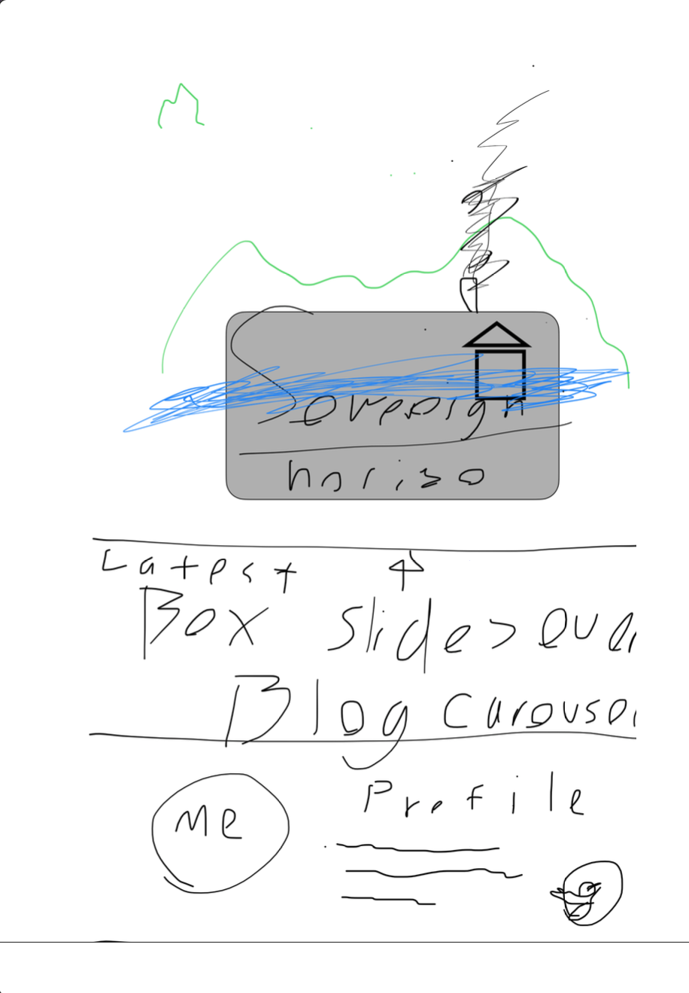

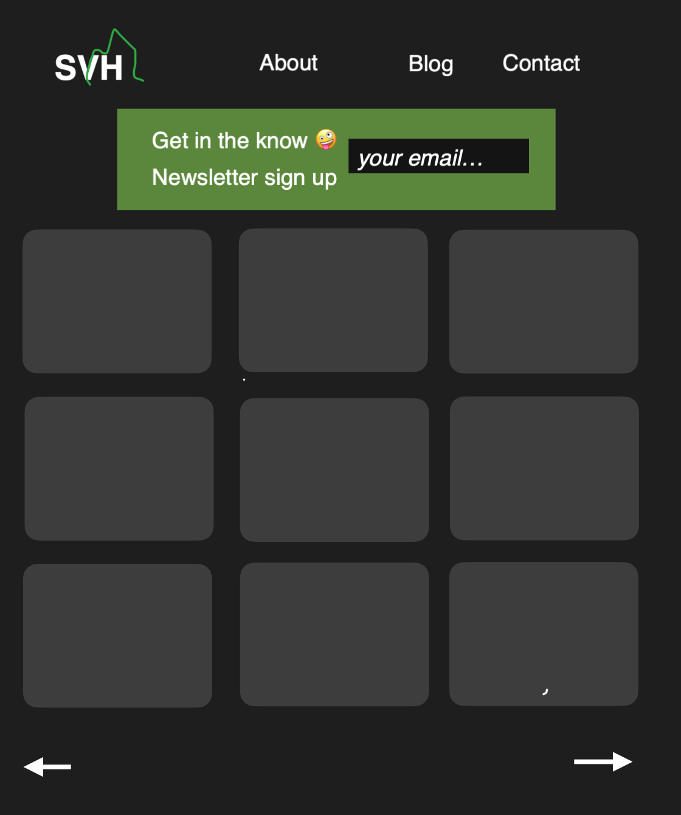

## User testing

After some testing with Hotjar, it became glaringly obvious what was the most sought after feature: clickable category tags:

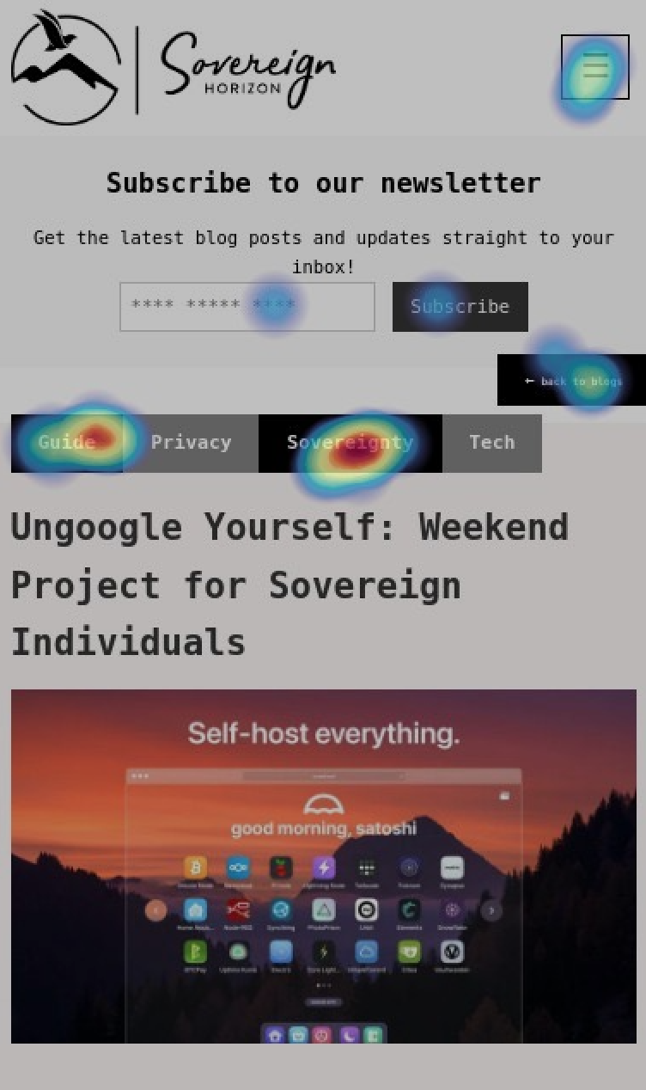

## References

(place references to websites, books, forums etc. that helped you in the project)

* nomadcapitalist.com
* sovereignman.com
* google.com