# Project Exam 1

Student Name

Word count

Trello board, added “to do – doing – done”, and added cards. Really helpful to keep me on track, and not forgetting something.

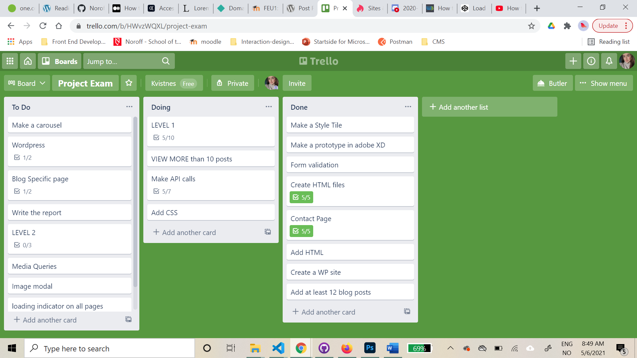

## Design

Prototype feedback: nice and clean layout, a some said it was a boring colour palette. I know I should listen to the feedback, but I will give the palette a chance and test some more users when it’s not a adobe XD prototype. My idea is that the images on the site will tilføye siden de fargene den trenger, and that the content itself should be in focus, and not too much of the design.

### **What went well on the project**

### **What was difficult/didn’t go well on the project**

### **What would you do differently next time**

Find a way that I like, so I may prefer designing for smaller screens first.

## Technical

### **What went well on the project**

Much tidier/neater with the html and css, DRY principle. Not sure about the JS, about reusing functions etc..

Mine tidligere oppgaver er veldig til hjelp! Hvis det er noe jeg ikke husker helt eller er usikker på, går jeg tilbake og ser på hva jeg har gjort tidligere.

Desktop first, because I prefer it. I know with the utviklingen I samfunnet in mind it’s a good idea to design for smaller screens first, but I think it’s easier to adjust it to a smaller size.

### **What was difficult/didn’t go well on the project**

Å hente bilder. Jeg hentet inn hele blogposten, og da fulgte bildet med, men ikke alt?

Carousel. Har ikke gjort det før.

Load more than 10 posts. Never done it before. I tried to find a way to fix the problem in the WordPress settings, but after changing what I thought might work, it still returned 10 objects.

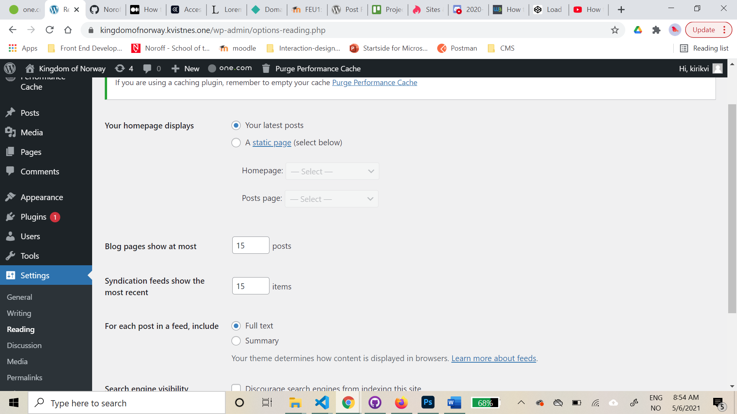 I googled the problem, and found a really helpful post by someone who had the same problem as me: <https://wordpress.org/support/topic/rest-api-only-returns-10-posts-2/> . I found out it only returned 10 posts by default, so I had to add a new parameter (?per_page=15) at the end of the url, which worked. Yay!

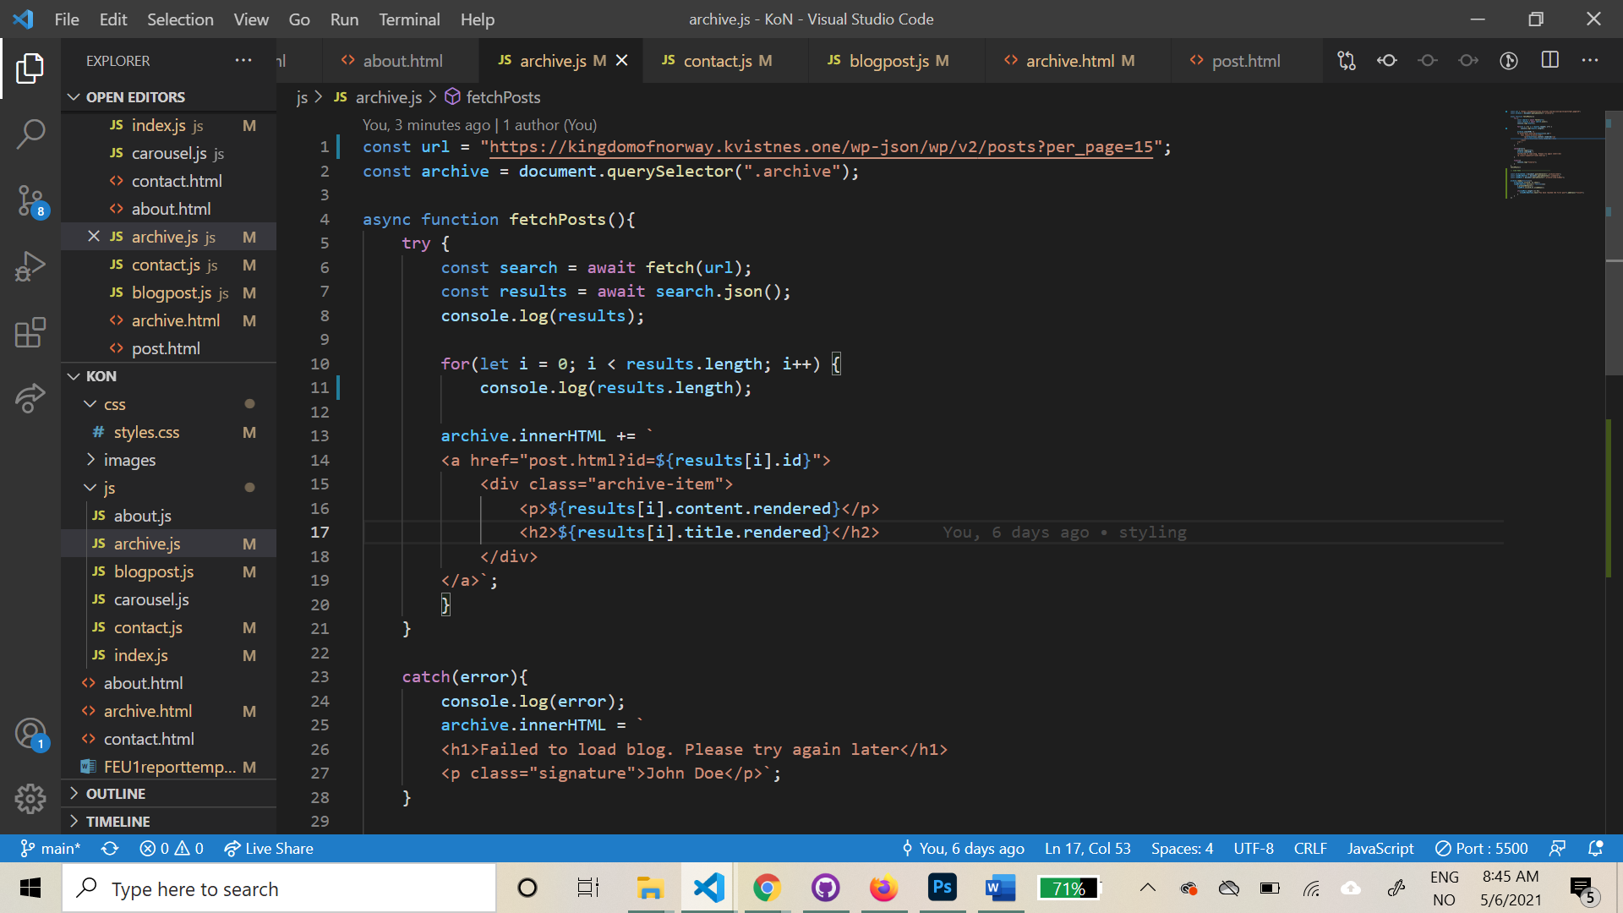

### **Da var det bare å få til å trykke mer for å laste inn resten av innholdet. Jeg strevde lenge med å få det til, og kom over mange ulike løsninger på det, men mange handlet om jQuery, og jeg ønsket å få det til med vanlig javascript. Etter å ha lest om både slice() og splice() uten å forstå helt hvordan jeg kunne bruke det, endte jeg opp med denne løsningen; to for loops and an on click event for getting the last posts when clicking a button. I added code to hide the button when all posts are loaded, and added text for the user to know that they have reached the last post.**

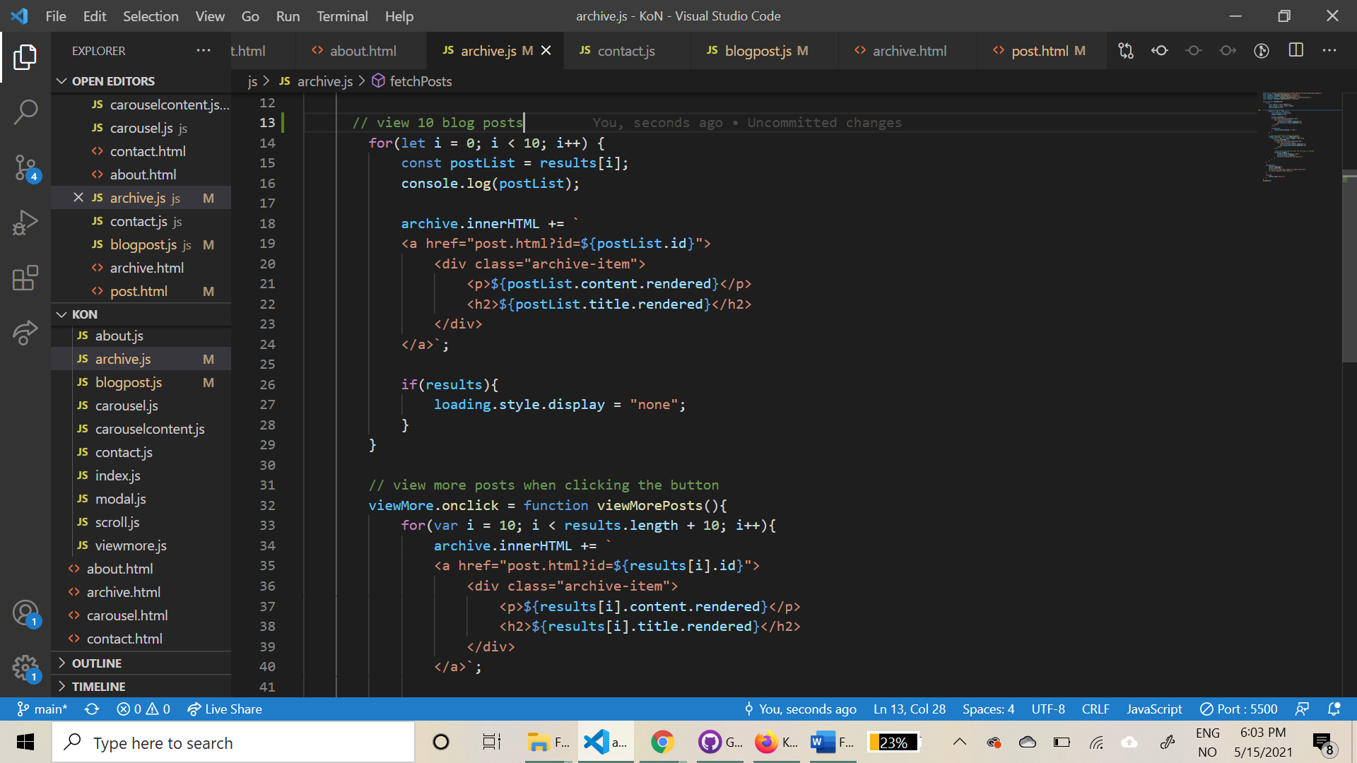

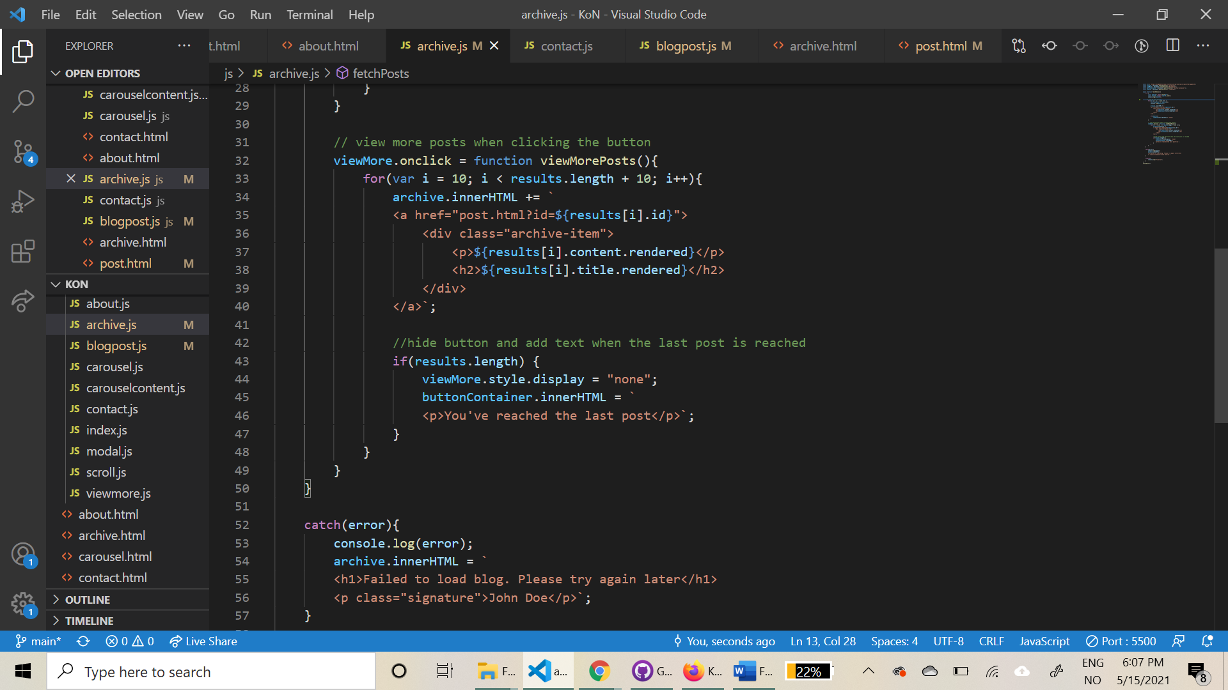

### **What would you do differently next time**

Prøvd å lage karusellen FØR jeg hentet innholdet fra Apiet. Kanskje enklere?

## WCAG guidelines, content management and SEO

### **What went well on the project**

Fargevalg, adobe color har en egen accessibility check. Visste med en gang at fargene var lette å skille før jeg I det hele tatt hadde startet å lage selve siden.

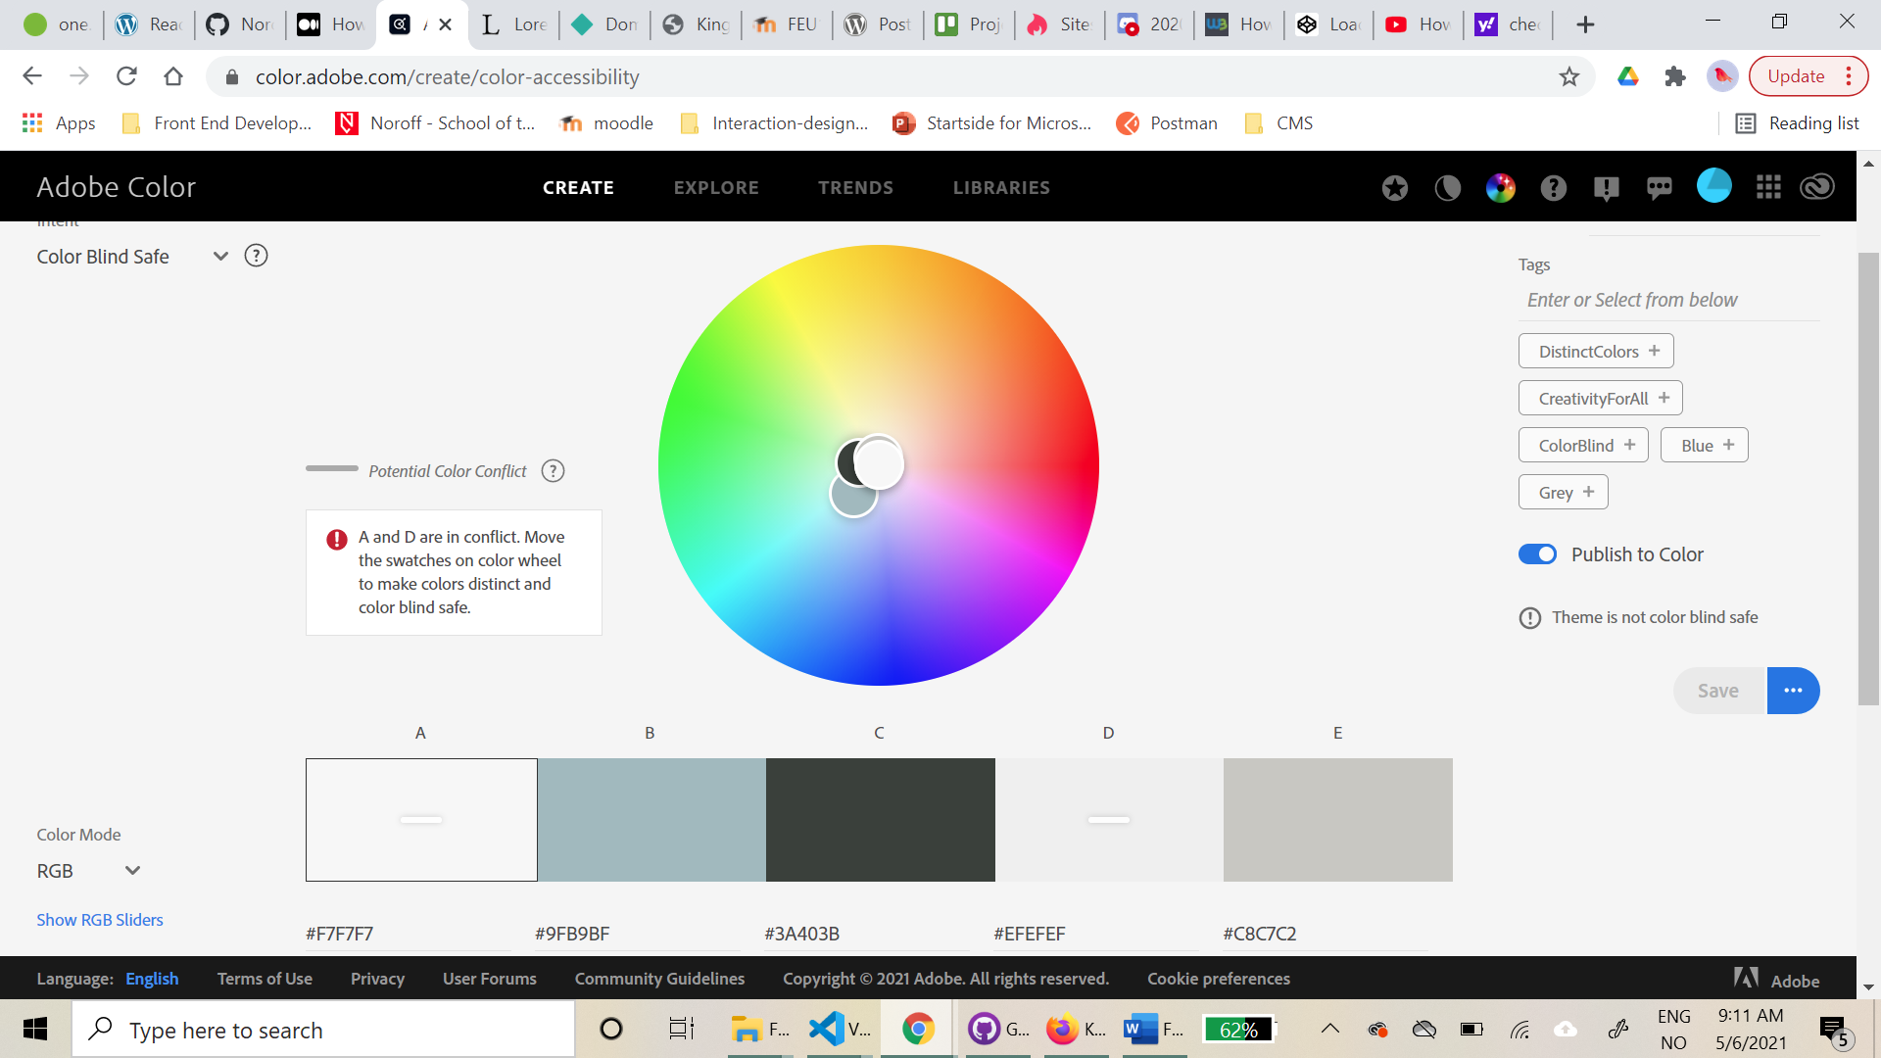

Den var kritisk til to av fargene(A og D), siden de er relativt like, men jeg kommer ikke til å bruke de to fargene til noe som er avgjørende for at brukeren skal klare å lese/se innholdet, så jeg ønsket å se hvordan fargene fungerer på siden som en helhet, og ta en sikkerhetssjekk når designet er satt. Da siden var “up and running” tok jeg en sikkerhetssjekk på <https://www.toptal.com/designers/colorfilter>, og det så bra ut, for alle typer fargeblindhet.

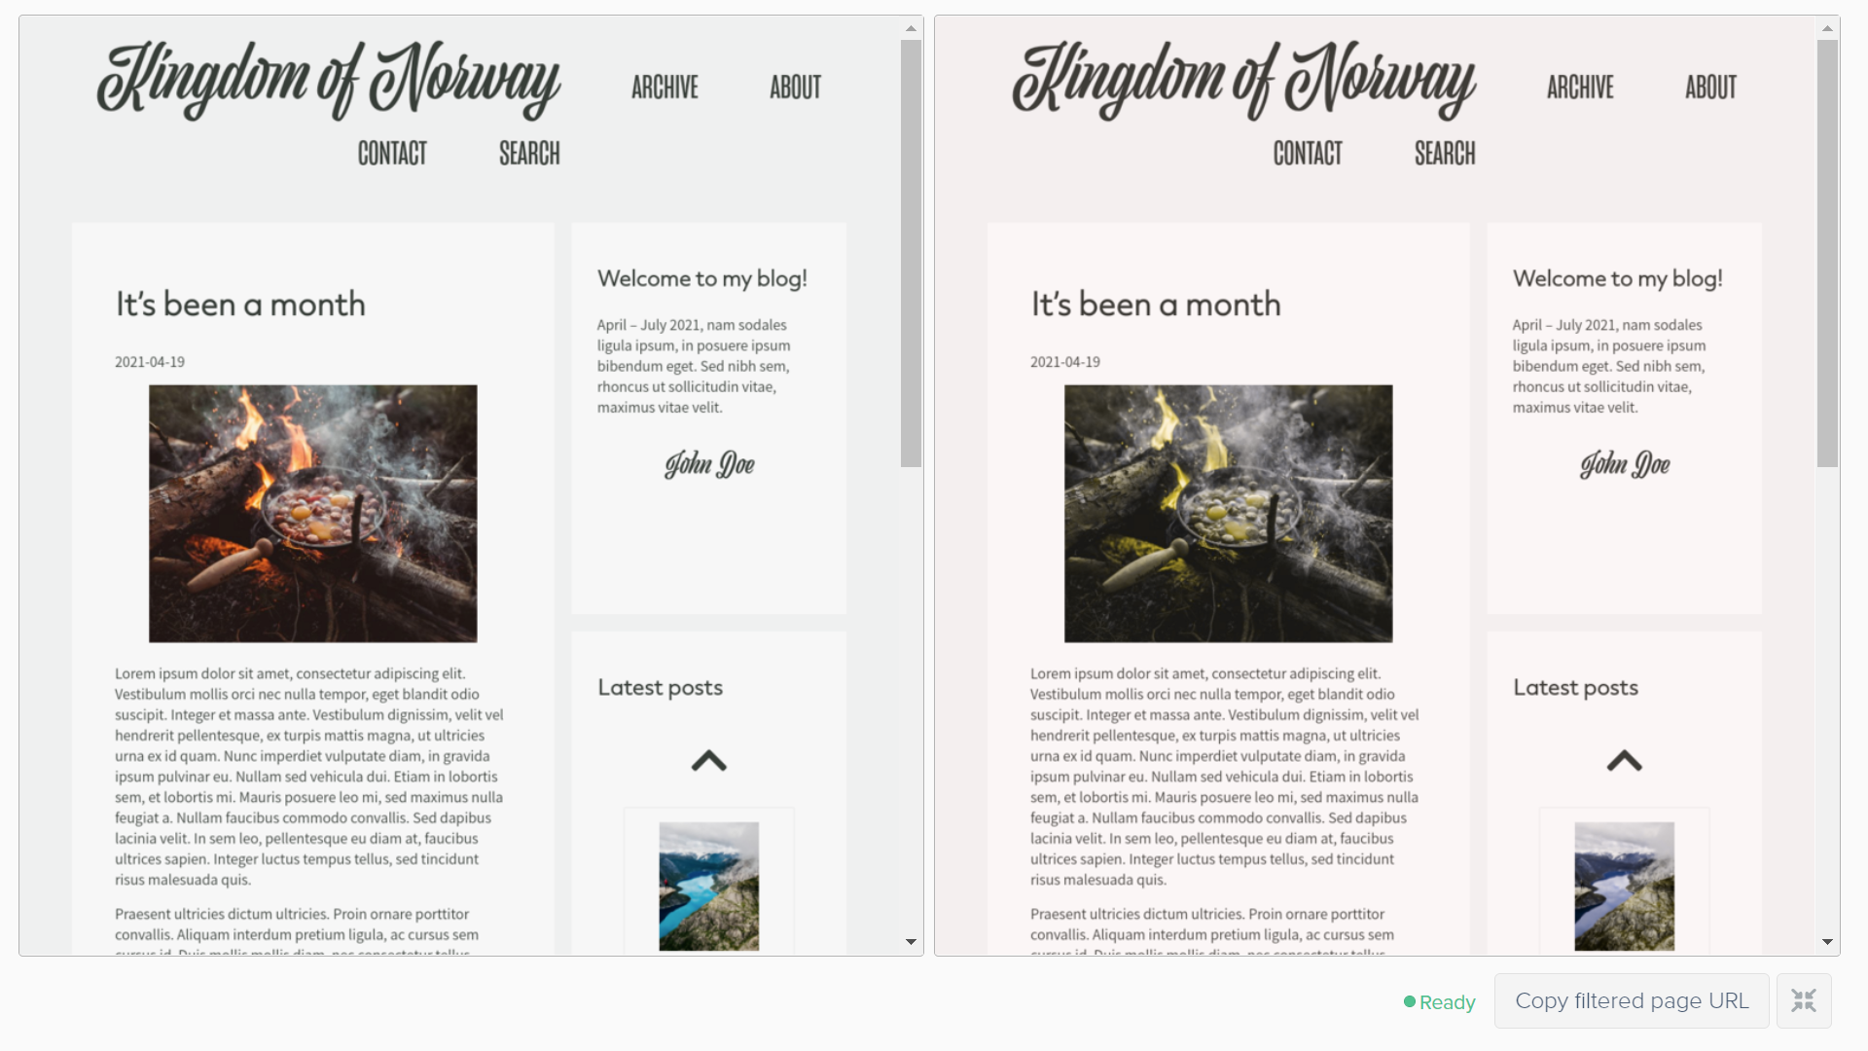

### **What was difficult/didn’t go well on the project**

Alt text on images.

### **What would you do differently next time**

## References

(place references to websites, books, forums etc. that helped you in the project)

* <https://medium.com/@marcusmichaels/how-to-build-a-carousel-from-scratch-in-vanilla-js-9a096d3b98c9>

Jon Duckett, JavaScript and jQuery – interactive front-end web development, p. 129

<https://developer.wordpress.org/rest-api/reference/posts/#arguments>

<https://wordpress.org/support/topic/rest-api-only-returns-10-posts-2/>

<https://www.w3schools.com/howto/howto_js_slideshow.asp>

<https://dalenguyen.medium.com/how-to-get-featured-image-from-wordpress-rest-api-5e023b9896c6>

[https://www.w3schools.com/css/css3_images.asp /](https://www.w3schools.com/css/css3_images.asp%20/) image modal (advanced)

<https://www.w3docs.com/snippets/html/how-to-add-an-image-in-the-title-bar.html>