Homework 5, STAT 613

Norris Jaber

3/5/2021

library(tidyverse)

## -- Attaching packages --------------------------------------- tidyverse 1.3.0 --

## v ggplot2 3.3.3 v purrr 0.3.4  
## v tibble 3.0.5 v dplyr 1.0.3  
## v tidyr 1.1.2 v stringr 1.4.0  
## v readr 1.4.0 v forcats 0.5.0

## -- Conflicts ------------------------------------------ tidyverse_conflicts() --  
## x dplyr::filter() masks stats::filter()  
## x dplyr::lag() masks stats::lag()

library(broom)  
Stockreturns <- c(-8.36, 1.63, -2.27, -2.93, -2.70,   
 -2.93, -9.14, -2.64, 6.82, -2.35,   
 -3.58, 6.13, 7.00, -15.25, -8.66,  
 -1.03, -9.16, -1.25, -1.22, -10.27,  
 -5.11, -0.80, -1.44, 1.28, -0.65,  
 4.34, 12.22, -7.21, -0.09, 7.34,   
 5.04, -7.24, -2.14, -1.01, -1.41,   
 12.03, -2.53, 4.33, 1.35)  
Stockreturns

## [1] -8.36 1.63 -2.27 -2.93 -2.70 -2.93 -9.14 -2.64 6.82 -2.35  
## [11] -3.58 6.13 7.00 -15.25 -8.66 -1.03 -9.16 -1.25 -1.22 -10.27  
## [21] -5.11 -0.80 -1.44 1.28 -0.65 4.34 12.22 -7.21 -0.09 7.34  
## [31] 5.04 -7.24 -2.14 -1.01 -1.41 12.03 -2.53 4.33 1.35

mean(Stockreturns) -> M  
M

## [1] -1.124615

sd(Stockreturns)-> S  
S

## [1] 5.977673

pnorm(q = -1.5, mean = M, sd = S)

## [1] 0.4749638

47.5% of returns are less than -1.5.

1 - qnorm(p = 0.75, mean = M, sd = S)

## [1] -1.907264

70% of the returns are above -1.91.

quantile(Stockreturns, prob=.25)

## 25%   
## -3.255

summary(Stockreturns)

## Min. 1st Qu. Median Mean 3rd Qu. Max.   
## -15.250 -3.255 -1.410 -1.125 1.490 12.220

1st Quartile of the data is -3.255.

boxplot(Stockreturns)

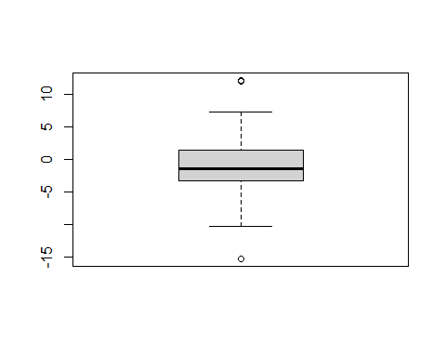

qqnorm(Stockreturns)  
qqline(Stockreturns)

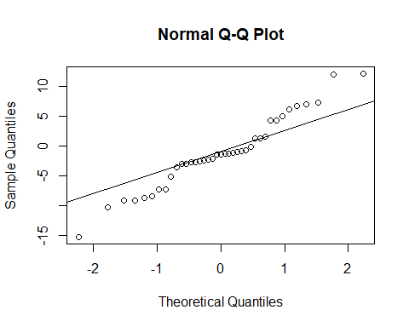 The data appears fairly normaly from the boxplot. There does appear to be two outlier on the boxplot, however most the data looks well spread. It is unknown if these outliers are influential. From the normal qq plot, we can see a fairly normal distribution. There does appear to to be two tails, on the right and left sides respectfully however it does not appear to deviate too much.

1. H(0): Average return rate is equal to 0.95. H(A): Average return rate is less than 0.95.

t.test(Stockreturns ,mu=0.95, alternative = "less", conf.level = .95)

##   
## One Sample t-test  
##   
## data: Stockreturns  
## t = -2.1674, df = 38, p-value = 0.01827  
## alternative hypothesis: true mean is less than 0.95  
## 95 percent confidence interval:  
## -Inf 0.4891698  
## sample estimates:  
## mean of x   
## -1.124615

At a low p-value of 0.01827 with an alpha level at 0.05 the null hypothesis should be rejected.

1. The broker does perform worse than average. From the p-value alone we can see that the return rate by the broker was less than 0.95 by the rejection of the null hypothesis. Also from the 95% confidence interval, we see that the true mean of the broker’s return rates are 0.4891 or less. From this we can see that the broker did perform worse.