1. **List the instances of the class Actor**

SELECT ?name ?age ?gender ?nationality

WHERE {

?name rdf:type ns:person.

?name ns:age ?age.

?name ns:gender ?gender.

optional{?name ns:nationality ?nationality.}

}

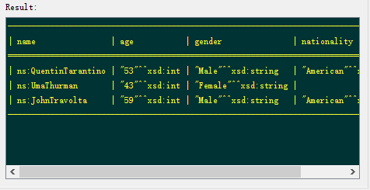

1. **List the name of all Thriller movies. For each one, display its director.**

SELECT DISTINCT ?movie ?director

WHERE {

?movie ns:genre "Thriller".

?director ns:isDirector ?person.

}

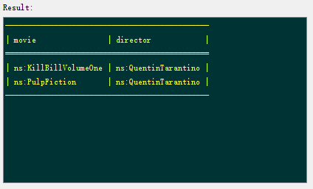

1. **List the name of all Crime Thriller movies.**

SELECT ?movie

WHERE {

?movie ns:genre "Thriller".

?movie ns:genre "Crime"

}

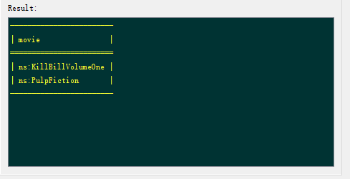

1. **List the name of Actors older than 51 years**

SELECT ?name ?age

WHERE {

?name ns:isActor ?actor.

?name ns:age ?age.

filter(?age>51)

}

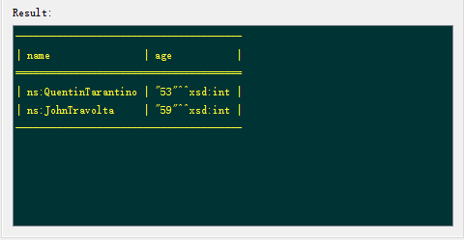

1. **A query that contains at least 2 Optional Graph Patterns**

SELECT DISTINCT ?name ?direct ?write

WHERE {

?name rdf:type ns:person.

optional{?name ns:isDirector ?direct.}

optional{?name ns:isWriter ?write.}

}

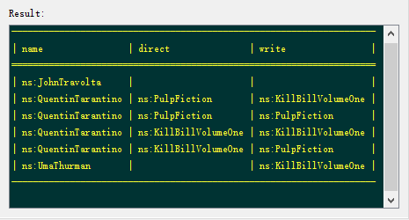

1. **A query that contains at least 2 alternatives and conjunctions**

SELECT ?x ?y ?a ?b

WHERE {

{?x ns:isActor ns:PulpFiction}UNION{?y ns:isActor ns:KillBillVolumeOne}

{?a ns:isDirector ns:PulpFiction}UNION{?b ns:isDirector ns:KillBillVolumeOne}

}

