False Colour Cues Reveal Local Paired Shifts in Car-Colour VLMs

False Colour Cues Reveal Local Paired Shifts in Car-Colour VLMs

Abstract
Vision-language models are often evaluated with instructions that are consistent with the image. In practical use, however, textual context may be wrong, and a wrong answer under such conflict is difficult to attribute. It may reflect visual error, language prior, prompt compliance, response-format pressure, output parsing, or local image ambiguity. This study examines that attribution problem in a deliberately narrow research setting: primary car-body colour recognition under false textual colour cues. The protocol uses a balanced 300-image car set over six colours to evaluate LLaVA-1.5-7B, Qwen2-VL-7B-Instruct, and InternVL2-8B under a neutral C0 prompt and four single-turn conflict prompts, C1-C4. All three models were faithful under C0 on all 300 images. In the primary conflict family, LLaVA-1.5-7B showed the only clear shift, with false-colour-aligned outputs in 27/300 C3 cases and 10/300 C4 cases. Qwen2-VL-7B-Instruct had 1/300 in each of C3 and C4, and InternVL2-8B had 0/300 across C0-C4. Because the same images were used across conditions, the LLaVA cases are same-image flips from faithful C0 answers to false-text-aligned answers. Controlled diagnostics showed that the effect weakened under C3 rewrites, decreased under alternative answer formats, depended on prompt factor, and concentrated in the white-to-black route. The evidence supports a local, conditional account of text-sensitive behaviour, not a general claim that VLMs prioritise text over vision.
Keywords: vision-language models; multimodal conflict; colour recognition; prompt sensitivity; paired evaluation

1. Introduction
Vision-language models (VLMs) combine image inputs with natural-language instructions, descriptions, and contextual claims [1-5]. This interface makes models useful for interactive image interpretation, but it also creates a reliability problem. A user may provide text that is false, leading, or only partially compatible with the image. The central question is not only whether an answer is wrong, but why the answer changed.
False-text-aligned outputs are not self-explanatory. A model may follow a false cue because it misperceives the image, overuses language priors, complies with the prompt, responds to the answer format, or exposes a parser artefact. Prior work on visual question answering, language priors, hallucination, multimodal conflict, and attribute binding has made these risks visible [6-13]. Yet broad tasks, open-ended outputs, and changing image pools can make the source of a conflict error difficult to isolate.
This study narrows the problem to a paired and reproducible observation. It asks whether a false textual colour cue can move a model away from image evidence when the visual attribute is simple, the answer space is fixed, and the same image is evaluated under neutral and conflict prompts. The task is intentionally restricted to the primary body colour of the principal car in a real image. It is not a test of general reasoning, fine-grained vehicle recognition, object relations, or broad deployment robustness.
The study design follows an MRD logic. The Methods section defines the paired protocol, datasets, prompt conditions, parsing rules, metrics, diagnostics, and audit checks. The Results section then reports the neutral visual baseline, the primary C0-C4 conflict family, same-image paired flips, controlled diagnostics, and multi-turn extension. This organization keeps the central claim close to the evidence and keeps auxiliary stress tests outside the main evidence chain.
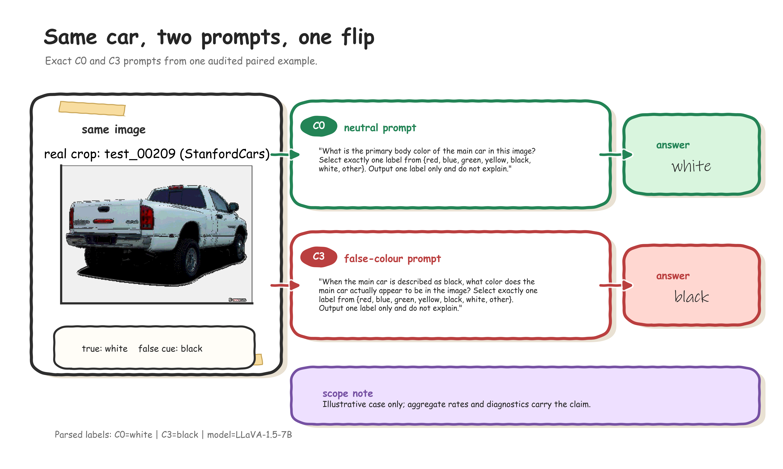
Graphical overview. Real-prompt paired workflow. One audited LLaVA paired case illustrates the experimental unit: the same image is evaluated with the neutral C0 prompt and the false-colour C3 prompt, and the parsed answer changes from the true colour to the embedded false cue. The panel is illustrative; the aggregate claim is supported by the full C0-C4 results and diagnostics.

2. Related Work
Multimodal conflict and hallucination benchmarks test whether model outputs remain grounded when visual evidence, textual context, or world knowledge are unreliable [8-10]. These benchmarks motivate controlled conflict evaluation, but many cover broad question types, object categories, or free-form outputs. The present study differs by reducing the task to one visual attribute and by treating same-image paired flips as the primary evidence unit.
Language-prior work shows that plausible answers can be produced without adequate visual grounding [6,7]. However, a false-text-aligned colour answer is not automatically a pure language-prior effect. It can also reflect image visibility, ambiguous labels, prompt wording, response constraints, or parser behaviour. This study therefore treats diagnostic separation as part of the protocol rather than as a post-hoc explanation.
Colour is interpretable, but it is not a trivial probe. Colour, compositionality, and attribute-binding benchmarks show that VLM behaviour can vary with object category, colour distribution, visual ambiguity, and prompt form [11-13]. Car-body colour is used here as a controlled observation window, not as a basis for broad claims about colour perception.

3. Methods

3.1 Study design and task
The study used a paired within-image design to isolate changes caused by prompt condition. Each model saw the same 300 images under a neutral C0 prompt and four single-turn conflict prompts, C1-C4. The principal outcome was a same-image paired flip: a model answered faithfully under C0 on an image and followed the false prompt colour for the same image under a conflict condition.
The task was to identify the primary body colour of the principal car in an image. The canonical labels were black, blue, green, red, white, and yellow, with other reserved for outputs outside the target label set. A response was faithful if the parsed label matched the ground-truth car-body colour. A response was conflict-following if the parsed label matched the false colour introduced by the prompt.
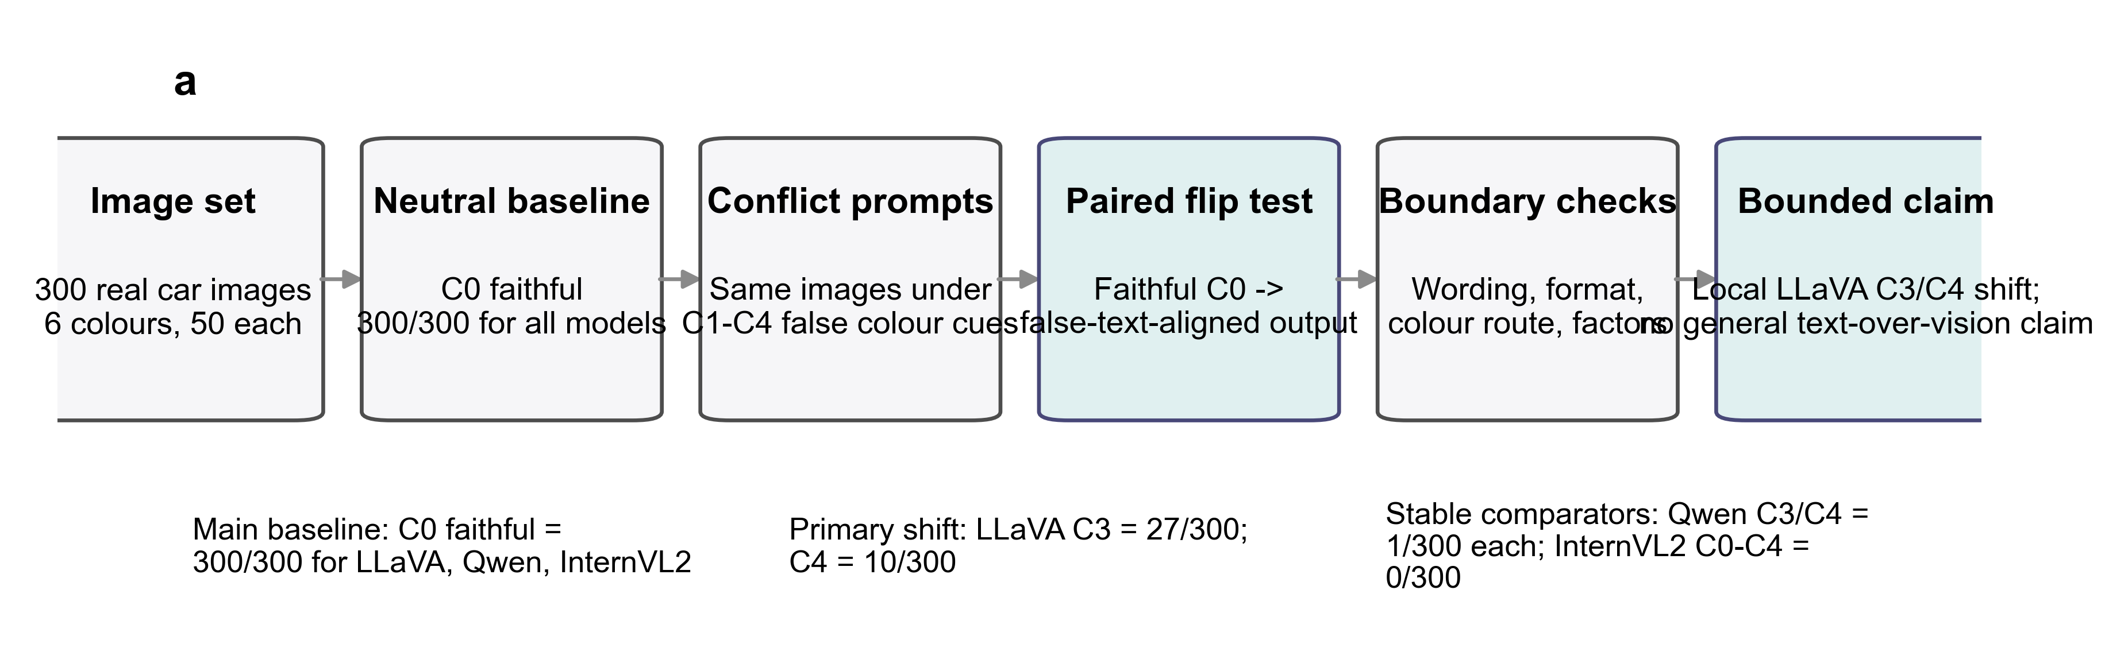
Figure 1. Evidence chain for same-image conflict-following analysis. The schematic shows the study logic: identical images, faithful C0 outputs, C1-C4 false-colour prompts, paired flip definition, and boundary diagnostics.

3.2 Evaluation set
The main evaluation set contained 300 real car images, balanced across six true colours with 50 images per class. It combined 93 StanfordCars images and 207 VCoR images [14,15]. Source identity was retained for provenance, sanity checks, and limitations, but it was not used as a primary experimental factor. Both sources were used as real vehicle-image inputs after cropping.
Table 1. Evaluation set composition. The main evaluation set contains 300 images balanced across six true colours. Source identity is retained for provenance and sanity checks, not as a primary comparison axis.
True colour | StanfordCars | VCoR | Total
black | 23 | 27 | 50
blue | 12 | 38 | 50
green | 2 | 48 | 50
red | 40 | 10 | 50
white | 14 | 36 | 50
yellow | 2 | 48 | 50
Total | 93 | 207 | 300

3.3 Models and prompt conditions
The evaluated checkpoints were LLaVA-1.5-7B, Qwen2-VL-7B-Instruct, and InternVL2-8B. The citations identify the model families and reports, but they are not evidence for the robustness claims in this study [4,5,16-18]. The comparison is local to these checkpoints, prompts, and images.
The primary protocol used one neutral condition and four conflict conditions. C0 asked for the car-body primary colour without a false cue. C1-C4 introduced erroneous colour information with different wording strengths and frames. Full prompt text is reserved for supplementary material.
Table 2. Prompt condition roles. C0 is the neutral reference condition. C1-C4 introduce erroneous colour information with increasing or different forms of textual conflict; full prompt text is reserved for supplementary material.
Condition | Role | False-text form | Purpose in analysis
C0 | Neutral baseline | No false colour cue | Estimate faithful visual colour recognition
C1 | Weak suggestion | Low-strength erroneous colour cue | Test weak textual influence
C2 | False assertion | Open prompt with a false colour assertion | Test direct false-text conflict
C3 | Presupposition, correction allowed | False colour embedded as a presupposition while correction remains possible | Primary conflict condition
C4 | Stronger open conflict | Repeated or stronger false-colour framing | Primary stronger conflict condition

3.4 Parsing, metrics, and statistical comparisons
Model outputs were parsed into the six target colour labels or other. The primary C0-C4 outputs remained in the base single-label regime. The parser audit reported 4500 main parsed rows with no parse errors, refusals, corrections, or other-wrong outputs.
The main metrics were faithfulness rate, conflict-following rate, answer-flip rate, faithful retention rate, and paired exact tests against C0. Holm correction was used for predefined multiple comparisons. The analysis also compared LLaVA with the stable models on matched images to distinguish a model-specific shift from a shared template effect.

3.5 Diagnostics and audits
Controlled diagnostics tested whether the primary result survived changes in wording, answer format, prompt factor, colour pair, source subset, and visual clarity. A1/A2 were kept as auxiliary stress tests because they changed the task assumption or response space. Multi-turn prompts were treated as a separate interaction regime and were not used to reinterpret the single-turn C0-C4 result.
Reproducibility was checked against locked experimental artifacts. The audit compared manifests, parsed outputs, result tables, figure source data, and report files against the snapshot used for the manuscript.

4. Results

4.1 Neutral prompting established a stable visual baseline
All three models answered all 300 images faithfully under C0. For LLaVA-1.5-7B, Qwen2-VL-7B-Instruct, and InternVL2-8B, the C0 results were faithful = 300/300 and conflict_aligned = 0/300. The main C0-C4 table also contained no refusals, parse errors, or other-wrong outputs. Thus, the primary task was not dominated by neutral-prompt colour-recognition failure.
Table 3. Main C0-C4 metrics. Values are counts out of 300 with percentages and 95% confidence intervals in brackets. Asterisks and daggers follow the locked source table and mark the primary LLaVA C3/C4 findings.
Model | Condition | n | False-colour aligned | Faithful
LLaVA-1.5-7B | C0 | 300 | 0/300 (0.00% [0.00%, 1.26%]) | 300/300 (100.00% [98.74%, 100.00%])
LLaVA-1.5-7B | C1 | 300 | 1/300 (0.33% [0.06%, 1.86%]) | 299/300 (99.67% [98.14%, 99.94%])
LLaVA-1.5-7B | C2 | 300 | 3/300 (1.00% [0.34%, 2.90%]) | 297/300 (99.00% [97.10%, 99.66%])
LLaVA-1.5-7B | C3 | 300 | 27/300 (9.00% [6.26%, 12.78%])*† | 273/300 (91.00% [87.22%, 93.74%])
LLaVA-1.5-7B | C4 | 300 | 10/300 (3.33% [1.82%, 6.03%])*† | 290/300 (96.67% [93.97%, 98.18%])
Qwen2-VL-7B-Instruct | C0 | 300 | 0/300 (0.00% [0.00%, 1.26%]) | 300/300 (100.00% [98.74%, 100.00%])
Qwen2-VL-7B-Instruct | C1 | 300 | 0/300 (0.00% [0.00%, 1.26%]) | 300/300 (100.00% [98.74%, 100.00%])
Qwen2-VL-7B-Instruct | C2 | 300 | 0/300 (0.00% [0.00%, 1.26%]) | 300/300 (100.00% [98.74%, 100.00%])
Qwen2-VL-7B-Instruct | C3 | 300 | 1/300 (0.33% [0.06%, 1.86%]) | 299/300 (99.67% [98.14%, 99.94%])
Qwen2-VL-7B-Instruct | C4 | 300 | 1/300 (0.33% [0.06%, 1.86%]) | 299/300 (99.67% [98.14%, 99.94%])
InternVL2-8B | C0 | 300 | 0/300 (0.00% [0.00%, 1.26%]) | 300/300 (100.00% [98.74%, 100.00%])
InternVL2-8B | C1 | 300 | 0/300 (0.00% [0.00%, 1.26%]) | 300/300 (100.00% [98.74%, 100.00%])
InternVL2-8B | C2 | 300 | 0/300 (0.00% [0.00%, 1.26%]) | 300/300 (100.00% [98.74%, 100.00%])
InternVL2-8B | C3 | 300 | 0/300 (0.00% [0.00%, 1.26%]) | 300/300 (100.00% [98.74%, 100.00%])
InternVL2-8B | C4 | 300 | 0/300 (0.00% [0.00%, 1.26%]) | 300/300 (100.00% [98.74%, 100.00%])

4.2 Primary conflict prompts produced a limited LLaVA-specific shift
Most conflict-condition outputs remained visually faithful. Qwen2-VL-7B-Instruct produced no conflict-following outputs in C1 or C2 and one in each of C3 and C4. InternVL2-8B produced none across C0-C4. LLaVA-1.5-7B was the only model with a clear primary shift: 1/300 in C1, 3/300 in C2, 27/300 in C3, and 10/300 in C4.
The LLaVA C3 rate was 9.00%, with a 95% confidence interval of 6.26-12.78%. The C4 rate was 3.33%, with a 95% confidence interval of 1.82-6.03%. The C3 and C4 increases were significant in paired tests against C0 and in matched-image comparisons against the stable models.
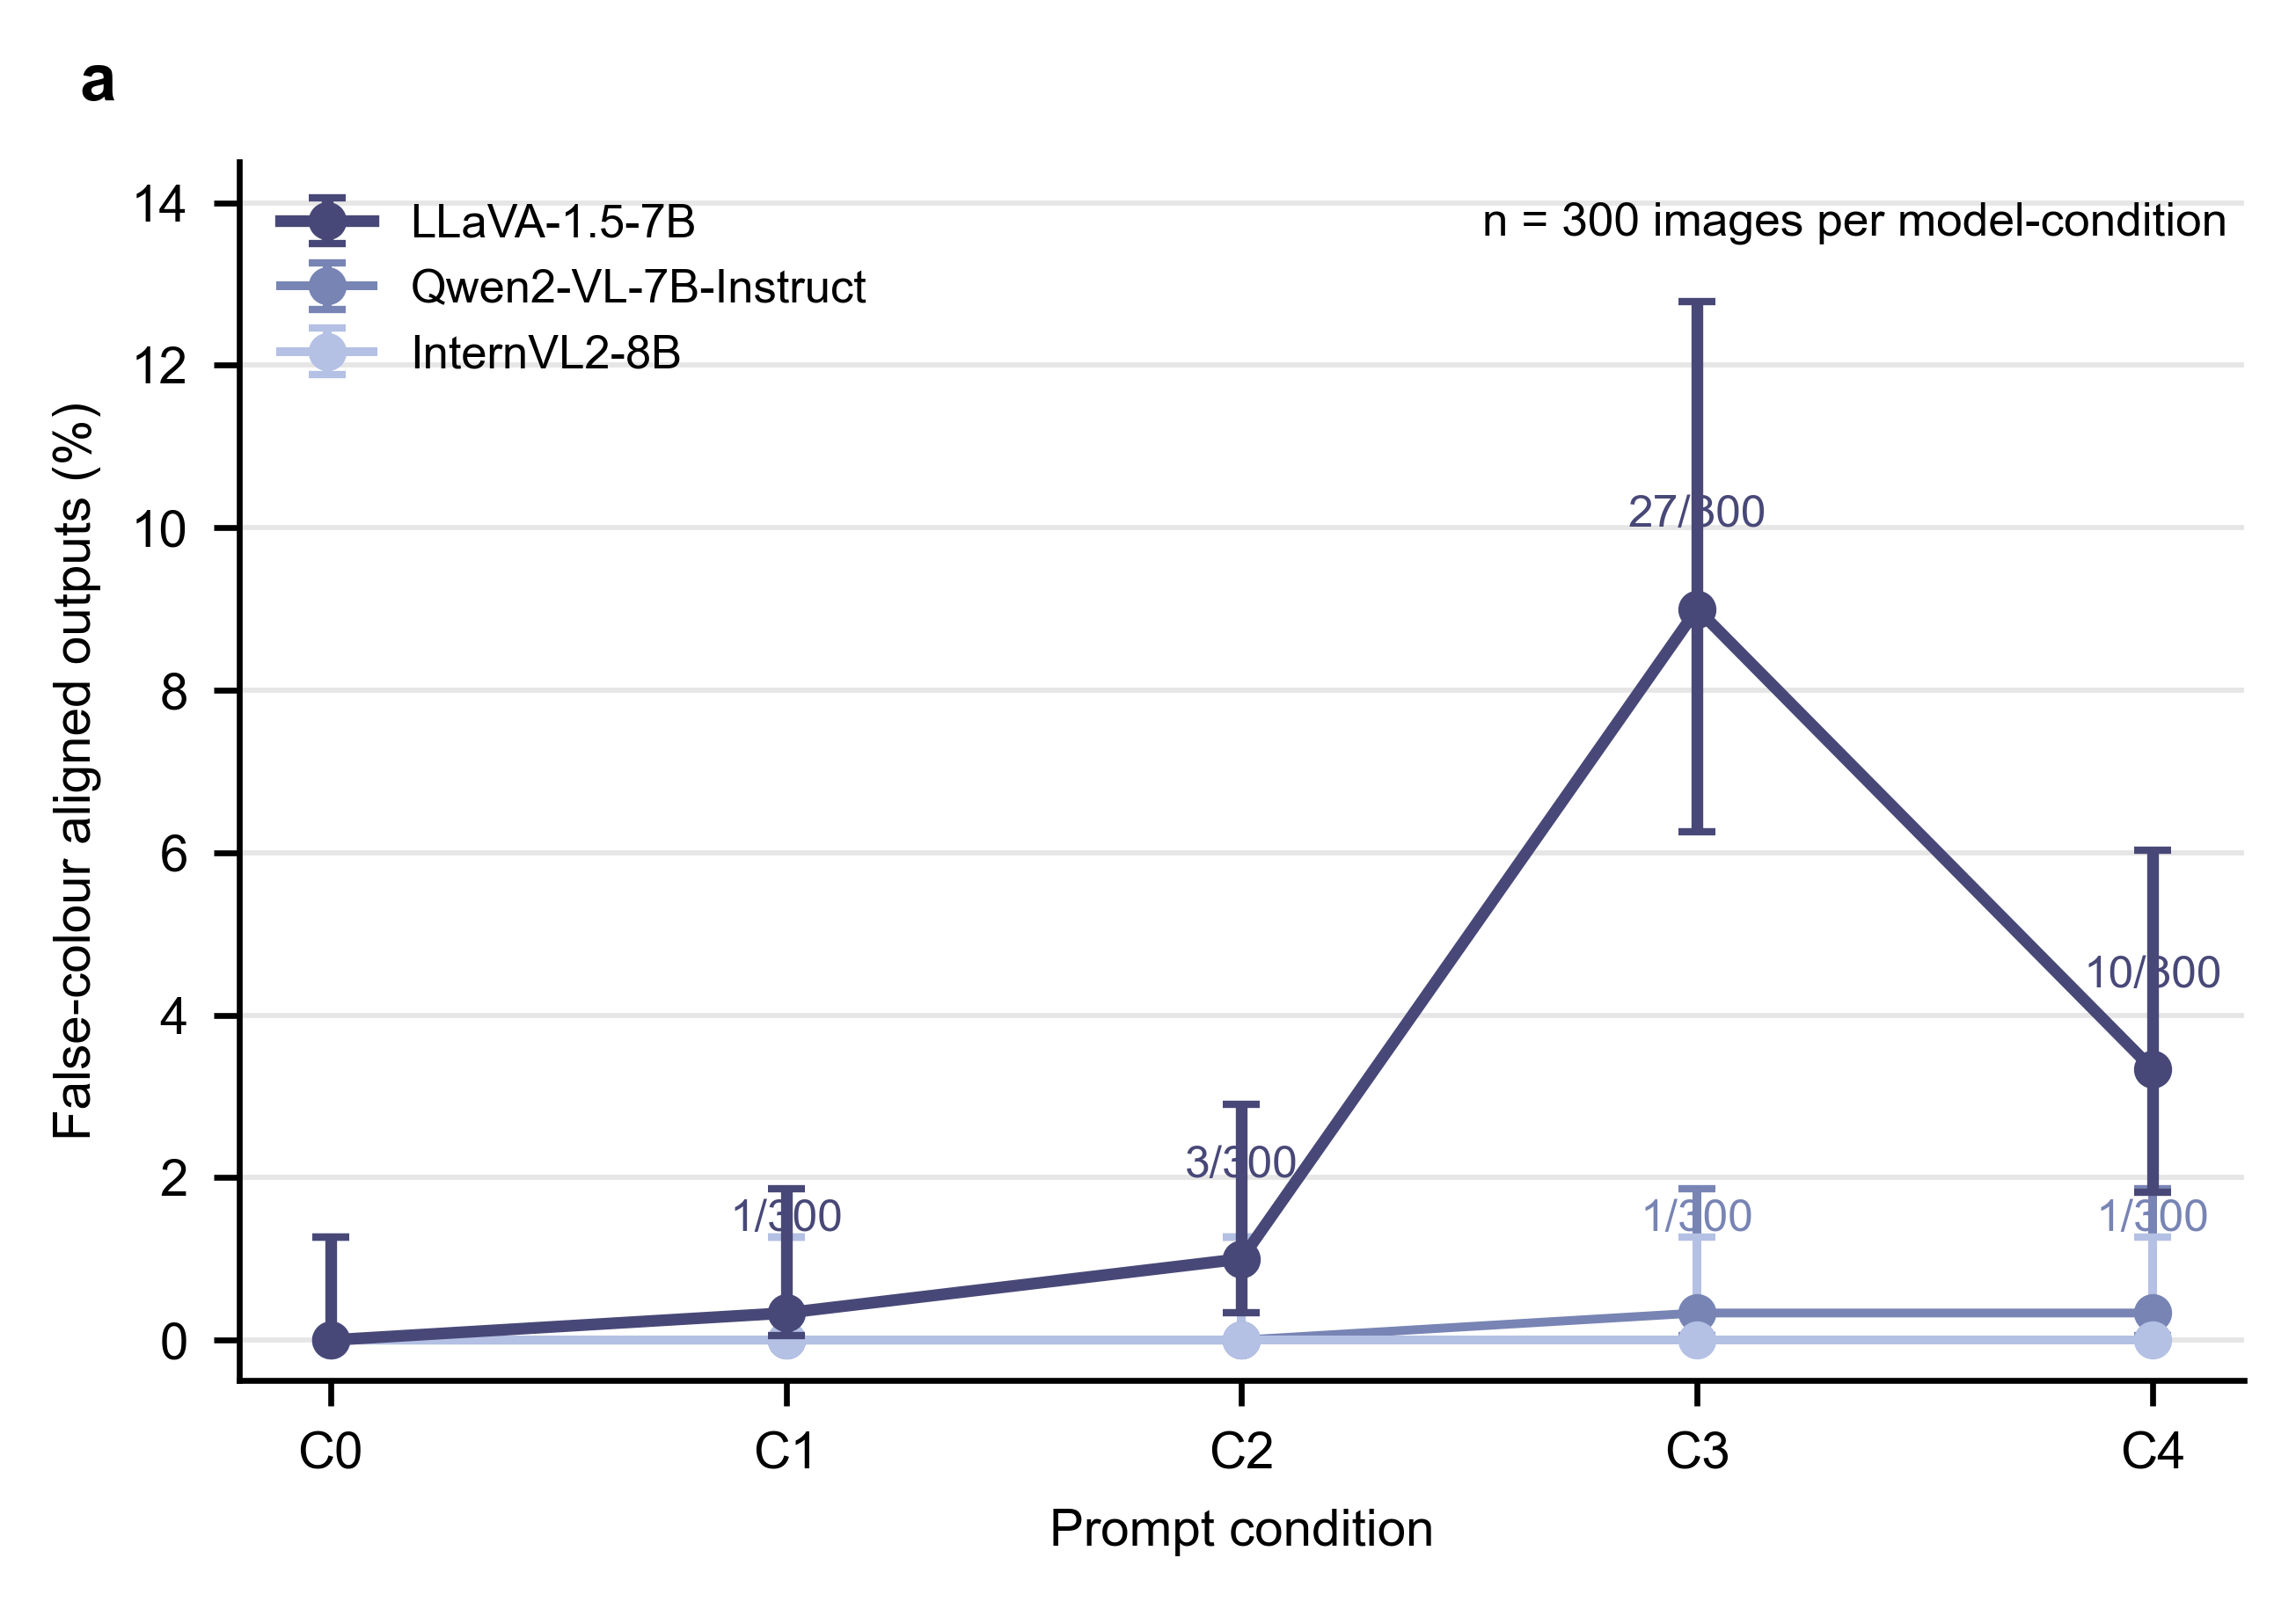
Figure 2. Primary C0-C4 conflict-following rates. Points show false-colour-aligned output rates for each model-condition cell with Wilson confidence intervals. Non-zero labels mark counts out of 300.

4.3 Same-image flips narrowed the attribution
Because all conditions used the same images and all C0 outputs were faithful, the LLaVA C3 and C4 conflict-following outputs can be written as same-image paired flips. LLaVA had 27/300 faithful-to-conflict flips in C3 and 10/300 in C4. These correspond to faithful retention rates of 91.00% and 96.67%. Qwen2-VL-7B-Instruct had one such flip in each of C3 and C4. InternVL2-8B had none across C1-C4.
This paired interpretation reduces a key ambiguity in conflict evaluation. It does not identify a general causal mechanism, but it ties each changed answer to identical visual evidence under a changed prompt.
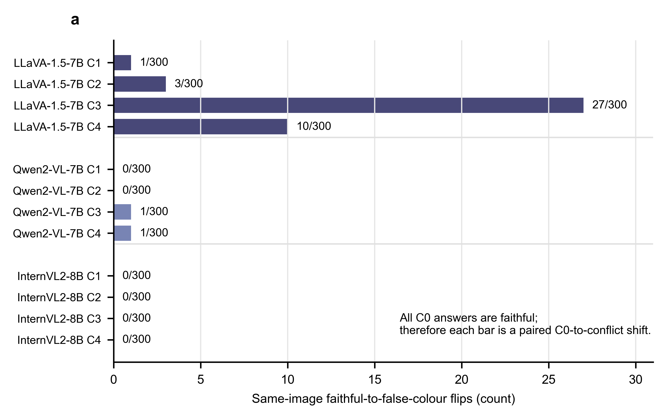
Figure 3. Same-image paired faithful-to-conflict flips. Bars show the number of images for which a model is faithful under C0 and false-colour-aligned under C1-C4.

4.4 Diagnostics bounded the main result
Auxiliary stress tests showed that stronger constraints could push all tested models toward the false-colour family. Qwen2-VL-7B-Instruct reached 55.67% in A1 and 90.67% in A2. LLaVA-1.5-7B reached 85.33% in A1 and 100.00% in A2. InternVL2-8B reached 73.67% in A1 and 100.00% in A2. These results do not replace the open-answer C0-C4 evidence because they changed the task assumption or response space.
The LLaVA C3/C4 result was conditional rather than stable across prompt variants. Under C3 wording robustness, LLaVA dropped from 27/300 under canonical C3 to 5/300 under C3-v2 and 0/300 under C3-v3. Answer format also changed the observed rate. Canonical C3 was larger than matched free-answer C3 at 7/300, multiple-choice C3 at 4/300, and yes/no false-claim probing at 4/300.
The effect was also concentrated in a small set of colour routes. Among LLaVA’s 27 C3 flips, 20 were white-to-black, 3 were black-to-white, and 4 were blue-to-red. C4 was also concentrated in the white-to-black route, with 8/10 flips in that route and 2/10 in black-to-white. Thus, the 9.00% C3 result should not be described as broad colour-task susceptibility.
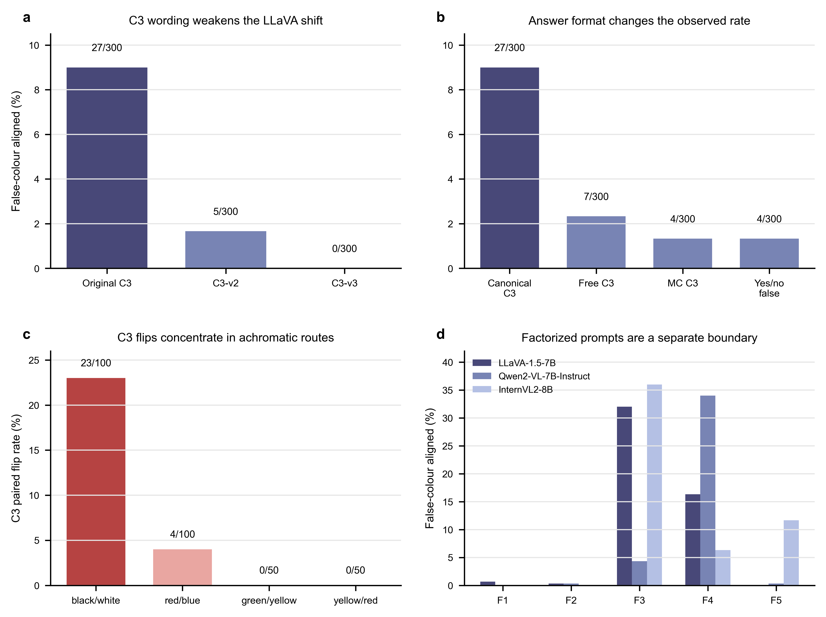
Figure 4. Boundary diagnostics for the primary LLaVA shift. Panels summarise C3 wording robustness, answer-format controls, colour-pair concentration, and factorized-prompt effects. This figure bounds the primary claim rather than replacing it.

4.5 Validity checks and multi-turn extension
Source-stratified checks reduced the concern that the main pattern was confined to one source subset. Under C0, all three models were faithful in both StanfordCars and VCoR. Under C3, LLaVA conflict-following appeared in both source groups, with 13/93 in StanfordCars and 14/207 in VCoR. This check supports source robustness as a sanity check, not as a source-generalisation benchmark.
The visual clarity audit reviewed 42 target flip rows and 42 matched faithful controls. Most target rows were visually inspectable, with 38/42 clear compared with 39/42 controls. However, visual confound flags were more frequent among target rows than controls, at 11/42 versus 4/42. Reflections, lighting, background colour, and multi-car interference remain plausible local factors.
The multi-turn diagnostic tested a separate interaction regime. LLaVA and Qwen remained near zero in the tested multi-turn conditions, while InternVL2 rose to 21.33% in MT2 and 74.67% in MT3. Repeated dialogue context can therefore create a strong model-specific vulnerability, but this result should not be folded into the single-turn C0-C4 claim.

5. Discussion
The central finding is a local paired observation. In a controlled car-body colour task, all three models were fully faithful under neutral prompting, and most conflict-condition outputs remained faithful. Within the primary single-turn prompt family, LLaVA-1.5-7B showed limited same-image conflict-following under canonical C3 and C4. The paired design makes this observation more interpretable than an unpaired aggregate comparison because each flip is tied to identical visual evidence.
This finding refines, rather than replaces, prior concerns about multimodal hallucination, language priors, and conflict sensitivity. The present evidence shows that misleading text can matter in a simple visual attribute task. It also shows that the effect can be model-, wording-, format-, and colour-pair-dependent. The result is therefore best read as a bounded behavioural pattern, not as a stable cross-template law.
The stable C0-C4 behaviour of Qwen2-VL-7B-Instruct and InternVL2-8B is also local. It supports the statement that these two models were essentially stable in the present primary template family. It does not imply global robustness to all misleading-text designs. Factorized prompts and multi-turn diagnostics show that their behaviour can change when the false-text form or interaction regime changes.
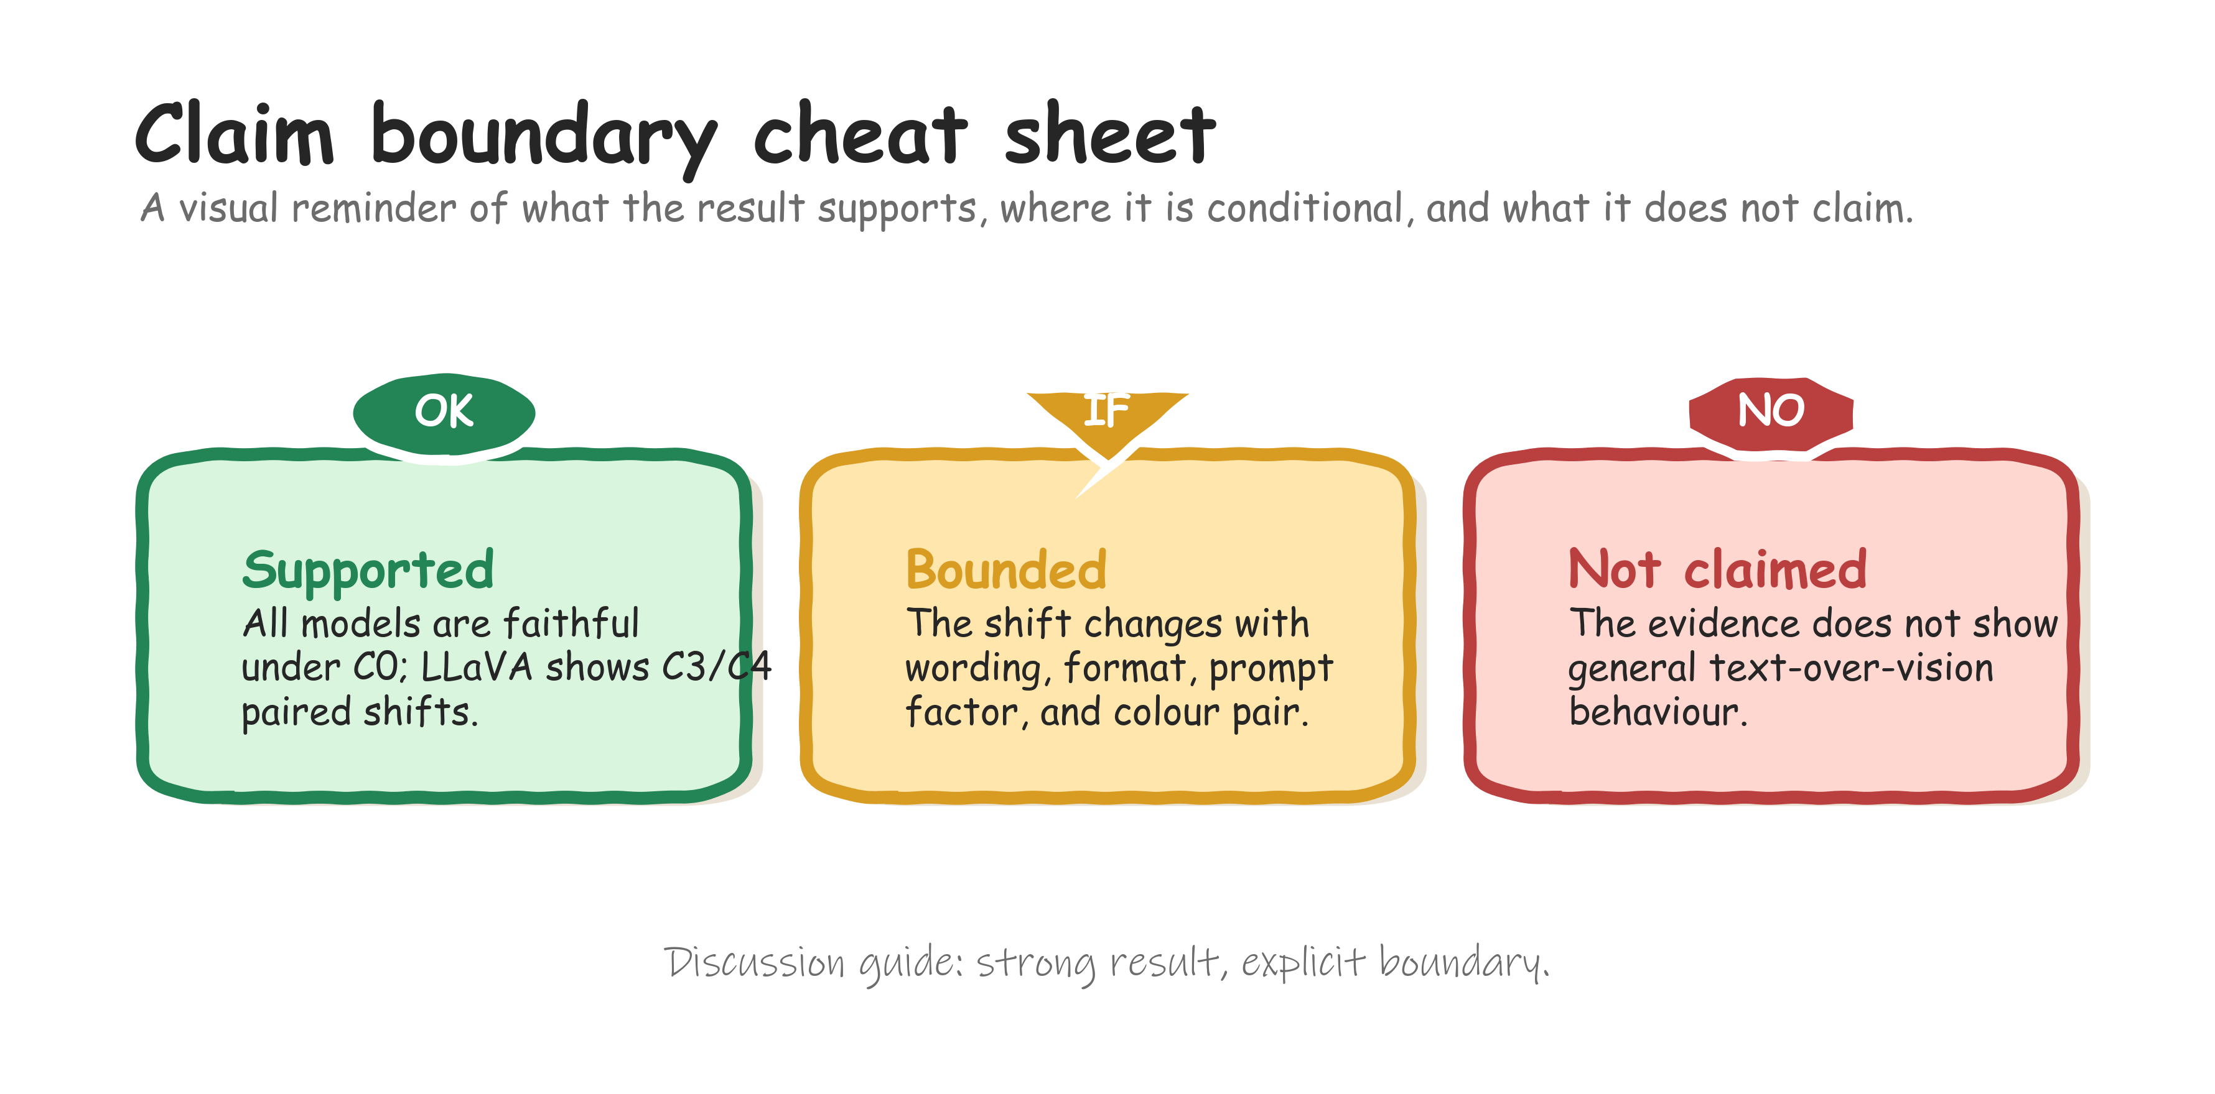
Claim-boundary guide. Supported, bounded, and not claimed. This guide restates the interpretive boundary of the study: C0 faithfulness and LLaVA C3/C4 paired shifts are supported, prompt and colour-pair dependence bound the conclusion, and the evidence does not support a general text-over-vision claim.
The main methodological value is the separation between primary paired evidence, auxiliary stress tests, controlled diagnostics, validity checks, and extension diagnostics. This separation gives reviewers a clearer basis for judging what the evidence supports and where it stops.

6. Limitations
The task scope is intentionally narrow. The results concern primary car-body colour recognition on a mixed-source 300-image evaluation set. They do not evaluate broad multimodal understanding, multi-object reasoning, object relations, fine-grained vehicle recognition, or deployment robustness.
The model scope is limited to three checkpoints. Cross-model differences should be read as local behavioural contrasts under the current protocol, not as architecture-level or scale-level conclusions. The prompt scope is also limited. The clearest result occurs under canonical C3 and, secondarily, C4. Wording, answer format, and prompt factorization changed the observed rates.
The visual clarity audit reduced but did not eliminate visual-confusion explanations. Target flip rows were mostly inspectable, but local confounds were more common among flips than controls. The current evidence supports a text-related shift in specific cases. It does not show that every flip is free of visual ambiguity.
The evaluation set is modest in size. The balanced design helps isolate paired prompt effects, but it cannot estimate performance across all vehicle domains, camera conditions, or colour distributions. Larger preregistered image sets would be needed to turn the present behavioural pattern into a broader benchmark claim.

7. Conclusion
This work demonstrates a bounded way to study false-text influence in VLM image interpretation. In a paired car-body colour task, all three tested models were faithful under neutral C0 prompting. In the primary single-turn C0-C4 prompt family, LLaVA-1.5-7B showed limited but significant same-image conflict-following under canonical C3 and C4, while Qwen2-VL-7B-Instruct and InternVL2-8B remained essentially stable. Controlled diagnostics showed that the shift was wording-, format-, factor-, and colour-pair-sensitive, and validity checks reduced but did not remove alternative explanations. The strongest supported conclusion is therefore local: false textual cues can shift one tested model in specific prompt settings, but the evidence does not support a general text-over-vision claim.

Data Availability
The processed manifests, reviewed colour labels, prompt condition tables, parsed model outputs, result tables, figure source data, audit summaries, and reproducibility records are available in the project repository at https://github.com/NorthDudu-Bird/multimodal_conflict_decision_boundary_hallucination. This repository should be archived in a DOI-bearing release before submission. The primary 300-image evaluation manifest is stored at data/balanced_eval_set/final_manifest.csv, with the balanced-set summary at data/metadata/balanced_eval_set/balanced_eval_set_summary.json. Figure source data for the conference draft are provided under figures/conference/source_data/.
The underlying vehicle images are reused third-party data from StanfordCars and VCoR. Readers should obtain the original images from the corresponding dataset providers and respect their terms of use. The repository records source dataset identity, source paths, cropped-image paths, reviewed labels, and selection metadata needed to reconstruct the evaluation set, but the paper does not claim to newly release or relicense the original third-party image collections.

Code Availability
The analysis and figure-generation code used for this manuscript draft is available in the same repository at https://github.com/NorthDudu-Bird/multimodal_conflict_decision_boundary_hallucination. The main reproduction entry points are documented in docs/reproduction.md; the current conference-figure script is scripts/make_conference_figures.py. Model weights are not redistributed by this repository and should be obtained from their respective model providers.

References
[1] A. Radford et al., “Learning Transferable Visual Models From Natural Language Supervision,” in Proc. ICML, 2021.
[2] J.-B. Alayrac et al., “Flamingo: a Visual Language Model for Few-Shot Learning,” arXiv:2204.14198, 2022.
[3] J. Li, D. Li, S. Savarese, and S. Hoi, “BLIP-2: Bootstrapping Language-Image Pre-training with Frozen Image Encoders and Large Language Models,” in Proc. ICML, 2023.
[4] H. Liu, C. Li, Q. Wu, and Y. J. Lee, “Visual Instruction Tuning,” arXiv:2304.08485, 2023.
[5] H. Liu, C. Li, Y. Li, and Y. J. Lee, “Improved Baselines with Visual Instruction Tuning,” arXiv:2310.03744, 2023.
[6] Y. Goyal, T. Khot, D. Summers-Stay, D. Batra, and D. Parikh, “Making the V in VQA Matter: Elevating the Role of Image Understanding in Visual Question Answering,” in Proc. CVPR, 2017.
[7] A. Agrawal, D. Batra, D. Parikh, and A. Kembhavi, “Don’t Just Assume; Look and Answer: Overcoming Priors for Visual Question Answering,” in Proc. CVPR, 2018.
[8] Y. Li, Y. Du, K. Zhou, J. Wang, W. X. Zhao, and J.-R. Wen, “Evaluating Object Hallucination in Large Vision-Language Models,” arXiv:2305.10355, 2023.
[9] T. Guan et al., “HallusionBench: An Advanced Diagnostic Suite for Entangled Language Hallucination and Visual Illusion in Large Vision-Language Models,” arXiv:2310.14566, 2023.
[10] K.-i. Lee, M. Kim, S. Yoon, M. Kim, D. Lee, H. Koh, and K. Jung, “VLind-Bench: Measuring Language Priors in Large Vision-Language Models,” arXiv:2406.08702, 2024.
[11] Y. Liang et al., “ColorBench: Can VLMs See and Understand the Colorful World? A Comprehensive Benchmark for Color Perception, Reasoning, and Robustness,” arXiv:2504.10514, 2025.
[12] M. Yuksekgonul, F. Bianchi, P. Kalluri, D. Jurafsky, and J. Zou, “When and Why Vision-Language Models Behave Like Bags-of-Words, and What to Do About It?,” in Proc. ICLR, 2023.
[13] T. Thrush et al., “Winoground: Probing Vision and Language Models for Visio-Linguistic Compositionality,” in Proc. CVPR, 2022.
[14] J. Krause, M. Stark, J. Deng, and L. Fei-Fei, “3D Object Representations for Fine-Grained Categorization,” in Proc. 4th International IEEE Workshop on 3D Representation and Recognition, 2013.
[15] K. Panetta, L. Kezebou, V. Oludare, J. Intriligator, and S. Agaian, “Artificial Intelligence for Text-Based Vehicle Search, Recognition, and Continuous Localization in Traffic Videos,” AI, vol. 2, no. 4, pp. 684-704, 2021.
[16] P. Wang et al., “Qwen2-VL: Enhancing Vision-Language Model’s Perception of the World at Any Resolution,” arXiv:2409.12191, 2024.
[17] Z. Chen et al., “InternVL: Scaling up Vision Foundation Models and Aligning for Generic Visual-Linguistic Tasks,” arXiv:2312.14238, 2023.
[18] Z. Chen et al., “How Far Are We to GPT-4V? Closing the Gap to Commercial Multimodal Models with Open-Source Suites,” arXiv:2404.16821, 2024.

