**Appendix A**

**(Recommendation Letter)**

**Appendix B**

**(Questionnaire and Pre Survey)**



Republic of the Philippines

Polytechnic University of the Philippines

Quezon City Branch

Don Fabian St. Commonwealth Ave., Quezon City

Dear Respondents,

We, the 3rd year BSIT students conducting a research study entitled: **The Development of Guidance and Counselling Management Information System**, in partial fulfilment of the subject Fundamental of Research.

This survey is a part of a thesis student project at the Polytechnic University of the Philippines, Quezon City Branch under the guidance of Prof. Demelyn E. Monzon. To ensure your anonymity, all of your answers are kept in utmost confidentiality. Your completed survey answers will be only be seen by the researchers and their adviser, regardless of the situation, no individual responses will be identified on any of the questionnaires.

We would like to know if having a guidance and counselling management information system will help and improve the guidance office transactions of Polytechnic University of the Philippines Quezon City Branch. Please take your time but try not to linger on any one question, your first response to the question is usually your true belief.

Please read each question carefully and indicate your response by selecting the most appropriate choice.

Thank You and God Bless.

**PART I. RESPONDENT’S PROFILE**

Research Title: “The Development of Guidance and Counselling Management Information System”

NAME (Optional) : _______________________________________________

COURSE & YEAR : _______________________________________________

Direction: Please check (/) your answer for the following questions below:

1. How often do you visit the Guidance Office?

[ ] Often [ ] Rarely [ ] Never

1. Have you recently visited the Guidance Office?

[ ] Yes [ ] No

**PART II. SURVEY QUESTIONS**

Direction: Please check (/) your answer below the question. The following number corresponds the following status. ***The status/rates will depend on the current process of the Guidance and Counselling Office***.

5 – Excellent 3 – Satisfactory 1 – Unsatisfactory

4 – Good 2 – Fair

|  |  |  |  |  |  |
| --- | --- | --- | --- | --- | --- |
| **EFFICIENCY** | 5 | 4 | 3 | 2 | 1 |
| Guidance and counselling services has enabled students to be well disciplined with improved academic performance |  |  |  |  |  |
| Through guidance and counselling comprehensive advice on career / courses is given to students |  |  |  |  |  |
| The guidance and counselling service has facilities that are adequate for services |  |  |  |  |  |
| Through guidance and counselling services, the problem of the students within the school is well managed. |  |  |  |  |  |
| The guidance and counselling is able to provide classroom guidance frequently enough to meet the needs of the students |  |  |  |  |  |

|  |  |  |  |  |  |
| --- | --- | --- | --- | --- | --- |
| **ACCURACY** | 5 | 4 | 3 | 2 | 1 |
| Precise in terms of record processing such as students’ information. |  |  |  |  |  |
| Retrieves previous visits and issues of students accurately |  |  |  |  |  |
| Fairness in analyzing and concluding the issues faced by the students. |  |  |  |  |  |
| Facilitating students’ personal development is an important goal of the guidance and counselling service |  |  |  |  |  |

|  |  |  |  |  |  |
| --- | --- | --- | --- | --- | --- |
| **RELIABILITY** | 5 | 4 | 3 | 2 | 1 |
| Dedicated and constant in terms of record processing. |  |  |  |  |  |
| The guidance is well adapted and trained to handle Gender Sensitive Problems and Orientation. |  |  |  |  |  |
| Information and data remains confidential |  |  |  |  |  |
| The guidance and counselling services is supported by the university. |  |  |  |  |  |
| The guidance and counselling service helps students with their attitude toward the academic purpose. |  |  |  |  |  |
| The guidance is considerate of the ethical beliefs and cultural origins of students. |  |  |  |  |  |
|  | 5 | 4 | 3 | 2 | 1 |
| The Guidance is managed by a qualified Guidance Counselor with acceptable credentials such as a Master's degree in Guidance and Counseling |  |  |  |  |  |
| The Counselling Room should have a pleasant Ambiance. |  |  |  |  |  |

**PART III. FINAL ASSESSMENT**

Direction: Please answer the following questions below.

It is applicable to have a Management System in the Guidance and Counselling Office?

_______________________________________________________________________

**Appendix C**

**(Computations)**

**Appendix D**

**(Curriculum Vitae)**

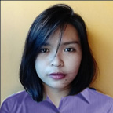

**Malene G. Dizon**

Area 4 sitio Veterans, Brgy. Bagong Silangan

Quezon City

Mobile No. 09776685572

[Email: malenedizon@gmail.com](mailto:Email:%20malenedizon@gmail.com)

**CAREER OBJECTIVE**

To be a part of the growing industry of professional Information Technology Experts.

**PERSONAL INFORMATION**

**Age :** 19 years old

**Height :** 5’4”

**Weight :** 50 kg

**Gender :** Female

**Birthdate :** June 10, 1998

**Nationality :** Filipino

**Civil Status :** Single

**Language :** Filipino and English

**Religion :** Roman Catholic

**SKILLS AND INTERESTS**

* Proficient computer literacy in
  + - Adobe Software
    - Multimedia and graphic design
    - Microsoft Software
    - web development
    - system development
    - basic java programming
    - basic database management
    - C, C++ and C#
* Excellent communication skills developed through experience as a part of an organization of young aspiring poets and spoken word artists.
* Exceptional leadership skills developed through experience in clubs and school organizations
* Highly critical thinker with effective researching skills
* Interpersonal and relationship building skills proven through experience in student council and as an event facilitator

**EDUCATIONAL BACKGROUND**

**TERTIARY Polytechnic University of the Philippines  
 Quezon City Branch**

Don Fabian St. Commonwealth Ave. Quezon City

Bachelor of Science in Information Technology

S.Y 2015 – Present

**SECONDARY Peacemaker International Christian Academy**

Gate 2, IBP Road, Batansan Hills, Quezon City

S.Y. 2011 – 2015

**ELEMENTARY Peacemaker International Christian Academy**

Area 3, sitio Veterans Brgy. Bagong Silangan QC

S.Y. 2005 – 2011

**EXPERIENCE**

**PICA Foundation Week**

Event Chairman

2015

**Betsins Artparasite Tula-Salitaan:**

**Spoken Word Workshop**

Event Organizer

May 2016

**Polytechnic University of the Philippines Quezon City**

**Strategic Planning 2017**

Event Organizer

May 2017

**Polytechnic University of the Philippines Quezon City**

**General Assembly 2017**

Event Organizer

2017

**Polytechnic University of the Philippines Quezon City**

**Acquaintance Party**

Event Organizer

2017

**Polytechnic University of the Philippines Quezon City**

**Project WATAWAT an HIMNO: PUPQC Community**

Project Manager / Overall Head

July 2017

**Mcdonald’s**

**Quezon Ave Garcia**

Part-time Crew

June 2017-Present

**ORGANIZATIONS AND AFFILIATIONS**

**(Academic Organizations):**

**Council of PICA Pupil Society (COPPS)**

President

2010 – 2011

**Supreme Student Government (SSG)**

2nd year Representative

2012 - 2013

**Cadet Advance Training (CAT)**

S1 1st Lt. Cadet Cor.2013 - 2014

**Cadet Advance Training (CAT)**

Corporal Commander

2014 – 2015

**Polytechnic University of the Philippines Quezon City**

**Council of Leaders**

Member

2015 - Present

**Polytechnic University of the Philippines Quezon City**

**CommITs**

Member

2015 – Present

**Polytechnic University of the Philippines Quezon City**

**Supreme Student Council (SSC)**

External Affairs

2017 - Present

**(Non – Academic Organizations):**

**Betsins Artparasite**

Visual and Performing Artist

Member

2015 – Present

**Betsins Artparasite Tula Salitaan**

Performing Artist

Business Officer

2016 - 2017

**Betsins Artparasite Tulaan**

Performing Artist

Member

2016 – Present

**Betsins Artparasite ART CLUB**

Visual Artist

Public Relations Officer

2017 - Present

**Polytechnic University of the Philippines Quezon City**

**Poetry**

Member

2016 – 2017

**ACADEMIC RESEARCH AND SOFTWARE DEVELOPMENT**

* **Pericarilya**

Programming Language : PHP

Software : Xampp

Position : Developer

Short Description Description : An online shop

* **Jollibee Ordering and Delivery System**

Programming Language : C#

Database : MS SQL 2012

Position : Developer

Short Description Description : A management system

* **Digitalized Module**

Programming Language : Javascript, PHP, CSS

Software : Mobirize

Position : Front End Designer

Short Description Description : A digitalized learning module

* **Coffee Shop Management System**

Programming Language : C#

Database : MS SQL 2014

Position : Developer

Description : A management system

**CHARACTER REFERENCE**

**Mrs. Zola Cristina Calope-Luciano**

Teacher

Peacemaker International Christian Academy

I hereby certify that the above information is true and correct to the best of my knowledge and belief.



**Oliven T. Tiu**

0468 Brgy. Gaya-Gaya City of San Jose del Monte

Bulacan

Mobile No. 09076083267

[Email: feralflare91@gmail.com](mailto:Email:%20feralflare91@gmail.com)

**CAREER OBJECTIVE**

To learn and to create new innovations as a part of the Information Technology Community.

**PERSONAL INFORMATION**

**Age :** 19 years old

**Height :** 5’7”

**Weight :** 55 kg

**Gender :** Male

**Birthdate :** September 1, 1998

**Nationality :** Filipino

**Civil Status :** Single

**Language :** Filipino and English

**Religion :** Roman Catholic

**SKILLS AND INTERESTS**

* Proficient computer literacy in
  + - Adobe Software
    - Microsoft Software
    - web development
    - system development
    - basic java programming
    - basic database management
* Highly critical thinker with effective researching skills

**EDUCATIONAL BACKGROUND**

**TERTIARY Polytechnic University of the Philippines  
 Quezon City Branch**

Don Fabian St. Commonwealth Ave. Quezon City

Bachelor of Science in Information Technology

S.Y 2015 – Present

**SECONDARY Christian Ecclesiastical School**

0491 Brgy. Gaya-Gaya, City of San Jose del Monte, Bulacan

S.Y. 2010 – 2014

**ELEMENTARY Gaya-Gaya Elementary School**

0468 N. Perez St., Brgy. Gaya-Gaya, City of San Jose del Monte, Bulacan

S.Y. 2004 – 2010

**EXPERIENCE**

**Government Internship Program**

Technical Working Group

2017

**ORGANIZATIONS AND AFFILIATIONS**

**(Academic Organizations):**

**Cadet Advance Training (CAT)**

Cadet 1st Class2013 - 2014

**Reserved Officers’ Training Corps (ROTC)**

Cadet 1st Class

2015 - 2016

**Polytechnic University of the Philippines Quezon City**

**CommITs**

Member

2015 – Present

**ACADEMIC RESEARCH AND SOFTWARE DEVELOPMENT**

* **Boxed Out**

Programming Language : PHP , HTML

Software : Xampp

Position : Developer

Short Description Description : An online review page

* **Book Rental System**

Programming Language : C#

Database : MS SQL 2016

Position : Developer

Short Description Description : A rental system

**CHARACTER REFERENCE**

**Mrs. Ma. Elena T. Quebedo**

Drafting Department Head

Quadstruct Structural Engineers Inc.

I hereby certify that the above information is true and correct to the best of my knowledge and belief.



**Johnroi G. Manalansan**

#487 Dirham St. Bankers Village San

Mateo Rizal

Mobile No. 09157507425

[Email: johnroigatan27@gmail.com](mailto:Email:%20johnroigatan27@gmail.com)

**CAREER OBJECTIVE**

[To contribute superior project and operations management skills and experience in an IT Service Management role.](http://www.greatsampleresume.com/resume-objectives/it-resume-objectives/superior-project-and-operations-management-skills/)

**PERSONAL INFORMATION**

**Age :** 19 years old

**Height :** 5’7”

**Weight :** 60 kg

**Gender :** Male

**Birthdate :** September 14, 1998

**Nationality :** Filipino

**Civil Status :** Single

**Language :** Filipino and English

**Religion :** Roman Catholic

**SKILLS AND INTERESTS**

* Proficient computer literacy in
  + - Adobe Software
    - Multimedia and graphic design
    - Microsoft Software
    - web development
    - system development
    - basic java programming
    - basic database management
    - C, C++ and C#

**EDUCATIONAL BACKGROUND**

**TERTIARY Polytechnic University of the Philippines  
 Quezon City Branch**

Don Fabian St. Commonwealth Ave. Quezon City

Bachelor of Science in Information Technology

S.Y 2015 – Present

**SECONDARY Saint Patrick School of Quezon City**  43 General Avenue, Brgy. Bahay Toro, Quezon

City 1106

**ELEMENTARY Saint Patrick School of Quezon City**  43 General Avenue, Brgy. Bahay Toro, Quezon

City 1106

**EXPERIENCE**

**CHARACTER REFERENCE**

**Sara Nicole T. Bautista**

Student

Polytechnic University of the Philippines

I hereby certify that the above information is true and correct to the best of my knowledge and belief.

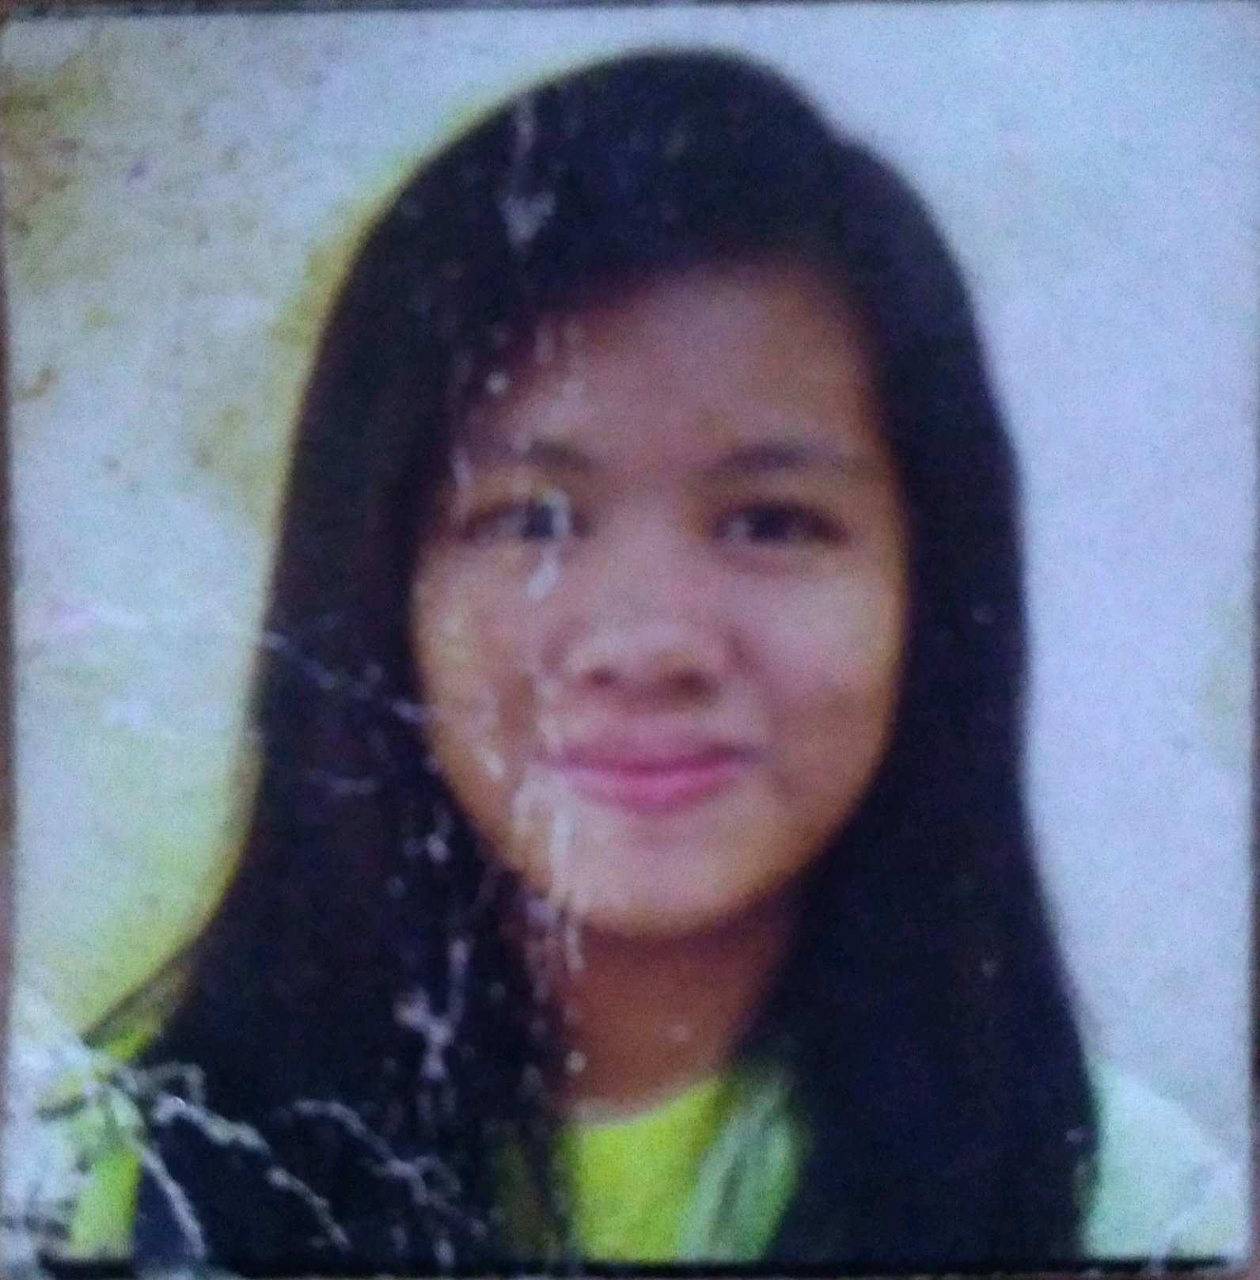

**Franchesca N. Ronquillo**

#21 N.Macario St. BF Homes Novaliches

Caloocan City

Mobile No. 0908354995

Email: youreronq@gmail.com

**CAREER OBJECTIVE**

To be able to accomplish work on with the right amount of enjoyment and enthusiasm and being able to inspire others in this line of work.

**PERSONAL INFORMATION**

**Age :** 19 years old

**Height :** 5’0”

**Weight :** 50 kg

**Gender :** Female

**Birthdate :** January 22, 1998

**Nationality :** Filipino

**Civil Status :** Single

**Language :** Filipino and English

**Religion :** Roman Catholic

**SKILLS AND INTERESTS**

* Proficient computer literacy in
  + - Adobe Software
    - Multimedia and graphic design
    - Microsoft Software
    - web development
    - system development
    - basic java programming
    - basic database management
    - C, C++ and C#
* Highly critical thinker with effective researching skills
* Interpersonal and relationship building skills

**EDUCATIONAL BACKGROUND**

**TERTIARY Polytechnic University of the Philippines  
 Quezon City Branch**

Don Fabian St. Commonwealth Ave. Quezon City

Bachelor of Science in Information Technology

S.Y 2015 – Present

**SECONDARY Holy Infant Montessori Center**

Bf Homes Phase 1 Novaliches, Caloocan City

S.Y. 2011 – 2015

**ELEMENTARY Holy Infant Montessori Center**

Bf Homes Phase 1 Novaliches, Caloocan City

S.Y. 2005 – 2011

**EXPERIENCE**

**Polytechnic University of the Philippines Quezon City**

**Project WATAWAT an HIMNO: PUPQC Community**

Videographer

July 2017

**ORGANIZATIONS AND AFFILIATIONS**

**Polytechnic University of the Philippines Quezon City**

**CommITs**

Member

2015 – Present

**ACADEMIC RESEARCH AND SOFTWARE DEVELOPMENT**

* **FoodMood**

Programming Language : PHP

Software : Xampp

Position : Developer

Short Description Description : An online directory

* **Concert Ticket Management System**

Programming Language : C#

Database : MS SQL 2014

Position : Developer

Description : A management system

**CHARACTER REFERENCE**

Anne Nicole A. Cagulang

Student

Polytechnic University of the Philippines

I hereby certify that the above information is true and correct to the best of my knowledge and belief.

**Appendix E**

**(Certificate of Proof Reading)**

**Certificate of Proofreading and Editing**

Herewith I, the undersigned, declare that I have proofread and edited the thesis entitled: **The Development of Guidance and Counselling Management Information System.**

By:

Dizon, Malene G.

Montes, Vincent Ian

Tiu, Oliveen T.

Ronquillo, Franchesca N.

Manalansan, Johnroi G.

**Ms. Joy Niña C. Luga**

**Ms. Azisah Domado**

**Appendix F**

**(Correction Forms)**

**Appendix G**

**(Revisions)**

**Attachments**