* objectives/purpose of the redesign
* state of the current site
  + accessibility audit
  + mobile friendliness
  + performance (how quickly does it load?)
  + functionality (does it work?)
  + ease of use (is it pleasant to use?
* user research (who are expected users? What do they want to accomplish?)
* device support necessary
* recommendations
  + deliverables- each with description & acceptance terms

State of the Current Site

* **accessibility audit**

<https://wave.webaim.org/> results:

* most images were missing alt text
* link text color is low contrast (difficult for color-/visually-impaired to view)
* **mobile friendliness**

***Google’s mobile-friendliness site***: not mobile-friendly

* Clickable elements too close together
* Viewport not set
* Text too small to read
* Content wider than screen
* **Performance**

[www.webpagetest.org](http://www.webpagetest.org):

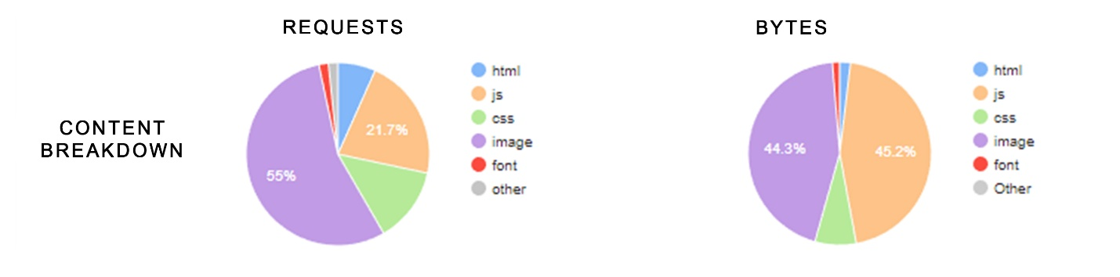

**Summary**: a lot of bandwidth dedicated to images and scripts

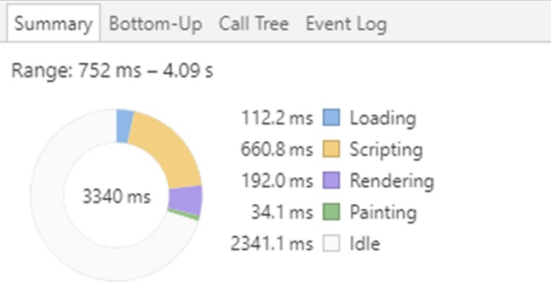

**Summary:** … and a lot of time spent loading, accessing, and rendering …

***Google PageSpeed Tools:***

* Optimization: 65/100 (medium)
* Page stats: *PSI estimates this page requires 3 additional round trips to load render blocking resources and 1.1 MB to fully render. The median page requires 4 render blocking round trips and 1.5 MB. Fewer round trips and bytes results in faster pages.*
* Optimizations present:
  + - No landing page redirects
    - Compression enabled
    - HTML minified
    - Above-the-fold content prioritized
  + Optimization recommendations:
    - Optimize images
    - Browser caching
    - Eliminate render-blocking Javascript and CSS in above-the fold content
    - Reduce server response time
    - Minify CSS
    - Minify Javascript
* **Functionality**
* The download brochure (pdf) link is broken (404 page not fount)
* Top navigation links all work
* Side navigation links all work
* Social network image links work
* University image links at bottom of page all work
* Main video works
* Helpful link ‘heating fuel comparison calculator’ Is broken (doesn’t point to a calculator)
* Energy industry page: images are click-able but serve no purpose (not linked to anything…don’t enlarge)
* The ‘visit us’ map/directions page works
* A lot of information on this site is out dated …is this site even being maintained? There doesn’t seem to be anything past 2015 in a lot of cases (deadlines for applications that passed 3 years ago… no more current links to research/publications after 2015)
* **Research** page is reasonably well-organized by program and provides information about participants and published research

Research info is out dated… in a lot of case there are no links to research past 2015

* **Education** page is also reasonably well-organized by topic

Free online classes page is poorly laid out

Out dated/poorly maintained

Energy job info is old

* **Demonstrations**

There is an error in the layout for this selection; unlike other choices, the box extends past the right border

* **Ease of use**

The site is clunky, unresponsive, slow, and difficult to navigate; a site you’d more than likely see back in 2000 than 2018. If it is still an active site, it is poorly maintained; a lot of information is out of date and needs to be removed and/or corrected

* **User Research**
* Not for casual browsers (targeted information for people who have a good sense of what they’re looking for)
* Educational Institutions (universities, similar programs, K-12, libraries)
* Community advisory boards (town and city government agencies)
* Environmental advocacy groups
* **Device support necessary**

This site is not designed for mobile browsing. Something that would be intended for older computers/browsers (like those in libraries and public schools).

* **Recommendations**
* Review end-user consumption of material and more efficiently organize information – consider compartmentalizing the site for targeted users: universities, media, local governments etc.

Greatly reduce number of navigational links and overall clutter

Maybe a curated experience for each of the different type of potential user

* Review all content and make sure it is timely and correct
* Implement site optimization suggestions to speed up page-load times and delivery content more effectively
* Consider using the JPL site as a reference (good contemporary web site with community outreach and effective presentation)
* Modernize/beautify site: apply web design best practices (responsiveness, accessibility, efficiency, etc.)