Manager Risk Brief
Approved Recovery Sprint Risk Brief
Escalated advertiser renewal portfolio, July 2026

Decision Header
Field | Approved Decision Record
Decision | Execute a value-and-risk prioritized recovery sprint for locally approved escalated advertiser accounts.
Approver | Elena Whitaker, Director of Regional Sales, approved 2026-07-15.
Scope | 18-account portfolio; 12 approved for local execution; 4 controlled exceptions; 2 excluded or hold records.
Execution window | 2026-07-17 through 2026-07-24 with daily 16:00 Eastern checkpoints.
Lifecycle state | Approved executable record; unsupported items stay controlled exceptions.

Executive Summary
The recommended sprint prioritizes the locally executable accounts with the strongest combination of renewal exposure, operational recovery risk, urgent renewal timing, and ready customer contact paths. The package protects local authority by routing over-limit, legal, contact-permission, and unresolved blocker issues as controlled exceptions rather than implied commitments.
The approved local sprint covers $2,612,000 of renewal exposure; the full 18-account portfolio carries $4,064,000 in exposure and a current Q3 forecast variance of ($557,000) versus the 2025 baseline.

Portfolio Evidence
Metric | Value | Evidence Basis
Total portfolio exposure | $4,064,000 | 18 CRM accounts
Approved executable exposure | $2,612,000 | 12 approved execution accounts
Controlled exception exposure | $1,255,000 | 4 accounts
Q3 forecast variance | ($557,000) | Current forecast minus 2025 Q3 baseline

Portfolio Matrix
The portfolio matrix plots renewal exposure against operational recovery risk so the manager can see why the sprint focuses on high-value, high-risk accounts while preserving manager-route exceptions.
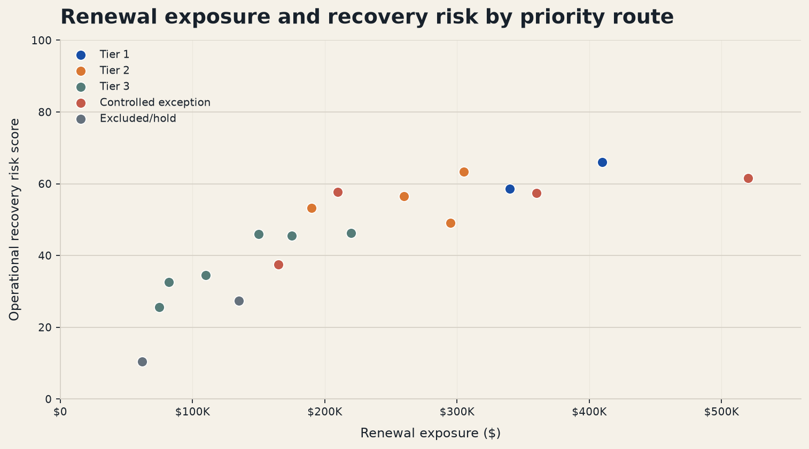
Figure 1. Renewal exposure and operational recovery risk by approved priority route.
Source: account_prioritization_model.xlsx Dashboard, using CRM, order, case, contact, activity, offer, and approval evidence.

Alternatives Considered
Option | Benefit | Risk | Decision
Value-and-risk priority sprint | Focuses 12 executable accounts with $2,612,000 exposure while preserving controls. | Requires tight owner capacity checks. | Approved
Equal coverage by rep | Simple to assign and explain. | Delays high-risk accounts such as Axion Robotics and Meridian Health Partners. | Rejected
Manager-only escalation queue | Reduces local commercial risk. | Creates avoidable delay for accounts already within authority. | Rejected

Approved Actions
Owner | Account | Approved Action | Due | Dependency
Devon Brooks | A-1005 Axion Robotics | Swap misaligned audience package and reset delivery proof | 2026-07-20 | Audience Mismatch
Maya Chen | A-1001 Meridian Health Partners | Confirm makegood inventory and delivery recovery plan | 2026-07-20 | Delivery Underpacing
Jordan Patel | A-1012 Vesta Apparel Collective | Confirm makegood placement and invoice correction route | 2026-07-22 | Delivery Underpacing
Jordan Patel | A-1007 Northline Insurance | Confirm makegood placement and revised delivery dates | 2026-07-22 | Delivery Underpacing
Priya Nair | A-1003 Cobalt Cloud Systems | Confirm verified billing credit and renewal rate hold | 2026-07-22 | Billing Error
Luis Romero | A-1009 Copper Trail Hospitality | Confirm package swap and creative approval timeline | 2026-07-22 | Creative Trafficking

Open Controlled Exceptions
Account | Exposure | Reason | Route
A-1013 BrightPath Dental Alliance | $165,000 | Decision-maker outreach permission pending | Hold customer-facing offer until decision-maker route is approved
A-1014 SummitBank SMB Services | $360,000 | Requested credit is above supervisor authority | Route credit request to manager; do not promise local credit
A-1015 Mesa Tool Supply | $210,000 | Ad-ops blocker not cleared | Wait for product feed fix before customer offer
A-1017 Atlas BioLabs | $520,000 | Contract terms outside local authority | Escalate to manager and legal owner; no rep commitment

Risk Register
Risk | Control | Owner | Checkpoint
Commercial overreach | Offer compliance check and MGR-REQ route for over-limit items. | Supervisor | Daily 16:00
Customer contact without permission | Use contact directory; hold or ops-only route when permission is absent. | Rep | Before outreach
Ad-ops blocker delays | Schedule dependency clearance before customer offer confirmation. | Functional owner | Within sprint
Rep capacity pressure | Capacity sheet checks owner workload and backup owner need. | Supervisor | Daily 16:00
Forecast variance persists | Brief and model reconcile variance by segment and exception status. | Revenue ops | Closeout

Approval and Closeout Controls
Execution may proceed only for the approved local scope. The supervisor will report completed outreach, unresolved dependencies, manager exceptions, and forecast movement at each checkpoint and at final closeout. A controlled exception can move to execution only after the approval evidence, offer authority, contact route, and operational blocker state agree.

