Working With
North State Framework in C++
V2.1



North State Software, LLC
www.northstatesoftware.com

Contents

1 Overview 3
1.1 Advantages 3
1.2 Features 4
1.3 Scope and References 4
2 Best Practices Using the North State Framework 5
2.1 Development Process 5
2.2 Draw the State Machine 6
2.3 Create the State Machine Class 7
2.4 Add State Machine Members 7
2.5 Write a Constructor 10
2.6 Write Actions 11
2.7 Write Guards 13
2.8 Write a Destructor 15
2.9 Run It! 15
3 Features and Advanced Techniques 16
3.1 Threading 16
3.2 Accessors 17
3.3 Events 18
3.4 Timers 20
3.5 Pseudo States 21
3.5.1 Initial States 21
3.5.2 Choice States 22
3.5.3 History States 24
3.6 Composite States and Concurrency 25
3.7 Extending State Machines 28
3.7.1 Inheritance 29
3.7.2 Composition 31
3.8 Tracing 34
3.9 Exception Handling 35
4 Porting to a New Platform 37
4.1 NSFOSMutex 37
4.2 NSFOSSignal 38
4.3 NSFOSThread 39
4.4 NSFOSTimer 42
4.5 Factory Methods 43
5 Conclusion 44

Overview

The Unified Modeling Language™ (UML™) specifies a set of diagrams for describing object-oriented software. These drawings facilitate design and development by communicating software architecture at a high level of abstraction using a standards-based description language.

UML 2.3 includes seven diagrams for describing the static (time-invariant) structure of a system, and seven diagrams for describing dynamic behavior. Many of these diagrams, particularly the static structure diagrams, are easily translated in source code. However, implementing dynamic behaviors, such as those described by UML State Machines, poses a more difficult problem.

UML state machines, based on Harel statecharts, are a powerful and compact notation for describing behavior. Simple state machines can be coded with “switch” statements or nested if-then-else constructs; however, these implementations are often tedious and error prone, particularly as the state machine grows in size. In addition, such implementations are difficult to extend or reuse through generalization.

The North State Framework™ (NSF™) simplifies the process of implementing UML state machines. The framework classes map directly to UML diagram elements, so that working executable code can be created in a straightforward, methodical fashion. The North State Framework is perfect for hand-coding UML model based designs or embedding into UML based modeling tools.

In short, the North State Framework bridges the gap between UML and code, enabling you to build better solutions, faster.

Advantages

The North State Framework simplifies the process of turning UML state machines into executable code. The one-to-one relationship between diagram elements and framework classes makes it easy to understand and implement.

Designed with extensibility in mind, the North State Framework allows extension through both inheritance and composition. Inherited state machines can add, remove, or change behavior from their bases class. In addition, state machines are “pluggable”, so that one state machine can be used inside another state machine, thus promoting reuse through composition.

UML model based development facilitates design at a high level of abstraction, thus speeding development, improving collaboration, and minimizing design errors. There are several UML based development environments available, but many companies don’t want to be tied to their code generation tool or can’t afford their price tag. The North State Framework provides an alternative. It allows developers their choice of modeling tools, from hand sketches to full-blown modeling environments, and provides the classes to quickly and reliably implement their designs.

For UML tool developers, the North State Framework provides an entry point into modeling dynamic behaviors. Many UML based modeling tools do not support code generation from state machines, and if they do, often the generated code is neither extensible nor suitable for production quality software, failing to adequately handle threading concerns or exception handling. With the North State Framework, extensibility, threading, and exception handling is built into the framework, reducing development efforts and improving product quality. And because the North State Framework classes directly map to state machine diagram elements, it is easily integrated into any diagram to code generation engine.

Features

The North State Framework supports the following features:

- State Machines – semantically correct, fully functional, and extensible
- States – including initial, choice, composite, deep history, and shallow history
- Delegates – dynamically add or remove state entry, state exit, or transitions actions
- Events – simple and payload carrying
- Transitions – including internal, local, and external
- Regions – implement concurrent behaviors
- Fork/Join – synchronize current behaviors
- Threads – assign one or more state machines to run on a thread
- Timers – schedule an event or execution of an action
- Inheritance – easily extend base state machine behavior
- Composition – plug one state machine into another
- Trace Logging – record state machine history

Scope and References

This document contains best practices for working with the North State Framework. It assumes the reader is somewhat familiar with UML State Machine notation and semantics. If this is not the case, there are numerous references available on the web, including the UML specification, which can be downloaded from www.omg.org.

Best Practices Using the North State Framework

Following are recommended best practices when using the North State Framework. These conventions have resulted from our years of experience designing and implementing state machine based solutions for complex systems. If we could sum up these practices into one sentence, it would be:

Design and code your state machines to be extensible.

The framework is designed to help achieve this goal, allowing your design to be flexible, and enabling creation of powerful and reusable components.

Development Process

Most developers benefit from laying out their designs graphically before diving into the details of the code. UML state machines are designed for just this purpose, enabling you to design graphically at a high-level, without worrying about all the underlying code details. Once your state machine design is complete, NSF will enable you to quickly and easily translate your UML State Machines into error-free, executable code.

Here are some things to remember when designing state machines:

- A state machine can represent the behavior of a single object or a process coordinating several objects.
- State machines can be used to monitor or control objects.
- Each state in the state machine should represent a unique condition that exists for some significant period of time.
- Be careful not to use state machines as flowcharts. Un-triggered, un-guarded transitions are a tell-tale sign that you have used a state machine as a flowchart. These result in states that don’t exist for significant periods of time.

Developing with NSF allows for a methodical process to create executable code from UML State Machines, as described below.

- Draw state machine
- Create the state machine class
- Add state machine members
- Write constructor
- Write actions
- Write guards
- Write destructor
- Run it!

Draw the State Machine

The act of drawing out the state machine will help you identify holes in your behavioral logic, before getting to the intricacies of coding. Don’t be fooled by the simplicity of this step. The time spent on a well-designed state machine may exceed the time for the implementation, and be well worth it. Do a good job here, and you’ll save yourself time and frustration. For the example used herein, we used Microsoft Office Visio™ to draw our UML state machine, as shown in Figure 2-1.

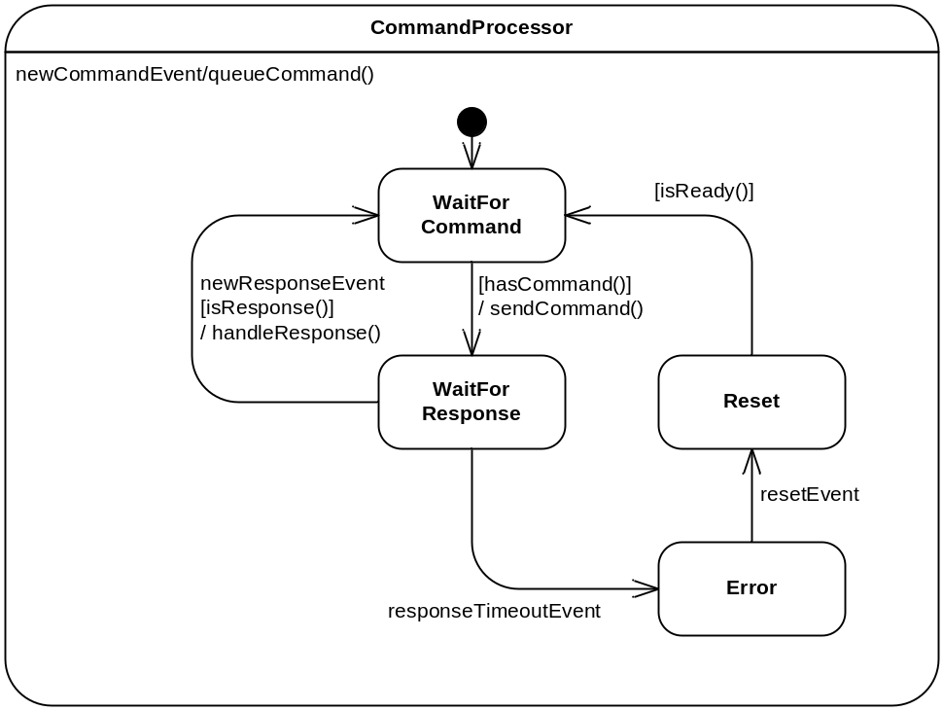

Figure 2-1: Command Processor Example

As you design your state machine, keep in mind that there are five places for actions (behaviors) to occur:

- On state entry.
- On state exit.
- On transition from one state to another.
- As a reaction in state to an event (internal transition).
- As a timer action.

Tips:

- Start with the “Happy Path” scenario on the first pass. Then add error handling details as the design matures.
- Name diagram members appropriately, including states, events, triggers, guards. Keep in mind that software Q/A or service personnel from your company may need to understand the state machine design from the diagram.
- Avoid putting implementation details on the drawing. Instead, rely on good naming at the diagram level, and leave the implementation details for the code. This will help you avoid diagram changes when implementation details change.
- Think the implementation. Plan what actions need to occur on the entry to, exit from, transitions between, and as reactions within each state. Annotate the drawing with notes describing what actions should occur, without specifying programmatically how to implement them.
- Look for race conditions in your logic. Many state machine designs are multithreaded, so pay careful attention to threading issues.
- Use the diagram to expose weaknesses in the design. A convoluted state machine diagram is an indication of a convoluted design.

Create the State Machine Class

The first step in transforming your state machine into working code is to create a class that inherits from NSFStateMachine, as illustrated below.

class CommandProcessor : public NSFStateMachine
{
…
}

Add State Machine Members

The second step in transforming your state machine into working code is to add members for each state machine element.

Although it is not always necessary to create members for every state machine element, it is recommended practice to do so. These members will be useful in the event that you want to extend the state machine, either via inheritance or composition. Another reason they are helpful is for debugging, so that you can examine the properties and relationships amongst members.

NSF is designed such that UML State Machine elements have corresponding NSF classes, which makes translation very straightforward. NSF contains the following classes to implement UML State Machines:

- NSFStateMachine – A state machine.
- NSFRegion – An area containing nested states and transitions.
- NSFState – A simple state that cannot contain nested regions.
- NSFCompositeState – A state that can contain nested states, regions, or submachines.
- NSFInitialState – The default entry point for a region.
- NSFChoiceState – A state that is used for decision branching.
- NSFDeepHistory – A state that allows returning to a prior state and all its substates.
- NSFShallowHistory – A state that allows returning to a prior state, but not its substates.
- NSFForkJoin – A state that provides synchronization and branching across multiple regions.
- NSFEvent – A trigger mechanism for transitions and reactions.
- NSFDataEvent – An NSFEvent that carries a data payload.
- NSFExternalTransition – A transition path from one state to another.
- NSFLocalTransition – A transition path from one state to another, where the source state is not exited.
- NSFInternalTransition – A state’s internal response to a trigger event. Also known as a reaction in state.
- NSFForkJoinTransition – A specialized NSFExternalTransition that can be used for transitioning between fork-joins.

The recommended translation process is:

- Declare event members for each unique event.
- Declare region and state members, from outer to inner
- Declare transition members.

Grouping states and transition together with their parent region or composite state helps organize the state machine members.

Following this process for the Command Processor Example in Figure 2-1 yields:

class CommandProcessor : public NSFStateMachine
{
public:
…
protected:
…
// Events
NSFDataEvent<string> newCommandEvent;
NSFDataEvent<string> newResponseEvent;
NSFEvent responseTimeoutEvent;
NSFEvent resetEvent;

// Regions and states, from outer to inner
NSFInitialState initialCommandProcessorState;
NSFCompositeState waitForCommandState;
NSFCompositeState waitForResponseState;
NSFCompositeState errorState;
NSFCompositeState resetState;

// Transitions
NSFInternalTransition reactionToNewCommand;
NSFExternalTransition initialCommandProcessorToWaitForCommandTransition;
NSFExternalTransition waitForCommandToWaitForResponseTransition;
NSFExternalTransition waitForResponseToWaitForCommandTransition;
NSFExternalTransition waitForResponseToErrorTransition;
NSFExternalTransition errorToResetTransition;
NSFExternalTransition resetToWaitForCommandTransition;
…
};

Tips:

- Create an initial state within each composite state and region whenever there are multiple substates. Although not always necessary, this approach helps add clarity to the diagram and avoids the mistake of forgetting to specify an initial state.
- Make state members of type NSFCompositeState, rather than NSFState, in case you want to extend the state by adding substates to it. NSFCompositeState provides capabilities for nesting states, regions, and submachines.
- Count the number of graphical elements on the state machine diagram and make sure it matches the number of state machine members in the code.

Write a Constructor

Once the state machine members are declared, the next step is to define them in a constructor. Each NSF class has several constructors which allow the objects to be tagged with names, as well as supply the requisite information for creation. Names are most useful for viewing in the automatic trace logging facilities.

The constructor for the Command Processor Example in Figure 2-1 is shown below.

CommandProcessor::CommandProcessor(NSFString& name)
: NSFStateMachine(name, new NSFEventThread(name)), responseTimeout(1000),

// Events
newCommandEvent("NewCommand", this, "CommandPayload"),
newResponseEvent("NewResponse", this, "ResponsePayload"),
responseTimeoutEvent("ResponseTimeout", this),
resetEvent("Reset", this),

// Regions and states, from outer to inner
initialCommandProcessorState("InitialCommandProcessor", this),
waitForCommandState("WaitForCommand", this, NULL, NULL),
waitForResponseState("WaitForResponse", this, NSFAction(this, &CommandProcessor::waitForResponseEntryActions), NSFAction(this, &CommandProcessor::waitForResponseExitActions)),
errorState("Error", this, NSFAction(this, &CommandProcessor::errorEntryActions), NULL),
resetState("Reset", this, NSFAction(this, &CommandProcessor::resetEntryActions), NULL),

// Transitions, ordered internal, local, external
reactionToNewCommand("ReactionToNewCommand", this, &newCommandEvent, NULL, NSFAction(this, &CommandProcessor::queueCommand)),
initialCommandProcessorToWaitForCommandTransition("InitialToWaitForCommand", &initialCommandProcessorState, &waitForCommandState, NULL, NULL, NULL),
waitForCommandToWaitForResponseTransition("WaitForCommandToWaitForResponse", &waitForCommandState, &waitForResponseState, NULL, NSFGuard(this, &CommandProcessor::hasCommand), NSFAction(this, &CommandProcessor::sendCommand)),
waitForResponseToWaitForCommandTransition("WaitForResponseToWaitForCommand", &waitForResponseState, &waitForCommandState, &newResponseEvent, NSFGuard(this, &CommandProcessor::isResponse), NSFAction(this, &CommandProcessor::handleResponse)),
waitForResponseToErrorTransition("WaitForResponseToError", &waitForResponseState, &errorState, &responseTimeoutEvent, NULL, NULL),
errorToResetTransition("ErrorToReset", &errorState, &resetState, &resetEvent, NULL, NULL),
resetToWaitForCommandTransition("ResetToWaitForCommand", &resetState, &waitForCommandState, NULL, NSFGuard(this, &CommandProcessor::isReady), NULL)
{
}

Tips:

- Notice the NSFAction and NSFGuard functions which simplify the syntax for creating action and guard delegates in state and transition constructors. Delegates encapsulate callback functions and are described in detail in the next two sections.
- Defining the members in the prescribed order will ensure that relationships are properly established.
- Supply names for all the states and events to facilitate tracing. Regions and transitions may not need names, but they can be useful in exceptional cases.
- State machine construction is not thread safe, so each state machine should be created from a single thread. Different state machines can be created from different threads, but don’t create part of a state machine from one thread and another part from another thread.

Write Actions

State machine actions are callback functions encapsulated as delegate objects. They can be executed on state entry, state exit, and during transitions. Most of your state machine development time will be spent designing the state machine diagram and writing the underlying actions.

For the Command Processor Example, actions are associated with their state machine element during member initialization, as illustrated below.

waitForResponseState("WaitForResponse", this, NSFAction(this, &CommandProcessor::waitForResponseEntryActions), NSFAction(this, &CommandProcessor::waitForResponseExitActions)),

Following are some of the action implementations for this example.

void CommandProcessor::queueCommand(const NSFStateMachineContext& context)
{
commandQueue.push(((NSFDataEvent<string>*)(context.getTrigger()))->getData());
}

void CommandProcessor::sendCommand(const NSFStateMachineContext& context)
{
string commandString = commandQueue.front();

// Code to send the command goes here
// …
}

void CommandProcessor::waitForResponseEntryActions(const NSFStateMachineContext& context)
{
responseTimeoutEvent.schedule(responseTimeout, 0);
}

void CommandProcessor::waitForResponseExitActions(const NSFStateMachineContext& context)
{
responseTimeoutEvent.unschedule();

commandQueue.pop();
}

void CommandProcessor::handleResponse(const NSFStateMachineContext& context)
{
// Code to handle the response goes here
// …
}

void CommandProcessor::errorEntryActions(const NSFStateMachineContext& context)
{
// Code to handle the error goes here
// …
}

void CommandProcessor::resetEntryActions(const NSFStateMachineContext& context)
{
// Code to reset hardware goes here
// …
}

In addition to specifying actions during member initialization, they can be added or removed on the fly with the += and -= operators, as illustrated below.

waitForResponseState.EntryActions += NSFAction(this, &CommandProcessor::waitForResponseEntryActions);

waitForResponseState.EntryActions -= NSFAction(this, &CommandProcessor::waitForResponseEntryActions);

This feature creates a powerful run-time facility to observe and react to state machine change. For example, if a state machine exposes one of its underlying states, a client object can connect a state entry action to that state, thus registering a callback function for notification whenever the state is entered.

Underlying this simple, yet powerful feature is a set of templates that implement delegates similar to those found in C#. The NSFAction template functions simplify the creation of action delegates from member or global functions. The action is then simply added to the list of Entry Actions with the += operator. The syntax for adding a global function action is as follows:

waitForResponseState.EntryActions += NSFAction(&someGlobalFunction);

The function signature for a state machine action is:

void functionName(const NSFStateMachineContext& context);

The NSFStateMachineContext argument provides contextual information for the action, such as the entering state, exiting state, triggering event, and transition taken.

Tips:

- Action (delegate) lists create their own copies of the delegates added to them, so there is no need to keep persistent copies of the delegate objects in the state machine implementation.
- Name the action function after the associated state or transition. For example, the entry actions for the error state are defined in the function “errorEntryActions”.
- Make use of the action delegate feature to add and remove entry/exit actions from state machines at any time. A common pattern is a state machine observer. When adding state machine observers during run-time, be sure to remove them at the appropriate time.
- Carefully consider race conditions when monitoring or observing state machine execution. A common mistake is to check if a state is active, and if not, then add an entry action to receive notification that it has become active. This creates a race condition because the state could change between the time it is checked and the time the action is added. The preferred pattern is to register the entry action, then check the state, then unregister the action when the state is active.
- Avoid registering member functions as actions when the underlying object can be deleted. Although the framework will handle the potential exception (due to the object having been deleted), it is best to restrict member function actions to refer to persistent objects.

Write Guards

Guards are boolean functions that must evaluate true for transitions to execute. They are implemented in much the same way as actions.

For this example, guards are specified during member initialization, as illustrated below.

waitForCommandToWaitForResponseTransition("WaitForCommandToWaitForResponse", &waitForCommandState, &waitForResponseState, NULL, NSFGuard(this, &CommandProcessor::hasCommand), NSFAction(this, &CommandProcessor::sendCommand)),

The guard implementations for the example are illustrated below.

bool CommandProcessor::hasCommand(const NSFStateMachineContext& context)
{
return (!commandQueue.empty());
}

bool CommandProcessor::isResponse(const NSFStateMachineContext& context)
{
// Code to verify that the resposne is correct for the command goes here.
// …

return true;
}

bool CommandProcessor::isReady(const NSFStateMachineContext& context)
{
// Code to check if hardware is reset properly goes here
// …

return true;
}

Just like actions, guards can be added or removed on the fly with the += and -= operators, although this is much less common in practice. Typically, guards would only be added or removed in derived classes that change the conditions under which a transition can be taken. Outside of this use case, changing guards on the fly should be carefully scrutinized, as it could result in non-obvious behavior.

Transition guards are lists of functions with the following signature:

bool functionName(const NSFStateMachineContext& context);

The framework provides template functions, named NSFGuard(…), for adding both member functions and global (or static) functions to these lists, as previously illustrated. The templates allow nullary (argument-less) functions to be wrapped as well.

Tips:

- Avoid putting side effects in guard functions, because they may be evaluated multiple times before a transition is taken.
- Carefully consider the design before adding and removing guards on the fly.

Write a Destructor

Before a state machine is destructed, it is important to ensure that it is no longer running and in a condition that allows for its components to be deleted. The framework supplies a terminate(…) method for this purpose, which should be called from the state machine’s destructor before deleting any dynamic memory objects. If the state machine dynamically created an event thread, it is responsible for deleting it. Other state machines that use this event thread will be automatically terminated when the event thread is deleted.

The destructor for the Command Processor Example is shown below.

CommandProcessor::~CommandProcessor()
{
// It is good practice to stop event processing (terminate) in the
// destructor of a state machine or event handler to prevent
// entry/exit actions from being performed on a destructing object.
terminate(true);
delete getEventThread();
}

Tips:

- Call the terminate(true) method from the destructor of all concrete state machine classes, before deleting any dynamic memory objects.
- Deleting an event thread will automatically terminate all state machines and event handlers running on that thread.

Run It!

To run your state machine, create an instance and call the method startStateMachine(), as illustrated below.

int main()
{
CommandProcessor commandProcessor(NSFString("CommandProcessor"));
commandProcessor.startStateMachine();
…
}

The framework handles all the execution details, ensuring compliance with UML semantics, including run-to-completion.

Features and Advanced Techniques

This section describes the features of NSF in more detail, and illustrates some advanced techniques for constructing state machines.

Threading

State machines can be run collectively on a common thread or individually on their own thread. The NSFEventThread class is provided to simplify state machine thread management. The thread is typically specified during construction, but can be reassigned at any time. In the Command Processor Example, a new thread is created during initialization, as illustrated below.

CommandProcessor::CommandProcessor(NSFString& name)
: NSFStateMachine(name, new NSFEventThread(name)), …

The NSFStateMachine class does not manage creation or deletion of NSFEventThreads, rather, your application will manage the threading model. To run a state machine on a run-time specified thread, create a constructor which allows specification of the thread, as illustrated below.

CommandProcessor::CommandProcessor(NSFString& name, NSFEventThread* thread)
: NSFStateMachine(name, thread), …

The state machine’s thread is available via the getEventThread() method.

Because NSF applications are often highly multi-threaded, it is important to consider mutual exclusion for any resource that may be accessed from multiple threads. To help with mutual exclusion, the framework contains a mutex class, NSFOSMutex, and two macros, LOCK and UNLOCK. The macros use the “Resource Acquisition Is Initialization” idiom to guarantee exception safe mutex usage, and make using mutexes more convenient. The following example illustrates how to use the macros.

LOCK(someMutex)
{
// Access some shared resource
…
}
ENDLOCK;

Tips:

- Spend some time thinking about the threading model for the application. Generally, several state machines can share a common thread, which will help minimize context switching and use of system resources. Often times, state machines within a common subsystem can share a thread, while high-priority or device driver state machines require a dedicated thread.
- Set up each state machine’s thread before starting the state machine.
- Avoid blocking calls within a mutex protected region of code. Within the framework, all mutexed regions of code are designed to complete quickly once the mutex resource is obtained, thus eliminating deadlock situations.

Accessors

State machines can easily be extended through inheritance, composition, or a combination of both. Part of the design process involves deciding which parts of the state machine to expose to derived or composite state machines, and even for classes that interact with the state machine. Accessors are a good way to expose those part of the state machine with which other classes may interact.

For the CommandProcessor example, the following accessors would be useful:

NSFState& getWaitForCommandState() { return waitForCommandState; };
NSFState& getWaitForResponseState() { return waitForResponseState; };
NSFState& getErrorState() { return errorState; };
NSFState& getResetState() { return resetState; };
NSFExternalTransition& getWaitForCommandToWaitForResponseTransition() { return waitForCommandToWaitForResponseTransition; };
NSFExternalTransition& getWaitForResponseToWaitForCommandTransition() { return waitForResponseToWaitForCommandTransition; };
NSFExternalTransition& getWaitForResponseToErrorTransition() { return waitForResponseToErrorTransition; };
NSFExternalTransition& getErrorToResetTransition() { return errorToResetTransition; };
NSFExternalTransition& getResetToWaitForCommandTransition() { return resetToWaitForCommandTransition; };

Tips:

- Create accessors for states and transitions to allow other classes to:
  - Query if a state is active
  - Add and remove actions

Events

Events are used to trigger state transitions. This process starts when an event is queued to the state machine’s thread through the queueEvent(…) methods, available in both the state machine and event interfaces. Events in the thread’s event queue are processed one at a time in the order they were queued. The processing sequence for an event is that it is first sent to the most deeply nested active state in the state machine (concurrent behavior is slightly different; see the section on concurrency for more detail). If the event causes a transition, then the event is considered to be “handled” and processing of that event stops. If the event is “unhandled”, then it is sent to the parent state where the same logic is applied. It is possible that an event will pass all the way up to the top level state machine and still be unhandled, whereupon the event will just be discarded. However, if the event is handled anywhere along the chain, processing of that event stops, at which time the state machine will then evaluate if any more transitions should occur, based on the new state of the state machine (following UML run-to-completion semantics). The figure below illustrates an event handling scenario. See the UML specification for more detail on state machine event handling.

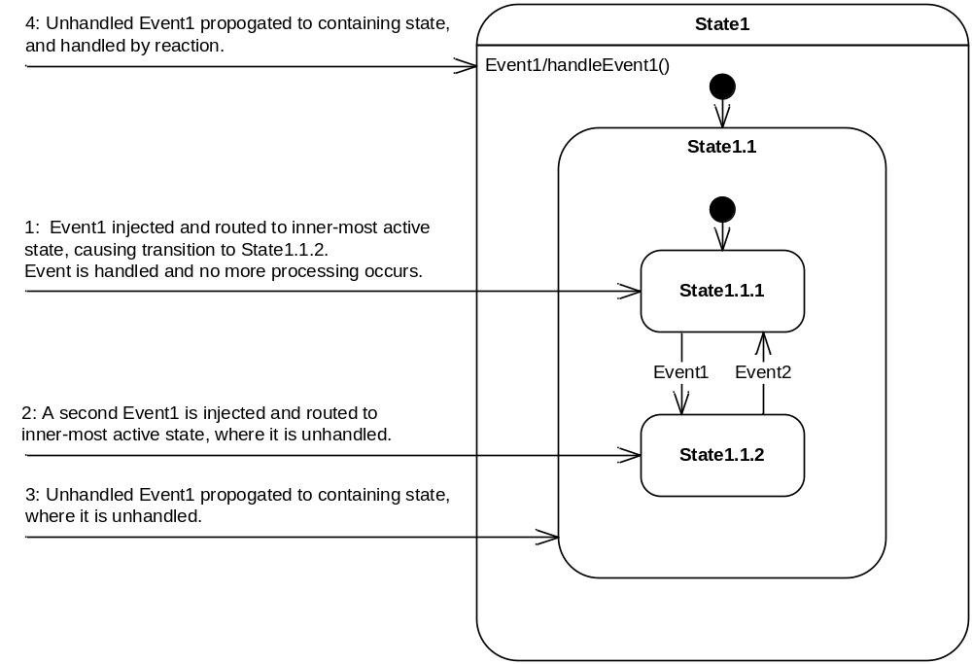

Figure 3-2: Event Propagation

NSF events contain a unique identifier that is used to compare the event in process to the event specified as part of transition construction. If the identifiers match, then the event satisfies the trigger requirement. Of course, if the event queued to the state machine’s thread is the same event used to define the transition or reaction trigger, then the identifiers will match. However, there are cases when it is beneficial to have multiple unique events that can trigger the same transition. The most common case is when each event carries specific payload data (see NSFDataEvent in the NSF documentation). To handle this situation, use the copy(…) method to create copies of the original event, so that each copy will have the same unique identifier. In the case of NSFDataEvent objects, each copy can contain a unique data payload, but will still share the same unique identifier if the copy(…) method is used. This technique is illustrated below.

class CommandProcessor : public NSFStateMachine
{
…
NSFDataEvent<string> newCommandEvent;
…
NSFInternalTransition reactionToNewCommand;
…
}

CommandProcessor::CommandProcessor(NSFString& name)
…
newCommandEvent(“NewCommand”, this),
…
reactionToNewCommand( … , &newCommandEvent, … ),
…
{
}

void CommandProcessor::addCommand(string& newCommand)
{
// The following event will have the same identifier as the newCommandEvent.
// It can be used interchangeably to trigger the reactionToNewCommand.
queueEvent(newCommandEvent.copy(true, newCommand)); }

Often times when copying an event, the event is used just one time and then needs to be deleted. This is particularly true for data carrying events which carry a unique payload. To facilitate memory management in these cases, the copy(…) methods contain an boolean argument “deleteAfterHandling”, which if set true, will result in the framework deleting the event after it has been processed by the state machine. This eliminates the need to manage event memory cleanup in the application.

Tips:

- Rather than exposing state machine events as part of the public interface, consider writing methods which internally queue the approprate events. This approach can make the client interface more easily understood and allows for internal changes in the future.
- Events that are permanent state machine members do not need to be deleted after handling, however, transient events do.

Timers

The NSFEvent class contains methods that make it easy to schedule an event to be queued at a specified time, as illustrated below.

…
NSFEvent timeoutEvent;
…
void someStateEntryActions(const NSFStateMachineContext& context)
{
// Automatically timeout after 1 second
timeoutEvent.schedule(1000, 0);
}

void someStateExitActions(const NSFStateMachineContext& context)
{
// Unschedule timeout in case leaving due to another event
timeoutEvent.unschedule();
}

A common pattern for a timeout event is to schedule it in the state’s entry actions and to unschedule it in the state’s exit actions. This ensures that the event won’t fire if the state is exited for some reason other than the timeout event. If the state is exiting due to the timeout event, the unschedule call has no effect.

Behind the scenes, the NSFEvent class uses the primary timer within the NSFTimerThread class to implement the schedule and unschedule behaviors. This timer is setup to run with a resolution of 1 mS (hardware must support), and can be used to schedule different types of actions.

Three types of timer actions are natively supported, events, scheduled actions, and signals. The NSFScheduledAction class allows an action (callback function) to be called at a specified time on a specified thread. See the online documentation for more details on these classes.
Tips:

- The primary timer in NSFTimerThread class can be accessed with the NSFTimerThread::getPrimaryTimerThread() method.
- The primary timer runs on its own thread at the highest thread priority.

Pseudo States

Non-persistent states are generically referred to as “pseudo states”. These include initial states, choice states, deep history states, and shallow history states. Because they are non-persistent, outgoing transitions must not contain triggers and must be guarded such that the pseudo state exits immediately after entering. Correspondingly, internal and local transitions are not valid for pseudo states.

Initial States

An initial state indicates the default entry point for a set of nested states in a composite state. Initial states must have a default (un-triggered and un-guarded) outgoing transition. The symbol for an initial state with a default transition is:



Figure 3-3: Initial State with Default Transition

Although not always necessary, it is good practice to include an initial state whenever a composite state or region contains multiple nested substates. This approach helps add clarity to the diagram and avoids the mistake of forgetting to specify an initial state.

Choice States

A common state machine pattern is to exit a state based on an event and transition to one of several states based on a guard. The choice state helps implement this pattern, as illustrated below:

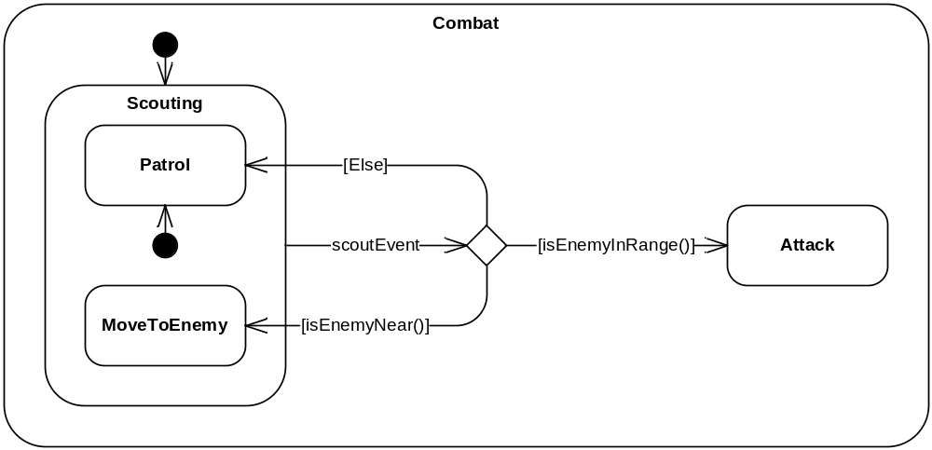

Figure 3-4: Combat Example

Choice states have multiple outgoing transitions, each with its own unique guard, and should have one outgoing default transition labeled “Else” which is taken if all other transition guards fail.

The NSFChoiceState class implements the state machine choice pseudo state. It handles the logic of identifying the default “Else” transition and makes sure it is taken only if all other transition guards fail. A portion of the class declaration for the Combat Example state machine is shown below.

class Combat : public NSFStateMachine
{
…
protected:

// Events
NSFEvent scoutEvent;

// Regions and states, from outer to inner
NSFInitialState combatInitialState;
NSFCompositeState scoutingState;
NSFInitialState scoutingInitialState;
NSFCompositeState patrolState;
NSFCompositeState moveToEnemyState;
NSFChoiceState attackChoiceState;
NSFCompositeState attackState;

// Transitions, ordered internal, local, external
NSFExternalTransition combatInitialToScoutingTransition;
NSFExternalTransition scoutingToAttackChoiceTransition;
NSFExternalTransition scoutingInitialToPatrolTransition;
NSFExternalTransition attackChoiceToPatrolTransition;
NSFExternalTransition attackChoiceToMoveToEnemyTransition;
NSFExternalTransition attackChoiceToAttackTransition;

private:

bool isEnemyNear(const NSFStateMachineContext& context);
bool isEnemyInRange(const NSFStateMachineContext& context);
};

Tips:

- Transitions without triggers entering into choice states are a warning sign that the state machine is being used as a flowchart. Don’t fall into this trap. Make sure states represent persistent conditions.
- Don’t put triggers on transitions out of choice states.
- Watch for race conditions when evaluating the guards for transitions emanating from choice states.

History States

History states allow a composite state to return to the last active condition before the state exited. There are two types of history states, deep history and shallow history. A deep history will restore the last condition of the composite state and all of its nested composite states. A shallow history will restore the last condition of the composite state, but will not restore any further nested composite states.

The following diagram illustrates the use of a history pseudo state. Notice that the history state can have one outgoing null transition to a default state. This transition is taken only on the first entry into the history state. All subsequent entries will return the composite state to the last active substate, and in the case of a deep history, all further nested substates.

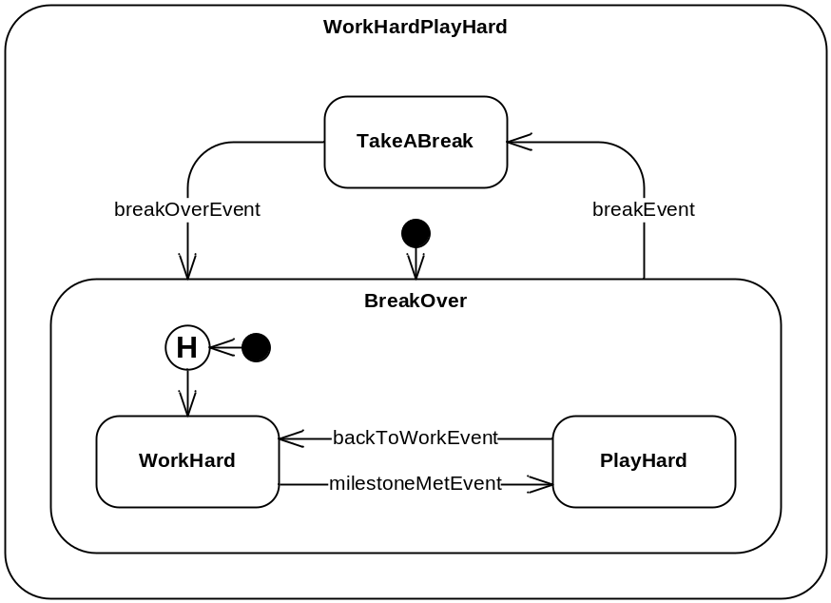

Figure 3-5: Work Hard Play Hard Example

The source code for this state machine is included in the NSF examples.

Tips:

- Be sure to provide a default transition out of the history pseudo state to indicate what should happen on first entry.

Composite States and Concurrency

As seen in the examples above, nested substates can be easily implemented by specifying the parent composite state in their constructor. Alternatively, substates can be implemented by first creating a region within a composite state, and then nesting substates within the region. Another alternative, illustrated in later chapters, is to nest submachines within a composite state.

Concurrent behavior is implemented in a state machine by creating multiple regions within a composite state, each region having its own set of substates. When an event is processed by a composite state, all regions within the substate are given the opportunity to handle the event, even if the event was already handled by another substate in a concurrent region. Remember that an event is considered “handled” only if it causes a transition to occur. Otherwise, the event is considered “unhandled”. Concurrent behavior is different than non-concurrent behavior, wherein the first state to handle the event is the only state that will have an opportunity to handle the event.

Tips:

- It is easy to get carried away with nested substates and concurrent regions. Don’t try to fit the behavior of an entire system into one state machine. The most flexible state machine designs (and software designs in general) group only those behaviors that truly require coupling. Remember, a key philosophy in good software design is to “divide and conquer”.

Regions are often organized into “swim-lanes” as illustrated in Figure 3-6 below. In this example, a hypothetical system contains two subsystems that must be coordinated by the system. This example also illustrates the use of a fork-join to provide synchronization and branching across regions. A fork-join provides synchronization by requiring all incoming transitions to occur before the outgoing transitions occur. Once all incoming transitions have taken place, all outgoing transitions will be taken. It is not valid to place a trigger or a guard on a transition exiting a fork-join. Fork-joins are the only mechanism that can affect a transition that crosses region boundaries, because it is not valid to have a transition between states in different regions.

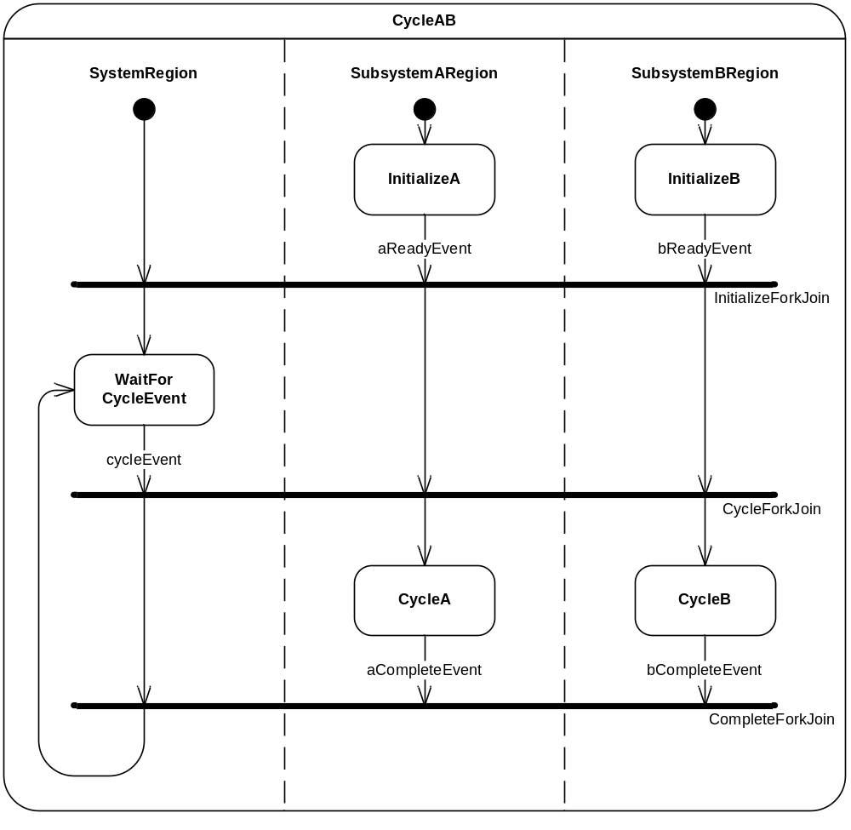

Figure 3-6: CycleAB Example

As with all NSF classes, fork-joins are easy to implement because there is a one-to-one correlation between graphical elements and NSF classes. The following source code illustrates part of the class declaration for the CycleAB Example state machine.

class CycleAB : public NSFStateMachine
{
…
protected:
…
// Events
NSFEvent cycleEvent;
NSFEvent aReadyEvent;
NSFEvent bReadyEvent;
NSFEvent aCompleteEvent;
NSFEvent bCompleteEvent;

// Regions and states, from outer to inner
NSFRegion systemRegion;
NSFRegion subsystemARegion;
NSFRegion subsystemBRegion;
NSFForkJoin initializeForkJoin;
NSFForkJoin cycleForkJoin;
NSFForkJoin completeForkJoin;

// System Region
// Regions and states, from outer to inner
NSFInitialState systemInitialState;
NSFCompositeState waitForCycleEventState;
// Transitions, ordered internal, local, external
NSFExternalTransition systemInitialToInitializeForkJoinTransition;
NSFExternalTransition initializeForkJoinToWaitForCycleEventTransition;
NSFExternalTransition waitForCycleEventToCycleForkJoinTransition;
NSFForkJoinTransition cycleForkJoinToCompleteForkJoinTransiiton;
NSFExternalTransition completeForkJoinToWaitForCycleEventTransition;

// Subystem A Region
// Regions and states, from outer to inner
NSFInitialState subsystemAInitialState;
NSFCompositeState initializeAState;
NSFCompositeState cycleAState;
// Transitions, ordered internal, local, external
NSFExternalTransition subsystemAInitialToInitializeATransition;
NSFExternalTransition initializeAToInitializeForkJoinTransition;
NSFForkJoinTransition initializeForkJoinToCycleForkJoinARegionTransition;
NSFExternalTransition cycleForkJoinToCycleATransition;
NSFExternalTransition cycleAToCompleteForkJoinTransition;

// Subystem B Region
// Regions and states, from outer to inner
NSFInitialState subsystemBInitialState;
NSFCompositeState initializeBState;
NSFCompositeState cycleBState;
// Transitions, ordered internal, local, external
NSFExternalTransition subsystemBInitialToInitializeBTransition;
NSFExternalTransition initializeBToInitializeForkJoinTransition;
NSFForkJoinTransition initializeForkJoinToCycleForkJoinBRegionTransition;
NSFExternalTransition cycleForkJoinToCycleBTransition;
NSFExternalTransition cycleBToCompleteForkJoinTransition;
…
};

Tips:

- All incoming transitions to a fork-join must originate from different regions, except in the case of fork-join to fork-join transitions (see below).
- All outgoing transitions from a fork-join must terminate in different regions, except in the case of fork-join to fork-join transitions (see below).
- As an extension to UML 2.x, NSF provides a fork-join to fork-join transition, implemented in the class NSFForkJoinTransition.
- Each transition into the fork-join occurs as soon as it is satisfied.
- Note that the NSF Fork-Join is an amalgamation of the UML Fork and Join constructs.

Extending State Machines

In contrast to many state machine tools, extending an NSF state machine through inheritance or composition is a straightforward process. NSF does not rely on a code generation tool to extend state machines; rather, the framework itself is designed to make it easy to add states, entry/exit actions, transitions, guards, or other features.

Tips:

- Make structural changes to a state machine only when it is not running, preferably at construction time. The same holds for adding and removing event reactions to generic event handlers.
- Use a single thread to construct and make structural changes to a state machine.

Inheritance

Extending an NSF state machine through inheritance is as simple as deriving a new state machine class from the base state machine, and then defining the new features therein. As an example, suppose we want to extend the previously described CommandProcessor state machine such that it will automatically retry sending the command after the first response timeout. This extension is illustrated below:

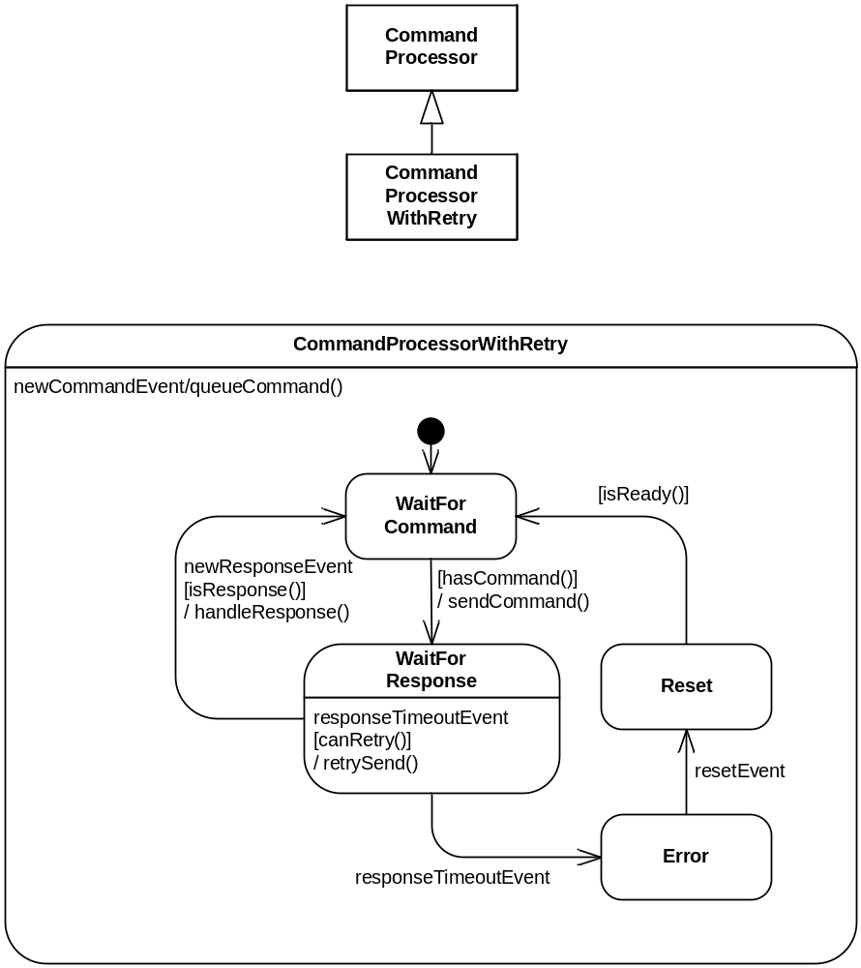

Figure 3-7: Command Processor With Retry Example

To accomplish this change, we simply derive the CommandProcessorWithRetry class from the CommandProcessor class, and include the internal transition and guard. The source code to implement the new class is shown below.

class CommandProcessorWithRetry : public CommandProcessor
{
public:

CommandProcessorWithRetry(NSFString& name);
~CommandProcessorWithRetry();

private:
…
// State Machine Components
NSFInternalTransition waitForResponseReactionToResponseTimeout;

// State machine guards and actions
void waitForResponseEntryActions(const NSFStateMachineContext& context);
void retrySend(const NSFStateMachineContext& context);
bool canRetry(const NSFStateMachineContext& context);
};

CommandProcessorWithRetry::CommandProcessorWithRetry(NSFString& name)
: CommandProcessor(name), retries(0), maxRetries(1), waitForResponseReactionToResponseTimeout("WaitForResponseReactionToResponseTimeout", &waitForResponseState, &responseTimeoutEvent, NSFGuard(this, &CommandProcessorWithRetry::canRetry), NSFAction(this, &CommandProcessorWithRetry::retrySend))
{
waitForResponseState.EntryActions +=
NSFAction(this, &CommandProcessorWithRetry::waitForResponseEntryActions);
}

CommandProcessorWithRetry::~CommandProcessorWithRetry()
{
terminate(true);
}

void CommandProcessorWithRetry::retrySend(const NSFStateMachineContext& context)
{
++retries;

// Code to re-send the command goes here
// …

// Schedule timeout event, in case no response received
responseTimeoutEvent.schedule(responseTimeout, 0);
}

void CommandProcessorWithRetry::waitForResponseEntryActions(const NSFStateMachineContext& context)
{
retries = 0;
}

bool CommandProcessorWithRetry::canRetry(const NSFStateMachineContext& context)
{
return (retries < maxRetries);
}

Composition

Another way to extend NSF state machines is via composition, using a powerful technique which facilitates which we call “pluggable state machine strategies”. There are two mechanisms for implementing state machine composition. The first mechanism is to use an externally defined state machine in place of a state, and the second is to plug in an externally defined state machine as a “submachine” within an existing NSFCompositeState.

State Machines as States

The first type of composition is possible because the NSFStateMachine class inherits from the NSFState class. This allows state machines to be treated just like any other state from a construction perspective. As an example of this type of composition, suppose there is an existing state machine that we wanted to include as part of the CommandProcessor to perform reset behavior after exiting the error state. The state machine might look as follows.

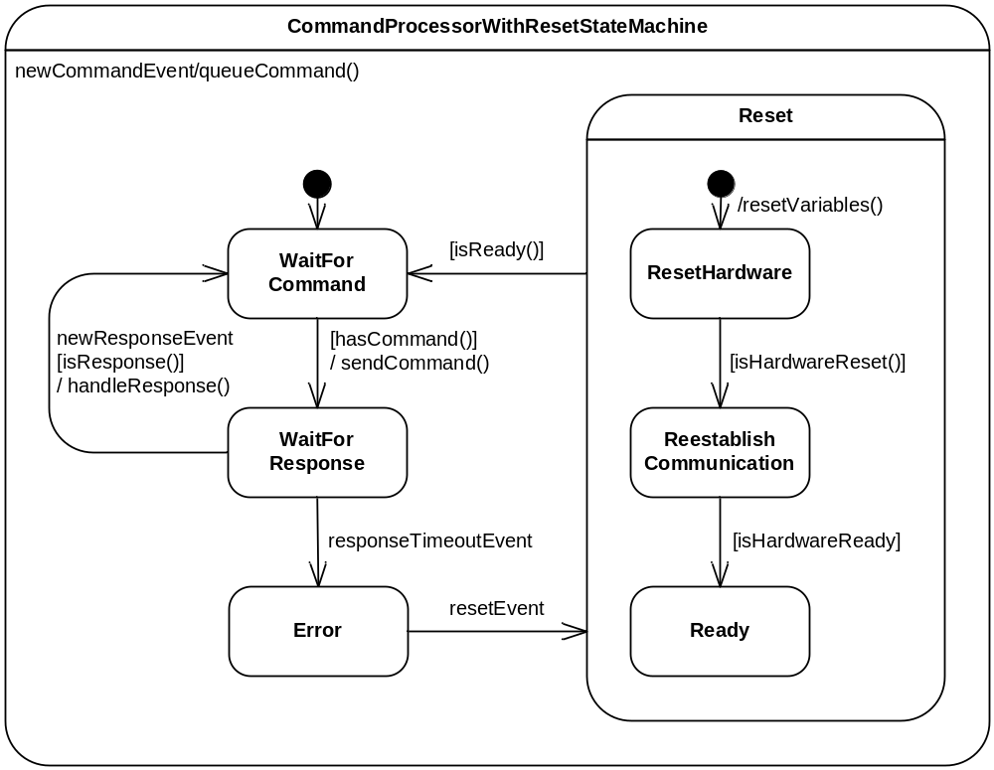

Figure 3-8: Command Processor With Reset State Machine Example

The source code to declare this state machine is as follows. Note how the ResetStrategy state machine is treated just like any other state during construction.

class CommandProcessorWithResetStateMachine : public NSFStateMachine
{
public:
…
CommandProcessorWithResetStateMachine(NSFString& name);

protected:
…
// Events
NSFDataEvent<string> newCommandEvent;
NSFDataEvent<string> newResponseEvent;
NSFEvent responseTimeoutEvent;
NSFEvent resetEvent;

// Regions and states, from outer to inner
NSFInitialState initialCommandProcessorState;
NSFCompositeState waitForCommandState;
NSFCompositeState waitForResponseState;
NSFCompositeState errorState;
// The ResetStrategy state machine is used as a state within this state machine.
ResetStrategy resetState;

// Transitions, ordered internal, local, external
NSFInternalTransition reactionToNewCommand;
NSFExternalTransition initialCommandProcessorToWaitForCommandTransition;
NSFExternalTransition waitForCommandToWaitForResponseTransition;
NSFExternalTransition waitForResponseToWaitForCommandTransition;
NSFExternalTransition waitForResponseToErrorTransition;
NSFExternalTransition errorToResetTransition;
NSFExternalTransition resetToWaitForCommandTransition;
…
};

State Machines as Pluggable Strategies

The second mechanism for implementing state machine composition is to plug in an externally defined state machine as a “submachine” within an existing NSFCompositeState. This technique is beneficial for designs where a base state machine describes the general behavior of several types of objects, and there exists a library of common strategies that need to be plugged into the base state machine. Not all designs benefit from this type of decomposition, but for those that do, this feature that saves enormous amounts of development and debug time.

A state machine and source code illustrating this technique is shown below. This state machine is behaviorally identical to the state machine in the previous section, but illustrates a different mechanism for implementation.

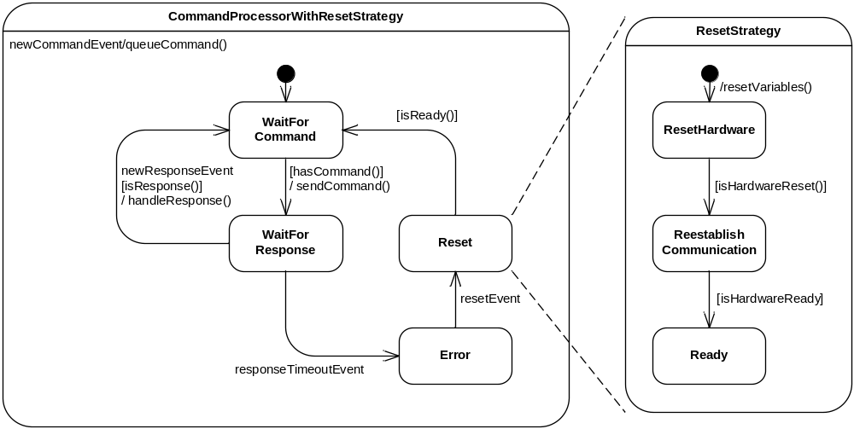

Figure 3-9: Command Processor With Reset Strategy Example

class CommandProcessorWithResetStrategy : public CommandProcessor
{
public:

CommandProcessorWithResetStrategy(NSFString& name);
~CommandProcessorWithResetStrategy();

private:

// The ResetStrategy state machine is a member of the derived class.
// It is plugged into the Reset state during initialization.
ResetStrategy resetState;
bool isReady(const NSFStateMachineContext& context);
};

CommandProcessorWithResetStrategy::CommandProcessorWithResetStrategy(NSFString& name)
: CommandProcessor(name), resetStrategy("ResetStrategy", &resetState)
{
resetToWaitForCommandTransition.Guards += NSFGuard(this, &CommandProcessorWithResetStrategy::isReady);
}

CommandProcessorWithResetStrategy::~CommandProcessorWithResetStrategy()
{
terminate(true);
}

bool CommandProcessorWithResetStrategy::isReady(const NSFStateMachineContext& context)
{
return resetStrategy.getReadyState().isActive();
}

For designs that lend themselves to this type of composition, this feature allows for a tremendous amount of reuse, thus saving time and reducing defects.

Tracing

NSF contains built-in support for tracing the run-time behavior of your application. The NSFTraceLog class implements this functionality. To turn on tracing (it is disabled by default), make the call:

NSFTraceLog::getPrimaryTraceLog().setEnabled(true);

The base tracing functionality is to automatically log event queueing and state entry. In addition, applications can log their own traces to record information of interest through the addTrace(…) methods. Finally, the trace file can be saved to an xml file at any time by calling the saveLog(…) method. Following is an excerpt from an example trace file.

<TraceLog>
…
<Trace>
<Time>6531</Time>
<EventQueued>
<Name>NewCommandEvent</Name>
<Source>CommandProcessor</Source>
<Destination>CommandProcessor</Destination>
</EventQueued>
</Trace>
…
<Trace>
<Time>6547</Time>
<StateEntered>
<StateMachine>CommandProcessor</StateMachine>
<State>WaitForResponseState</State>
</StateEntered>
</Trace>
<Trace>
<Time>7031</Time>
<EventQueued>
<Name>NewResponseEvent</Name>
<Source>CommandProcessor</Source>
<Destination>CommandProcessor</Destination>
</EventQueued>
</Trace>
<Trace>
<Time>7047</Time>
<StateEntered>
<StateMachine>CommandProcessor</StateMachine>
<State>WaitForCommandState</State>
</StateEntered>
</Trace>
…
</TraceLog>

Each individual trace within the log has the following format (where text with the square brackets is trace specific).

<Trace>
<Time>[time in mS since application began]</Time>
<[trace type]>
<[tag1]>[data1]</[tag1]>
…
</[trace type]>
</Trace>

In order to keep the trace file from growing indefinitely, the maximum number of traces in the log is capped at a user specifiable number, with the default being 500 traces. After the maximum number of traces is reached, each new trace added to the log results in the removal of the oldest trace in the log.

Tracing is an invaluable tool for understanding the run-time behavior of your application. The xml format of the trace file makes it easy to integrate with visualization tools or spreadsheet applications such as Microsoft Office Excel™.

Tips:

- If your application permits, turn on tracing so that you have the trace information should it be needed.

Exception Handling

The NSF strategy for handling run-time exceptions is to capture all exceptions, so that the application stays up and running, and to provide a mechanism to notify the application of exceptions when they occur. Exceptions during construction of NSF classes are not caught, as most construction activity occurs during application startup.

Exceptions are caught by NSF classes that implement delegates, threads, state machines, and trace logs. This approach ensures that a bad action, event, guard, etc won’t take down a state machine, or worse, the entire application. In all cases, the exception is caught, and then passed to a parent object, along with context information. If there is no parent object to pass the exception information on to, it is passed to the global exception handler, NSFExceptionHandler. In this manner, all run-time exceptions eventually propagate up to the global exception handler, which logs a trace, optionally saves a trace file, and calls any application exception actions registered with its ExceptionActions list.

Exception actions follow the same delegate pattern used for state entry and exit actions, with a slightly different function signature. Correspondingly, the NSFAction template functions can be used to add member and global (or static) function delegates to the exception action lists. The function signature for an exception action is:

void methodName(const NSFExceptionContext& context);

However, the templates allow nullary (argument-less) functions to be wrapped as well.

The following example illustrates how to register an exception action with the global exception handler.

void exceptionAction(const NSFExceptionContext& context)
{
std::cout << "Exception caught: " << context.getException().what() << std::endl;
}

int main()
{
…
NSFExceptionHandler::ExceptionActions += NSFAction(exceptionAction);
…
}

In addition to the global exception handler, there are three other locations where an application can register an exception action: NSFEventThread::ExceptionActions, NSFTimerThread::ExceptionActions, and NSFStateMachine::ExceptionActions.

Porting to a New Platform

The NSF platform abstraction layer consists of four classes: NSFOSMutex, NSFOSSignal, NSFOSThread, and NSFOSTimer. The process of porting NSF to a new platform involves creating concrete classes derived from these base classes, defining constructors and bodies for their pure virtual methods, defining creation methods for these concrete classes, and customizing any configuration settings.

NSF in C++ V2.1 supports the following platforms:

- Windows (WIN32 API)
- eCOS
- POSIX.4

Following the example classes from these platform abstraction layers is helpful in porting to other environments.

NSFOSMutex

NSFOSMutex is the base class defining objects that provide mutual exclusion for a shared resource. It contains two pure virtual methods that must be provided by the derived class.

/// <summary>
/// Represents a mutex that may be used to provide mutual exclusion for a shared resource.
/// </summary>
class NSFOSMutex
{
public:
…
/// <summary>
/// Locks the mutex.
/// </summary>
/// </remarks>
/// If the mutex is already locked when the calling thread calls lock,
/// then the calling thread will block until the mutex is unlocked.
/// </remarks>
virtual void lock() = 0;

/// <summary>
/// Unlocks the mutex.
/// </summary>
virtual void unlock() = 0;
…
};

The derived class should provide a constructor with the following signature (illustrated from the WIN32 implementation).

/// <summary>
/// Creates a mutex.
/// </summary>
NSFOSMutex_WIN32();

Finally, the static NSFOSMutex::create() method must be defined. This method can be defined in the concrete class’ implementation file, e.g. NSFOSMutex_WIN32.cpp, as illustrated below:

NSFOSMutex* NSFOSMutex::create()
{
return new NSFOSMutex_WIN32();
}

NSFOSSignal

NSFOSSignal is the base class defining objects that provide a mechanism to block a thread until a signal is sent. It contains four pure virtual methods that must be provided by the derived class.

/// <summary>
/// Represents a signal that may be used to block thread execution until
/// the signal is sent.
/// </summary>
class NSFOSSignal : public NSFTimerAction
{
public:
…
/// <summary>
/// Clears the signal.
/// </summary>
/// <remarks>
/// This method sets the signal to a non-signaled state,
/// so that the next wait will block until a send is called.
/// </remarks>
virtual void clear() = 0;

/// <summary>
/// Sends the signal.
/// </summary>
virtual void send() = 0;

/// <summary>
/// Waits for signal to be sent.
/// </summary>
/// <returns>True if the signal was sent, false otherwise.</returns>
/// <remarks>
/// This method will block the calling thread until the signal is sent.
/// Multiple threads must not wait on the same signal.
/// </remarks>
virtual bool wait() = 0;

/// <summary>
/// Waits for up to <paramref name="timeout"/> milliseconds for a signal to be sent.
/// </summary>
/// <param name="timeout">The maximum number of milliseconds to wait.</param>
/// <returns>True if the signal was sent, false otherwise.</returns>
/// <remarks>
/// This method will block the calling thread until the signal is sent or
/// the timeout occurs. Multiple threads must not wait on the same signal.
/// </remarks>
virtual bool wait(Int32 timeout) = 0;
…
};

The derived class should also provide a constructor with the following signature (illustrated from the WIN32 implementation).

/// <summary>
/// Creates a signal.
/// </summary>
/// <param name="name">The name of the signal.</param>
NSFOSSignal_WIN32(const NSFName& name);

Finally, the static NSFOSSignal::create() method must be defined. This method can be defined in the concrete class’ implementation file, e.g. NSFOSSignal_WIN32.cpp, as illustrated below:

NSFOSSignal* NSFOSSignal::create(const NSFString& name)
{
return new NSFOSSignal_WIN32(name);
}

NSFOSThread

NSFOSThread is the base class defining objects that provide a thread of execution. It contains four pure virtual methods that must be provided by the derived class.

/// <summary>
/// Represents a general purpose thread.
/// </summary>
class NSFOSThread : public NSFTaggedObject
{
public:

/// <summary>
/// Gets the priority of the thread.
/// </summary>
/// <returns>The priority of the thread.</returns>
virtual int getPriority() = 0;

/// <summary>
/// Sets the priority of the thread.
/// </summary>
/// <param name="priority">The priority of the thread.</param>
virtual void setPriority(int priority) = 0;

/// <summary>
/// Gets the operating system specific thread id.
/// </summary>
/// <returns>The OS specific thread id.</returns>
virtual int getOSThreadId() = 0;
…
/// <summary>
/// Starts the thread by calling its execution action.
/// </summary>
virtual void startThread() = 0;
…
};

The derived class should also provide two constructors with the following signatures (illustrated from the WIN32 implementation).

/// <summary>
/// Creates a thread.
/// </summary>
/// <param name="name">The name for the thread.</param>
/// <param name="executionAction">The action executed by the thread.</param>
/// <returns>The new thread.</returns>
/// <remarks>
/// The thread execution action is typically an execution loop.
/// When the action returns, the thread is terminated.
/// </remarks>
NSFOSThread_WIN32(const NSFName& name, const NSFAction& executionAction);

/// <summary>
/// Creates a thread.
/// </summary>
/// <param name="name">The name for the thread.</param>
/// <param name="executionAction">The action executed by the thread.</param>
/// <param name="priority">The priority of the thread.</param>
/// <returns>The new thread.</returns>
/// <remarks>
/// The thread execution action is typically an execution loop.
/// When the action returns, the thread is terminated.
/// </remarks>
NSFOSThread_WIN32(const NSFName& name, const NSFAction& executionAction, UInt32 priority);

The derived class must call the base class method executeAction() from its thread entry method. This call will pass control to the executionAction specified in the constructor.

In addition to the static create methods, several static method definitions in the NSFOSThread base class need to be completed for the new platform. These methods are:

/// <summary>
/// Represents a general purpose thread.
/// </summary>
class NSFOSThread : public NSFTaggedObject
{
public:

/// <summary>
/// Gets the value for the highest priority thread.
/// </summary>
/// <returns>The highest thread priority.</returns>
/// <remarks>
/// This methods returns the highest priority that an NSFOSThread may have.
/// The system may support higher thread priorities which are reserved for system use.
/// Only the NSFOSTimer should use this priority level.
/// </remarks>
int getHighestPriority();

/// <summary>
/// Gets the value for a high priority thread.
/// </summary>
/// <returns>The highest thread priority.</returns>
/// <remarks>
/// Use setPriority to set a threads priority.
/// </remarks>
int getHighPriority();

/// <summary>
/// Gets the value for the lowest priority thread.
/// </summary>
/// <returns>The lowest thread priority.</returns>
/// <remarks>
/// This methods returns the lowest priority that an NSFOSThread may have.
/// The system may support lower thread priorities which are reserved for system use.
/// </remarks>
int getLowestPriority();

/// <summary>
/// Gets the value for a low priority thread.
/// </summary>
/// <returns>The low thread priority.</returns>
/// <remarks>
/// Use setPriority to set a threads priority.
/// </remarks>
int getLowPriority();

/// <summary>
/// Gets the value for a medium priority thread.
/// </summary>
/// <returns>The medium thread priority.</returns>
/// <remarks>
/// Use setPriority to set a threads priority.
/// </remarks>
int getMediumPriority();
…
/// <summary>
/// Sleeps the calling thread for the specified number of milliseconds.
/// </summary>
/// <param name="sleepTime">Time to sleep in milliseconds.</param>
/// <remarks>
/// This method sleeps the calling thread, not the thread object on which it is called.
/// A sleep time of zero has OS defined behavior.
/// </remarks>
virtual void sleep(UInt32 sleepTime) = 0;
…
};

These methods can be defined in the concrete class’ implementation file, e.g. NSFOSThread_WIN32.cpp, as illustrated below:

NSFOSThread* NSFOSThread::create(const NSFString& name,
const NSFVoidAction<NSFContext>& executionAction)
{
return new NSFOSThread_WIN32(name, executionAction);
}

void NSFOSThread::sleep(UInt32 sleepTime)
{
::Sleep(sleepTime);
}

NSFOSTimer

NSFOSTimer is the base class defining objects that provide a timing mechanism. It contains three pure virtual methods that must be provided by the derived class.

/// <summary>
/// Represents a simple timer.
/// </summary>
class NSFOSTimer : public NSFTaggedObject
{
public:
…
/// <summary>
/// Gets the current time in milliseconds since the timer was created.
/// </summary>
/// <returns>The current time in milliseconds.</returns>
virtual NSFTime getCurrentTime() = 0;
…
/// <summary>
/// Sets the next timeout.
/// </summary>
/// <param name="timeout">The relative time until the next timeout in milliseconds.</param>
/// <remarks>
/// A thread blocked by the method waitForNextTimeTimeout() must unblock
/// after the specified timeout.
/// </remarks>
virtual void setNextTimeout(NSFTime timeout) = 0;

/// <summary>
/// Waits for the next tick period.
/// </summary>
/// <remarks>
/// This method shall block the calling thread until the timeout specified
/// by setNextTimeout(...).
/// </remarks>
virtual void waitForNextTimeout() = 0; …
};

The derived class should also provide a constructor with the following signature (illustrated from the WIN32 implementation).

/// <summary>
/// Creates a timer.
/// </summary>
/// <param name="name">The name of the timer.</param>
/// <param name="tickPeriod">The tick period of the timer.</param>
/// <remarks>
/// The tick period defines the resolution of the timer,
/// and is used by the method waitForNextTick().
/// </remarks>
NSFOSTimer_WIN32(const NSFName& name, UInt32 tickPeriod);

Finally, the static NSFOSTimer::create() method must be defined. This method can be defined in the concrete class’ implementation file, e.g. NSFOSTimer_WIN32.cpp, as illustrated below:

NSFOSTimer* NSFOSTimer::create(const NSFString& name, UInt32 tickPeriod)
{
return new NSFOSTimer_WIN32(name, tickPeriod);
}

Custom Configuration

The file NSFCustomConfig.h contains customization settings which can be useful when porting to a new platform. Several configuration settings are shown below.

// This switch allows applications to control when the first threads are
// started. Comment out this line to keep the timer and trace log from
// auto starting during program initialization. If this line is commented
// out, applications must call NSFEnvironment::start() before using the
// framework classes.
#define NSF_AUTO_START

// This switch allows applications to define their own types for the core
// integer types: Int8, UInt8, Int16, UInt16, Int32, UInt32, Int64, UInt64.
// Comment out this line to keep NSF from defining these core types. If
// this line is commented out, applications must provide type definitions
// for these types as part of this file, either directly or indirectly.
#define NSF_DEFINE_INTEGER_TYPES

// This switch allows applications to define which operating system to
// target. Comment out all but one of these lines to select the operating
// system, or use a compilation constant.
#define NSF_OS_WIN32
//#define NSF_OS_ECOS
//#define NSF_OS_POSIX

// This setting controls the tick period (resolution) of the NSF timer,
// if supported by the abstraction layer for the particular operating system.
#define NSF_TIMER_TICK_PERIOD 1 // in milliseconds

After completing writing the concrete abstraction layer classes and setting up any custom configuration, the framework is ready to be compiled for the target platform.

Conclusion

We thank you for your interest in North State Software and the North State Framework. As you work with the framework, please share your experiences with us at: http://www.northstatesoftware.com.

