本文是关于ESP8266芯片使用arduino框架的WIFI和UDP发包官方文档, 原文地址:
WIFI
https://arduino-esp8266.readthedocs.io/en/latest/esp8266wifi/readme.html
UDP
https://arduino-esp8266.readthedocs.io/en/latest/esp8266wifi/udp-examples.html

ESP8266WiFi library
ESP8266 is all about Wi-Fi. If you are eager to connect your new ESP8266 module to a Wi-Fi network to start sending and receiving data, this is a good place to start. If you are looking for more in depth details of how to program specific Wi-Fi networking functionality, you are also in the right place.

Introduction
The Wi-Fi library for ESP8266 has been developed based on ESP8266 SDK, using the naming conventions and overall functionality philosophy of the Arduino WiFi library. Over time, the wealth of Wi-Fi features ported from ESP9266 SDK to esp8266 / Arduino outgrew Arduino WiFi library and it became apparent that we would need to provide separate documentation on what is new and extra.
This documentation will walk you through several classes, methods and properties of the ESP8266WiFi library. If you are new to C++ and Arduino, don’t worry. We will start from general concepts and then move to detailed description of members of each particular class including usage examples.
The scope of functionality offered by the ESP8266WiFi library is quite extensive and therefore this description has been broken up into separate documents marked with :arrow_right:.

Quick Start
Hopefully, you are already familiar how to load the Blink.ino sketch to an ESP8266 module and get the LED blinking. If not, please use this tutorial by Adafruit or another great tutorial developed by Sparkfun.
To hook up the ESP module to Wi-Fi (like hooking up a mobile phone to a hot spot), you need only a couple of lines of code:
#include <ESP8266WiFi.h>
void setup(){
Serial.begin(115200);
Serial.println();

WiFi.begin("network-name", "pass-to-network");

Serial.print("Connecting");
while (WiFi.status() != WL_CONNECTED)
{
delay(500);
Serial.print(".");
}
Serial.println();

Serial.print("Connected, IP address: ");
Serial.println(WiFi.localIP());}
void loop() {}
In the line WiFi.begin("network-name", "pass-to-network") replace network-name and pass-to-network with the name and password of the Wi-Fi network you would like to connect to. Then, upload this sketch to ESP module and open the serial monitor. You should see something like:
How does it work? In the first line of the sketch, #include <ESP8266WiFi.h> we are including the ESP8266WiFi library. This library provides ESP8266 specific Wi-Fi routines that we are calling to connect to the network.
The actual connection to Wi-Fi is initialized by calling:
WiFi.begin("network-name", "pass-to-network");
The connection process can take couple of seconds and we are checking for whether this has completed in the following loop:
while (WiFi.status() != WL_CONNECTED){
delay(500);
Serial.print(".");}
The while() loop will keep looping as long as WiFi.status() is other than WL_CONNECTED. The loop will exit only if the status changes to WL_CONNECTED.
The last line will then print out the IP address assigned to the ESP module by DHCP:
Serial.println(WiFi.localIP());
If you don’t see the last line but just more and more dots ........., then likely name or password to the Wi-Fi network is entered incorrectl in the sketchy. Verify the name and password by connecting from scratch to this Wi-Fi network with a PC or a mobile phone.
Note: if connection is established, and then lost for some reason, ESP will automatically reconnect to the last used access point once it is again back on-line. This will be done automatically by Wi-Fi library, without any user intervention.
That’s all you need to connect ESP8266 to Wi-Fi. In the following chapters we will explain what cool things can be done by the ESP once it’s connected.

Who is Who
Devices that connect to Wi-Fi networks are called stations (STA). Connection to Wi-Fi is provided by an access point (AP), that acts as a hub for one or more stations. The access point on the other end is connected to a wired network. An access point is usually integrated with a router to provide access from a Wi-Fi network to the internet. Each access point is recognized by a SSID (Service Set IDentifier), that essentially is the name of network you select when connecting a device (station) to the Wi-Fi.
ESP8266 modules can operate as a station, so we can connect it to the Wi-Fi network. It can also operate as a soft access point (soft-AP), to establish its own Wi-Fi network. When the ESP8266 module is operating as a soft access point, we can connect other stations to the ESP module. ESP8266 is also able to operate as both a station and a soft access point mode. This provides the possibility of building e.g. mesh networks.
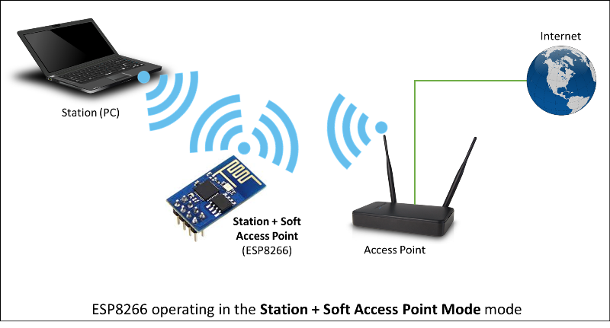
The ESP8266WiFi library provides a wide collection of C++ methods (functions) and properties to configure and operate an ESP8266 module in station and / or soft access point mode. They are described in the following chapters.

Class Description
The ESP8266WiFi library is broken up into several classes. In most of cases, when writing the code, the user is not concerned with this classification. We are using it to break up description of this library into more manageable pieces.
Chapters below describe all function calls (methods and properties in C++ terms) listed in particular classes of ESP8266WiFi. The description is illustrated with application examples and code snippets to show how to use functions in practice. This information is broken up into the following documents.

Station
Station (STA) mode is used to get the ESP module connected to a Wi-Fi network established by an access point.
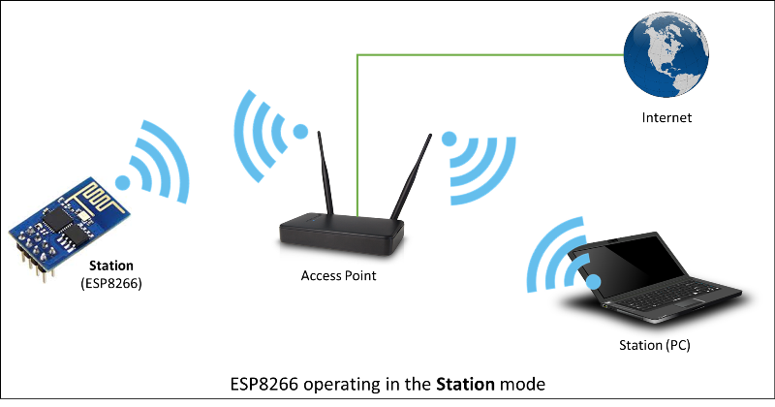
Station class has several features to facilitate the management of a Wi-Fi connection. In case the connection is lost, the ESP8266 will automatically reconnect to the last used access point, once it is available again. The same happens on module reboot. This is possible since ESP saves the credentials to the last used access point in flash (non-volatile) memory. Using the saved data ESP will also reconnect if sketch has been changed but code does not alter the Wi-Fi mode or credentials.
Station Class documentation
Check out separate section with examples.

Soft Access Point
An access point (AP) is a device that provides access to a Wi-Fi network to other devices (stations) and connects them to a wired network. The ESP8266 can provide similar functionality, except it does not have interface to a wired network. Such mode of operation is called soft access point (soft-AP). The maximum number of stations that can simultaneously be connected to the soft-AP can be set from 0 to 8, but defaults to 4.
The soft-AP mode is often used and an intermediate step before connecting ESP to a Wi-Fi in a station mode. This is when SSID and password to such network is not known upfront. ESP first boots in soft-AP mode, so we can connect to it using a laptop or a mobile phone. Then we are able to provide credentials to the target network. Then, the ESP is switched to the station mode and can connect to the target Wi-Fi.
Another handy application of soft-AP mode is to set up mesh networks. The ESP can operate in both soft-AP and Station mode so it can act as a node of a mesh network.
Soft Access Point Class documentation
Check out the separate section with examples.

Scan
To connect a mobile phone to a hot spot, you typically open Wi-Fi settings app, list available networks and pick the hot spot you need. Then enter a password (or not) and you are in. You can do the same with the ESP. Functionality of scanning for, and listing of available networks in range is implemented by the Scan Class.
Scan Class documentation
Check out the separate section with examples.

Client
The Client class creates clients that can access services provided by servers in order to send, receive and process data.
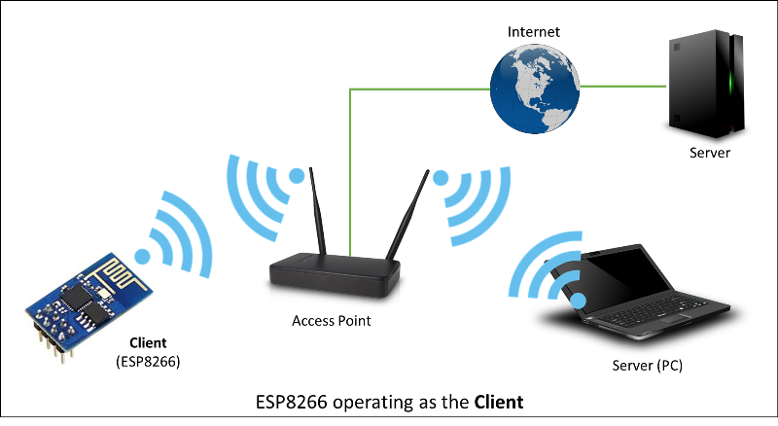
Check out the separate section with examples / list of functions

UDP
The purpose of example application below is to demonstrate UDP communication between ESP8266 and an external client. The application (performing the role of a server) is checking inside the loop() for an UDP packet to arrive. When a valid packet is received, an acknowledge packet is sent back to the client to the same port it has been sent out.

Table of Contents
- Declarations
- Wi-Fi Connection
- UDP Setup
- An UDP Packet Arrived!
- An Acknowledge Send Out
- Complete Sketch
- How to Check It?
- Conclusion

Declarations
At the beginning of sketch we need to include two libraries:
#include <ESP8266WiFi.h>#include <WiFiUdp.h>
The first library ESP8266WiFi.h is required by default if we are using ESP8266’s Wi-Fi. The second one WiFiUdp.h is needed specifically for programming of UDP routines.
Once we have libraries in place we need to create a WiFiUDP object. Then we should specify a port to listen to incoming packets. There are conventions on usage of port numbers, for information please refer to the List of TCP and UDP port numbers. Finally we need to set up a buffer for incoming packets and define a reply message.
WiFiUDP Udp;unsigned int localUdpPort = 4210;char incomingPacket[256];char replyPacket[] = "Hi there! Got the message :-)";

Wi-Fi Connection
At the beginning of setup() let’s implement typical code to connect to an access point. This has been discussed in Quick Start. Please refer to it if required.

UDP Setup
Once connection is established, you can start listening to incoming packets.
Udp.begin(localUdpPort);
That is all required preparation. We can move to the loop() that will be handling actual UDP communication.

An UDP Packet Arrived!
Waiting for incoming UDP packed is done by the following code:
int packetSize = Udp.parsePacket();if (packetSize){
Serial.printf("Received %d bytes from %s, port %d\n", packetSize, Udp.remoteIP().toString().c_str(), Udp.remotePort());
int len = Udp.read(incomingPacket, 255);
if (len > 0)
{
incomingPacket[len] = '\0';
}
Serial.printf("UDP packet contents: %s\n", incomingPacket);

(...)}
Once a packet is received, the code will printing out the IP address and port of the sender as well as the length of received packet. If the packet is not empty, its contents will be printed out as well.

An Acknowledge Send Out
For each received packet we are sending back an acknowledge packet:
Udp.beginPacket(Udp.remoteIP(), Udp.remotePort());Udp.write(replyPacket);Udp.endPacket();
Please note we are sending reply to the IP and port of the sender by using Udp.remoteIP() and Udp.remotePort().

Complete Sketch
The sketch performing all described functionality is presented below:
#include <ESP8266WiFi.h>#include <WiFiUdp.h>
const char* ssid = "********";const char* password = "********";
WiFiUDP Udp;unsigned int localUdpPort = 4210; // local port to listen onchar incomingPacket[255]; // buffer for incoming packetschar replyPacket[] = "Hi there! Got the message :-)"; // a reply string to send back

void setup(){
Serial.begin(115200);
Serial.println();

Serial.printf("Connecting to %s ", ssid);
WiFi.begin(ssid, password);
while (WiFi.status() != WL_CONNECTED)
{
delay(500);
Serial.print(".");
}
Serial.println(" connected");

Udp.begin(localUdpPort);
Serial.printf("Now listening at IP %s, UDP port %d\n", WiFi.localIP().toString().c_str(), localUdpPort);}

void loop(){
int packetSize = Udp.parsePacket();
if (packetSize)
{
// receive incoming UDP packets
Serial.printf("Received %d bytes from %s, port %d\n", packetSize, Udp.remoteIP().toString().c_str(), Udp.remotePort());
int len = Udp.read(incomingPacket, 255);
if (len > 0)
{
incomingPacket[len] = 0;
}
Serial.printf("UDP packet contents: %s\n", incomingPacket);

// send back a reply, to the IP address and port we got the packet from
Udp.beginPacket(Udp.remoteIP(), Udp.remotePort());
Udp.write(replyPacket);
Udp.endPacket();
}}

How to Check It?
Upload sketch to module and open serial monitor. You should see confirmation that ESP has connected to Wi-Fi and started listening to UDP packets:
Connecting to twc-net-3 ........ connectedNow listening at IP 192.168.1.104, UDP port 4210
Now we need another application to send some packets to IP and port shown by ESP above.
Instead of programming another ESP, let’s make it easier and use a purpose build application. I have selected the Packet Sender. It is available for popular operating systems. Download, install and execute it.
Once Packet Sender’s window show up enter the following information: * Name of the packet * ASCII text of the message to be send inside the packet * IP Address shown by our ESP * Port shown by the ESP * Select UDP
What I have entered is shown below:
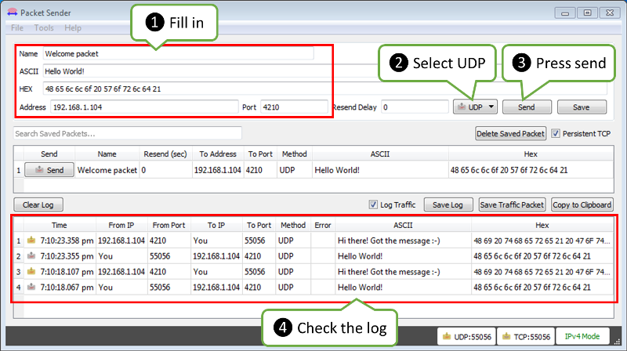
Now click Send.
Immediately after that you should see the following on ESP’s serial monitor:
Received 12 bytes from 192.168.1.106, port 55056
UDP packet contents: Hello World!
The text 192.168.1.106, port 55056 identifies a PC where the packet is send from. You will likely see different values.
As ESP sends an acknowledge packet back, you should see it in the log in the bottom part of the Packet Sender’s window.

Conclusion
This simple example shows how to send and receive UDP packets between ESP and an external application. Once tested in this minimal set up, you should be able to program ESP to talk to any other UDP device. In case of issues to establish communication with a new device, use the Packet Sender or other similar program for troubleshooting
For review of functions provided to send and receive UDP packets, please refer to the UDP Class documentation.

