基于陀螺仪数据的计步器算法, 原文链接:

<https://ieeexplore.ieee.org/abstract/document/6346344>

#### The 8th International Conference on Computer Science & Education (ICCSE 2013)

April 26-28, 2013. Colombo, Sri Lanka SuC2.3

A Gyroscopic Data based Pedometer Algorithm

### Sampath Jayalath



Department of Electrical and Computer Engineering Sri Lanka Institute of Information Technology

New Kandy Rd, Malabe, Sri Lanka [adasdj](mailto:adasdjsampath@gmail.com)[sampath@gmail.com](mailto:sampath@gmail.com)

Abstract-Accuracy of step counting is one of the main problems that exist in current Pedometers, especially when walking slowly on flat lands and performing different activities, such as climbing up and down stairs and walking on inclined planes. Although accelerometer based pedometers provide a reasonable accuracy when walking at higher speeds, the accuracy of them are not sufficient at slow walking speeds and performing different activities. This paper proposes a novel algorithm to detect steps using single-point gyroscopic sensors embedded in mobile devices. Preliminary analysis of data collected in different environments with the involvement of male and female volunteers indicated that gyroscope alone provides sufficient information necessary for accurate step detection. Algorithm was developed based on the gyroscopic data in conjunction with zero crossing and threshold detection techniques. The results proved that gyroscope based step detection algorithm provide a high accuracy when performing different activities and at slow paced walking.

### Keywords-Pedometer algorithms; gyroscopic data; single­ point sensors; o-the-shelfdevices; mobile applications;

1. INTRODUCTION

Modern medical researches highlight that pedometers support not only to physical body but mental activities of human beings to a greater extent[I],[2],[3]. Low cost pedometers help to improve the motivation of the walker [4], indoor navigation, activity recognition and for various applications in the field of health care. Pedometers can be used to detect steps from vertical acceleration of the human body. This works under two systems of mechanism. One is of mechanical based and other being of the electrical based accelerometers. Modem pedometers are generally based on MEMS (micro-electromechanical systems) accelerometer, mostly I-axis, but the use of 2-axis and 3-axis accelerometers, gyroscopes and magnetometers improves precision and releases some utilization constraints e.g. positioning of the pedometer. The accuracy of these systems is at an acceptable level but not perfect due to various drawbacks [5]. Applications of pedometer are now upgraded and can be found in mobile devices. [t is obvious with the application of pedometers to mobile devices, has now improved the standards of healthcare applications.

The approaches of some pedometer algorithms proposed by researchers are discussed in the background section including their features and drawbacks.

#### 978-1-4673-4463-0/13/$31.00 ©2013 IEEE 551

Nimsiri Abhayasinghe

Department of Electrica[ and Computer Engineering Sri Lanka Institute of Information Technology

New Kandy Rd, Malabe, Sri Lanka [nimsiri.a@sliit.lk](mailto:nimsiri.a@sliit.lk)

1. BACKGROUND

S.E Crouter et al. [6] have compared the accuracy and reliability of 10 pedometers available in the market. These pedometers were based on mechanisms like, accelerometer, metal-on-metal and magnetic reed proximity switch. [t is important to notice that all the testing was done at normal walking speeds. Their conclusion was that accuracy of pedometers was highly subjective upon the internal mechanism and sensitivity. But they have failed to measure the accuracy of pedometers when walking slowly and performing different activities like ascending and descending stairs.

Comparative study with commercially available pedometers done by Jerome and Albright [7] has shown accuracies are poor with a minimum average absolute error value of 13%. Their conclusion was that none of the pedometers can be used for research purpose or general usage.

Wasiq Waqar et al. [8] have developed a pedometer based on accelerometer for their "[ndoor Positioning System" which consists of a preset threshold based peak detection method to identify a valid step and step cycle pattern detection method to discard invalid steps due to instantaneous readings of the accelerometer. [t should be noted that the results of the pedometer may change with different individual walking patterns and speeds due to preset threshold.

Melis Oner et al. [9] have implemented another step detecting algorithm for their "Early detection of the falling event system". Step detection of this particular algorithm relies on the detecting peaks within a period in the data produced by the accelerometer sensor during walking. They were able to achieve higher accuracies during higher speeds of walking and with the mobile based pedometer placed fixed and loose in the pocket. However, their algorithms failed to count steps accurately during slow paced walking.

Mi-hee Lee et al. [10] were able to achieve 99% accuracy in their portable acceleration sensor module with some advanced processing like FFT, Fuzzy C and statistical calcu[ations. But they have agreed finally that their system doesn't process data in real time, inability to measure steps during activities [ike ascending and descending stairs walking and need for an efficient device to cary out processing.

A.M. Cavalcante et al. [[ 1] have developed a pedometer to be used with their research on "Real-time indoor tracking on

#### SuC2.3

mobile devices". System compares mean values of acceleration samples in conjunction with a sliding window mechanism to detect steps. Their conclusion was that a proper sampling rate, sliding window and quality sensors embedded in mobile devices are a major requirement to detect steps accurately.



According to Garcia et al. [12] comparative study on the accuracies of mobile phone based pedometers with the commercially available pedometers concluded that mobile phones provide a competitive performance against the commercially available pedometers. Further both indicate less accuracy when at slower speed and high accuracy while in faster walking.

Lim et al. [13] have proposed a pedometer based on gyroscope but not discussed deeply on its practical usage. Zhong et al. [14] has also discussed pedometer based on accelerometer sensor attached to foot with processing done on a PDA and were able to achieve accuracies more than 90%. But none of these pedometers are inconvenient to be used with any application as sensors are attached to the body.

According to G. Boyce et al. [IS] comparative study on the accuracies of mobile phone based pedometer technologies which are freely available in the market, concluded that mobile phone based applications lag behind the use of a commercially available pedometer when determining step count. Further manipulation of settings is required to improve the accuracy of step counting for one activity level, but recalibration is required as intensity of activity changes.

M. Ayabe et al. [16] have conducted an important research on accuracies of pedometers during ascending and descending stairs. They have used one spring-levered and two piezo­ electric pedometers to test the accuracy. Their conclusion was that pedometers can assess the number of step accurately within an acceptable range of measurement error during the stair climbing activities at a stepping rate of 80 step·min-I or faster with 18 cm or higher stairs. However, it should be noted that they have highlighted the poor accuracy at slower stepping rates.

Most of the previous researches have identified that pedometers are less valid and reliable during slow walking speeds. This inaccuracy results from smaller vertical movements of the hip which are below the specific pedometer threshold value and are therefore not recorded. Another limitation is that pedometers do not contain an internal clock; therefore it is not possible to determine the intensity or duration of activity performed.

1. IMPLEMENTED ALGORITHM

The development of this algorithm is based on the experimental results of the research conducted by N. Abhayasinghe et al. on "Indoor Positioning and Indoor Navigation" [17]. This particular algorithm only uses gyroscopic data produced by the mobile device to predict steps. It can be described as follows;

#### 552

1. *Initial concept behind the algorithm*

Leg movement during walking shows a sinusoidal behavior. This behavior can be clearly identified by monitoring the angular velocity of the leg. Therefore one axis of the gyroscope provides the information about the movement of the leg depending on the orientation of the device. A small research on "ways of placing the modern mobile devices on a pocket" proved that almost all the users placed their devices vertically in the pocket. Therefore monitoring the gyroscopic x axis data is considered. It is important to notice for different orientations only variable that needed to change is the axis that we are obtaining data from the gyroscope.

## *Filtering raw data*

Initially raw data are filtered using a proper filter that would preserve the properties of walking. A typical walking pace may be around 2 Hz, while running may be double and slow walking may be half of that. A choice of cutoff frequency that accommodates slow-paced activities is a major concern in achieving better accuracy. Therefore choice of the filter was a simple sixth order Butterworth low-pass filter having a cutoff frequency in the range of 0.9 Hz to 3 Hz. Fig. I depicts the raw gyro-x value and filtered version (2 Hz) of it.

## *Removal ofunwanted signal components*

Gyroscopic data takes a sinusoidal behavior after filtering for both steps and instantaneous movement of the device. A sample out technique is used to reduce wrong step counting due to instantaneous movement of the device. According to the experimental results a step occurs on an average of OAO to l.20 seconds depending on the intensity of walking. Therefore once a step is detected, the algorithm can be set to eliminate any signal that can be counted as a valid step before the average step time.

## *key features thefiltered signal*

The main idea for the step detection in this algorithm relies on detecting zero crosses in the data produced by the filtered gyro-x. Fig. 2 illustrates the consecutive zero crosses that occurs during a single stride. In addition to zero crossing an adaptive peak threshold is used to validate a step. An individual can train the algorithm to learn the minimum signal peak that can be used to realize a valid step, especially when moving slowly as possible and descending stairs. So this peak threshold is used as a parameter to validate a step. Threshold peak detection helps to avoid instantaneous and small movements of the device. Further this threshold peak can be adjusted so that the algorithm is capable of detecting steps when the device is placed in different pockets which are loose or tight (Signal strength differs with the environment where the device is placed). Fig. 2, Fig 3 and Fig 4 depict the strength of the gyro-x signal (Upward-peak signal) when walking (Average = 1.3rad/s), ascending (Average = 1.6rad/s) and descending (Average = 0.9rad/s) stairs for an individual. It is important to note that these averages vary with different patterns and intensities of walking.

#### SuC2.3

3

2

'U>

# l

### Gyro Sensor X-axis Reading

-- Filtered at 2Hz

### Gyro Sensor X-axis Reading(Descending stairs)

-- Filtered

L 1

0.5 -r -

### xe 0

-1

I;I 'i

### II �I

---TI

### II il :

---1I

### �I II'

- +I --I1 \1

"

" I "

o

### -0.5

1I

----- 4 ----

1 -

---f------

-2 ----- �II -I�I ----nii----7III �I--- - �I -_II- I _

-----1---- ----

" Ii /

I

0 2 4 6

Time (s)

8 10 12

o 2 4 6

Time (s)

8 10 12

Figure 1. Gyroscopic X Axis reading (Raw and Filtered Value at 2 Hz)

Figure 4. Strength of the gyro-x signal when descending stairs

'U>

# l

�

### 1.5

0.5

0

-0.5

-1

Gyro Sensor X-axis Reading(Walking at Normal Speed)

1. *Experimental test and result*

Apple devices are used to test the Pedometer algorithm, which provide a higher data rate and accuracy when extracting data from the embedded sensor. The proposed algorithm was implemented on iPhone 4S and iPod 4G.

Testing of the algorithm was done with the involvement of

5 male and 5 female members with random heights and weights. Since this algorithm aimed to detect steps irrespective of age, sex and various physical aspect of human being, we were not much concerned of varieties of the people involved sex etc. When the application starts we assume that the initial orientation of the device is closer to zero degrees. Then users were instructed to perform different activities, such as climbing

up and down stairs and walking on inclined planes. Sample of

-1.50 2 4 6 8 10 12 14

Time (s)

Figure 2. Strength of the gyro-x signal when walking at a medium pace

counted steps for an individual is tabulated in Table I.

TABLE 1. EXPERIMENTAL RESULTS OF THE PROPOSED ALGORITHM FOR AN INDTVUAL PERFORMING DIFFERENT ACTIVITIES

### Gyro Sensor X-axis Reading(Ascending stairs)

Activity

Actual Calculated

number of by the

1.5 ----�----------

-- Filtered at

Walking slowly on flat lands

steps algorithm

27 26

### 0.5

o

### -I T

1 --- -I1- ---1---

---1----

Walking faster on flat lands 49 49

Climbing up stairs 11 11

Climbing down stairs 11 11

Walking on inclined plane(up) 40 40

Walking on inclined planes(down)

1 -0.5 ---- ""1-----,- - ---1- - -r-----I- - -1"----

-1 -------1-- -t- -

---1---

-r- ----

-- -+----

A Similar reading profile was maintained for each

### -1.5

-------i l- -

--1--

-+-- ---- -+----

individual who participate the testing process. Combined results were tabulated in Table [I.

-2 - - - - --J - - - - - L 1 1- 1 1.

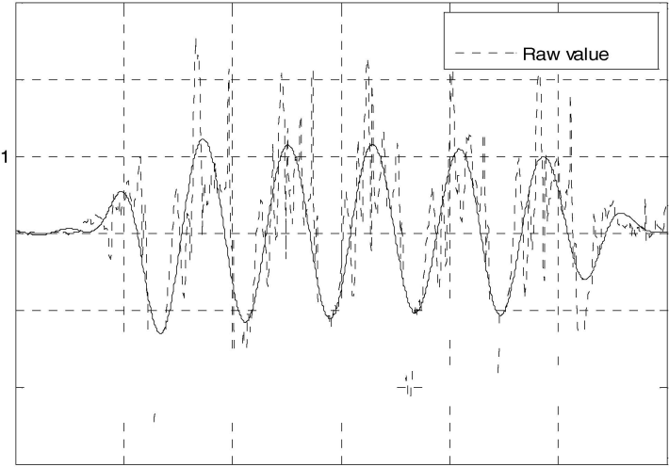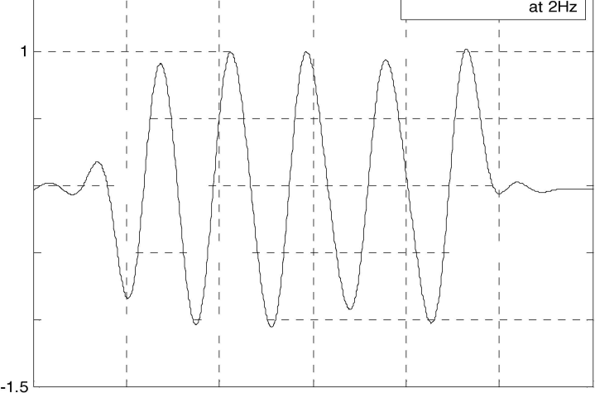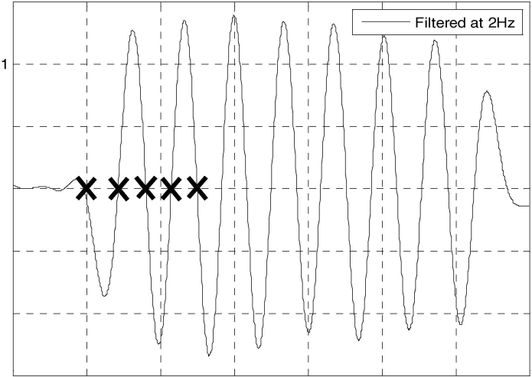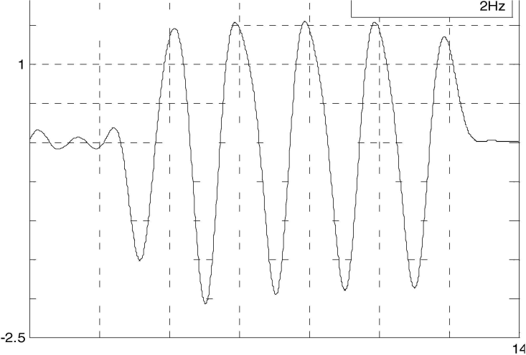

o 2 4 6 8 10 12

Time (s)

Figure 3. Strength of the gyro-x signal when ascending stairs

#### 553

SuC2.3

TABLE II. EXPERIMENTAL RESULTS OF THE PROPOSED ALGORITHM FOR ALL PARTICIPANTS

Actual Calculated Accuracy

Activity number by the as a

Overall accuracy of the algorithm was above 94%. It is evident from the results that climbing down stairs registered a low percentage of accuracy. This is mainly due to the weak signal strength by the user. Apart from that other errors were due to weak signal strength of different individuals at the start

Walking on inclined planes(down) 422 410 97.15

Further this algorithm was tested for accuracy at different walking speeds and stepping speeds with the involvement of multiple male and female volunteers. Table III shows the variation of the accuracies at different walking speeds on a flat land while accuracies at different stepping speeds are tabulated in Table IV and Table V.

TABLE III. ACCUARACY OF THE ALGORITHM AT DIFFERENT WALKING SPEEDS

Actual Calculated Accuracy

Speeds of walking number by the as a of steps algorithm percentage

down. This is achieved by setting a proper filtering process along with an adaptive peak threshold set by the user. It is important to notice that accuracies of pedometers at slow speeds of activity intensities were a major requirement for both research activities and consumers of pedometers.

|  |  |  |  |  |
| --- | --- | --- | --- | --- |
| Walking slowly on flat lands | of  285 | 276 | 96.84 | and end of the travel. |
| Walking faster on flat lands | 491 | 485 | 98.77 | F. *Advantages ofthe Proposed Algorithm* |
| Climbing up stairs 110 107 97.27 There are several advantages in gyroscopic data based step | | | | |
| Climbing down stairs | 110 | 104 | 94.54 | detection algorithm. One main advantage is the ability to detect |
| Walking on inclined planes(up) | 433 | 425 | 98.15 | steps at slow speeds for both walking and stepping up and |

In addition to those, the algorithm depends only on the data of a single axis of the gyroscope. This provides lesser computations and ability to integrate this function in research areas like Indoor Navigation.

Further algorithm is implemented in currently available high end mobile devices, which is more convenient to be used with any application as sensors are not attached to the body.

G. *Future Work*

|  |  |  |  |  |
| --- | --- | --- | --- | --- |
| 50 steps/min | 259 | 255 | 98.45 | In this paper we discuss the algorithm used to detect steps, |
| 75 steps/min | 378 | 370 | 97.88 | even at slow walking speeds. In this particular algorithm user |
| 100 steps/min | 510 | 499 | 97.84 | may need to change threshold to be consistent with accurate |

TABLE IY.

ACCUARACY OF THE ALGORITHM AT DIFFERENT STEPPING UP SPEEDS

Actual Calculated Accuracy

step counting as the environment that places the device changes. So designing a neural network that learns different thresholds with the changing environments can solve this inconvenience.

The error percentage of the algorithm is due to the fact that it is detecting the movement of the phone to validate a step. So we will be working on an improved solution to avoid such false

|  |  |  |  |
| --- | --- | --- | --- |
| 125 steps/min | 625 | 620 | 99.20 |
| 150 steps/min | 745 | 739 | 99.19 |

counts.

Stepping up speeds number by the as a of steps algorithm percentage

Integration of the Barrow meter with the proposed

50 steps/min

110 108 98.18

algorithm may provide a better solution to inaccuracies found

|  |  |  |  |  |
| --- | --- | --- | --- | --- |
| 75 steps/min | 110 | 106 | 96.36 | during stepping down due to weak signal strength. |
| 100 steps/min | 110 | 108 | 98.18 | Further integrating an activity recognition algorithm with |
| 125 steps/min | 110 | 106 | 96.36 | the proposed algorithm may increase the accuracy during |
| 150 steps/min | 110 | 109 | 99.09 | different activities. |

TABLE V.

ACCUARACY OF THE ALGORITHM AT DIFFERENT STEPPING DOWN SPEEDS

Actual Calculated Accuracy

1. CONCLUSIONS

It is evident from the results of past researches that most of the pedometer algorithms perform very poorly at slow speeds of walking (50-70 steps/min) and when performing different

Stepping down speeds number by the as a of steps algorithm percentage

50 steps/min 110 105 95.45

75 steps/min 110 107 97.27

100 steps/min 110 106 96.36

125 steps/min 110 105 95.45

150 steps/min 110 108 98.18

activities at varying speeds. Therefore the need of developing a reliable algorithm which performs at any walking speed and with different walking patterns was a major requirement among modern researchers and consumers of pedometers. Key points of the algorithm presented in this paper consist of engineering techniques like noise removal, zero crossing and threshold detection. Further it makes use of the natural rotational motion of the leg of the human being to predict steps rather than the



#### 554

SuC2.3

linear motion of the body. Overall accuracy of the algorithm was above 94%, in which accuracies at slow speeds of walking was remarkably high. It is also important to notice that this accuracy can be further improved with proposed engineering techniques.

ACKNOWLEDGMENT

The authors would like to thank Dr.lain Murray from Curtin University, Australia for providing all hardware and software accessories required to accomplish this task and all the volunteer participants (students of Sri Lanka Institute of Information Technology, Malabe, Sri Lanka) for their participation in the experiments conducted.

REFERENCES

1. AZ. LaCroix, S.G. Leveille, J.A. Hecht, L.c. Grothaus and E.H. Wagner, "Does walking decrease the risk of cardiovascular disease hospitalizations and death in older adults?," Journal of the American Geriatrics Society, vol. 44, no.2, pp.113-120, Feb 1996.
2. E.M. Simonsick, .l.M. Guralnik, S. Volpato, .I. Balfour, and L.P. Fried, "Just get out of the door! Importance of walking outside the home for maintaining mobility: Findings from the women's health and aging study," Journal of the American Geriatrics Society, vol.53, no.2, pp.19S- 203, Feb 2005.
3. Y. Hatano, "Use of the pedometer for promoting daily walking exercise," International Council for Health, Physical Education, and Recreation, vol. 29, pp.4-S, 1993.
4. E. Garcia, Hang Ding, A Sarela and M. Karunanithi, "Can a mobile phone be used as a pedometer in an outpatient cardiac rehabilitation program?," in IEEE/ICME International Conference on Complex Medical Engineering (CME) 2010., 2010, pp.250-253.
5. D.S. Michaud, E. Giovannucci, W.C. Willett, G.A. Colditz, M.l Stampfer and C.S. Fuchs, "Physical activity, obesity, height, and the risk of pancreatic cancer," Journal of the American Medical Association, vol. 2S6, no.S, pp. 921-929, Aug 2001.
6. S.E. Crouter, E. Scott, P.L. Schneider, M. Karabulut and D.R. Bassett, "Validity of 10 electronics pedometers for measuring steps, distance and energy cost," Medicine and Science in Sports and Exercise, vol. 35, no.S, pp.1455-1460, 2003.
7. G. .I. Jerome and C. Albright. (2011, June). "Accuracy of Five Talking Pedometers under Controlled Conditions." The Journal of Blindness

Innovation and Research. [On-line]. 1(2). Available: www.nfb­ jbir.org/index.php/JBIR/article/view!l7/3S [Oct. 27, 2011].

[S] W. Waqar, A Vardy and Y. Chen. "Motion Modelling using Smart phones for Indoor Mobilephone Positioning," presented at the 20th Newfoundland Electrical and Computer Engineering Conference, Newfoundland, Canada, 2011.

1. M. Oner, J.A. Pulcifer-Stump, P. Seeling and T. Kaya. "Towards the Run and Walk Activity Classification through Step Detection- An Androi Application,"in 34th Annual International Conference of the IEEE Engineering in Medicine and Biology, 2012, pp.19S0-19S3.
2. M. Lee, J. Kim, K. Kim, I. Lee, S.H. .lee and S.K. Yoo. "Physical Activity Recognition Using a Single Tri-Axis Accelerometer," in Proceedings of the World Congress on Engineering and Computer Science, vol I, pp.14-17, October 2009.
3. AM. Cavalcante, E.B. Souza, J.J. Bazzo, N. Bezerra, A Pontesand and RD. Vieira. " A Pedometer-Based System for Real-time Indoor Tracking on Mobile Devices," in XXIX Brazilian Symposium on Telecommunications, Curitiba, Brazil, Oct,2011. [Online]. Available:

<http://mwsl.unb.brlindex.php/pt/publicacoes>[Apr. 12,2012].

1. E. Garcia, H. Ding, A Sarela and M. Karunanithi, "Can a mobile phone be used as a pedometer in an outpatient cardiac rehabilitation program?," in IEEE/ICME International Conference on Complex Medical Engineering (CME) 2010., 2010, pp.250-253.
2. Y.P. Lim, LT. Brown and lC.T. Khoo, "An accurate and robust gyroscope-gased pedometer," in 30th Annual International Conference of the IEEE Engineering in Medicine and Biology Society, 200S. EMBS 200S., 200S, pp.45S7-4590.
3. S. Zhong, L. Wang, AM. Bernardos and M. Song, "An accurate and adaptive pedometer integrated in mobile health application," in IET International Conference on Wireless Sensor Network, 2010. IET­ WSN., 2010, pp.7S-S3.
4. G. Boyce, G. Padmasekara, M. Blum. "Accuracy of Mobile Phone Pedometer Technology". Journal of Mobile Technology in Medicine, vol. I, pp.16-22, June 2012.
5. M. Ayabe, l Aoki, K. Ishii, K. Takayama, H. Tanaka "Pedometer accuracy during stair climbing and bench stepping exercises". Journal of Sports Science and Medicine, vol. 7, pp.249-254, June 200S.
6. N. Abhayasinghe, I. Murray, "A Novel Approach for Indoor Localization Using Human Gait Analysis with Gyroscopic Data," in International Conferenc on Indoor Positioning and Indoor Navigation,November 2012, [Online]. Available :

[www.surveysurveying.unsw.edu.aulipin2012/papers.php](http://www.surveysurveying.unsw.edu.aulipin2012/papers.php) [Dec.10,2012].



#### 555