docker-machine create --driver virtualbox manager1 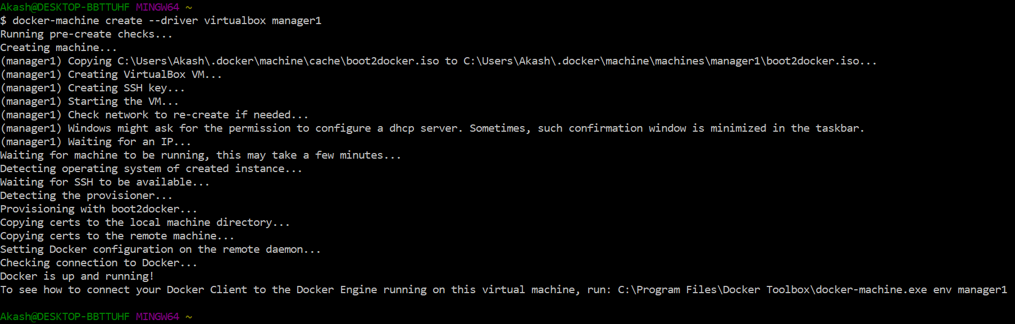

docker-machine create --driver virtualbox worker1

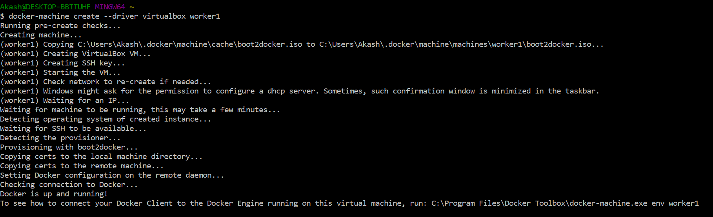

docker-machine create --driver virtualbox worker2

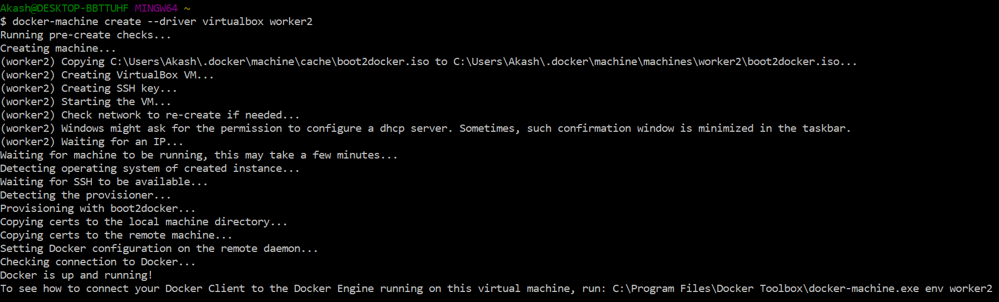

docker-machine ls //to list of docker machines

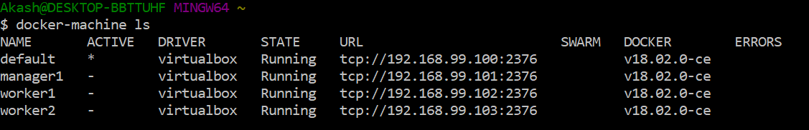

Ip’s of docker machines

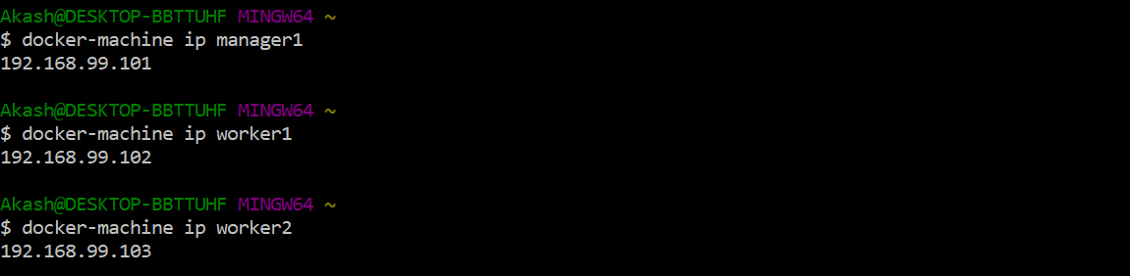

docker-machine ssh manager1

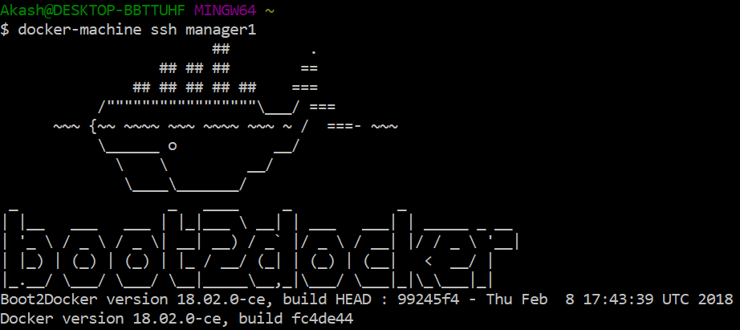

docker swarm init --advertise-addr MANAGER_IP

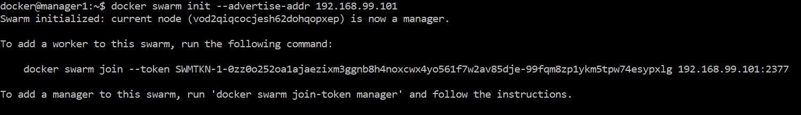

docker swarm join-token worker



docker swarm join-token manager



docker node ls



**Open a new docker terminal**

docker-machine ssh worker1

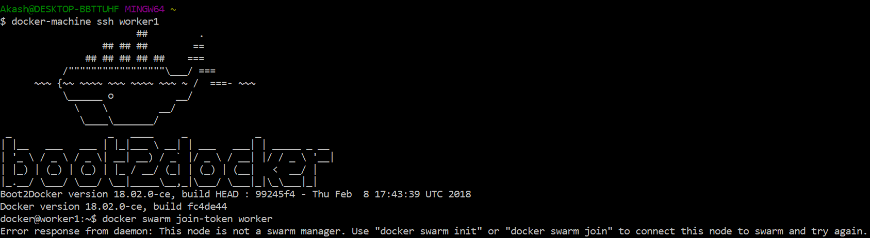

Join worker1 to the swarm



docker node ls //on the manager1



**Open a new docker terminal**

docker-machine ssh worker2

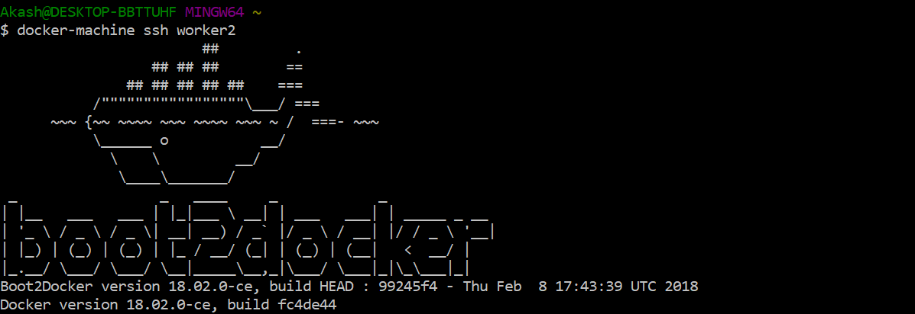

Join worker2 to the swarm



docker node ls //on the manager1

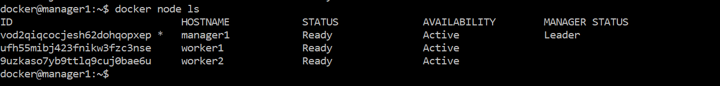

docker info //on the manager1 and zoom into the swarm section

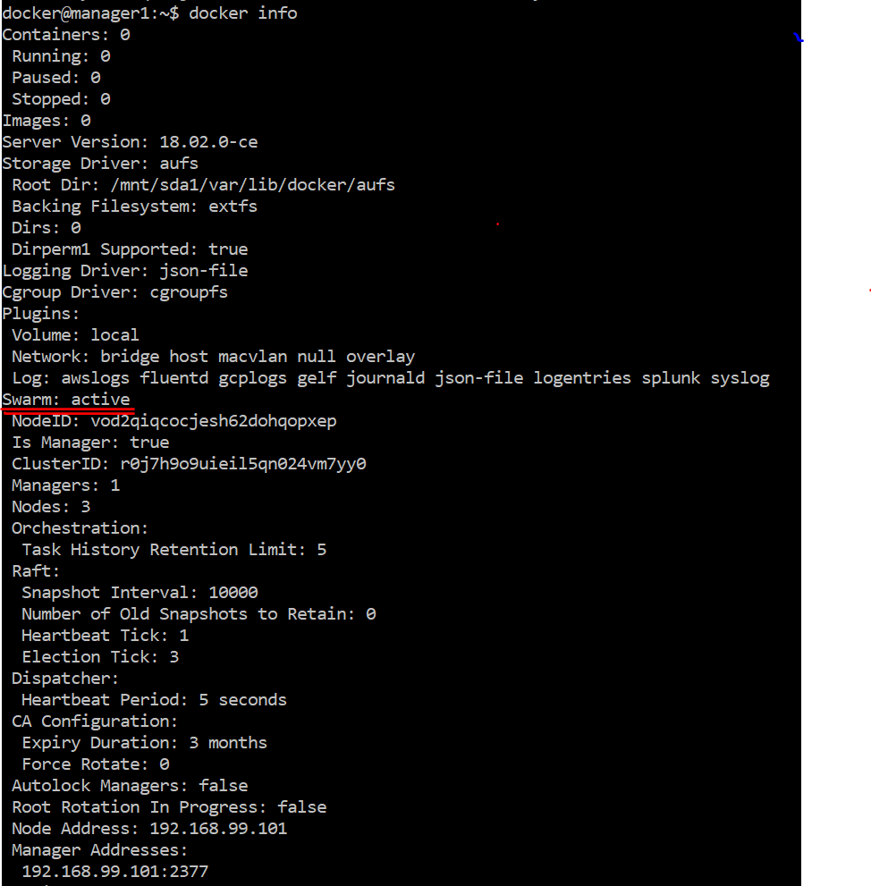

**Create a Service**

Creating 2 replicas

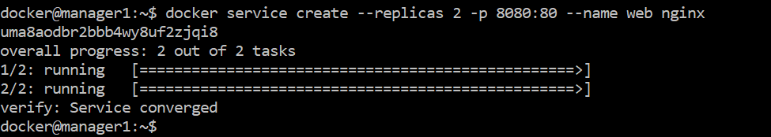

Status of service







**Accessing the Service**

http://<any machine ip>:8080

list of docker machines and their ip’s //on new docker terminal

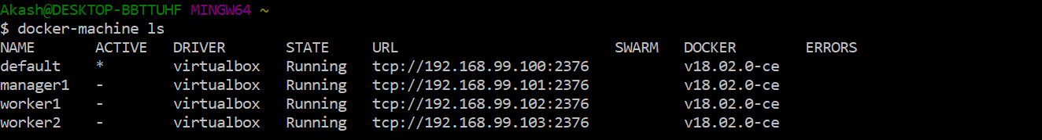

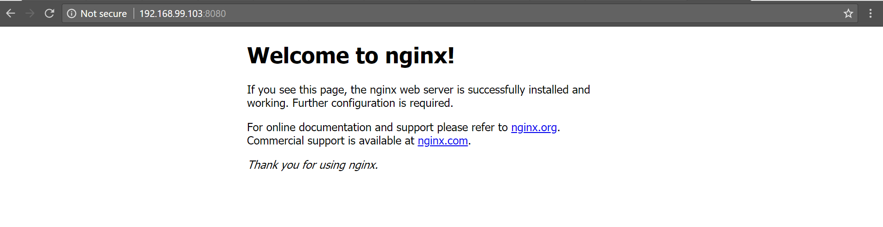

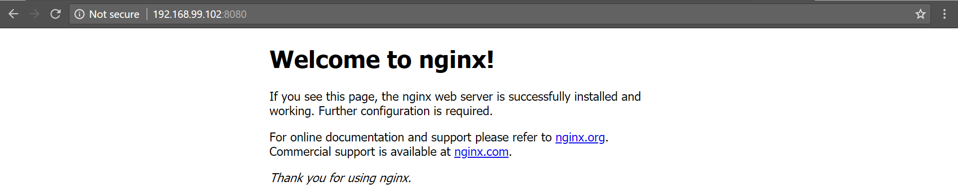

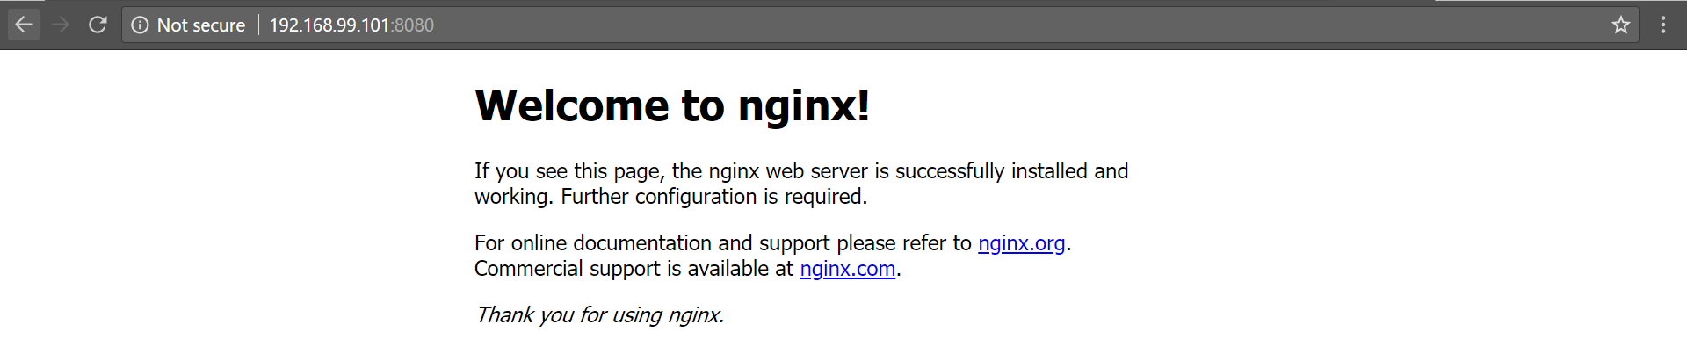

**Scaling up and Scaling down**

Scaling up to 5 replicas from 2 replicas

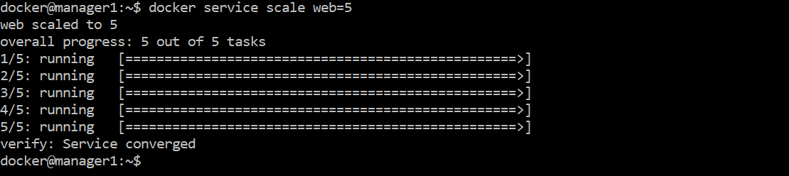

Checking status of service

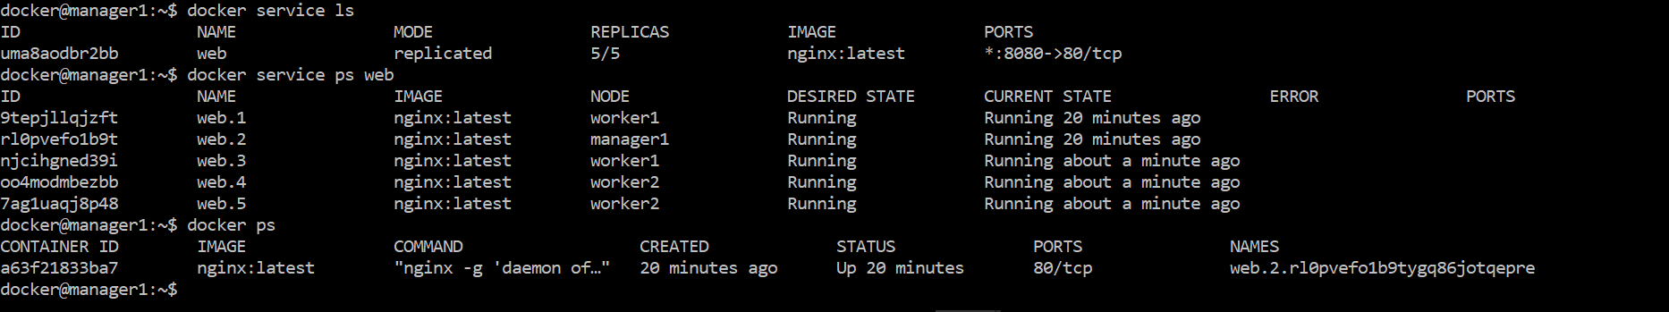

Checking tasks running on manager1



Checking tasks running worker1 and worker2

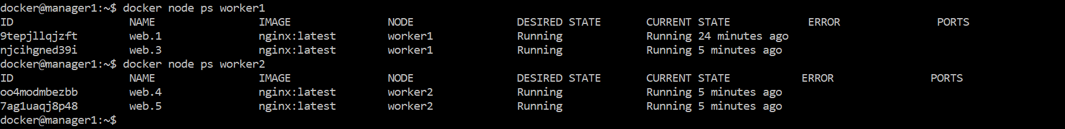

**Checking availability of nodes**

docker node inspect [--pretty] Nodename

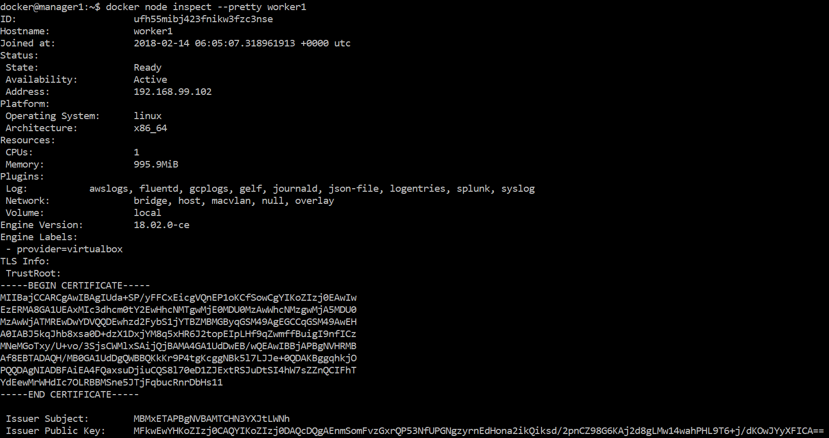

**Draining a node**

docker node update --availability drain Nodename

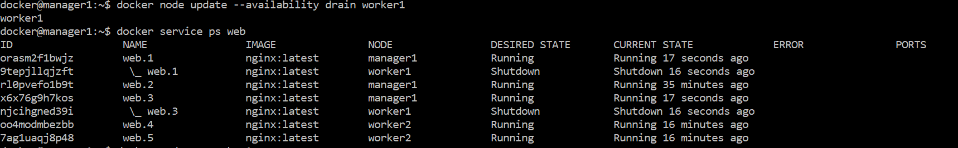

Checking replicas running on worker1,worker2 and manager1

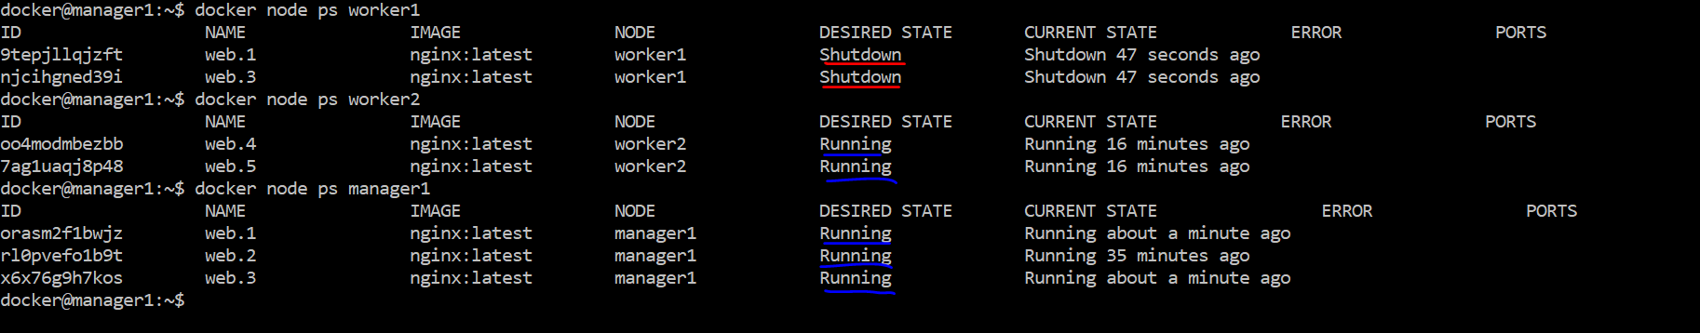

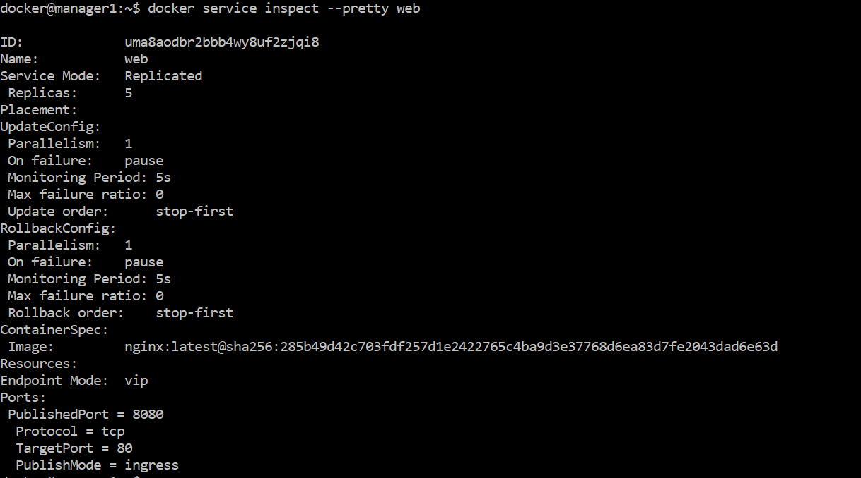

**Remove the Service**

docker service rm ServiceName

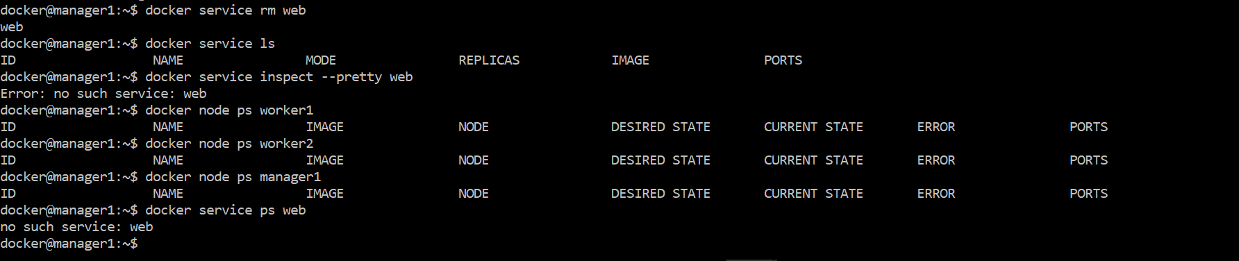

Stopping docker machine

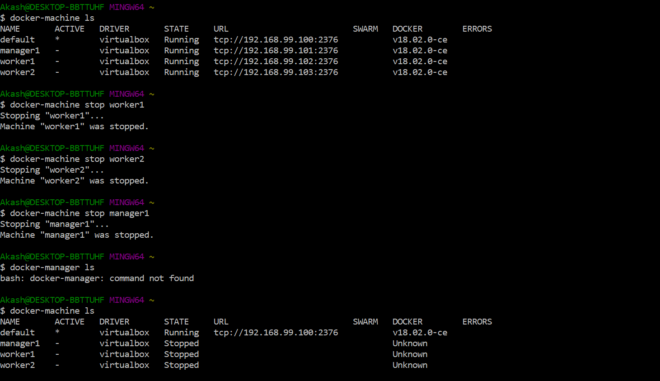

Deleting docker-machine

