NAO-Communicator
Project Report



published by
Hannes Eilers
at
University of Applied Sciences
Kiel, Germany

together with
NorthernStars Robotics Group

February 2015

The NAO-Communicator project and this paper is published
under Creative Commons License version 3.0
(CC BY-NC-SA 3.0)

You must attribute the work in the manner specified by the author or licensor (but not in any way that suggests that they endorse you or your use of the work).
You may not use this work for commercial purposes.
If you alter, transform, or build upon this work, you may distribute the resulting work only under the same or similar license to this one.
See http://creativecommons.org/licenses/by-nc-sa/3.0/legalcode for more information.

© 2014/2015 Hannes Eilers,
NorthernStars Robotics Group, UAS Kiel

Content
1 Abstract 1
2 The NAO Robot System 2
2.1 NAOqi Framework 2
2.2 Integrated Algorithms 3
3 Objectives 4
4 Concept 4
5 Implementation 6

Abstract
In the past robots where only used in academic or industrial context. They were complex mechanical and electronic products, requiring specialized engineers to manage them. But in the present more and more robots are available, that are suitable for end users. In academic context the NAO robot from Aldebaran Robotics in France has become very popular. The completely build up robot comes with an easy to understand framework. Anyway programming the robot needs further skills in robotics. Although there are many applications available for the NAO, it's not possible to use them all together easily. So doing some demonstration of different applications needs skills in programming an additional application that connects the already available applications.
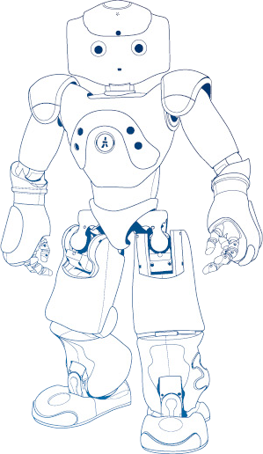Figure 1: NAO Robot Line Drawing [1]
To make different applications of the NAO available for easy to use demonstrations and end users that are not able to program complex programs, the NAO-Communicator project developed two application that allow an easy access using a mobile Android device to remote control the NAO robot. The application focuses on offering functions for small demonstrations of the NAO's features and a simple way to install all required software without knowledge about the NAO's embedded systems.

The NAO Robot System
The humanoid robot NAO (see Figure 1) is developed by Aldebaran Robotics since 2004. In 2007 it replaces Sony's Aibos robot dog as robot for the international RoboCup Standard Platform League [2]. It has become very popular in education, especially in computer science classes [3]. The robot is about 58 cm tall and comes with several motors and ultrasonic sensors, internal gyroscope and accelerometer, two cameras, infrared transceiver, tactile touch sensors, food bumpers, microphones for sound localization and an integrated computer system. The internal computer system runs a Linux kernel and Aldebaran's proprietary middleware NAOqi. The robot uses a lithium polymer battery pack for autonomous operations and can connect to other robots or computer via Ethernet or WiFi.

NAOqi Framework
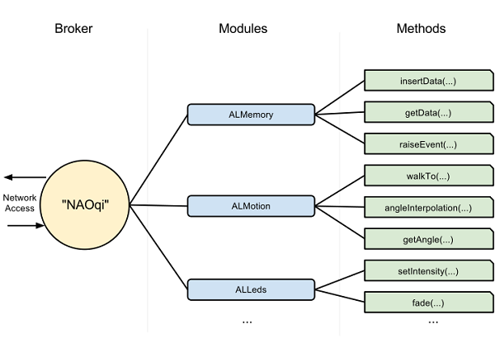Figure 2: NAOqi Framework Key Concept [4]
While NAOqi is the main software running on the NAO, the “NAOqi Framework is the programming framework used to program Aldebaran robots.” The NAOqi works as broker, loading several modules after it is started. These modules can offer methods for accessing NAO's features and hardware (see Figure 2). Modules can also make use of other modules. The NAOqi broker allows access via network connection. So both, local and remote applications can access modules. Modules can also be executed on remote devices and get connected through so called proxies with other NAOqi's broker. This allows several ways to develop applications running remote or on the robot.
Modules can be programmed using several languages. Typically C++ is used for libraries (because for better performance) and modules where Python is used to program the robots behavior (because of easier programming). Aldebaran offers a software called Choregraphe to program the robot by connection several boxes running Python code. There are also other libraries to access NAOqi brokers using other programming languages like Java or Urbi. Using an internal memory called ALMemory, NAOqi modules can share data via adding own data sets to the memory or registering for callbacks on other modules data sets changes.

Integrated Algorithms
Aldebaran delivers some good working algorithms of NAO's mostly used functions. These include for example walking, sitting down or stand up, a Thai Chi animation, face/object detection, speech synthesis and recognition. These algorithms ca be used for the most common behaviors. Aldebaran also offers an online website where other NAO users can upload their projects to share them.

Objectives
The main objective of the NAO-Communicator project was to develop an Android application (app) for mobile devices, that offers remote control functions for the NAO robot. The app has to implement functions to install and update additionally required software on the robot, without expert knowledge of the app user. It has to offer access to integrated algorithms to for robot's remote control. Further more the app should integrate external applications like dance animations for demonstration purposes, a simple programming interface for rapid developing of small programs and functions to start application from expert users, that are running on the robot.

Concept
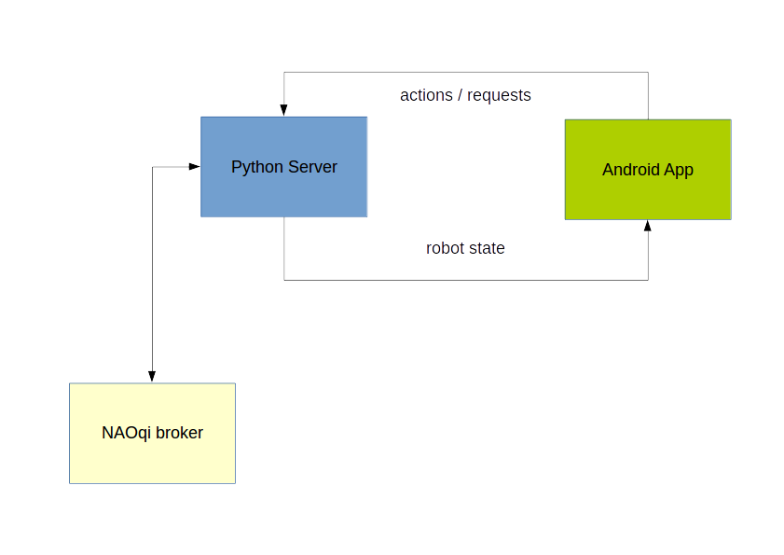Figure 3: NAO-Communicator Concept
The NAO-Communicator project uses a Python server to offer network access to a selected set of NAO's functions. Although it is possible to connect directly to NAOqi's broker via network, an additional server allows handling of incorrect or unauthorized access to the robot to avoid malfunctions. In general communication between mobile device and robot is done the following way (see Figure 3). The Android app connects to the Python server running on the robot. The server than start sending information data about the robots state to the app. The app sends actions, triggered by the app user via a graphical user interface (GUI) back to the server. If the requested action is allowed, the server executes it. Using this way of communication an action is also executed, even if the app crashes. Also the server can always set the robot back into a stable state and controls allowed and disallowed requests. Details are described by the following user story:

Any user, also non-robotic-experts, is able to download the NAO-Communicator Android application using Google's Play Store. The application scans the wireless network for NAO robots the user can connect to or offers adding a custom robot IP. The user can use the app to install the required server and modules on the NAO, if they aren't installed. If the server is installed the app can start it, if not already running and connects to the server. The app constantly receives data about the robots state and show this using the app GUI. The app offers functions via the GUI for the app user. These functions include integrated algorithms of the NAO robot like standing up or sitting down, wave the arm. speak sentences, starting and stopping object trackers or changing led colors. The app has a simple programming interface to generate a list of sequential processed actions the app can send to the server. Also the app allows the user to add own ALMemory values that can get called to start external applications via ALMemory events. If the connection to server is lost, it tries to reconnect to the last connected NAO to reestablish the connection. To avoid malfunctions due to several users accessing one NAO, the server allows only one connected app.

Implementation
References
1: Aldebaran 2.1.2.17 documentation, http://doc.aldebaran.com/2-1/ (07.02.2015)
2: NAO (robot), https://en.wikipedia.org/wiki/Nao_%28robot%29 (07.02.105)
3: NAO robot: intelligent and friendly companion, https://www.aldebaran.com/en/humanoid-robot/nao-robot (07.02.2015)
4: Key concepts - Aldebaran 2.1.2.17 documentation, http://doc.aldebaran.com/2-1/dev/naoqi/index.html (07.02.2015)

Key concepts - Aldebaran 2.1.2.17 documentation, http://doc.aldebaran.com/2-1/dev/naoqi/index.html (07.02.2015)

